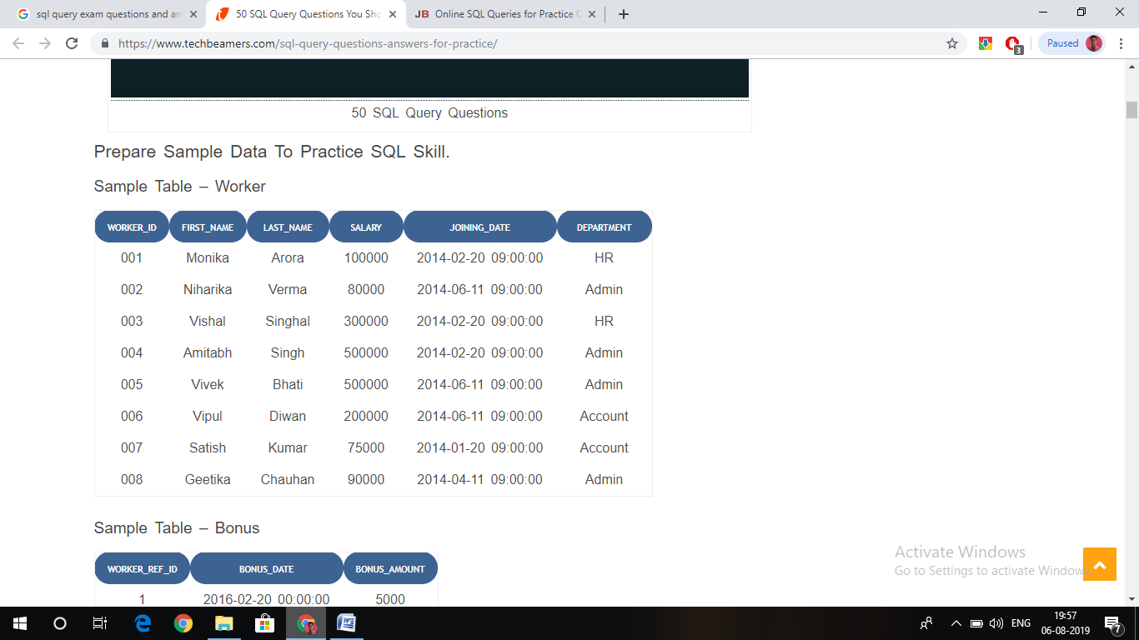

Sample table: Bonus

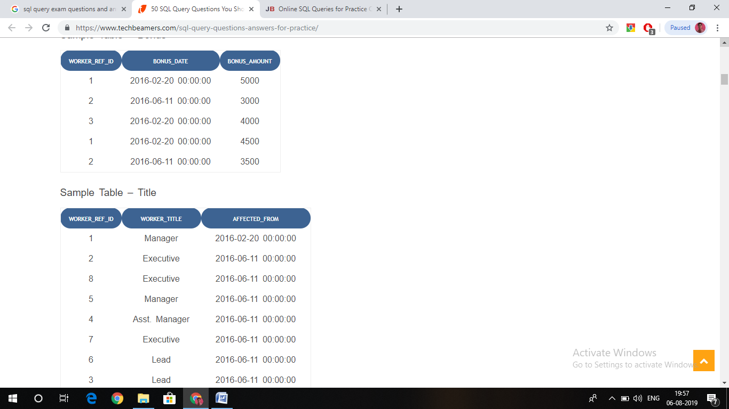

1. Write An SQL Query To Fetch “FIRST_NAME” From Worker Table In Upper Case alias as WORKER_FIRSTNAME.

#### Write An SQL Query To Print The First Three Characters Of  FIRST_NAME From Worker Table.

#### Write An SQL Query To Find The Position Of The Alphabet (‘A’) In The First Name Column ‘Amitabh’ From Worker Table.

#### Write An SQL Query To Print The FIRST_NAME And LAST_NAME From Worker Table Into A Single Column COMPLETE_NAME. A Space Char Should Separate Them.

#### Write An SQL Query To Print All Worker Details From The Worker Table Order By FIRST_NAME Ascending And DEPARTMENT Descending.

#### Write An SQL Query To Print Details Of The Workers Whose FIRST_NAME Contains ‘A’.

#### Write An SQL Query To Print Details Of The Workers Whose FIRST_NAME Ends With ‘A’.

#### Write An SQL Query To Print Details Of The Workers Whose SALARY Lies Between 100000 And 500000.

#### Write An SQL Query To Fetch The Count Of Employees Working In The Department ‘Admin’.

#### Write An SQL Query To Fetch The No. Of Workers For Each Department In The Descending Order.

#### Write An SQL Query To Print Details Of The Workers Who Are Also Managers.

#### Write An SQL Query To Show Only Odd Rows From A Table

#### Write An SQL Query To Show Records From One Table That Another Table Does Not Have.

#### Write An SQL Query To Show The Top N (Say 10) Records Of A Table.

#### Write An SQL Query To Fetch The List Of Employees With The Same Salary.

#### Write An SQL Query To Show All Departments Along With The Number Of People Working There.

#### Write An SQL Query To Print The Name Of Employees Having The Highest Salary In Each Department.

#### Write An SQL Query To Fetch Departments Along With The Total Salaries Paid For Each Of Them.

#### Consider the following relations for an order processing database application in a company.

#### CUSTOMER (Cust #: int, Cname: string, City: string)

#### ORDER (Order #: int, Odate: date, Cust #: int, Ord-Amt: int) ORDER-ITEM (Order #: int, Item #: int, qty: int)

#### ITEM (Item #: int, Unit Price: int)

#### SHIPMENT (Order #: int, Warehouse #: int, Ship-Date: date) WAREHOUSE (Warehouse #: int, City: string)

#### Create the above tables by properly specifying the primary keys and the foreign keys.

#### Enter at least five tuples for each relation.

#### Produce a listing: CUSTNAME, NO_OF_ORDERS, AVG_ORDER_AMT, where the middle column is the total number of orders by the customer and the last column is the average order amount for that customer

#### List the Order# for the orders that were shipped from all the warehouses that the company has in a specific city

#### Demonstrate how you delete Item# 10 from the ITEM table and make that field null in the ORDER- ITEM table.

#### Create a table Emp(e_no, e_name, e_phone, e_addr,e_salary) to store records of 10 employees:

#### Alter the data type of e_no from number to varchar

#### Alter table by setting e_no as primary key

#### Alter table by adding a column e_pin

#### Update the phone number of an employee in the table

#### Create a table Dept(dept_no, dept_name,e_no, dept_loc,dept_hod) to store records of 10 departments:

#### Create the reference between Emp and Dept table with e_no attribute.

#### Assign dept_no as primary key.

#### Update the dept_hod for one department.

#### Delete one department.

#### Solve the following queries

#### Write a query to find the employee name and dept_hod whose dept_hod is SAY, “John”.

#### Write a query to find the average salary of the employee of CSE department.