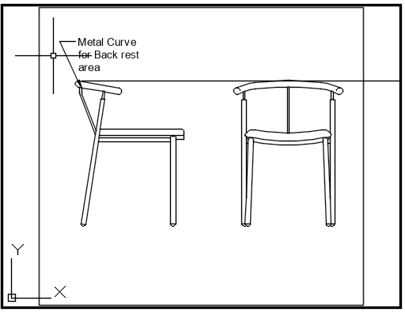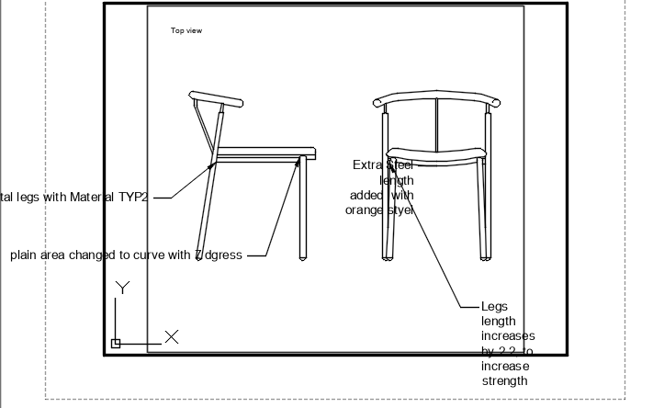

 | Interior Decoration Diploma | Drawing Name: Side View Chair | Project: Chair
 | Date: 25th November 2025 | Drawn By: Mohit Bhanot | Scale: Inches | Sheet1/4

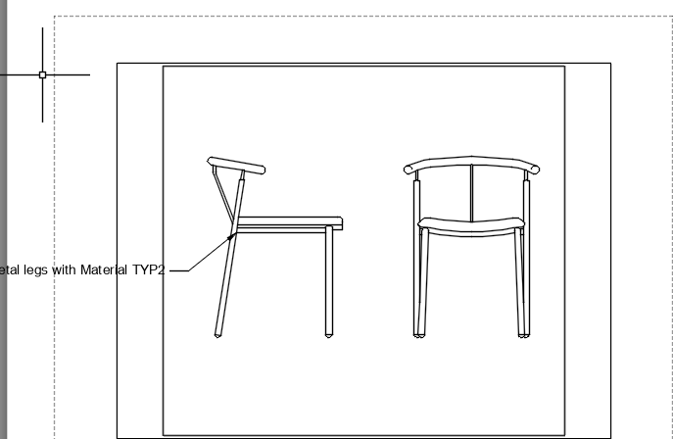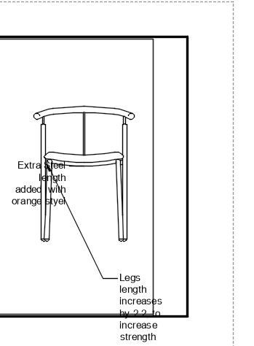

 | Interior Decoration Diploma | Drawing Name: Isometric View | Project: Chair
 | Date: 25th November 2025 | Drawn By: Mohit Bhanot | Scale: Inches | Sheet 2/4

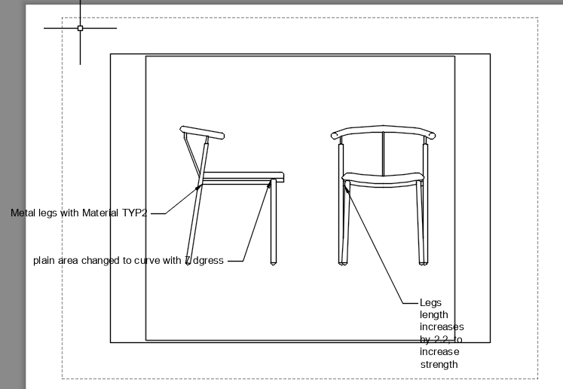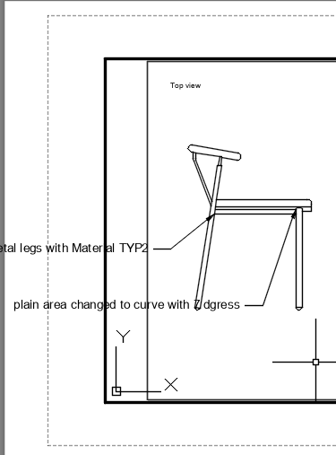

 | Interior Decoration Diploma | Drawing Name: Left View |  | Project: Chair
 | Date: 25th November 2025 | Drawn By: Mohit Bhanot | Scale “Inches |  | Sheet3/4

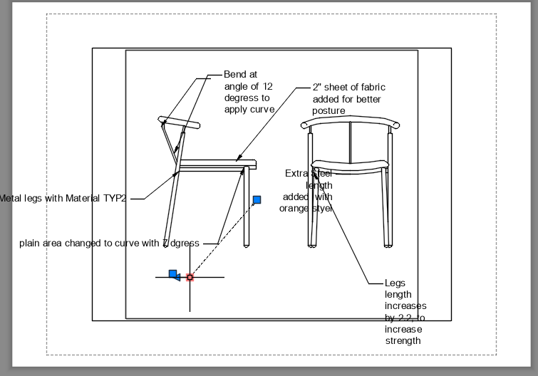

 | Interior Decoration Diploma | Drawing Name: Front View | Project: Chair
 | Date: 25th November 2025 | Drawn By: Mohit Bhanot | Scale “Inches | Sheet4/4

