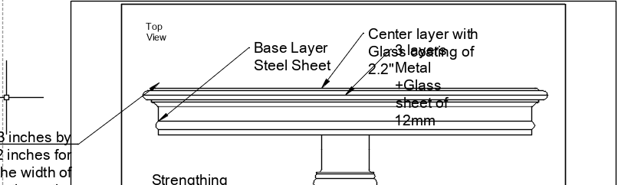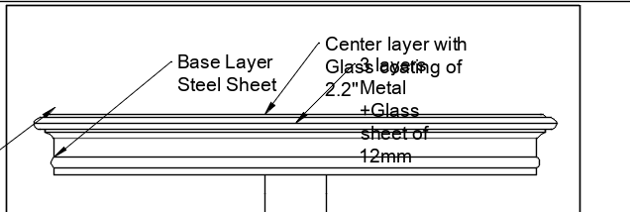

 | Interior Decoration Diploma | Drawing Name: Table | Project: Table
 | Date: 25th November 2025 | Drawn By: Mantaj singh | Scale: Inches | Sheet: 1/4

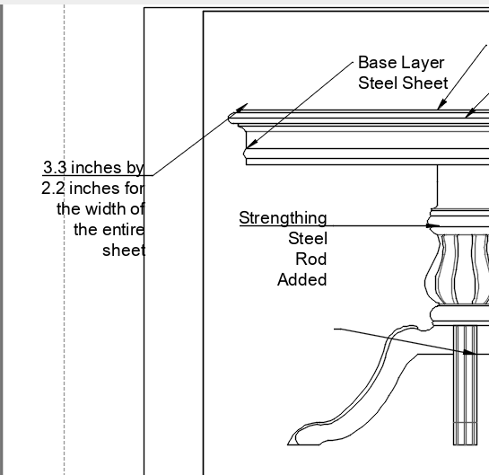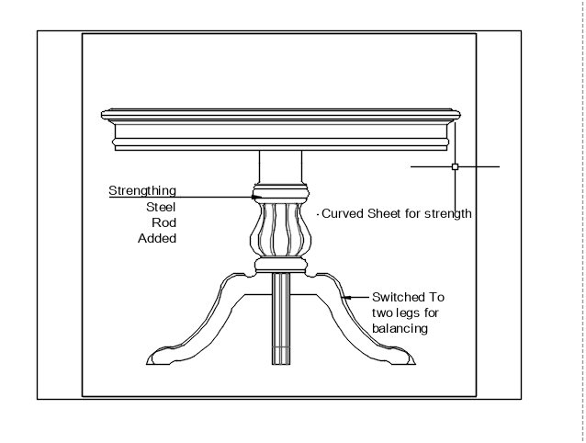

 | Interior Decoration Diploma | Drawing Name: Table | Project: Table
 | Date: 25th November 2025 | Drawn By: Mantaj singh | Scale: Inches | Sheet: 2/4

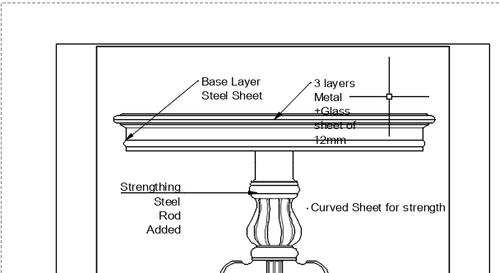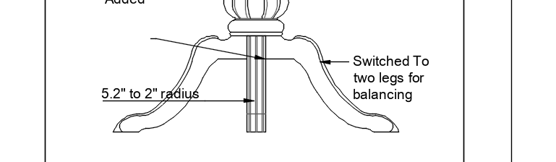

 | Interior Decoration Diploma | Drawing Name: Table | Project: Table
 | Date: 25th November 2025 | Drawn By: Mantaj singh | Scale: Inches | Sheet: 3/4

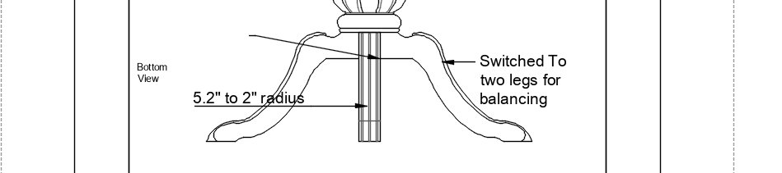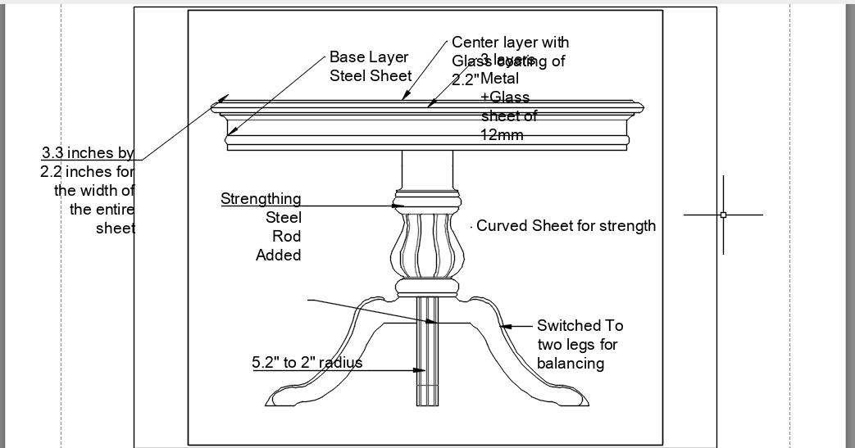

 | Interior Decoration Diploma | Drawing Name: Table | Project: Table
 | Date: 25th November 2025 | Drawn By: Mantaj singh | Scale: Inches | Sheet: 4/4

