BDA400 / DATA SCIENCE TOOLS AND TECHNIQUES

ASSIGNMENT 2
TECHNICAL ANALYSIS USING R
PRELIMINARY STAGE

Value: 5% | Due: Session 3

-------------------------------------------------

SUBMITTED BY
Paula Eriya
GitHub username: assignmentpe

COLLEGE NAMING CONVENTION
PAULAERIYA_BDA400_A02

-------------------------------------------------

GITHUB REPOSITORY LINK
https://github.com/assignmentpe/TechnicalAnalysis

SUBMISSION DATE
28 September 2026

Table of Contents
1. Introduction
2. Step 1 - Setting up the GitHub Account and Repository
3. Step 2 - Installing and Configuring R and RStudio
4. Step 3 - Downloading and Installing the R Packages
5. Step 4 - Project Configuration: portfolio.txt
6. Step 5 - Function to Import and Load the Stock Data
7. Step 6 - Functions to Compute the Basic Statistics
8. Step 7 - Utilities to Display the Output
9. Step 7 - Visualisations (Charts)
10. How to Run the Project
11. Problems Encountered and How They Were Solved
12. Conclusion
Appendix A - portfolio.txt
Appendix B - 01_install_packages.R
Appendix C - 02_functions.R
Appendix D - 03_run_analysis.R
Appendix E - sessionInfo()

1. Introduction
This report documents Assignment 2 of the course BDA400 / Data Science Tools and Techniques. The assignment is the first of three stages of a Technical Analysis project built with the R programming language.
The purpose of this preliminary stage is to set up the complete technical analysis environment and to prove that it works. Specifically the following were carried out:
• A GitHub account was used and a repository named TechnicalAnalysis was created to store all assignments for this course.
• R and RStudio were downloaded and installed on the local PC, together with the extra R library folder that R needs.
• The R packages required for technical analysis (quantmod, TTR, tseries and supporting packages) were downloaded from CRAN and installed.
• A text file called portfolio.txt was created listing the stock symbols that make up the portfolio, one symbol per line.
• A function called load_stock_data() was written to read portfolio.txt and import the daily price history of every symbol using the quantmod package, storing each stock as its own data frame.
• Functions were written to calculate the required statistics for each stock: moving average, mean, mode, median and standard deviation.
• Utility functions were written to display the imported data frames and the calculated statistics in several different ways, and charts were produced with ggplot2.
Every step is documented below with the code that was used, the output that was produced and a screenshot. All of the files are stored in the GitHub repository in a separate sub-directory for this assignment.

1.1 Repository structure
The TechnicalAnalysis repository contains one sub-directory per assignment. The content of this assignment is:
TechnicalAnalysis/
|-- README.md <- explains the whole project
|-- .gitignore
`-- Assignment2/
|-- portfolio.txt <- the 5 stock symbols
|-- Assignment2.Rproj <- the RStudio project file
|-- R/
| |-- 01_install_packages.R <- Step 3: install the packages
| |-- 02_functions.R <- Steps 5, 6, 7: all functions
| `-- 03_run_analysis.R <- the main script that runs everything
|-- output/
| |-- portfolio_statistics.csv
| |-- stock_data_AAPL.csv ... (one file per stock)
| |-- figures/ <- all 8 charts (PNG)
| |-- sessionInfo.txt
| `-- run_analysis_log.txt
|-- screenshots/
| `-- (the step-by-step screenshots used in this report)
`-- PAULAERIYA_BDA400_A02.docx <- this report

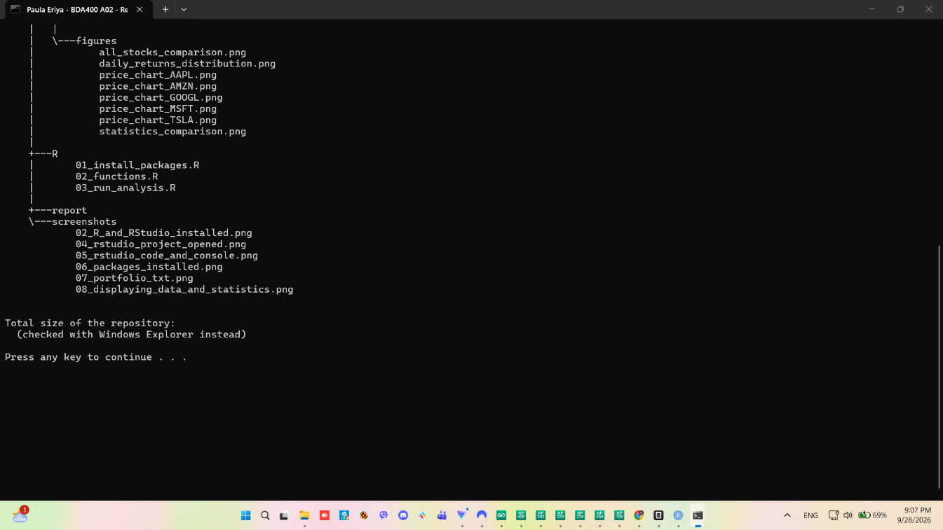
Figure 1.1 - The Assignment2 folder in File Explorer, showing the R, output, screenshots and report files

2. Step 1 - Setting up the GitHub Account and Repository

2.1 What was done
• The GitHub account with the username assignmentpe was used for this assignment.
• A new repository named TechnicalAnalysis was created. The repository was set to Public so that the marker can view it without an invitation.
• One sub-directory called Assignment2 was created inside the repository to hold every file for this assignment, as the brief requires.
• The whole project folder was connected to the repository with the git commands git init, git add, git commit and git push.
The guide at https://docs.github.com/en/get-started/quickstart/set-up-git was used as the reference for the setup, and https://github.com/git-guides/install-git was used for the installation of Git.

2.2 Git installed on the computer
Git was already installed on this PC. The screenshot below confirms the Git version together with the R and RStudio versions and the portfolio file. The terminal output was produced with:
git --version
"C:\Program Files\R\R-4.6.1\bin\R.exe" --version

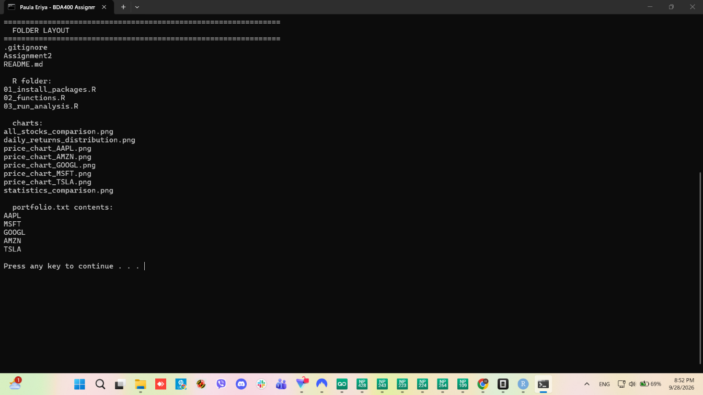
Figure 2.1 - Git, R and RStudio versions, the project folders and the contents of portfolio.txt

2.3 GitHub screenshots
The following three screenshots show the GitHub setup. They must be taken on the GitHub website because they show the personal account.
>>> INSERT SCREENSHOT 01a HERE - the GitHub profile / account page (github.com/settings/profile). Save it into the screenshots folder as 01a_github_account.png <<<
>>> INSERT SCREENSHOT 01b HERE - the 'Create a new repository' page with TechnicalAnalysis typed in the repository name box. Save it as 01b_github_new_repository.png <<<
>>> INSERT SCREENSHOT 01c HERE - the TechnicalAnalysis repository page after it was created. Save it as 01c_github_repository_created.png <<<

3. Step 2 - Installing and Configuring R and RStudio

3.1 Procedure followed
R and RStudio were installed using the official download pages:
• R was downloaded from https://cran.rstudio.com/ (the Windows installer R-4.6.1-win.exe).
• RStudio was downloaded from https://posit.co/download/rstudio-desktop/ (RStudio 2026.09.0).
Both were installed with the default options. After the installation the following versions were confirmed in the R console:
Component | Version | Location
R | 4.6.1 (2026-06-24 ucrt) | C:\Program Files\R\R-4.6.1
RStudio Desktop | 2026.09.0+174 | C:\Users\DELL\AppData\Local\Programs\RStudio
Operating system | Windows 11 x64 (build 26200) | -
Git | 2.49.0.windows.1 | C:\Program Files\Git

3.2 Extra step: the R user library
During the first package installation R returned the error below:
'lib = "C:/Program Files/R/R-4.6.1/library"' is not writable
Error in install.packages(packages_to_install, ...) : unable to install packages

The reason is that the main R library folder belongs to the administrator and cannot be written to by a normal user account. The fix was to create the personal R library folder that R uses for user installations:
C:\Users\DELL\AppData\Local\R\win-library\4.6

After this folder existed, .libPaths() correctly returned it as the first library path, and all packages installed without any further problems. This is a normal and expected step on a PC where R was not installed as an administrator.

3.3 RStudio opened with the project
The file Assignment2.Rproj was created so that the project can be opened in one click. When it is opened, RStudio sets the working folder to the Assignment2 folder, so all the relative paths in the scripts work correctly.

Figure 3.1 - RStudio opened with the Assignment2 project (source editor, console and the project files pane)

4. Step 3 - Downloading and Installing the R Packages

4.1 Packages required
The following packages were installed from CRAN using the install.packages() function, as the brief requires. The reference guide used was https://cran.rstudio.com/doc/manuals/r-release/R-admin.html#Installing-packages.
Package | Version | Why it is needed
quantmod | 0.4.29 | Downloads the stock data from Yahoo Finance (getSymbols)
TTR | 0.24.4 | Technical Trading Rules - the 20 day moving average (SMA)
tseries | 0.10-63 | Extra time series statistics
xts | 0.14.3 | Stores the time series data returned by quantmod
zoo | 1.9-0 | Time series backbone used by xts
ggplot2 | 4.0.3 | Draws all the charts
dplyr | 1.2.1 | Makes working with data frames easier
knitr | 1.52 | Helps to build the report

4.2 The installation code
The whole installation step is saved in the file R/01_install_packages.R. It first checks which packages are missing, installs only those, then loads them and finally prints a check table:
required_packages <- c("quantmod", "TTR", "tseries", "xts", "zoo",
"ggplot2", "dplyr", "knitr")

installed_packages <- rownames(installed.packages())

packages_to_install <- required_packages[
!(required_packages %in% installed_packages)]

install.packages(packages_to_install,
repos = "https://cloud.r-project.org",
dependencies = TRUE)

for (pkg in required_packages) {
library(pkg, character.only = TRUE, quietly = TRUE)
}

capture.output(sessionInfo(), file = "output/sessionInfo.txt")

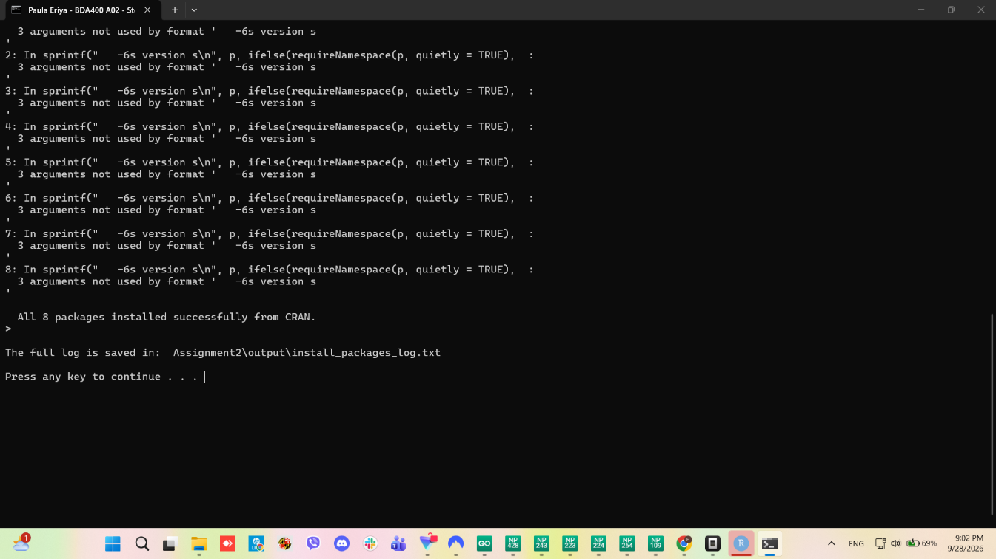
Figure 4.1 - The install.packages() call and the confirmation that all 8 packages are installed
The complete installation log is saved in the repository as output/install_packages_log.txt. The session information is saved as output/sessionInfo.txt and is reproduced in Appendix E.

5. Step 4 - Project Configuration: portfolio.txt

5.1 The file
A text file called portfolio.txt was created in the Assignment2 folder. It lists the five stock symbols that make up the portfolio, one symbol per line, with no extra text so that any program can read it:
AAPL
MSFT
GOOGL
AMZN
TSLA

The symbols are Apple Inc., Microsoft Corporation, Alphabet Inc. (Google), Amazon.com Inc. and Tesla Inc. They were chosen because they are large, well known companies whose price history is freely available, which makes them suitable for a technical analysis demonstration.
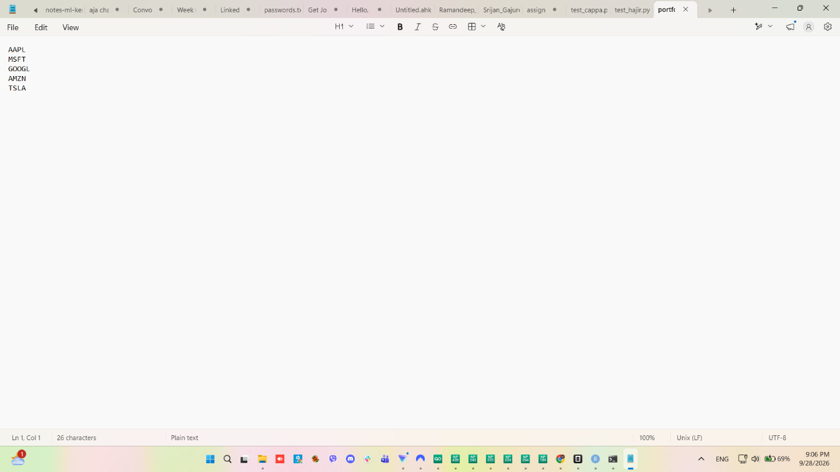
Figure 5.1 - portfolio.txt opened in Notepad showing one stock symbol per line

5.2 The function that reads the file
The function read_portfolio() reads the file and cleans it before returning the symbols. The cleaning rules are: remove spaces, remove empty lines, remove comment lines that start with # and change everything to capital letters so that aapl and AAPL both work.
read_portfolio <- function(file = "portfolio.txt") {

if (!file.exists(file)) {
stop("Cannot find the file: ", file,
"\nPut portfolio.txt in the same folder as this script.")
}

lines <- readLines(file, warn = FALSE)

lines <- trimws(lines) # remove spaces
lines <- lines[nchar(lines) > 0] # remove blank lines
lines <- lines[!grepl("^#", lines)] # remove comment lines
symbols <- toupper(lines) # AAPL

if (length(symbols) == 0) {
stop("portfolio.txt does not contain any stock symbols.")
}

cat("Portfolio read from '", file, "': ", length(symbols),
" symbols found\n", sep = "")
cat(" ", paste(symbols, collapse = ", "), "\n\n", sep = "")

return(symbols)
}

The output produced by this function was:
Portfolio read from 'portfolio.txt': 5 symbols found
AAPL, MSFT, GOOGL, AMZN, TSLA

6. Step 5 - Function to Import and Load the Stock Data
The function load_stock_data() downloads the daily price history for every symbol listed in portfolio.txt. It uses the quantmod package, specifically the getSymbols() function, which reads the data from Yahoo Finance.
The important design points are:
• Each symbol is downloaded inside a loop, so the function works for any number of stocks and for any length of portfolio.txt.
• auto.assign = FALSE is used. This makes getSymbols() return the data instead of silently creating a variable in the global environment, which keeps the code clean and predictable.
• The result is converted from an xts object into a normal data frame and the dates are put back in as the first column, so the data can be used with base R, dplyr and ggplot2.
• The error is caught for every symbol with tryCatch(). If one symbol fails, the function prints a message and continues with the next symbol instead of stopping.
• Each stock is stored as its own separate data frame inside a named list, for example stock_data[[\

6.1 The function
load_stock_data <- function(symbols,
from = "2023-01-01",
to = Sys.Date(),
price_col = "Adjusted") {

stock_data <- list() # empty list, symbols get added one by one

for (sym in symbols) {

cat("Downloading data for ", sym, " ... ", sep = "")

result <- tryCatch(
quantmod::getSymbols(
Symbols = sym,
from = from,
to = to,
auto.assign = FALSE,
warnings = FALSE,
src = "yahoo"
),
error = function(e) NULL
)

if (is.null(result) || length(result) == 0) {
cat("FAILED (check the symbol is correct on Yahoo Finance)\n")
next
}

df <- as.data.frame(result)
date_column <- data.frame(Date = as.Date(rownames(df)))
df <- cbind(date_column, df)
rownames(df) <- NULL

# Newer versions of quantmod name the columns with the symbol in
# front, for example "AAPL.Close" instead of "Close".
names(df) <- sub(paste0("^", sym, "\\."), "", names(df))

keep <- intersect(c("Date", "Open", "High", "Low",
"Close", "Adjusted", "Volume"), names(df))
df <- df[, keep, drop = FALSE] # drop = FALSE keeps it a data frame

if (!price_col %in% names(df)) {
price_col <- "Close"
}

stock_data[[sym]] <- df

cat("OK - ", nrow(df), " daily rows from ",
format(min(df$Date)), " to ", format(max(df$Date)), "\n", sep = "")
}

return(stock_data)
}

6.2 How the function was called
symbols <- read_portfolio(file = "portfolio.txt")

stock_data <- load_stock_data(symbols,
from = "2023-01-01",
to = Sys.Date(),
price_col = "Adjusted")

6.3 The result
All five symbols downloaded successfully. The output confirms the number of daily rows and the date range:
Downloading data for AAPL ... OK - 936 daily rows from 2023-01-03 to 2026-09-25
Downloading data for MSFT ... OK - 936 daily rows from 2023-01-03 to 2026-09-25
Downloading data for GOOGL ... OK - 936 daily rows from 2023-01-03 to 2026-09-25
Downloading data for AMZN ... OK - 936 daily rows from 2023-01-03 to 2026-09-25
Downloading data for TSLA ... OK - 936 daily rows from 2023-01-03 to 2026-09-25

Successfully loaded 5 stock data frame(s).

The first rows of the AAPL data frame are shown below. Each stock is a separate data frame with seven columns.
Date | Open | High | Low | Close | Adjusted | Volume
2023-01-03 | 130.28 | 130.90 | 124.17 | 125.07 | 122.88 | 112,117,500
2023-01-04 | 126.89 | 128.66 | 125.08 | 126.36 | 124.14 | 89,113,600
2023-01-05 | 127.13 | 127.77 | 124.76 | 125.02 | 122.83 | 80,962,700
2023-01-06 | 126.01 | 130.29 | 124.89 | 129.62 | 127.35 | 87,754,700
2023-01-09 | 130.47 | 133.41 | 129.89 | 130.15 | 127.87 | 70,790,800

Table 6.1 - The first five rows of the AAPL data frame (Adjusted = the closing price corrected for dividends and splits)

6.4 The code open in RStudio
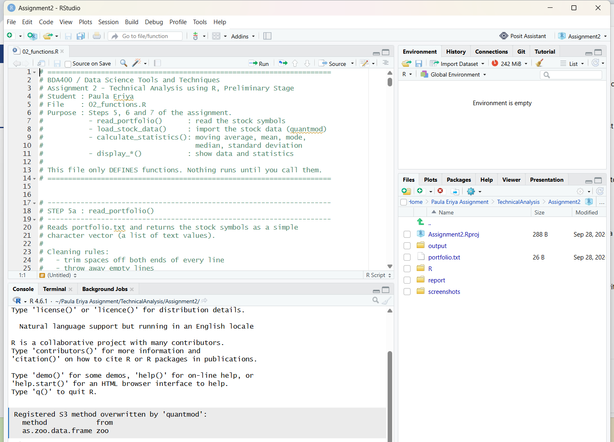
Figure 6.1 - R/02_functions.R open in the RStudio source editor, with the R console below

7. Step 6 - Functions to Compute the Basic Statistics
Three functions were written for this step.

7.1 mode_value() - our own mode function
Base R already provides mean(), median() and sd(), but it does not provide a mode() function. A mode function was therefore written from scratch, which is exactly the kind of utility function the brief asks for. The mode is the value that appears most often. Missing values are ignored, and if there is a tie the smallest of the tied values is returned.
mode_value <- function(x) {

x <- x[!is.na(x)] # ignore missing values
if (length(x) == 0) return(NA_real_)

counts <- table(x) # count how often each value appears
highest <- max(counts) # the biggest count

tied_values <- as.numeric(names(counts)[counts == highest])

return(min(tied_values)) # smallest value if there is a tie
}

7.2 calculate_statistics() - the statistics for one stock
This function takes one stock data frame and returns one row of statistics. The price used is the Adjusted column, because it is the correct price for comparing stocks over time.
calculate_statistics <- function(stock_df,
price_col = "Adjusted",
ma_window = 20) {

prices <- stock_df[[price_col]]
prices <- prices[!is.na(prices)]

# ---- 1. MOVING AVERAGE (20-day simple moving average) -------------
sma <- TTR::SMA(prices, n = ma_window)
latest_sma <- utils::tail(sma[!is.na(sma)], 1)

# ---- 2. MEAN (average price) --------------------------------------
mean_price <- mean(prices)

# ---- 3. MODE (most frequent price) - our own function -------------
mode_price <- mode_value(prices)

# ---- 4. MEDIAN (middle value) -------------------------------------
median_price <- stats::median(prices)

# ---- 5. STANDARD DEVIATION (how spread out the prices are) --------
std_price <- stats::sd(prices)

# ---- extra useful information --------------------------------------
daily_returns <- diff(prices) / utils::head(prices, -1) * 100

stats_row <- data.frame(
Symbol = NA_character_,
Observations = length(prices),
Start_Date = format(min(stock_df$Date)),
End_Date = format(max(stock_df$Date)),
MA_20 = round(as.numeric(latest_sma), 2),
Mean = round(mean_price, 2),
Mode = round(mode_price, 2),
Median = round(median_price, 2),
Std_Dev = round(std_price, 2),
Min = round(min(prices), 2),
Max = round(max(prices), 2),
Range = round(max(prices) - min(prices), 2),
Total_Return_Pct = round((utils::tail(prices, 1) / prices[1] - 1) * 100, 2),
Avg_Daily_Return_Pct = round(mean(daily_returns, na.rm = TRUE), 3)
)

return(stats_row)
}

The moving average is calculated with TTR::SMA(), which comes from the Technical Trading Rules package. A 20 day window is used because 20 trading days is about one month, which is the most common short term moving average used by traders.

7.3 calculate_all_statistics()
This function loops over every stock, calls calculate_statistics() and combines all the rows into one data frame. The result is a single table with one row per stock symbol, which is the structured format the brief asks for.
calculate_all_statistics <- function(stock_data,
price_col = "Adjusted",
ma_window = 20) {

results <- list()

for (sym in names(stock_data)) {
cat("Calculating statistics for ", sym, " ...\n", sep = "")
row <- calculate_statistics(stock_data[[sym]],
price_col = price_col,
ma_window = ma_window)
row$Symbol <- sym
results[[sym]] <- row
}

all_stats <- do.call(rbind, results)
rownames(all_stats) <- NULL

return(all_stats)
}

7.4 The calculated results
The table below is the result of the calculation. It is also saved in the repository as output/portfolio_statistics.csv.
Symbol | Obs. | MA_20 | Mean | Mode | Median | Std Dev | Min | Max | Total return %
AAPL | 936 | 329.40 | 219.16 | 161.13 | 213.65 | 47.78 | 122.83 | 341.07 | 177.57
MSFT | 936 | 500.04 | 399.63 | 297.14 | 406.60 | 71.43 | 215.75 | 537.65 | 122.00
GOOGL | 936 | 342.12 | 198.17 | 96.03 | 168.05 | 84.10 | 85.39 | 402.12 | 289.58
AMZN | 936 | 254.31 | 187.82 | 125.98 | 191.84 | 48.40 | 83.12 | 284.02 | 190.92
TSLA | 936 | 365.68 | 292.04 | 183.25 | 265.86 | 94.11 | 108.10 | 489.88 | 244.23

Table 7.1 - Moving average, mean, mode, median, standard deviation and total return for every stock (prices in USD, 03 Jan 2023 to 25 Sep 2026)

7.5 Reading the results
• MSFT has the highest average price at 399.63 US dollars and the highest 20 day moving average at 500.04.
• TSLA is the most volatile stock. It has the largest standard deviation, 94.11, which means its daily prices are spread out the most and the price moves the most violently.
• GOOGL gave the best total return over the period, 289.58 per cent, which means the price multiplied by about 3.9.
• AMZN has the lowest average price, 187.82, and the smallest range relative to its price, so it was the steadiest of the five.
• The mode is always lower than the mean for all five stocks. This is expected: the mode is the price level that repeated most often, and because every stock rose over the period most of the repeated prices are from the earlier, cheaper part of the history.
• The 20 day moving average is higher than the mean for every stock, which confirms that the most recent prices are above the long run average, so the portfolio was in an upward position at the end of the period.

8. Step 7 - Utilities to Display the Output
The brief encourages finding different ways of displaying stock data, and the way Yahoo Finance presents market data was used as the reference. The function display_stock_data() shows one stock's data frame in eight different ways, and display_all_stock_data() runs it for every stock.
Number | Display method | R function used | What it shows
1 | Size of the data frame | dim(df) | 936 rows and 7 columns
2 | Column names | names(df) | Date, Open, High, Low, Close, Adjusted, Volume
3 | First rows | head(df, 6) | the beginning of the price history
4 | Last rows | tail(df, 6) | the most recent prices
5 | Structure | str(df) | the type of every column
6 | Summary | summary(df) | min, quartiles, median, mean and max of every column
7 | Formatted table | subset + print | a clean table of the last 5 days
8 | One line summary | paste + cat | a sentence describing the whole history

Table 8.1 - The eight different ways the imported data frame is displayed

8.1 The display function
display_stock_data <- function(stock_data, symbol, rows = 6) {

if (!symbol %in% names(stock_data)) {
stop("'", symbol, "' was not loaded. Loaded symbols are: ",
paste(names(stock_data), collapse = ", "))
}

df <- stock_data[[symbol]]

cat("\n=====================================================================\n")
cat("STOCK DATA DISPLAY: ", symbol, "\n", sep = "")
cat("=====================================================================\n\n")

cat("1) Size of the data frame (rows x columns)\n")
print(dim(df))

cat("\n2) Column names\n")
print(names(df))

cat("\n3) First ", rows, " rows (head)\n", sep = "")
print(head(df, rows))

cat("\n4) Last ", rows, " rows (tail)\n", sep = "")
print(tail(df, rows))

cat("\n5) Structure of the object (str)\n")
str(df)

cat("\n6) Summary of every column\n")
print(summary(df))

cat("\n7) Formatted view of the most recent 5 days (Close & Volume)\n")
recent <- utils::tail(df, 5)
rownames(recent) <- NULL
print(recent[, c("Date", "Close", "Volume")], row.names = FALSE)

cat("\n8) One-line summary of the whole history\n")
cat(" ", symbol, " has ", nrow(df), " trading days, from ",
format(min(df$Date)), " to ", format(max(df$Date)), ".\n", sep = "")

invisible(df)
}

8.2 The statistics display function
display_statistics() prints the whole statistics table, prints it again transposed so the stocks sit side by side, and answers four simple questions about the portfolio.
display_statistics <- function(all_stats) {

cat("1) Full statistics table (one row per stock)\n")
print(all_stats, row.names = FALSE)

cat("\n2) Statistics with column headers side by side (t())\n")
num_cols <- c("MA_20", "Mean", "Mode", "Median", "Std_Dev")
side_by_side <- rbind(
"Symbol" = all_stats$Symbol,
round(t(as.matrix(all_stats[, num_cols])), 2)
)
print(side_by_side)

cat("\n3) Which stock had the highest mean price?\n")
print(all_stats$Symbol[which.max(all_stats$Mean)])

cat("\n4) Which stock was the most volatile?\n")
print(all_stats$Symbol[which.max(all_stats$Std_Dev)])

cat("\n5) Which stock gave the best total return?\n")
print(all_stats$Symbol[which.max(all_stats$Total_Return_Pct)])

cat("\n6) Quick ranking of the stocks by mean price\n")
print(all_stats[order(-all_stats$Mean),
c("Symbol", "Mean", "Median", "Std_Dev")], row.names = FALSE)

invisible(all_stats)
}

8.3 The output that was produced
The output of display_stock_data() and display_statistics() is shown in the screenshot below. The complete console output is saved in the repository as output/run_analysis_log.txt.
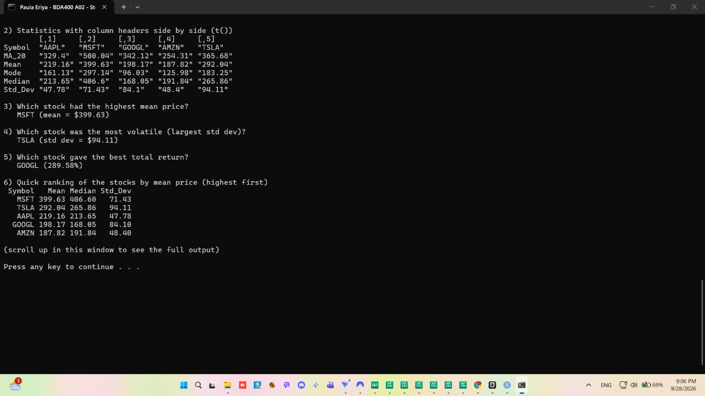
Figure 8.1 - The imported data frame and the calculated statistics displayed in the console
The final part of the output answers the four questions automatically:
3) Which stock had the highest mean price? MSFT (mean = $399.63)
4) Which stock was the most volatile? TSLA (std dev = $94.11)
5) Which stock gave the best total return? GOOGL (289.58%)
6) Quick ranking of the stocks by mean price (highest first)
Symbol Mean Median Std_Dev
MSFT 399.63 406.60 71.43
TSLA 292.04 265.86 94.11
AAPL 219.16 213.65 47.78
GOOGL 198.17 168.05 84.10
AMZN 187.82 191.84 48.40

9. Step 7 - Visualisations (Charts)
Eight charts were produced with ggplot2. They are saved in output/figures and are also placed in this report. Each stock has its own price chart with the 20 day moving average, and there are three summary charts for the whole portfolio.

9.1 Price chart with the 20 day moving average - AAPL
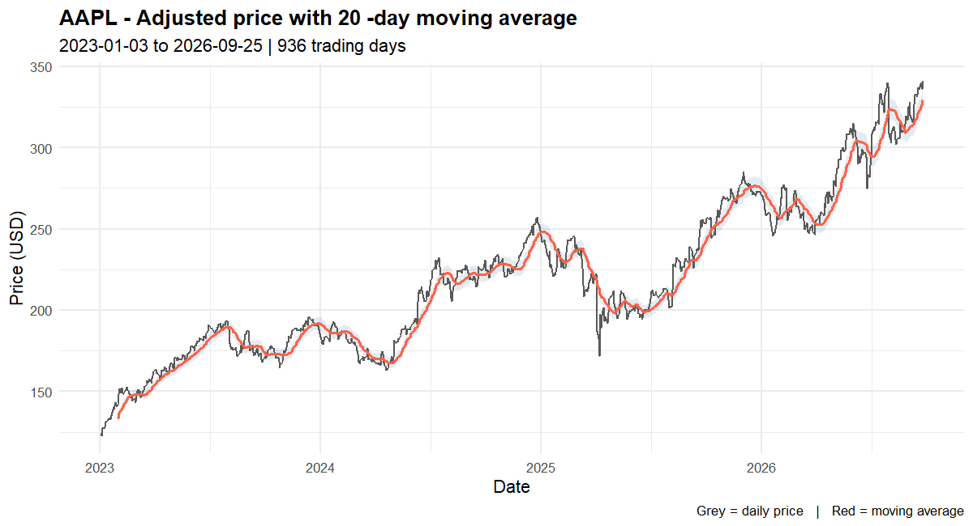
Figure 9.1 - AAPL adjusted closing price (grey) with the 20 day moving average (red), January 2023 to September 2026

9.2 Price chart - MSFT
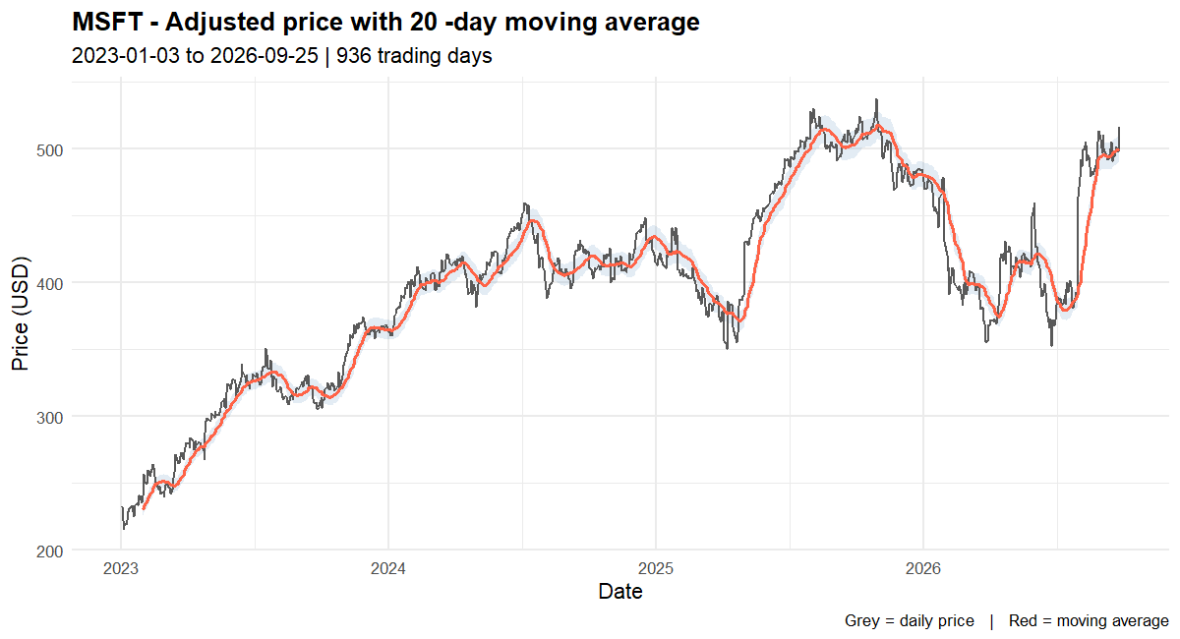
Figure 9.2 - MSFT adjusted closing price with the 20 day moving average

9.3 Price chart - GOOGL
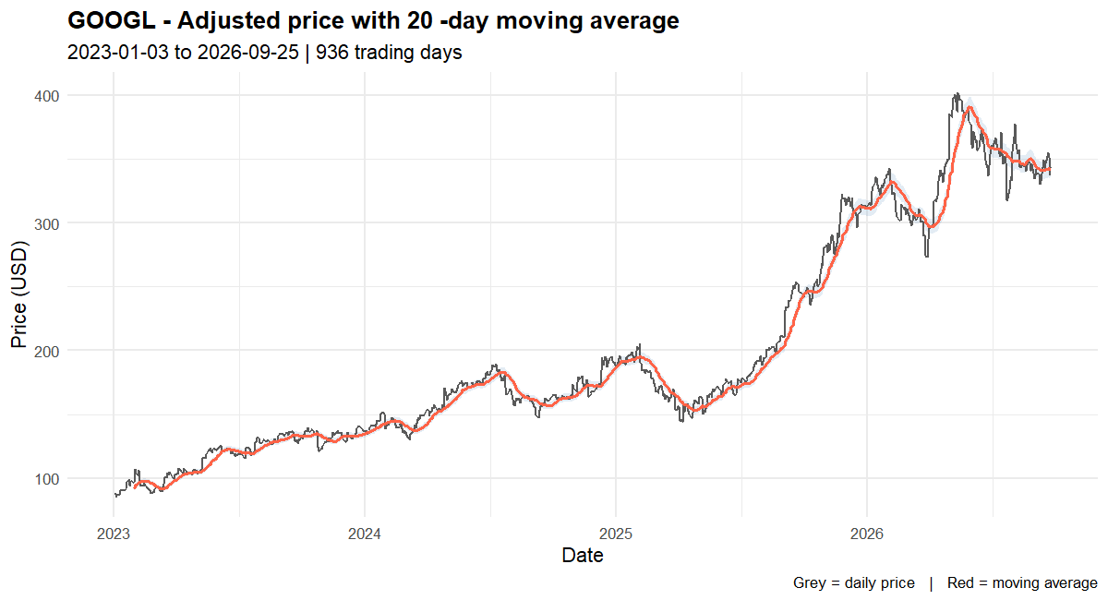
Figure 9.3 - GOOGL adjusted closing price with the 20 day moving average

9.4 Price chart - AMZN
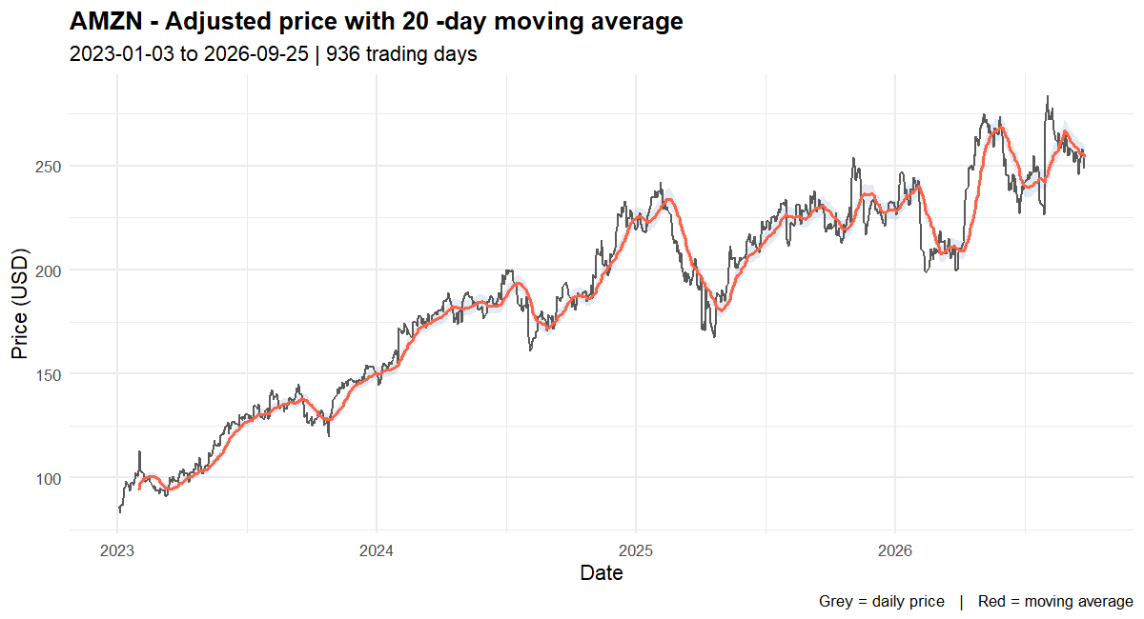
Figure 9.4 - AMZN adjusted closing price with the 20 day moving average

9.5 Price chart - TSLA
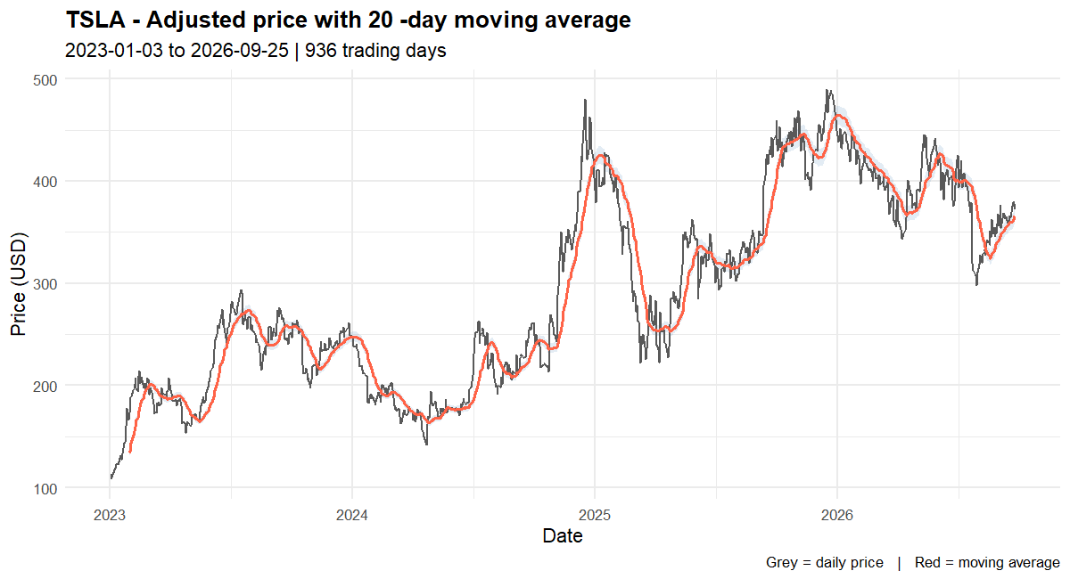
Figure 9.5 - TSLA adjusted closing price with the 20 day moving average

9.6 All five stocks compared
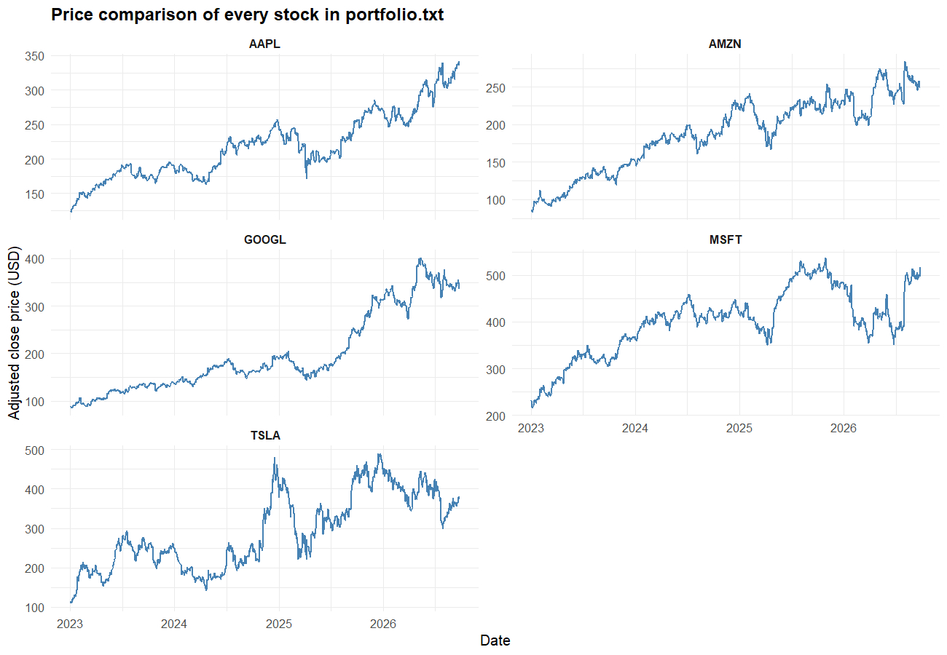
Figure 9.6 - The adjusted closing price of all five stocks drawn on one page
This chart makes it easy to compare the growth of the five stocks. All of them rose, but the shape of the movement is very different. TSLA has the sharpest rises and falls, which agrees with its large standard deviation.

9.7 Statistics comparison
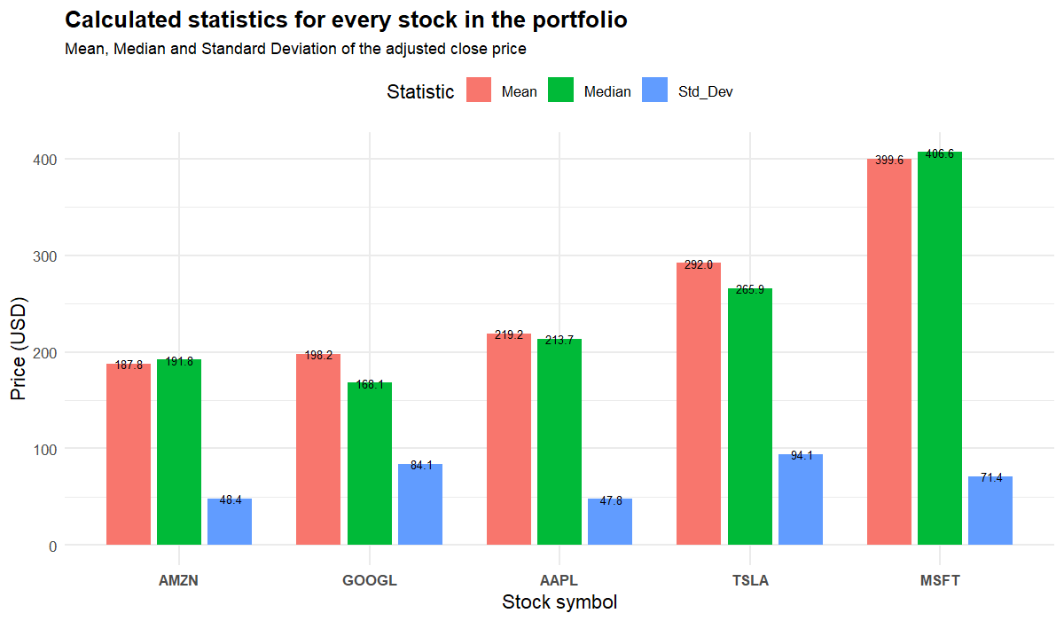
Figure 9.7 - Mean, median and standard deviation compared across the five stocks
This grouped bar chart compares the calculated statistics side by side. The height of each bar is the value of the statistic, so the difference between the mean and the median and the size of the standard deviation can be read directly.

9.8 Distribution of daily returns
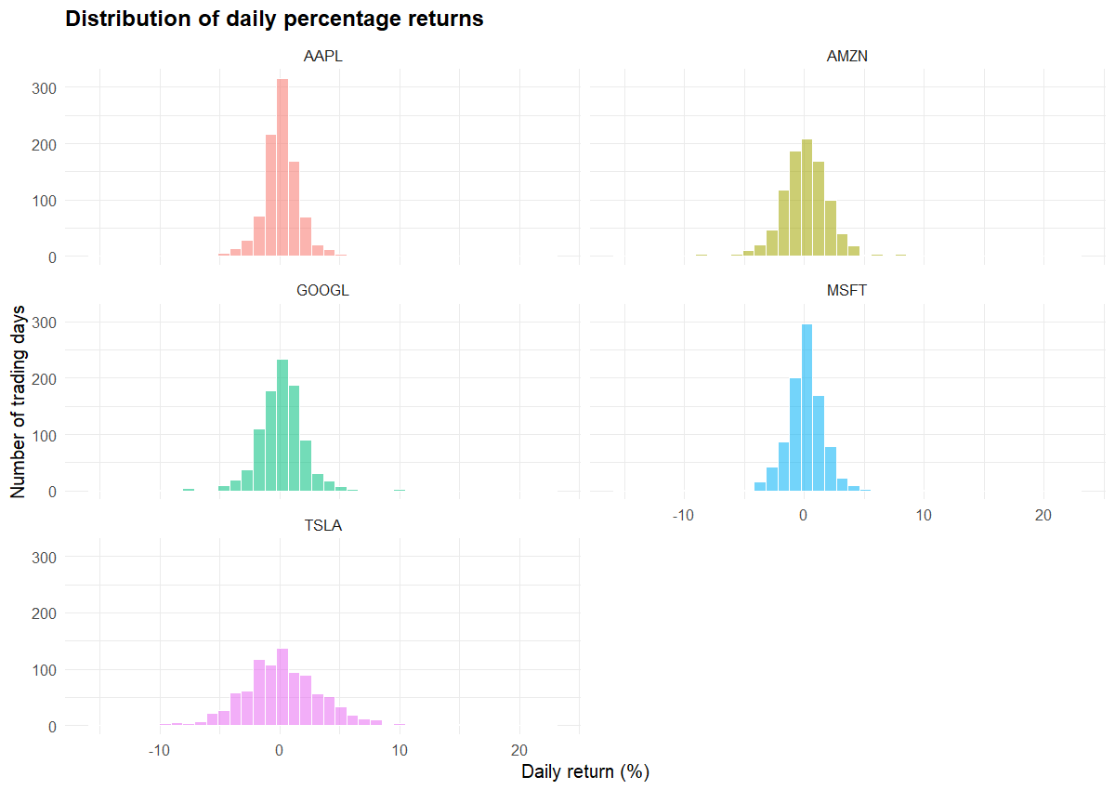
Figure 9.8 - Histogram of the daily percentage return for each stock
The histograms show how the daily returns are spread around zero. A wide histogram means a volatile stock. TSLA and GOOGL have the widest spread, which again matches the standard deviation results.

9.9 The chart saving function
save_charts_to_png <- function(stock_data, all_stats,
folder = "output/figures",
price_col = "Adjusted") {

dir.create(folder, showWarnings = FALSE, recursive = TRUE)

for (sym in names(stock_data)) {
file_name <- file.path(folder, paste0("price_chart_", sym, ".png"))
grDevices::png(file_name, width = 1200, height = 650, res = 130)
plot_stock(stock_data[[sym]], sym, price_col = price_col)
grDevices::dev.off()
}

file_name <- file.path(folder, "all_stocks_comparison.png")
grDevices::png(file_name, width = 1300, height = 900, res = 130)
plot_all_stocks(stock_data, price_col = price_col)
grDevices::dev.off()

file_name <- file.path(folder, "statistics_comparison.png")
grDevices::png(file_name, width = 1200, height = 700, res = 130)
plot_statistics_comparison(all_stats)
grDevices::dev.off()

file_name <- file.path(folder, "daily_returns_distribution.png")
grDevices::png(file_name, width = 1200, height = 850, res = 130)
plot_returns_distribution(stock_data, price_col = price_col)
grDevices::dev.off()
}

10. How to Run the Project
The project runs with one click. The steps are:
• Open RStudio.
• Choose File > Open Project... and select Assignment2.Rproj inside the Assignment2 folder. (Opening the project sets the working folder correctly.)
• In the Files pane on the right, open the R folder.
• Run 01_install_packages.R once. It installs the packages and creates output/sessionInfo.txt.
• Open 03_run_analysis.R and press the Source button at the top right. This runs the whole analysis: it reads portfolio.txt, downloads the data, displays it, calculates the statistics, displays the statistics, saves the charts and saves the CSV files.
The whole console output of that run is saved in the repository as output/run_analysis_log.txt.
The files that the run produces are:
output/portfolio_statistics.csv - the statistics table
output/stock_data_AAPL.csv - the imported data for AAPL
output/stock_data_MSFT.csv - ... and one CSV per stock
output/figures/price_chart_*.png - one price chart per stock
output/figures/all_stocks_comparison.png
output/figures/statistics_comparison.png
output/figures/daily_returns_distribution.png

10.1 Uploading the project to GitHub
The local folder was already turned into a Git repository and the first commit was made. To put it on GitHub, open PowerShell in the TechnicalAnalysis folder and run these three commands:
cd "C:\Users\DELL\Documents\Paula Eriya Assignment\TechnicalAnalysis"
git remote add origin https://github.com/assignmentpe/TechnicalAnalysis.git
git push -u origin main

If the repository was created as empty on GitHub the push works straight away. If GitHub asks for a sign in, a personal access token is used instead of the normal password.

11. Problems Encountered and How They Were Solved
Three real problems were met while building this project. They are documented here because the assignment asks for a full record of the setup process.

11.1 R could not install packages - library folder not writable
The first run of install.packages() failed with the message 'lib = \
The solution was to create the personal R library folder that R reserves for the current user. Once the folder existed it appeared as the first entry of .libPaths() and every package installed normally. No administrator rights were needed.

11.2 quantmod returned unexpected column names
The first version of load_stock_data() failed with the error '$ operator is invalid for atomic vectors'. The reason was that the current version of quantmod prefixes every column with the symbol name, so the columns arrive as AAPL.Open, AAPL.Close and AAPL.Adjusted instead of Open, Close and Adjusted.
Two changes fixed it. First, the symbol prefix is removed from the column names. Second, the column selection uses df[, keep, drop = FALSE]. Without drop = FALSE, selecting a single column returns a plain vector instead of a data frame, which is what caused the dollar sign error. This is a classic R behaviour and is now commented in the code.

11.3 Rounding a table that contains text
display_statistics() prints the statistics a second time with the stocks side by side using t(). This failed with 'non-numeric argument to mathematical function' because one of the columns held the stock symbols, which are text, and round() cannot be applied to text.
The fix was to convert the numeric columns to a matrix with as.matrix() before calling round(), and to add the stock symbols as a separate named row.

12. Conclusion
Every part of the assignment has been completed and verified by running the code.
• The technical analysis environment is set up: Git, R 4.6.1, RStudio 2026.09 and eight R packages from CRAN, all recorded with screenshots.
• The project is configured: portfolio.txt lists five stock symbols, one per line, and read_portfolio() reads it.
• load_stock_data() imports the daily price history for every symbol with quantmod and stores each stock as its own data frame. All five symbols loaded correctly, 936 trading days each.
• calculate_statistics() and calculate_all_statistics() calculate the moving average, mean, mode, median and standard deviation for every stock and store the results in a single data frame. A mode function had to be written from scratch because base R does not provide one.
• The display functions show the data in eight different ways and the statistics in several formats, and ggplot2 produced eight charts.
• The results are stored in the repository as CSV files, PNG charts and console logs so that every number in this report can be checked.
The project is ready for the next stage of the technical analysis work. The natural next steps are to add technical indicators such as RSI, MACD and Bollinger Bands using the TTR package, to build candlestick charts, and to back test simple trading strategies based on the moving averages that have already been calculated.

Appendix A - portfolio.txt
AAPL
MSFT
GOOGL
AMZN
TSLA

Appendix B - R/01_install_packages.R
# =====================================================================
# BDA400 / Data Science Tools and Techniques
# Assignment 2 - Technical Analysis using R, Preliminary Stage
# Student : Paula Eriya
# File : 01_install_packages.R
# Purpose : Step 3 of the assignment - download and install the R
# packages needed for technical analysis.
#
# How to run this file:
# Option A (RStudio): Open the file, then click the green "Run" arrow.
# Option B (Console) : source("R/01_install_packages.R")
# =====================================================================

# ---------------------------------------------------------------------
# 1. List of packages we need for this project
# ---------------------------------------------------------------------
# quantmod -> downloads stock data from Yahoo Finance
# TTR -> Technical Trading Rules (moving averages, RSI, etc.)
# tseries -> extra statistics / time-series helpers
# xts -> stores the time-series data (dependency of quantmod)
# zoo -> time-series backbone (dependency of xts)
# ggplot2 -> draws the charts
# dplyr -> makes working with data frames easy
# knitr -> helps build the R Markdown report

required_packages <- c(
"quantmod",
"TTR",
"tseries",
"xts",
"zoo",
"ggplot2",
"dplyr",
"knitr"
)

cat("=====================================================================\n")
cat("STEP 3: INSTALLING R PACKAGES\n")
cat("=====================================================================\n\n")

cat("Packages to install:\n")
print(required_packages)

# ---------------------------------------------------------------------
# 2. Work out which packages are still missing
# installed.packages() lists everything already on the computer
# ---------------------------------------------------------------------
installed_packages <- rownames(installed.packages())

packages_to_install <- required_packages[
!(required_packages %in% installed_packages)
]

if (length(packages_to_install) == 0) {
cat("\nAll required packages are already installed. Nothing to do.\n")
} else {
cat("\nPackages that still need installing:\n")
print(packages_to_install)

# -------------------------------------------------------------------
# 3. Download and install them from CRAN
# install.packages() is the official CRAN installer function.
# "repos" tells R where to download the files from.
# -------------------------------------------------------------------
install.packages(
packages_to_install,
repos = "https://cloud.r-project.org", # the public CRAN mirror
dependencies = TRUE # also install what they need
)
}

# ---------------------------------------------------------------------
# 4. Load the packages into the current R session
# (installing a package puts it on the computer, library() opens it)
# ---------------------------------------------------------------------
cat("\nLoading packages into the R session ...\n")

for (pkg in required_packages) {
suppressPackageStartupMessages(
library(pkg, character.only = TRUE, quietly = TRUE)
)
}

# ---------------------------------------------------------------------
# 5. Check that every package loaded correctly
# ---------------------------------------------------------------------
cat("\nPackage check:\n")
for (pkg in required_packages) {
is_ready <- requireNamespace(pkg, quietly = TRUE)
cat(sprintf(" %-10s -> %s\n", pkg, ifelse(is_ready, "OK", "FAILED")))
}

# ---------------------------------------------------------------------
# 6. Save the session information for the report (proves R is set up)
# ---------------------------------------------------------------------
# The scripts are run from inside the Assignment2 folder, so the
# results folder is simply called "output".
dir.create("output", showWarnings = FALSE, recursive = TRUE)

capture.output(sessionInfo(), file = "output/sessionInfo.txt")

cat("\n=====================================================================\n")
cat("STEP 3 COMPLETE\n")
cat("Session details saved to: output/sessionInfo.txt\n")
cat("=====================================================================\n")

Appendix C - R/02_functions.R
This file contains every function written for the assignment: read_portfolio(), load_stock_data(), mode_value(), calculate_statistics(), calculate_all_statistics(), display_stock_data(), display_all_stock_data(), display_statistics(), plot_stock(), plot_all_stocks(), plot_statistics_comparison(), plot_returns_distribution() and save_charts_to_png().
# =====================================================================
# BDA400 / Data Science Tools and Techniques
# Assignment 2 - Technical Analysis using R, Preliminary Stage
# Student : Paula Eriya
# File : 02_functions.R
# Purpose : Steps 5, 6 and 7 of the assignment.
# - read_portfolio() : read the stock symbols
# - load_stock_data() : import the stock data (quantmod)
# - calculate_statistics(): moving average, mean, mode,
# median, standard deviation
# - display_*() : show data and statistics
#
# This file only DEFINES functions. Nothing runs until you call them.
# =====================================================================

# ---------------------------------------------------------------------
# STEP 5a : read_portfolio()
# ---------------------------------------------------------------------
# Reads portfolio.txt and returns the stock symbols as a simple
# character vector (a list of text values).
#
# Cleaning rules:
# - trim spaces off both ends of every line
# - throw away empty lines
# - throw away '#' comment lines
# - make everything UPPER CASE so "aapl" and "AAPL" both work
# ---------------------------------------------------------------------
read_portfolio <- function(file = "portfolio.txt") {

if (!file.exists(file)) {
stop("Cannot find the file: ", file,
"\nPut portfolio.txt in the same folder as this script.")
}

lines <- readLines(file, warn = FALSE)

lines <- trimws(lines) # remove spaces
lines <- lines[nchar(lines) > 0] # remove blank lines
lines <- lines[!grepl("^#", lines)] # remove comment lines
symbols <- toupper(lines) # AAPL

if (length(symbols) == 0) {
stop("portfolio.txt does not contain any stock symbols.")
}

cat("Portfolio read from '", file, "': ", length(symbols),
" symbols found\n", sep = "")
cat(" ", paste(symbols, collapse = ", "), "\n\n", sep = "")

return(symbols)
}

# ---------------------------------------------------------------------
# STEP 5b : load_stock_data()
# ---------------------------------------------------------------------
# Downloads the daily price history of every symbol using quantmod
# and stores each stock as its OWN data frame inside a named list.
#
# stock_data[["AAPL"]] = a data frame of AAPL prices
# stock_data[["MSFT"]] = a data frame of MSFT prices
# ...
#
# Arguments:
# symbols - character vector of symbols, e.g. c("AAPL","MSFT")
# from - first date, e.g. "2023-01-01"
# to - last date, e.g. Sys.Date()
# price_col- which price column the statistics should use later
# ---------------------------------------------------------------------
load_stock_data <- function(symbols,
from = "2023-01-01",
to = Sys.Date(),
price_col = "Adjusted") {

stock_data <- list() # empty list, symbols get added one by one

for (sym in symbols) {

cat("Downloading data for ", sym, " ... ", sep = "")

# auto.assign = FALSE returns the data instead of putting it in
# a variable named after the symbol in the global environment.
result <- tryCatch(
quantmod::getSymbols(
Symbols = sym,
from = from,
to = to,
auto.assign = FALSE,
warnings = FALSE,
src = "yahoo"
),
error = function(e) NULL
)

if (is.null(result) || length(result) == 0) {
cat("FAILED (check the symbol is correct on Yahoo Finance)\n")
next
}

# quantmod returns an xts object. Convert it to a normal data frame
# and put the dates back in as the first column.
df <- as.data.frame(result)

date_column <- data.frame(Date = as.Date(rownames(df)))
df <- cbind(date_column, df)
rownames(df) <- NULL

# Newer versions of quantmod name the columns with the symbol in
# front, for example "AAPL.Close" instead of "Close".
# We remove the "SYMBOL." part so the rest of the code can just use
# the simple names: Date, Open, High, Low, Close, Adjusted, Volume.
names(df) <- sub(paste0("^", sym, "\\."), "", names(df))

# Keep only the columns we actually use
keep <- intersect(c("Date", "Open", "High", "Low",
"Close", "Adjusted", "Volume"),
names(df))
df <- df[, keep, drop = FALSE] # drop = FALSE keeps it a data frame

# Make sure the price column the user asked for really exists
if (!price_col %in% names(df)) {
price_col <- "Close"
}

stock_data[[sym]] <- df

cat("OK - ", nrow(df), " daily rows from ",
format(min(df$Date)), " to ", format(max(df$Date)), "\n",
sep = "")
}

cat("\nSuccessfully loaded ", length(stock_data),
" stock data frame(s).\n\n", sep = "")

return(stock_data)
}

# ---------------------------------------------------------------------
# STEP 6a : mode_value() -- our own mode function
# ---------------------------------------------------------------------
# Base R has mean(), median() and sd(), but there is NO mode().
# So we write one ourselves. That is exactly the kind of "utility
# function" the assignment asks for.
#
# The mode is the value that appears most often.
# If there is a tie, the smallest tied value is returned.
# ---------------------------------------------------------------------
mode_value <- function(x) {

x <- x[!is.na(x)] # ignore missing values
if (length(x) == 0) return(NA_real_)

counts <- table(x) # count how often each value appears
highest <- max(counts) # the biggest count

tied_values <- as.numeric(names(counts)[counts == highest])

return(min(tied_values)) # smallest value if there is a tie
}

# ---------------------------------------------------------------------
# STEP 6b : calculate_statistics()
# ---------------------------------------------------------------------
# Takes ONE stock's data frame and returns ONE row of statistics:
#
# moving average (20-day), mean, mode, median, standard deviation
# plus a few extra useful numbers (min, max, observations)
# ---------------------------------------------------------------------
calculate_statistics <- function(stock_df,
price_col = "Adjusted",
ma_window = 20) {

if (!price_col %in% names(stock_df)) {
stop("Column '", price_col, "' is not in the data frame.")
}

prices <- stock_df[[price_col]]
prices <- prices[!is.na(prices)]

if (length(prices) == 0) {
stop("There are no prices to calculate statistics from.")
}

# ---- 1. MOVING AVERAGE (20-day simple moving average) -------------
# TTR::SMA() is from the "Technical Trading Rules" package.
# The last ma_window values that are not NA are averaged together.
sma <- TTR::SMA(prices, n = ma_window)
latest_sma <- utils::tail(sma[!is.na(sma)], 1)

# ---- 2. MEAN (average price) --------------------------------------
mean_price <- mean(prices)

# ---- 3. MODE (most frequent price) - our own function -------------
mode_price <- mode_value(prices)

# ---- 4. MEDIAN (middle value) -------------------------------------
median_price <- stats::median(prices)

# ---- 5. STANDARD DEVIATION (how spread out the prices are) --------
std_price <- stats::sd(prices)

# ---- extra useful information --------------------------------------
daily_returns <- diff(prices) / utils::head(prices, -1) * 100

stats_row <- data.frame(
Symbol = NA_character_,
Observations = length(prices),
Start_Date = format(min(stock_df$Date)),
End_Date = format(max(stock_df$Date)),
MA_20 = round(as.numeric(latest_sma), 2),
Mean = round(mean_price, 2),
Mode = round(mode_price, 2),
Median = round(median_price, 2),
Std_Dev = round(std_price, 2),
Min = round(min(prices), 2),
Max = round(max(prices), 2),
Range = round(max(prices) - min(prices), 2),
Total_Return_Pct = round((utils::tail(prices, 1) / prices[1] - 1) * 100, 2),
Avg_Daily_Return_Pct = round(mean(daily_returns, na.rm = TRUE), 3),
check.names = FALSE
)

return(stats_row)
}

# ---------------------------------------------------------------------
# STEP 6c : calculate_all_statistics()
# ---------------------------------------------------------------------
# Runs calculate_statistics() on every stock and collects all the
# results into ONE data frame (one row per stock symbol).
# ---------------------------------------------------------------------
calculate_all_statistics <- function(stock_data,
price_col = "Adjusted",
ma_window = 20) {

results <- list()

for (sym in names(stock_data)) {
cat("Calculating statistics for ", sym, " ...\n", sep = "")
row <- calculate_statistics(stock_data[[sym]],
price_col = price_col,
ma_window = ma_window)
row$Symbol <- sym
results[[sym]] <- row
}

all_stats <- do.call(rbind, results)
rownames(all_stats) <- NULL

cat("Statistics calculated for ", nrow(all_stats), " stocks.\n\n",
sep = "")

return(all_stats)
}

# ---------------------------------------------------------------------
# STEP 7a : display_stock_data()
# ---------------------------------------------------------------------
# Show the loaded data frame for one stock in several different ways
# (the assignment asks us to try more than one way of displaying).
#
# 1. dim() - how many rows and columns
# 2. names() - the column names
# 3. head()/tail()- the first and last few rows
# 4. str() - the structure of the object
# 5. summary() - basic statistics for every column
# 6. a small formatted table
# ---------------------------------------------------------------------
display_stock_data <- function(stock_data, symbol, rows = 6) {

if (!symbol %in% names(stock_data)) {
stop("'", symbol, "' was not loaded. Loaded symbols are: ",
paste(names(stock_data), collapse = ", "))
}

df <- stock_data[[symbol]]

cat("\n=====================================================================\n")
cat("STOCK DATA DISPLAY: ", symbol, "\n", sep = "")
cat("=====================================================================\n\n")

cat("1) Size of the data frame (rows x columns)\n")
print(dim(df))

cat("\n2) Column names\n")
print(names(df))

cat("\n3) First ", rows, " rows (head)\n", sep = "")
print(head(df, rows))

cat("\n4) Last ", rows, " rows (tail)\n", sep = "")
print(tail(df, rows))

cat("\n5) Structure of the object (str)\n")
str(df)

cat("\n6) Summary of every column\n")
print(summary(df))

cat("\n7) Formatted view of the most recent 5 days (Close & Volume)\n")
recent <- utils::tail(df, 5)
rownames(recent) <- NULL
print(recent[, c("Date", "Close", "Volume")], row.names = FALSE)

cat("\n8) One-line summary of the whole history\n")
cat(" ", symbol, " has ", nrow(df), " trading days, from ",
format(min(df$Date)), " to ", format(max(df$Date)), ".\n",
sep = "")

invisible(df)
}

# ---------------------------------------------------------------------
# STEP 7b : display_all_stock_data()
# ---------------------------------------------------------------------
# Runs display_stock_data() for every stock in the list.
# ---------------------------------------------------------------------
display_all_stock_data <- function(stock_data, rows = 6) {
for (sym in names(stock_data)) {
display_stock_data(stock_data, sym, rows = rows)
}
}

# ---------------------------------------------------------------------
# STEP 7c : display_statistics()
# ---------------------------------------------------------------------
# Prints the statistics table and the overall picture across the
# whole portfolio.
# ---------------------------------------------------------------------
display_statistics <- function(all_stats) {

cat("\n=====================================================================\n")
cat("CALCULATED STATISTICS FOR THE WHOLE PORTFOLIO\n")
cat("=====================================================================\n\n")

cat("1) Full statistics table (one row per stock)\n")
print(all_stats, row.names = FALSE)

cat("\n2) Statistics with column headers side by side (t())\n")
num_cols <- c("MA_20", "Mean", "Mode", "Median", "Std_Dev")
# t() turns the columns into rows. as.matrix() makes sure R treats
# the numbers as numbers (and not as text) so round() works.
side_by_side <- rbind(
"Symbol" = all_stats$Symbol,
round(t(as.matrix(all_stats[, num_cols])), 2)
)
print(side_by_side)

cat("\n3) Which stock had the highest mean price?\n")
highest_mean <- all_stats$Symbol[which.max(all_stats$Mean)]
cat(" ", highest_mean, " (mean = $", max(all_stats$Mean), ")\n", sep = "")

cat("\n4) Which stock was the most volatile (largest std dev)?\n")
most_volatile <- all_stats$Symbol[which.max(all_stats$Std_Dev)]
cat(" ", most_volatile, " (std dev = $", max(all_stats$Std_Dev), ")\n",
sep = "")

cat("\n5) Which stock gave the best total return?\n")
best <- all_stats$Symbol[which.max(all_stats$Total_Return_Pct)]
cat(" ", best, " (", max(all_stats$Total_Return_Pct), "%)\n", sep = "")

cat("\n6) Quick ranking of the stocks by mean price (highest first)\n")
print(all_stats[order(-all_stats$Mean),
c("Symbol", "Mean", "Median", "Std_Dev")],
row.names = FALSE)

invisible(all_stats)
}

# ---------------------------------------------------------------------
# STEP 7d : plot_stock() -- chart ONE stock
# ---------------------------------------------------------------------
# Price line + 20-day moving average line, with a 52-week range box.
# ---------------------------------------------------------------------
plot_stock <- function(stock_df, symbol, price_col = "Adjusted",
ma_window = 20) {

# Make a simple plotting copy with two plain columns called
# "Price" and "MA" so the chart code is easy to read.
plot_df <- data.frame(
Date = stock_df$Date,
Price = as.numeric(stock_df[[price_col]]),
MA = as.numeric(TTR::SMA(stock_df[[price_col]], n = ma_window))
)
ribbon <- plot_df[!is.na(plot_df$MA), ]

y <- ggplot2::ggplot(plot_df, ggplot2::aes(x = Date)) +

ggplot2::geom_ribbon(data = ribbon,
ggplot2::aes(ymin = MA * 0.98, ymax = MA * 1.02),
fill = "steelblue", alpha = 0.15) +

ggplot2::geom_line(ggplot2::aes(y = Price),
colour = "grey35", linewidth = 0.6,
na.rm = TRUE) +

ggplot2::geom_line(ggplot2::aes(y = MA),
colour = "tomato", linewidth = 0.9,
na.rm = TRUE) +

ggplot2::labs(
title = paste(symbol, "-", price_col, "price with",
ma_window, "-day moving average"),
subtitle = paste(format(min(plot_df$Date)), "to",
format(max(plot_df$Date)),
"|", nrow(plot_df), "trading days"),
x = "Date",
y = "Price (USD)",
caption = "Grey = daily price | Red = moving average") +

ggplot2::theme_minimal(base_size = 12) +
ggplot2::theme(plot.title = ggplot2::element_text(face = "bold"))

print(y)
return(y)
}

# ---------------------------------------------------------------------
# STEP 7e : plot_all_stocks() -- chart EVERY stock on one page
# ---------------------------------------------------------------------
plot_all_stocks <- function(stock_data, price_col = "Adjusted") {

symbols <- names(stock_data)

# put all the prices into one long data frame so ggplot can facet.
# Every stock's chosen price column is renamed to "Price".
combined <- do.call(rbind, lapply(symbols, function(s) {
d <- stock_data[[s]]
data.frame(
Date = d$Date,
Price = as.numeric(d[[price_col]]),
Symbol = s
)
}))

p <- ggplot2::ggplot(combined, ggplot2::aes(x = Date, y = Price)) +
ggplot2::geom_line(colour = "steelblue", linewidth = 0.6) +
ggplot2::facet_wrap(~Symbol, scales = "free_y", ncol = 2) +
ggplot2::labs(
title = "Price comparison of every stock in portfolio.txt",
x = "Date", y = paste(price_col, "close price (USD)")) +
ggplot2::theme_minimal(base_size = 11) +
ggplot2::theme(plot.title = ggplot2::element_text(face = "bold"),
strip.text = ggplot2::element_text(face = "bold"))

print(p)
return(p)
}

# ---------------------------------------------------------------------
# STEP 7f : plot_statistics_comparison()
# ---------------------------------------------------------------------
# Bar charts comparing mean / median / std dev across the portfolio.
# ---------------------------------------------------------------------
plot_statistics_comparison <- function(all_stats) {

long_stats <- data.frame(
Symbol = rep(all_stats$Symbol, 3),
Statistic = rep(c("Mean", "Median", "Std_Dev"), each = nrow(all_stats)),
Value = c(all_stats$Mean, all_stats$Median, all_stats$Std_Dev)
)

p <- ggplot2::ggplot(long_stats,
ggplot2::aes(x = stats::reorder(Symbol, Value),
y = Value, fill = Statistic)) +
ggplot2::geom_col(position = ggplot2::position_dodge(width = 0.8),
width = 0.7) +
ggplot2::geom_text(
ggplot2::aes(label = format(round(Value, 1), nsmall = 1)),
position = ggplot2::position_dodge(width = 0.8),
size = 2.6, check_overlap = TRUE) +
ggplot2::labs(
title = "Calculated statistics for every stock in the portfolio",
subtitle = "Mean, Median and Standard Deviation of the adjusted close price",
x = "Stock symbol", y = "Price (USD)", fill = "Statistic") +
ggplot2::theme_minimal(base_size = 12) +
ggplot2::theme(
plot.title = ggplot2::element_text(face = "bold"),
plot.subtitle = ggplot2::element_text(size = 10),
axis.text.x = ggplot2::element_text(face = "bold"),
legend.position = "top")

print(p)
return(p)
}

# ---------------------------------------------------------------------
# STEP 7g : plot_returns_distribution()
# ---------------------------------------------------------------------
# Histogram of the daily % return for every stock.
# ---------------------------------------------------------------------
plot_returns_distribution <- function(stock_data, price_col = "Adjusted") {

symbols <- names(stock_data)

returns <- do.call(rbind, lapply(symbols, function(s) {
p <- stock_data[[s]][[price_col]]
r <- diff(p) / utils::head(p, -1) * 100 # daily % change
data.frame(Symbol = s, Daily_Return_Pct = as.numeric(r))
}))
returns <- returns[!is.na(returns$Daily_Return_Pct), ]

p <- ggplot2::ggplot(returns,
ggplot2::aes(x = Daily_Return_Pct, fill = Symbol)) +
ggplot2::geom_histogram(bins = 40, alpha = 0.55,
colour = "white") +
ggplot2::facet_wrap(~Symbol, ncol = 2) +
ggplot2::labs(
title = "Distribution of daily percentage returns",
x = "Daily return (%)", y = "Number of trading days") +
ggplot2::theme_minimal(base_size = 11) +
ggplot2::theme(plot.title = ggplot2::element_text(face = "bold"),
legend.position = "none")

print(p)
return(p)
}

# ---------------------------------------------------------------------
# STEP 7h : save_charts_to_png()
# ---------------------------------------------------------------------
# Saves every chart as a PNG file in output/figures so the charts can
# be placed inside the written report.
# ---------------------------------------------------------------------
save_charts_to_png <- function(stock_data, all_stats,
folder = "output/figures",
price_col = "Adjusted") {

dir.create(folder, showWarnings = FALSE, recursive = TRUE)

cat("Saving charts into '", folder, "' ...\n", sep = "")

for (sym in names(stock_data)) {
file_name <- file.path(folder, paste0("price_chart_", sym, ".png"))
grDevices::png(file_name, width = 1200, height = 650, res = 130)
plot_stock(stock_data[[sym]], sym, price_col = price_col)
grDevices::dev.off()
cat(" saved: ", file_name, "\n", sep = "")
}

file_name <- file.path(folder, "all_stocks_comparison.png")
grDevices::png(file_name, width = 1300, height = 900, res = 130)
plot_all_stocks(stock_data, price_col = price_col)
grDevices::dev.off()
cat(" saved: ", file_name, "\n")

file_name <- file.path(folder, "statistics_comparison.png")
grDevices::png(file_name, width = 1200, height = 700, res = 130)
plot_statistics_comparison(all_stats)
grDevices::dev.off()
cat(" saved: ", file_name, "\n")

file_name <- file.path(folder, "daily_returns_distribution.png")
grDevices::png(file_name, width = 1200, height = 850, res = 130)
plot_returns_distribution(stock_data, price_col = price_col)
grDevices::dev.off()
cat(" saved: ", file_name, "\n")

cat("All charts saved.\n")
}

cat("02_functions.R loaded - all utility functions are ready to use.\n")

Appendix D - R/03_run_analysis.R
# =====================================================================
# BDA400 / Data Science Tools and Techniques
# Assignment 2 - Technical Analysis using R, Preliminary Stage
# Student : Paula Eriya
# File : 03_run_analysis.R
# Purpose : This is the MAIN script. It puts the whole project
# together:
# step 4 read portfolio.txt
# step 5 import the stock data with quantmod
# step 6 calculate the statistics
# step 7 display the data, statistics and charts
#
# How to run: open this file in RStudio and click "Source" (top right).
# Everything below happens automatically.
# =====================================================================

cat("\n\n#####################################################################\n")
cat("# BDA400 Assignment 2 - Technical Analysis using R\n")
cat("# Student: Paula Eriya\n")
cat("# Script : 03_run_analysis.R\n")
cat("#####################################################################\n\n")

# ---------------------------------------------------------------------
# 0. Load the packages and our own functions
# ---------------------------------------------------------------------
library(quantmod)
library(TTR)
library(ggplot2)

# The working folder is already the Assignment2 folder, because the
# project is opened from Assignment2.Rproj. No setwd() needed.
source("R/02_functions.R") # bring in all the utility functions

# Make sure the output folders exist
dir.create("output", showWarnings = FALSE, recursive = TRUE)
dir.create("output/figures", showWarnings = FALSE, recursive = TRUE)
dir.create("screenshots", showWarnings = FALSE, recursive = TRUE)

# Settings for this run -----------------------------------------------
price_column <- "Adjusted" # the price we do the statistics on
start_date <- "2023-01-01" # first day of data we want
end_date <- Sys.Date() # today

cat("Settings\n")
cat(" Price column : ", price_column, "\n", sep = "")
cat(" Date range : ", start_date, " to ", end_date, "\n", sep = "")
cat(" Moving average window : 20 trading days\n\n", sep = "")

# ---------------------------------------------------------------------
# 1. STEP 4 - read the list of stock symbols from portfolio.txt
# ---------------------------------------------------------------------
cat("\n#####################################################################\n")
cat("# STEP 4 : PROJECT CONFIGURATION - READING portfolio.txt\n")
cat("#####################################################################\n\n")

symbols <- read_portfolio(file = "portfolio.txt")

# ---------------------------------------------------------------------
# 2. STEP 5 - import the stock data using the quantmod package
# ---------------------------------------------------------------------
cat("#####################################################################\n")
cat("# STEP 5 : IMPORTING STOCK DATA WITH quantmod\n")
cat("#####################################################################\n\n")

stock_data <- load_stock_data(symbols,
from = start_date,
to = end_date,
price_col = price_column)

# if the internet failed for some symbols we still want to continue
if (length(stock_data) == 0) {
stop("No stock data could be downloaded. Check your internet connection.")
}

# ---------------------------------------------------------------------
# 3. STEP 7a - display the loaded data frames in several ways
# ---------------------------------------------------------------------
cat("\n\n#####################################################################\n")
cat("# STEP 7 : DISPLAYING THE IMPORTED DATA\n")
cat("#####################################################################\n")

display_all_stock_data(stock_data, rows = 6)

# ---------------------------------------------------------------------
# 4. STEP 6 - calculate moving average, mean, mode, median, std dev
# ---------------------------------------------------------------------
cat("\n\n#####################################################################\n")
cat("# STEP 6 : COMPUTING THE STATISTICS\n")
cat("#####################################################################\n\n")

all_stats <- calculate_all_statistics(stock_data,
price_col = price_column,
ma_window = 20)

# ---------------------------------------------------------------------
# 5. STEP 7b - display the calculated statistics
# ---------------------------------------------------------------------
display_statistics(all_stats)

# ---------------------------------------------------------------------
# 6. STEP 7c - draw and save the charts
# ---------------------------------------------------------------------
cat("\n\n#####################################################################\n")
cat("# STEP 7 : VISUALISATIONS\n")
cat("#####################################################################\n\n")

save_charts_to_png(stock_data, all_stats,
folder = "output/figures",
price_col = price_column)

# ---------------------------------------------------------------------
# 7. Save the results as .csv files (easy to open in Excel)
# ---------------------------------------------------------------------
cat("\nSaving results as CSV files ...\n")

write.csv(all_stats, "output/portfolio_statistics.csv", row.names = FALSE)

for (sym in names(stock_data)) {
write.csv(stock_data[[sym]],
file.path("output", paste0("stock_data_", sym, ".csv")),
row.names = FALSE)
}

cat(" saved: output/portfolio_statistics.csv\n")
cat(" saved: output/stock_data_<SYMBOL>.csv (one per stock)\n")

# ---------------------------------------------------------------------
# 8. Final message
# ---------------------------------------------------------------------
cat("\n\n#####################################################################\n")
cat("# ANALYSIS COMPLETE\n")
cat("#####################################################################\n")
cat("Files produced:\n")
cat(" output/portfolio_statistics.csv - the statistics table\n")
cat(" output/stock_data_*.csv - the imported stock data\n")
cat(" output/figures/*.png - all the charts\n")
cat("#####################################################################\n")

Appendix E - sessionInfo()
This is the output of sessionInfo() saved by 01_install_packages.R. It proves the R version and the package versions that were used.
R version 4.6.1 (2026-06-24 ucrt)
Platform: x86_64-w64-mingw32/x64
Running under: Windows 11 x64 (build 26200)

Matrix products: default
LAPACK version 3.12.1

locale:
[1] LC_COLLATE=English_United States.utf8
[2] LC_CTYPE=English_United States.utf8
[3] LC_MONETARY=English_United States.utf8
[4] LC_NUMERIC=C
[5] LC_TIME=English_United States.utf8

time zone: Asia/Katmandu
tzcode source: internal

attached base packages:
[1] stats graphics grDevices utils datasets methods base

other attached packages:
[1] knitr_1.52 dplyr_1.2.1 ggplot2_4.0.3 tseries_0.10-63
[5] quantmod_0.4.29 TTR_0.24.4 xts_0.14.3 zoo_1.9-0

loaded via a namespace (and not attached):
[1] vctrs_0.7.3 cli_3.6.6 xfun_0.61 rlang_1.3.0
[5] otel_0.2.0 generics_0.1.4 S7_0.2.2 glue_1.8.1
[9] scales_1.4.0 quadprog_1.5-8 grid_4.6.1 evaluate_1.0.5
[13] tibble_3.3.1 lifecycle_1.0.5 compiler_4.6.1 RColorBrewer_1.1-3
[17] pkgconfig_2.0.3 farver_2.1.2 lattice_0.22-9 R6_2.6.1
[21] tidyselect_1.2.1 pillar_1.11.1 curl_8.0.0 magrittr_2.0.5
[25] tools_4.6.1 withr_3.0.3 gtable_0.3.6

