Multimedia University Faculty of Business

**ATTACHMENT**

## COVER PAGE TEMPLATE (APPENDIX 1)

**BWP2024**

**-**

**Internet**

**and World Wide Web**

**Programming**

Trimester

2

,

2013/2014



# Web Development

**Submission date: ______________________**

**Lecturer: ______________________**

*Prepared by:*

|  |  |
| --- | --- |
| **Student ID** | **Student Name** |
| **1111112370** | **MUHAMMAD WILDAN BIN MOHD BADIUZZAMAN** |
| **1121117475** | **IRFAN HAQIM ISMAIL** |
| **1151304340** | **MOHAMAD KHAIRI KAM RUDIN** |
| **1141124594** | **SHAHRIEL D.B ALUDAH** |
|  |  |

## Declaration by group leader

*(This section is to be filled in the student’s own handwriting.)* I hereby declare that all group members’ names are correctly included in the above section. I hold a copy of this assignment which I can produce if the original is lost or damaged. I certify that no part of this assignment has been copied from any other student’s work or from any other source except where due acknowledgement is made in the assignment.

Group leader’s signature : _____________________________

Group leader’s name : _____________________________

Group leader’s student ID : _____________________________

Date : _____________________________

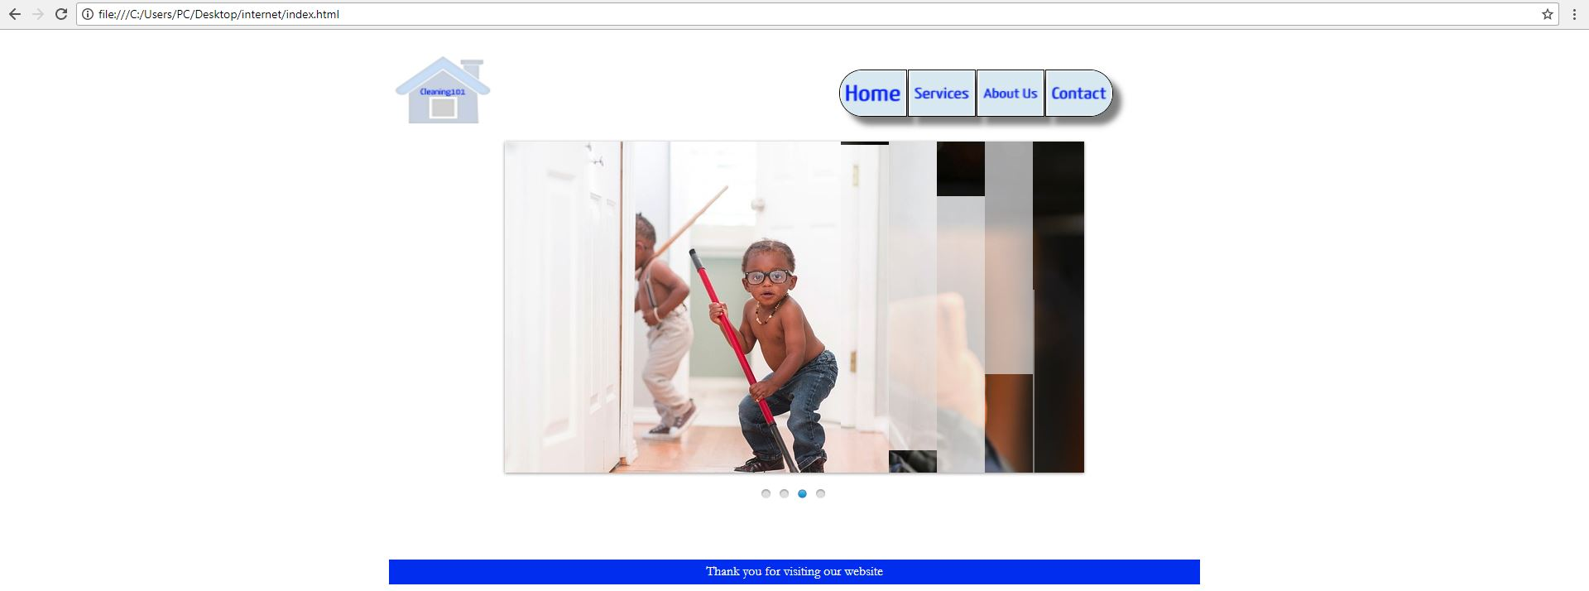

**(figure 1.1 : the main page)**

This is the main page for cleaning101, it is equip with a scroll of images in the center to give new feedbacks and info about cleaning101. Javascript is used for the image scrolling. The image will also stop as the cursor is hover above the images, this help the user to read important information and more. There is also a home, services, about us and contact button that link to different pages. The logo of the cleaning101 on the upper left is also a home button that link back to the home page.

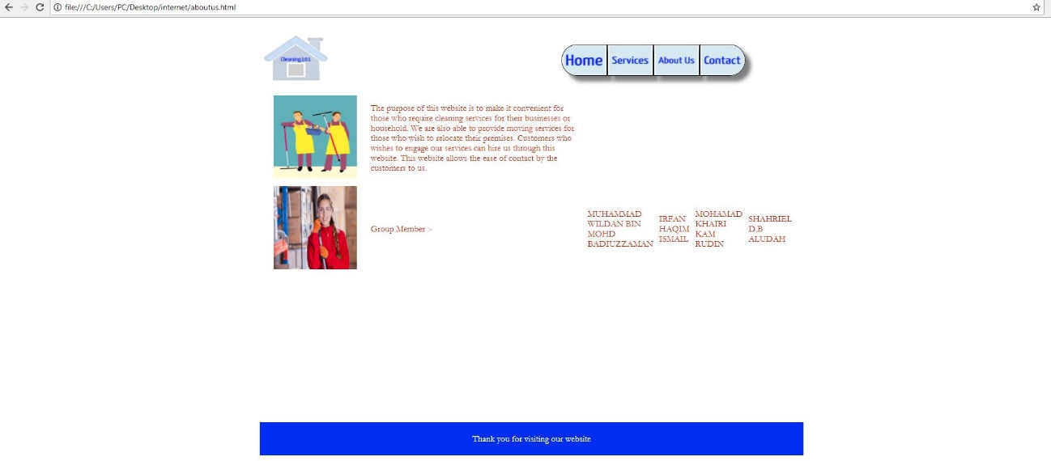

**(figure 1.2 : about us)**

This is the about us page that can be access from the about us button at the upper right side of the website. This page serve as the information of the website and also the person in charge of the website. This page has also the logo of the cleaning101 for easy home button.

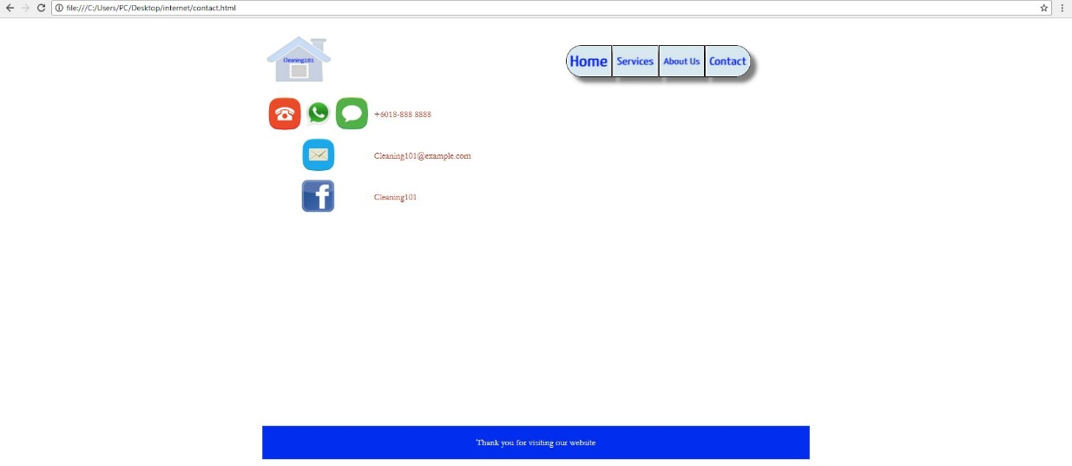

**(figure 1.3 : contact)**

This page serve as the way for the user to contact cleaning101 either for the services, feedback and others. This page has also includes the links to the cleaning101 facebook and email for contacting purposes.

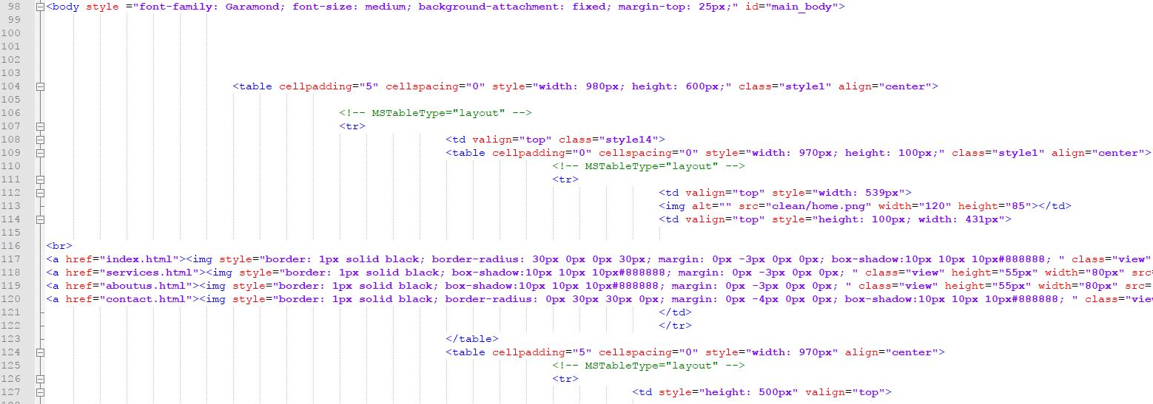

**(image 1.4 : Buttons code)**

This is the coding for the button that is used through all of the cleaning101 pages. We use ahref to link it to other pages and also included css coding to reshape the images to make look more presentable. the button code starts from line 114 to 121.

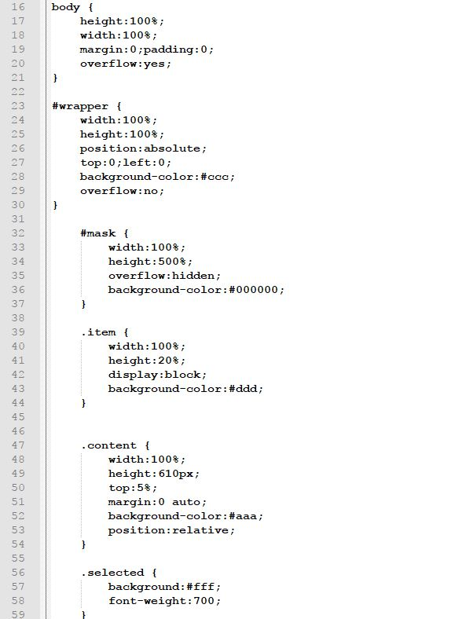

**(image 1.5 : css code)**

This the part of the css for internal use, we also use inline css to use for specific purpose on some part. This is to indicate the size, color of the content for the whole website.

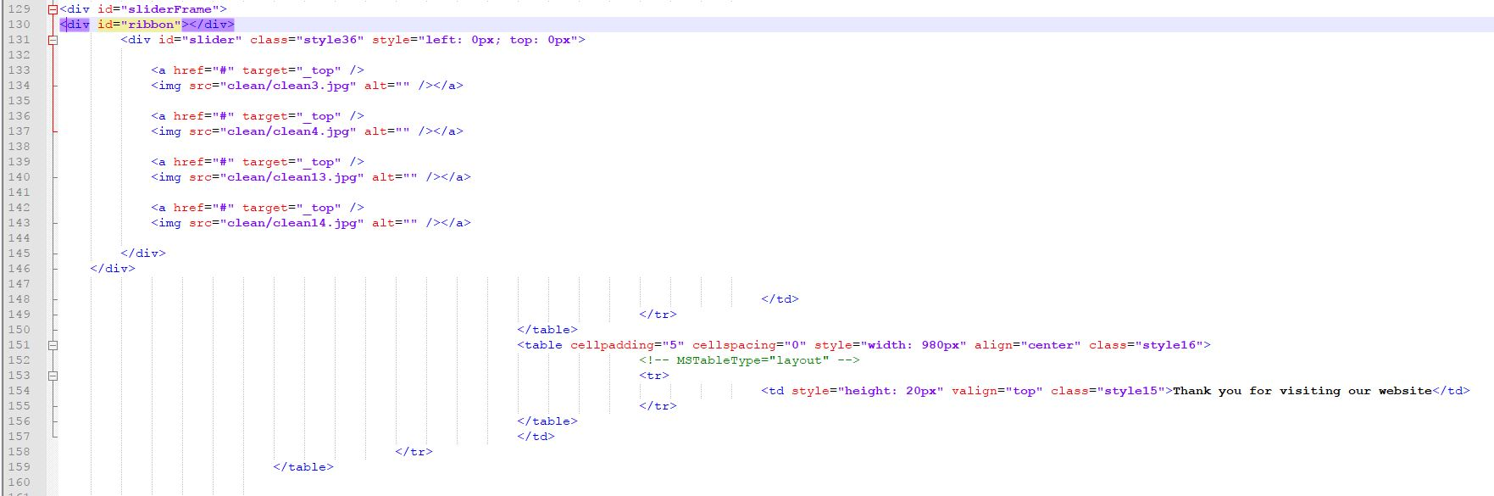

**(image 1.6 : slider images)**

This is the code for the slider used on the home page. This include the image src code to input the images inside the website. We use jpg, jpeg and png file images for the website.

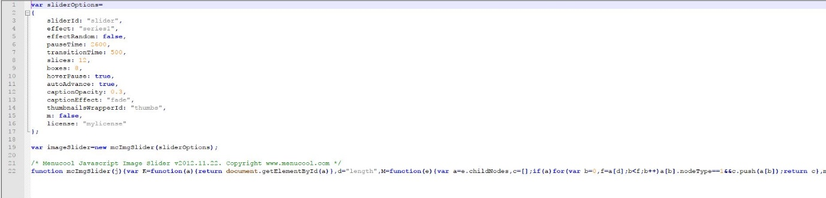

**(image 1.7 : javascript for the scroll effect)**

This is the javascript used for the scrolling on the homepage. Here is where we define the speed of the scroll, the autostop hover and also effect for the scrolling. This is very important to give more added features and feels for the website.

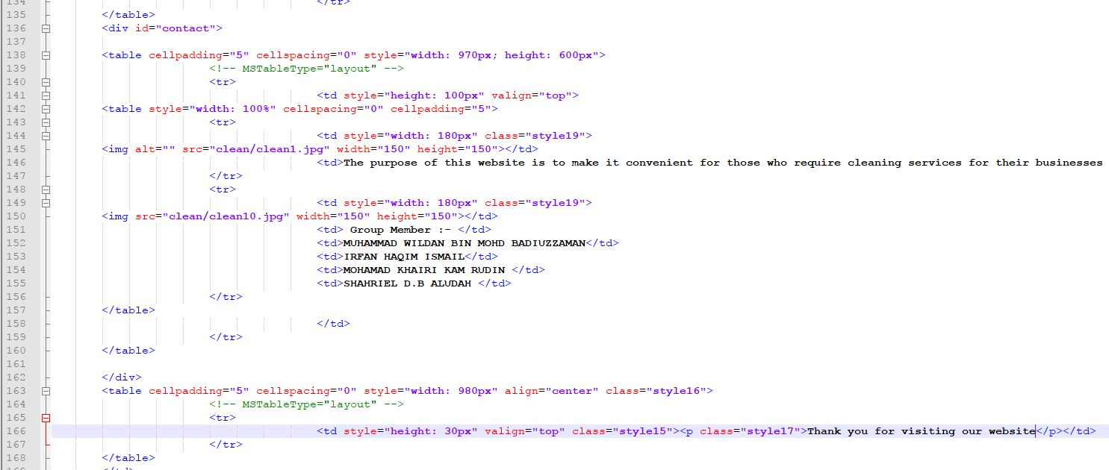

**(image 1.8 : about us page code)**

This the code used for the about us page. Here we specify the information used for the page such as the company purpose and also the admin or person in charge information. We also added images beside the information to make it more attracting for the user. The line starts from line 136 to 162 from the div id = contact.

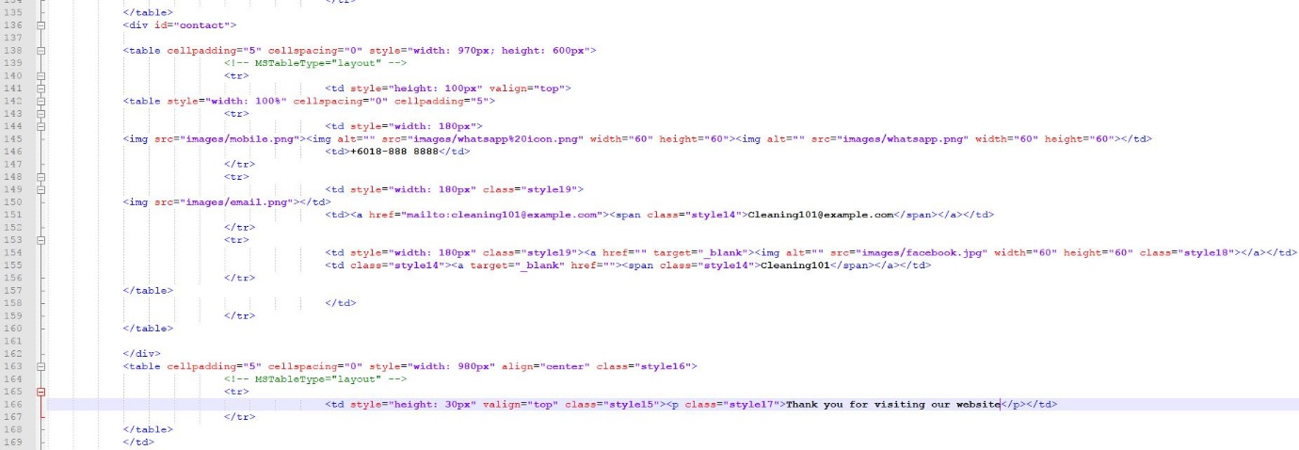

**(image 1.9 : contact page code)**

This is the code used for the contact page of cleaning101 website. It is almost the same as the code as in about us page because of most of it is information for the user, but unlike the about us page. This page is more interactive, as the images and the information is clickable and will link to the email and facebook for cleaning101.

**Evaluation Forms**

**(Appendix 2)**

# DOCUMENTATION EVALUATION FORM

**TITLE : _________________________________________________________________**

**DATE : _________________________________________________________________**

**LECTURER :** **_________________________________________________________________**

## MARKING GUIDE

|  |  |  |  |  |
| --- | --- | --- | --- | --- |
| 1. Poor | 2. Average | 3. Satisfactory | 4. Good | 5. Excellent |

|  |  |  |
| --- | --- | --- |
| **REPORT EVALUATION CRITERIA** | | **MARKS** |
| 1. | Organisation |  |
| 2. | Grammar and formatting |  |
| 3. | Relevant content |  |
| 4. | All submission requirements are met |  |
| **COMMENTS** | |  |
|  | |  |

**TOTAL MARKS: ____ / 20**

10

**TOTAL MARKS :**

# WEBSITE (PROTOTYPE) EVALUATION FORM

**TITLE : _________________________________________________________________**

**DATE : _________________________________________________________________**

**LECTURER :** **_________________________________________________________________**

## MARKING GUIDE

|  |  |  |  |  |
| --- | --- | --- | --- | --- |
| 1. Poor | 2. Average | 3. Satisfactory | 4. Good | 5. Excellent |

|  |  |  |
| --- | --- | --- |
| **Web Portal** | | **MARKS** |
| 1. | Home Page |  |
| 2. | Navigation (menu and menu items) |  |
| 3. | Contact us page |  |
| 4. | Sample articles/content |  |
| **COMMENTS** | |  |
|  | |  |

**TOTAL MARKS: ____ / 20**

5

**TOTAL MARKS :**

# WEBSITE (ACTUAL) EVALUATION FORM

**TITLE : _________________________________________________________________**

**DATE : _________________________________________________________________**

**LECTURER :** **_________________________________________________________________**

## MARKING GUIDE

|  |  |  |  |  |
| --- | --- | --- | --- | --- |
| 1. Poor | 2. Average | 3. Satisfactory | 4. Good | 5. Excellent |

|  |  |  |
| --- | --- | --- |
| **Web Portal** | | **MARKS** |
| 1. | Originality, User friendliness, Creativity |  |
| 2. | Captivating information/articles |  |
| 3. | Web design (colour scheme, fonts, images, functionalities, etc.) |  |
| 4. | Consistency (Proper placement and use of languages, fonts, buttons) |  |
| 5. | Error free (No broken links, all features are working) |  |
| 6. | Additional features (widgets or gadgets e.g. chat box, etc.) |  |
| **COMMENTS** | |  |
|  | |  |

**TOTAL MARKS: ____ / 30**

10

**TOTAL MARKS :**

# PRESENTATION EVALUATION FORM

**TITLE : _________________________________________________________________**

**DATE : _________________________________________________________________**

**LECTURER :** **_________________________________________________________________**

## MARKING GUIDE

|  |  |  |  |  |
| --- | --- | --- | --- | --- |
| 1. Poor | 2. Average | 3. Satisfactory | 4. Good | 5. Excellent |

|  |  |  |
| --- | --- | --- |
| **REPORT EVALUATION CRITERIA** | | **MARKS** |
| 1. | Good eye-contact |  |
| 2. | Communicate naturally and fluently |  |
| 3. | Clearly organised |  |
| 4. | Demonstrate appropriately (computer programs and functionalities) |  |
| **COMMENTS** | |  |
|  | |  |

**TOTAL MARKS: ____ / 20**

5

**TOTAL MARKS :**