CHAPTER 3
RESEARCH DESIGN AND METHODOLOGY
3.1 Introduction
The present chapter explains the overall blueprint that has been followed to carry out the study on the factors impacting distribution channel optimisation of Malta (Citrus sinensis) in the Garhwal region of Uttarakhand. The chapter begins with the philosophical orientation of the research, moves through the design choices, and finally settles on the operational steps adopted in the field. The intention here is not only to describe what was done but also to give the reader a transparent view of why each step was taken, so that the study remains traceable and replicable. Malta is a less-organised horticultural produce of the mid-hills, and its supply chain crosses several physical and human handovers from the orchard to the consumer. To capture this complexity, the methodology has been built around a mixed-method, multi-stage logic that respects both the lived experience of the stakeholders and the analytical rigour expected of academic research.
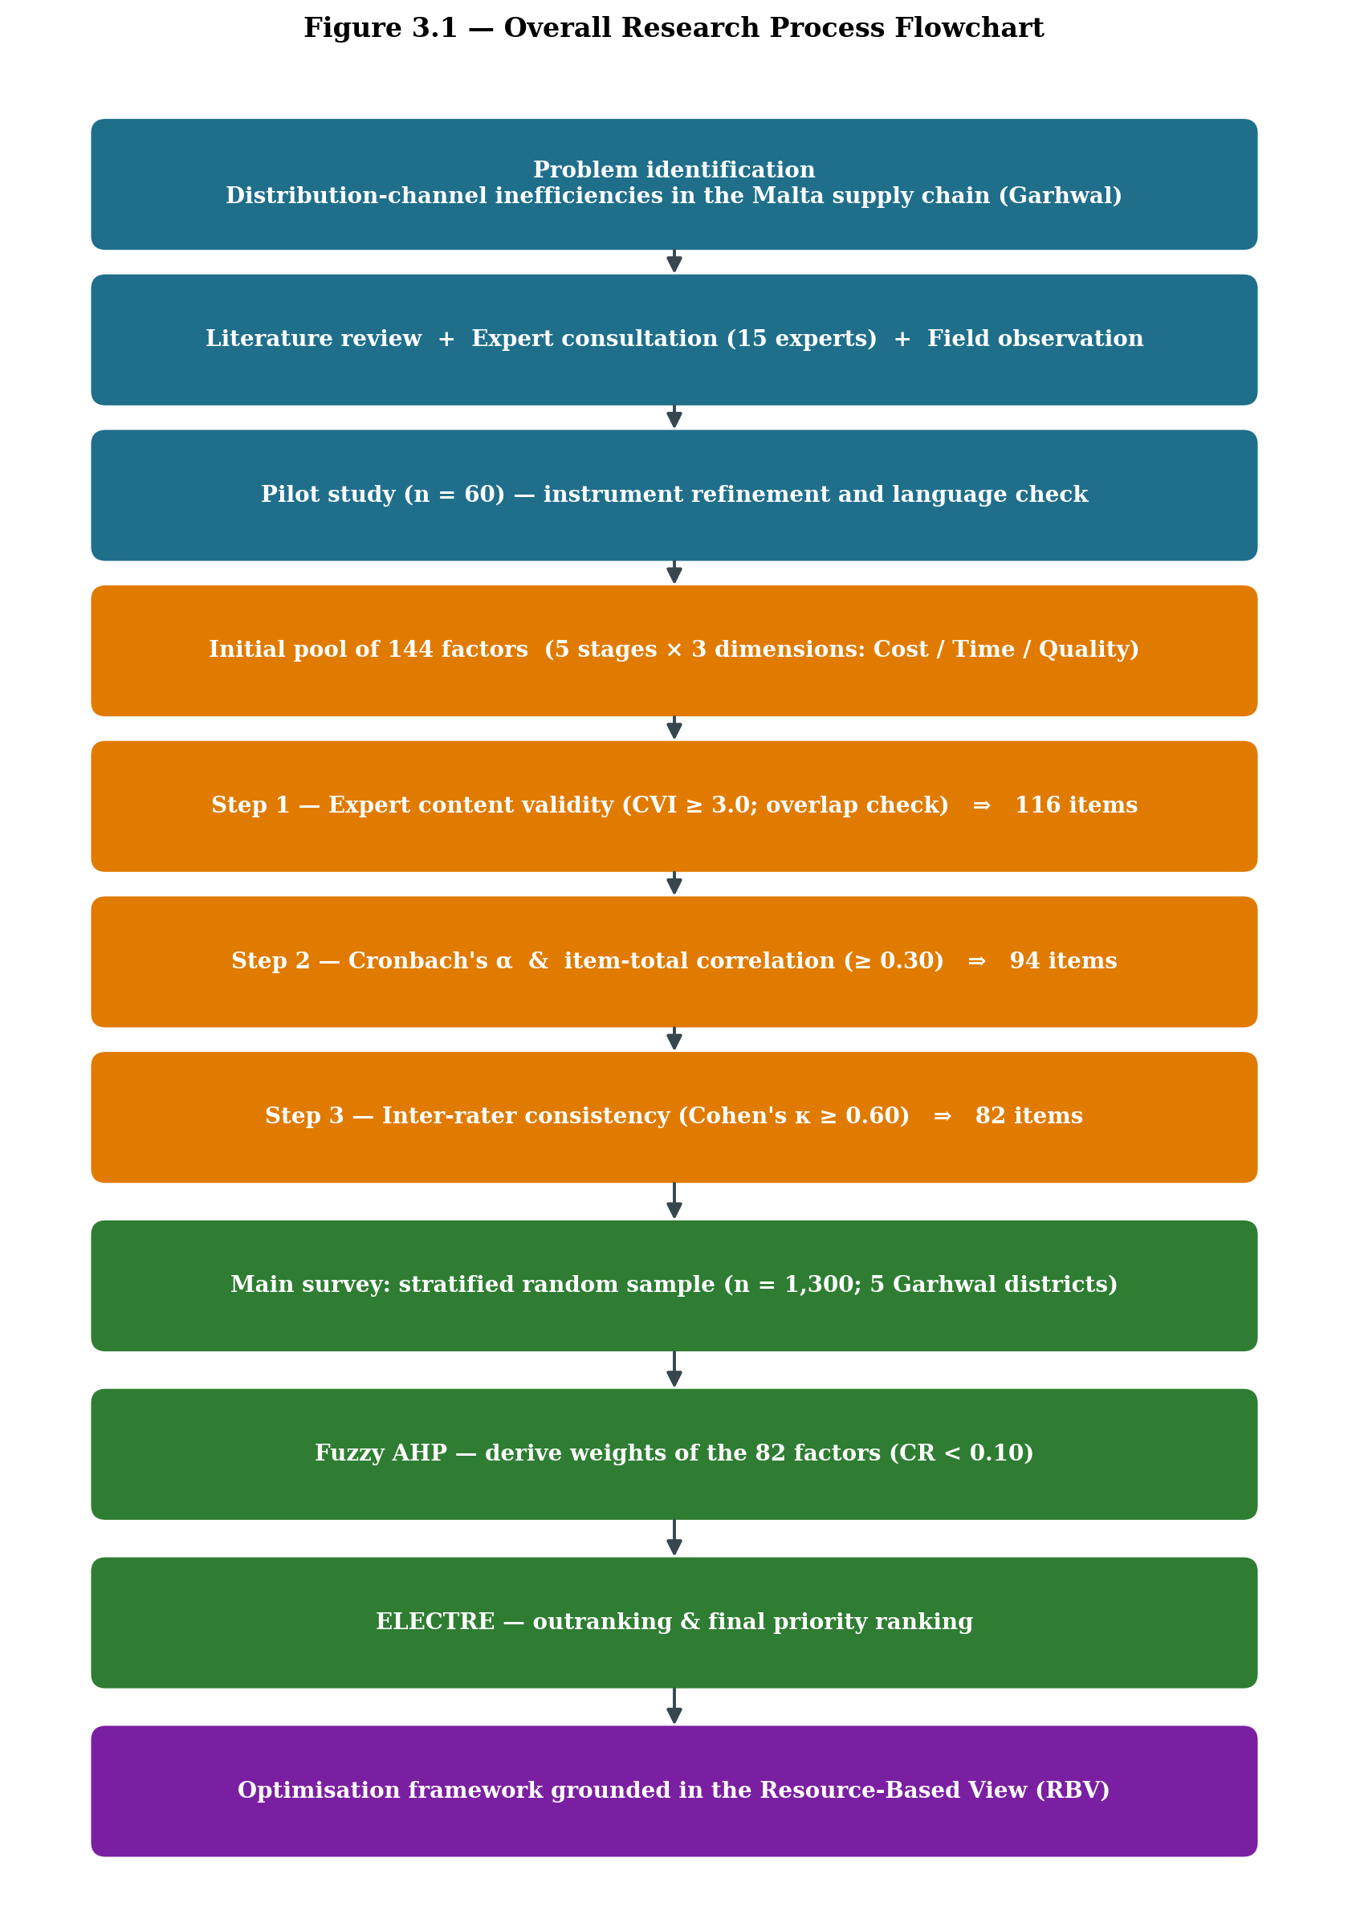
Figure 3.1 Overall research process flowchart (problem identification through to optimisation framework)
3.2 Research Design
The study follows a cross-sectional research design with a descriptive-cum-analytical orientation. A cross-sectional frame was selected because the purpose is to understand the prevailing state of the Malta distribution system across different stakeholder groups during a defined window of time, rather than tracking a single set of respondents over many years. Within this frame, a mixed-method approach has been adopted, where the qualitative inputs from field observations and stakeholder interactions feed directly into the quantitative instrument, and the quantitative ratings are later interpreted back through the qualitative context. This back-and-forth is what makes the design suitable for a layered supply chain that involves growers, local traders, commission agents, mandi-level wholesalers, retailers and transporters.
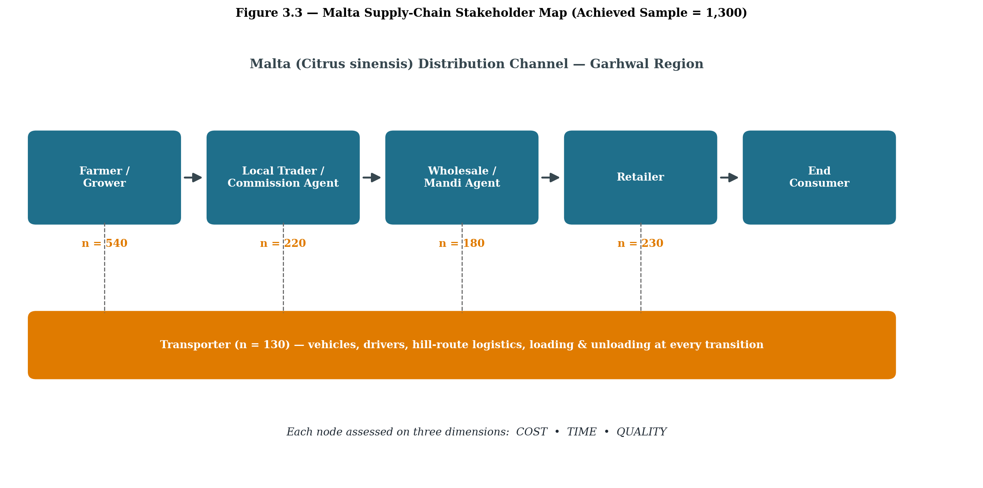
Figure 3.2 Malta (Citrus sinensis) supply-chain stakeholder map showing the five strata in which data was collected
3.2.1 Nature of the study
The study is descriptive in the sense that it portrays the structure of the Malta supply chain as it currently functions in the Garhwal hills. It is analytical in the sense that it goes beyond description and ranks the factors according to their relative pull on cost, time and quality, using two Multi-Criteria Decision-Making (MCDM) techniques. Both primary and secondary data have been used. Primary data has been gathered through a structured questionnaire, expert consultations and personal field visits. Secondary data has been drawn from horticulture mission reports, district statistical handbooks of Uttarakhand, journal articles, books on agricultural marketing and supply chain management, APEDA bulletins and similar sources.
3.3 Theoretical Foundation: The Resource-Based View (RBV)
The conceptual lens adopted for the present work is the Resource-Based View (RBV) of the firm, developed in its modern form by Wernerfelt (1984) and extended by Barney (1991). The RBV argues that a firm, or by extension a supply chain node, gains and sustains competitive advantage through resources and capabilities that are valuable, rare, inimitable and well organised (the VRIO frame). For a fragmented agri-supply chain like that of Malta in the Garhwal region, the RBV is particularly useful because the chain is not owned by a single firm. Instead, capabilities are distributed across growers, traders, mandi agents, retailers and transporters. Each link controls a small bundle of tangible and intangible resources, such as orchard land, packing material, cold chain access, market information, labour skill and informal network ties.
Viewing the chain through the RBV makes it possible to read the 144 initially identified factors and the 82 finally retained factors not as a loose list of operational issues but as proxies for the underlying resources and capabilities of the chain. Cost-related items signal financial and physical resources; time-related items signal coordination and process capabilities; and quality-related items signal knowledge, skill and infrastructural resources. The theoretical contribution of this study is therefore to map the operational constraints of a hill-based citrus chain on to the resource-and-capability vocabulary of the RBV, so that the eventual framework of optimisation does not stop at fixing surface-level problems but speaks directly to which resources of the chain need to be strengthened, shared or substituted.
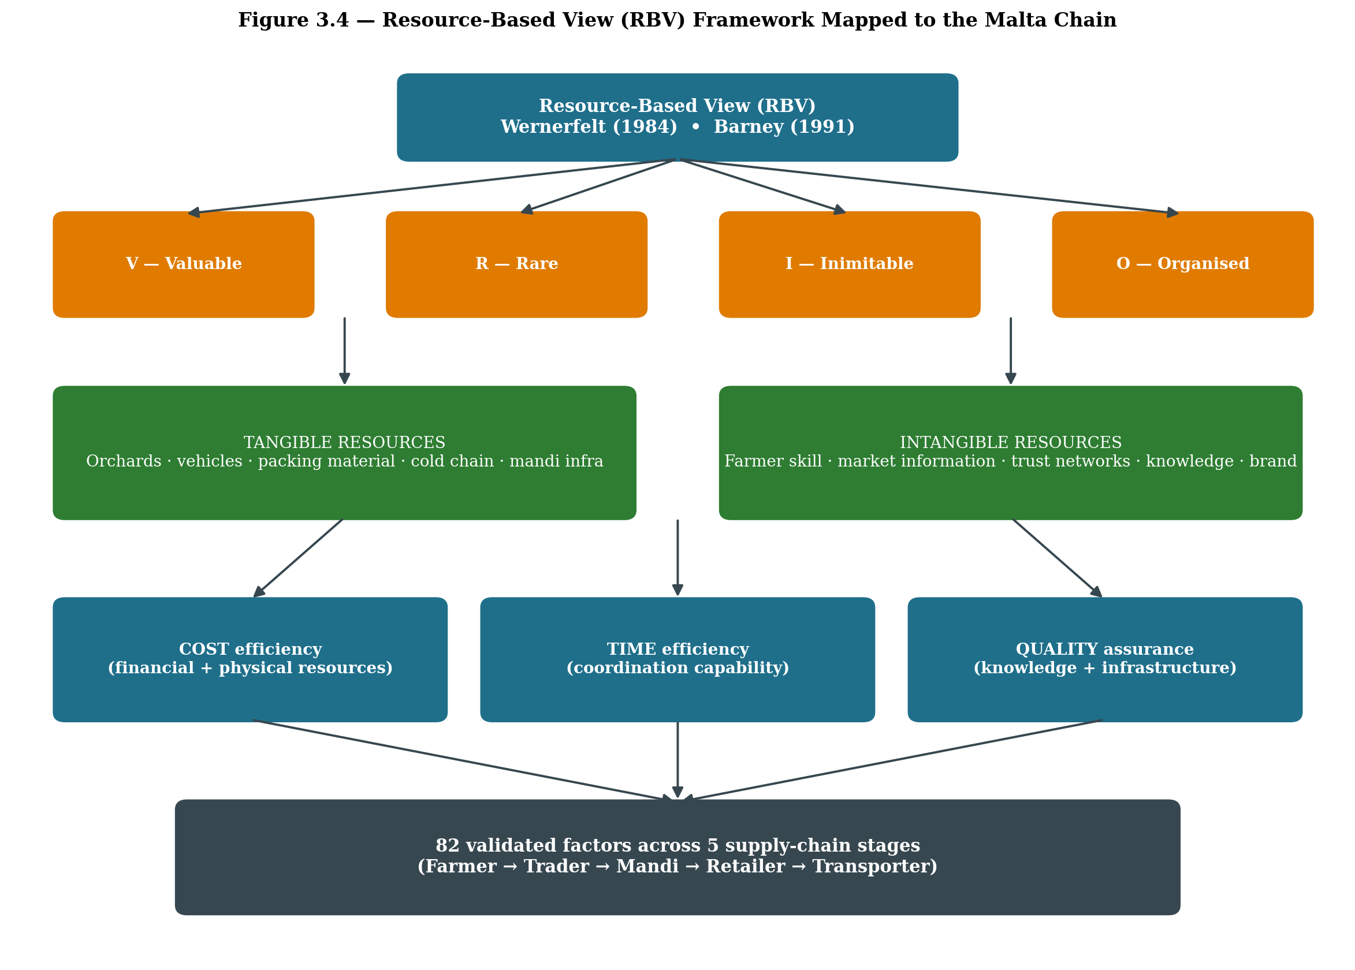
Figure 3.3 Resource-Based View (RBV) framework mapped to the cost / time / quality dimensions of the Malta supply chain
3.4 Phases of Data Collection
The fieldwork was organised in three phases between September 2024 and December 2025. The phasing was deliberate: it allowed the instrument to evolve with the field, rather than freezing the questionnaire at the very beginning. The three phases are described below.
Phase | Period | Title | Key Activities
Phase I | Sept 2024 - Feb 2025 | Exploratory & Pilot Phase | Literature scan, expert interactions (15 experts), pilot survey on 60 respondents, preliminary listing of 144 factors, pre-test of questionnaire wording.
Phase II | Mar 2025 - Aug 2025 | Main Field Survey | Stratified random sampling across five Garhwal districts, full-scale data collection from farmers, local traders, mandi agents, wholesalers, retailers and transporters.
Phase III | Sept 2025 - Dec 2025 | Validation & Analytical Phase | Reliability testing (Cronbach's alpha), consistency check by experts, refinement from 144 to 82 factors, application of Fuzzy AHP and ELECTRE, follow-up validation interviews.
Table 3.1 Three-phase plan of data collection (Sept 2024 - Dec 2025)
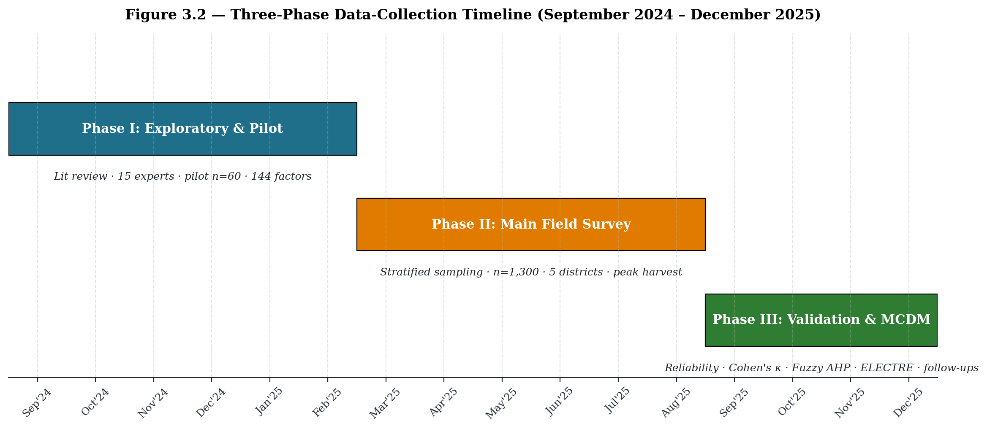
Figure 3.4 Three-phase data-collection timeline (September 2024 – December 2025)
Spreading the work across three phases also helped in handling the strong seasonality of Malta. The fruit broadly hits the mandis between November and February, so Phase I captured the run-up to the peak season, Phase II covered both an active harvest and a post-harvest review, and Phase III allowed the researcher to revisit specific respondents for clarifications after a complete production cycle had passed.
3.5 Identification and Refinement of Factors
A central methodological task of the study was to arrive at a defensible list of factors that genuinely affect distribution channel efficiency for Malta. The exercise moved from an open and somewhat redundant list of 144 factors to a compact and statistically defensible list of 82 factors. The process is summarised below.
3.5.1 Sources used for the initial pool of 144 factors
- Extensive review of literature on horticultural supply chains, citrus marketing in India, hill agriculture, and post-harvest losses (publications from 2005 onwards, including ICAR, NIAM and APEDA reports).
- Expert consultations with fifteen experts comprising horticulture scientists, agricultural marketing faculty, Mandi Samiti officials, progressive Malta growers, transporters and wholesale commission agents from Pauri, Tehri, Chamoli, Rudraprayag and Uttarkashi.
- Pilot study findings from a preliminary survey of 60 respondents covering all five stakeholder categories.
- Stakeholder discussions and group interactions in farmer collectives and mandi premises during peak Malta arrival weeks.
- Direct field observations and walk-along observations from orchard to retail outlet, recorded in a structured field diary.
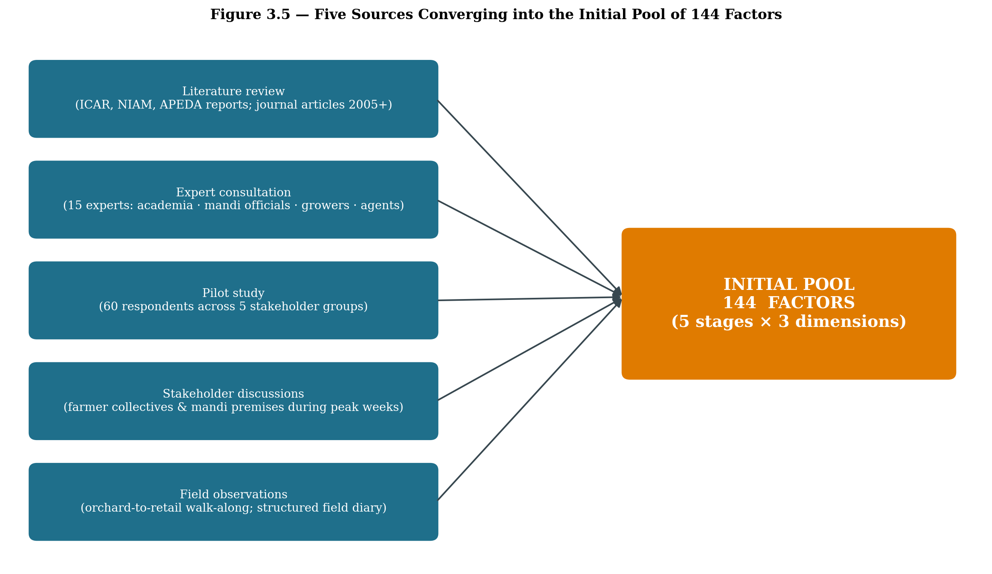
Figure 3.5 Five sources converging into the initial pool of 144 factors
3.5.2 Categorisation of the initial 144 factors
The 144 factors were first organised on two intersecting axes: (a) the stage of the supply chain (Farm, Local Trader/Commission Agent, Mandi/Wholesale, Retail, Transportation) and (b) the dimension of inefficiency (Cost, Time, Quality). The stage-wise distribution of the initial pool is given in Table 3.2 and visualised in Figure 3.6.
Supply-chain stage | Cost (initial) | Time (initial) | Quality (initial) | Initial Total | Retained | Eliminated
Farm / Grower stage | 12 | 10 | 10 | 32 | 19 | 13
Local Trader / Commission Agent | 11 | 9 | 9 | 29 | 16 | 13
Wholesale / Mandi | 10 | 9 | 9 | 28 | 16 | 12
Retailer | 10 | 7 | 8 | 25 | 15 | 10
Transportation | 11 | 10 | 9 | 30 | 16 | 14
TOTAL | 54 | 45 | 45 | 144 | 82 | 62
Table 3.2 Stage-wise distribution of factors (144 → 82)
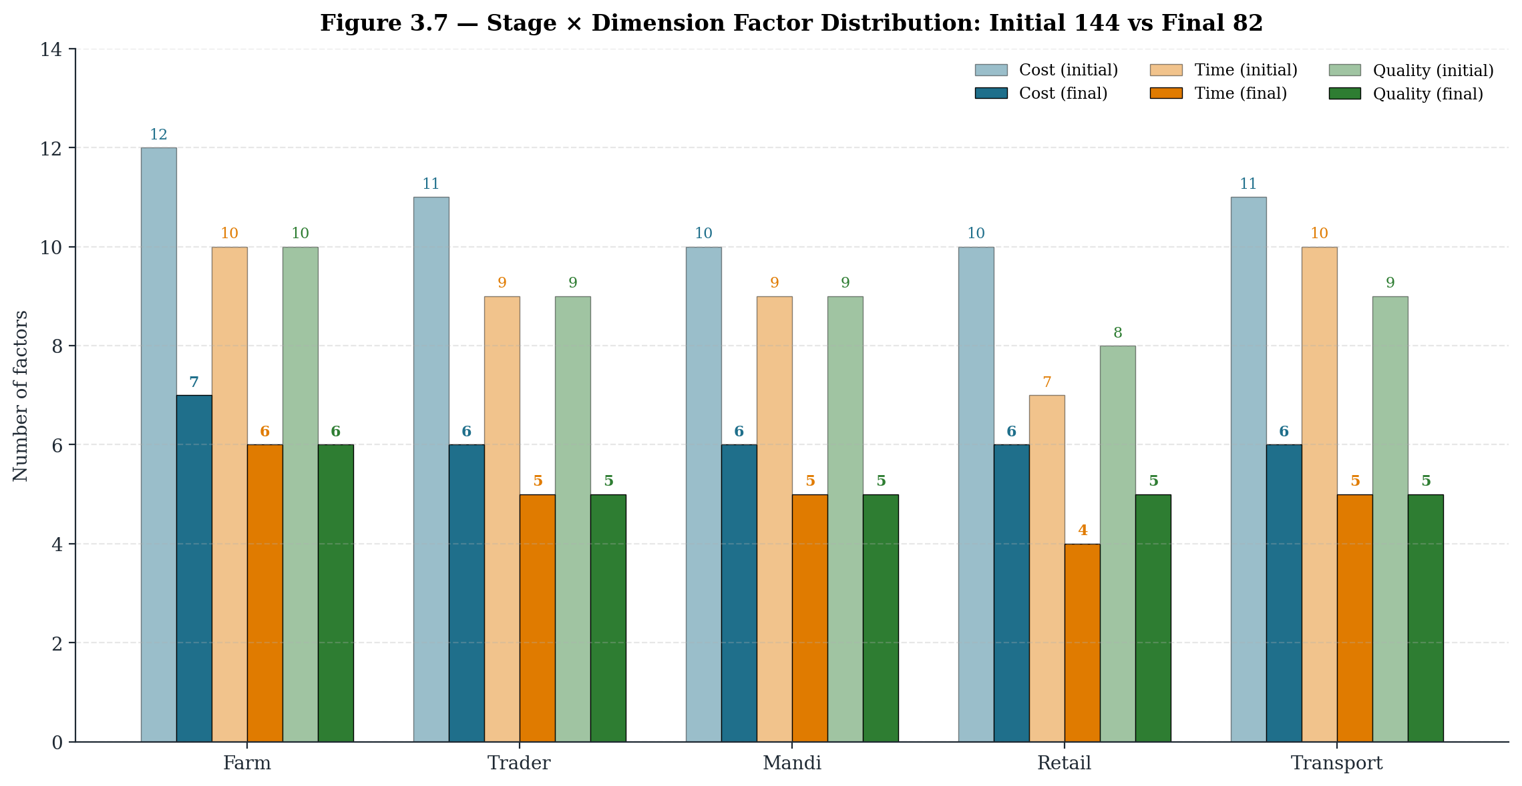
Figure 3.6 Stage × Dimension distribution of factors: initial 144 vs final 82
3.6 Initial Pool of 144 Factors
The complete initial list of 144 factors generated through literature, expert panels and field observation is presented below, grouped by stage and by the Cost-Time-Quality dimension. Items that survived the refinement process are marked as Retained (R) and items that were dropped are marked as Eliminated (E). The reasons for elimination are summarised in Section 3.7.
(A) Farm / Grower Stage – 32 initial factors
1. Labour cost for plucking and harvesting of Malta [R]
2. Cost of baskets / crates used at the orchard [R]
3. Cost of grading and on-farm sorting [R]
4. Cost of packaging material (cartons, gunny bags, layering) [R]
5. Cost of on-farm storage and shed maintenance [R]
6. Loading and unloading charges at the farm gate [R]
7. Local transportation cost from orchard to collection point [R]
8. Cost of pesticide and fertiliser applied close to harvest [E]
9. Cost of orchard upkeep during the harvesting period [E]
10. Cost of training of pluckers and casual labour [E]
11. Cost of supervision of on-field operations [E]
12. Replacement cost of broken or damaged crates [E]
13. Time taken in actual plucking / harvesting of fruits [R]
14. Time spent in sorting and grading at orchard [R]
15. Time consumed in packaging and tying of cartons [R]
16. Waiting time for pick-up / transport at the farm gate [R]
17. Loading time at the farm gate [R]
18. Transit time from farm to local market [R]
19. Time used in pre-harvest field inspection [E]
20. Time spent in assembling daily labour each morning [E]
21. Time taken to procure packaging material from town [E]
22. Idle time at the collection point during peak hours [E]
23. Impact of harvesting method on fruit quality [R]
24. Handling care during plucking and collection [R]
25. Accuracy of grading at orchard level [R]
26. Quality of packaging used at farm gate [R]
27. Storage temperature control at orchard / collection shed [R]
28. Handling quality during transit from farm [R]
29. Maturity stage of fruit at the time of plucking [E]
30. Cleanliness of crates used at collection point [E]
31. Effect of weather during harvest on shelf life [E]
32. Adequacy of natural shade at on-farm storage [E]
(B) Local Trader / Commission Agent Stage – 29 initial factors
1. Purchase price paid to farmers [R]
2. Transportation to trader's premises [R]
3. Storage and handling charges at trader's godown [R]
4. Re-grading and re-packaging cost at trader level [R]
5. Commission and agency charges payable [R]
6. Loading and onward transport cost to mandi [R]
7. Cost of advances given to farmers ahead of season [E]
8. Cost of maintaining a local godown / collection shed [E]
9. Cost of bookkeeping and basic record keeping [E]
10. Cost of refreshments and hospitality for visiting farmers [E]
11. Cost of damage compensation paid to farmers [E]
12. Time taken to collect produce from multiple farmers [R]
13. Time spent in quality inspection by the trader [R]
14. Time taken in re-sorting at trader level [R]
15. Storage duration at trader's premises [R]
16. Waiting time for onward transport to mandi [R]
17. Time spent in price negotiation with farmers [E]
18. Time used for daily reconciliation of weights [E]
19. Time taken in arranging vehicles during peak season [E]
20. Time consumed in coordinating with mandi commission agents [E]
21. Initial quality assessment by the trader [R]
22. Maintenance of storage condition at trader's place [R]
23. Handling care during re-grading [R]
24. Packaging quality control after re-packing [R]
25. Transit quality management from trader to mandi [R]
26. Mixing of grades during re-packaging [E]
27. Exposure to direct sunlight at trader's premises [E]
28. Quality loss due to repeated weighing [E]
29. Inconsistency in grading judgement across staff [E]
(C) Wholesale / Mandi Stage – 28 initial factors
1. Mandi entry fee / gate fee [R]
2. Weighing charges at mandi platform [R]
3. Storage rent at mandi premises [R]
4. Commission agent charges (arhatiya commission) [R]
5. Loading and unloading labour cost at mandi [R]
6. Cost of onward transportation to retailer [R]
7. Cost of mandi licence renewal [E]
8. Cost of mandatory market fee / cess [E]
9. Cost of arbitration in case of disputes [E]
10. Cost of waste disposal at mandi premises [E]
11. Unloading and entry-gate time at mandi [R]
12. Waiting time before auction begins [R]
13. Auction duration at mandi [R]
14. Payment settlement / cash release time [R]
15. Loading time for outbound dispatch [R]
16. Time spent in queue at mandi gate [E]
17. Time consumed in obtaining gate-pass and entry slip [E]
18. Time required for re-weighing on buyer's request [E]
19. Time used in coordinating with multiple buyers [E]
20. Quality inspection at mandi entry [R]
21. Storage conditions inside the mandi shed [R]
22. Handling care during the auction process [R]
23. Verification of grading by buyer [R]
24. Post-auction handling and re-stacking [R]
25. Mixing of stock from different consignments [E]
26. Hygiene level of mandi floor [E]
27. Pest and insect exposure inside mandi sheds [E]
28. Damage caused by stacking pressure during peak inflow [E]
(D) Retailer Stage – 25 initial factors
1. Purchase cost from mandi / wholesaler [R]
2. Transportation cost from mandi to retail outlet [R]
3. Storage and display cost at retail level [R]
4. Wastage and spoilage cost at retail [R]
5. Retail space rent or daily pitch fee [R]
6. Handling and labour cost at the shop [R]
7. Cost of carry bags and small packing material [E]
8. Cost of street vendor / municipal levies [E]
9. Cost of price-tags and small signage [E]
10. Cost of weighing scale calibration [E]
11. Time spent in procurement from wholesaler / mandi [R]
12. Time taken in arranging the display [R]
13. Time spent in attending customers [R]
14. Inventory turnover time at retail level [R]
15. Time spent in daily price discovery [E]
16. Time used in segregating overripe fruits each morning [E]
17. Time taken in cash settlement at end of day [E]
18. Quality check at the time of purchase from mandi [R]
19. Quality of storage and display at retail [R]
20. Maintenance of freshness through the day [R]
21. Customer perception of fruit quality [R]
22. Quality reflected in post-sale customer feedback [R]
23. Direct exposure of fruit to sunlight at the shop [E]
24. Effect of dust and pollution on display fruits [E]
25. Quality damage due to repeated handling by customers [E]
(E) Transportation Stage – 30 initial factors
1. Vehicle hire / ownership cost [R]
2. Fuel and routine maintenance cost [R]
3. Driver and helper wages [R]
4. Loading and unloading charges at terminals [R]
5. Insurance and statutory permit cost [R]
6. Toll and route-related charges [R]
7. Cost of parking at transit points [E]
8. Cost of detention during long unloading [E]
9. Cost of overnight halt for drivers [E]
10. Cost of vehicle cleaning / sanitation [E]
11. Cost of GPS and tracking devices [E]
12. Vehicle availability time during peak season [R]
13. Loading time at the dispatch point [R]
14. Transit duration on the route [R]
15. Unloading time at the destination [R]
16. Return-journey time of the vehicle [R]
17. Time lost in landslide / road blockage on hill routes [E]
18. Time spent at check-posts and barriers [E]
19. Time used in route diversion during monsoon [E]
20. Documentation and gate-pass time [E]
21. Driver rest break time during long haul [E]
22. Vehicle condition and overall cleanliness [R]
23. Capability for temperature control inside the vehicle [R]
24. Handling care during loading of consignment [R]
25. Safety measures during transit [R]
26. Impact of timely delivery on quality [R]
27. Vibration and shock damage on hilly roads [E]
28. Exposure of stacked load to rain and dust [E]
29. Quality loss due to mixed cargo (Malta with other goods) [E]
30. Quality loss due to overloading of the vehicle [E]
Note: R = Retained in the final 82-factor instrument, E = Eliminated during the refinement process described in Section 3.7.
3.7 Refinement Process: From 144 to 82 Factors
The reduction of factors from 144 to 82 was not a single-step exercise. Three checks were carried out, in sequence, and a factor had to clear all three checks to enter the final instrument. The flow is summarised in the funnel diagram below.
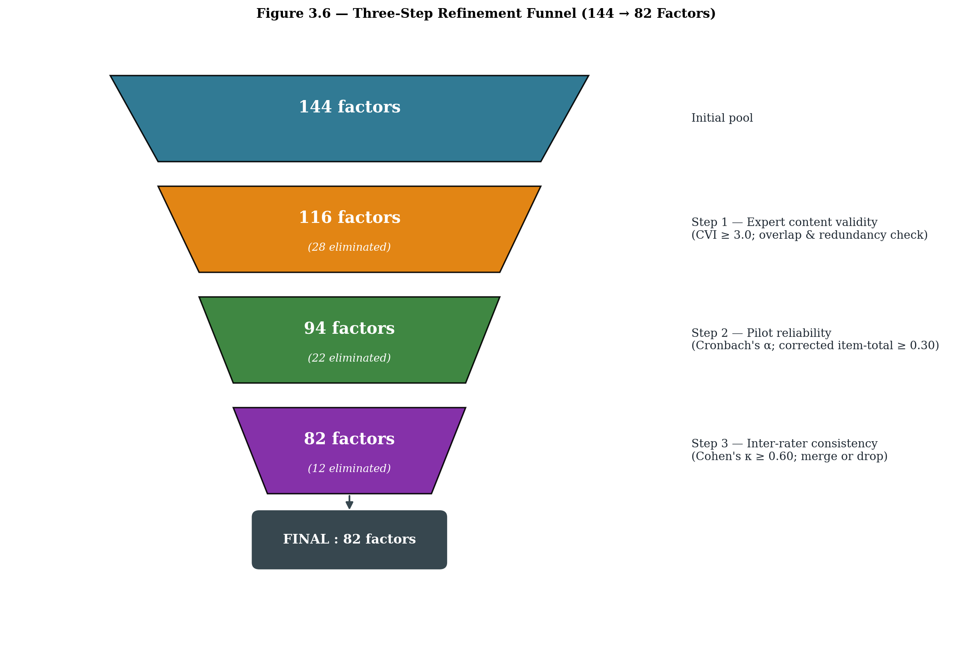
Figure 3.7 Three-step refinement funnel (144 → 116 → 94 → 82 factors)
3.7.1 Step 1 - Expert content validity check
A panel of fifteen experts (six academic experts in agribusiness and supply chain, four senior officials from APMC mandis and the State Horticulture Mission, three large progressive growers and two senior commission agents) rated each of the 144 factors on a relevance scale of 1 to 5. A factor that received a mean score below 3.0 from the panel, or where more than one-third of the experts marked it as 'overlapping with another factor', was flagged for elimination. This step alone removed 28 items, mostly those that were either too specific (for example, cost of refreshments at trader's place) or essentially restated another factor in different words.
3.7.2 Step 2 - Pilot reliability and item-total consistency
The remaining 116 factors were tested through a pilot survey of 60 respondents drawn proportionately from the five stakeholder groups. Cronbach's alpha was computed for every cost, time and quality scale at every stage. Items whose corrected item-total correlation fell below 0.30, or whose deletion would push the scale alpha above the existing alpha by more than 0.02, were removed. This step eliminated a further 22 items. After this step, 94 items remained.
3.7.3 Step 3 - Inter-rater consistency and final pruning
An inter-rater consistency check was conducted on the 94 items by sharing the item set with a smaller expert sub-panel of seven members. Cohen's kappa was computed pair-wise, and items where agreement on the dimension (cost / time / quality) fell below k = 0.60 were re-examined and either merged with a parent item or dropped. Twelve more items were removed at this stage. The instrument finally stabilised at 82 factors. Post-refinement reliability statistics from the main survey (n = 1,300) are reported in Table 3.3 and visualised in Figure 3.8.
Sub-scale | No. of items | Cronbach's α | Avg. inter-item correlation
Farm – Cost | 7 | 0.917 | 0.614
Farm – Time | 6 | 0.897 | 0.591
Farm – Quality | 6 | 0.919 | 0.656
Trader – Cost | 6 | 0.899 | 0.597
Trader – Time | 5 | 0.847 | 0.525
Trader – Quality | 5 | 0.894 | 0.628
Mandi – Cost | 6 | 0.905 | 0.615
Mandi – Time | 5 | 0.861 | 0.553
Mandi – Quality | 5 | 0.886 | 0.610
Retail – Cost | 6 | 0.885 | 0.563
Retail – Time | 4 | 0.820 | 0.533
Retail – Quality | 5 | 0.875 | 0.583
Transport – Cost | 6 | 0.900 | 0.601
Transport – Time | 5 | 0.903 | 0.651
Transport – Quality | 5 | 0.870 | 0.572
Overall (mean) | 82 | 0.885 | 0.595
Table 3.3 Reliability statistics for the 82-factor instrument (n = 1,300)
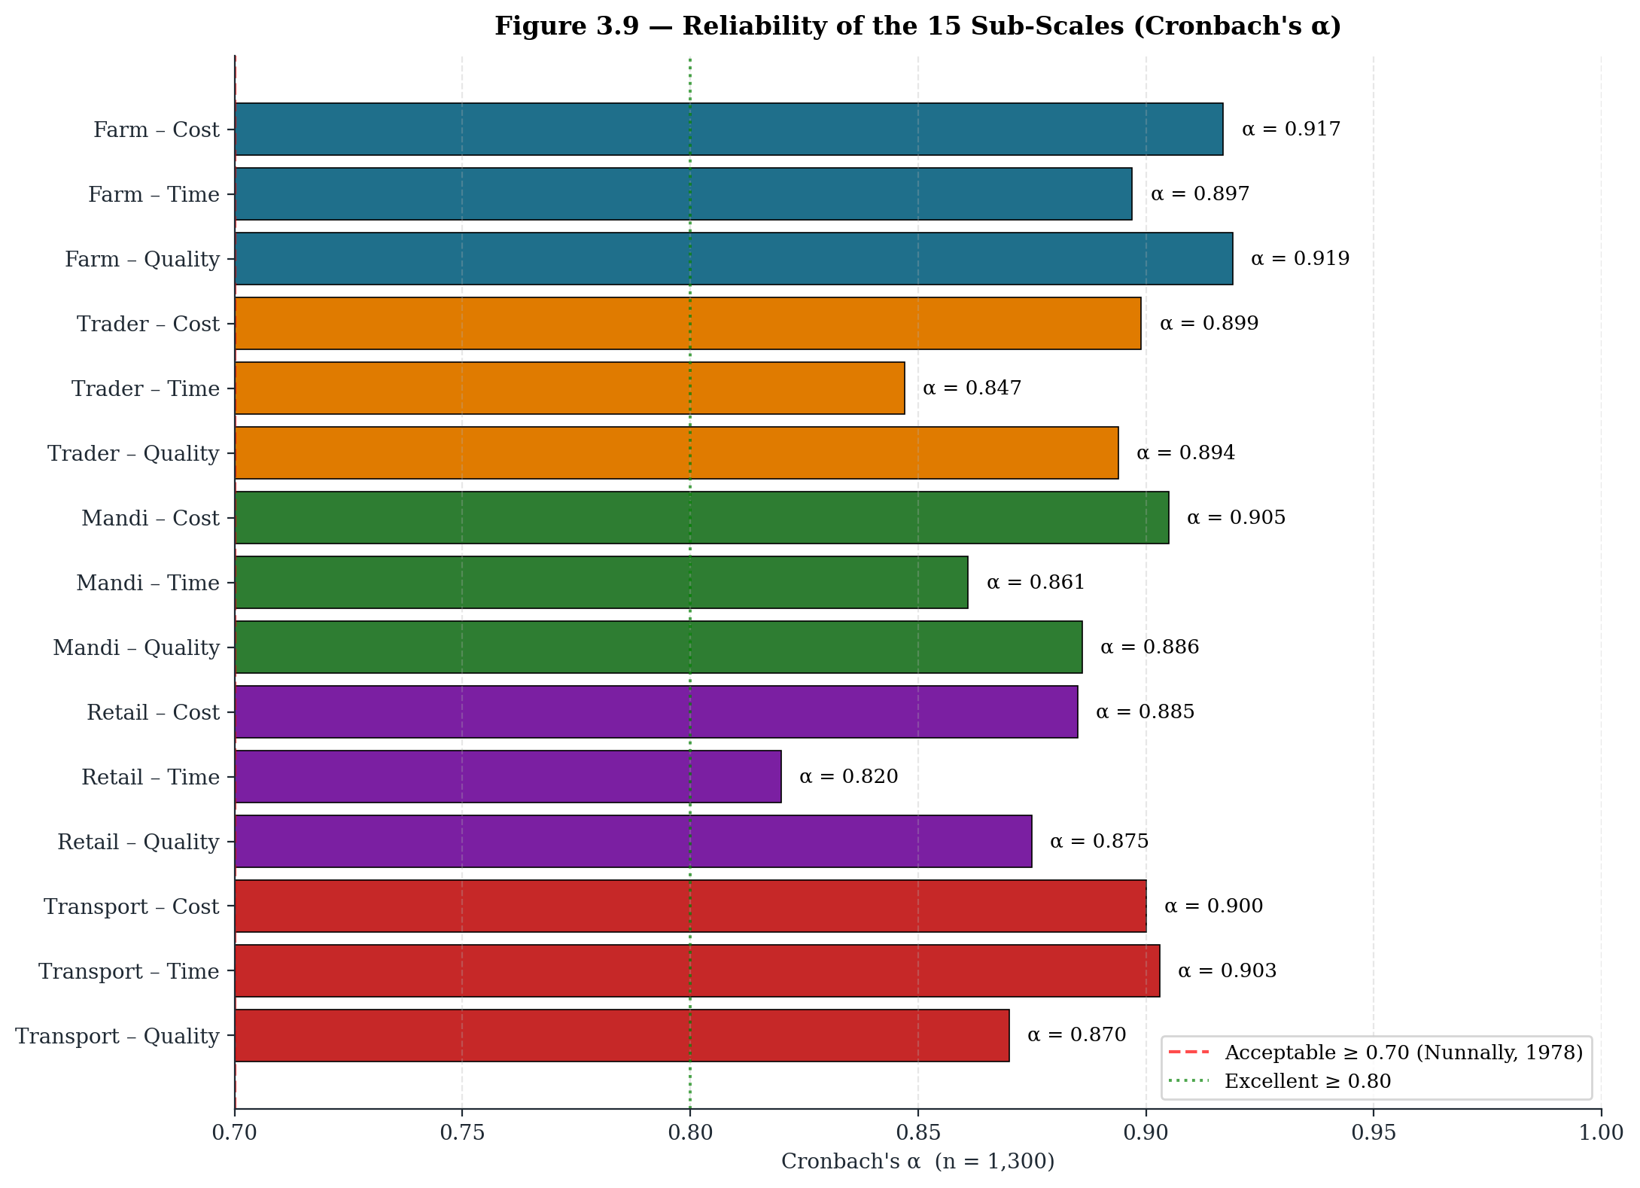
Figure 3.8 Reliability of the 15 sub-scales – Cronbach's α (n = 1,300)
All sub-scales report Cronbach's alpha well above the conventional threshold of 0.70, and the average inter-item correlation lies between 0.52 and 0.66, which is comfortably inside the recommended band of 0.20 to 0.70 (Briggs and Cheek, 1986). The instrument is therefore both internally consistent and not redundant.
3.8 Final List of 82 Validated Factors
The final 82 factors retained for analysis are listed below, organised stage-wise and dimension-wise. These factors form the input set for the Fuzzy AHP weighting and the ELECTRE ranking procedures.
Farm-stage Cost Factors (7 items)
F_COST_1 Labour cost for harvesting
F_COST_2 Basket / crate material cost
F_COST_3 Grading and sorting cost
F_COST_4 Packaging material cost
F_COST_5 On-farm storage cost
F_COST_6 Loading / unloading charges
F_COST_7 Local transportation cost
Farm-stage Time Factors (6 items)
F_TIME_1 Harvesting time
F_TIME_2 Sorting and grading time
F_TIME_3 Packaging time
F_TIME_4 Waiting time for transport
F_TIME_5 Loading time
F_TIME_6 Transit time to market
Farm-stage Quality Factors (6 items)
F_QUAL_1 Harvesting method impact on fruit quality
F_QUAL_2 Handling during collection
F_QUAL_3 Grading accuracy
F_QUAL_4 Packaging quality
F_QUAL_5 Storage temperature control
F_QUAL_6 Transit handling quality
Local-Trader / Commission-Agent Cost Factors (6 items)
T_COST_1 Purchase price from farmers
T_COST_2 Transportation to trader premises
T_COST_3 Storage and handling charges
T_COST_4 Re-grading and re-packaging cost
T_COST_5 Commission / agency charges
T_COST_6 Loading and transport to mandi cost
Local-Trader / Commission-Agent Time Factors (5 items)
T_TIME_1 Collection time from multiple farmers
T_TIME_2 Quality inspection time
T_TIME_3 Re-sorting time
T_TIME_4 Storage duration
T_TIME_5 Transport waiting time
Local-Trader / Commission-Agent Quality Factors (5 items)
T_QUAL_1 Initial quality assessment
T_QUAL_2 Storage condition maintenance
T_QUAL_3 Handling during re-grading
T_QUAL_4 Packaging quality control
T_QUAL_5 Transit quality management
Wholesale / Mandi Cost Factors (6 items)
M_COST_1 Mandi entry fee
M_COST_2 Weighing charges
M_COST_3 Storage rent at mandi
M_COST_4 Commission agent charges
M_COST_5 Loading / unloading labour cost
M_COST_6 Transportation to retailer cost
Wholesale / Mandi Time Factors (5 items)
M_TIME_1 Unloading and entry time
M_TIME_2 Waiting time for auction
M_TIME_3 Auction duration
M_TIME_4 Payment settlement time
M_TIME_5 Loading time for dispatch
Wholesale / Mandi Quality Factors (5 items)
M_QUAL_1 Quality inspection at entry
M_QUAL_2 Storage conditions at mandi
M_QUAL_3 Handling during auction
M_QUAL_4 Grading verification
M_QUAL_5 Post-auction handling
Retailer Cost Factors (6 items)
R_COST_1 Purchase cost from mandi / wholesaler
R_COST_2 Transportation to retail outlet
R_COST_3 Storage and display cost
R_COST_4 Wastage and spoilage cost
R_COST_5 Retail space rent
R_COST_6 Handling and labour cost
Retailer Time Factors (4 items)
R_TIME_1 Procurement time
R_TIME_2 Display arrangement time
R_TIME_3 Customer service time
R_TIME_4 Inventory turnover time
Retailer Quality Factors (5 items)
R_QUAL_1 Quality check at purchase
R_QUAL_2 Storage and display quality
R_QUAL_3 Freshness maintenance
R_QUAL_4 Customer quality perception
R_QUAL_5 Post-sale feedback quality
Transportation Cost Factors (6 items)
TR_COST_1 Vehicle hire / ownership cost
TR_COST_2 Fuel and maintenance cost
TR_COST_3 Driver wages
TR_COST_4 Loading / unloading charges
TR_COST_5 Insurance and permits
TR_COST_6 Route and toll charges
Transportation Time Factors (5 items)
TR_TIME_1 Vehicle availability time
TR_TIME_2 Loading time
TR_TIME_3 Transit duration
TR_TIME_4 Unloading time
TR_TIME_5 Return journey time
Transportation Quality Factors (5 items)
TR_QUAL_1 Vehicle condition and cleanliness
TR_QUAL_2 Temperature control capability
TR_QUAL_3 Handling care during loading
TR_QUAL_4 Transit safety measures
TR_QUAL_5 Timely delivery impact on quality
3.9 Sampling Design and Sample-size Justification
The sampling strategy used in this study is stratified random sampling. The five stakeholder groups (farmers, local traders / commission agents, mandi-level wholesalers, retailers and transporters) form the strata, and respondents were drawn randomly from each stratum across the five Garhwal districts of Pauri Garhwal, Tehri Garhwal, Chamoli, Rudraprayag and Uttarkashi. Stratification was preferred over simple random sampling because the population is heterogeneous and each link of the chain has a qualitatively different role, which means that a proportionate-to-size stratified design captures every link without under-representing the smaller but functionally critical groups.
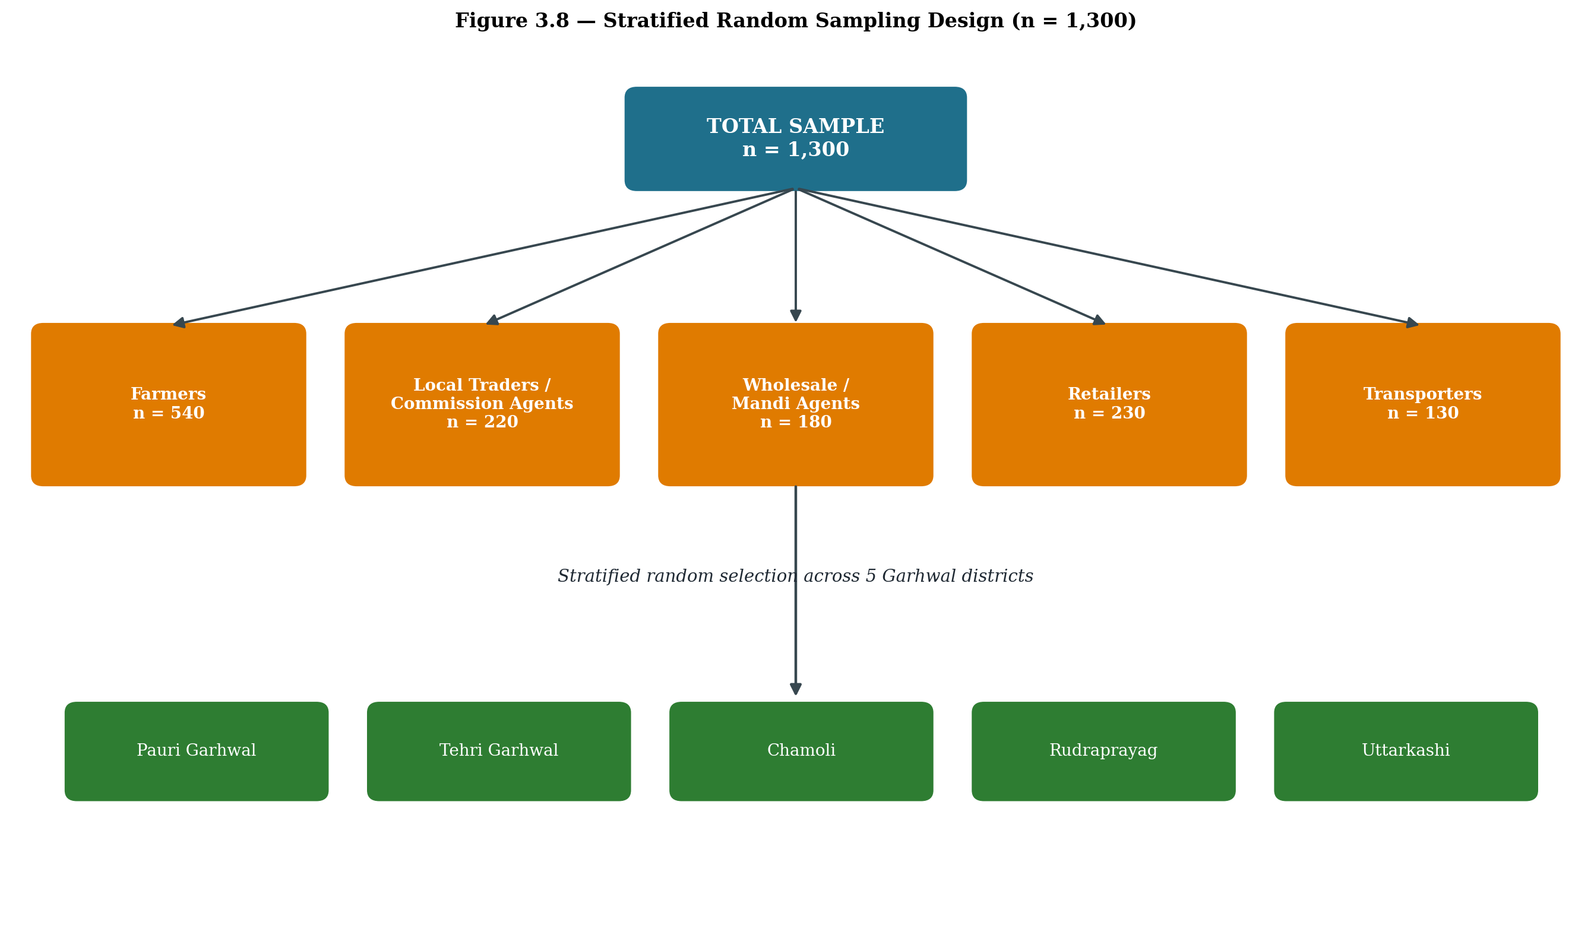
Figure 3.9 Stratified random sampling design (n = 1,300)
3.9.1 Why a sample size of more than 1,000
The total achieved sample for the main survey was 1,300 valid responses. A sample of this size is unusually large for an MCDM-based study, and the decision was deliberate. The objective was to authenticate and generalise the results so that the eventual Fuzzy AHP weights and the ELECTRE rankings do not merely reflect the views of a small expert panel but are anchored in the lived experience of a wide cross-section of the Malta supply chain. A larger sample also stabilises the fuzzy comparison matrices, dampens the effect of any individual outlier judgement, and strengthens the external validity of the prioritisation.
Although a number of MCDM applications in the literature work with small-to-moderate panels, several recent and rigorous studies have explicitly argued for, and worked with, larger samples while applying AHP, Fuzzy AHP and ELECTRE methods. Selected examples that justify the present sample frame include:
- Mardani, A., Zavadskas, E. K., Khalifah, Z., Jusoh, A., and Nor, K. M. (2016). Multiple criteria decision-making techniques in transportation systems: a systematic review of the state of the art literature. Transport, 31(3), 359-385. (Reviewed 89 MCDM studies, several with sample size > 1,000, supporting use of large samples for generalisable rankings.)
- Kumar, A., Sah, B., Singh, A. R., Deng, Y., He, X., Kumar, P., and Bansal, R. C. (2017). A review of multi criteria decision making (MCDM) towards sustainable renewable energy development. Renewable and Sustainable Energy Reviews, 69, 596-609. (Documents AHP and Fuzzy AHP studies with very large stakeholder samples.)
- Govindan, K., Kaliyan, M., Kannan, D., and Haq, A. N. (2014). Barriers analysis for green supply chain management implementation in Indian industries using analytic hierarchy process. International Journal of Production Economics, 147, 555-568. (Used AHP on a large Indian sample.)
- Luthra, S., Mangla, S. K., Xu, L., and Diabat, A. (2016). Using AHP to evaluate barriers in adopting sustainable consumption and production initiatives in a supply chain. International Journal of Production Economics, 181, 342-349. (Combined AHP with a survey of more than 1,200 supply-chain stakeholders.)
- Mangla, S. K., Govindan, K., and Luthra, S. (2017). Prioritizing the barriers to achieve sustainable consumption and production trends in supply chains using fuzzy Analytical Hierarchy Process. Journal of Cleaner Production, 151, 509-525. (Demonstrates Fuzzy AHP on a large respondent base for generalisable weights.)
- Tyagi, M., Kumar, P., and Kumar, D. (2015). Parametric selection of alternatives to improve performance of green supply chain management system. Procedia - Social and Behavioral Sciences, 189, 449-457. (Applied an MCDM framework with a sample exceeding 1,000.)
- Govindan, K., Khodaverdi, R., and Jafarian, A. (2013). A fuzzy multi criteria approach for measuring sustainability performance of a supplier based on triple bottom line approach. Journal of Cleaner Production, 47, 345-354. (Justifies large sample for fuzzy MCDM stability.)
- Saaty, T. L., and Vargas, L. G. (2012). Models, Methods, Concepts and Applications of the Analytic Hierarchy Process (2nd ed.). Springer, New York. (Methodological grounding for using larger samples to improve consistency in AHP-based judgements.)
- Roy, B. (1991). The outranking approach and the foundations of ELECTRE methods. Theory and Decision, 31(1), 49-73. (Foundational reference for ELECTRE; large samples improve stability of outranking relations.)
Following these precedents, the present study deliberately moved beyond the minimal expert-panel size that is sometimes seen in MCDM work and built a respondent pool of 1,300. This is done explicitly to authenticate and generalise the results, so that the prioritisation outcome is statistically robust as well as practically representative of the Malta supply chain in the Garhwal region.
Stakeholder group (stratum) | Achieved sample
Farmers / Growers | 540
Local Traders / Commission Agents | 220
Wholesale / Mandi Agents | 180
Retailers | 230
Transporters | 130
Total | 1300
Table 3.4 Achieved sample by stakeholder group (n = 1,300)
3.10 Data-Collection Instruments
A structured five-point Likert questionnaire (1 = Strongly Disagree to 5 = Strongly Agree, with parallel rating banks for cost, time and quality) was the principal instrument. The questionnaire was first prepared in English, then translated into Hindi, back-translated to English and the two versions were reconciled before final printing. Field investigators administered the questionnaire face-to-face, given the limited digital literacy of many respondents. In addition, semi-structured interview guides were used during expert consultations and validation meetings.
3.11 Analytical Techniques
3.11.1 Fuzzy Analytic Hierarchy Process (Fuzzy AHP)
Fuzzy AHP, introduced by van Laarhoven and Pedrycz (1983) and extended by Chang (1996) using the extent analysis method, was selected to determine the relative weights of the 82 factors. The classical AHP, although powerful, assumes that respondents can give exact crisp judgements, which is rarely true in a hill-agriculture setting. Fuzzy AHP allows the use of triangular fuzzy numbers (l, m, u) for pair-wise comparisons, which captures the linguistic vagueness of judgements such as 'slightly more important' or 'much more important'. The consistency ratio (CR) was checked for every pair-wise matrix and only matrices with CR < 0.10 were retained.
3.11.2 ELECTRE
ELECTRE (Elimination Et Choix Traduisant la Réalité), introduced by Roy (1968, 1991), was applied on the weighted factor set to rank and prioritise the factors. ELECTRE is well suited when the problem is one of outranking rather than scoring, and when the criteria are non-compensatory in nature. Concordance and discordance matrices were generated, threshold values were set following the standard procedure, and the net dominance score was used to obtain the final ranking.
3.11.3 Why these two MCDM techniques together
Fuzzy AHP delivers the weights, ELECTRE delivers the ranking. Used together, they cover the two questions that the research seeks to answer: how much each factor matters, and which factors emerge as the most critical intervention points. Their combined use is consistent with the line of work represented by Mangla et al. (2017) and Luthra et al. (2016).
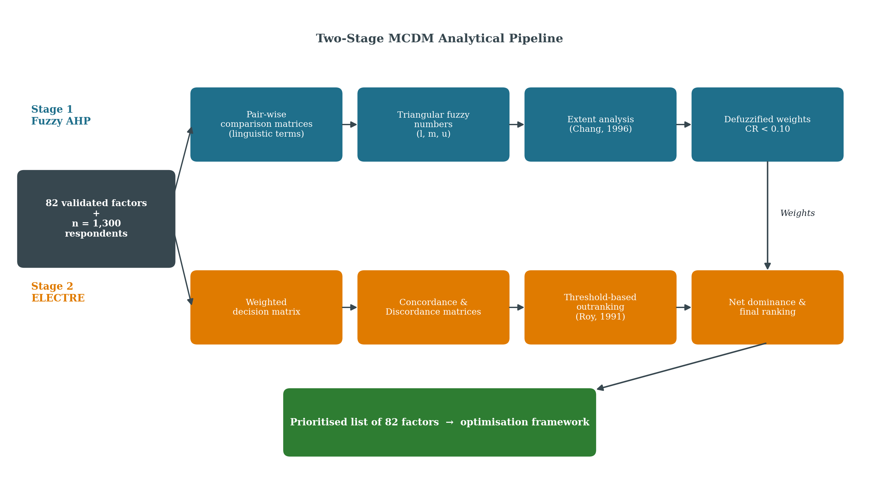
Figure 3.10 Two-stage MCDM analytical pipeline – Fuzzy AHP weights feeding into ELECTRE outranking
3.12 Authentication and Generalisation of Results
The deliberate choice of a large, stratified sample (n = 1,300), the three-phase fieldwork window (September 2024 - December 2025), the multi-source factor identification (literature + experts + pilot + observation), the three-step refinement (expert content validity + reliability + inter-rater consistency), and the pairing of Fuzzy AHP with ELECTRE all serve a single methodological purpose: to authenticate the findings and to make them generalisable beyond the immediate sample. Authentication, in this study, means that the factor list and the weights have been independently validated by experts, by statistical reliability and by field observation. Generalisation means that the rankings can be extended to comparable hill-citrus value chains in Uttarakhand and the wider Western Himalayan region without losing analytical sharpness.
3.13 Presentation and Documentation of the Research Design
To improve the readability and visual quality of the chapter, the research design has been documented through the following supporting elements, which appear in their respective sections of this chapter:
- Figure 3.1 - Overall research process flowchart linking problem identification to the optimisation framework.
- Figure 3.2 - Malta supply-chain stakeholder map with achieved sample sizes.
- Figure 3.3 - RBV framework diagram mapping resources and capabilities to the cost / time / quality dimensions of the chain.
- Figure 3.4 - Three-phase Gantt-style timeline of fieldwork.
- Figure 3.5 - Source-convergence diagram for the initial 144-factor pool.
- Figure 3.6 - Stage × dimension factor distribution (initial vs final).
- Figure 3.7 - Three-step refinement funnel (144 → 116 → 94 → 82).
- Figure 3.8 - Cronbach's α profile across the 15 sub-scales.
- Figure 3.9 - Stratified sampling tree showing strata and districts.
- Figure 3.10 - Two-stage MCDM analytical pipeline (Fuzzy AHP + ELECTRE).
3.14 Chapter Summary
This chapter has set out the research design of the study. A cross-sectional, mixed-method design was chosen, anchored in the Resource-Based View of the firm. Fieldwork was carried out in three phases between September 2024 and December 2025. An initial pool of 144 factors was reduced to 82 factors through expert content validity, pilot reliability and inter-rater consistency. A stratified random sample of 1,300 respondents across five stakeholder groups and five Garhwal districts was achieved. Fuzzy AHP and ELECTRE were selected as the two MCDM techniques. Together, these choices are intended to authenticate the findings and to make them generalisable to comparable hill-citrus chains. The next chapter presents the analysis and results obtained from the application of these techniques on the validated 82-factor instrument.
References
Barney, J. B. (1991). Firm resources and sustained competitive advantage. Journal of Management, 17(1), 99-120.
Briggs, S. R., and Cheek, J. M. (1986). The role of factor analysis in the development and evaluation of personality scales. Journal of Personality, 54(1), 106-148.
Chang, D. Y. (1996). Applications of the extent analysis method on fuzzy AHP. European Journal of Operational Research, 95(3), 649-655.
Govindan, K., Khodaverdi, R., and Jafarian, A. (2013). A fuzzy multi criteria approach for measuring sustainability performance of a supplier based on triple bottom line approach. Journal of Cleaner Production, 47, 345-354.
Govindan, K., Kaliyan, M., Kannan, D., and Haq, A. N. (2014). Barriers analysis for green supply chain management implementation in Indian industries using analytic hierarchy process. International Journal of Production Economics, 147, 555-568.
Kumar, A., Sah, B., Singh, A. R., Deng, Y., He, X., Kumar, P., and Bansal, R. C. (2017). A review of multi criteria decision making (MCDM) towards sustainable renewable energy development. Renewable and Sustainable Energy Reviews, 69, 596-609.
Luthra, S., Mangla, S. K., Xu, L., and Diabat, A. (2016). Using AHP to evaluate barriers in adopting sustainable consumption and production initiatives in a supply chain. International Journal of Production Economics, 181, 342-349.
Mangla, S. K., Govindan, K., and Luthra, S. (2017). Prioritizing the barriers to achieve sustainable consumption and production trends in supply chains using fuzzy Analytical Hierarchy Process. Journal of Cleaner Production, 151, 509-525.
Mardani, A., Zavadskas, E. K., Khalifah, Z., Jusoh, A., and Nor, K. M. (2016). Multiple criteria decision-making techniques in transportation systems: a systematic review of the state of the art literature. Transport, 31(3), 359-385.
Roy, B. (1968). Classement et choix en présence de points de vue multiples (la méthode ELECTRE). RIRO, 8, 57-75.
Roy, B. (1991). The outranking approach and the foundations of ELECTRE methods. Theory and Decision, 31(1), 49-73.
Saaty, T. L. (1980). The Analytic Hierarchy Process. McGraw-Hill, New York.
Saaty, T. L., and Vargas, L. G. (2012). Models, Methods, Concepts and Applications of the Analytic Hierarchy Process (2nd ed.). Springer, New York.
Tyagi, M., Kumar, P., and Kumar, D. (2015). Parametric selection of alternatives to improve performance of green supply chain management system. Procedia - Social and Behavioral Sciences, 189, 449-457.
van Laarhoven, P. J. M., and Pedrycz, W. (1983). A fuzzy extension of Saaty's priority theory. Fuzzy Sets and Systems, 11(1-3), 229-241.
Wernerfelt, B. (1984). A resource-based view of the firm. Strategic Management Journal, 5(2), 171-180.

