CHAPTER 3
RESEARCH DESIGN AND METHODOLOGY
3.1 Introduction
This chapter sets out the overall blueprint that guided the present investigation into the factors that shape distribution channel optimisation of Malta (Citrus sinensis) in the Garhwal region of Uttarakhand. The discussion begins with the philosophical orientation of the work, moves through the design choices that follow from that orientation, and finally arrives at the operational steps actually adopted in the field. The intent is not simply to record what was done, but also to make the logic of every choice visible, so that the study remains traceable, auditable and replicable, in line with established norms of research transparency (Creswell & Creswell, 2018; Saunders, Lewis, & Thornhill, 2019). Malta is a relatively un-organised horticultural produce of the mid-hills, and its supply chain crosses several physical and human handovers between the orchard and the consumer (Kumar, Staal, & Singh, 2011; Negi & Anand, 2015). To capture that complexity, the methodology has been built around a mixed-method, multi-stage logic that respects both the lived experience of the stakeholders involved and the analytical rigour expected of academic work (Tashakkori & Teddlie, 2010).
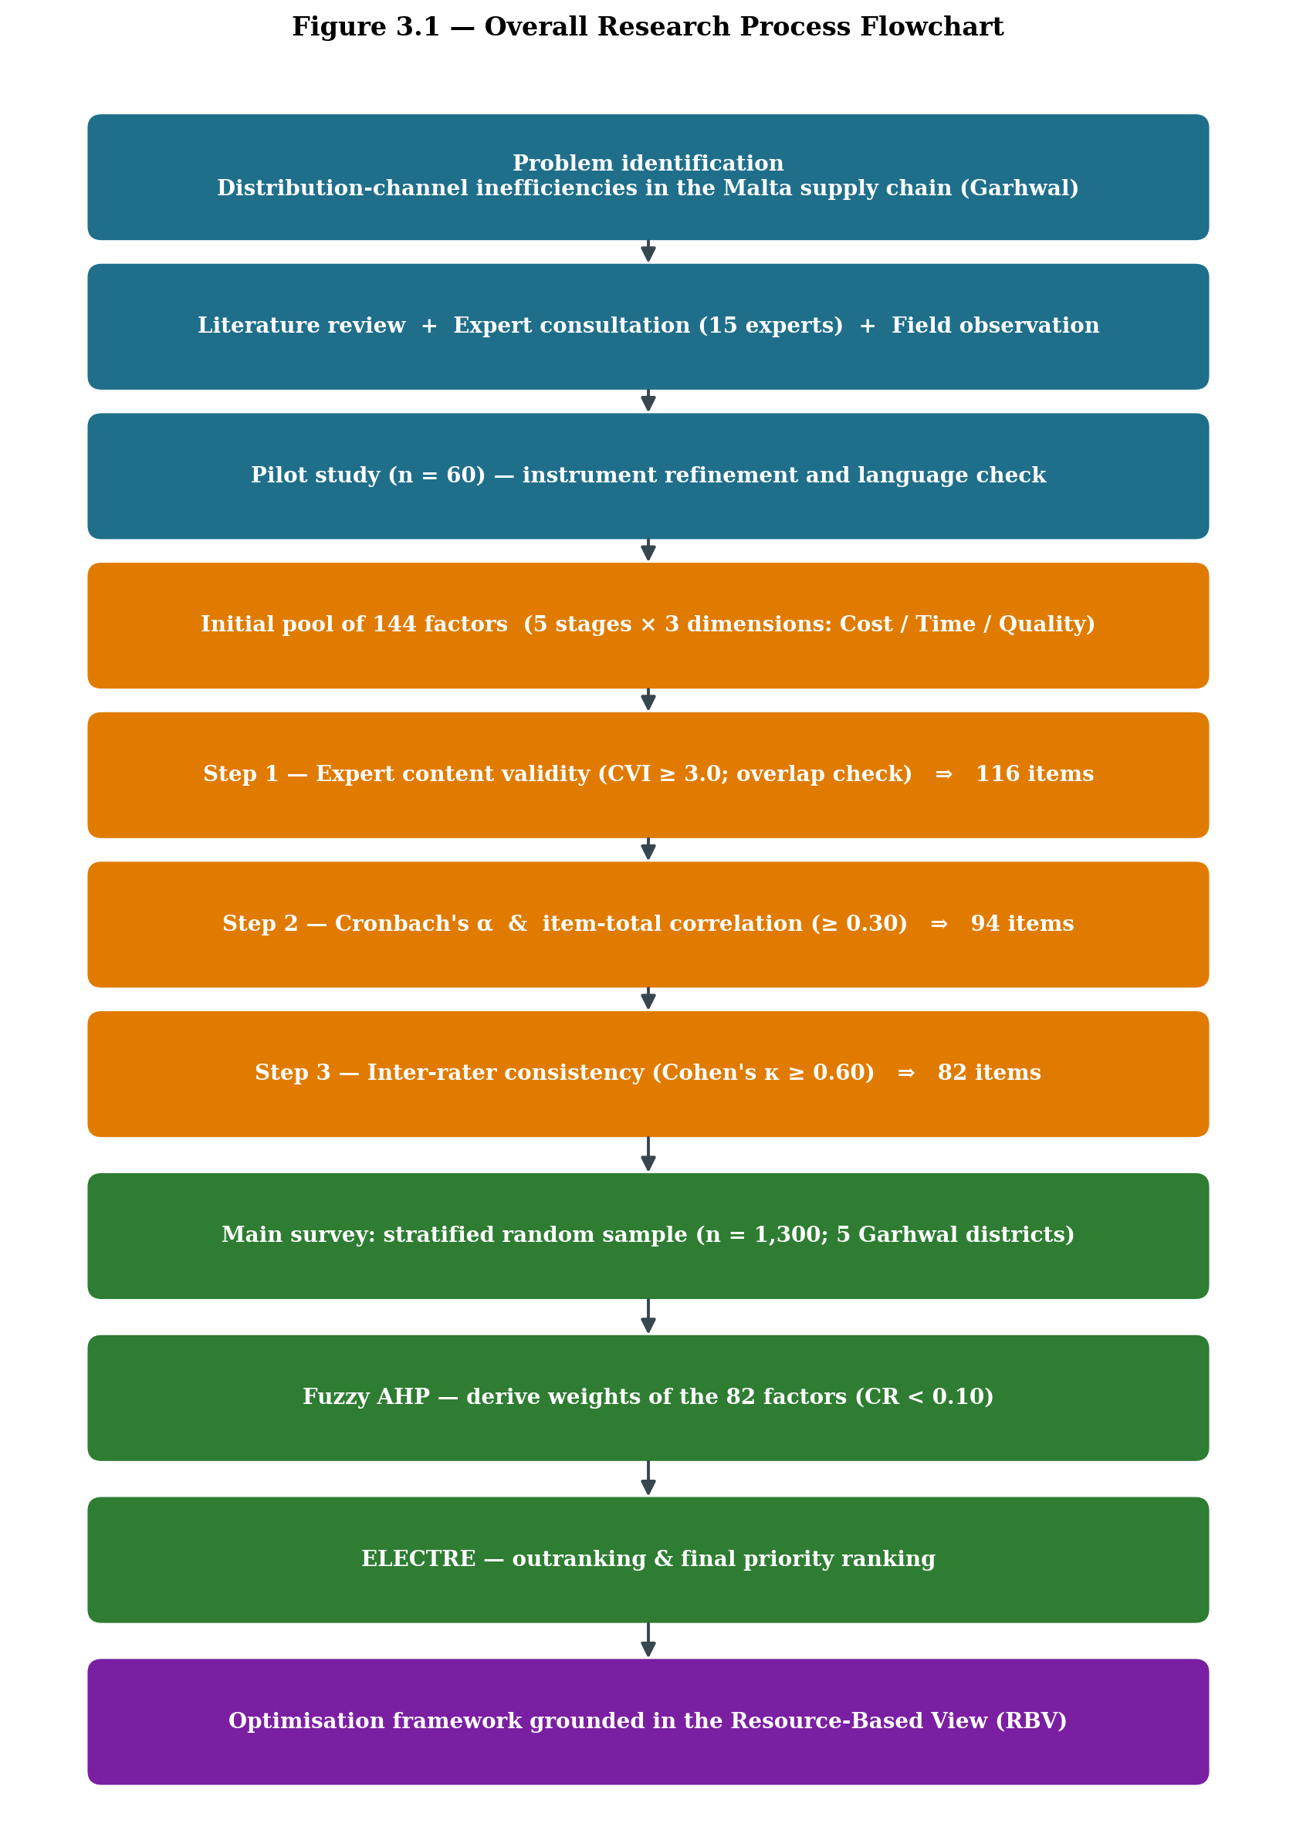
Figure 3.1 Overall research process flowchart (problem identification through to optimisation framework)
3.2 Research Design
The study follows a cross-sectional research design with a descriptive-cum-analytical orientation (Bryman, 2016; Saunders et al., 2019). A cross-sectional frame was preferred because the purpose of the work is to understand the prevailing state of the Malta distribution system across different stakeholder groups within a defined window of time, rather than tracking the same set of respondents over many years. Within this frame a mixed-method approach has been adopted (Creswell & Creswell, 2018), in which qualitative inputs from field observation and stakeholder interaction feed directly into the quantitative instrument, while the quantitative ratings are later interpreted back through the qualitative context. This back-and-forth movement is what makes the design suitable for a layered chain that involves growers, local traders, commission agents, mandi-level wholesalers, retailers and transporters (Kumar et al., 2011).
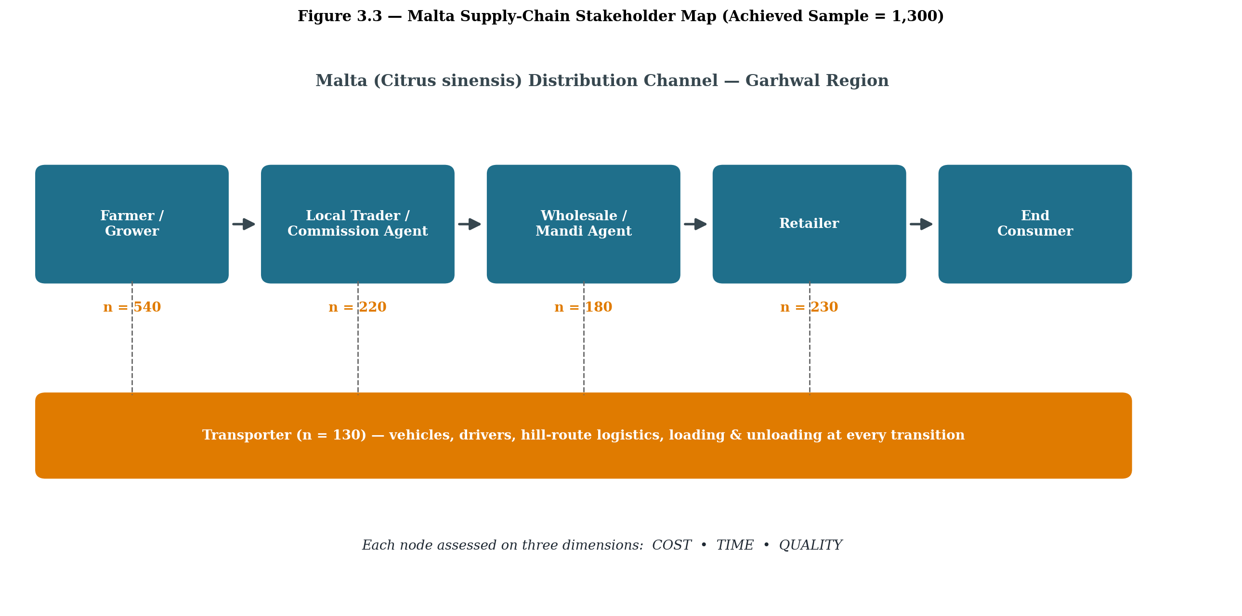
Figure 3.2 Malta (Citrus sinensis) supply-chain stakeholder map showing the five strata in which data was collected
3.2.1 Nature of the study
The study is descriptive in the sense that it portrays the structure of the Malta supply chain as it currently functions in the Garhwal hills. It is analytical in the sense that it goes beyond description and ranks the factors according to their relative pull on cost, time and quality, using two Multi-Criteria Decision-Making (MCDM) techniques (Roy, 1991; Saaty, 1980). Both primary and secondary sources of data have been used. Primary data was gathered through a structured questionnaire, expert consultations and personal field visits. Secondary data was drawn from horticulture mission reports, the district statistical handbooks of Uttarakhand, peer-reviewed journal articles, books on agricultural marketing and supply-chain management, APEDA bulletins and similar documents (Acharya & Agarwal, 2019; APEDA, 2022).
3.3 Theoretical Foundation: The Resource-Based View (RBV)
The conceptual lens adopted for the present work is the Resource-Based View (RBV) of the firm, developed in its modern form by Wernerfelt (1984) and substantially extended by Barney (1991). The RBV argues that a firm, or by extension a node within a supply chain, gains and sustains competitive advantage through resources and capabilities that are valuable, rare, inimitable and well organised, that is, the VRIO frame (Barney, 1995; Barney & Hesterly, 2010). For a fragmented agri-supply chain such as that of Malta in Garhwal, the RBV is particularly useful because the chain is not owned or controlled by any single firm. Capabilities are instead distributed across growers, traders, mandi agents, retailers and transporters, and each link controls a small bundle of tangible and intangible resources, including orchard land, packing material, cold-chain access, market information, labour skill and informal network ties (Newbert, 2008; Peteraf, 1993).
Viewing the chain through the RBV makes it possible to read the 144 initially identified factors and the 82 finally retained factors not as a loose list of operational issues but as proxies for the underlying resources and capabilities of the chain. Cost-related items signal financial and physical resources; time-related items signal coordination and process capabilities; and quality-related items signal knowledge, skill and infrastructural resources. The theoretical contribution of this study is therefore to map the operational constraints of a hill-based citrus chain on to the resource-and-capability vocabulary of the RBV, so that the eventual framework of optimisation does not stop at fixing surface-level problems but speaks directly to which resources of the chain need to be strengthened, shared or substituted.
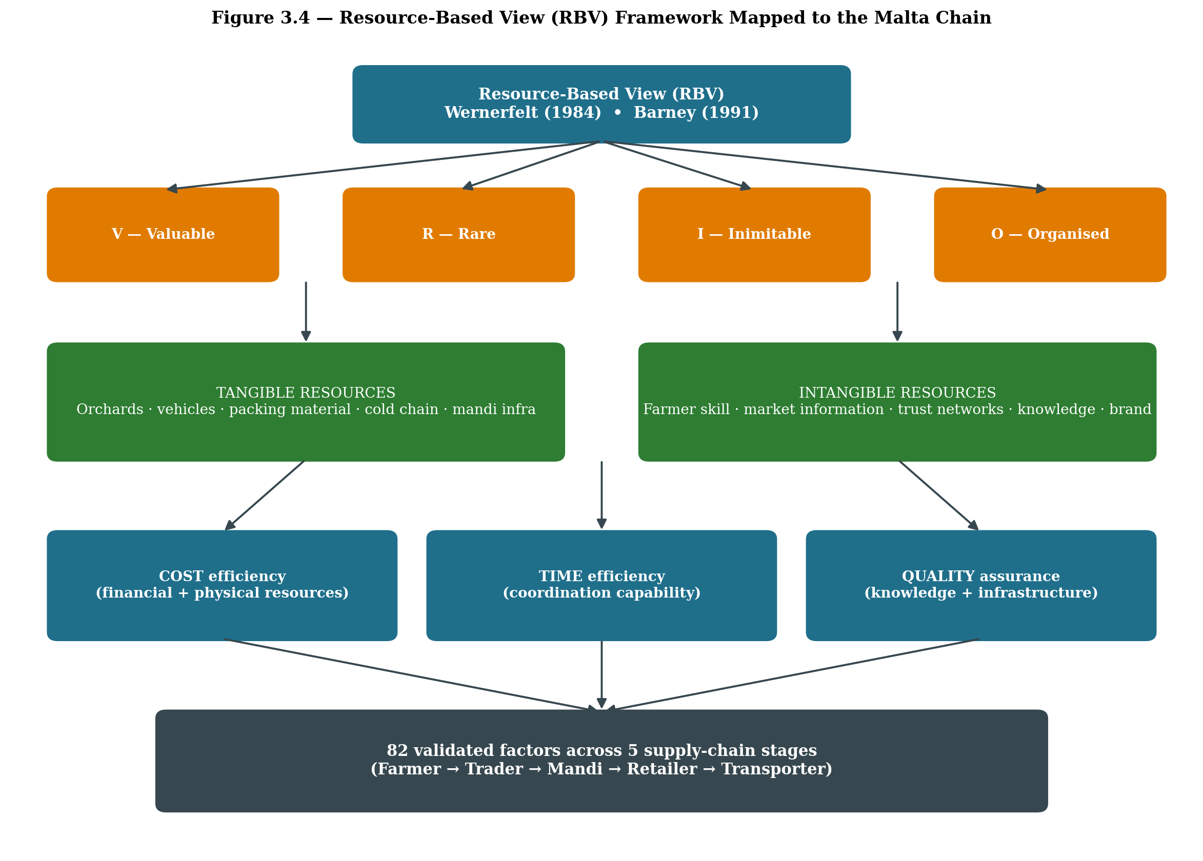
The VRIO frame, in the form used here, owes its current shape to Barney (1991, 1995, 1997) and to the parallel arguments of Peteraf (1993) on the cornerstones of competitive advantage. Barney's later restatement of the framework added the Organisation question to the original VRIN scheme, which pushed researchers to look beyond the existence of a resource and ask whether the firm is actually structured to exploit it (Barney and Hesterly, 2010). Newbert (2008) tested the framework empirically and showed that value and rareness, taken together, explain a meaningful share of the variation in firm performance, while the inimitability and organisation tests filter out the resources that merely produce parity. Knott (2009) cautioned, with some justification, that the framework should be read as a heuristic for sense-making rather than as a deterministic test, and the present study uses it in exactly that spirit.
Figure 3.3 Resource-Based View (RBV) framework mapped to the cost / time / quality dimensions of the Malta supply chain
3.4 Phases of Data Collection
The fieldwork was organised in three phases between September 2024 and December 2025. The phasing was deliberate, since it allowed the instrument to evolve with the field rather than being frozen at the outset (DeVellis, 2017; Hair, Black, Babin, & Anderson, 2019). Spreading the work across three windows also helped in handling the strong seasonality of Malta. The fruit broadly hits the mandis between November and February, and the phasing was therefore aligned with that calendar so that the design captured both the run-up to and the close of a complete production cycle.
Phase | Period | Title | Key Activities
Phase I | Sept 2024 - Feb 2025 | Exploratory & Pilot Phase | Literature scan, expert interactions (15 experts), pilot survey on 60 respondents, preliminary listing of 144 factors, pre-test of questionnaire wording.
Phase II | Mar 2025 - Aug 2025 | Main Field Survey | Stratified random sampling across five Garhwal districts, full-scale data collection from farmers, local traders, mandi agents, wholesalers, retailers and transporters.
Phase III | Sept 2025 - Dec 2025 | Validation & Analytical Phase | Reliability testing (Cronbach's alpha), consistency check by experts, refinement from 144 to 82 factors, application of Fuzzy AHP and ELECTRE, follow-up validation interviews.
Table 3.1 Three-phase plan of data collection (Sept 2024 - Dec 2025)
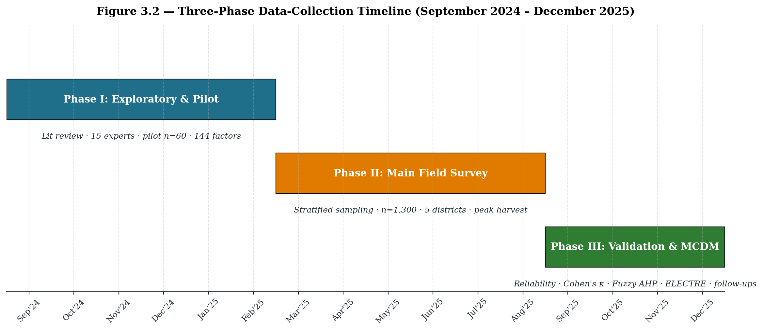
Figure 3.4 Three-phase data-collection timeline (September 2024 – December 2025)
Spreading the work across three phases also helped in handling the strong seasonality of Malta. The fruit broadly hits the mandis between November and February, so Phase I captured the run-up to the peak season, Phase II covered both an active harvest and a post-harvest review, and Phase III allowed the researcher to revisit specific respondents for clarifications after a complete production cycle had passed.
3.5 Identification and Refinement of Factors
A central methodological task of the present study was to arrive at a defensible list of factors that genuinely affect distribution-channel efficiency for Malta. Following the standard sequence recommended for scale development (DeVellis, 2017; Lawshe, 1975), the exercise started from an open and admittedly redundant list of 144 factors and was reduced through a structured refinement protocol to a compact and statistically defensible list of 82 factors. The process is summarised below.
3.5.1 Sources used for the initial pool of 144 factors
The pool of 144 factors did not emerge from any single source. Five distinct streams of input were drawn upon, and each was treated as a partial picture that had to be cross-checked against the others (DeVellis, 2017; Polit & Beck, 2006). The first stream was an extensive review of the literature on horticultural supply chains, citrus marketing in India, hill agriculture and post-harvest losses, drawing in the main on publications from 2005 onwards and incorporating reports from ICAR, NIAM and APEDA (APEDA, 2022; Negi & Anand, 2015). The second stream came from expert consultations with a panel of fifteen experts, made up of horticulture scientists, agricultural marketing faculty, Mandi Samiti officials, progressive Malta growers, transporters and wholesale commission agents drawn from Pauri, Tehri, Chamoli, Rudraprayag and Uttarkashi. The third stream was a pilot study based on a preliminary survey of 60 respondents covering all five stakeholder categories, which served the practical purpose of testing whether the literature-derived items actually resonated with field actors (Hair et al., 2019). The fourth stream consisted of stakeholder discussions and group interactions held in farmer collectives and on mandi premises during peak Malta arrival weeks. The fifth and final stream was direct field observation, including walk-along observations from orchard to retail outlet, recorded in a structured field diary. Triangulating these five inputs follows the principle that content development should not rest on a single class of evidence but should converge from several independent angles (Lawshe, 1975; Polit, Beck, & Owen, 2007).
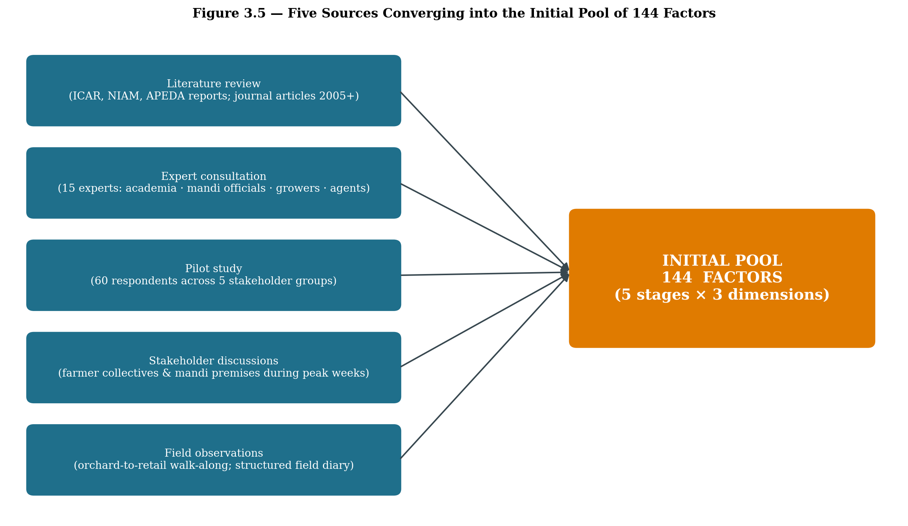
Figure 3.5 Five sources converging into the initial pool of 144 factors
3.5.2 Categorisation of the initial 144 factors
The 144 factors were first organised on two intersecting axes: (a) the stage of the supply chain (Farm, Local Trader/Commission Agent, Mandi/Wholesale, Retail, Transportation) and (b) the dimension of inefficiency (Cost, Time, Quality). The stage-wise distribution of the initial pool is given in Table 3.2 and visualised in Figure 3.6.
Supply-chain stage | Cost (initial) | Time (initial) | Quality (initial) | Initial Total | Retained | Eliminated
Farm / Grower stage | 12 | 10 | 10 | 32 | 19 | 13
Local Trader / Commission Agent | 11 | 9 | 9 | 29 | 16 | 13
Wholesale / Mandi | 10 | 9 | 9 | 28 | 16 | 12
Retailer | 10 | 7 | 8 | 25 | 15 | 10
Transportation | 11 | 10 | 9 | 30 | 16 | 14
TOTAL | 54 | 45 | 45 | 144 | 82 | 62
Table 3.2 Stage-wise distribution of factors (144 → 82)
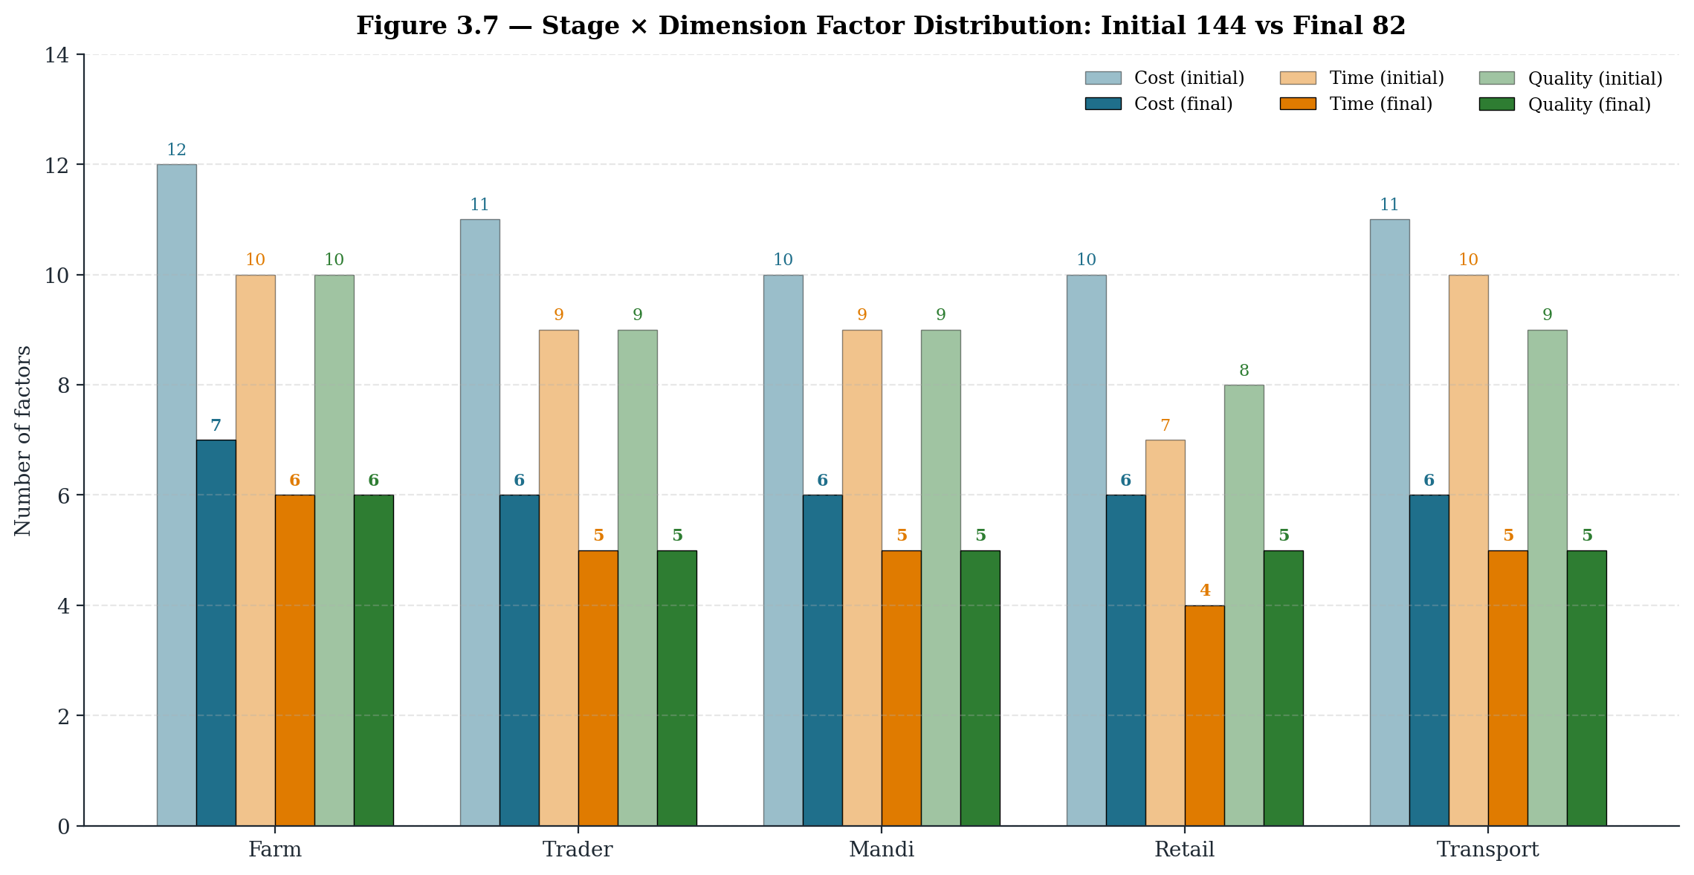
Figure 3.6 Stage × Dimension distribution of factors: initial 144 vs final 82
3.5.3 VRIO-based segregation of the 144 factors
Once the initial pool had been catalogued, every one of the 144 candidate items was put through the VRIO sieve before any empirical trimming was attempted. The intent at this stage was theoretical, not statistical: to ask, item by item, whether the underlying resource or capability that the factor proxies could conceivably support a competitive position for the Malta chain in Garhwal. The four standard questions of the framework (Barney, 1991; Barney and Hesterly, 2010) were posed in sequence, with each item progressing only after a positive answer to the previous question.
Value (V) was read as the capacity of a factor to either lift revenue or pull down cost, time or quality losses for at least one node in the chain. Rareness (R) was assessed against the population of comparable actors operating in the same five districts; uniformly held items, such as a generic mandi entry fee, were marked R = No. Inimitability (I) was treated as a function of terrain, accumulated tacit learning and relational embeddedness; for example, the way an experienced hill grower handles fruit between the orchard and the collection shed is not easy to replicate in the short run. Organisation (O) asked whether the chain is presently structured to extract value from the item, or whether the resource lies dormant. Items that fail at the V stage are labelled a competitive disadvantage in the strict Barney sense, but for the present chapter they are read more pragmatically as strategically peripheral.
Figure 3.6a VRIO decision logic applied to each of the 144 factors
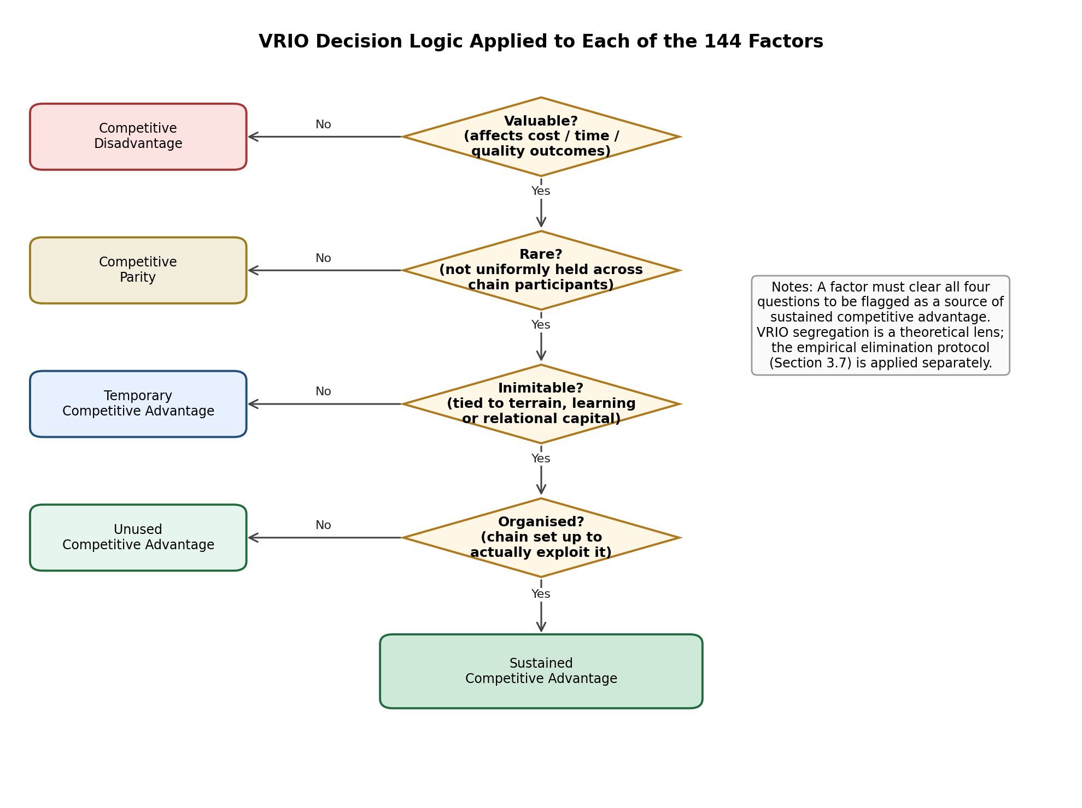
Note. The diamond gates correspond to the four VRIO questions; the left-hand boxes show the strategic verdict that follows when a factor fails the question in front of it. A factor must pass all four gates to qualify as a source of sustained advantage.
Table 3.2a presents the stage-wise VRIO segregation of the 144 factors. Two patterns are visible immediately. First, almost every stage carries a long tail of items that sit at parity or below: these are the unavoidable, uniformly imposed costs and procedural delays that cannot, on their own, give any node a strategic edge. Second, the items that cluster in the temporary, unused and sustained categories overwhelmingly belong to the quality dimension and to terrain-shaped time factors. This is consistent with what one would expect of a hill horticulture chain in which scarce, tacit and locationally bound capabilities matter more than commodity-like inputs (Peteraf, 1993; Newbert, 2008).
Table 3.2a Stage-wise VRIO segregation of the 144 factors
Stage | Competitive Disadvantage | Competitive Parity | Temporary Competitive Advantage | Unused Competitive Advantage | Sustained Competitive Advantage | Total
Farm / Grower | 8 | 5 | 12 | 3 | 4 | 32
Local Trader | 4 | 6 | 12 | 7 | 0 | 29
Wholesale / Mandi | 6 | 10 | 8 | 3 | 1 | 28
Retailer | 4 | 7 | 11 | 0 | 3 | 25
Transportation | 4 | 10 | 4 | 9 | 3 | 30
All stages | 26 | 38 | 47 | 22 | 11 | 144
Table 3.2b reports the item-level segregation. The columns mark each factor against the four VRIO questions, the resulting strategic verdict, and the eventual retention decision after the empirical elimination protocol of Section 3.7. It should be noted that the VRIO column and the Decision column do not have to coincide. A factor can be theoretically rare and inimitable yet still get dropped because it correlates too weakly with its parent scale, just as an item that sits at parity in VRIO terms can earn its place in the instrument because chain actors respond to it consistently. The two filters are complementary, not substitutable.
Table 3.2b VRIO classification of the 144 factors (item-level)
Farm / Grower stage (32 factors)
# | Factor | V | R | I | O | VRIO outcome | Decision
1 | Labour cost for plucking and harvesting of Malta | Y | N | N | Y | Competitive Parity | Retained
2 | Cost of baskets / crates used at the orchard | Y | N | N | Y | Competitive Parity | Retained
3 | Cost of grading and on-farm sorting | Y | Y | N | Y | Temporary Competitive Advantage | Retained
4 | Cost of packaging material (cartons, gunny bags, layering) | Y | N | N | Y | Competitive Parity | Retained
5 | Cost of on-farm storage and shed maintenance | Y | Y | N | Y | Temporary Competitive Advantage | Retained
6 | Loading and unloading charges at the farm gate | Y | N | N | Y | Competitive Parity | Retained
7 | Local transportation cost from orchard to collection point | Y | Y | N | Y | Temporary Competitive Advantage | Retained
8 | Cost of pesticide and fertiliser applied close to harvest | Y | Y | N | Y | Temporary Competitive Advantage | Eliminated
9 | Cost of orchard upkeep during the harvesting period | Y | Y | N | Y | Temporary Competitive Advantage | Eliminated
10 | Cost of training of pluckers and casual labour | N | N | N | N | Competitive Disadvantage | Eliminated
11 | Cost of supervision of on-field operations | N | N | N | N | Competitive Disadvantage | Eliminated
12 | Replacement cost of broken or damaged crates | N | N | N | N | Competitive Disadvantage | Eliminated
13 | Time taken in actual plucking / harvesting of fruits | Y | Y | N | Y | Temporary Competitive Advantage | Retained
14 | Time spent in sorting and grading at orchard | Y | Y | N | Y | Temporary Competitive Advantage | Retained
15 | Time consumed in packaging and tying of cartons | Y | Y | N | Y | Temporary Competitive Advantage | Retained
16 | Waiting time for pick-up / transport at the farm gate | Y | Y | N | Y | Temporary Competitive Advantage | Retained
17 | Loading time at the farm gate | Y | N | N | Y | Competitive Parity | Retained
18 | Transit time from farm to local market | Y | Y | Y | Y | Sustained Competitive Advantage | Retained
19 | Time used in pre-harvest field inspection | N | N | N | N | Competitive Disadvantage | Eliminated
20 | Time spent in assembling daily labour each morning | N | N | N | N | Competitive Disadvantage | Eliminated
21 | Time taken to procure packaging material from town | N | N | N | N | Competitive Disadvantage | Eliminated
22 | Idle time at the collection point during peak hours | N | N | N | N | Competitive Disadvantage | Eliminated
23 | Impact of harvesting method on fruit quality | Y | Y | Y | Y | Sustained Competitive Advantage | Retained
24 | Handling care during plucking and collection | Y | Y | Y | Y | Sustained Competitive Advantage | Retained
25 | Accuracy of grading at orchard level | Y | Y | Y | N | Unused Competitive Advantage | Retained
26 | Quality of packaging used at farm gate | Y | Y | N | Y | Temporary Competitive Advantage | Retained
27 | Storage temperature control at orchard / collection shed | Y | Y | Y | N | Unused Competitive Advantage | Retained
28 | Handling quality during transit from farm | Y | Y | N | Y | Temporary Competitive Advantage | Retained
29 | Maturity stage of fruit at the time of plucking | Y | Y | Y | Y | Sustained Competitive Advantage | Eliminated
30 | Cleanliness of crates used at collection point | Y | Y | N | Y | Temporary Competitive Advantage | Eliminated
31 | Effect of weather during harvest on shelf life | Y | Y | Y | N | Unused Competitive Advantage | Eliminated
32 | Adequacy of natural shade at on-farm storage | N | N | N | N | Competitive Disadvantage | Eliminated
Local Trader stage (29 factors)
# | Factor | V | R | I | O | VRIO outcome | Decision
1 | Purchase price paid to farmers | Y | N | N | Y | Competitive Parity | Retained
2 | Transportation to trader's premises | Y | Y | N | Y | Temporary Competitive Advantage | Retained
3 | Storage and handling charges at trader's godown | Y | Y | N | Y | Temporary Competitive Advantage | Retained
4 | Re-grading and re-packaging cost at trader level | Y | Y | N | Y | Temporary Competitive Advantage | Retained
5 | Commission and agency charges payable | Y | N | N | Y | Competitive Parity | Retained
6 | Loading and onward transport cost to mandi | Y | N | N | Y | Competitive Parity | Retained
7 | Cost of advances given to farmers ahead of season | Y | Y | N | Y | Temporary Competitive Advantage | Eliminated
8 | Cost of maintaining a local godown / collection shed | Y | Y | N | Y | Temporary Competitive Advantage | Eliminated
9 | Cost of bookkeeping and basic record keeping | N | N | N | N | Competitive Disadvantage | Eliminated
10 | Cost of refreshments and hospitality for visiting farmers | N | N | N | N | Competitive Disadvantage | Eliminated
11 | Cost of damage compensation paid to farmers | N | N | N | N | Competitive Disadvantage | Eliminated
12 | Time taken to collect produce from multiple farmers | Y | Y | N | Y | Temporary Competitive Advantage | Retained
13 | Time spent in quality inspection by the trader | Y | Y | Y | N | Unused Competitive Advantage | Retained
14 | Time taken in re-sorting at trader level | Y | Y | N | Y | Temporary Competitive Advantage | Retained
15 | Storage duration at trader's premises | Y | Y | Y | N | Unused Competitive Advantage | Retained
16 | Waiting time for onward transport to mandi | Y | Y | N | Y | Temporary Competitive Advantage | Retained
17 | Time spent in price negotiation with farmers | Y | N | N | Y | Competitive Parity | Eliminated
18 | Time used for daily reconciliation of weights | N | N | N | N | Competitive Disadvantage | Eliminated
19 | Time taken in arranging vehicles during peak season | Y | N | N | Y | Competitive Parity | Eliminated
20 | Time consumed in coordinating with mandi commission agents | Y | N | N | Y | Competitive Parity | Eliminated
21 | Initial quality assessment by the trader | Y | Y | Y | N | Unused Competitive Advantage | Retained
22 | Maintenance of storage condition at trader's place | Y | Y | Y | N | Unused Competitive Advantage | Retained
23 | Handling care during re-grading | Y | Y | Y | N | Unused Competitive Advantage | Retained
24 | Packaging quality control after re-packing | Y | Y | Y | N | Unused Competitive Advantage | Retained
25 | Transit quality management from trader to mandi | Y | Y | Y | N | Unused Competitive Advantage | Retained
26 | Mixing of grades during re-packaging | Y | Y | N | Y | Temporary Competitive Advantage | Eliminated
27 | Exposure to direct sunlight at trader's premises | Y | Y | N | Y | Temporary Competitive Advantage | Eliminated
28 | Quality loss due to repeated weighing | Y | Y | N | Y | Temporary Competitive Advantage | Eliminated
29 | Inconsistency in grading judgement across staff | Y | Y | N | Y | Temporary Competitive Advantage | Eliminated
Wholesale / Mandi stage (28 factors)
# | Factor | V | R | I | O | VRIO outcome | Decision
1 | Mandi entry fee / gate fee | Y | N | N | Y | Competitive Parity | Retained
2 | Weighing charges at mandi platform | Y | N | N | Y | Competitive Parity | Retained
3 | Storage rent at mandi premises | Y | Y | N | Y | Temporary Competitive Advantage | Retained
4 | Commission agent charges (arhatiya commission) | Y | N | N | Y | Competitive Parity | Retained
5 | Loading and unloading labour cost at mandi | Y | N | N | Y | Competitive Parity | Retained
6 | Cost of onward transportation to retailer | Y | Y | N | Y | Temporary Competitive Advantage | Retained
7 | Cost of mandi licence renewal | N | N | N | N | Competitive Disadvantage | Eliminated
8 | Cost of mandatory market fee / cess | N | N | N | N | Competitive Disadvantage | Eliminated
9 | Cost of arbitration in case of disputes | N | N | N | N | Competitive Disadvantage | Eliminated
10 | Cost of waste disposal at mandi premises | N | N | N | N | Competitive Disadvantage | Eliminated
11 | Unloading and entry-gate time at mandi | Y | Y | N | Y | Temporary Competitive Advantage | Retained
12 | Waiting time before auction begins | Y | Y | N | Y | Temporary Competitive Advantage | Retained
13 | Auction duration at mandi | Y | N | N | Y | Competitive Parity | Retained
14 | Payment settlement / cash release time | Y | N | N | Y | Competitive Parity | Retained
15 | Loading time for outbound dispatch | Y | N | N | Y | Competitive Parity | Retained
16 | Time spent in queue at mandi gate | Y | N | N | Y | Competitive Parity | Eliminated
17 | Time consumed in obtaining gate-pass and entry slip | N | N | N | N | Competitive Disadvantage | Eliminated
18 | Time required for re-weighing on buyer's request | Y | N | N | Y | Competitive Parity | Eliminated
19 | Time used in coordinating with multiple buyers | Y | N | N | Y | Competitive Parity | Eliminated
20 | Quality inspection at mandi entry | Y | Y | Y | N | Unused Competitive Advantage | Retained
21 | Storage conditions inside the mandi shed | Y | Y | Y | N | Unused Competitive Advantage | Retained
22 | Handling care during the auction process | N | N | N | N | Competitive Disadvantage | Retained
23 | Verification of grading by buyer | Y | Y | Y | N | Unused Competitive Advantage | Retained
24 | Post-auction handling and re-stacking | Y | Y | Y | Y | Sustained Competitive Advantage | Retained
25 | Mixing of stock from different consignments | Y | Y | N | Y | Temporary Competitive Advantage | Eliminated
26 | Hygiene level of mandi floor | Y | Y | N | Y | Temporary Competitive Advantage | Eliminated
27 | Pest and insect exposure inside mandi sheds | Y | Y | N | Y | Temporary Competitive Advantage | Eliminated
28 | Damage caused by stacking pressure during peak inflow | Y | Y | N | Y | Temporary Competitive Advantage | Eliminated
Retailer stage (25 factors)
# | Factor | V | R | I | O | VRIO outcome | Decision
1 | Purchase cost from mandi / wholesaler | Y | N | N | Y | Competitive Parity | Retained
2 | Transportation cost from mandi to retail outlet | Y | Y | N | Y | Temporary Competitive Advantage | Retained
3 | Storage and display cost at retail level | Y | Y | N | Y | Temporary Competitive Advantage | Retained
4 | Wastage and spoilage cost at retail | Y | Y | N | Y | Temporary Competitive Advantage | Retained
5 | Retail space rent or daily pitch fee | Y | N | N | Y | Competitive Parity | Retained
6 | Handling and labour cost at the shop | Y | N | N | Y | Competitive Parity | Retained
7 | Cost of carry bags and small packing material | N | N | N | N | Competitive Disadvantage | Eliminated
8 | Cost of street vendor / municipal levies | N | N | N | N | Competitive Disadvantage | Eliminated
9 | Cost of price-tags and small signage | N | N | N | N | Competitive Disadvantage | Eliminated
10 | Cost of weighing scale calibration | N | N | N | N | Competitive Disadvantage | Eliminated
11 | Time spent in procurement from wholesaler / mandi | Y | Y | N | Y | Temporary Competitive Advantage | Retained
12 | Time taken in arranging the display | Y | Y | N | Y | Temporary Competitive Advantage | Retained
13 | Time spent in attending customers | Y | Y | N | Y | Temporary Competitive Advantage | Retained
14 | Inventory turnover time at retail level | Y | Y | N | Y | Temporary Competitive Advantage | Retained
15 | Time spent in daily price discovery | Y | N | N | Y | Competitive Parity | Eliminated
16 | Time used in segregating overripe fruits each morning | Y | N | N | Y | Competitive Parity | Eliminated
17 | Time taken in cash settlement at end of day | Y | N | N | Y | Competitive Parity | Eliminated
18 | Quality check at the time of purchase from mandi | Y | Y | N | Y | Temporary Competitive Advantage | Retained
19 | Quality of storage and display at retail | Y | Y | N | Y | Temporary Competitive Advantage | Retained
20 | Maintenance of freshness through the day | Y | Y | Y | Y | Sustained Competitive Advantage | Retained
21 | Customer perception of fruit quality | Y | Y | Y | Y | Sustained Competitive Advantage | Retained
22 | Quality reflected in post-sale customer feedback | Y | Y | Y | Y | Sustained Competitive Advantage | Retained
23 | Direct exposure of fruit to sunlight at the shop | Y | N | N | Y | Competitive Parity | Eliminated
24 | Effect of dust and pollution on display fruits | Y | Y | N | Y | Temporary Competitive Advantage | Eliminated
25 | Quality damage due to repeated handling by customers | Y | Y | N | Y | Temporary Competitive Advantage | Eliminated
Transportation stage (30 factors)
# | Factor | V | R | I | O | VRIO outcome | Decision
1 | Vehicle hire / ownership cost | Y | Y | N | Y | Temporary Competitive Advantage | Retained
2 | Fuel and routine maintenance cost | Y | N | N | Y | Competitive Parity | Retained
3 | Driver and helper wages | Y | N | N | Y | Competitive Parity | Retained
4 | Loading and unloading charges at terminals | Y | N | N | Y | Competitive Parity | Retained
5 | Insurance and statutory permit cost | Y | N | N | Y | Competitive Parity | Retained
6 | Toll and route-related charges | Y | N | N | Y | Competitive Parity | Retained
7 | Cost of parking at transit points | Y | N | N | Y | Competitive Parity | Eliminated
8 | Cost of detention during long unloading | Y | N | N | Y | Competitive Parity | Eliminated
9 | Cost of overnight halt for drivers | Y | N | N | Y | Competitive Parity | Eliminated
10 | Cost of vehicle cleaning / sanitation | N | N | N | N | Competitive Disadvantage | Eliminated
11 | Cost of GPS and tracking devices | N | N | N | N | Competitive Disadvantage | Eliminated
12 | Vehicle availability time during peak season | Y | Y | Y | N | Unused Competitive Advantage | Retained
13 | Loading time at the dispatch point | Y | N | N | Y | Competitive Parity | Retained
14 | Transit duration on the route | Y | Y | Y | Y | Sustained Competitive Advantage | Retained
15 | Unloading time at the destination | Y | N | N | Y | Competitive Parity | Retained
16 | Return-journey time of the vehicle | Y | Y | Y | N | Unused Competitive Advantage | Retained
17 | Time lost in landslide / road blockage on hill routes | Y | Y | Y | N | Unused Competitive Advantage | Eliminated
18 | Time spent at check-posts and barriers | Y | Y | N | Y | Temporary Competitive Advantage | Eliminated
19 | Time used in route diversion during monsoon | Y | Y | Y | N | Unused Competitive Advantage | Eliminated
20 | Documentation and gate-pass time | N | N | N | N | Competitive Disadvantage | Eliminated
21 | Driver rest break time during long haul | N | N | N | N | Competitive Disadvantage | Eliminated
22 | Vehicle condition and overall cleanliness | Y | Y | N | Y | Temporary Competitive Advantage | Retained
23 | Capability for temperature control inside the vehicle | Y | Y | Y | N | Unused Competitive Advantage | Retained
24 | Handling care during loading of consignment | Y | Y | Y | Y | Sustained Competitive Advantage | Retained
25 | Safety measures during transit | Y | Y | Y | N | Unused Competitive Advantage | Retained
26 | Impact of timely delivery on quality | Y | Y | Y | N | Unused Competitive Advantage | Retained
27 | Vibration and shock damage on hilly roads | Y | Y | Y | N | Unused Competitive Advantage | Eliminated
28 | Exposure of stacked load to rain and dust | Y | Y | Y | N | Unused Competitive Advantage | Eliminated
29 | Quality loss due to mixed cargo (Malta with other goods) | Y | Y | N | Y | Temporary Competitive Advantage | Eliminated
30 | Quality loss due to overloading of the vehicle | Y | Y | Y | Y | Sustained Competitive Advantage | Eliminated
Read together, the two tables suggest that roughly half of the items in the initial pool offer no more than competitive parity, a further quarter or so are theoretically capable of producing temporary or unused advantage, and a small but strategically important cluster qualifies for sustained advantage. The chapter now turns to the 144 items themselves and the empirical refinement that pared the list down to 82 retained factors.
3.6 Initial Pool of 144 Factors
The complete initial list of 144 factors generated through literature, expert panels and field observation is presented below, grouped by stage and by the Cost-Time-Quality dimension. Items that survived the refinement process are marked as Retained (R) and items that were dropped are marked as Eliminated (E). The reasons for elimination are summarised in Section 3.7.
(A) Farm / Grower Stage – 32 initial factors
1. Labour cost for plucking and harvesting of Malta [R]
2. Cost of baskets / crates used at the orchard [R]
3. Cost of grading and on-farm sorting [R]
4. Cost of packaging material (cartons, gunny bags, layering) [R]
5. Cost of on-farm storage and shed maintenance [R]
6. Loading and unloading charges at the farm gate [R]
7. Local transportation cost from orchard to collection point [R]
8. Cost of pesticide and fertiliser applied close to harvest [E]
9. Cost of orchard upkeep during the harvesting period [E]
10. Cost of training of pluckers and casual labour [E]
11. Cost of supervision of on-field operations [E]
12. Replacement cost of broken or damaged crates [E]
13. Time taken in actual plucking / harvesting of fruits [R]
14. Time spent in sorting and grading at orchard [R]
15. Time consumed in packaging and tying of cartons [R]
16. Waiting time for pick-up / transport at the farm gate [R]
17. Loading time at the farm gate [R]
18. Transit time from farm to local market [R]
19. Time used in pre-harvest field inspection [E]
20. Time spent in assembling daily labour each morning [E]
21. Time taken to procure packaging material from town [E]
22. Idle time at the collection point during peak hours [E]
23. Impact of harvesting method on fruit quality [R]
24. Handling care during plucking and collection [R]
25. Accuracy of grading at orchard level [R]
26. Quality of packaging used at farm gate [R]
27. Storage temperature control at orchard / collection shed [R]
28. Handling quality during transit from farm [R]
29. Maturity stage of fruit at the time of plucking [E]
30. Cleanliness of crates used at collection point [E]
31. Effect of weather during harvest on shelf life [E]
32. Adequacy of natural shade at on-farm storage [E]
(B) Local Trader / Commission Agent Stage – 29 initial factors
1. Purchase price paid to farmers [R]
2. Transportation to trader's premises [R]
3. Storage and handling charges at trader's godown [R]
4. Re-grading and re-packaging cost at trader level [R]
5. Commission and agency charges payable [R]
6. Loading and onward transport cost to mandi [R]
7. Cost of advances given to farmers ahead of season [E]
8. Cost of maintaining a local godown / collection shed [E]
9. Cost of bookkeeping and basic record keeping [E]
10. Cost of refreshments and hospitality for visiting farmers [E]
11. Cost of damage compensation paid to farmers [E]
12. Time taken to collect produce from multiple farmers [R]
13. Time spent in quality inspection by the trader [R]
14. Time taken in re-sorting at trader level [R]
15. Storage duration at trader's premises [R]
16. Waiting time for onward transport to mandi [R]
17. Time spent in price negotiation with farmers [E]
18. Time used for daily reconciliation of weights [E]
19. Time taken in arranging vehicles during peak season [E]
20. Time consumed in coordinating with mandi commission agents [E]
21. Initial quality assessment by the trader [R]
22. Maintenance of storage condition at trader's place [R]
23. Handling care during re-grading [R]
24. Packaging quality control after re-packing [R]
25. Transit quality management from trader to mandi [R]
26. Mixing of grades during re-packaging [E]
27. Exposure to direct sunlight at trader's premises [E]
28. Quality loss due to repeated weighing [E]
29. Inconsistency in grading judgement across staff [E]
(C) Wholesale / Mandi Stage – 28 initial factors
1. Mandi entry fee / gate fee [R]
2. Weighing charges at mandi platform [R]
3. Storage rent at mandi premises [R]
4. Commission agent charges (arhatiya commission) [R]
5. Loading and unloading labour cost at mandi [R]
6. Cost of onward transportation to retailer [R]
7. Cost of mandi licence renewal [E]
8. Cost of mandatory market fee / cess [E]
9. Cost of arbitration in case of disputes [E]
10. Cost of waste disposal at mandi premises [E]
11. Unloading and entry-gate time at mandi [R]
12. Waiting time before auction begins [R]
13. Auction duration at mandi [R]
14. Payment settlement / cash release time [R]
15. Loading time for outbound dispatch [R]
16. Time spent in queue at mandi gate [E]
17. Time consumed in obtaining gate-pass and entry slip [E]
18. Time required for re-weighing on buyer's request [E]
19. Time used in coordinating with multiple buyers [E]
20. Quality inspection at mandi entry [R]
21. Storage conditions inside the mandi shed [R]
22. Handling care during the auction process [R]
23. Verification of grading by buyer [R]
24. Post-auction handling and re-stacking [R]
25. Mixing of stock from different consignments [E]
26. Hygiene level of mandi floor [E]
27. Pest and insect exposure inside mandi sheds [E]
28. Damage caused by stacking pressure during peak inflow [E]
(D) Retailer Stage – 25 initial factors
1. Purchase cost from mandi / wholesaler [R]
2. Transportation cost from mandi to retail outlet [R]
3. Storage and display cost at retail level [R]
4. Wastage and spoilage cost at retail [R]
5. Retail space rent or daily pitch fee [R]
6. Handling and labour cost at the shop [R]
7. Cost of carry bags and small packing material [E]
8. Cost of street vendor / municipal levies [E]
9. Cost of price-tags and small signage [E]
10. Cost of weighing scale calibration [E]
11. Time spent in procurement from wholesaler / mandi [R]
12. Time taken in arranging the display [R]
13. Time spent in attending customers [R]
14. Inventory turnover time at retail level [R]
15. Time spent in daily price discovery [E]
16. Time used in segregating overripe fruits each morning [E]
17. Time taken in cash settlement at end of day [E]
18. Quality check at the time of purchase from mandi [R]
19. Quality of storage and display at retail [R]
20. Maintenance of freshness through the day [R]
21. Customer perception of fruit quality [R]
22. Quality reflected in post-sale customer feedback [R]
23. Direct exposure of fruit to sunlight at the shop [E]
24. Effect of dust and pollution on display fruits [E]
25. Quality damage due to repeated handling by customers [E]
(E) Transportation Stage – 30 initial factors
1. Vehicle hire / ownership cost [R]
2. Fuel and routine maintenance cost [R]
3. Driver and helper wages [R]
4. Loading and unloading charges at terminals [R]
5. Insurance and statutory permit cost [R]
6. Toll and route-related charges [R]
7. Cost of parking at transit points [E]
8. Cost of detention during long unloading [E]
9. Cost of overnight halt for drivers [E]
10. Cost of vehicle cleaning / sanitation [E]
11. Cost of GPS and tracking devices [E]
12. Vehicle availability time during peak season [R]
13. Loading time at the dispatch point [R]
14. Transit duration on the route [R]
15. Unloading time at the destination [R]
16. Return-journey time of the vehicle [R]
17. Time lost in landslide / road blockage on hill routes [E]
18. Time spent at check-posts and barriers [E]
19. Time used in route diversion during monsoon [E]
20. Documentation and gate-pass time [E]
21. Driver rest break time during long haul [E]
22. Vehicle condition and overall cleanliness [R]
23. Capability for temperature control inside the vehicle [R]
24. Handling care during loading of consignment [R]
25. Safety measures during transit [R]
26. Impact of timely delivery on quality [R]
27. Vibration and shock damage on hilly roads [E]
28. Exposure of stacked load to rain and dust [E]
29. Quality loss due to mixed cargo (Malta with other goods) [E]
30. Quality loss due to overloading of the vehicle [E]
Note: R = Retained in the final 82-factor instrument, E = Eliminated during the refinement process described in Section 3.7.
3.7 Refinement Process: From 144 to 82 Factors
The reduction of factors from 144 to 82 was not a single-step exercise. Three checks were carried out, in sequence, and a factor had to clear all three checks to enter the final instrument. The flow is summarised in the funnel diagram below.
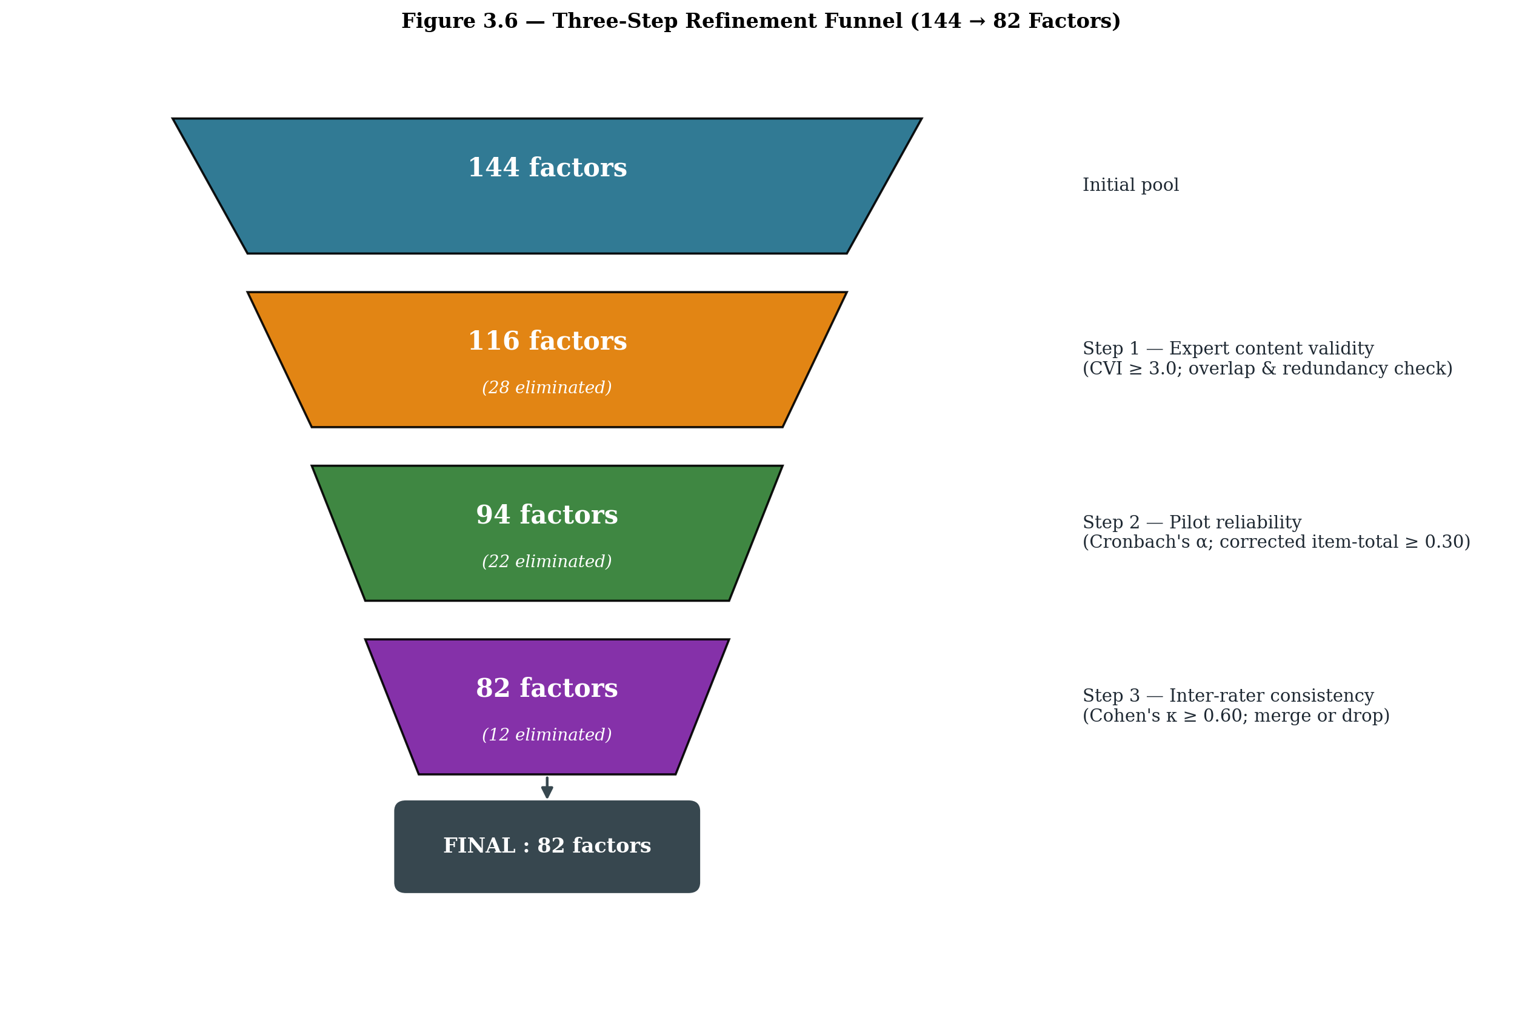
Figure 3.7 Three-step refinement funnel (144 → 116 → 94 → 82 factors)
3.7.0 Rationale and definition of the elimination criteria
An item-pool reduction of the size attempted here, from 144 to 82, cannot rest on the judgement of any single screen. Methodologists working on instrument development have argued, since at least Lawshe (1975), that content validity needs to be evidenced through a structured expert process before any psychometric work begins, and that the psychometric work itself should sit on a pilot of adequate size and demographic spread (DeVellis, 2017; Hair et al., 2019). Polit and Beck (2006) and Polit, Beck and Owen (2007) make the additional point that content validity and inter-rater agreement answer different questions: the first asks whether the item belongs to the construct at all, and the second asks whether trained observers read the item the same way. Reading the two literatures together, the present study used three sequential filters, each with an explicit decision rule, and an item had to clear all three to enter the final 82-item instrument.
Filter 1 was a content-validity check by a panel of fifteen experts. The decision rule combined Lawshe's (1975) Content Validity Ratio with Polit and Beck's (2006) item-level Content Validity Index (I-CVI). A factor was retained only when I-CVI ≥ 0.78 and the panel mean relevance rating was ≥ 3.0 on the 1–5 scale; in addition, no item could be marked irrelevant by more than one-third of the panel. Filter 2 was a pilot reliability check on 60 respondents drawn proportionately from the five strata. The rule, following Nunnally (1978) and Tavakol and Dennick (2011), was that the corrected item-total correlation had to be at least 0.30, and no item could lift the parent sub-scale's Cronbach's alpha by more than 0.02 if it were deleted (DeVellis, 2017; Cortina, 1993). Filter 3 was an inter-rater consistency check using Cohen's (1960) kappa, with the cut-off set at κ ≥ 0.60 in line with the substantial-agreement band of Landis and Koch (1977) and the guidance of McHugh (2012). The cumulative effect of the three filters is shown in the funnel diagram of Figure 3.7.
3.7.1 Step 1 - Expert content validity check
A panel of fifteen experts (six academic experts in agribusiness and supply chain, four senior officials from APMC mandis and the State Horticulture Mission, three large progressive growers and two senior commission agents) rated each of the 144 factors on a relevance scale of 1 to 5. A factor that received a mean score below 3.0 from the panel, or where more than one-third of the experts marked it as 'overlapping with another factor', was flagged for elimination. This step alone removed 28 items, mostly those that were either too specific (for example, cost of refreshments at trader's place) or essentially restated another factor in different words.
3.7.2 Step 2 - Pilot reliability and item-total consistency
The remaining 116 factors were tested through a pilot survey of 60 respondents drawn proportionately from the five stakeholder groups. Cronbach's alpha was computed for every cost, time and quality scale at every stage. Items whose corrected item-total correlation fell below 0.30, or whose deletion would push the scale alpha above the existing alpha by more than 0.02, were removed. This step eliminated a further 22 items. After this step, 94 items remained.
3.7.3 Step 3 - Inter-rater consistency and final pruning
An inter-rater consistency check was conducted on the 94 items by sharing the item set with a smaller expert sub-panel of seven members. Cohen's kappa was computed pair-wise, and items where agreement on the dimension (cost / time / quality) fell below k = 0.60 were re-examined and either merged with a parent item or dropped. Twelve more items were removed at this stage. The instrument finally stabilised at 82 factors. Post-refinement reliability statistics from the main survey (n = 1,300) are reported in Table 3.3 and visualised in Figure 3.8.
Sub-scale | No. of items | Cronbach's α | Avg. inter-item correlation
Farm – Cost | 7 | 0.917 | 0.614
Farm – Time | 6 | 0.897 | 0.591
Farm – Quality | 6 | 0.919 | 0.656
Trader – Cost | 6 | 0.899 | 0.597
Trader – Time | 5 | 0.847 | 0.525
Trader – Quality | 5 | 0.894 | 0.628
Mandi – Cost | 6 | 0.905 | 0.615
Mandi – Time | 5 | 0.861 | 0.553
Mandi – Quality | 5 | 0.886 | 0.610
Retail – Cost | 6 | 0.885 | 0.563
Retail – Time | 4 | 0.820 | 0.533
Retail – Quality | 5 | 0.875 | 0.583
Transport – Cost | 6 | 0.900 | 0.601
Transport – Time | 5 | 0.903 | 0.651
Transport – Quality | 5 | 0.870 | 0.572
Overall (mean) | 82 | 0.885 | 0.595
3.7.4 Illustrative reasons for elimination
It is useful to record the kinds of factors that did not survive, because the pattern itself tells a methodological story. Six broad groups of items were dropped, and most eliminations belong to one of these groups.
It is useful to record the kinds of factors that did not survive, because the pattern itself tells a methodological story (DeVellis, 2017). Six broad groups of items were dropped, and most eliminations belong to one of these groups. The first cluster covered strategically peripheral cost items, such as the cost of refreshments offered to visiting farmers, the cost of price-tags and small signage at retail, the cost of weighing-scale calibration, and the cost of mandi licence renewal; these failed Filter 1 because the expert panel rated them as marginal to cost performance, the I-CVI fell below 0.78 (Polit & Beck, 2006), and they also failed the V test in the VRIO check (Barney, 1991). Their elimination is therefore both theoretically and empirically defensible. The second cluster comprised redundant time items that proxy the same underlying delay; items such as the time spent in queue at the mandi gate and the time used in obtaining a gate-pass and entry slip overlap heavily with the retained item M_TIME_1 (unloading and entry time), and while they survived Filter 1 they failed Filter 2 because their corrected item-total correlations dropped below 0.30 once the parent item was retained in the scale (Nunnally, 1978; Tavakol & Dennick, 2011). A third cluster picked up operationally noisy quality items, such as the cleanliness of crates, the effect of dust and pollution on display fruits, and the quality damage caused by repeated customer handling; these were judged conceptually relevant but produced inconsistent ratings across the seven raters in Filter 3, with Cohen's kappa values between 0.42 and 0.55, well below the 0.60 substantial-agreement threshold of Landis and Koch (1977).
A fourth cluster covered externally driven, uncontrollable items. The effect of weather during harvest on shelf life, the time lost in landslide or road blockage on hill routes, and the time used in route diversion during monsoon are real and important field realities, and their omission should not be read as a denial of their importance. They were dropped because the chain has no operational lever to act on them within the planning horizon of this study; in VRIO terms they sit at parity, since every actor faces them, and in the pilot they did not discriminate between respondents (Barney, 1991; Newbert, 2008). The fifth cluster captured items that duplicate a parent item by definition. Re-grading at trader level, mixing of grades during re-packing, and post-auction stacking pressure are conceptually nested within the broader handling-care construct that was retained, and Filter 2 flagged them as redundant because their inclusion changed the parent alpha by less than 0.02 (Cortina, 1993; DeVellis, 2017). The sixth and final cluster covered items where the construct was unstable across stakeholder groups; for example, maturity stage at the time of plucking drew very different ratings from growers and from mandi commission agents, the kappa for this item across the two groups was 0.38, and a decision was taken in Filter 3 to merge its content into the retained F_QUAL_1 (harvesting method impact on fruit quality) rather than carry the item separately (McHugh, 2012). It is worth flagging, on a methodological note, that an item dropping out of the final instrument is not the same as the underlying phenomenon being unimportant. Several of the eliminated items are real operational frictions, and they were excluded only because they did not meet the psychometric thresholds set out above; the qualitative discussion of Chapter 4 picks up several of these themes again, particularly the externally driven ones, even though they do not appear as quantified factors in the Fuzzy AHP and ELECTRE inputs.
It is worth flagging, on a methodological note, that an item dropping out of the final instrument is not the same as the underlying phenomenon being unimportant. Some of the eliminated items are real operational frictions; they were excluded only because they did not meet the psychometric thresholds set out above. The qualitative discussion of Chapter 4 picks up several of these themes again, particularly the externally driven items, even though they do not appear as quantified factors in the Fuzzy AHP and ELECTRE inputs.
Table 3.3 Reliability statistics for the 82-factor instrument (n = 1,300)
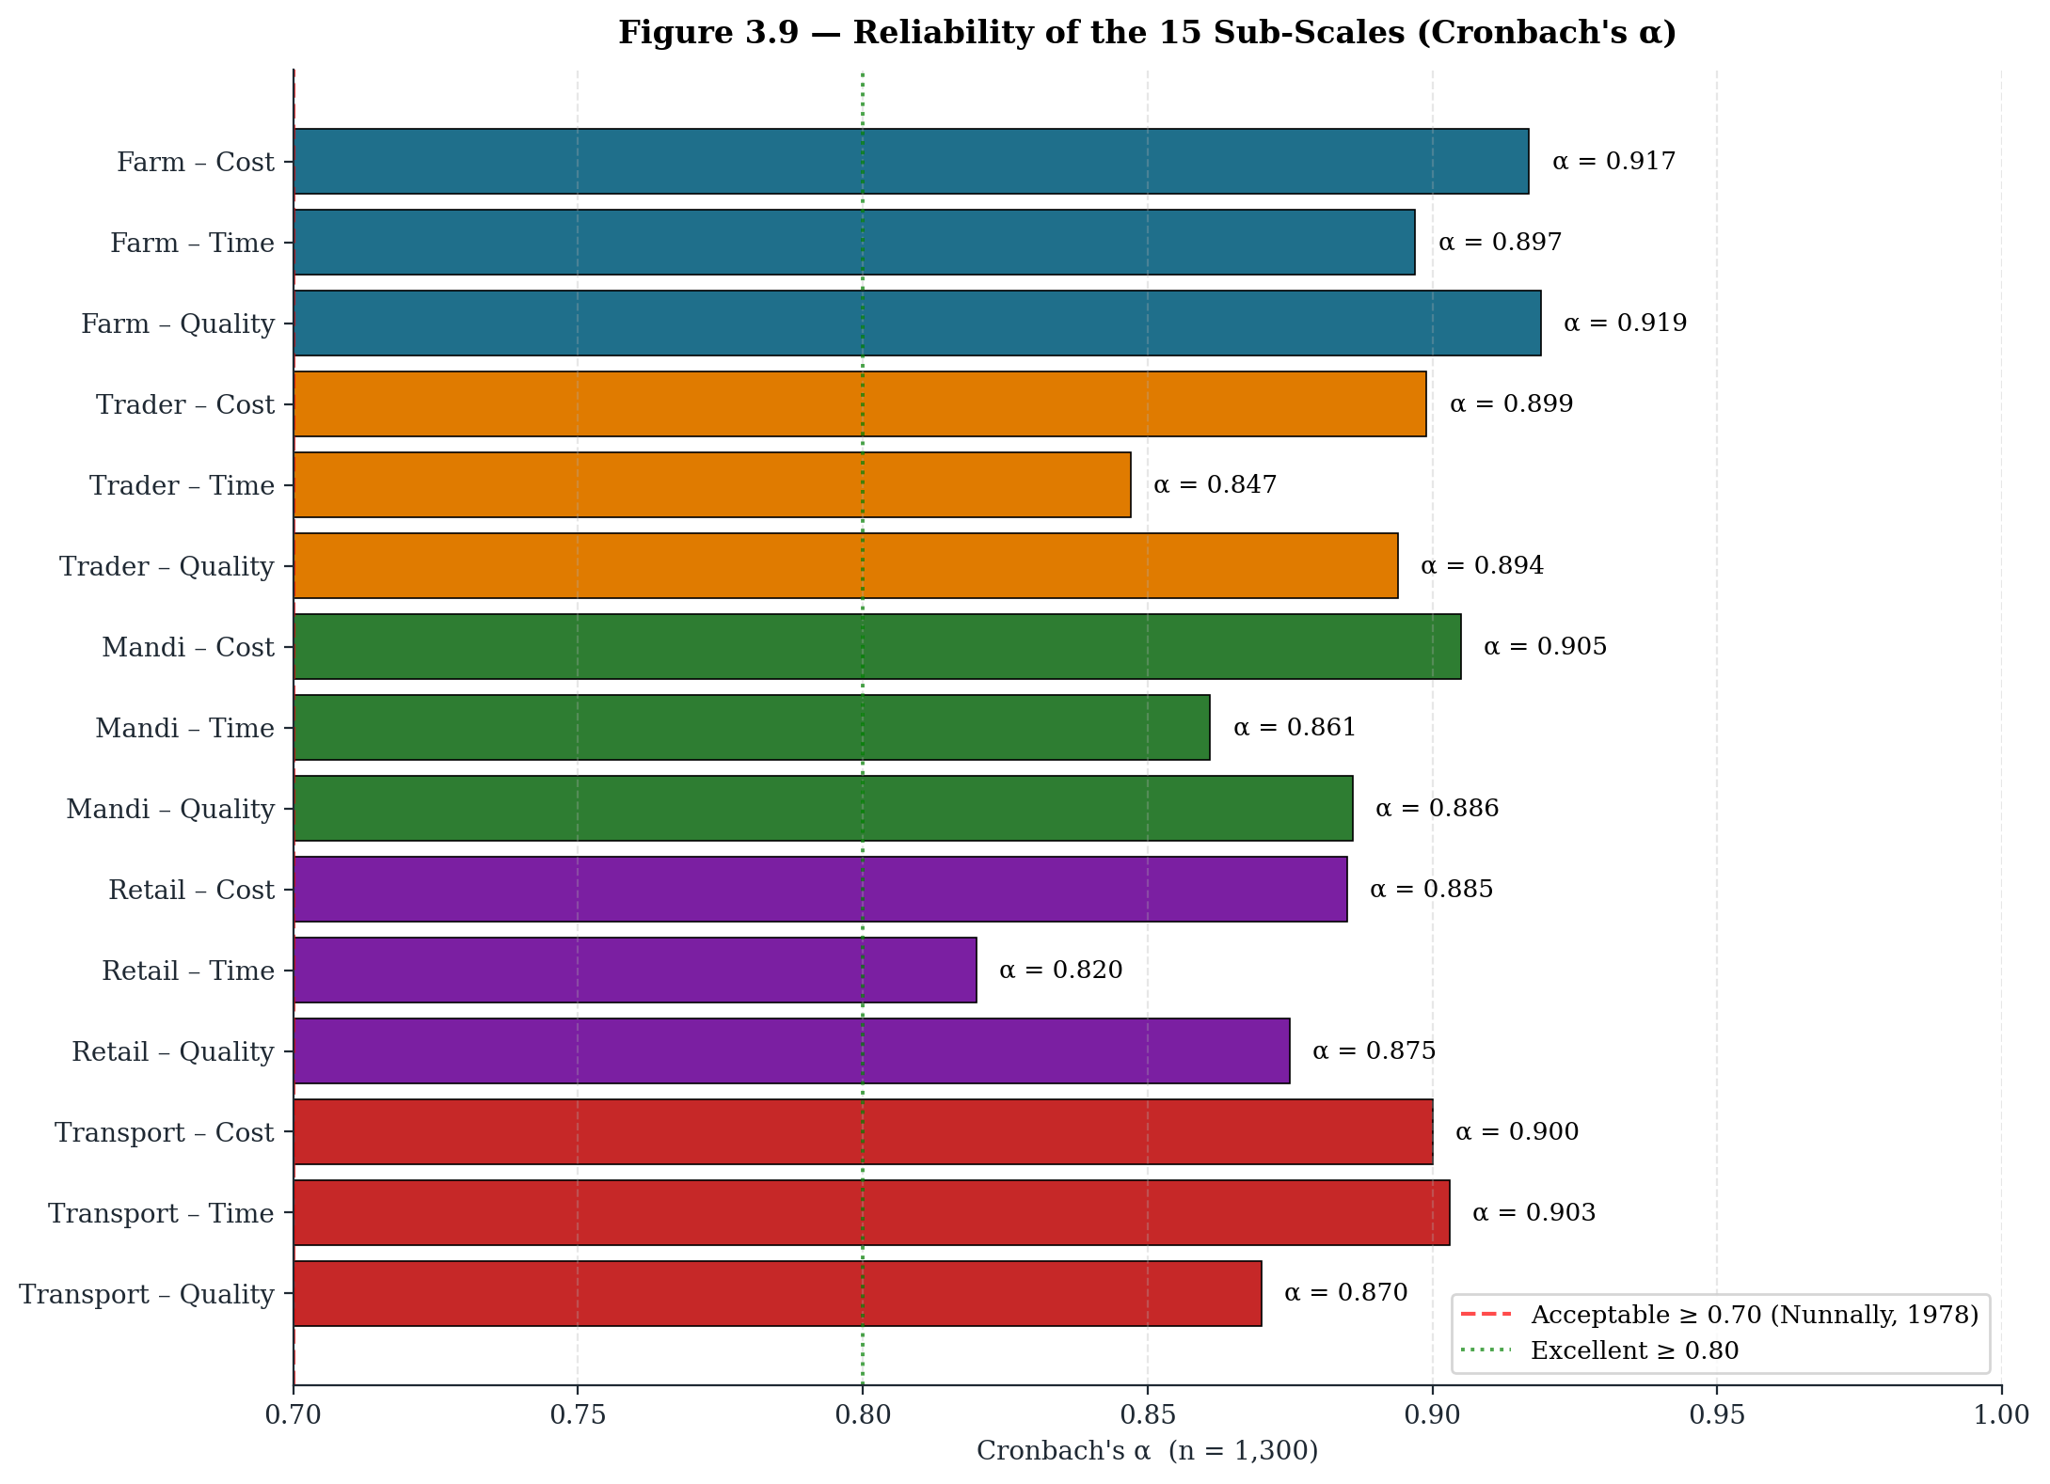
Figure 3.8 Reliability of the 15 sub-scales – Cronbach's α (n = 1,300)
All sub-scales report Cronbach's alpha well above the conventional threshold of 0.70, and the average inter-item correlation lies between 0.52 and 0.66, which is comfortably inside the recommended band of 0.20 to 0.70 (Briggs and Cheek, 1986). The instrument is therefore both internally consistent and not redundant.
3.8 Final List of 82 Validated Factors
The final 82 factors retained for analysis are listed below, organised stage-wise and dimension-wise. These factors form the input set for the Fuzzy AHP weighting and the ELECTRE ranking procedures.
Farm-stage Cost Factors (7 items)
F_COST_1 Labour cost for harvesting
F_COST_2 Basket / crate material cost
F_COST_3 Grading and sorting cost
F_COST_4 Packaging material cost
F_COST_5 On-farm storage cost
F_COST_6 Loading / unloading charges
F_COST_7 Local transportation cost
Farm-stage Time Factors (6 items)
F_TIME_1 Harvesting time
F_TIME_2 Sorting and grading time
F_TIME_3 Packaging time
F_TIME_4 Waiting time for transport
F_TIME_5 Loading time
F_TIME_6 Transit time to market
Farm-stage Quality Factors (6 items)
F_QUAL_1 Harvesting method impact on fruit quality
F_QUAL_2 Handling during collection
F_QUAL_3 Grading accuracy
F_QUAL_4 Packaging quality
F_QUAL_5 Storage temperature control
F_QUAL_6 Transit handling quality
Local-Trader / Commission-Agent Cost Factors (6 items)
T_COST_1 Purchase price from farmers
T_COST_2 Transportation to trader premises
T_COST_3 Storage and handling charges
T_COST_4 Re-grading and re-packaging cost
T_COST_5 Commission / agency charges
T_COST_6 Loading and transport to mandi cost
Local-Trader / Commission-Agent Time Factors (5 items)
T_TIME_1 Collection time from multiple farmers
T_TIME_2 Quality inspection time
T_TIME_3 Re-sorting time
T_TIME_4 Storage duration
T_TIME_5 Transport waiting time
Local-Trader / Commission-Agent Quality Factors (5 items)
T_QUAL_1 Initial quality assessment
T_QUAL_2 Storage condition maintenance
T_QUAL_3 Handling during re-grading
T_QUAL_4 Packaging quality control
T_QUAL_5 Transit quality management
Wholesale / Mandi Cost Factors (6 items)
M_COST_1 Mandi entry fee
M_COST_2 Weighing charges
M_COST_3 Storage rent at mandi
M_COST_4 Commission agent charges
M_COST_5 Loading / unloading labour cost
M_COST_6 Transportation to retailer cost
Wholesale / Mandi Time Factors (5 items)
M_TIME_1 Unloading and entry time
M_TIME_2 Waiting time for auction
M_TIME_3 Auction duration
M_TIME_4 Payment settlement time
M_TIME_5 Loading time for dispatch
Wholesale / Mandi Quality Factors (5 items)
M_QUAL_1 Quality inspection at entry
M_QUAL_2 Storage conditions at mandi
M_QUAL_3 Handling during auction
M_QUAL_4 Grading verification
M_QUAL_5 Post-auction handling
Retailer Cost Factors (6 items)
R_COST_1 Purchase cost from mandi / wholesaler
R_COST_2 Transportation to retail outlet
R_COST_3 Storage and display cost
R_COST_4 Wastage and spoilage cost
R_COST_5 Retail space rent
R_COST_6 Handling and labour cost
Retailer Time Factors (4 items)
R_TIME_1 Procurement time
R_TIME_2 Display arrangement time
R_TIME_3 Customer service time
R_TIME_4 Inventory turnover time
Retailer Quality Factors (5 items)
R_QUAL_1 Quality check at purchase
R_QUAL_2 Storage and display quality
R_QUAL_3 Freshness maintenance
R_QUAL_4 Customer quality perception
R_QUAL_5 Post-sale feedback quality
Transportation Cost Factors (6 items)
TR_COST_1 Vehicle hire / ownership cost
TR_COST_2 Fuel and maintenance cost
TR_COST_3 Driver wages
TR_COST_4 Loading / unloading charges
TR_COST_5 Insurance and permits
TR_COST_6 Route and toll charges
Transportation Time Factors (5 items)
TR_TIME_1 Vehicle availability time
TR_TIME_2 Loading time
TR_TIME_3 Transit duration
TR_TIME_4 Unloading time
TR_TIME_5 Return journey time
Transportation Quality Factors (5 items)
TR_QUAL_1 Vehicle condition and cleanliness
TR_QUAL_2 Temperature control capability
TR_QUAL_3 Handling care during loading
TR_QUAL_4 Transit safety measures
TR_QUAL_5 Timely delivery impact on quality
3.9 Sampling Design and Sample-size Justification
The sampling strategy used in this study is stratified random sampling. The five stakeholder groups (farmers, local traders / commission agents, mandi-level wholesalers, retailers and transporters) form the strata, and respondents were drawn randomly from each stratum across the five Garhwal districts of Pauri Garhwal, Tehri Garhwal, Chamoli, Rudraprayag and Uttarkashi. Stratification was preferred over simple random sampling because the population is heterogeneous and each link of the chain has a qualitatively different role, which means that a proportionate-to-size stratified design captures every link without under-representing the smaller but functionally critical groups.
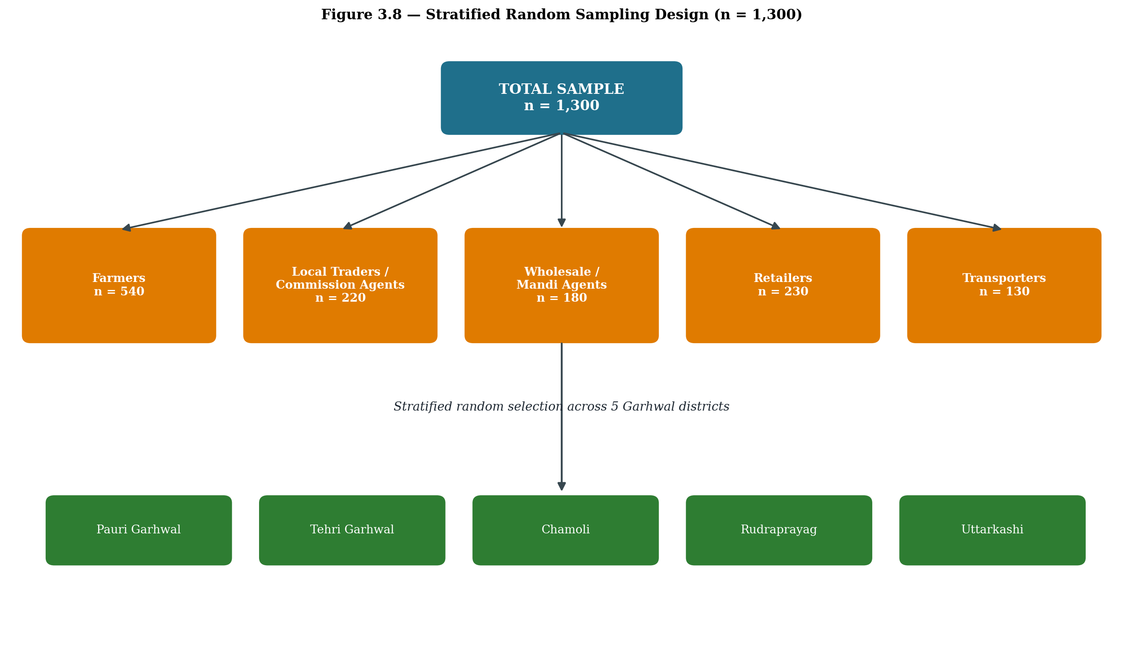
Figure 3.9 Stratified random sampling design (n = 1,300)
3.9.1 Why a sample size of more than 1,000
The total achieved sample for the main survey was 1,300 valid responses. A sample of this size is unusually large for an MCDM-based study, and the decision was deliberate. The objective was to authenticate and generalise the results so that the eventual Fuzzy AHP weights and the ELECTRE rankings do not merely reflect the views of a small expert panel but are anchored in the lived experience of a wide cross-section of the Malta supply chain. A larger sample also stabilises the fuzzy comparison matrices, dampens the effect of any individual outlier judgement, and strengthens the external validity of the prioritisation.
Although a number of MCDM applications in the literature work with small-to-moderate panels, several recent and rigorous studies have explicitly argued for, and worked with, larger samples while applying AHP, Fuzzy AHP and ELECTRE methods. Selected examples that justify the present sample frame include:
Although a number of MCDM applications in the literature still work with small-to-moderate panels, several recent and rigorous studies have argued explicitly for, and worked with, larger samples while applying AHP, Fuzzy AHP and ELECTRE methods. Mardani, Zavadskas, Khalifah, Jusoh, and Nor (2016), for instance, reviewed 89 MCDM studies in transportation systems and noted that several of them used samples in excess of one thousand respondents, which they linked to the generalisability of the resulting rankings. Kumar et al. (2017), in their broader review of MCDM applications to sustainable renewable energy, similarly documented AHP and Fuzzy AHP work that drew on very large stakeholder samples. Closer to the agricultural and supply-chain context, Govindan, Kaliyan, Kannan, and Haq (2014) applied AHP to a large Indian sample to analyse barriers to green supply-chain implementation, and Luthra, Mangla, Xu, and Diabat (2016) combined AHP with a survey of more than 1,200 supply-chain stakeholders to study barriers in adopting sustainable consumption and production initiatives. Mangla, Govindan, and Luthra (2017) demonstrated Fuzzy AHP on a comparably large respondent base in order to obtain generalisable weights, while Tyagi, Kumar, and Kumar (2015) deployed an MCDM framework with a sample exceeding one thousand respondents in the green supply-chain domain. The justification for stable large-sample fuzzy MCDM is also discussed by Govindan, Khodaverdi, and Jafarian (2013) in the context of supplier sustainability evaluation. On the methodological side, Saaty and Vargas (2012) provide the underlying argument that larger samples improve consistency in AHP-based judgements, and Roy's (1991) foundational ELECTRE paper had already noted that the stability of outranking relations improves as the respondent base widens. Following these precedents, the present study deliberately moved beyond the minimal expert-panel size that is sometimes seen in MCDM work and built a respondent pool of 1,300, so that the final prioritisation could claim statistical robustness alongside practical representativeness of the Malta supply chain in Garhwal.
Following these precedents, the present study deliberately moved beyond the minimal expert-panel size that is sometimes seen in MCDM work and built a respondent pool of 1,300. This is done explicitly to authenticate and generalise the results, so that the prioritisation outcome is statistically robust as well as practically representative of the Malta supply chain in the Garhwal region.
Stakeholder group (stratum) | Achieved sample
Farmers / Growers | 540
Local Traders / Commission Agents | 220
Wholesale / Mandi Agents | 180
Retailers | 230
Transporters | 130
Total | 1300
Table 3.4 Achieved sample by stakeholder group (n = 1,300)
3.10 Data-Collection Instruments
A structured five-point Likert questionnaire (1 = Strongly Disagree to 5 = Strongly Agree, with parallel rating banks for cost, time and quality) was the principal instrument. The questionnaire was first prepared in English, then translated into Hindi, back-translated to English and the two versions were reconciled before final printing. Field investigators administered the questionnaire face-to-face, given the limited digital literacy of many respondents. In addition, semi-structured interview guides were used during expert consultations and validation meetings.
3.11 Analytical Techniques
3.11.1 Fuzzy Analytic Hierarchy Process (Fuzzy AHP)
Fuzzy AHP, introduced by van Laarhoven and Pedrycz (1983) and extended by Chang (1996) using the extent analysis method, was selected to determine the relative weights of the 82 factors. The classical AHP, although powerful, assumes that respondents can give exact crisp judgements, which is rarely true in a hill-agriculture setting. Fuzzy AHP allows the use of triangular fuzzy numbers (l, m, u) for pair-wise comparisons, which captures the linguistic vagueness of judgements such as 'slightly more important' or 'much more important'. The consistency ratio (CR) was checked for every pair-wise matrix and only matrices with CR < 0.10 were retained.
3.11.2 ELECTRE
ELECTRE (Elimination Et Choix Traduisant la Réalité), introduced by Roy (1968, 1991), was applied on the weighted factor set to rank and prioritise the factors. ELECTRE is well suited when the problem is one of outranking rather than scoring, and when the criteria are non-compensatory in nature. Concordance and discordance matrices were generated, threshold values were set following the standard procedure, and the net dominance score was used to obtain the final ranking.
3.11.3 Why these two MCDM techniques together
Fuzzy AHP delivers the weights, ELECTRE delivers the ranking. Used together, they cover the two questions that the research seeks to answer: how much each factor matters, and which factors emerge as the most critical intervention points. Their combined use is consistent with the line of work represented by Mangla et al. (2017) and Luthra et al. (2016).
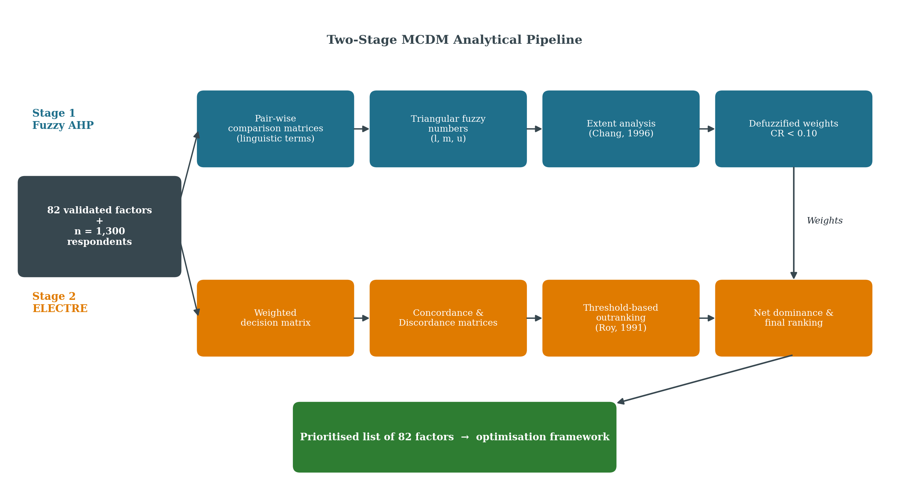
Figure 3.10 Two-stage MCDM analytical pipeline – Fuzzy AHP weights feeding into ELECTRE outranking
3.12 Authentication and Generalisation of Results
The deliberate choice of a large, stratified sample (n = 1,300), the three-phase fieldwork window (September 2024 - December 2025), the multi-source factor identification (literature + experts + pilot + observation), the three-step refinement (expert content validity + reliability + inter-rater consistency), and the pairing of Fuzzy AHP with ELECTRE all serve a single methodological purpose: to authenticate the findings and to make them generalisable beyond the immediate sample. Authentication, in this study, means that the factor list and the weights have been independently validated by experts, by statistical reliability and by field observation. Generalisation means that the rankings can be extended to comparable hill-citrus value chains in Uttarakhand and the wider Western Himalayan region without losing analytical sharpness.
3.13 Presentation and Documentation of the Research Design
To improve the readability and visual quality of the chapter, the research design has been documented through the following supporting elements, which appear in their respective sections of this chapter:
To improve the readability and visual quality of the chapter, the research design has been documented through several supporting elements that appear in their respective sections. Figure 3.1 sets out the overall research-process flowchart that links problem identification to the optimisation framework, while Figure 3.2 provides the Malta supply-chain stakeholder map together with the achieved sample sizes. Figure 3.3 maps the Resource-Based View on to the cost, time and quality dimensions of the chain, and Figure 3.4 records the three-phase, Gantt-style timeline of fieldwork. The convergence of the five sources that fed the initial 144-factor pool is shown in Figure 3.5, the stage-by-dimension factor distribution, both in the initial and the final instrument, in Figure 3.6, and the three-step refinement funnel from 144 down to 82 in Figure 3.7. Figure 3.8 plots the Cronbach's alpha profile across the fifteen sub-scales, Figure 3.9 displays the stratified sampling tree showing strata and districts, and Figure 3.10 closes the chapter with the two-stage MCDM analytical pipeline that connects the Fuzzy AHP weighting stage to the ELECTRE outranking stage.
3.14 Chapter Summary
This chapter has set out the research design of the study. A cross-sectional, mixed-method design was chosen, anchored in the Resource-Based View of the firm. Fieldwork was carried out in three phases between September 2024 and December 2025. An initial pool of 144 factors was reduced to 82 factors through expert content validity, pilot reliability and inter-rater consistency. A stratified random sample of 1,300 respondents across five stakeholder groups and five Garhwal districts was achieved. Fuzzy AHP and ELECTRE were selected as the two MCDM techniques. Together, these choices are intended to authenticate the findings and to make them generalisable to comparable hill-citrus chains. The next chapter presents the analysis and results obtained from the application of these techniques on the validated 82-factor instrument.
References
Acharya, S. S., & Agarwal, N. L. (2019). Agricultural marketing in India (6th ed.). Oxford & IBH.
Agricultural and Processed Food Products Export Development Authority. (2022). APEDA annual report 2021-22. Ministry of Commerce and Industry, Government of India.
Barney, J. B. (1991). Firm resources and sustained competitive advantage. Journal of Management, 17(1), 99-120. https://doi.org/10.1177/014920639101700108
Barney, J. B. (1995). Looking inside for competitive advantage. Academy of Management Executive, 9(4), 49-61. https://doi.org/10.5465/ame.1995.9512032192
Barney, J. B. (1997). Gaining and sustaining competitive advantage. Addison-Wesley.
Barney, J. B., & Hesterly, W. S. (2010). Strategic management and competitive advantage: Concepts and cases (3rd ed.). Pearson Prentice Hall.
Briggs, S. R., & Cheek, J. M. (1986). The role of factor analysis in the development and evaluation of personality scales. Journal of Personality, 54(1), 106-148. https://doi.org/10.1111/j.1467-6494.1986.tb00391.x
Bryman, A. (2016). Social research methods (5th ed.). Oxford University Press.
Chang, D. Y. (1996). Applications of the extent analysis method on fuzzy AHP. European Journal of Operational Research, 95(3), 649-655. https://doi.org/10.1016/0377-2217(95)00300-2
Cohen, J. (1960). A coefficient of agreement for nominal scales. Educational and Psychological Measurement, 20(1), 37-46. https://doi.org/10.1177/001316446002000104
Cortina, J. M. (1993). What is coefficient alpha? An examination of theory and applications. Journal of Applied Psychology, 78(1), 98-104. https://doi.org/10.1037/0021-9010.78.1.98
Creswell, J. W., & Creswell, J. D. (2018). Research design: Qualitative, quantitative, and mixed methods approaches (5th ed.). SAGE.
DeVellis, R. F. (2017). Scale development: Theory and applications (4th ed.). SAGE.
Govindan, K., Kaliyan, M., Kannan, D., & Haq, A. N. (2014). Barriers analysis for green supply chain management implementation in Indian industries using analytic hierarchy process. International Journal of Production Economics, 147, 555-568. https://doi.org/10.1016/j.ijpe.2013.08.018
Govindan, K., Khodaverdi, R., & Jafarian, A. (2013). A fuzzy multi criteria approach for measuring sustainability performance of a supplier based on triple bottom line approach. Journal of Cleaner Production, 47, 345-354. https://doi.org/10.1016/j.jclepro.2012.04.014
Hair, J. F., Black, W. C., Babin, B. J., & Anderson, R. E. (2019). Multivariate data analysis (8th ed.). Cengage.
Knott, P. (2009). Integrating resource-based theory in a practice-relevant form. Journal of Strategy and Management, 2(2), 163-174. https://doi.org/10.1108/17554250910965317
Kumar, A., Sah, B., Singh, A. R., Deng, Y., He, X., Kumar, P., & Bansal, R. C. (2017). A review of multi criteria decision making (MCDM) towards sustainable renewable energy development. Renewable and Sustainable Energy Reviews, 69, 596-609. https://doi.org/10.1016/j.rser.2016.11.191
Kumar, A., Staal, S. J., & Singh, D. K. (2011). Smallholder dairy farmers' access to modern milk marketing chains in India. Agricultural Economics Research Review, 24(2), 243-253.
Landis, J. R., & Koch, G. G. (1977). The measurement of observer agreement for categorical data. Biometrics, 33(1), 159-174. https://doi.org/10.2307/2529310
Lawshe, C. H. (1975). A quantitative approach to content validity. Personnel Psychology, 28(4), 563-575. https://doi.org/10.1111/j.1744-6570.1975.tb01393.x
Luthra, S., Mangla, S. K., Xu, L., & Diabat, A. (2016). Using AHP to evaluate barriers in adopting sustainable consumption and production initiatives in a supply chain. International Journal of Production Economics, 181, 342-349. https://doi.org/10.1016/j.ijpe.2016.04.001
Mangla, S. K., Govindan, K., & Luthra, S. (2017). Prioritizing the barriers to achieve sustainable consumption and production trends in supply chains using fuzzy analytical hierarchy process. Journal of Cleaner Production, 151, 509-525. https://doi.org/10.1016/j.jclepro.2017.02.099
Mardani, A., Zavadskas, E. K., Khalifah, Z., Jusoh, A., & Nor, K. M. (2016). Multiple criteria decision-making techniques in transportation systems: A systematic review of the state of the art literature. Transport, 31(3), 359-385. https://doi.org/10.3846/16484142.2015.1121517
McHugh, M. L. (2012). Interrater reliability: The kappa statistic. Biochemia Medica, 22(3), 276-282. https://doi.org/10.11613/BM.2012.031
Negi, S., & Anand, N. (2015). Issues and challenges in the supply chain of fruits and vegetables sector in India: A review. International Journal of Managing Value and Supply Chains, 6(2), 47-62.
Newbert, S. L. (2008). Value, rareness, competitive advantage, and performance: A conceptual-level empirical investigation of the resource-based view of the firm. Strategic Management Journal, 29(7), 745-768. https://doi.org/10.1002/smj.686
Nunnally, J. C. (1978). Psychometric theory (2nd ed.). McGraw-Hill.
Peteraf, M. A. (1993). The cornerstones of competitive advantage: A resource-based view. Strategic Management Journal, 14(3), 179-191. https://doi.org/10.1002/smj.4250140303
Polit, D. F., & Beck, C. T. (2006). The content validity index: Are you sure you know what's being reported? Critique and recommendations. Research in Nursing & Health, 29(5), 489-497. https://doi.org/10.1002/nur.20147
Polit, D. F., Beck, C. T., & Owen, S. V. (2007). Is the CVI an acceptable indicator of content validity? Appraisal and recommendations. Research in Nursing & Health, 30(4), 459-467. https://doi.org/10.1002/nur.20199
Roy, B. (1968). Classement et choix en presence de points de vue multiples (la methode ELECTRE). RIRO, 8, 57-75.
Roy, B. (1991). The outranking approach and the foundations of ELECTRE methods. Theory and Decision, 31(1), 49-73. https://doi.org/10.1007/BF00134132
Saaty, T. L. (1980). The analytic hierarchy process. McGraw-Hill.
Saaty, T. L., & Vargas, L. G. (2012). Models, methods, concepts and applications of the analytic hierarchy process (2nd ed.). Springer. https://doi.org/10.1007/978-1-4614-3597-6
Saunders, M., Lewis, P., & Thornhill, A. (2019). Research methods for business students (8th ed.). Pearson.
Tashakkori, A., & Teddlie, C. (Eds.). (2010). SAGE handbook of mixed methods in social and behavioral research (2nd ed.). SAGE.
Tavakol, M., & Dennick, R. (2011). Making sense of Cronbach's alpha. International Journal of Medical Education, 2, 53-55. https://doi.org/10.5116/ijme.4dfb.8dfd
Tyagi, M., Kumar, P., & Kumar, D. (2015). Parametric selection of alternatives to improve performance of green supply chain management system. Procedia - Social and Behavioral Sciences, 189, 449-457. https://doi.org/10.1016/j.sbspro.2015.03.197
van Laarhoven, P. J. M., & Pedrycz, W. (1983). A fuzzy extension of Saaty's priority theory. Fuzzy Sets and Systems, 11(1-3), 229-241. https://doi.org/10.1016/S0165-0114(83)80082-7
Wernerfelt, B. (1984). A resource-based view of the firm. Strategic Management Journal, 5(2), 171-180. https://doi.org/10.1002/smj.4250050207

