Some of the thoughts I have is to put this logo at the top and make the web page match the same color blue along with the stars throughout the entire page. Also Rudolph’s nose needs to blink.

WELCOME TO

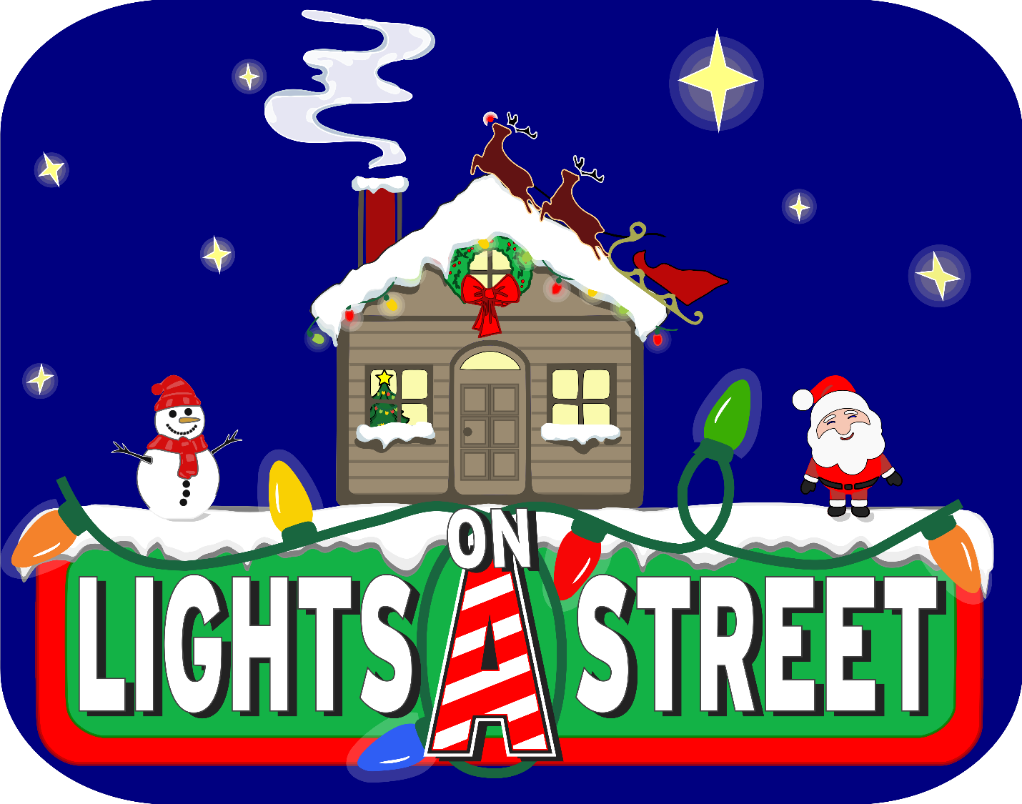

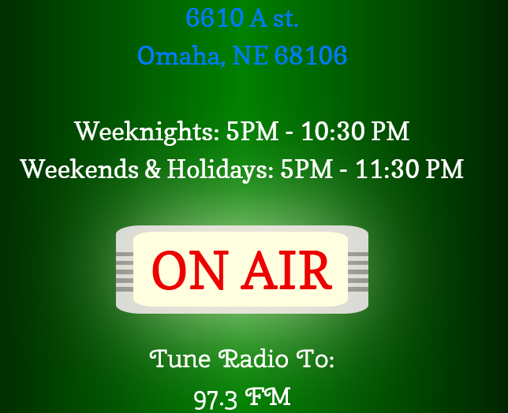

Vote for your favorite song from the list below. Your vote will be added to the song you chose. The song with the most votes will play when the current song is finished.

I do like the snowflakes on this one as they fall down over everything. They are not to big to take away from the info like several others are.



I like this layout section for the radio station

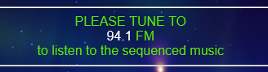

I like how this is worded and labeled. Our show starts Thanksgiving night. I do not want to put a end date on it because it changes depending on the weather.



When I was looking thru others on page 7 someone has music playing that I like

This one has lights the chase and was wondering if that could be made to surround the entire web page. (top Bottom and both sides)

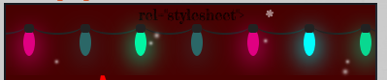

A facebook link <https://www.facebook.com/profile.php?id=100064599226087> and let us know what you liked.