mkdir CATS2

sudo apt-get install libsdl2-dev
sudo apt-get install libavahi-compat-libdnssd-dev
ZeroMQ

cmake

sudo apt install ncurses* (required by cmake to create ccmake)
wget https://cmake.org/files/v3.8/cmake-3.8.0.tar.gz
tar -xvf cmake-3.8.0.tar.gz
cd cmake-3.8.0/
./bootstrap --qt-gui
make -j36
make install

install gcc-4.9

sudo add-apt-repository ppa:ubuntu-toolchain-r/test
sudo apt-get update
sudo apt-get install g++-4.9
switch between gcc-4.9 and gcc-4.8 (https://askubuntu.com/questions/26498/choose-gcc-and-g-version)

sudo update-alternatives --remove-all gcc
sudo update-alternatives --remove-all g++
sudo apt-get install gcc-4.8 gcc-4.8 g++-4.9 g++-4.9

sudo update-alternatives --install /usr/bin/gcc gcc /usr/bin/gcc-4.8 10
sudo update-alternatives --install /usr/bin/gcc gcc /usr/bin/gcc-4.9 20

sudo update-alternatives --install /usr/bin/g++ g++ /usr/bin/g++-4.8 10
sudo update-alternatives --install /usr/bin/g++ g++ /usr/bin/g++-4.9 20

sudo update-alternatives --install /usr/bin/cc cc /usr/bin/gcc 30
sudo update-alternatives --set cc /usr/bin/gcc

sudo update-alternatives --install /usr/bin/c++ c++ /usr/bin/g++ 30
sudo update-alternatives --set c++ /usr/bin/g++

Qt5.6 or later

Dashel
https://github.com/aseba-community/dashel

Enki
https://github.com/enki-community/enki

aseba
https://github.com/gribovskiy/aseba

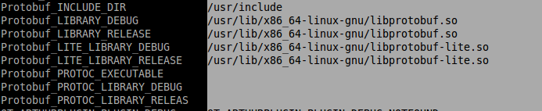
qt-gstreamer-0.10

cmake -DQT_VERSION=5 ..
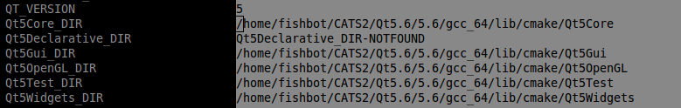

protobuf
git clone https://github.com/google/protobuf.git
https://github.com/google/protobuf/blob/master/src/README.md

export LD_LIBRARY_PATH=$LD_LIBRARY_PATH:/usr/local/lib

OpenCV

git clone https://github.com/opencv/opencv_contrib.git
cd opencv_contrib
git checkout 3.2.0
cd ..
git clone https://github.com/opencv/opencv.git
cd opencv
git checkout 3.2.0
mkdir build
cd build
cmake ..

(uncheck BUILD_opencv_xfeatures2d and BUILD_opencv_dnn)
provide path for OPENCV_EXTRA_MODULES_PATH

CATS2

git clone https://github.com/gribovskiy/CATS2.git

cd CATS2/
git submodule init
git submodule update
mkdir build
cd build
cmake ..

and set all the missing variables for cmake

./cats -bc if ../../../config/camera-calibration/epfl-setup-180/cats2-180-angle-below-camera.png -mc if ../../../config/setup/epfl-two-rooms.png -c ../../../config/cats2-epfl-setup.xml -sri 0

