Science class 10 - NCERT

National Council Of Educational Research

Training

# NOTICE

This accessible media has been made available to people with bona fide disabilities that affect reading. This notice tells you about restrictions on the use of this accessible media, which could be a book, a periodical, or other content.

## Copyright Notice

**Title:** Science class 10 - NCERT

**Author:** National Council of Educational Research and Training

**Copyright** 2019 by National Council of Educational Research and Training

This notice is not part of the copyrighted work, which begins below after the phrase "Begin Content".

Bookshare distributes this accessible media as the third party agent of an authorized organization and under restrictions set forth pursuant to and in accordance with the provisions of Section 52(1)(zb) of the Indian Copyright Act, 1957. This accessible media is intended solely for the use of persons with print disabilities. If you are not a person with a print disability, or an organization serving people with print disabilities, you should not use this accessible media and should destroy this content. If you are a person with a print disability, you are permitted under this restricted license to use this digital copy for your own personal use. You are not allowed to redistribute content derived from this accessible media to anybody else, with one exception: we allow hardcopy Braille books prepared from accessible media to be provided to other blind people to the extent required for private or personal use, educational purpose, or research. Any further reproduction, distribution, or any commercial usage requires the express, prior consent of the copyright holder. We have the right to stop the supply of further works in accessible media to you if we believe that you have distributed the accessible media in violation of these restrictions. You will also be liable for such other legal consequences as are applicable.

Access to accessible media through Bookshare is a valuable right and privilege. Protect this access for the print disabled community by complying with these restrictions!

You, your parents, or your school (or agency) signed a Bookshare agreement. For the full text of the current version of the Member Agreements, please visit www.bookshare.org/Agreements. This information in this accessible media file does not in any way change the terms of your Agreement with Bookshare.

## Limitation of Liability

Most authors and publishers do not have control over the content available through Bookshare. By downloading and using this material, you agree that neither Bookshare nor the authors or original publishers of the materials shall be financially responsible for any loss or damage to you or any third parties caused by the failure or malfunction of the Bookshare website (www.bookshare.org) or because of any inaccuracy or lack of completeness of any content that you download from the website.

BOOKSHARE, AND THE AUTHORS, PUBLISHERS, AND COPYRIGHT OWNERS OF THE MATERIALS, SHALL NOT IN ANY CASE BE LIABLE FOR DIRECT, INDIRECT, SPECIAL, INCIDENTAL, OR CONSEQUENTIAL DAMAGES, WHETHER BASED ON CONTRACT, TORT, OR ANY OTHER LEGAL THEORY, IN CONNECTION WITH OR ARISING OUT OF THE FURNISHING OF CONTENT, THE FUNCTIONING OF THE WEB SITE, OR ANY OTHER ASPECT OF YOUR USE OF THE WEB SITE AND THE CONTENTS PROVIDED HEREUNDER.

## Digital Rights Management

This material contains digital watermarks and fingerprints designed to identify this material as a Bookshare digital material that was specifically downloaded by you. It is a violation of the terms of your Member Agreement, and may be illegal, to delete or modify these watermarks and fingerprints. Your Member Agreement expressly authorizes us to include these security devices, solely for this use, as an express exception to current and future privacy laws relating to protection of personal information data. Should any future privacy law or regulation preclude the use of this personal data for purposes of tracking the downloading and use of these materials and enforcing the limitations of relevant copyright law or the Member Agreement, your right to use these materials will terminate on the effective date of any such law or regulation.

This material was downloaded by Assistech Lab and is digitally fingerprinted in the manner described above.

## Book Quality

Bookshare is interested in improving book quality over time, if you can help us by providing any book quality feedback, we'll work hard to make those changes and republish the books.

Begin Content

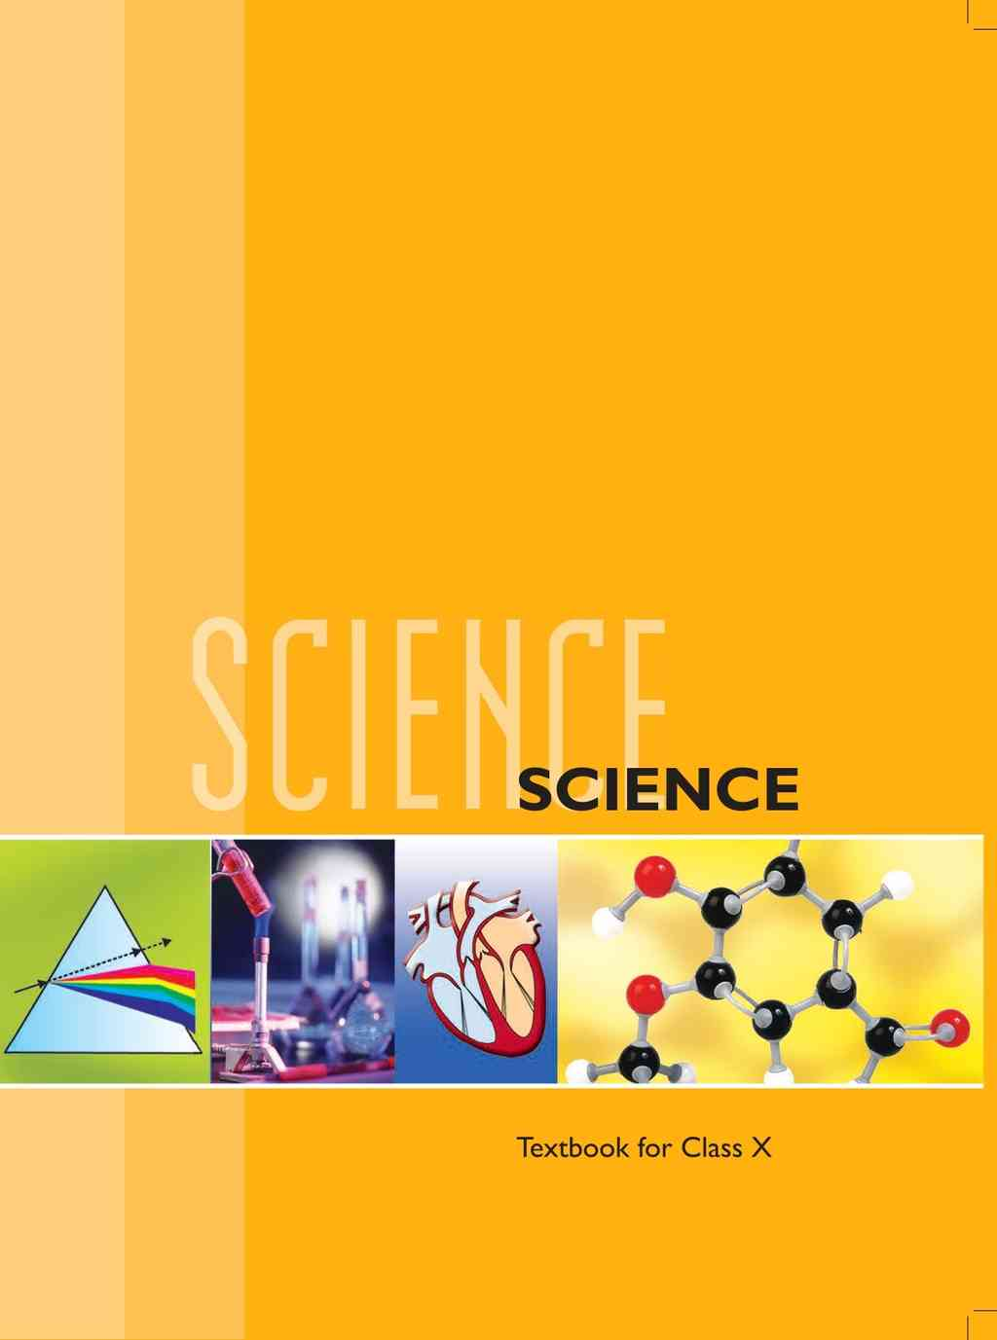

# SCIENCE

**Textbook for Class X**



1064

Logo of National Council of Educational Research and Training.

**राष्ट्रीय शैक्षिक अनुसंधान और प्रशिक्षण परिषद्**

**NATIONAL COUNCIL OF EDUCATIONAL RESEARCH AND TRAINING**

***First Edition***

*December 2006 Agrahayana 1928*

***Reprinted***

*November 2007 Kartika 1929*

*January 2009 Pausa 1930*

*December 2009 Pausa 1931*

*November 2010 Kartika 1932*

*January 2012 Magha 1933*

*November 2012 Kartika 1934*

*October 2013 Asvina 1935*

*December 2014 Pausa 1936*

*December 2015 Agrahayana 1937*

*February 2017 Magha 1938*

*January 2018 Pausa 1939*

*January 2019 Pausa 1940*

*August 2019 Bhadrapada 1941*

**PD 750T BS**

***© National Council of Educational Research and Training, 2006***

**₹ 190.00**

*Printed on 80 GSM paper with NCERT watermark*

Published at the Publication Division by the Secretary, National Council of Educational Research and Training, Sri Auroblndo Marg, New Delhi 110016 and printed at Ana Print O Grafix Pvt. Ltd., 347-K, Udyog Kendra Extn.—II, Sector Ecotech—III, Greater Noida— 201306

**ISBN 81-7450-636-5**

**ALL RIGHTS RESERVED**

No part of this publication may be reproduced, stored in a retrieval system or transmitted, in any form or by any means, electronic, mechanical, photocopying, recording or otherwise without the prior permission of the publisher.

This book is sold subject to the condition that it shall not, by way of trade, be lent, re-sold, hired out or otherwise disposed of without the publisher’s consent, in any form of binding or cover other than that in which it is published.

The correct price of this publication is the price printed on this page, Any revised price indicated by a rubber stamp or by a sticker or by any other means is incorrect and should be unacceptable.

**OFFICES OF THE PUBLICATION DIVISION, NCERT**

NCERT Campus Sri Aurobindo Marg **New Delhi 110016** **Phone: 011-26562708**

108, 100 Feet Road Hosdakere Halli Extension Banashankari III Stage **Bengaluru 560085** **Phone: 080-26725740**

Navjivan Trust Building P.O. Navjivan **Ahmedabad 380014** **Phone: 079-27541446**

CWC Campus Opp. Dhankal Bus Stop Panihati **Kolkata 700114** **Phone: 033-25530454**

CWC Complex Maligaon **Guwahati 781021** **Phone: 0361-2674869**

**Publication Team**

Head, Publication Division: *M. Siraj Anwar*

Chief Editor: *Shveta Uppal*

Chief Production Officer: *Arun Chitkara*

Chief Business Manager: *Bibash Kumar Das*

Production Assistant: *Rajesh Pippal*

Cover, Layout and Illustrations: *Digital Expressions*

## Foreword

The National Curriculum Framework, (NCF), 2005, recommends that children’s life at school must be linked to their life outside the school. This principle marks a departure from the legacy of bookish learning which continues to shape our system and causes a gap between the school, home and community. The syllabi and textbooks developed on the basis of NCF signify an attempt to implement this basic idea. They also attempt to discourage rote learning and the maintenance of sharp boundaries between different subject areas. We hope these measures will take us significantly further in the direction of a child-centered system of education outlined in the National Policy on Education (1986).

The success of this effort depends on the steps that school principals and teachers will take to encourage children to reflect on their own learning and to pursue imaginative activities and questions. We must recognize that, given space, time and freedom, children generate new knowledge by engaging with the information passed on to them by adults. Treating the prescribed textbook as the sole basis of examination is one of the key reasons why other resources and sites of learning are ignored. Inculcating creativity and initiative is possible if we perceive and treat children as participants in learning, not as receivers of a fixed body of knowledge.

These aims imply considerable change in school routines and mode of functioning. Flexibility in the daily time-table is as necessary as rigor in implementing the annual calendar so that the required number of teaching days are actually devoted to teaching. The methods used for teaching and evaluation will also determine how effective this textbook proves for making children’s life at school a happy experience, rather than a source of stress or boredom. Syllabus designers have tried to address the problem of curricular burden by restructuring and reorienting knowledge at different stages with greater consideration for child psychology and the time available for teaching. The textbook attempts to enhance this endeavour by giving higher priority and space to opportunities for contemplation and wondering, discussion in small groups, and activities requiring hands-on experience.

The National Council of Educational Research and Training (NCERT) appreciates the hard work done by the textbook development team responsible for this book. We wish to thank the Chairman of the advisory group in science and mathematics, Professor J.V. Narlikar and the Chief Advisor for this book, Professor Rupamanjari Ghosh, School of Physical Sciences, Jawaharlal Nehru University, New Delhi, for guiding the work of this committee. Several teachers contributed to the development of this textbook; we are grateful to them and their principals for making this possible. We are indebted to the institutions and organisations which have generously permitted us to draw upon their resources, material and personnel. We are especially grateful to the members of the National Monitoring Committee, appointed by the Department of Secondary and Higher Education, Ministry of Human Resource Development under the Chairmanship of Professor Mrinal Miri and Professor G.P. Deshpande, for their valuable time and contribution. As an organisation committed to systemic reform and continuous improvement in the quality of its products, NCERT welcomes comments and suggestions which will enable us to undertake further revision and refinement.

*New Delhi*

20 November 2006

*Director*

National Council of Educational Research and Training

## Preface

This textbook of Science for Class X is a continuation of our attempt in the Class IX Science textbook to comply with the guidelines of the National Curriculum Framework-2005. We had to work within a limited time frame and also had our own constraints coming in the way of this radical change. The revised and re-structured syllabus for Class X covers selected topics in the broad themes of — Materials, The World of the Living, How Things Work, Natural Phenomena and Natural Resources. We have interpreted the syllabus to present a coherent coverage of scientific concepts related to our daily life on the select topics. It is an integrated approach to science at this level, with no sharp divisions into disciplines such as Physics, Chemistry, Biology and Environmental Science.

There has been a conscious attempt to address the relevant social concerns in this science textbook wherever possible — the concerns for people with special needs, the issues of gender discrimination, energy and environment have found their natural place in this book. Students have been encouraged to get into the debates on some of the management concerns (for sustainable development, for example) so that they can arrive at their own decisions after a scientific analysis of all the facts.

This book has some features which are meant to enhance its effectiveness. The theme of each chapter has been introduced with examples from daily life, and if possible, by a relevant activity that the students have to perform. The entire approach of the book is, in fact, activity-based, i.e., the students are required to construct knowledge themselves from these activities. The emphasis is not on definitions and technical terms, but on the concepts involved. Special care has been taken so that the rigour of science is not lost while simplifying the language. Difficult and challenging ideas, which are not to be covered at this stage, have often been placed as extra material in the boxes in light orange. The excitement of doing science comes from pursuing the unknown — the students would have the opportunity to think and explore somewhat beyond the syllabus and may feel the urge to continue their scientific expedition at higher levels. All such box items, including brief biography of scientists, are, of course, non-evaluative.

Solved examples are provided, wherever felt necessary, to clarify a concept. The in-text questions after a main section are for the students to check their understanding of the topic. At the end of each chapter, there is a quick review of the important points covered in the chapter. We have introduced some multiple choice questions in the exercises. There are problems of different difficulty levels answers to the multiple-choice questions and numericals, and hints for the difficult questions are included at the end of the book.

This book has been made possible because of the active participation of many people. I wish to thank Professor Krishna Kumar, *Director*, NCERT, Prof. G. Ravindra, *Joint* *Director*, NCERT, and Professor Hukum Singh, Head, Department of Education in Science and Mathematics, NCERT, specially for their keen interest in the development of the book and for all the administrative support. I wish to put on record my sincere appreciation for Dr Anjni Koul, the member-coordinator of the textbook development committee, for her extraordinary commitment and efficiency. It has been a real pleasure working with my textbook development team and the review committee. The chosen editorial team worked extremely hard, on tight deadlines, to bring the book close to the shape that we dreamt of. Fruitful discussions with some members of the MHRD Monitoring Committee helped in providing the final touches to the book. I do not have the words to acknowledge the professional and personal inputs I received from some of my close friends during the preparation of this book. We warmly welcome comments and suggestions for improvement from our readers.

Rupamanjari Ghosh

Professor of Physics

School of Physical Sciences

Jawaharlal Nehru University

New Delhi

## Textbook Development Committee

**Chairman, Advisory Group for textbooks in Science and Mathematics**

J.V. Narlikar, *Emeritus* *Professor*, Inter-University Centre for Astronomy and Astrophysics (IUCAA), Ganeshkhind, Pune University, Pune

**Chief Advisor**

Rupamanjari Ghosh, *Professor*, School of Physical Sciences, Jawaharlal Nehru University, New Delhi

**Members**

Alka Mehrotra, *Reader*, DESM, NCERT, New Delhi

Animesh K. Mohapatra, *Reader*, Regional Institute of Education, Ajmer

B.B. Swain, *Professor* (Retd.), Department of Physics, Utkal University, Orissa

B.K. Sharma, *Professor*, DESM, NCERT, New Delhi

B.K. Tripathi, *Reader*, DESM, NCERT, New Delhi

Brahm Parkash, *Professor*, DESM, NCERT, New Delhi

Charu Maini, *PGT*, Salwan Public School, Gurgaon, Haryana

Dinesh Kumar, *Reader*, DESM, NCERT, New Delhi

Gagan Gupta, *Reader*, DESM, NCERT, New Delhi

H.L. Satheesh, *TGT*, DM School, Regional Institute of Education, Mysore

Ishwant Kaur, *PGT*, DM School, Regional Institute of Education, Bhopal

J.D. Arora, *Reader*, Hindu College, Moradabad, Uttar Pradesh

Meenambika Menon, *TGT*, Cambridge School, Noida, Uttar Pradesh

Puran Chand, *Professor* *and* *Jt*. *Director* (Retd.), Central Institute of Educational Technology NCERT, New Delhi

Reeta Sharma, *Reader*, Regional Institute of Education, Bhopal

R.P. Singh, *Lecturer*, Rajkiya Pratibha Vikas Vidyalaya, Kishan Ganj, Delhi

Satyajit Rath, *Scientist*, National Institute of Immunology, JNU Campus, New Delhi

S.K. Dash, *Reader*, Regional Institute of Education, Bhubaneswar

Sunita Ramrakhiani, *PGT*, Ahlcon Public School, Delhi

Uma Sudhir, Eklavya, Indore, Madhya Pradesh

Vandana Saxena, *TGT*, Kendriya Vidyalaya—4, Kandhar Lines, Delhi Cantt., New Delhi

Vinod Kumar, *Reader*, Hans Raj College, Delhi University, Delhi

**Member-coordinator**

Anjni Koul, *Lecturer*, DESM, NCERT, New Delhi

## Acknowledgements

The National Council of Educational Research and Training (NCERT), besides expressing its gratefulness towards the members of the Textbook Development Committee for their contribution in the development of the Science Textbook for Class X, also acknowledges the contribution of the following members for reviewing, editing, refining, and finalisation of the manuscript of the book. Kanhiya Lal, *Principal* (Retd.), Directorate of Education, NCT, Delhi; Ranveer Singh, *Lecturer*, Sarvodaya Bal Vidyalaya, Timarpur, Delhi; Bharat Poorey, *Professor* (Retd.), Govt. Post Graduate College, Indore; Gagandeep Bajaj, *Lecturer*, S.P.M. College, Delhi University, Delhi; Ravinder Kaur, *TGT*, Kendriya Vidyalaya, Rohini, Delhi; Renu Puri, *TGT*, N.C. Jindal Public School, New Delhi; Sarita Kumar, *Reader*, Acharya Narendra Dev College, Delhi University, Delhi; Shashi Prabha, *Lecturer*, DESM, NCERT, Delhi; Rashmi Sharma, *Lecturer*, NERIE, Shillong; Sushma Jaireth, *Reader*, DWS, NCERT, New Delhi; Y.P. Purang, Addl. Director of Education (Retd.), NCT, Delhi; Neeta Agarwal, *TGT*, D.L.D.A.V. Model School, Pitampura, Delhi; Roma Anand, *TGT*, D.L.D.A.V., Pitampura, Delhi; Veer Pal Singh, *Reader*, DEME, NCERT, New Delhi and S.L. Varte, *Lecturer*, DESM, NCERT, New Delhi.

The Council also acknowledges the valuable contribution of Sunita Farkya (*Professor*, DESM), Pushplata Verma (*Assistant* *Professor*, DESM), K.C. Tripathi (*Professor*, DEL) and Jatindra Mohan Misra (*Professor*, DEL) in updating Chapter 16 titled “Sustainable Management of Natural Resources”, and also in the review of this textbook.

The contribution of R.S. Sindhu, *Professor* (Retd.), DESM; V.P. Srivastava, *Professor* (Retd.), DESM; R.K. Parashar, Rachna Garg (*Professors*, DESM); V.V. Anand, *Professor* (Retd.), RIE Mysore; S.V. Sharma (*Professor*, RIE Mysore); V.P. Singh (*Professor*, RIE Ajmer); R. Joshi, *Associate* *Professor* (Retd.), DESM; C.V. Shimray, Ruchi Verma (*Associate* *Professors*, DESM); Ram Babu Pareek (*Associate* *Professor*, RIE Ajmer); A.K. Srivastava, Rejaul Karim Barbhuiya, Pramila Tanwar (*Assistant* *Professors*, DESM); R.R. Koireng (*Assistant* *Professor*, DCS); V. Tangpu (*Assistant* *Professor*, RIE Mysore) and Akhileshwar Mishra (*Head* *Master*, DMS, RIE Bhubaneswar), in the review of this textbook in 2017-18 are acknowledged.

Special thanks are due to Hukum Singh, *Professor* and Former *Head*, DESM, NCERT, New Delhi, for providing all academic and administrative support.

The Council also gratefully acknowledges the support provided by the APC Office of DESM, administrative staff of DESM; Deepak Kapoor, *Incharge*, Computer Station, DESM; Saima and Arvind Sharma, *DTP* *Operators* and Rajesh Handa, *Illustrator*; Mohd. Qamar Tabrez and Musarrat Parveen, *Copy* *Editors*; Seema Yadav, *Proof* *Reader*. The efforts of the Publication Department, NCERT are also highly appreciated.

# Contents

## The Constitution of India

**PREAMBLE**

**WE, THE PEOPLE OF INDIA,** having solemnly resolved to constitute India into a 1**[SOVEREIGN SOCIALIST SECULAR DEMOCRATIC REPUBLIC]** and to secure to all its citizens:

**JUSTICE,** social, economic and political;

**LIBERTY** of thought, expression, belief, faith and worship;

**EQUALITY** of status and of opportunity; and to promote among them all

**FRATERNITY** assuring the dignity of the individual and the 2[unity and integrity of the Nation];

**IN OUR CONSTITUENT ASSEMBLY** this twenty-sixth day of November, 1949 do **HEREBY ADOPT, ENACT AND GIVE TO OURSELVES THIS CONSTITUTION.**



Subs. by the Constitution (Forty-second Amendment) Act, 1976, See.2, for “Sovereign Democratic Republic” (w.e.f. 3.1.1977)↩︎



Subs. by the Constitution (Forty-second Amendment) Act, 1976, See.2, for “Unity of the Nation” (w.e.f. 3.1.1977)↩︎

## Chapter 1 – Chemical Reactions and Equations



1064CH01

***“Facts are not science — as the dictionary is not literature.”***

***-Martin H. Fischer***

Consider the following situations of daily life and think what happens when—

milk is left at room temperature during summers.

an iron tawa/pan/nail is left exposed to humid atmosphere.

grapes get fermented.

food is cooked.

food gets digested in our body.

we respire.

In all the above situations, the nature and the identity of the initial substance have somewhat changed. We have already learnt about physical and chemical changes of matter in our previous classes. Whenever a chemical change occurs, we can say that a chemical reaction has taken place.

You may perhaps be wondering as to what is actually meant by a chemical reaction. How do we come to know that a chemical reaction has taken place? Let us perform some activities to find the answer to these questions.

### Activity 1.1

**CAUTION:** This Activity needs the teacher’s assistance. It would be better if students wear suitable eyeglasses.

Clean a magnesium ribbon about 3-4 cm long by rubbing it with sandpaper.

Hold it with a pair of tongs. Burn it using a spirit lamp or burner and collect the ash so formed in a watch-glass as shown in Fig. 1.1. Burn the magnesium ribbon keeping it away as far as possible from your eyes.

What do you observe?

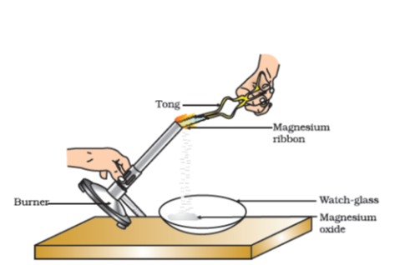

Figure 1.1 Burning of a magnesium ribbon in air and collection of magnesium oxide in a watch-glass

You must have observed that magnesium ribbon burns with a dazzling white flame and changes into a white powder. This powder is magnesium oxide. It is formed due to the reaction between magnesium and oxygen present in the air.

### Activity 1.2

Take lead nitrate solution in a test tube.

Add potassium iodide solution to this.

What do you observe?

### Activity 1.3

Take a few zinc granules in a conical flask or a test tube.

Add dilute hydrochloric acid or sulphuric acid to this (Fig. 1.2).

**CAUTION:** Handle the acid with care.

Do you observe anything happening around the zinc granules?

Touch the conical flask or test tube. Is there any change in its temperature?

From the above three activities, we can say that any of the following observations helps us to determine whether a chemical reaction has taken place—

change in state

change in colour

evolution of a gas

change in temperature.

As we observe the changes around us, we can see that there is a large variety of chemical reactions taking place around us. We will study about the various types of chemical reactions and their symbolic representation in this Chapter.

### 1.1 - Chemical Equations

Activity 1.1 can be described as— when a magnesium ribbon is burnt in oxygen, it gets converted to magnesium oxide. This description of a chemical reaction in a sentence form is quite long. It can be written in a shorter form. The simplest way to do this is to write it in the form of a word-equation.

The word-equation for the above reaction would be—

︸Magnesium+Oxygenreactants→︸Magnesium oxideproduct\underset{\text{reactants}}{\overset{Magnesium + Oxygen}{︸}} \rightarrow \underset{\text{product}}{\overset{\text{Magnesium\ oxide}}{︸}}

…(1.1)

The substances that undergo chemical change in the reaction (1.1), magnesium and oxygen, are the reactants. The new substance is magnesium oxide, formed during the reaction, as a product.

A word-equation shows change of reactants to products through an arrow placed between them. The reactants are written on the left-hand side (LHS) with a plus sign (+) between them. Similarly, products are written on the right-hand side (RHS) with a plus sign (+) between them. The arrowhead points towards the products, and shows the direction of the reaction.

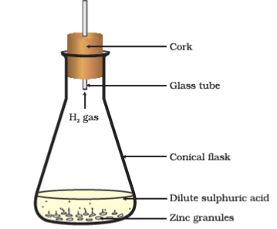

Figure 1.2 Formation of hydrogen gas by the action of dilute sulphuric acid on zinc

#### 1.1.1 - Writing a Chemical Equation

Is there any other shorter way for representing chemical equations? Chemical equations can be made more concise and useful if we use chemical formulae instead of words. A chemical equation represents a chemical reaction. If you recall formulae of magnesium, oxygen and magnesium oxide, the above word-equation can be written as –

Mg + O2→ MgO\text{Mg\ +\ }\text{O}_{2}\ \rightarrow \text{\ MgO}

…(1.2)

Count and compare the number of atoms of each element on the LHS and RHS of the arrow. Is the number of atoms of each element the same on both the sides? If yes, then the equation is balanced. If not, then the equation is unbalanced because the mass is not the same on both sides of the equation. Such a chemical equation is a skeletal chemical equation for a reaction. Equation (1.2) is a skeletal chemical equation for the burning of magnesium in air.

#### 1.1.2 - Balanced Chemical Equations

Recall the law of conservation of mass that you studied in Class IX; mass can neither be created nor destroyed in a chemical reaction. That is, the total mass of the elements present in the products of a chemical reaction has to be equal to the total mass of the elements present in the reactants.

In other words, the number of atoms of each element remains the same, before and after a chemical reaction. Hence, we need to balance a skeletal chemical equation. Is the chemical Eq. (1.2) balanced? Let us learn about balancing a chemical equation step by step.

The word-equation for Activity 1.3 may be represented as –

Zinc+Sulphuric acid → Zinc sulphate+HydrogenZinc\ + \ Sulph\text{uric\ acid\ } \rightarrow \text{\ Zinc\ sulp}hate\ + \ Hydrogen

The above word-equation may be represented by the following chemical equation –

Zn+H2SO4→ZnSO4 + H2\text{Zn}\ + \ \text{H}_{2}\text{S}O_{4}\ \rightarrow \ \text{ZnS}O_{4}\text{\ +\ }H_{2}

…(1.3)

Let us examine the number of atoms of different elements on both sides of the arrow.

| **Element** | **Number of atoms in reactants (LHS)** | **Number of atoms in products (RHS)** |
| --- | --- | --- |
| Zn | 1 | 1 |
| H | 2 | 2 |
| S | 1 | 1 |
| O | 4 | 4 |

As the number of atoms of each element is the same on both sides of the arrow, Eq. (1.3) is a balanced chemical equation.

Let us try to balance the following chemical equation –

Fe+H2O → Fe3O4 + H2Fe\ + \ H_{2}\text{O\ } \rightarrow \text{\ F}e_{3}O_{4}\text{\ +\ }H_{2}

…(1.4)

**Step I:** To balance a chemical equation, first draw boxes around each formula. Do not change anything inside the boxes while balancing the equation.

Fe+H2O→FeO4+H2Fe\ + \ H_{2}O \rightarrow \text{Fe}O_{4} + H_{2}

…(1.5)

**Step II:** List the number of atoms of different elements present in the unbalanced equation (1.5).

|  |  |  |
| --- | --- | --- |
| **Element** | **Number of atoms in reactants (LHS)** | **Number of atoms in products (RHS)** |
| Fe | 1 | 3 |
| H | 2 | 2 |
| O | 1 | 4 |

**Step III:** It is often convenient to start balancing with the compound that contains the maximum number of atoms. It may be a reactant or a product. In that compound, select the element which has the maximum number of atoms. Using these criteria, we select Fe3O4\text{Fe}_{3}O_{4}

and the element oxygen in it. There are four oxygen atoms on the RHS and only one on the LHS.

To balance the oxygen atoms –

| **Atoms of oxygen** | **In reactants** | **In products** |
| --- | --- | --- |
| Initial | 1 (inH2O\ H_{2}O  ) | 4 (InFe3O4\text{Fe}_{3}O_{4}  ) |
| To balance | 1×4\text{1\ }\text{×}\text{\ 4} | 4 |

To equalise the number of atoms, it must be remembered that we cannot alter the formulae of the compounds or elements involved in the reactions. For example, to balance oxygen atoms we can put coefficient ‘4’ as 4 H2OH_{2}O

and not H2O4H_{2}O_{4}

H2O4H_{2}O_{4}

or (H2O)4\left( H_{2}O \right)_{4}

. Now the partly balanced equation becomes –

Fe+4H2O→Fe3O4+H2Fe\ + \ 4\text{H}_{2}O \rightarrow \text{Fe}_{3}O_{4} + H_{2}

…(1.6) (partly balanced equation)

**Step IV:** Fe and H atoms are still not balanced. Pick any of these elements to proceed further. Let us balance hydrogen atoms in the partly balanced equation.

To equalise the number of H atoms, make the number of molecules of hydrogen as four on the RHS.

| **Atoms of hydrogen** | **In reactants** | **In products** |
| --- | --- | --- |
| Initial | 8 (in4H2O4\ H_{2}O  ) | 2 (inH2H_{2}  ) |
| To balance | 8 | 2×4\text{2\ }\text{×}\text{\ 4} |

The equation would be –

Fe+4H2O→Fe3O4+4H2Fe\ + \ 4\text{H}_{2}O \rightarrow \text{Fe}_{3}O_{4} + 4H_{2}

…(1.7) (partly balanced equation)

**Step V:** Examine the above equation and pick up the third element which is not balanced. You find that only one element is left to be balanced, that is, iron.

| **Atoms of iron** | **In reactants** | **In products** |
| --- | --- | --- |
| Initial | 1 (in Fe) | 3 (inFe3O4\text{Fe}_{3}O_{4}  ) |
| To balance | 1×3\text{1\ }\text{×}\text{\ 3} | 3 |

To equalise Fe, we take three atoms of Fe on the LHS.

3Fe+4H2O→Fe3O4+4 H23Fe\ + \ 4H_{2}O \rightarrow \text{Fe}_{3}O_{4} + 4\text{\ }H_{2}

…(1.8)

**Step VI:** Finally, to check the correctness of the balanced equation, we count atoms of each element on both sides of the equation.

3Fe+4H2O→Fe3O4+4H23Fe\ + \ 4H_{2}O \rightarrow \text{Fe}_{3}O_{4} + \text{4}H_{2}

…(1.9) (balanced equation)

The numbers of atoms of elements on both sides of Eq. (1.9) are equal. This equation is now balanced. This method of balancing chemical equations is called hit-and-trial method as we make trials to balance the equation by using the smallest whole number coefficient.

**Step VII:** ***Writing Symbols of Physical States*** Carefully examine the above balanced Eq. (1.9). Does this equation tell us anything about the physical state of each reactant and product? No information has been given in this equation about their physical states.

To make a chemical equation more informative, the physical states of the reactants and products are mentioned along with their chemical formulae. The gaseous, liquid, aqueous and solid states of reactants and products are represented by the notations (g), (1), (aq) and (s), respectively. The word aqueous (aq) is written if the reactant or product is present as a solution in water.

The balanced Eq. (1.9) becomes

3Fe(s) + 4H2O(g)→ Fe3O4(s) + 4H2(g)3\text{Fe}(s)\text{\ +\ 4}H_{2}O(g)\ \rightarrow \text{\ }\text{Fe}_{3}O_{4}(s)\text{\ +\ 4}H_{2}(g)

…(1.10)

Note that the symbol (g) is used with H2OH_{2}O

to indicate that in this reaction water is used in the form of steam.

Usually physical states are not included in a chemical equation unless it is necessary to specify them.

Sometimes the reaction conditions, such as temperature, pressure, catalyst, etc., for the reaction are indicated above and/or below the arrow in the equation. For example –

CO(g) + 2H2(g)→340atmCH3OH(l)\text{CO}(g)\text{\ +\ 2}H_{2}(g)\overset{\text{340atm}}{\rightarrow}CH_{3}\text{OH}(l)

…(1.11)

6CO2(aq)+12H2O(l)→SunlightChlorophyllC6H12O6(aq)(Glucose)+6O2(aq)+6H2O(l)6C\text{O}_{2}(\text{aq})\ + 12H_{2}O(l)\overset{\begin{matrix} \text{Sunlig}ht \\ Ch\text{lorop}h\text{yll} \\ \end{matrix}}{\rightarrow}\underset{(\text{Glucose})}{C_{6}H_{\text{12}}O_{6}(\text{aq})}\ + 6O_{2}(\text{aq})\ + 6H_{2}O(l)

…(1.12)

Using these steps, can you balance Eq. (1.2) given in the text earlier?

#### Questions

Why should a magnesium ribbon be cleaned before burning in air?

Write the balanced equation for the following chemical reactions.

Hydrogen+Chlorine → Hydrogen chlorideHydrogen + Ch\text{lorine\ } \rightarrow \text{\ Hydrogen\ c}h\text{loride}

Barium chloride+Aluminiumsulphate → Barium sulphate+Aluminiumchloride\text{Barium\ c}hloride\ + \ Aluminium\ sulph\text{ate\ } \rightarrow \text{\ Barium\ sulp}hate\ + \ Aluminium\ ch\text{loride}

Sodium+Water→ Sodium hydroxide+HydrogenSodium\ + \ Water\ \rightarrow \text{\ Sodium\ }hydroxide\ + \ Hydrogen

Write a balanced chemical equation with state symbols for the following reactions.

Solutions of barium chloride and sodium sulphate in water react to give insoluble barium sulphate and the solution of sodium chloride.

Sodium hydroxide solution (in water) reacts with hydrochloric acid solution (in water) to produce sodium chloride solution and water.

### 1.2 - Types Of Chemical Reactions

We have learnt in Class IX that during a chemical reaction atoms of one element do not change into those of another element. Nor do atoms disappear from the mixture or appear from elsewhere. Actually, chemical reactions involve the breaking and making of bonds between atoms to produce new substances. You will study about types of bonds formed between atoms in Chapters 3 and 4.

#### 1.2.1 - Combination Reaction

##### Activity 1.4

Take a small amount of calcium oxide or quick lime in a beaker.

Slowly add water to this.

Touch the beaker as shown in Fig. 1.3.

Do you feel any change in temperature?

Calcium oxide reacts vigorously with water to produce slaked lime (calcium hydroxide) releasing a large amount of heat.

CaO(s)(Quicklime)+ H2O(l)→Ca(OH)2(aq)(Slakedlime)+Heat\underset{(Quick\ lime)}{\text{CaO}(s)}\ + \text{\ }H_{2}O(l)\ \rightarrow \ \underset{(Slaked\ lime)}{\text{Ca}(\text{OH})_{2}(aq)}\ + \ Heat

…(1.13)

In this reaction, calcium oxide and water combine to form a single product, calcium hydroxide. Such a reaction in which a single product is formed from two or more reactants is known as a combination reaction.

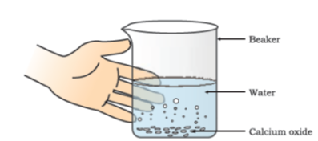

Figure 1.3 Formation of slaked lime by the reaction of calcium oxide with water

##### Do you know?

A solution of slaked lime produced by the reaction 1.13 is used for whitewashing walls. Calcium hydroxide reacts slowly with the carbon dioxide in air to form a thin layer of calcium carbonate on the walls. Calcium carbonate is formed after two to three days of whitewashing and gives a shiny finish to the walls. It is interesting to note that the chemical formula for marble is also CaCO3\text{CaC}\text{O}_{3}

.

Ca(OH)2(aq)(Calciumhydroxide)+CO2(g)→CaCO3(s)(Calciumcarbonate)+ H2O(l)\underset{(\text{Calcium}\ h\text{ydroxide})}{\text{Ca}(\text{OH})_{2}(\text{aq})}\ + \ CO_{2}(g)\ \rightarrow \ \underset{(\text{Calcium}\ \text{carbonate})}{\text{CaC}O_{3}(s)}\ \text{+\ }H_{2}O(l)

…(1.14)

Let us discuss some more examples of combination reactions.

Burning of coal

C(s) + O2(g)→ CO2(g)C(s)\text{\ +\ }O_{2}(g)\ \rightarrow \text{\ C}O_{2}(g)

…(1.15)

Formation of water from H2H_{2}

(g) and O2O_{2}

(g)

2H2(g) + O2(g)→2H2O(l)2H_{2}(g)\text{\ +\ }O_{2}(g)\ \rightarrow \ 2H_{2}O(l)

…(1.16)

In simple language we can say that when two or more substances (elements or compounds) combine to form a single product, the reactions are called combination reactions.

In Activity 1.4, we also observed that a large amount of heat is evolved. This makes the reaction mixture warm. Reactions in which heat is released along with the formation of products are called exothermic chemical reactions.

Other examples of exothermic reactions are –

Burning of natural gas

CH4(g)+2O2(g)→CO2(g)+2H2O(g)CH_{4}(g)\ + \ 2O_{2}\ (g)\ \rightarrow \ CO_{2}\ (g)\ + \ 2H_{2}O\ (g)

…(1.17)

Do you know that respiration is an exothermic process?

We all know that we need energy to stay alive. We get this energy from the food we eat. During digestion, food is broken down into simpler substances. For example, rice, potatoes and bread contain carbohydrates. These carbohydrates are broken down to form glucose. This glucose combines with oxygen in the cells of our body and provides energy. The special name of this reaction is respiration, the process of which you will study in Chapter 6.

︸C6H12O6(aq)(Glucose)+6O2(aq)→6CO2(aq)+6H2O(l)+energy\underset{(Glucose)}{\overset{C_{6}H_{\text{12}}O_{6}(aq)}{︸}}\ + \ 6O_{2}(aq)\ \rightarrow \ 6C\text{O}_{2}(\text{aq})\ + \ 6H_{2}O(l)\ + \ energy

…(1.18)

The decomposition of vegetable matter into compost is also an example of an exothermic reaction.

Identify the type of the reaction taking place in Activity 1.1, where heat is given out along with the formation of a single product.

#### 1.2.2 - Decomposition Reaction

##### Activity 1.5

Take about 2 g ferrous sulphate crystals in a dry boiling tube.

Note the colour of the ferrous sulphate crystals.

Heat the boiling tube over the flame of a burner or spirit lamp as shown in Fig. 1.4.

Observe the colour of the crystals after heating.

Have you noticed that the green colour of the ferrous sulphate crystals has changed? You can also smell the characteristic odour of burning Sulphur.

︸2FeSO4(s)(Ferroussulphate)→Heat︸Fe2O3(s)(Ferricoxide)+SO2(g)+SO3(g)\underset{(Ferrous\ sulph\text{ate})}{\overset{2FeSO_{4}\left( s \right)}{︸}}\overset{\text{Heat}}{\rightarrow}\underset{(Ferric\ oxide)}{\overset{\text{Fe}_{2}O_{3}\left( s \right)}{︸}}\ + \ SO_{2}\left( g \right)\ + \ SO_{3}\left( g \right)

…(1.19)

In this reaction you can observe that a single reactant breaks down to give simpler products. This is a decomposition reaction. Ferrous sulphate crystals (FeSO4\text{FeS}O_{4}

, 7H2O7H_{2}O

) lose water when heated and the colour of the crystals changes. It then decomposes to ferric oxide (Fe2O3\text{Fe}_{2}O_{3}

), Sulphur dioxide (SO2SO_{2}

) and Sulphur trioxide (SO3\text{S}\text{O}_{3}

). Ferric oxide is a solid, while SO2\text{S}\text{O}_{2}

and SO3\text{S}\text{O}_{3}

are gases.

Decomposition of calcium carbonate to calcium oxide and carbon dioxide on heating is an important decomposition reaction used in various industries. Calcium oxide is called lime or quick lime. It has many uses – one is in the manufacture of cement. When a decomposition reaction is carried out by heating, it is called thermal decomposition.

︸CaCO3(s)(Limestone)→Heat︸CaO(s)(quicklime)+CO2(g)\underset{(Limestone)}{\overset{\text{CaC}O_{3}(s)}{︸}}\overset{\text{Heat}}{\rightarrow}\underset{(quicklime)}{\overset{CaO(s)}{︸}}\ + \ CO_{2}(g)

…(1.20)

Another example of a thermal decomposition reaction is given in Activity 1.6.

##### Activity 1.6

Take about 2 g lead nitrate powder in a boiling tube.

Hold the boiling tube with a pair of tongs and heat it over a flame, as shown in Fig. 1.5.

What do you observe? Note down the change, if any.

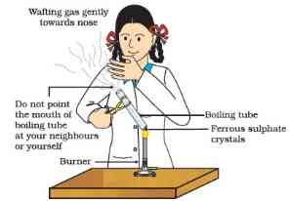

Figure 1.4 Correct way of heating the boiling tube containing crystals of ferrous sulphate and of smelling the odour

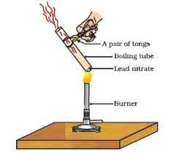

Figure 1.5 Heating of lead nitrate and emission of nitrogen dioxide

You will observe the emission of brown fumes. These fumes are of nitrogen dioxide (NO2NO_{2}

). The reaction that takes place is –

︸2Pb(NO3)2(Leadnitrate)(s)→Heat︸2PbO(s)(Leadoxide)+︸4NO2(g)Nitrogendioxide+︸O2(g)(oxygen)\underset{(\text{Lead}\ \text{nitrate})}{\overset{2\text{Pb}(NO_{3})_{2}}{︸}}(s)\overset{\text{Heat}}{\rightarrow}\underset{(\text{Lead}\ \text{oxide})}{\overset{2\text{PbO}(s)}{︸}}\ + \ \underset{\text{Nitrogen}\ \text{dioxide}}{\overset{4NO_{2}(g)}{︸}}\ + \ \underset{(oxygen)}{\overset{O_{2}(g)}{︸}}

…(1.21)

Let us perform some more decomposition reactions as given in Activities 1.7 and 1.8.

##### Activity 1.7

Take a plastic mug. Drill two holes at its base and fit rubber stoppers in these holes. Insert carbon electrodes in these rubber stoppers as shown in Fig. 1.6.

Connect these electrodes to a 6 volt battery.

Fill the mug with water such that the electrodes are immersed. Add a few drops of dilute sulphuric acid to the water.

Take two test tubes filled with water and invert them over the two carbon electrodes.

Switch on the current and leave the apparatus undisturbed for some time.

You will observe the formation of bubbles at both the electrodes. These bubbles displace water in the test tubes.

Is the volume of the gas collected the same in both the test tubes?

Once the test tubes are filled with the respective gases, remove them carefully.

Test these gases one by one by bringing a burning candle close to the mouth of the test tubes.

**CAUTION:** This step must be performed carefully by the teacher.

What happens in each case?

Which gas is present in each test tube?

##### Activity 1.8

Take about 2 g silver chloride in a china dish.

What is its colour?

Place this china dish in sunlight for some time (Fig. 1.7).

Observe the colour of the silver chloride after some time.

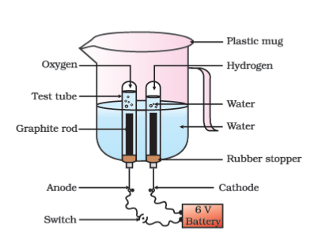

Figure 1.6 Electrolysis of water

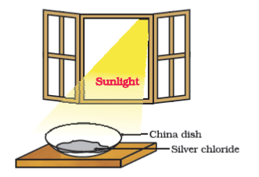

Figure 1.7 Silver chloride turns grey in sunlight to form silver metal

You will see that white silver chloride turns grey in sunlight. This is due to the decomposition of silver chloride into silver and chlorine by light.

2AgCl(s)→Sunlight2Ag(s) + Cl2(g)\text{2AgCl}(s)\overset{\text{Sunlight}}{\rightarrow}\text{2Ag}(s)\text{\ +\ C}\text{l}_{2}(g)

…(1.22)

Silver bromide also behaves in the same way.

2AgBr(s)→Sunlight2Ag(s) + Br2(g)\text{2AgBr}(s)\overset{\text{Sunlight}}{\rightarrow}\text{2Ag}(s)\text{\ +\ B}\text{r}_{2}(g)

…(1.23)

The above reactions are used in black and white photography.

What form of energy is causing these decomposition reactions?

We have seen that the decomposition reactions require energy either in the form of heat, light or electricity for breaking down the reactants. Reactions in which energy is absorbed are known as endothermic reactions.

##### Carry out the following Activity

Take about 2 g barium hydroxide in a test tube. Add 1 g of ammonium chloride and mix with the help of a glass rod. Touch the bottom of the test tube with your palm. What do you feel? Is this an exothermic or endothermic reaction?

#### Questions

A solution of a substance ‘X’ is used for whitewashing.

Name the substance ‘X’ and write its formula.

Write the reaction of the substance ‘X’ named in (i) above with water.

Why is the amount of gas collected in one of the test tubes in Activity 1.7 double of the amount collected in the other? Name this gas.

#### 1.2.3 - Displacement Reaction

##### Activity 1.9

Take three iron nails and clean them by rubbing with sand paper.

Take two test tubes marked as (A) and (B). In each test tube, take about 10 mL copper sulphate solution.

Tie two iron nails with a thread and immerse them carefully in the copper sulphate solution in test tube B for about 20 minutes [Fig. 1.8 (a)]. Keep one iron nail aside for comparison.

After 20 minutes, take out the iron nails from the copper sulphate solution.

Compare the intensity of the blue colour of copper sulphate solutions in test tubes (A) and (B) [Fig. 1.8 (b)].

Also, compare the colour of the iron nails dipped in the copper sulphate solution with the one kept aside [Fig. 1.8 (b)].

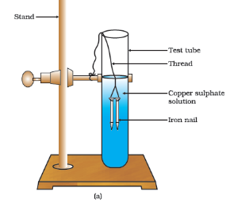

Figure 1.8 Iron nails dipped in copper sulphate solution

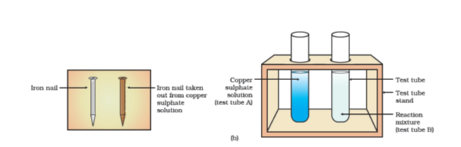

Figure 1.8 (b) Iron nails and copper sulphate solutions compared before and after the experiment

Why does the iron nail become brownish in colour and the blue colour of copper sulphate solution fades?

The following chemical reaction takes place in this Activity–

Fe(s)+︸CuSO4(aq)(coppersulphate)→︸FeSO4(aq)(ironsulphate)+Cu(s)\text{Fe}(s) + \underset{(\text{copper}\ \text{sulp}h\text{ate})}{\overset{\text{CuSO}_{4}(\text{aq})}{︸}} \rightarrow \underset{(\text{iron}\ \text{sulp}h\text{ate})}{\overset{\text{FeSO}_{4}(\text{aq})}{︸}} + \text{Cu}(s)

…(1.24)

In this reaction, iron has displaced or removed another element, copper, from copper sulphate solution. This reaction is known as displacement reaction.

Other examples of displacement reactions are

Zn(s)+︸CuSO4(aq)(coppersulphate)→︸ZnSO4(aq)(Zincsulphate)+Cu(s)\text{Zn}(s) + \underset{(copper\ sulphate)}{\overset{\text{CuSO}_{4}(\text{aq})}{︸}} \rightarrow \underset{(Zinc\ sulphate)}{\overset{\text{ZnSO}_{4}}{︸}(aq)} + \text{Cu}(s)

…(1.25)

Pb(s)+︸CuCl2(aq)(copperchloride)→︸PbCl2(aq)(leadchloride)+Cu(s)\text{Pb}(s) + \underset{(\text{copper}\ ch\text{loride})}{\overset{\text{CuCl}_{2}(\text{aq})}{︸}} \rightarrow \underset{(\text{lead}\ ch\text{loride})}{\overset{\text{PbCl}_{2}(\text{aq})}{︸}} + \text{Cu}(s)

…(1.26)

Zinc and lead are more reactive elements than copper. They displace copper from its compounds.

#### 1.2.4 - Double Displacement Reaction

##### Activity 1.10

Take about 3 mL of sodium sulphate solution in a test tube.

In another test tube, take about 3 mL of barium chloride solution.

Mix the two solutions (Fig. 1.9).

What do you observe?

You will observe that a white substance, which is insoluble in water, is formed. This insoluble substance formed is known as a precipitate. Any reaction that produces a precipitate can be called a precipitation reaction.

︸Na2SO4(aq)(sodiumsulphate)+︸BaCl2(aq)(bariumchloride)→︸BaSO4(s)(bariumsulphate)+︸2NaCl(aq)(sodiumchloride)\underset{(sodium\ sulphate)}{\overset{\text{Na}_{2}\text{SO}_{4}\left( \text{aq} \right)}{︸}} + \underset{(barium\ chloride)}{\overset{\text{BaCl}_{2}\left( \text{aq} \right)}{︸}} \rightarrow \underset{(barium\ sulphate)}{\overset{\text{BaSO}_{4}\left( s \right)}{︸}} + \underset{(sodium\ chloride)}{\overset{2\text{NaCl}\left( \text{aq} \right)}{︸}}

…(1.27)

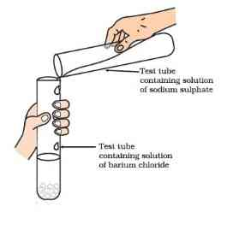

Figure 1.9 Formation of barium sulphate and sodium chloride

What causes this? The white precipitate of BaSO4\text{BaS}O_{4}

is formed by the reaction of SO42−\text{SO}_{4}^{2 -}

and Ba2+\text{Ba}^{2 +}

. The other product formed is sodium chloride which remains in the solution. Such reactions in which there is an exchange of ions between the reactants are called double displacement reactions.

***Recall Activity 1.2,*** where you have mixed the solutions of lead (II) nitrate and potassium iodide.

What was the colour of the precipitate formed? Can you name the compound precipitated?

Write the balanced chemical equation for this reaction.

Is this also a double displacement reaction?

#### 1.2.5 - Oxidation and Reduction

##### Activity 1.11

Heat a china dish containing about 1 g copper powder (Fig. 1.10).

What do you observe?

The surface of copper powder becomes coated with black copper (II) oxide. Why has this black substance formed?

This is because oxygen is added to copper and copper oxide is formed.

2Cu+O2→Heat2CuO2Cu{+ O}_{2}\overset{\text{Heat}}{\rightarrow}2CuO

…(1.28)

If hydrogen gas is passed over this heated material (CuO), the black coating on the surface turns brown as the reverse reaction takes place and copper is obtained.

CuO+H2→HeatCu+H2OCuO\ + H_{2}\overset{\text{Heat}}{\rightarrow}\ Cu + H_{2}O

…(1.29)

If a substance gains oxygen during a reaction, it is said to be oxidised. If a substance loses oxygen during a reaction, it is said to be reduced.

During this reaction (1.29), the copper (II) oxide is losing oxygen and is being reduced. The hydrogen is gaining oxygen and is being oxidised. In other words, one reactant gets oxidised while the other gets reduced during a reaction. Such reactions are called oxidation-reduction reactions or redox reactions.

CuO+H3→Heat︸CuReduction+︸H2OOxidation\text{CuO} + H_{3}\overset{\text{Heat}}{\longrightarrow}\underset{\text{Reduction}}{\overset{\text{Cu}}{︸}} + \underset{\text{Oxidation}}{\overset{H_{2}O}{︸}}

…(1.30)

Some other examples of redox reactions are:

ZnO+C→Zn+CO\text{ZnO}\ + \ C\ \rightarrow \ \text{Zn}\ + \ \text{CO}

…(1.31)

MnO2+4HCl→MnCl2+2H2O+Cl2\text{Mn}O_{2} + \ 4\text{HCl} \rightarrow \text{MnC}l_{2} + 2\text{H}_{2}O + Cl_{2}

…(1.32)

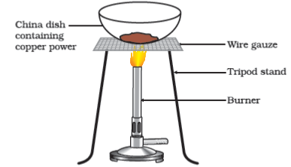

Figure 1.10 Oxidation of copper to copper oxide

In reaction (1.31) carbon is oxidised to CO and ZnO is reduced to Zn. In reaction (1.32) HCL is oxidised to Cl2\text{C}\text{l}_{2}

whereas MnO2\text{Mn}\text{O}_{2}

is reduced to MnCl2\text{MnC}l_{2}

.

From the above examples we can say that if a substance gains oxygen or loses hydrogen during a reaction, it is oxidised. If a substance loses oxygen or gains hydrogen during a reaction, it is reduced.

***Recall Activity 1.1,*** where a magnesium ribbon burns with a dazzling flame in air (oxygen) and changes into a white substance, magnesium oxide. Is magnesium being oxidised or reduced in this reaction?]

### 1.3 - Have You Observed The Effects Of Oxidation Reactions In Everyday Life?

#### 1.3.1 - Corrosion

You must have observed that iron articles are shiny when new, but get coated with a reddish brown powder when left for some time. This process is commonly known as rusting of iron. Some other metals also get tarnished in this manner. Have you noticed the colour of the coating formed on copper and silver? When a metal is attacked by substances around it such as moisture, acids, etc., it is said to corrode and this process is called corrosion. The black coating on silver and the green coating on copper are other examples of corrosion.

Corrosion causes damage to car bodies, bridges, iron railings, ships and to all objects made of metals, specially those of iron. Corrosion of iron is a serious problem. Every year an enormous amount of money is spent to replace damaged iron. You will learn more about corrosion in Chapter 3.

#### 1.3.2 - Rancidity

Have you ever tasted or smelt the fat/oil containing food materials left for a long time?

When fats and oils are oxidised, they become rancid and their smell and taste change. Usually substances which prevent oxidation (antioxidants) are added to foods containing fats and oil. Keeping food in air tight containers helps to slow down oxidation. Do you know that chips manufacturers usually flush bags of chips with gas such as nitrogen to prevent the chips from getting oxidised?

#### Questions

Why does the colour of copper sulphate solution change when an iron nail is dipped in it?

Give an example of a double displacement reaction other than the one given in Activity 1.10.

Identify the substances that are oxidised and the substances that are reduced in the following reactions.

4Na(s)+O2(g)→2Na2O(s)4Na(s)\ + \ \text{O}_{2}(g)\ \rightarrow \ 2N\text{a}_{2}O(s)

CuO(s)+H2(g)→ Cu(s)+H2O(l)\text{CuO}(s)\ + \ \text{H}_{2}(g)\ \rightarrow \text{\ Cu}(s)\ + \ \text{H}_{2}O(l)

### What you have learnt

A complete chemical equation represents the reactants, products and their physical states symbolically.

A chemical equation is balanced so that the numbers of atoms of each type involved in a chemical reaction are the same on the reactant and product sides of the equation. Equations must always be balanced.

In a combination reaction two or more substances combine to form a new single substance.

Decomposition reactions are opposite to combination reactions. In a decomposition reaction, a single substance decomposes to give two or more substances.

Reactions in which heat is given out along with the products are called exothermic reactions.

Reactions in which energy is absorbed are known as endothermic reactions.

When an element displaces another element from its compound, a displacement reaction occurs.

Two different atoms or groups of atoms (ions) are exchanged in double displacement reactions.

Precipitation reactions produce insoluble salts.

Reactions also involve the gain or loss of oxygen or hydrogen by substances. Oxidation is the gain of oxygen or loss of hydrogen. Reduction is the loss of oxygen or gain of hydrogen.

### Exercises

Which of the statements about the reaction below are incorrect?

2PbO(s)+C(s)→2Pb(s)+CO2(g)2PbO(s)\ + \ C(s)\ \rightarrow \ 2Pb(s)\ + \ C\text{O}_{2}(g)

Lead is getting reduced.

Carbon dioxide is getting oxidised.

Carbon is getting oxidised.

Lead oxide is getting reduced.

(a) and (b)

(a) and (c)

(a), (b) and (c)

all

Fe2O3+2Al→ Al2O3+2Fe\text{F}\text{e}_{2}O_{3}\ + \ 2\text{Al}\ \rightarrow \text{\ A}\text{l}_{2}O_{3}\ + \ 2Fe

The above reaction is an example of a

combination reaction.

double displacement reaction.

decomposition reaction.

displacement reaction.

What happens when dilute hydrochloric acid is added to iron fillings? Tick the correct answer.

Hydrogen gas and iron chloride are produced.

Chlorine gas and iron hydroxide are produced.

No reaction takes place.

Iron salt and water are produced.

What is a balanced chemical equation? Why should chemical equations be balanced?

Translate the following statements into chemical equations and then balance them.

Hydrogen gas combines with nitrogen to form ammonia.

Hydrogen sulphide gas burns in air to give water and sulpur dioxide.

Barium chloride reacts with aluminium sulphate to give aluminium chloride and a precipitate of barium sulphate.

Potassium metal reacts with water to give potassium hydroxide and hydrogen gas.

Balance the following chemical equations.

HNO3+Ca(OH)2→ Ca(NO3)2+H2O\text{HN}\text{O}_{3}\ + \ Ca(\text{OH})_{2}\ \rightarrow \text{\ Ca}(\text{N}\text{O}_{3})_{2}\ + \ \text{H}_{2}O

NaOH+H2SO4→ Na2SO4+H2ONaOH\ + \ \text{H}_{2}\text{S}\text{O}_{4}\ \rightarrow \text{\ N}\text{a}_{2}\text{S}\text{O}_{4}\ + \ \text{H}_{2}O

NaCl+AgNO3→AgCl+NaNO3NaCl\ + \ AgN\text{O}_{3}\ \rightarrow \ AgCl\ + \ NaN\text{O}_{3}

BaCl2+H2SO4→ BaSO4+HCl\text{BaC}\text{l}_{2}\ + \ \text{H}_{2}\text{S}\text{O}_{4}\ \rightarrow \text{\ BaS}\text{O}_{4}\ + \ HCl

Write the balanced chemical equations for the following reactions.

Calcium hydroxide+Carbondioxide→Calciumcarbonate+Water\text{Calcium\ }hydroxide\ + \ Carbon\ dioxide \rightarrow Calcium\ carbonate\ + \ Water

Zinc+Silvernitrate→Zincnitrate+SilverZinc\ + \ Silver\ nitrate\ \rightarrow \ Zinc\ nitrate\ + \ Silver

Aluminium+Copperchloride → Aluminium chloride+CopperAluminium\ + \ Copper\ ch\text{loride\ } \rightarrow \text{\ Aluminium\ c}hloride\ + \ Copper

Barium chloride+Potassiumsulphate→Barium sulphate+Potassiumchloride\text{Barium\ c}hloride\ + \ Potassium\ sulph\text{ate} \rightarrow \text{Barium\ sulp}hate\ + \ Potassium\ ch\text{loride}

Write the balanced chemical equation for the following and identify the type of reaction in each case.

Potassium bromide(aq)+Bariumiodide(aq)→ Potassium iodide(aq) + Barium bromide(s)\text{Potassium\ bromide}(\text{aq})\ + \ Barium\ iodide(\text{aq})\ \rightarrow \text{\ Potassium\ iodide}(\text{aq})\text{\ +\ Barium\ bromide}(s)

Zinc carbonate(s)→ Zinc oxide(s)+Carbondioxide(g)\text{Zinc\ carbonate}(s)\ \rightarrow \text{\ Zinc\ oxide}(s)\ + \ Carbon\ dioxide(g)

Hydrogen(g)+Chlorine(g)→ Hydrogen chloride(g)\text{Hydrogen}(g)\ + \ Ch\text{lorine}(g)\ \rightarrow \text{\ Hydrogen\ c}h\text{loride}(g)

Magnesium(s)+Hydrochloricacid(aq)→Magnesiumchloride(aq)+Hydrogen(g)\text{Magnesium}(s)\ + \ \text{Hydroc}h\text{loric}\ \text{acid}(\text{aq})\ \rightarrow \ \text{Magnesium}\ ch\text{loride}(\text{aq})\ + \ \text{Hydrogen}(g)

What does one mean by exothermic and endothermic reactions? Give examples.

Why is respiration considered an exothermic reaction? Explain.

Why are decomposition reactions called the opposite of combination reactions? Write equations for these reactions.

Write one equation each for decomposition reactions where energy is supplied in the form of heat, light or electricity.

What is the difference between displacement and double displacement reactions? Write equations for these reactions.

In the refining of silver, the recovery of silver from silver nitrate solution involved displacement by copper metal. Write down the reaction involved.

What do you mean by a precipitation reaction? Explain by giving examples.

Explain the following in terms of gain or loss of oxygen with two examples each.

Oxidation

Reduction

A shiny brown coloured element ‘X’ on heating in air becomes black in colour. Name the element ‘X’ and the black coloured compound formed.

Why do we apply paint on iron articles?

Oil and fat containing food items are flushed with nitrogen. Why?

Explain the following terms with one example each.

Corrosion

Rancidity

**Group Activity**

Perform the following activity.

Take four beakers and label them as A, B, C and D.

Put 25 mL of water in A, B and C beakers and copper sulphate solution in beaker D.

Measure and record the temperature of each liquid contained in the beakers above.

Add two spatulas of potassium sulphate, ammonium nitrate, anhydrous copper sulphate and fine iron fillings to beakers A, B, C and D respectively and stir.

Finally measure and record the temperature of each of the mixture above.

Find out which reactions are exothermic and which ones are endothermic in nature.

## Chapter 2 – Acids, Bases and Salts



1064CH02

You have learnt in your previous classes that the sour and bitter tastes of food are due to acids and bases, respectively, present in them.

If someone in the family is suffering from a problem of acidity after overeating, which of the following would you suggest as a remedy– lemon juice, vinegar or baking soda solution?

Which property did you think of while choosing the remedy? Surely you must have used your knowledge about the ability of acids and bases to nullify each other’s effect.

Recall how we tested sour and bitter substances without tasting them.

You already know that acids are sour in taste and change the colour of blue litmus to red, whereas, bases are bitter and change the colour of the red litmus to blue. Litmus is a natural indicator, turmeric is another such indicator. Have you noticed that a stain of curry on a white cloth becomes reddish-brown when soap, which is basic in nature, is scrubbed on it? It turns yellow again when the cloth is washed with plenty of water. You can also use synthetic indicators such as methyl orange and phenolphthalein to test for acids and bases.

In this Chapter, we will study the reactions of acids and bases, how acids and bases cancel out each other’s effects and many more interesting things that we use and see in our day-to-day life.

### Do you know?

Litmus solution is a purple dye, which is extracted from lichen, a plant belonging to the division Thallophyta, and is commonly used as an indicator. When the litmus solution is neither acidic nor basic, its colour is purple. There are many other natural materials like red cabbage leaves, turmeric, coloured petals of some flowers such as *Hydrangea*, *Petunia* and *Geranium*, which indicate the presence of acid or base in a solution. These are called acid-base indicators or sometimes simply indicators.

### Question

You have been provided with three test tubes. One of them contains distilled water and the other two contain an acidic solution and a basic solution, respectively. If you are given only red litmus paper, how will you identify the contents of each test tube?

### 2.1 - Understanding The Chemical Properties of Acids and Bases

#### 2.1.1 - Adds and Bases in the Laboratory

##### Activity 2.1

Collect the following solutions from the science laboratory–hydrochloric acid (HCL), sulphuric acid (H2SO4H_{2}\text{S}\text{O}_{4}

), nitric acid (HNO3\text{HN}\text{O}_{3}

), acetic acid (CH3COOH\text{C}\text{H}_{3}\text{COOH}

), sodium hydroxide (NaOH), calcium hydroxide [Ca(OH)2\text{Ca}(\text{OH})_{2}

], potassium hydroxide (KOH), magnesium hydroxide [Mg(OH)2\text{Mg}(\text{OH})_{2}

], and ammonium hydroxide (NH4OH\text{N}\text{H}_{4}\text{OH}

).

Put a drop of each of the above solutions on a watch-glass one by one and test with a drop of the indicators shown in Table 2.1.

What change in colour did you observe with red litmus, blue litmus, phenolphthalein and methyl orange solutions for each of the solutions taken?

Tabulate your observations in Table 2.1.

**Table 2.1**

|  |  |  |  |  |
| --- | --- | --- | --- | --- |
| Sample solution | Red litmus solution | Blue litmus solution | Phenolphthalein solution | Methyl orange solution |
|  |  |  |  |  |

These indicators tell us whether a substance is acidic or basic by change in colour. There are some substances whose odour changes in acidic or basic media. These are called olfactory indicators. Let us try out some of these indicators.

##### Activity 2.2

Take some finely chopped onions in a plastic bag along with some strips of clean cloth. Tie up the bag tightly and leave overnight in the fridge. The cloth strips can now be used to test for acids and bases.

Take two of these cloth strips and check their odour.

Keep them on a clean surface and put a few drops of dilute HCL solution on one strip and a few drops of dilute NaOH solution on the other.

Rinse both cloth strips with water and again check their odour.

Note your observations.

Now take some dilute vanilla essence and clove oil and check their odour.

Take some dilute HCL solution in one test tube and dilute NaOH solution in another. Add a few drops of dilute vanilla essence to both test tubes and shake well. Check the odour once again and record changes in odour, if any.

Similarly, test the change in the odour of clove oil with dilute HCL and dilute NaOH solutions and record your observations.

Which of these – vanilla, onion and clove, can be used as olfactory indicators on the basis of your observations?

Let us do some more activities to understand the chemical properties of acids and bases.

#### 2.1.2 - How do Adds and Bases React with Metals?

##### Activity 2.3

**CAUTION:** This activity needs the teacher’s assistance.

Set the apparatus as shown in Fig. 2.1.

Take about 5 mL of dilute sulphuric acid in a test tube and add a few pieces of zinc granules to it.

What do you observe on the surface of zinc granules?

Pass the gas being evolved through the soap solution.

Why are bubbles formed in the soap solution?

Take a burning candle near a gas filled bubble.

What do you observe?

Repeat this Activity with some more acids like HCl, HNO3\text{HCl,\ HN}\text{O}_{3}

and CH3COOH\text{C}\text{H}_{3}\text{COOH}

.

Are the observations in all the cases the same or different?

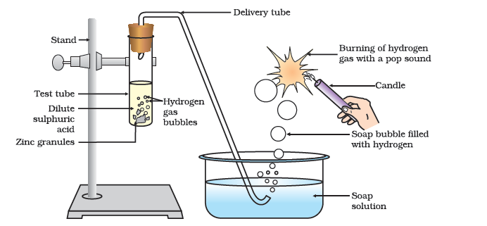

Figure 2.1 Reaction of zinc granules with dilute sulphuric acid and testing hydrogen gas by burning

Note that the metal in the above reactions displaces hydrogen atoms from the acids as hydrogen gas and forms a compound called a salt. Thus, the reaction of a metal with an acid can be summarised as –

Acid+Metal→Salt+HydrogengasAcid\ + \ Metal\ \rightarrow \ Salt\ + \ Hydrogen\ gas

Can you now write the equations for the reactions you have observed?

##### Activity 2.4

Place a few pieces of granulated zinc metal in a test tube.

Add 2 mL of sodium hydroxide solution and warm the contents of the test tube.

Repeat the rest of the steps as in Activity 2.3 and record your observations.

The reaction that takes place can be written as follows.

2NaOH(aq)+Zn(s)→︸Na2ZnO2(s)(sodiumzincate)+H2(g)\text{2NaOH}(\text{aq})\ + \ \text{Zn}(s)\ \rightarrow \underset{(\text{sodium}\ \text{zincate})}{\overset{Na_{2}\text{Zn}O_{2}(s)}{︸}}\ + \ \text{H}_{2}(g)

You find again that hydrogen is formed in the reaction. However, such reactions are not possible with all metals.

#### 2.1.3 - How do Metal Carbonates and Metal Hydrogen carbonates React with Acids?

##### Activity 2.5

Take two test tubes, label them as A and B.

Take about 0.5 g of sodium carbonate (Na2CO3\text{N}\text{a}_{2}\text{C}\text{O}_{3}

) in test tube A and about 0.5 g of sodium hydrogencarbonate (NaHCO3\text{NaHC}\text{O}_{3}

) in test tube B.

Add about 2 mL of dilute HCL to both the test tubes.

What do you observe?

Pass the gas produced in each case through lime water (calcium hydroxide solution) as shown in Fig. 2.2 and record your observations.

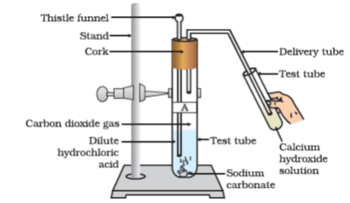

**Figure 2.2** Passing carbon dioxide gas through calcium hydroxide solution

The reactions occurring in the above Activity are written as –

Test tube A: Na2CO3(s)+2HCl(aq)→2NaCl(aq)+H2O(l)+CO2(g)\text{Na}_{2}\text{CO}_{3}(s) + 2\text{HCl}(\text{aq}) \rightarrow 2\text{NaCl}(\text{aq}) + H_{2}O(l) + \text{CO}_{2}(g)

Test tube B: NaHCO3(s)+HCl(aq)→NaCl(aq)+H2O(l)+CO2(g)\text{NaHCO}_{3}(s) + \text{HCl}(\text{aq}) \rightarrow \text{NaCl}(\text{aq}) + H_{2}O(l) + \text{CO}_{2}(g)

On passing the carbon dioxide gas evolved through lime water,

︸Ca(OH)2(aq)(Limewater)+CO2(g)→︸CaCO3(s)(Whiteprecipitate)+H2O(l)\underset{(Lime\ water)}{\overset{\text{Ca}(\text{OH})_{2}(\text{aq})}{︸}} + \text{CO}_{2}(g) \rightarrow \underset{(White\ precipitate)}{\overset{\text{CaCO}_{3}(s)}{︸}} + H_{2}O(l)

On passing excess carbon dioxide the following reaction takes place:

CaCO3(s)+H2O(I)+CO2(g)→︸Ca(HCO3)2(aq)(Solubleinwater)\text{CaCO}_{3}(s) + H_{2}O(I) + \text{CO}_{2}(g) \rightarrow \underset{(Soluble\ in\ water)}{\overset{\text{Ca}\left( \text{HCO}_{3} \right)_{2}(\text{aq})}{︸}}

Limestone, chalk and marble are different forms of calcium carbonate. All metal carbonates and hydrogencarbonates react with acids to give a corresponding salt, carbon dioxide and water.

Thus, the reaction can be summarised as –

Metalcarbonate/Metalhydrogencarbonate+Acid→Salt+Carbondioxide+WaterMetal\ carbonate/Metal\ hydrogencarbonate\ + \ Acid\ \rightarrow \ Salt\ + \ Carbon\ dioxide\ + \ Water

#### 2.1.4 - How do Adds and Bases React with each other?

##### Activity 2.6

Take about 2 mL of dilute NaOH solution in a test tube and add two drops of phenolphthalein solution.

What is the colour of the solution?

Add dilute HCL solution to the above solution drop by drop.

Is there any colour change for the reaction mixture?

Why did the colour of phenolphthalein change after the addition of an acid?

Now add a few drops of NaOH to the above mixture.

Does the pink colour of phenolphthalein reappear?

Why do you think this has happened?

In the above Activity, we have observed that the effect of a base is nullified by an acid and vice-versa. The reaction taking place is written as –

NaOH(aq)+HCl(aq)→NaCl(aq)+H2O(l)\text{NaOH}(\text{aq}) + \text{HCl}(\text{aq}) \rightarrow \text{NaCl}(\text{aq}) + H_{2}O(l)

The reaction between an acid and a base to give a salt and water is known as a neutralisation reaction. In general, a neutralisation reaction can be written as –

Base+Acid→Salt+WaterBase\ + \ Acid\ \rightarrow \ Salt\ + \ Water

#### 2.1.5 - Reaction of Metallic Oxides with Acids

##### Activity 2.7

Take a small amount of copper oxide in a beaker and add dilute hydrochloric acid slowly while stirring.

Note the colour of the solution. What has happened to the copper oxide?

You will notice that the colour of the solution becomes blue-green and the copper oxide dissolves. The blue-green colour of the solution is due to the formation of copper(II) chloride in the reaction. The general reaction between a metal oxide and an acid can be written as –

Metaloxide+Acid→Salt+WaterMetal\ oxide\ + \ Acid\ \rightarrow \ Salt\ + \ Water

Now write and balance the equation for the above reaction. Since metallic oxides react with acids to give salts and water, similar to the reaction of a base with an acid, metallic oxides are said to be basic oxides.

#### 2.1.6 - Reaction of a Non-metallic Oxide with Base

You saw the reaction between carbon dioxide and calcium hydroxide (lime water) in Activity 2.5. Calcium hydroxide, which is a base, reacts with carbon dioxide to produce a salt and water. Since this is similar to the reaction between a base and an acid, we can conclude that non-metallic oxides are acidic in nature.

#### Questions

Why should curd and sour substances not be kept in brass and copper vessels?

Which gas is usually liberated when an acid reacts with a metal? Illustrate with an example. How will you test for the presence of this gas?

Metal compound A reacts with dilute hydrochloric acid to produce effervescence. The gas evolved extinguishes a burning candle. Write a balanced chemical equation for the reaction if one of the compounds formed is calcium chloride.

### 2.2 - What Do All Acids And All Bases Have In Common?

In Section 2.1 we have seen that all acids have similar chemical properties. What leads to this similarity in properties? We saw in Activity 2.3 that all acids generate hydrogen gas on reacting with metals, so hydrogen seems to be common to all acids. Let us perform an Activity to investigate whether all compounds containing hydrogen are acidic.

#### Activity 2.8

Take solutions of glucose, alcohol, hydrochloric acid, sulphuric acid, etc.

Fix two nails on a cork, and place the cork in a 100 mL beaker.

Connect the nails to the two terminals of a 6 volt battery through a bulb and a switch, as shown in Fig. 2.3.

Now pour some dilute HCL in the beaker and switch on the current.

Repeat with dilute sulphuric acid.

What do you observe?

Repeat the experiment separately with glucose and alcohol solutions. What do you observe now?

Does the bulb glow in all cases?

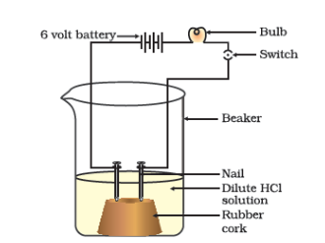

Figure 2.3 Acid solution in water conducts electricity

The bulb will start glowing in the case of acids, as shown in Fig. 2.3. But you will observe that glucose and alcohol solutions do not conduct electricity. Glowing of the bulb indicates that there is a flow of electric current through the solution. The electric current is carried through the acidic solution by ions.

Acids contain H+H^{+}

ion as cation and anion such as Cl−{Cl}^{-}

in HCL, NO3−\text{NO}_{3}^{-}

in HNO3\text{HNO}_{3}

, SO42−\text{SO}_{4}^{2 -}

in H2SO4H_{2}\text{SO}_{4}

,CH3COOO−CH_{3}\text{COOO}^{-}

in CH3COOH\text{CH}_{3}\text{COOH}

. Since the cation present in acids is H+H^{+}

, this suggests that acids produce hydrogen ions, H+H^{+}

(aq), in solution, which are responsible for their acidic properties.

Repeat the same Activity using alkalis such as sodium hydroxide, calcium hydroxide, etc. What can you conclude from the results of this Activity?

#### 2.2.1 - What Happens to an Acid or a Base in a Water Solution?

Do acids produce ions only in aqueous solution? Let us test this.

##### Activity 2.9

Take about 1g solid NaCl in a clean and dry test tube and set up the apparatus as shown in Fig. 2.4.

Add some concentrated sulphuric acid to the test tube.

What do you observe? Is there a gas coming out of the delivery tube?

Test the gas evolved successively with dry and wet blue litmus paper.

In which case does the litmus paper change colour?

On the basis of the above Activity, what do you infer about the acidic character of:

dry HCl gas

HCl solution?

**Note to teachers:** If the climate is very humid, you will have to pass the gas produced through a guard tube (drying tube) containing calcium chloride to dry the gas.

This experiment suggests that hydrogen ions in HCl are produced in the presence of water. The separation of H+H^{+}

ion from HCl molecules cannot occur in the absence of water.

HCl+H2O→H3O++Cl−\text{HCl} + H_{2}O \rightarrow H_{3}O^{+} + \text{Cl}^{-}

Hydrogen ions cannot exist alone, but they exist after combining with water molecules. Thus hydrogen ions must always be shown as H+H^{+}

(aq) or hydronium ion (H3O+)\left( H_{3}O^{+} \right)

.

H++H2O→H3O+H^{+} + H_{2}O \rightarrow H_{3}O^{+}

We have seen that acids give H3O+H_{3}O^{+}

or H+H^{+}

(aq) ion in water. Let us see what happens when a base is dissolved in water.

NaOH(s)→H2ONa+(aq)+OH−(aq)\text{NaOH}(s)\overset{H_{2}O}{\rightarrow}\text{Na}^{+}(\text{aq}) + \text{OH}^{-}(\text{aq})

KOH(s)→H2OK+(aq)+OH−(aq)\text{KOH}(s)\overset{H_{2}O}{\rightarrow}K^{+}(\text{aq}) + \text{OH}^{-}(\text{aq})

Mg(OH)2(s)→H2OMg2+(aq)+2OH−(aq)M_{g}(\text{OH})_{2}(s)\overset{H_{2}O}{\rightarrow}\text{Mg}^{2 +}(\text{aq}) + 2\text{OH}^{-}(\text{aq})

Bases generate hydroxide (OH−)\left( \text{OH}^{-} \right)

ions in water. Bases which are soluble in water are called alkalis.

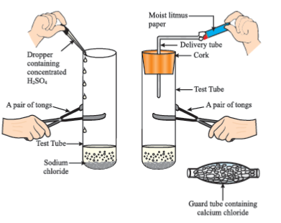

Figure 2.4 Preparation of HCl gas

##### Do you know?

All bases do not dissolve in water. An alkali is a base that dissolves in water. They are soapy to touch, bitter and corrosive. Never taste or touch them as they may cause harm. Which of the bases in the Table 2.1 are alkalis?

Now as we have identified that all acids generate H+H^{+}

(aq) and all bases generate OH−\text{OH}^{-}

(aq), we can view the neutralization reaction as follows –

Acid+Base→Salt+WaterAcid\ + \ Base\ \rightarrow \ Salt\ + \ Water

HX+MOH→MX+HOHHX + MOH\ \rightarrow \ MX\ + \ HOH

H+(aq)+OH−(aq)→H2O(l)H^{+}(\text{aq}) + \text{OH}^{-}(\text{aq}) \rightarrow H_{2}O(l)

Let us see what is involved when water is mixed with an acid or a base.

##### Activity 2.10

Take 10 mL water in a beaker.

Add a few drops of concentrated H2SO4H_{2}SO_{4}

to it and swirl the beaker slowly.

Touch the base of the beaker.

Is there a change in temperature?

Is this an exothermic or endothermic process?

Repeat the above Activity with sodium hydroxide pellets and record your observations.

The process of dissolving an acid or a base in water is a highly exothermic one. Care must be taken while mixing concentrated nitric acid or sulphuric acid with water. The acid must always be added slowly to water with constant stirring. If water is added to a concentrated acid, the heat generated may cause the mixture to splash out and cause burns. The glass container may also break due to excessive local heating. Look out for the warning sign (shown in Fig. 2.5) on the can of concentrated sulphuric acid and on the bottle of sodium hydroxide pellets.

Mixing an acid or base with water results in decrease in the concentration of ions (H3O+/OH−)\left( H_{3}O^{+}/\text{O}\text{H}^{-} \right)

per unit volume. Such a process is called dilution and the acid or the base is said to be diluted.

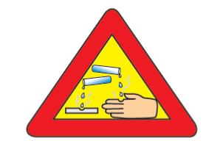

Figure 2.5 Warning sign displayed on containers containing concentrated acids and bases

#### Questions

Why do HCl, HNO3\text{HN}O_{3}

, etc., show acidic characters in aqueous solutions while solutions of compounds like alcohol and glucose do not show acidic character?

Why does an aqueous solution of an acid conduct electricity?

Why does dry HCl gas not change the colour of the dry litmus paper?

While diluting an acid, why is it recommended that the acid should be added to water and not water to the acid?

How is the concentration of hydronium ions (H3O+)\left( H_{3}O^{+} \right)

affected when a solution of an acid is diluted?

How is the concentration of hydroxide ions (OH−)\left( \text{OH}^{-} \right)

affected when excess base is dissolved in a solution of sodium hydroxide?

### 2.3 - How Strong Are Acid Or Base Solutions?

We know how acid-base indicators can be used to distinguish between an acid and a base. We have also learnt in the previous section about dilution and decrease in concentration of H+H^{+}

or OH−\text{OH}^{-}

ions in solutions. Can we quantitatively find the amount of these ions present in a solution? Can we judge how strong a given acid or base is?

We can do this by making use of a universal indicator, which is a mixture of several indicators. The universal indicator shows different colours at different concentrations of hydrogen ions in a solution.

A scale for measuring hydrogen ion concentration in a solution, called pH scale has been developed. The p in pH stands for ‘*potenz’* in German, meaning power. On the pH scale we can measure pH generally from 0 (very acidic) to 14 (very alkaline). pH should be thought of simply as a number which indicates the acidic or basic nature of a solution. Higher the hydronium ion concentration, lower is the pH value.

The pH of a neutral solution is 7. Values less than 7 on the pH scale represent an acidic solution. As the pH value increases from 7 to 14, it represents an increase in OH−\text{OH}^{-}

ion concentration in the solution, that is, increase in the strength of alkali (Fig. 2.6). Generally paper impregnated with the universal indicator is used for measuring pH.

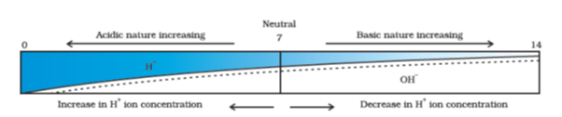

**Figure 2.6** Variation of pH with the change in concentration ofH+H^{+}

(aq) andOH−\text{OH}^{-}

(aq) ions

#### Activity 2.11

Test the pH values of solutions given in Table 2.2.

Record your observations.

What is the nature of each substance on the basis of your observations?

**Table 2.2**

| **S. No.** | **Solution** | **Colour of pH paper** | **Approx-imate pH value** | **Nature of substance** |
| --- | --- | --- | --- | --- |
|  | Saliva (before meal) |  |  |  |
|  | Saliva (after meal) |  |  |  |
|  | Lemon juice |  |  |  |
|  | Colourless aerated drink |  |  |  |
|  | Carrot juice |  |  |  |
|  | Coffee |  |  |  |
|  | Tomato juice |  |  |  |
|  | Tap water |  |  |  |
|  | 1M NaOH |  |  |  |
|  | 1M HCL |  |  |  |

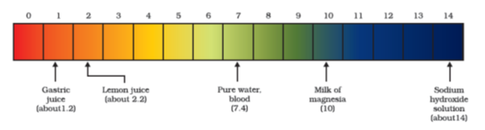

Figure 2.7 pH of some common substances shown on a pH paper (colours are only a rough guide)

The strength of acids and bases depends on the number of H+H^{+}

ions and OH−\text{OH}^{-}

ions produced, respectively. If we take hydrochloric acid and acetic acid of the same concentration, say one molar, then these produce different amounts of hydrogen ions. Acids that give rise to more H+H^{+}

ions are said to be strong acids, and acids that give less H+H^{+}

ions are said to be weak acids. Can you now say what weak and strong bases are?

#### 2.3.1 - Importance of pH in Everyday Life

**Are plants and animals pH sensitive?**

Our body works within the pH range of 7.0 to 7.8. Living organisms can survive only in a narrow range of pH change. When pH of rain water is less than 5.6, it is called acid rain. When acid rain flows into the rivers, it lowers the pH of the river water. The survival of aquatic life in such rivers becomes difficult.

##### Do you Know?

**Acids in other planets**

The atmosphere of venus is made up of thick white and yellowish clouds of sulphuric acid. Do you think life can exist on this planet?

**What is the pH of the soil in your backyard?**

Plants require a specific pH range for their healthy growth. To find out the pH required for the healthy growth of a plant, you can collect the soil from various places and check the pH in the manner described below in Activity 2.12. Also, you can note down which plants are growing in the region from which you have collected the soil.

##### Activity 2.12

Put about 2 g soil in a test tube and add 5 mL water to it.

Shake the contents of the test tube.

Filter the contents and collect the filtrate in a test tube.

Check the pH of this filtrate with the help of universal indicator paper.

What can you conclude about the ideal soil pH for the growth of plants in your region?

**pH in our digestive system**

It is very interesting to note that our stomach produces hydrochloric acid. It helps in the digestion of food without harming the stomach. During indigestion the stomach produces too much acid and this causes pain and irritation. To get rid of this pain, people use bases called antacids. One such remedy must have been suggested by you at the beginning of this Chapter. These antacids neutralise the excess acid. Magnesium hydroxide (Milk of magnesia), a mild base, is often used for this purpose.

**pH change as the cause of tooth decay**

Tooth decay starts when the pH of the mouth is lower than 5.5. Tooth enamel, made up of calcium hydroxyapatite (a crystalline form of calcium phosphate) is the hardest substance in the body. It does not dissolve in water, but is corroded when the pH in the mouth is below 5.5. Bacteria present in the mouth produce acids by degradation of sugar and food particles remaining in the mouth after eating. The best way to prevent this is to clean the mouth after eating food. Using toothpastes, which are generally basic, for cleaning the teeth can neutralise the excess acid and prevent tooth decay.

**Self defence by animals and plants through chemical warfare**

Have you ever been stung by a honey-bee? Bee-sting leaves an acid which causes pain and irritation. Use of a mild base like baking soda on the stung area gives relief. Stinging hair of nettle leaves inject methanoic acid causing burning pain.

##### Do you Know?

**Nature provides neutralisation options**

Nettle is a herbaceous plant which grows in the wild. Its leaves have stinging hair, which cause painful stings when touched accidentally. This is due to the methanoic acid secreted by them. A traditional remedy is rubbing the area with the leaf of the dock plant, which often grows beside the nettle in the wild. Can you guess the nature of the dock plant? So next time you know what to look out for if you accidentally touch a nettle plant while trekking. Are you aware of any other effective traditional remedies for such stings?

**Table 2.3** Some naturally occurring acids

| **Natural source** | **Acid** | **Natural source** | **Acid** |
| --- | --- | --- | --- |
| Vinegar | Acetic acid | Sour milk (Curd) | Lactic acid |
| Orange | Citric acid | Lemon | Citric acid |
| Tamarind | Tartaric acid | Ant sting | Methanoic acid |
| Tomato | Oxalic acid | Nettle sting | Methanoic acid |

#### Questions

You have two solutions, A and B. The pH of solution A is 6 and pH of solution B is 8. Which solution has more hydrogen ion concentration? Which of this is acidic and which one is basic?

What effect does the concentration of H+H^{+}

(aq) ions have on the nature of the solution?

Do basic solutions also have H+H^{+}

(aq) ions? If yes, then why are these basic?

Under what soil condition do you think a farmer would treat the soil of his fields with quick lime (calcium oxide) or slaked lime (calcium hydroxide) or chalk (calcium carbonate)?

### 2.4 - More About Salts

In the previous sections we have seen the formation of salts during various reactions. Let us understand more about their preparation, properties and uses.

#### 2.4.1 - Family of Salts

##### Activity 2.13

Write the chemical formulae of the salts given below. Potassium sulphate, sodium sulphate, calcium sulphate, magnesium sulphate, copper sulphate, sodium chloride, sodium nitrate, sodium carbonate and ammonium chloride.

Identify the acids and bases from which the above salts may be obtained.

Salts having the same positive or negative radicals are said to belong to a family. For example, NaCl and Na2SO4\text{N}\text{a}_{2}\text{S}\text{O}_{4}

belong to the family of sodium salts. Similarly, NaCl and KCl belong to the family of chloride salts. How many families can you identify among the salts given in this Activity?

#### 2.4.2 - pH of Salts

##### Activity 2.14

Collect the following salt samples – sodium chloride, potassium nitrate, aluminium chloride, zinc sulphate, copper sulphate, sodium acetate, sodium carbonate and sodium hydrogen carbonate (some other salts available can also be taken).

Check their solubility in water (use distilled water only).

Check the action of these solutions on litmus and find the pH using a pH paper.

Which of the salts are acidic, basic or neutral?

Identify the acid or base used to form the salt.

Report your observations in Table 2.4.

Salts of a strong acid and a strong base are neutral with pH value of 7. On the other hand, salts of a strong acid and weak base are acidic with pH value less than 7 and those of a strong base and weak acid are basic in nature, with pH value more than 7.

**Table 2.4**

| Salt | pH | Acid used | Base used |
| --- | --- | --- | --- |
|  |  |  |  |
|  |  |  |  |
|  |  |  |  |

#### 2.4.3 - Chemicals from Common Salt

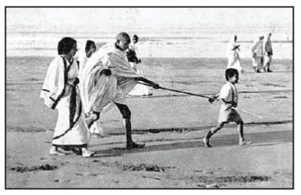

By now you have learnt that the salt formed by the combination of hydrochloric acid and sodium hydroxide solution is called sodium chloride. This is the salt that you use in food. You must have observed in the above Activity that it is a neutral salt.

Seawater contains many salts dissolved in it. Sodium chloride is separated from these salts. Deposits of solid salt are also found in several parts of the world. These large crystals are often brown due to impurities. This is called rock salt. Beds of rock salt were formed when seas of bygone ages dried up. Rock salt is mined like coal.

You must have heard about Mahatma Gandhi’s *Dandi* *March*. Did you know that sodium chloride was such an important symbol in our struggle for freedom?

**Common salt — A raw material for chemicals**

The common salt thus obtained is an important raw material for various materials of daily use, such as sodium hydroxide, baking soda, washing soda, bleaching powder and many more. Let us see how one substance is used for making all these different substances.

**Sodium hydroxide**

When electricity is passed through an aqueous solution of sodium chloride (called brine), it decomposes to form sodium hydroxide. The process is called the chlor-alkali process because of the products formed–chlor for chlorine and alkali for sodium hydroxide.

2NaCl(aq)+2H2O(l)→2NaOH(aq)+Cl2(g)+H2(g)2\text{NaCl}(\text{aq}) + 2H_{2}O(l) \rightarrow 2\text{NaOH}(\text{aq}) + \text{Cl}_{2}(g) + H_{2}(g)

Chlorine gas is given off at the anode, and hydrogen gas at the cathode. Sodium hydroxide solution is formed near the cathode. The three products produced in this process are all useful. Figure 2.8 shows the different uses of these products.

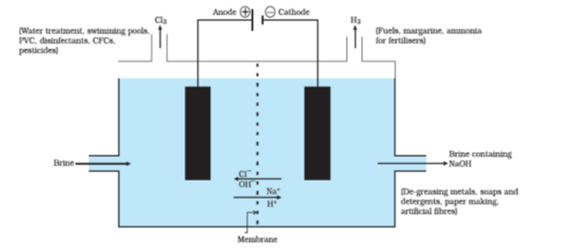

Figure 2.8 Important products from the chlor-alkali process

**Bleaching powder**

You have already come to know that chlorine is produced during the electrolysis of aqueous sodium chloride (brine). This chlorine gas is used for the manufacture of bleaching powder. Bleaching powder is produced by the action of chlorine on dry slaked lime [Ca(OH)2\text{Ca}(\text{OH})_{2}

]. Bleaching powder is represented as CaOCl2\text{CaO}\text{Cl}_{2}

, though the actual composition is quite complex.

Ca(OH)2+Cl2→CaOCl2+H2O\text{Ca}(\text{OH})_{2} + \text{Cl}_{2} \rightarrow \text{CaOCl}_{2} + H_{2}O

**Bleaching powder is used –**

for bleaching cotton and linen in the textile industry, for bleaching wood pulp in paper factories and for bleaching washed clothes in laundry;

as an oxidising agent in many chemical industries; and

to make drinking water free from germs.

**Baking soda**

The baking soda is commonly used in the kitchen for making tasty crispy pakoras, etc. Sometimes it is added for faster cooking. The chemical name of the compound is sodium hydrogencarbonate (NaHCO3\text{NaHC}\text{O}_{3}

). It is produced using sodium chloride as one of the raw materials.

NaCl+H2O+CO2+NH3→︸NH4Cl(Ammoniumchloride)+︸NaHCO3(Sodiumhydrogencarbonate)\text{NaCl} + H_{2}O + \text{CO}_{2} + \text{NH}_{3} \rightarrow \underset{(Ammonium\ chloride)}{\overset{\text{NH}_{4}\text{Cl}}{︸}} + \underset{(Sodium\ hydrogencarbonate)}{\overset{\text{NaHCO}_{3}}{︸}}

Did you check the pH of sodium hydrogencarbonate in Activity 2.14? Can you correlate why it can be used to neutralise an acid? It is a mild non-corrosive basic salt. The following reaction takes place when it is heated during cooking –

︸2NaHCO3Sodium hydrogencarbonate→heat︸Na2CO3sodium carbonate+H2O+CO2\underset{\text{Sodium\ hydrogencarbonate}}{\overset{2\text{NaHCO}_{3}}{︸}}\overset{\text{heat}}{\rightarrow}\underset{\text{sodium\ carbonate}}{\overset{\text{Na}_{2}\text{CO}_{3}}{︸}} + H_{2}O + \text{CO}_{2}

Sodium hydrogencarbonate has got various uses in the household.

**Uses of Baking soda**

For making baking powder, which is a mixture of baking soda (sodium hydrogencarbonate) and a mild edible acid such as tartaric acid. When baking powder is heated or mixed in water, the following reaction takes place –

NaHCO3+H+→CO2+H2O+ Sodium salt of acid \text{NaHCO}_{3} + H^{+} \rightarrow \text{CO}_{2} + H_{2}O + \text{\ Sodium\ salt\ of\ acid\ }

…(From any acid)

Carbon dioxide produced during the reaction can cause bread or cake to rise making them soft and spongy.

Sodium hydrogencarbonate is also an ingredient in antacids. Being alkaline, it neutralises excess acid in the stomach and provides relief.

It is also used in soda-acid fire extinguishers.

**Washing soda**

Another chemical that can be obtained from sodium chloride is Na2CO3\text{N}\text{a}_{2}\text{C}\text{O}_{3}

.10H2O\text{10}\text{H}_{2}O

(washing soda). You have seen above that sodium carbonate can be obtained by heating baking soda; recrystallisation of sodium carbonate gives washing soda. It is also a basic salt.

︸Na2CO3(Sodiumcarbonate)+10H2O→Na2CO3⋅10H2O\underset{(Sodium\ carbonate)}{\overset{\text{Na}_{2}\text{CO}_{3}}{︸}} + 10H_{2}O \rightarrow \text{Na}_{2}\text{CO}_{3} \cdot 10H_{2}O

What does 10H2O\text{10}H_{2}O

signify? Does it make Na2CO3\text{N}a_{2}CO_{3}

wet? We will address this question in the next section.

Sodium carbonate and sodium hydrogen carbonate are useful chemicals for many industrial processes as well.

**Uses of washing soda**

Sodium carbonate (washing soda) is used in glass, soap and paper industries.

It is used in the manufacture of sodium compounds such as borax.

Sodium carbonate can be used as a cleaning agent for domestic purposes.

It is used for removing permanent hardness of water.

#### 2.4.4 - Are the Crystals of Salts really Dry?

##### Activity 2.15

Heat a few crystals of copper sulphate in a dry boiling tube.

What is the colour of the copper sulphate after heating?

Do you notice water droplets in the boiling tube? Where have these come from?

Add 2-3 drops of water on the sample of copper sulphate obtained after heating.

What do you observe? Is the blue colour of copper sulphate restored?

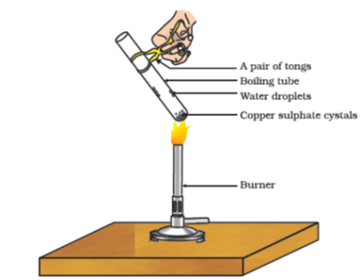

Figure 2.9 Removing water of crystallization

Copper sulphate crystals which seem to be dry contain water of crystallisation. When we heat the crystals, this water is removed and the salt turns white.

If you moisten the crystals again with water, you will find that blue colour of the crystals reappears.

Water of crystallisation is the fixed number of water molecules present in one formula unit of a salt. Five water molecules are present in one formula unit of copper sulphate. Chemical formula for hydrated copper sulphate is CuSO4⋅5H2O\text{CuS}O_{4} \cdot 5H_{2}O

. Now you would be able to answer the question whether the molecule of Na2CO3.10H2O\text{N}\text{a}_{2}\text{C}\text{O}_{3}\text{.10}\text{H}_{2}O

is wet.

One other salt, which possesses water of crystallisation is gypsum. It has two water molecules as water of cyrstallisation. It has the chemical formula CaSO4⋅2H2O\text{CaS}O_{4} \cdot {2H}_{2}O

. Let us look into the use of this salt.

**Plaster of Paris**

On heating gypsum at 373 K, it loses water molecules and becomes calcium sulphate hemihydrate (CaSO412H2O\text{CaS}O_{4}\frac{1}{2}H_{2}O

). This is called Plaster of Paris, the substance which doctors use as plaster for supporting fractured bones in the right position. Plaster of Paris is a white powder and on mixing with water, it changes to gypsum once again giving a hard solid mass.

︸CaSO4⋅12H2O(PlasterofParis)+112H2O→︸CaSO4⋅2H2O(gypsum)\underset{(Plaster\ of\ Paris)}{\overset{\text{CaSO}_{4} \cdot \frac{1}{2}H_{2}O}{︸}} + 1\frac{1}{2}H_{2}O \rightarrow \underset{(gypsum)}{\overset{\text{CaSO}_{4} \cdot 2H_{2}O}{︸}}

Note that only half a water molecule is shown to be attached as water of crystallisation. How can you get half a water molecule? It is written in this form because two formula units of CaSO4\text{CaS}O_{4}

share one molecule of water. Plaster of Paris is used for making toys, materials for decoration and for making surfaces smooth. Try to find out why is calcium sulphate hemihydrate called ‘Plaster of Paris’?

#### Questions

What is the common name of the compound CaOCl2\text{CaO}\text{Cl}_{2}

?

Name the substance which on treatment with chlorine yields bleaching powder.

Name the sodium compound which is used for softening hard water.

What will happen if a solution of sodium hydrocarbonate is heated? Give the equation of the reaction involved.

Write an equation to show the reaction between Plaster of Paris and water.

### What you have learnt

Acid-base indicators are dyes or mixtures of dyes which are used to indicate the presence of acids and bases.

Acidic nature of a substance is due to the formation of H+H^{+}

(aq) ions in solution. Formation of OH−\text{OH}^{-}

(aq) ions in solution is responsible for the basic nature of a substance.

When an acid reacts with a metal, hydrogen gas is evolved and a corresponding salt is formed.

When a base reacts with a metal, along with the evolution of hydrogen gas a salt is formed which has a negative ion composed of the metal and oxygen.

When an acid reacts with a metal carbonate or metal hydrogencarbonate, it gives the corresponding salt, carbon dioxide gas and water.

Acidic and basic solutions in water conduct electricity because they produce hydrogen and hydroxide ions respectively.

The strength of an acid or an alkali can be tested by using a scale called the pH scale (0-14) which gives the measure of hydrogen ion concentration in a solution.

A neutral solution has a pH of exactly 7, while an acidic solution has a pH less than 7 and a basic solution a pH more than 7.

Living beings carry out their metabolic activities within an optimal pH range.

Mixing concentrated acids or bases with water is a highly exothermic process.

Acids and bases neutralise each other to form corresponding salts and water.

Water of crystallisation is the fixed number of water molecules present in one formula unit of a salt.

Salts have various uses in everyday life and in industries.

### Exercises

A solution turns red litmus blue, its pH is likely to be

1

4

5

10

A solution reacts with crushed egg-shells to give a gas that turns lime-water milky. The solution contains

NaCl

HCl

LiCl

KCl

10 mL of a solution of NaOH is found to be completely neutralised by 8 mL of a given solution of HCl. If we take 20 mL of the same solution of NaOH, the amount HCl solution (the same solution as before) required to neutralise it will be

4 mL

8 mL

12 mL

16 mL

Which one of the following types of medicines is used for treating indigestion?

Antibiotic

Analgesic

Antacid

Antiseptic

Write word equations and then balanced equations for the reaction taking place when –

dilute sulphuric acid reacts with zinc granules.

dilute hydrochloric acid reacts with magnesium ribbon.

dilute sulphuric acid reacts with aluminium powder.

dilute hydrochloric acid reacts with iron filings.

Compounds such as alcohols and glucose also contain hydrogen but are not categorised as acids. Describe an Activity to prove it.

Why does distilled water not conduct electricity, whereas rain water does?

Why do acids not show acidic behaviour in the absence of water?

Five solutions A,B,C,D and E when tested with universal indicator showed pH as 4, 1, 11, 7 and 9, respectively. Which solution is

neutral?

strongly alkaline?

strongly acidic?

weakly acidic?

weakly alkaline?

Arrange the pH in increasing order of hydrogen-ion concentration.

Equal lengths of magnesium ribbons are taken in test tubes A and B. Hydrochloric acid (HCl) is added to test tube A, while acetic acid (CH3COOHCH_{3}\text{COOH}

) is added to test tube B. Amount and concentration taken for both the acids are same. In which test tube will the fizzing occur more vigorously and why?

Fresh milk has a pH of 6. How do you think the pH will change as it turns into curd? Explain your answer.

A milkman adds a very small amount of baking soda to fresh milk.

Why does he shift the pH of the fresh milk from 6 to slightly alkaline?

Why does this milk take a long time to set as curd?

Plaster of Paris should be stored in a moisture-proof container. Explain why?

What is a neutralisation reaction? Give two examples.

Give two important uses of washing soda and baking soda.

### Group Activity

**Prepare your own indicator**

Crush beetroot in a mortar.

Add sufficient water to obtain the extract.

Filter the extract by the procedure learnt by you in earlier classes.

Collect the filtrate to test the substances you may have tasted earlier.

Arrange four test tubes in a test tube stand and label them as A,B,C and D. Pour 2 mL each of lemon juice solution, soda-water, vinegar and baking soda solution in them respectively.

Put 2-3 drops of the beetroot extract in each test tube and note the colour change if any. Write your observation in a Table.

You can prepare indicators by using other natural materials like extracts of red cabbage leaves, coloured petals of some flowers such as *Petunia, Hydrangea* and *Geranium*.

**Preparing a soda-acid fire extinguisher**

The reaction of acids with metal hydrogencarbonates is used in the fire extinguishers which produce carbon dioxide.

Take 20 mL of sodium hydrogencarbonate (NaHCO3\text{NaHC}\text{O}_{3}

) solution in a wash-bottle.

Suspend an ignition tube containing dilute sulphuric acid in the wash-bottle (Fig. 2.10).

Close the mouth of the wash-bottle.

Tilt the wash-bottle so that the acid from the ignition tube mixes with the sodium hydrogencarbonate solution below.

You will notice discharge coming out of the nozzle.

Direct this discharge on a burning candle. What happens?

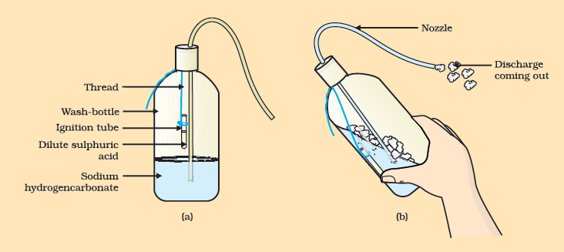

Figure 2.10 (a) Ignition tube containing dilute sulphuric acid suspended in a wash-bottle containing sodium hydrogencarbonate, (b) Discharge coming out of the nozzle

## Chapter 3 – Metals and Non-metals



1064CH03

In Class IX you have learnt about various elements. You have seen that elements can be classified as metals or non-metals on the basis of their properties.

Think of some uses of metals and non-metals in your daily life.

What properties did you think of while categorising elements as metals or non-metals?

How are these properties related to the uses of these elements? Let us look at some of these properties in detail.

### 3.1 - Physical Properties

#### 3.1.1 - Metals

The easiest way to start grouping substances is by comparing their physical properties. Let us study this with the help of the following activities. For performing Activities 3.1 to 3.6, collect the samples of following metals – iron, copper, aluminium, magnesium, sodium, lead, zinc and any other metal that is easily available.

##### Activity 3.1

Take samples of iron, copper, aluminium and magnesium. Note the appearance of each sample.

Clean the surface of each sample by rubbing them with sand paper and note their appearance again.

Metals, in their pure state, have a shining surface. This property is called metallic lustre.

##### Activity 3.2

Take small pieces of iron, copper, aluminium, and magnesium. Try to cut these metals with a sharp knife and note your observations.

Hold a piece of sodium metal with a pair of tongs.

**CAUTION:** Always handle sodium metal with care. Dry it by pressing between the folds of a filter paper.

Put it on a watch-glass and try to cut it with a knife.

What do you observe?

You will find that metals are generally hard. The hardness varies from metal to metal.

##### Activity 3.3

Take pieces of iron, zinc, lead and copper.

Place any one metal on a block of iron and strike it four or five times with a hammer. What do you observe?

Repeat with other metals.

Record the change in the shape of these metals.

You will find that some metals can be beaten into thin sheets. This property is called malleability. Did you know that gold and silver are the most malleable metals?

##### Activity 3.4

List the metals whose wires you have seen in daily life.

The ability of metals to be drawn into thin wires is called ductility. Gold is the most ductile metal. You will be surprised to know that a wire of about 2 km length can be drawn from one gram of gold.

It is because of their malleability and ductility that metals can be given different shapes according to our needs.

Can you name some metals that are used for making cooking vessels? Do you know why these metals are used for making vessels? Let us do the following Activity to find out the answer.

##### Activity 3.5

Take an aluminium or copper wire. Clamp this wire on a stand, as shown in Fig. 3.1.

Fix a pin to the free end of the wire using wax.

Heat the wire with a spirit lamp, candle or a burner near the place where it is clamped.

What do you observe after some time?

Note your observations. Does the metal wire melt?

The above activity shows that metals are good conductors of heat and have high melting points. The best conductors of heat are silver and copper. Lead and mercury are comparatively poor conductors of heat.

Do metals also conduct electricity? Let us find out.

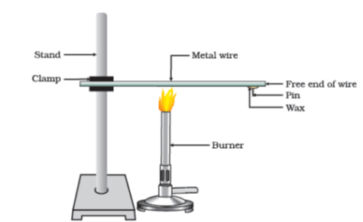

Figure 3.1 Metals are good conductors of heat.

##### Activity 3.6

*Set up an electric circuit as shown in Fig. 3.2.*

*Place the metal to be tested in the circuit between terminals A and B as shown.*

*Does the bulb glow? What does this indicate?*

*You must have seen that the* wires that carry current in your homes have a coating of polyvinylchloride (PVC) or a rubber-like material. Why are electric wires coated with such substances?

What happens when metals strike a hard surface? Do they produce a sound? The metals that produce a sound on striking a hard surface are said to be sonorous. Can you now say why school bells are made of metals?

#### 3.1.2 - Non-metals

In the previous Class you have learnt that there are very few non-metals as compared to metals. Some of the examples of non-metals are carbon, sulphur, iodine, oxygen, hydrogen, etc. The non-metals are either solids or gases except bromine which is a liquid.

Do non-metals also have physical properties similar to that of metals? Let us find out.

##### Activity 3.7

Collect samples of carbon (coal or graphite), sulphur and iodine.

Carry out the Activities 3.1 to 3.4 and 3.6 with these non-metals and record your observations.

Compile your observations regarding metals and non-metals in Table 3.1.

**Table 3.1**

| **Element** | **Symbol** | **Type of surface** | **Hardness** | **Malleability** | **Ductility** | **Conducts Electricity** | **Sonority** |
| --- | --- | --- | --- | --- | --- | --- | --- |
|  |  |  |  |  |  |  |  |
|  |  |  |  |  |  |  |  |
|  |  |  |  |  |  |  |  |

On the bases of the observations recorded in Table 3.1, discuss the general physical properties of metals and non-metals in the class. You must have concluded that we cannot group elements according to their physical properties alone, as there are many exceptions. For example –

All metals except mercury exist as solids at room temperature. In Activity 3.5, you have observed that metals have high melting points but gallium and cesium have very low melting points. These two metals will melt if you keep them on your palm.

Iodine is a non-metal but it is lustrous.

Carbon is a non-metal that can exist in different forms. Each form is called an allotrope. Diamond, an allotrope of carbon, is the hardest natural substance known and has a very high melting and boiling point. Graphite, another allotrope of carbon, is a conductor of electricity.

Alkali metals (lithium, sodium, potassium) are so soft that they can be cut with a knife. They have low densities and low melting points.

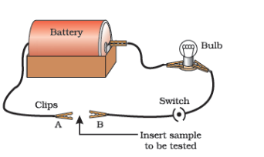

Figure 3.2 Metals are good conductors of electricity.

Elements can be more clearly classified as metals and non-metals on the basis of their chemical properties.

##### Activity 3.8

Take a magnesium ribbon and some sulphur powder.

Burn the magnesium ribbon. Collect the ashes formed and dissolve them in water.

Test the resultant solution with both red and blue litmus paper.

Is the product formed on burning magnesium acidic or basic?

Now burn sulphur powder. Place a test tube over the burning sulphur to collect the fumes produced.

Add some water to the above test tube and shake.

Test this solution with blue and red litmus paper.

Is the product formed on burning sulphur acidic or basic?

Can you write equations for these reactions?

Most non-metals produce acidic oxides when dissolve in water. On the other hand, most metals, give rise to basic oxides. You will be learning more about these metal oxides in the next section.

#### Questions

Give an example of a metal which

is a liquid at room temperature.

can be easily cut with a knife.

is the best conductor of heat.

is a poor conductor of heat.

Explain the meanings of malleable and ductile.

### 3.2 - Chemical Properties of Metals

We will learn about the chemical properties of metals in the following Sections 3.2.1 to 3.2.4. For this, collect the samples of following metals – aluminium, copper, iron, lead, magnesium, zinc and sodium.

#### 3.2.1 - What happens when Metals are burnt in Air?

You have seen in Activity 3.8 that magnesium burns in air with a dazzling white flame. Do all metals react in the same manner? Let us check by performing the following Activity.

##### Activity 3.9

**CAUTION:** The following activity needs the teacher’s assistance. It would be better if students wear eye protection.

Hold any of the samples taken above with a pair of tongs and try burning over a flame. Repeat with the other metal samples.

Collect the product if formed.

Let the products and the metal surface cool down.

Which metals burn easily?

What flame colour did you observe when the metal burnt?

How does the metal surface appear after burning?

Arrange the metals in the decreasing order of their reactivity towards oxygen.

Are the products soluble in water?

Almost all metals combine with oxygen to form metal oxides.

Metal+Oxygen→ Metal oxideMetal\ + \ Oxygen\ \rightarrow \text{\ Metal\ oxide}

For example, when copper is heated in air, it combines with oxygen to form copper(II) oxide, a black oxide.

︸2Cu(copper)+O2→︸2CuO(Copper(II)oxide)\underset{(copper)}{\overset{2Cu}{︸}}\ + \ O_{2}\ \rightarrow \underset{(Copper(II)\ oxide)}{\overset{\ 2CuO}{︸}}

Similarly, aluminium forms aluminium oxide.

︸4Al(Aluminium)+3O2→︸2Al2O3(Aluminiumoxide)\underset{(Aluminium)\ }{\overset{4\text{Al}}{︸}} + 3O_{2} \rightarrow \underset{(Aluminium\ oxide)}{\overset{2\text{Al}_{2}O_{3}}{︸}}

Recall from Chapter 2, how copper oxide reacts with hydrochloric acid. We have learnt that metal oxides are basic in nature. But some metal oxides, such as aluminium oxide, zinc oxide show both acidic as well as basic behaviour. Such metal oxides which react with both acids as well as bases to produce salts and water are known as amphoteric oxides. Aluminium oxide reacts in the following manner with acids and bases –

Al2O3+6HCl→2AlCl3+3H2O\text{Al}_{2}O_{3} + 6\text{HCl} \rightarrow 2\text{AlCl}_{3} + 3H_{2}O

Al2O3+2NaOH→︸2NaAlO2(Sodiumaluminate)+H2O\text{Al}_{2}O_{3} + 2\text{NaOH} \rightarrow \underset{(Sodium\ aluminate)}{\overset{2\text{NaAlO}_{2}}{︸}} + H_{2}O

Most metal oxides are insoluble in water but some of these dissolve in water to form alkalis. Sodium oxide and potassium oxide dissolve in water to produce alkalis as follows –

Na2O(s)+H2O(l)→2NaOH(aq)\text{Na}_{2}O\left( s \right) + H_{2}O\left( l \right) \rightarrow 2\text{NaOH}\left( \text{aq} \right)

K2O(s)+H2O(l)→2KOH(aq)K_{2}O(s) + H_{2}O(l) \rightarrow 2\text{KOH}(\text{aq})

We have observed in Activity 3.9 that all metals do not react with oxygen at the same rate. Different metals show different reactivities towards oxygen. Metals such as potassium and sodium react so vigorously that they catch fire if kept in the open. Hence, to protect them and to prevent accidental fires, they are kept immersed in kerosene oil. At ordinary temperature, the surfaces of metals such as magnesium, aluminium, zinc, lead, etc., are covered with a thin layer of oxide. The protective oxide layer prevents the metal from further oxidation. Iron does not burn on heating but iron filings burn vigorously when sprinkled in the flame of the burner. Copper does not burn, but the hot metal is coated with a black coloured layer of copper(II) oxide. Silver and gold do not react with oxygen even at high temperatures.

##### Do you Know?

Anodising is a process of forming a thick oxide layer of aluminium. Aluminium develops a thin oxide layer when exposed to air. This aluminium oxide coat makes it resistant to further corrosion. The resistance can be improved further by making the oxide layer thicker. During anodising, a clean aluminium article is made the anode and is electrolysed with dilute sulphuric acid. The oxygen gas evolved at the anode reacts with aluminium to make a thicker protective oxide layer. This oxide layer can be dyed easily to give aluminium articles an attractive finish.

After performing Activity 3.9, you must have observed that sodium is the most reactive of the samples of metals taken here. The reaction of magnesium is less vigorous implying that it is not as reactive as sodium. But burning in oxygen does not help us to decide about the reactivity of zinc, iron, copper or lead. Let us see some more reactions to arrive at a conclusion about the order of reactivity of these metals.

#### 3.2.2 - What happens when Metals react with Water?

##### Activity 3.10

**CAUTION:** This Activity needs the teacher’s assistance.

Collect the samples of the same metals as in Activity 3.9.

Put small pieces of the samples separately in beakers half-filled with cold water.

Which metals reacted with cold water? Arrange them in the increasing order of their reactivity with cold water.

Did any metal produce fire on water?

Does any metal start floating after some time?

Put the metals that did not react with cold water in beakers half-filled with hot water.

For the metals that did not react with hot water, arrange the apparatus as shown in Fig. 3.3 and observe their reaction with steam.

Which metals did not react even with steam?

Arrange the metals in the decreasing order of reactivity with water.

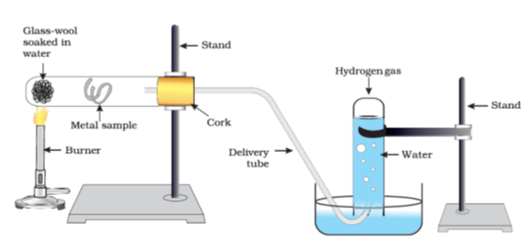

Figure 3.3 Action of steam on a metal

Metals react with water and produce a metal oxide and hydrogen gas. Metal oxides that are soluble in water dissolve in it to further form metal hydroxide. But all metals do not react with water.

Metal+Water→Metaloxide+HydrogenMetal\ + \ Water\ \rightarrow \ Metal\ oxide\ + \ Hydrogen

Metaloxide+Water→ Metal hydroxideMetal\ oxide\ + \ Water\ \rightarrow \text{\ Metal\ }h\text{ydroxide}

Metals like potassium and sodium react violently with cold water. In case of sodium and potassium, the reaction is so violent and exothermic that the evolved hydrogen immediately catches fire.

2K(s)+2H2O(l)→2KOH(aq)+H2(g)+ heat energy2K(s) + 2H_{2}O(l) \rightarrow 2\text{KOH}(\text{aq}) + H_{2}(g) + \text{\ heat\ energy}

2Na(s)+2H2O(l)→2NaOH(aq)+H2(g)+ heat energy 2\text{Na}(s) + 2H_{2}O(l) \rightarrow 2\text{NaOH}(\text{aq}) + H_{2}(g) + \text{\ heat\ energy\ }

The reaction of calcium with water is less violent. The heat evolved is not sufficient for the hydrogen to catch fire.

Ca(s)+2H2O(l)→Ca(OH)2(aq)+H2(g)\text{Ca}(s) + 2H_{2}O(l) \rightarrow \text{Ca}(\text{OH})_{2}(\text{aq}) + H_{2}(g)

Calcium starts floating because the bubbles of hydrogen gas formed stick to the surface of the metal.

Magnesium does not react with cold water. It reacts with hot water to form magnesium hydroxide and hydrogen. It also starts floating due to the bubbles of hydrogen gas sticking to its surface.

Metals like aluminium, iron and zinc do not react either with cold or hot water. But they react with steam to form the metal oxide and hydrogen.

2Al(s)+3H2O(g)→Al2O3(s)+3H2(g)2\text{Al}(s) + 3H_{2}O(g) \rightarrow \text{Al}_{2}O_{3}(s) + 3H_{2}(g)

3Fe(s)+4H2O(g)→Fe3O4(s)+4H2(g)3\text{Fe}(s) + 4H_{2}O(g) \rightarrow \text{Fe}_{3}O_{4}(s) + 4H_{2}(g)

Metals such as lead, copper, silver and gold do not react with water at all.

#### 3.2.3 - What happens when Metals react with Acids?

You have already learnt that metals react with acids to give a salt and hydrogen gas.

Metal+Diluteacid→Salt+HydrogenMetal\ + \ Dilute\ acid\ \rightarrow \ Salt\ + \ Hydrogen

But do all metals react in the same manner? Let us find out.

##### Activity 3.11

Collect all the metal samples except sodium and potassium again. If the samples are tarnished, rub them clean with sand paper.

CAUTION: Do not take sodium and potassium as they react vigorously even with cold water.

Put the samples separately in test tubes containing dilute hydrochloric acid.

Suspend thermometers in the test tubes, so that their bulbs are dipped in the acid.

Observe the rate of formation of bubbles carefully.

Which metals reacted vigorously with dilute hydrochloric acid?

With which metal did you record the highest temperature?

Arrange the metals in the decreasing order of reactivity with dilute acids.

Write equations for the reactions of magnesium, aluminium, zinc and iron with dilute hydrochloric acid.

Hydrogen gas is not evolved when a metal reacts with nitric acid. It is because HNO3\text{HN}O_{3}

is a strong oxidising agent. It oxidises the H2H_{2}

produced to water and itself gets reduced to any of the nitrogen oxides (N2O,NO,NO2N_{2}O,\ NO,\ NO_{2}

). But magnesium (Mg) and manganese (Mn) react with very dilute HNO3\text{HN}O_{3}

to evolve H2H_{2}

gas.

You must have observed in Activity 3.11, that the rate of formation of bubbles was the fastest in the case of magnesium. The reaction was also the most exothermic in this case. The reactivity decreases in the order Mg > Al > Zn > Fe. In the case of copper, no bubbles were seen and the temperature also remained unchanged. This shows that copper does not react with dilute HCl.

##### Do you Know?

*Aqua regia*, (Latin for ‘royal water’) is a freshly prepared mixture of concentrated hydrochloric acid and concentrated nitric acid in the ratio of 3:1. It can dissolve gold, even though neither of these acids can do so alone. *Aqua regia* is a highly corrosive, fuming liquid. It is one of the few reagents that is able to dissolve gold and platinum.

#### 3.2.4 - How do Metals react with Solutions of other Metal Salts?

##### Activity 3.12

Take a clean wire of copper and an iron nail.

Put the copper wire in a solution of iron sulphate and the iron nail in a solution of copper sulphate taken in test tubes (Fig. 3.4).

Record your observations after 20 minutes.

In which test tube did you find that a reaction has occurred?

On what basis can you say that a reaction has actually taken place?

Can you correlate your observations for the Activities 3.9, 3.10 and 3.11?

Write a balanced chemical equation for the reaction that has taken place.

Name the type of reaction.

Reactive metals can displace less reactive metals from their compounds in solution or molten form.

We have seen in the previous sections that all metals are not equally reactive. We checked the reactivity of various metals with oxygen, water and acids. But all metals do not react with these reagents. So we were not able to put all the metal samples we had collected in decreasing order of their reactivity. Displacement reactions studied in Chapter 1 give better evidence about the reactivity of metals. It is simple and easy if metal A displaces metal B from its solution, it is more reactive than B.

MetalA+SaltsolutionofB→SaltsolutionofA+MetalBMetal\ A\ + \ Salt\ solution\ of\ B\ \rightarrow \ Salt\ solution\ of\ A\ + \ Metal\ B

Which metal, copper or iron, is more reactive according to your observations in Activity 3.12?

#### 3.2.5 - The Reactivity Series

The reactivity series is a list of metals arranged in the order of their decreasing activities. After performing displacement experiments (Activities 1.9 and 3.12), the following series, (Table 3.2) known as the reactivity or activity series has been developed.

Table 3.2 Activity series: Relative reactivities of metals

|  |  |  |
| --- | --- | --- |
| K | Potassium | Most reactive |
| Na | Sodium |  |
| Ca | Calcium |  |
| Mg | Magnesium |  |
| Al | Aluminium |  |
| Zn | Zinc | Reactivity decreases |
| Fe | Iron |  |
| Pb | Lead |  |
| [H] | [Hydrogen] |  |
| Cu | Copper |  |
| Hg | Mercury |  |
| Ag | Silver |  |
| Au | Gold | Least reactive |

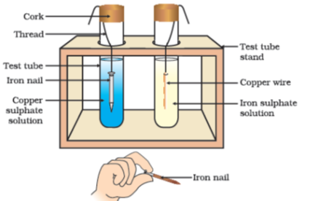

Figure 3.4 Reaction of metals with salt solutions

#### Questions

Why is sodium kept immersed in kerosene oil?

Write equations for the reactions of

iron with steam

calcium and potassium with water

Samples of four metals A, B, C and D were taken and added to the following solution one by one. The results obtained have been tabulated as follows.

| **Metal** | **Iron(II) sulphate** | **Copper(II) sulphate** | **Zinc sulphate** | **Silver nitrate** |
| --- | --- | --- | --- | --- |
|  | No reaction | Displacement |  |  |
|  | Displacement |  | No reaction |  |
|  | No reaction | No reaction | No reaction | Displacement |
|  | No reaction | No reaction | No reaction | No reaction |

Use the Table above to answer the following questions about metals A, B, C and D.

Which is the most reactive metal?

What would you observe if B is added to a solution of Copper(II) sulphate?

Arrange the metals A, B, C and D in the order of decreasing reactivity.

Which gas is produced when dilute hydrochloric acid is added to a reactive metal? Write the chemical reaction when iron reacts with diluteH2SO4H_{2}SO_{4}

.

What would you observe when zinc is added to a solution of iron(II) sulphate? Write the chemical reaction that takes place.

### 3.3 - How Do Metals and Non-Metals React?

In the above activities, you saw the reactions of metals with a number of reagents. Why do metals react in this manner? Let us recall what we learnt about the electronic configuration of elements in Class IX. We learnt that noble gases, which have a completely filled valence shell, show little chemical activity. We, therefore, explain the reactivity of elements as a tendency to attain a completely filled valence shell.

Let us have a look at the electronic configuration of noble gases and some metals and non-metals.

We can see from Table 3.3 that a sodium atom has one electron in its outermost shell. If it loses the electron from its M shell then its L shell now becomes the outermost shell and that has a stable octet. The nucleus of this atom still has 11 protons but the number of electrons has become 10, so there is a net positive charge giving us a sodium cationNa+\ \text{Na}^{+}

. On the other hand chlorine has seven electrons in its outermost shell and it requires one more electron to complete its octet. If sodium and chlorine were to react, the electron lost by sodium could be taken up by chlorine. After gaining an electron, the chlorine atom gets a unit negative charge, because its nucleus has 17 protons and there are 18 electrons in its K, L and M shells. This gives us a chloride anionCl−\ \text{Cl}^{-}

. So both these elements can have a give-and-take relation between them as follows (Fig. 3.5).

**Table 3.3** Electronic configurations of some elements

| **Type of element** | **Element** | **Atomic number** | **Number of electrons in shells** |  |  |  |
| --- | --- | --- | --- | --- | --- | --- |
|  |  |  | K | L | M | N |
| Noble gases | Helium (He) | 2 | 2 |  |  |  |
|  | Neon (Ne) | 10 | 2 | 8 |  |  |
|  | Argon (Ar) | 18 | 2 | 8 | 8 |  |
| Metals | Sodium (Na) | 11 | 2 | 8 | 1 |  |
|  | Magnesium (Mg) | 12 | 2 | 8 | 2 |  |
|  | Aluminium (Al) | 13 | 2 | 8 | 3 |  |
|  | Potassium (K) | 19 | 2 | 8 | 8 | 1 |
|  | Calcium (Ca) | 20 | 2 | 8 | 8 | 2 |
| Non-metals | Nitrogen (N) | 7 | 2 | 5 |  |  |
|  | Oxygen (O) | 8 | 2 | 6 |  |  |
|  | Fluorine (F) | 9 | 2 | 7 |  |  |
|  | Phosphorus (P) | 15 | 2 | 8 | 5 |  |
|  | Sulphur (S) | 16 | 2 | 8 | 6 |  |
|  | Chlorine (Cl) | 17 | 2 | 8 | 7 |  |

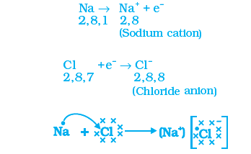

Figure 3.5 Formation of sodium chloride

Sodium and chloride ions, being oppositely charged, attract each other and are held by strong electrostatic forces of attraction to exist as sodium chloride (NaCl). It should be noted that sodium chloride does not exist as molecules but aggregates of oppositely charged ions.

Let us see the formation of one more ionic compound, magnesium chloride (Fig. 3.6).

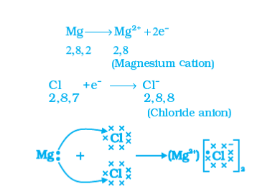

Figure 3.6 Formation of magnesium chloride

The compounds formed in this manner by the transfer of electrons from a metal to a non-metal are known as ionic compounds or electrovalent compounds. Can you name the cation and anion present inMgCl2\text{MgC}\text{l}_{2}

?

#### 3.3.1 - Properties of Ionic Compounds

To learn about the properties of ionic compounds, let us perform the following Activity:

##### Activity 3.13

Take samples of sodium chloride, potassium iodide, barium chloride or any other salt from the science laboratory.

What is the physical state of these salts?

Take a small amount of a sample on a metal spatula and heat directly on the flame (Fig. 3.7). Repeat with other samples.

What did you observe? Did the samples impart any colour to the flame? Do these compounds melt?

Try to dissolve the samples in water, petrol and kerosene. Are they soluble?

Make a circuit as shown in Fig. 3.8 and insert the electrodes into a solution of one salt. What did you observe? Test the other salt samples too in this manner.

What is your inference about the nature of these compounds?

**Table 3.4** Melting and boiling points of some ionic compounds

| Ionic compound | Melting point (K) | Boiling point (K) |
| --- | --- | --- |
| NaCl | 1074 | 1686 |
| LiCl | 887 | 1600 |
| CaCl2\text{Ca}\text{Cl}_{2} | 1045 | 1900 |
| CaO | 2850 | 3120 |
| MgCl2\text{Mg}\text{Cl}_{2} | 981 | 1685 |

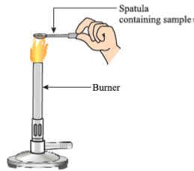

Figure 3.7 Heating a salt sample on a spatula

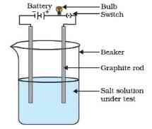

Figure 3.8 Testing the conductivity of a salt solution

You may have observed the following general properties for ionic compounds—

*Physical nature:* Ionic compounds are solids and are somewhat hard because of the strong force of attraction between the positive and negative ions. These compounds are generally brittle and break into pieces when pressure is applied.

*Melting and Boiling points:* Ionic compounds have high melting and boiling points (see Table 3.4). This is because a considerable amount of energy is required to break the strong inter-ionic attraction.

*Solubility:* Electrovalent compounds are generally soluble in water and insoluble in solvents such as kerosene, petrol, etc.

*Conduction of Electricity:* The conduction of electricity through a solution involves the movement of charged particles. A solution of an ionic compound in water contains ions, which move to the opposite electrodes when electricity is passed through the solution. Ionic compounds in the solid state do not conduct electricity because movement of ions in the solid is not possible due to their rigid structure. But ionic compounds conduct electricity in the molten state. This is possible in the molten state since the electrostatic forces of attraction between the oppositely charged ions are overcome due to the heat. Thus, the ions move freely and conduct electricity.

#### Questions

Write the electron-dot structures for sodium, oxygen and magnesium.

Show the formation of Na2O\text{N}a_{2}O

and MgO by the transfer of electrons.

What are the ions present in these compounds?

Why do ionic compounds have high melting points?

### 3.4 - Occurrence of Metals

The earth’s crust is the major source of metals. Seawater also contains some soluble salts such as sodium chloride, magnesium chloride, etc. The elements or compounds, which occur naturally in the earth’s crust, are known as minerals. At some places, minerals contain a very high percentage of a particular metal and the metal can be profitably extracted from it. These minerals are called ores.

#### 3.4.1 - Extraction of Metals

You have learnt about the reactivity series of metals. Having this knowledge, you can easily understand how a metal is extracted from its ore. Some metals are found in the earth’s crust in the free state. Some are found in the form of their compounds. The metals at the bottom of the activity series are the least reactive. They are often found in a free state. For example, gold, silver, platinum and copper are found in the free state. Copper and silver are also found in the combined state as their sulphide or oxide ores. The metals at the top of the activity series (K, Na, Ca, Mg and Al) are so reactive that they are never found in nature as free elements. The metals in the middle of the activity series (Zn, Fe, Pb, etc.) are moderately reactive. They are found in the earth’s crust mainly as oxides, sulphides or carbonates. You will find that the ores of many metals are oxides. This is because oxygen is a very reactive element and is very abundant on the earth.

Thus on the basis of reactivity, we can group the metals into the following three categories (Fig. 3.9) – (i) Metals of low reactivity; (ii) Metals of medium reactivity; (iii) Metals of high reactivity. Different techniques are to be used for obtaining the metals falling in each category.

Several steps are involved in the extraction of pure metal from ores. A summary of these steps is given in Fig.3.10. Each step is explained in detail in the following sections.

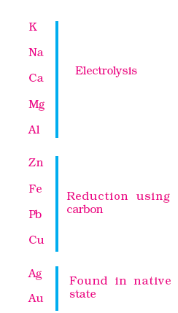

Figure 3.9 Activity series and related metallurgy

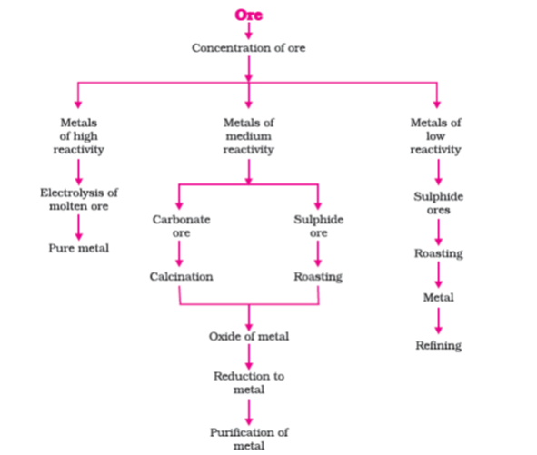

Figure 3.10 Steps involved in the extraction of metals from ores

#### 3.4.2 - Enrichment of Ores

Ores mined from the earth are usually contaminated with large amounts of impurities such as soil, sand, etc., called gangue. The impurities must be removed from the ore prior to the extraction of the metal. The processes

used for removing the gangue from the ore are based on the differences between the physical or chemical properties of the gangue and the ore. Different separation techniques are accordingly employed.

#### 3.4.3 - Extracting Metals Low in the Activity Series

Metals low in the activity series are very unreactive. The oxides of these metals can be reduced to metals by heating alone. For example, cinnabar (HgS) is an ore of mercury. When it is heated in air, it is first converted into mercuric oxide (HgO). Mercuric oxide is then reduced to mercury on further heating.

2HgS(s)+3O2(g)→heat2HgO(s)+2SO2[g]2\text{HgS}(s) + 3O_{2}(g)\overset{\text{heat}}{\rightarrow}2\text{HgO}(s) + 2\text{SO}_{2}\lbrack g\rbrack

2HgO(s)→heat2Hg(l)+O2(g)2\text{HgO}(s)\overset{\text{heat}}{\rightarrow}2\text{Hg}(l) + O_{2}(g)

Similarly, copper which is found as Cu2S\text{C}\text{u}_{2}S

in nature can be obtained from its ore by just heating in air.

2Cu2S+3O2(g)→heat2Cu2O(s)+2SO2(g)2\text{Cu}_{2}S + 3O_{2}(g)\overset{\text{heat}}{\rightarrow}2\text{Cu}_{2}O(s) + 2\text{SO}_{2}(g)

2Cu2O+Cu2S→heat6Cu(s)+SO2(g)2\text{Cu}_{2}O + \text{Cu}_{2}S\overset{\text{heat}}{\rightarrow}6\text{Cu}(s) + \text{SO}_{2}(g)

#### 3.4.4 - Extracting Metals in the Middle of the Activity Series

The metals in the middle of the activity series such as iron, zinc, lead, copper, are moderately reactive. These are usually present as sulphides or carbonates in nature. It is easier to obtain a metal from its oxide, as compared to its sulphides and carbonates. Therefore, prior to reduction, the metal sulphides and carbonates must be converted into metal oxides. The sulphide ores are converted into oxides by heating strongly in the presence of excess air. This process is known as roasting. The carbonate ores are changed into oxides by heating strongly in limited air. This process is known as calcination. The chemical reaction that takes place during roasting and calcination of zinc ores can be shown as follows –

Roasting

2ZnS(s)+3O2(g)→heat2ZnO(s)+2SO2(g)2\text{ZnS}(s) + 3O_{2}(g)\overset{\text{heat}}{\rightarrow}2\text{ZnO}(s) + 2\text{SO}_{2}(g)

Calcination

ZnCO3(s)→heatZnO(s)+CO2(g)\text{ZnCO}_{3}(s)\overset{\text{heat}}{\rightarrow}\text{ZnO}(s) + \text{CO}_{2}(g)

The metal oxides are then reduced to the corresponding metals by using suitable reducing agents such as carbon. For example, when zinc oxide is heated with carbon, it is reduced to metallic zinc.

ZnO(s)+C(s)→Zn(s)+CO(g)\text{ZnO}(s) + C(s) \rightarrow \text{Zn}(s) + \text{CO}(g)

You are already familiar with the process of oxidation and reduction explained in the first Chapter. Obtaining metals from their compounds is also a reduction process.

Besides using carbon (coke) to reduce metal oxides to metals, sometimes displacement reactions can also be used. The highly reactive metals such as sodium, calcium, aluminium, etc., are used as reducing agents because they can displace metals of lower reactivity from their compounds. For example, when manganese dioxide is heated with aluminium powder, the following reaction takes place –

3MnO2(s)+4Al(s)→3Mn(l)+2Al2O3(s)+ Heat 3\text{MnO}_{2}(s) + 4\text{Al}(s) \rightarrow 3\text{Mn}(l) + 2\text{Al}_{2}O_{3}(s) + \text{\ Heat\ }

Can you identify the substances that are getting oxidised and reduced?

These displacement reactions are highly exothermic. The amount of heat evolved is so large that the metals are produced in the molten state. In fact, the reaction of iron(III) oxide (Fe2O3\text{Fe}_{2}O_{3}

) with aluminium is used to join railway tracks or cracked machine parts. This reaction is known as the thermit reaction.

Fe2O3(s)+2Al(s)→2Fe(l)+Al2O3(s)+ Heat \text{Fe}_{2}O_{3}(s) + 2\text{Al}(s) \rightarrow 2\text{Fe}(l) + \text{Al}_{2}O_{3}(s) + \text{\ Heat\ }

#### 3.4.5 - Extracting Metals towards the Top of the Activity Series

The metals high up in the reactivity series are very reactive. They cannot be obtained from their compounds by heating with carbon. For example, carbon cannot reduce the oxides of sodium, magnesium, calcium, aluminium, etc., to the respective metals. This is because these metals have more affinity for oxygen than carbon. These metals are obtained by electrolytic reduction. For example, sodium, magnesium and calcium are obtained by the electrolysis of their molten chlorides. The metals are deposited at the cathode (the negatively charged electrode), whereas, chlorine is liberated at the anode (the positively charged electrode). The reactions are

At cathode Na++e−→ Na\text{N}\text{a}^{+}\ + \ \text{e}^{-}\ \rightarrow \text{\ Na}

At anode 2Cl−→Cl2+2e−2\text{Cl}^{-}\ \rightarrow \text{Cl}_{2}\ + \ 2\text{e}^{-}

Similarly, aluminium is obtained by the electrolytic reduction of aluminium oxide.

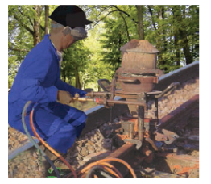

Figure 3.11 Thermit process for joining railway tracks

#### 3.4.6 - Refining of Metals

The metals produced by various reduction processes described above are not very pure. They contain impurities, which must be removed to obtain pure metals. The most widely used method for refining impure metals is electrolytic refining.

***Electrolytic Refining:*** Many metals, such as copper, zinc, tin, nickel, silver, gold, etc., are refined electrolytically. In this process, the impure metal is made the anode and a thin strip of pure metal is made the cathode. A solution of the metal salt is used as an electrolyte. The apparatus is set up as shown in Fig. 3.12. On passing the current through the electrolyte, the pure metal from the anode dissolves into the electrolyte. An equivalent amount of pure metal from the electrolyte is deposited on the cathode. The soluble impurities go into the solution, whereas, the insoluble impurities settle down at the bottom of the anode and are known as anode mud.

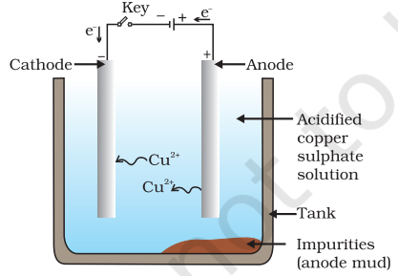

Figure 3.12 Electrolytic refining of copper. The electrolyte is a solution of acidified copper sulphate. The anode is impure copper, whereas, the cathode is a strip of pure copper. On passing electric current, pure copper is deposited on the cathode.

#### Questions

Define the following terms.

Mineral

Ore

Gangue

Name two metals which are found in nature in the free state.

What chemical process is used for obtaining a metal from its oxide?

### 3.5 - Corrosion

You have learnt the following about corrosion in Chapter 1 –

Silver articles become black after some time when exposed to air. This is because it reacts with sulphur in the air to form a coating of silver sulphide.

Copper reacts with moist carbon dioxide in the air and slowly loses its shiny brown surface and gains a green coat. This green substance is basic copper carbonate.

Iron when exposed to moist air for a long time acquires a coating of a brown flaky substance called rust.

Let us find out the conditions under which iron rusts.

#### Activity 3.14

Take three test tubes and place clean iron nails in each of them.

Label these test tubes A, B and C. Pour some water in test tube A and cork it.

Pour boiled distilled water in test tube B, add about 1 mL of oil and cork it. The oil will float on water and prevent the air from dissolving in the water.

Put some anhydrous calcium chloride in test tube C and cork it. Anhydrous calcium chloride will absorb the moisture, if any, from the air. Leave these test tubes for a few days and then observe (Fig. 3.13).

You will observe that iron nails rust in test tube A, but they do not rust in test tubes B and C. In the test tube A, the nails are exposed to both air and water. In the test tube B, the nails are exposed to only water, and the nails in test tube C are exposed to dry air. What does this tell us about the conditions under which iron articles rust?

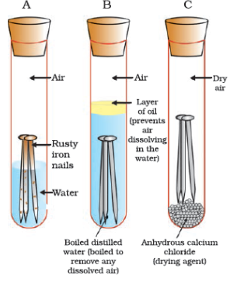

Figure 3.13 Investigating the conditions under which iron rusts. In tube A. both air and water are present In tube B, there is no air dissolved in the water. In tube C, the air is dry.

#### 3.5.1 - Prevention of Corrosion

The rusting of iron can be prevented by painting, oiling, greasing, galvanising, chrome plating, anodising or making alloys.

Galvanisation is a method of protecting steel and iron from rusting by coating them with a thin layer of zinc. The galvanised article is protected against rusting even if the zinc coating is broken. Can you reason this out?

Alloying is a very good method of improving the properties of a metal. We can get the desired properties by this method. For example, iron is the most widely used metal. But it is never used in its pure state. This is because pure iron is very soft and stretches easily when hot. But, if it is mixed with a small amount of carbon (about 0.05 %), it becomes hard and strong. When iron is mixed with nickel and chromium, we get stainless steel, which is hard and does not rust. Thus, if iron is mixed with some other substance, its properties change. In fact, the properties of any metal can be changed if it is mixed with some other substance. The substance added may be a metal or a non-metal. An alloy is a homogeneous mixture of two or more metals, or a metal and a non-metal. It is prepared by first melting the primary metal, and then, dissolving the other elements in it in definite proportions. It is then cooled to room temperature.

##### Do you Know?

Pure gold, known as 24 carat gold, is very soft. It is, therefore, not suitable for making jewellery. It is alloyed with either silver or copper to make it hard. Generally, in India, 22 carat gold is used for making ornaments. It means that 22 parts of pure gold is alloyed with 2 parts of either copper or silver.

If one of the metals is mercury, then the alloy is known as an amalgam. The electrical conductivity and melting point of an alloy is less than that of pure metals. For example, brass, an alloy of copper and zinc (Cu and Zn), and bronze, an alloy of copper and tin (Cu and Sn), are not good conductors of electricity whereas copper is used for making electrical circuits. Solder, an alloy of lead and tin (Pb and Sn), has a low melting point and is used for welding electrical wires together.

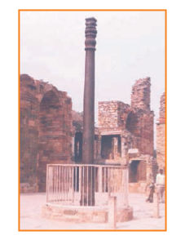

Iron pillar at Delhi

##### More to know!

**The wonder of ancient Indian metallurgy**

The iron pillar near the Qutub Minar in Delhi was built more than 1600 years ago by the iron workers of India. They had developed a process which prevented iron from rusting. For its quality of rust resistance it has been examined by scientists from all parts of the world. The iron pillar is 8 m high and weighs 6 tonnes (6000 kg).

#### Questions

Metallic oxides of zinc, magnesium and copper were heated with the following metals.

| Metal | Zinc | Magnesium | Copper |
| --- | --- | --- | --- |
| Zinc oxide |  |  |  |
| Magnesium oxide |  |  |  |
| Copper oxide |  |  |  |

In which cases will you find displacement reactions taking place?

Which metals do not corrode easily?

What are alloys?

### What you have learnt

Elements can be classified as metals and non-metals.

Metals are lustrous, malleable, ductile and are good conductors of heat and electricity. They are solids at room temperature, except mercury which is a liquid.

Metals can form positive ions by losing electrons to non-metals.

Metals combine with oxygen to form basic oxides. Aluminium oxide and zinc oxide show the properties of both basic as well as acidic oxides. These oxides are known as amphoteric oxides.

Different metals have different reactivities with water and dilute acids.

A list of common metals arranged in order of their decreasing reactivity is known as an activity series.

Metals above hydrogen in the Activity series can displace hydrogen from dilute acids.

A more reactive metal displaces a less reactive metal from its salt solution.

Metals occur in nature as free elements or in the form of their compounds.

The extraction of metals from their ores and then refining them for use is known as metallurgy.

An alloy is a homogeneous mixture of two or more metals, or a metal and a non-metal.

The surface of some metals, such as iron, is corroded when they are exposed to moist air for a long period of time. This phenomenon is known as corrosion.

Non-metals have properties opposite to that of metals. They are neither malleable nor ductile. They are bad conductors of heat and electricity, except for graphite, which conducts electricity.

Non-metals form negatively charged ions by gaining electrons when reacting with metals.

Non-metals form oxides which are either acidic or neutral.

Non-metals do not displace hydrogen from dilute acids. They react with hydrogen to form hydrides.

### Exercises

Which of the following pairs will give displacement reactions?

NaCl solution and copper metal

MgCl2\text{Mg}\text{Cl}_{2}

solution and aluminium metal

FeSO4\text{FeS}O_{4}

solution and silver metal

AgNO3\text{AgN}O_{3}

solution and copper metal.

Which of the following methods is suitable for preventing an iron frying pan from rusting?

Applying grease

Applying paint

Applying a coating of zinc

All of the above.

An element reacts with oxygen to give a compound with a high melting point. This compound is also soluble in water. The element is likely to be

calcium

carbon

silicon

iron.

Food cans are coated with tin and not with zinc because

zinc is costlier than tin.

zinc has a higher melting point than tin.

zinc is more reactive than tin.

zinc is less reactive than tin.

You are given a hammer, a battery, a bulb, wires and a switch.

How could you use them to distinguish between samples of metals and non-metals?

Assess the usefulness of these tests in distinguishing between metals and non-metals.

What are amphoteric oxides? Give two examples of amphoteric oxides.

Name two metals which will displace hydrogen from dilute acids, and two metals which will not.

In the electrolytic refining of a metal M, what would you take as the anode, the cathode and the electrolyte?

Pratyush took sulphur powder on a spatula and heated it. He collected the gas evolved by inverting a test tube over it, as shown in figure below.

What will be the action of gas on

dry litmus paper?

moist litmus paper?

Write a balanced chemical equation for the reaction taking place.

State two ways to prevent the rusting of iron.

What type of oxides are formed when non-metals combine with oxygen?

Give reasons

Platinum, gold and silver are used to make jewellery.

Sodium, potassium and lithium are stored under oil.

Aluminium is a highly reactive metal, yet it is used to make utensils for cooking.

Carbonate and sulphide ores are usually converted into oxides during the process of extraction.

You must have seen tarnished copper vessels being cleaned with lemon or tamarind juice. Explain why these sour substances are effective in cleaning the vessels.

Differentiate between metal and non-metal on the basis of their chemical properties.

A man went door to door posing as a goldsmith. He promised to bring back the glitter of old and dull gold ornaments. An unsuspecting lady gave a set of gold bangles to him which he dipped in a particular solution. The bangles sparkled like new but their weight was reduced drastically. The lady was upset but after a futile argument the man beat a hasty retreat. Can you play the detective to find out the nature of the solution he had used?

Give reasons why copper is used to make hot water tanks and not steel (an alloy of iron).

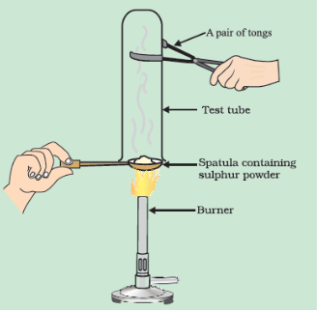

Collection of gas

## Chapter 4 – Carbon and its Compounds



1064CH04

In the last Chapter, we came to know many compounds of importance to us. In this Chapter we will study about some more interesting compounds and their properties. Also, we shall be learning about carbon, an element which is of immense significance to us in both its elemental form and in the combined form.

### Activity 4.1

Make a list of ten things you have used or consumed since the morning.

Compile this list with the lists made by your classmates and then sort the items into the adjacent Table.

If there are items which are made up of more than one material, put them into both the relevant columns of the table.

| **Things made of metal** | **Things made of glass/clay** | **Others** |
| --- | --- | --- |
|  |  |  |
|  |  |  |
|  |  |  |
|  |  |  |
|  |  |  |

Look at the items that come in the last column of the above table filled by you – your teacher will be able to tell you that most of them are made up of compounds of carbon. Can you think of a method to test this? What would be the product if a compound containing carbon is burnt? Do you know of any test to confirm this?

Food, clothes, medicines, books, or many of the things that you listed are all based on this versatile element carbon. In addition, all living structures are carbon based. The amount of carbon present in the earth’s crust and in the atmosphere is quite meagre. The earth’s crust has only 0.02% carbon in the form of minerals (like carbonates, hydrogen-carbonates, coal and petroleum) and the atmosphere has 0.03% of carbon dioxide. In spite of this small amount of carbon available in nature, the importance of carbon seems to be immense. In this Chapter, we will know about the properties of carbon which make carbon so important to us.

### 4.1 - Bonding In Carbon: The Covalent Bond

In the previous Chapter, we have studied the properties of ionic compounds. We saw that ionic compounds have high melting and boiling points and conduct electricity in solution or in the molten state. We also saw how the nature of bonding in ionic compounds explains these properties. Let us now study the properties of some carbon compounds.

Most carbon compounds are poor conductors of electricity as we have seen in Chapter 2. From the data given in Table 4.1 on the boiling and melting points of the carbon compounds, we find that these compounds have low melting and boiling points as compared to ionic compounds (Chapter 3). We can conclude that the forces of attraction between the molecules are not very strong. Since these compounds are largely non-conductors of electricity, we can conclude that the bonding in these compounds does not give rise to any ions.

In Class IX, we learnt about the combining capacity of various elements and how it depends on the number of valence electrons. Let us now look at the electronic configuration of carbon. The atomic number of carbon is 6. What would be the distribution of electrons in various shells of carbon? How many valence electrons will carbon have?

We know that the reactivity of elements is explained as their tendency to attain a completely filled outer shell, that is, attain noble gas configuration. Elements forming ionic compounds achieve this by either gaining or losing electrons from the outermost shell. In the case of carbon, it has four electrons in its outermost shell and needs to gain or lose four electrons to attain noble gas configuration. If it were to gain or lose electrons –

It could gain four electrons forming C4−C^{4 -}

anion. But it would be difficult for the nucleus with six protons to hold on to ten electrons, that is, four extra electrons.

It could lose four electrons forming C4+C^{4 +}

cation. But it would require a large amount of energy to remove four electrons leaving behind a carbon cation with six protons in its nucleus holding on to just two electrons.

Carbon overcomes this problem by sharing its valence electrons with other atoms of carbon or with atoms of other elements. Not just carbon, but many other elements form molecules by sharing electrons in this manner. The shared electrons ‘belong’ to the outermost shells of both the atoms and lead to both atoms attaining the noble gas configuration. Before going on to compounds of carbon, let us look at some simple molecules formed by the sharing of valence electrons.

The simplest molecule formed in this manner is that of hydrogen. As you have learnt earlier, the atomic number of hydrogen is 1. Hence hydrogen has one electron in its K shell and it requires one more electron to fill the K shell. So two hydrogen atoms share their electrons to form a molecule of hydrogen,H2H_{2}

. This allows each hydrogen atom to attain the electronic configuration of the nearest noble gas, helium, which has two electrons in its K shell. We can depict this using dots or crosses to represent valence electrons (Fig. 4.1).

**Table 4.1** Melting points and boiling points of some compounds of carbon

| **Compound** | **Melting point (K)** | **Boiling point (K)** |
| --- | --- | --- |
| Acetic acid (CH3COOHCH_{3}\text{COOH}  ) | 290 | 391 |
| Chloroform (CHCl3\text{CH}\text{Cl}_{3}  ) | 209 | 334 |
| Ethanol (CH3CH2OH\text{CH}_{3}\text{CH}_{2}\text{OH}  ) | 156 | 351 |
| Methane (CH4\text{CH}_{4}  ) | 90 | 111 |

The shared pair of electrons is said to constitute a single covalent bond between the two hydrogen atoms. A single covalent bond is also represented by a line between the two atoms, as shown in Fig. 4.2.

The atomic number of chlorine is 17. What would be its electronic configuration and its valency? Chlorine forms a diatomic molecule, Cl2\text{Cl}_{2}

. Can you draw the electron dot structure for this molecule? Note that only the valence shell electrons need to be depicted.

In the case of oxygen, we see the formation of a double bond between two oxygen atoms. This is because an atom of oxygen has six electrons in its L shell (the atomic number of oxygen is eight) and it requires two more electrons to complete its octet. So each atom of oxygen shares two electrons with another atom of oxygen to give us the structure shown in Fig. 4.3. The two electrons contributed by each oxygen atom give rise to two shared pairs of electrons. This is said to constitute a double bond between the two atoms.

Can you now depict a molecule of water showing the nature of bonding between one oxygen atom and two hydrogen atoms? Does the molecule have single bonds or double bonds?

What would happen in the case of a diatomic molecule of nitrogen? Nitrogen has the atomic number 7. What would be its electronic configuration and its combining capacity? In order to attain an octet, each nitrogen atom in a molecule of nitrogen contributes three electrons giving rise to three shared pairs of electrons. This is said to constitute a triple bond between the two atoms. The electron dot structure of N2N_{2}

and its triple bond can be depicted as in Fig. 4.4.

A molecule of ammonia has the formulaNH3\ \text{NH}_{3}

. Can you draw the electron dot structure for this molecule showing how all four atoms achieve noble gas configuration? Will the molecule have single, double or triple bonds?

Let us now take a look at methane, which is a compound of carbon. Methane is widely used as a fuel and is a major component of bio-gas and Compressed Natural Gas (CNG). It is also one of the simplest compounds formed by carbon. Methane has a formulaCH4\ \text{CH}_{4}

. Hydrogen, as you know, has a valency of 1. Carbon is tetravalent because it has four valence electrons. In order to achieve noble gas configuration, carbon shares these electrons with four atoms of hydrogen as shown in Fig. 4.5.

Such bonds which are formed by the sharing of an electron pair between two atoms are known as covalent bonds. Covalently bonded molecules are seen to have strong bonds within the molecule, but intermolecular forces are weak. This gives rise to the low melting and boiling points of these compounds. Since the electrons are shared between atoms and no charged particles are formed, such covalent compounds are generally poor conductors of electricity.

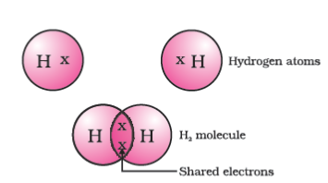

Figure 4.1 A molecule of hydrogen

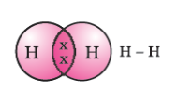

**Figure 4.2** Single bond between two hydrogen atoms

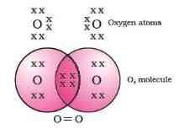

Figure 4.3 Double bond between two oxygen atoms

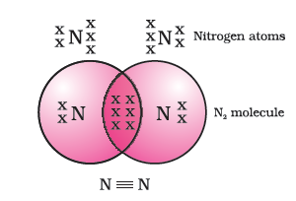

Figure 4.4 Triple bond between two nitrogen atoms

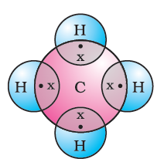

Figure 4.5 Electron dot structure for methane

#### More to know!

**Allotropes of carbon**

The element carbon occurs in different forms in nature with widely varying physical properties. Both diamond and graphite are formed by carbon atoms, the difference lies in the manner in which the carbon atoms are bonded to one another. In diamond, each carbon atom is bonded to four other carbon atoms forming a rigid three-dimensional structure. In graphite, each carbon atom is bonded to three other carbon atoms in the same plane giving a hexagonal array. One of these bonds is a double-bond, and thus the valency of carbon is satisfied. Graphite structure is formed by the hexagonal arrays being placed in layers one above the other.

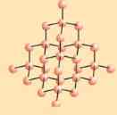

The structure of diamond

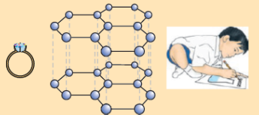

The structure of graphite

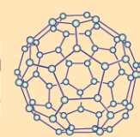

The structure of C-60 Buckminsterfullerene

These two different structures result in diamond and graphite having very different physical properties even though their chemical properties are the same. Diamond is the hardest substance known while graphite is smooth and slippery. Graphite is also a very good conductor of electricity unlike other non-metals that you studied in the previous Chapter.

Diamonds can be synthesised by subjecting pure carbon to very high pressure and temperature. These synthetic diamonds are small but are otherwise indistinguishable from natural diamonds.

Fullerenes form another class of carbon allotropes. The first one to be identified was C-60 which has carbon atoms arranged in the shape of a football. Since this looked like the geodesic dome designed by the US architect Buckminster Fuller, the molecule was named fullerene.

#### Questions

What would be the electron dot structure of carbon dioxide which has the formulaCO2\text{C}\text{O}_{2}

?

What would be the electron dot structure of a molecule of sulphur which is made up of eight atoms of sulphur? (**Hint** – The eight atoms of sulphur are joined together in the form of a ring.)

### 4.2 - Versatile Nature of Carbon

We have seen the formation of covalent bonds by the sharing of electrons in various elements and compounds. We have also seen the structure of a simple carbon compound, methane. In the beginning of the Chapter, we saw how many things we use contain carbon. In fact, we ourselves are made up of carbon compounds. The numbers of carbon compounds whose formulae are known to chemists was recently estimated to be in millions! This outnumbers by a large margin the compounds formed by all the other elements put together. Why is it that this property is seen in carbon and no other element? The nature of the covalent bond enables carbon to form a large number of compounds. Two factors noticed in the case of carbon are –

Carbon has the unique ability to form bonds with other atoms of carbon, giving rise to large molecules. This property is called catenation. These compounds may have long chains of carbon, branched chains of carbon or even carbon atoms arranged in rings. In addition, carbon atoms may be linked by single, double or triple bonds. Compounds of carbon, which are linked by only single bonds between the carbon atoms are called saturated compounds. Compounds of carbon having double or triple bonds between their carbon atoms are called unsaturated compounds.

No other element exhibits the property of catenation to the extent seen in carbon compounds. Silicon forms compounds with hydrogen which have chains of upto seven or eight atoms, but these compounds are very reactive. The carbon-carbon bond is very strong and hence stable. This gives us the large number of compounds with many carbon atoms linked to each other.

Since carbon has a valency of four, it is capable of bonding with four other atoms of carbon or atoms of some other mono-valent element. Compounds of carbon are formed with oxygen, hydrogen, nitrogen, sulphur, chlorine and many other elements giving rise to compounds with specific properties which depend on the elements other than carbon present in the molecule.

Again the bonds that carbon forms with most other elements are very strong making these compounds exceptionally stable. One reason for the formation of strong bonds by carbon is its small size. This enables the nucleus to hold on to the shared pairs of electrons strongly. The bonds formed by elements having bigger atoms are much weaker.

#### More to know!

**Organic compounds**

The two characteristic features seen in carbon, that is, tetravalency and catenation, put together give rise to a large number of compounds. Many have the same non-carbon atom or group of atoms attached to different carbon chains. These compounds were initially extracted from natural substances and it was thought that these carbon compounds or organic compounds could only be formed within a living system. That is, it was postulated that a ‘vital force’ was necessary for their synthesis. Friedrich Wöhler disproved this in 1828 by preparing urea from ammonium cyanate. But carbon compounds, except for carbides, oxides of carbon, carbonate and hydrogencarbonate salts continue to be studied under organic chemistry.

#### 4.2.1 - Saturated and Unsaturated Carbon Compounds

We have already seen the structure of methane. Another compound formed between carbon and hydrogen is ethane with a formula ofC2H6C_{2}H_{6}

. In order to arrive at the structure of simple carbon compounds, the first step is to link the carbon atoms together with a single bond (Fig. 4.6a) and then use the hydrogen atoms to satisfy the remaining valencies of carbon (Fig. 4.6b). For example, the structure of ethane is arrived in the following steps –

A carbon atom bonded to an other carbon atom with a single bond between them

Figure 4.6 (a) Carbon atoms linked together with a single bond

Three valencies of each carbon atom remain unsatisfied, so each is bonded to three hydrogen atoms giving:

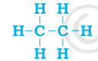

Figure 4.6 (b) Each carbon atom bonded to three hydrogen atoms

The electron dot structure of ethane is shown in Fig. 4.6(c).

Can you draw the structure of propane, which has the molecular formula C3H8C_{3}H_{8}

in a similar manner? You will see that the valencies of all the atoms are satisfied by single bonds between them. Such carbon compounds are called saturated compounds. These compounds are normally not very reactive.

A carbon atom bonded to an other carbon atom with a single bond between them

Step 1

However, another compound of carbon and hydrogen has the formula C2H4C_{2}H_{4}

and is called ethene. How can this molecule be depicted? We follow the same step-wise approach as above.

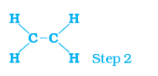

Carbon-carbon atoms linked together with a single bond (Step 1).

We see that one valency per carbon atom remains unsatisfied (Step 2). This can be satisfied only if there is a double bond between the two carbons (Step 3).

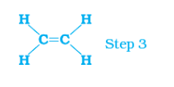

The electron dot structure for ethene is given in Fig. 4.7. Yet another compound of hydrogen and carbon has the formula C2H2C_{2}H_{2}

and is called ethyne. Can you draw the electron dot structure for ethyne? How many bonds are necessary between the two carbon atoms in order to satisfy their valencies? Such compounds of carbon having double or triple bonds between the carbon atoms are known as unsaturated carbon compounds and they are more reactive than the saturated carbon compounds.

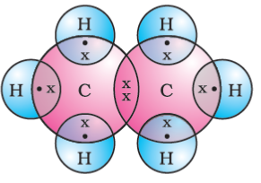

Figure 4.6 (c) Electron dot structure of ethane

#### 4.2.2 - Chains, Branches and Rings

In the earlier section, we mentioned the carbon compounds methane, ethane and propane, containing respectively 1, 2 and 3 carbon atoms. Such ‘chains’ of carbon atoms can contain many more carbon atoms. The names and structures of six of these are given in Table 4.2.

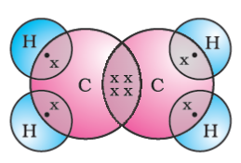

Figure 4.7 Structure of ethene

**Table 4.2** Formulae and structures of saturated compounds of carbon and hydrogen

| **No. of C atoms** | **Name** | **Formula** | **Structure** |
| --- | --- | --- | --- |
|  | Methane | CH4\text{CH}_{4} | A hydrocarbon chain structure of methane |
|  | Ethane | C2H6C_{2}H_{6} | A hydrocarbon chain structure of ethane |
|  | Propane | C3H8C_{3}H_{8} | A hydrocarbon chain structure of propane |
|  | Butane | C4H10C_{4}H_{\text{10}} | A hydrocarbon chain structure of butane |
|  | Pentane | C5H12C_{5}H_{\text{12}} | A hydrocarbon chain structure of pentane |
|  | Hexane | C6H14C_{6}H_{\text{14}} | A hydrocarbon chain structure of hexane |

But, let us take another look at butane. If we make the carbon ‘skeleton’ with four carbon atoms, we see that two different possible ‘skeletons’ are –

a chain of carbon atoms single bonded to each other

Figure 4.8 (a) Two possible carbon-skeletons

Filling the remaining valencies with hydrogen gives us –

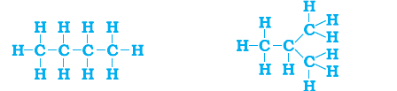

**Figure 4.8** (b) Complete molecules for two structures with formulaC4H10C_{4}H_{\text{10}}

We see that both these structures have the same formulaC4H10C_{4}H_{\text{10}}

. Such compounds with identical molecular formula but different structures are called structural isomers.

In addition to straight and branched carbon chains, some compounds have carbon atoms arranged in the form of a ring. For example, cyclohexane has the formula C6H12C_{6}H_{\text{12}}

and the following structure –

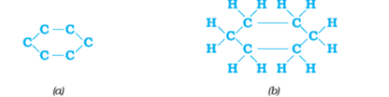

Figure 4.9 Structure of cyclohexane (a) carbon skeleton (b) complete molecule

Can you draw the electron dot structure for cyclohexane? Straight chain, branched chain and cyclic carbon compounds, all may be saturated or unsaturated. For example, benzene, C6H6C_{6}H_{6}

, has the following structure

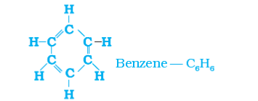

Figure 4.10 Structure of benzene

All these carbon compounds which contain only carbon and hydrogen are called hydrocarbons. Among these, the saturated hydrocarbons are called alkanes. The unsaturated hydrocarbons which contain one or more double bonds are called alkenes. Those containing one or more triple bonds are called alkynes.

#### 4.2.3 - Will you be my Friend?

Carbon seems to be a very friendly element. So far we have been looking at compounds containing carbon and hydrogen only. But carbon also forms bonds with other elements such as halogens, oxygen, nitrogen and sulphur. In a hydrocarbon chain, one or more hydrogens can be replaced by these elements, such that the valency of carbon remains satisfied. In such compounds, the element replacing hydrogen is referred to as a heteroatom. These heteroatoms are also present in some groups as given in Table 4.3. These heteroatoms and the group containing these confer specific properties to the compound, regardless of the length and nature of the carbon chain and hence are called functional groups. Some important functional groups are given in the Table 4.3. Free valency or valencies of the group are shown by the single line. The functional group is attached to the carbon chain through this valency by replacing one hydrogen atom or atoms.

**Table 4.3** Some functional groups in carbon compounds

| **Hetero atom** | **Class of compounds** | **Formula of functional group** |
| --- | --- | --- |
| Cl/Br | Halo- (Chloro/bromo) alkane | —Cl, —Br (substitutes for hydrogen atom) |
| Oxygen | Alcohol | —OH |
|  | Aldehyde | chain formula of aldehyde |
|  | Ketone | chain formula of ketone |
|  | Carboxylic acid | chain formula of carboxylic acid |

#### 4.2.4 - Homologous Series

You have seen that carbon atoms can be linked together to form chains of varying lengths. These chains can be branched also. In addition, hydrogen atom or other atoms on these carbon chains can be replaced by any of the functional groups that we saw above. The presence of a functional group such as alcohol decides the properties of the carbon compound, regardless of the length of the carbon chain. For example, the chemical properties of CH3OH,C2H5OH,C3H7OH\text{CH}_{3}OH,\ \text{C}_{2}H_{5}OH,\ \text{C}_{3}H_{7}\text{OH}

and C4H9OHC_{4}H_{9}\text{OH}

are all very similar. Hence, such a series of compounds in which the same functional group substitutes for hydrogen in a carbon chain is called a homologous series.

Let us look at the homologous series that we saw earlier in Table 4.2. If we look at the formulae of successive compounds, say –

CH4 and C2H6 \text{CH}_{4}\text{\ and\ }C_{2}H_{6}\text{\ }

— these differ by a CH2\text{CH}_{2}

unit

C2H6 and C3H8—C_{2}H_{6}\text{\ and\ }\text{C}_{3}H_{8}\ —

these differ by a CH2\text{CH}_{2}

unit

What is the difference between the next pair – propane and butane (C4H10C_{4}H_{\text{10}}

)?

Can you find out the difference in molecular masses between these pairs (the atomic mass of carbon is 12 u and the atomic mass of hydrogen is 1 u)?

Similarly, take the homologous series for alkenes. The first member of the series is ethene which we have already come across in Section 4.2.1. What is the formula for ethene? The succeeding members have the formula C3H6,C4H8C_{3}H_{6},\ C_{4}H_{8}

andC5H10C_{5}H_{\text{10}}

. Do these also differ by a −CH2−- \text{CH}_{2} -

unit? Do you see any relation between the number of carbon and hydrogen atoms in these compounds? The general formula for alkenes can be written as CnH2nC_{n}H_{\text{2n}}

, where n = 2, 3, 4\text{n\ =\ 2,\ 3,\ 4}

. Can you similarly generate the general formula for alkanes and alkynes?

As the molecular mass increases in any homologous series, a gradation in physical properties is seen. This is because the melting and boiling points increase with increasing molecular mass. Other physical properties such as solubility in a particular solvent also show a similar gradation. But the chemical properties, which are determined solely by the functional group, remain similar in a homologous series.

##### Activity 4.2

Calculate the difference in the formulae and molecular masses for (a) CH3OH\text{CH}_{3}\text{OH}

and C2H5OHC_{2}H_{5}\text{OH}

(b) C2H5OHC_{2}H_{5}\text{OH}

and C3H7OHC_{3}H_{7}\text{OH}

, and (c) C3H7OHC_{3}H_{7}\text{OH}

andC4H9OH\ C_{4}H_{9}\text{OH}

.

Is there any similarity in these three?

Arrange these alcohols in the order of increasing carbon atoms to get a family. Can we call this family a homologous series?

Generate the homologous series for compounds containing up to four carbons for the other functional groups given in Table 4.3.

#### 4.2.5 - Nomenclature of Carbon Compounds

The names of compounds in a homologous series are based on the name of the basic carbon chain modified by a “prefix” “phrase before” or “suffix” “phrase after” indicating the nature of the functional group. For example, the names of the alcohols taken in Activity 4.2 are methanol, ethanol, propanol and butanol.

Naming a carbon compound can be done by the following method –

Identify the number of carbon atoms in the compound. A compound having three carbon atoms would have the name propane.

In case a functional group is present, it is indicated in the name of the compound with either a prefix or a suffix (as given in Table 4.4).

If the name of the functional group is to be given as a suffix, and the suffix of the functional group begins with a vowel a, e, i, o, u, then the name of the carbon chain is modified by deleting the final ‘e’ and adding the appropriate suffix. For example, a three-carbon chain with a ketone group would be named in the following *manner - Propane 'e' = propan + 'one' = propanone*.

If the carbon chain is unsaturated, then the final ‘ane’ in the name of the carbon chain is substituted by ‘ene’ or ‘yne’ as given in Table 4.4. For example, a three-carbon chain with a double bond would be called propene and if it has a triple bond, it would be called propyne.

**Table 4.4** Nomenclature of organic compounds

| **Class of compounds** | **Prefix/Suffix** | **Example** |
| --- | --- | --- |
| Halo alkane | Prefix-chloro, bromo, etc. | Chloropropane chain  Chloropropane |
|  |  | Bromopropane chain  Bromopropane |
| Alcohol | Suffix - ol | Propanol chain  Propanol |
| Aldehyde | Suffix - al | Propanal chain  Propanal |
| Ketone | Suffix - one | Propanone chain  Propanone |
| Carboxylic acid | Suffix - oic acid | Propanoic acid chain  Propanoic acid |
| Alkenes | Suffix - ene | Propene chain  Propene |
| Alkynes | Suffix - yne | Propyne chain  Propyne |

#### Questions

How many structural isomers can you draw for pentane?

What are the two properties of carbon which lead to the huge number of carbon compounds we see around us?

What will be the formula and electron dot structure of cyclopentane?

Draw the structures for the following compounds.

Ethanoic acid

Bromopentane*

Butanone

Hexanal.

*Are structural isomers possible for bromopentane?

How would you name the following compounds?

chain formula for a compund

chain formula for a compund

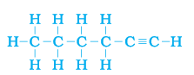

### 4.3 - Chemical Properties of Carbon Compounds

In this section we will be studying about some of the chemical properties of carbon compounds. Since most of the fuels we use are either carbon or its compounds, we shall first study combustion.

#### 4.3.1 - Combustion

Carbon, in all its allotropic forms, burns in oxygen to give carbon dioxide along with the release of heat and light. Most carbon compounds also release a large amount of heat and light on burning. These are the oxidation reactions that you learnt about in the first Chapter –

C+O2→CO2+heat and lightC\ + \ O_{2}\ \rightarrow \text{CO}_{2}\ + \ h\text{eat\ and\ lig}ht

CH3+O2→CO2+H2O+heatandlight\text{CH}_{3} + O_{2} \rightarrow \text{CO}_{2} + H_{2}O + \ heat\ and\ light

CH3CH2OH+O2→CO2+H2O+ heat and light \text{CH}_{3}\text{CH}_{2}\text{OH} + O_{2} \rightarrow \text{CO}_{2} + H_{2}O + \text{\ heat\ and\ light\ }

Balance the latter two reactions like you learnt in the first Chapter.

##### Activity 4.3

**CAUTION:** This Activity needs the teacher’s assistance.

Take some carbon compounds (naphthalene, camphor, alcohol) one by one on a spatula and burn them.

Observe the nature of the flame and note whether smoke is produced.

Place a metal plate above the flame. Is there a deposition on the plate in case of any of the compounds?

##### Activity 4.4

Light a bunsen burner and adjust the air hole at the base to get different types of flames/presence of smoke.

When do you get a yellow, sooty flame?

When do you get a blue flame?

Saturated hydrocarbons will generally give a clean flame while unsaturated carbon compounds will give a yellow flame with lots of black smoke. This results in a sooty deposit on the metal plate in Activity 4.3. However, limiting the supply of air results in incomplete combustion of even saturated hydrocarbons giving a sooty flame. The gas/kerosene stove used at home has inlets for air so that a sufficiently oxygen-rich mixture is burnt to give a clean blue flame. If you observe the bottoms of cooking vessels getting blackened, it means that the air holes are blocked and fuel is getting wasted. Fuels such as coal and petroleum have some amount of nitrogen and sulphur in them. Their combustion results in the formation of oxides of sulphur and nitrogen which are major pollutants in the environment.

##### Do you Know?

**Why do substances burn with or without a flame?**

Have you ever observed either a coal or a wood fire? If not, the next time you get a chance, take close note of what happens when the wood or coal starts to burn. You have seen above that a candle or the LPG in the gas stove burns with a flame. However, you will observe the coal or charcoal in an ‘angithi’ sometimes just glows red and gives out heat without a flame. This is because a flame is only produced when gaseous substances burn. When wood or charcoal is ignited, the volatile substances present vapourise and burn with a flame in the beginning.

A luminous flame is seen when the atoms of the gaseous substance are heated and start to glow. The colour produced by each element is a characteristic property of that element. Try and heat a copper wire in the flame of a gas stove and observe its colour. You have seen that incomplete combustion gives soot which is carbon. On this basis, what will you attribute the yellow colour of a candle flame to?

##### More to know!

**Formation of coal and petroleum**

Coal and petroleum have been formed from biomass which has been subjected to various biological and geological processes. Coal is the remains of trees, ferns, and other plants that lived millions of years ago. These were crushed into the earth, perhaps by earthquakes or volcanic eruptions. They were pressed down by layers of earth and rock. They slowly decayed into coal. Oil and gas are the remains of millions of tiny plants and animals that lived in the sea. When they died, their bodies sank to the sea bed and were covered by silt. Bacteria attacked the dead remains, turning them into oil and gas under the high pressures they were being subjected to. Meanwhile, the silt was slowly compressed into rock. The oil and gas seeped into the porous parts of the rock, and got trapped like water in a sponge. Can you guess why coal and petroleum are called fossil fuels?

#### 4.3.2 - Oxidation

You have learnt about oxidation reactions in the first Chapter. Carbon compounds can be easily oxidised on combustion. In addition to this complete oxidation, we have reactions in which alcohols are converted to carboxylic acids –

##### Activity 4.5

Take about 3 mL of ethanol in a test tube and warm it gently in a water bath.

Add a 5% solution of alkaline potassium permanganate drop by drop to this solution.

Does the colour of potassium permanganate persist when it is added initially?

Why does the colour of potassium permanganate not disappear when excess is added?

CH3−CH2OH→Alkaline KMnO4+ Heat Or acidified K2Cr2O7+HeatCH3COOH\text{CH}_{3} - \text{CH}_{2}\text{OH}\overset{\begin{matrix} \text{Alkaline\ }\text{KMnO}_{4} + \text{\ Heat\ } \\ \text{Or}\text{\ acidified\ }K_{2}\text{Cr}_{2}O_{7} + \text{Heat} \\ \end{matrix}}{\rightarrow}\text{CH}_{3}\text{COOH}

We see that some substances are capable of adding oxygen to others. These substances are known as oxidising agents.

Alkaline potassium permanganate or acidified potassium dichromate are oxidising alcohols to acids, that is, adding oxygen to the starting material. Hence they are known as oxidising agents.

#### 4.3.3 - Addition Reaction

Unsaturated hydrocarbons add hydrogen in the presence of catalysts such as palladium or nickel to give saturated hydrocarbons. Catalysts are substances that cause a reaction to occur or proceed at a different rate without the reaction itself being affected. This reaction is commonly used in the hydrogenation of vegetable oils using a nickel catalyst. Vegetable oils generally have long unsaturated carbon chains while animal fats have saturated carbon chains.

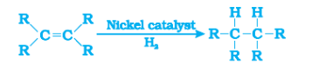

You must have seen advertisements stating that some vegetable oils are ‘healthy’. Animal fats generally contain saturated fatty acids which are said to be harmful for health. Oils containing unsaturated fatty acids should be chosen for cooking.

#### 4.3.4 - Substitution Reaction

Saturated hydrocarbons are fairly unreactive and are inert in the presence of most reagents. However, in the presence of sunlight, chlorine is added to hydrocarbons in a very fast reaction. Chlorine can replace the hydrogen atoms one by one. It is called a substitution reaction because one type of atom or a group of atoms takes the place of another. A number of products are usually formed with the higher homologues of alkanes.

CH4+Cl2→CH3Cl+HCl(inthepresenceofsunlight)\text{CH}_{4} + \text{Cl}_{2} \rightarrow \text{CH}_{3}\text{Cl} + \text{HCl}\ (in\ the\ presence\ of\ sunlight)\

#### Questions

Why is the conversion of ethanol to ethanoic acid an oxidation reaction?

A mixture of oxygen and ethyne is burnt for welding. Can you tell why a mixture of ethyne and air is not used?

### 4.4 - Some Important Carbon Compounds – Ethanol And Ethanoic Acid

Many carbon compounds are invaluable to us. But here we shall study the properties of two commercially important compounds – ethanol and ethanoic acid.

#### 4.4.1 - Properties of Ethanol

Ethanol is a liquid at room temperature (refer to Table 4.1 for the melting and boiling points of ethanol). Ethanol is commonly called alcohol and is the active ingredient of all alcoholic drinks. In addition, because it is a good solvent, it is also used in medicines such as tincture iodine, cough syrups, and many tonics. Ethanol is also soluble in water in all proportions. Consumption of small quantities of dilute ethanol causes drunkenness. Even though this practice is condemned, it is a socially widespread practice. However, intake of even a small quantity of pure ethanol (called absolute alcohol) can be lethal. Also, long-term consumption of alcohol leads to many health problems.

***Reactions of Ethanol***

Reaction with sodium –

2Na+2CH3CH2OH→︸2CH3CH2ONa+(Sodiumethoxide)+H22\text{Na} + 2\text{CH}_{3}\text{CH}_{2}\text{OH} \rightarrow \underset{(Sodium\ ethoxide)}{\overset{2\text{CH}_{3}\text{CH}_{2}O\text{Na}^{+}}{︸}} + H_{2}

Alcohols react with sodium leading to the evolution of hydrogen. With ethanol, the other product is sodium ethoxide. Can you recall which other substances produce hydrogen on reacting with metals?

Reaction to give unsaturated hydrocarbon: Heating ethanol at 443 K with excess concentrated sulphuric acid results in the dehydration of ethanol to give ethene –

CH3−CH2OH→Hot conc. H2SO4CH2=CH2+H2O\text{CH}_{3} - \text{CH}_{2}\text{OH}\overset{\text{Hot\ conc.\ }H_{2}\text{SO}_{4}}{\rightarrow}\text{CH}_{2} = \text{CH}_{2} + H_{2}O

The concentrated sulphuric acid can be regarded as a dehydrating agent which removes water from ethanol.

##### Activity 4.6

Teacher’s demonstration –

Drop a small piece of sodium, about the size of a couple of grains of rice, into ethanol (absolute alcohol).

What do you observe?

How will you test the gas evolved?

##### Do you Know?

**How do alcohols affect living beings?**

When large quantities of ethanol are consumed, it tends to slow metabolic processes and to depress the central nervous system. This results in lack of coordination, mental confusion, drowsiness, lowering of the normal inhibitions, and finally stupor. The individual may feel relaxed without realising that his sense of judgement, sense of timing, and muscular coordination have been seriously impaired.

Unlike ethanol, intake of methanol in very small quantities can cause death. Methanol is oxidised to methanal in the liver. Methanal reacts rapidly with the components of cells. It coagulates the protoplasm, in much the same way an egg is coagulated by cooking. Methanol also affects the optic nerve, causing blindness.

Ethanol is an important industrial solvent. To prevent the misuse of ethanol produced for industrial use, it is made unfit for drinking by adding poisonous substances like methanol to it. Dyes are also added to colour the alcohol blue so that it can be identified easily. This is called denatured alcohol.

##### Do you Know?

**Alcohol as a fuel**

Sugarcane plants are one of the most efficient convertors of sunlight into chemical energy. Sugarcane juice can be used to prepare molasses which is fermented to give alcohol (ethanol). Some countries now use alcohol as an additive in petrol since it is a cleaner fuel which gives rise to only carbon dioxide and water on burning in sufficient air (oxygen).

#### 4.4.2 - Properties of Ethanoic Acid

Ethanoic acid is commonly called acetic acid and belongs to a group of acids called carboxylic acids. 5-8% solution of acetic acid in water is called vinegar and is used widely as a preservative in pickles. The melting point of pure ethanoic acid is 290 K and hence it often freezes during winter in cold climates. This gave rise to its name glacial acetic acid.

The group of organic compounds called carboxylic acids are obviously characterised by their acidic nature. However, unlike mineral acids like HCl, which are completely ionised, carboxylic acids are weak acids.

##### Activity 4.7

Compare the pH of dilute acetic acid and dilute hydrochloric acid using both litmus paper and universal indicator.

Are both acids indicated by the litmus test?

Does the universal indicator show them as equally strong acids?

##### Activity 4.8

Take 1 mL ethanol (absolute alcohol) and 1 mL glacial acetic acid along with a few drops of concentrated sulphuric acid in a test tube.

Warm in a water-bath for at least five minutes as shown in Fig. 4.11.

Pour into a beaker containing 20-50 mL of water and smell the resulting mixture.

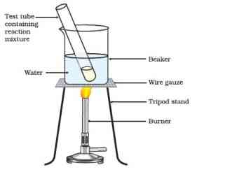

Figure 4.11 Formation of ester

**Reactions of ethanoic acid:**

*Esterification reaction:* Esters are most commonly formed by reaction of an acid and an alcohol. Ethanoic acid reacts with absolute ethanol in the presence of an acid catalyst to give an ester –

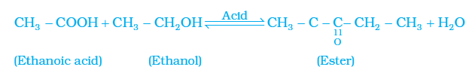

Generally, esters are sweet-smelling substances. These are used in making perfumes and as flavouring agents. On treating with sodium hydroxide, which is an alkali, the ester is converted back to alcohol and sodium salt of carboxylic acid. This reaction is known as saponification because it is used in the preparation of soap. Soaps are sodium or potassium salts of long chain carboxylic acid.

CH3COOC2H5→NaOHC2H5OH+CH3COONa\text{CH}_{3}\text{COOC}_{2}H_{5}\overset{\text{NaOH}}{\rightarrow}C_{2}H_{5}\text{OH} + \text{CH}_{3}\text{COONa}

*Reaction with a base:* Like mineral acids, ethanoic acid reacts with a base such as sodium hydroxide to give a salt (sodium ethanoate or commonly called sodium acetate) and water:

NaOH+CH3COOH→CH3COONa+H2O\text{NaOH} + \text{CH}_{3}\text{COOH} \rightarrow \text{CH}_{3}\text{COONa} + H_{2}O

**How does ethanoic acid react with carbonates and hydrogen carbonates?**

Let us perform an activity to find out.

*Reaction with carbonates and hydrogen carbonates:* Ethanoic acid reacts with carbonates and hydrogen carbonates to give rise to a salt, carbon dioxide and water. The salt produced is commonly called sodium acetate.

2CH3COOH+Na2CO3→2CH3COONa+H2O+CO22\text{CH}_{3}\text{COOH} + \text{Na}_{2}\text{CO}_{3} \rightarrow 2\text{CH}_{3}\text{COONa} + H_{2}O + \text{CO}_{2}

CH3COOH+NaHCO3→CH3COONa+H2O+CO2\text{CH}_{3}COOH\ + \ NaH\text{CO}_{3}\ \rightarrow \text{CH}_{3}COONa\ + \ H_{2}O\ + \ \text{CO}_{2}

##### Activity 4.9

Set up the apparatus as shown in Chapter 2, Activity 2.5.

Take a spatula full of sodium carbonate in a test tube and add 2 mL of dilute ethanoic acid.

What do you observe?

Pass the gas produced through freshly prepared lime-water. What do you observe?

Can the gas produced by the reaction between ethanoic acid and sodium carbonate be identified by this test?

Repeat this Activity with sodium hydrogen carbonate instead of sodium carbonate.

#### Questions

How would you distinguish experimentally between an alcohol and a carboxylic acid?

What are oxidising agents?

### 4.5 - Soaps And Detergents

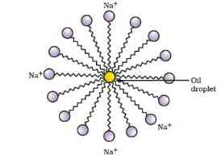

Figure 4.12 Formation of micelles

#### Activity 4.10

Take about 10 mL of water each in two test tubes. Add a drop of oil (cooking oil) to both the test tubes and label them as A and B.

To test tube B, add a few drops of soap solution.

Now shake both the test tubes vigorously for the same period of time.

Can you see the oil and water layers separately in both the test tubes immediately after you stop shaking them?

Leave the test tubes undisturbed for some time and observe. Does the oil layer separate out? In which test tube does this happen first?

This activity demonstrates the effect of soap in cleaning. Most dirt is oily in nature and as you know, oil does not dissolve in water. The molecules of soap are sodium or potassium salts of long-chain carboxylic acids. The ionic-end of soap interacts with water while the carbon chain interacts with oil. The soap molecules, thus form structures called micelles (see Fig. 4.12) where one end of the molecules is towards the oil droplet while the ionic-end faces outside. This forms an emulsion in water. The soap micelle thus helps in pulling out the dirt in water and we can wash our clothes clean (Fig. 4.13).

Can you draw the structure of the micelle that would be formed if you dissolve soap in a hydrocarbon?

##### More to know!

**Micelles**

Soaps are molecules in which the two ends have differing properties, one is hydrophilic, that is, it interacts with water, while the other end is hydrophobic, that is, it interacts with hydrocarbons. When soap is at the surface of water, the hydrophobic ‘tail’ of soap will not be soluble in water and the soap will align along the surface of water with the ionic end in water and the hydrocarbon ‘tail’ protruding out of water. Inside water, these molecules have a unique orientation that keeps the hydrocarbon portion out of the water. Thus, clusters of molecules in which the hydrophobic tails are in the interior of the cluster and the ionic ends are on the surface of the cluster. This formation is called a micelle. Soap in the form of a micelle is able to clean, since the oily dirt will be collected in the centre of the micelle. The micelles stay in solution as a colloid and will not come together to precipitate because of ion-ion repulsion. Thus, the dirt suspended in the micelles is also easily rinsed away. The soap micelles are large enough to scatter light. Hence a soap solution appears cloudy.

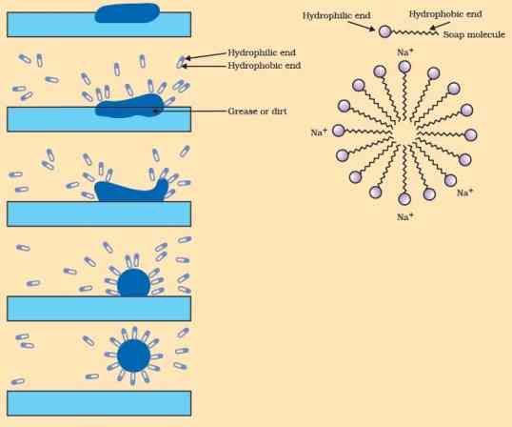

Figure 4.13 Effect of soap in cleaning

##### Activity 4.11

Take about 10 mL of distilled water (or rain water) and 10 mL of hard water (from a tubewell or hand-pump) in separate test tubes.

Add a couple of drops of soap solution to both.

Shake the test tubes vigorously for an equal period of time and observe the amount of foam formed.

In which test tube do you get more foam?

In which test tube do you observe a white curdy precipitate?

***Note for the teacher:*** If hard water is not available in your locality, prepare some hard water by dissolving hydrogencarbonates/sulphates/chlorides of calcium or magnesium in water.

##### Activity 4.12

Take two test tubes with about 10 mL of hard water in each.

Add five drops of soap solution to one and five drops of detergent solution to the other.

Shake both test tubes for the same period.

Do both test tubes have the same amount of foam?

In which test tube is a curdy solid formed?

Have you ever observed while bathing that foam is formed with difficulty and an insoluble substance (scum) remains after washing with water? This is caused by the reaction of soap with the calcium and magnesium salts, which cause the hardness of water. Hence you need to use a larger amount of soap. This problem is overcome by using another class of compounds called detergents as cleansing agents. Detergents are generally sodium salts of sulphonic acids or ammonium salts with chlorides or bromides ions, etc. Both have long hydrocarbon chain. The charged ends of these compounds do not form insoluble precipitates with the calcium and magnesium ions in hard water. Thus, they remain effective in hard water. Detergents are usually used to make shampoos and products for cleaning clothes.

#### Questions

Would you be able to check if water is hard by using a detergent?

People use a variety of methods to wash clothes. Usually after adding the soap, they ‘beat’ the clothes on a stone, or beat it with a paddle, scrub with a brush or the mixture is agitated in a washing machine. Why is agitation necessary to get clean clothes?

### What you have learnt

Carbon is a versatile element that forms the basis for all living organisms and many of the things we use.

This large variety of compounds is formed by carbon because of its tetravalency and the property of catenation that it exhibits.

Covalent bonds are formed by the sharing of electrons between two atoms so that both can achieve a completely filled outermost shell.

Carbon forms covalent bonds with itself and other elements such as hydrogen, oxygen, sulphur, nitrogen and chlorine.

Carbon also forms compounds containing double and triple bonds between carbon atoms. These carbon chains may be in the form of straight chains, branched chains or rings.

The ability of carbon to form chains gives rise to a homologous series of compounds in which the same functional group is attached to carbon chains of different lengths.

The functional groups such as alcohols, aldehydes, ketones and carboxylic acids bestow characteristic properties to the carbon compounds that contain them.

Carbon and its compounds are some of our major sources of fuels.

Ethanol and ethanoic acid are carbon compounds of importance in our daily lives.

The action of soaps and detergents is based on the presence of both hydrophobic and hydrophilic groups in the molecule and this helps to emulsify the oily dirt and hence its removal.

### Exercises

Ethane, with the molecular formula C2H6C_{2}H_{6}

has

6 covalent bonds.

7 covalent bonds.

8 covalent bonds.

9 covalent bonds.

Butanone is a four-carbon compound with the functional group

carboxylic acid.

aldehyde.

ketone.

alcohol.

While cooking, if the bottom of the vessel is getting blackened on the outside, it means that

the food is not cooked completely.

the fuel is not burning completely.

the fuel is wet.

the fuel is burning completely.

Explain the nature of the covalent bond using the bond formation in CH3Cl\text{CH}_{3}\text{Cl}

.

Draw the electron dot structures for

ethanoic acid.

H2SH_{2}S

.

propanone.

F2F_{2}

.

What is an homologous series? Explain with an example.

How can ethanol and ethanoic acid be differentiated on the basis of their physical and chemical properties?

Why does micelle formation take place when soap is added to water? Will a micelle be formed in other solvents such as ethanol also?

Why are carbon and its compounds used as fuels for most applications?

Explain the formation of scum when hard water is treated with soap.

What change will you observe if you test soap with litmus paper (red and blue)?

What is hydrogenation? What is its industrial application?

Which of the following hydrocarbons undergo addition reactions:

C2H6, C3H8, C3H6, C2H2C_{2}H_{6}\text{,\ }\text{C}_{3}H_{8}\text{,\ }\text{C}_{3}H_{6}\text{,\ }\text{C}_{2}H_{2}

and CH4\text{CH}_{4}

.

Give a test that can be used to differentiate between saturated and unsaturated hydrocarbons.

Explain the mechanism of the cleaning action of soaps.

### Group Activity

Use molecular model kits to make models of the compounds you have learnt in this Chapter.

Take about 20 mL of castor oil/cotton seed oil/linseed oil/soyabean oil in a beaker. Add 30 mL of 20 % sodium hydroxide solution. Heat the mixture with continuous stirring for a few minutes till the mixture thickens. Add 5-10 g of common salt to this. Stir the mixture well and allow it to cool.

You can cut out the soap in fancy shapes. You can also add perfume to the soap before it sets.

## Chapter 5 – Periodic Classification of Elements



1064CH05

In Class IX we have learnt that matter around us is present in the form of elements, compounds and mixtures and the elements contain atoms of only one type. Do you know how many elements are known till date? At present, 118 elements are known to us. All these have different properties. Out of these 118, only 94 are naturally occurring.

As different elements were being discovered, scientists gathered more and more information about the properties of these elements. They found it difficult to organise all that was known about the elements. They started looking for some pattern in their properties, on the basis of which they could study such a large number of elements with ease.

### 5.1 - Making Order Out of Chaos – Early Attempts at the Classification of Elements

We have been learning how various things or living beings can be classified on the basis of their properties. Even in other situations, we come across instances of organisation based on some properties. For example, in a shop, soaps are kept together at one place while biscuits are kept together elsewhere. Even among soaps, bathing soaps are stacked separately from washing soaps. Similarly, scientists made several attempts to classify elements according to their properties and obtain an orderly arrangement out of chaos.

The earliest attempt to classify the elements resulted in grouping the then known elements as metals and non-metals. Later further classifications were tried out as our knowledge of elements and their properties increased.

#### 5.1.1 - Döbereiner’s Triads

In the year 1817, Johann Wolfgang Döbereiner, a German chemist, tried to arrange the elements with similar properties into groups. He identified some groups having three elements each. So he called these groups ‘triads’. Döbereiner showed that when the three elements in a triad were written in the order of increasing atomic masses; the atomic mass of the middle element was roughly the average of the atomic masses of the other two elements.

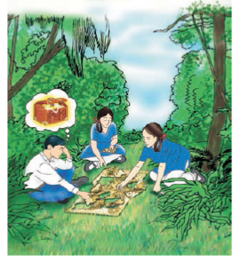

Figure 5.1 Imagine you and your friends have found pieces of an old map to reach a treasure. Would it be easy or chaotic to find the way to the treasure? Similar chaos was there in Chemistry as elements were known but there was no clue as to how to classify and study about them.

For example, take the triad consisting of lithium (Li), sodium (Na) and potassium (K) with the respective atomic masses 6.9, 23.0 and 39.0. What is the average of the atomic masses of Li and K? How does this compare with the atomic mass of Na?

Given below (Table 5.1) are some groups of three elements. These elements are arranged downwards in order of increasing atomic masses. Can you find out which of these groups form Döbereiner triads?

Table 5.1

| **Group A element** | **Atomic mass** | **Group B element** | **Atomic mass** | **Group C elements** | **Atomic mass** |
| --- | --- | --- | --- | --- | --- |
| N | 14.0 | Ca | 40.1 | Cl | 35. 5 |
| P | 31.0 | Sr | 87.6 | Br | 79.9 |
| As | 74.9 | Ba | 137.3 | I | 126.9 |

You will find that groups B and C form Döbereiner triads. Döbereiner could identify only three triads from the elements known at that time (Table 5.2). Hence, this system of classification into triads was not found to be useful.

**Table 5.2** Döbereiner’s triads

| Li | Ca | Cl |
| --- | --- | --- |
| Na | Sr | Br |
| K | Ba | I |

**Johann Wolfgang Döbereiner (1780-1849)**

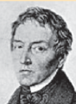

Johann Wolfgang Döbereiner studied as a pharmacist at Münchberg in Germany, and then studied chemistry at Strasbourg. Eventually he became a professor of chemistry and pharmacy at the University of Jena. Döbereiner made the first observations on platinum as a catalyst and discovered similar triads of elements which led to the development of the Periodic Table of elements.

#### 5.1.2 - Newlands’ Law of Octaves

The attempts of Döbereiner encouraged other chemists to correlate the properties of elements with their atomic masses. In 1866, John Newlands, an English scientist, arranged the then known elements in the order of increasing atomic masses. He started with the element having the lowest atomic mass (hydrogen) and ended at thorium which was the 56th element. He found that every eighth element had properties similar to that of the first. He compared this to the octaves found in music. Therefore, he called it the ‘Law of Octaves’. It is known as ‘Newlands’ Law of Octaves’. In Newlands’ Octaves, the properties of lithium and sodium were found to be the same. Sodium is the eighth element after lithium. Similarly, beryllium and magnesium resemble each other. A part of the original form of Newlands’ Octaves is given in Table 5.3.

It was found that the Law of Octaves was applicable only upto calcium, as after calcium every eighth element did not possess properties similar to that of the first.

It was assumed by Newlands that only 56 elements existed in nature and no more elements would be discovered in the future. But, later on, several new elements were discovered, whose properties did not fit into the Law of Octaves.

In order to fit elements into his Table, Newlands adjusted two elements in the same slot, but also put some unlike elements under the same note. Can you find examples of these from Table 5.3? Note that cobalt and nickel are in the same slot and these are placed in the same column as fluorine, chlorine and bromine which have very different properties than these elements. Iron, which resembles cobalt and nickel in properties, has been placed far away from these elements. With the discovery of noble gases, the Law of Octaves became irrelevant.

Thus, Newlands’ Law of Octaves worked well with lighter elements only.

**Table 5.3 Newlands’ Octaves**

**Notes of music:**

| **sa**  **(do)** | **re**  **(re)** | **ga**  **(mi)** | **ma**  **(fa)** | **pa**  **(so)** | **da**  **(la)** | **ni**  **(ti)** |
| --- | --- | --- | --- | --- | --- | --- |
| H | Li | Be | B | C | N | O |
| F | Na | Mg | Al | Si | P | s |
| Cl | K | Ca | Cr | Ti | Mn | Fe |
| Co and Ni | Cu | Zn | Y | In | As | Se |
| Br | Rb | Sr | Ce and La | Zr | — | — |

##### Do you Know?

**Are you familiar with musical notes?**

In the Indian system of music, there are seven musical notes in a scale— *sa, re, ga, ma, pa, da, ni.* In the west, they use the notations— *do, re, mi, fa, so, la, ti*. The notes in a scale are separated by whole and half-step frequency intervals of tones and semitones. A musician uses these notes for composing the music of a song. Naturally, there must be some repetition of notes. Every eighth note is similar to the first one and it is the first note of the next scale.

#### Questions

Did Döbereiner’s triads also exist in the columns of Newlands’ Octaves? Compare and find out.

What were the limitations of Döbereiner’s classification?

What were the limitations of Newlands’ Law of Octaves?

### 5.2 - Making Order Out Of Chaos – Mendeléev’s Periodic Table

Even after the rejection of Newlands’ Law of Octaves, many scientists continued to search for a pattern that correlated the properties of elements with their atomic masses.

The main credit for classifying elements goes to Dmitri Ivanovich Mendeléev, a Russian chemist. He was the most important contributor to the early development of a Periodic Table of elements wherein the elements were arranged on the basis of their fundamental property, the atomic mass, and also on the similarity of chemical properties.

When Mendeléev started his work, 63 elements were known. He examined the relationship between the atomic masses of the elements and their physical and chemical properties. Among chemical properties, Mendeléev concentrated on the compounds formed by elements with oxygen and hydrogen. He selected hydrogen and oxygen as they are very reactive and formed compounds with most elements. The formulae of the hydrides and oxides formed by an element were treated as one of the basic properties of an element for its classification. He then took 63 cards and on each card he wrote down the properties of one element. He sorted out the elements with similar properties and pinned the cards together on a wall. He observed that most of the elements got a place in a Periodic Table and were arranged in the order of their increasing atomic masses. It was also observed that there occurs a periodic recurrence of elements with similar physical and chemical properties. On this basis, Mendeléev formulated a Periodic Law, which states that ‘the properties of elements are the periodic function of their atomic masses’.

Mendeléev’s Periodic Table contains vertical columns called ‘groups’ and horizontal rows called ‘periods’ (Table 5.4).

**Table 5.4 Mendeléev’s Periodic Table**

| **Group** | **I** | **II** | **III** | **IV** | **V** | **VI** | **VII** | **VIII** |  |  |  |  |  |  |  |
| --- | --- | --- | --- | --- | --- | --- | --- | --- | --- | --- | --- | --- | --- | --- | --- |
| **Oxide** | 𝐑2𝐎\mathbf{R}_{\mathbf{2}}\mathbf{O} | RO\mathbf{\text{RO}} | 𝐑2𝐎3\mathbf{R}_{\mathbf{2}}\mathbf{O}_{\mathbf{3}} | 𝐑𝐎2\mathbf{R}\mathbf{O}_{\mathbf{2}} | 𝐑2𝐎5\mathbf{R}_{\mathbf{2}}\mathbf{O}_{\mathbf{5}} | 𝐑𝐎3\mathbf{R}\mathbf{O}_{\mathbf{3}} | 𝐑2𝐎7\mathbf{R}_{\mathbf{2}}\mathbf{O}_{\mathbf{7}} | 𝐑𝐎4\mathbf{R}\mathbf{O}_{\mathbf{4}} |  |  |  |  |  |  |  |
| **Hydride** | **RH** | RH2\mathbf{\text{RH}}_{\mathbf{2}} | RH3\mathbf{\text{RH}}_{\mathbf{3}} | RH4\mathbf{\text{RH}}_{\mathbf{4}} | RH3\mathbf{\text{RH}}_{\mathbf{3}} | RH2\mathbf{\text{RH}}_{\mathbf{2}} | **RH** |  |  |  |  |  |  |  |  |
| **Periods**↓\mathbf{\downarrow} | **A** | **B** | **A** | **B** | **A** | **B** | **A** | **B** | **A** | **B** | **A** | **B** | **A** | **B** | **Transition series** |
| **1** | H 1.008 |  |  |  |  |  |  |  |  |  |  |  |  |  |  |
| **2** | Li 6.939 |  | Be 9.012 |  | B 10.81 |  | C 12.011 |  | N 14.007 |  | O 15.999 |  | F 18.998 |  |  |
| 3 | Na 22.99 |  | Mg 24.31 |  | Al 29.98 |  | Si 28.09 |  | P 30.974 |  | S 32.06 |  | Cl 35.453 |  |  |
| 4 First series: | K 39.102 |  | Ca 40.08 |  |  | Sc 44.96 |  | Ti 47.90 |  | V 50.94 |  | Cr 50.20 |  | Mn 54.94 | Fe 55.85  Co 58.93  Ni 58.71 |
| Second series: |  | Cu 63.54 |  | Zn 65.37 | Ga 69.72 |  | Ge 72.59 |  | As 74.92 |  | Se 78.96 |  | Br 79.909 |  |  |
| **5 First series:** | Rb 85.47 |  | Sr 87.62 |  |  | Y 88.91 |  | Zr 91.22 |  | Nb 92.91 |  | Mo 95.94 |  | Tc 99 | Ru 101.07  Rh 102.91  Pd 106.4 |
| **Second series:** |  | Ag 107.87 |  | Cd 112.40 | In 114.82 |  | Sn 118.69 |  | Sb 121.75 |  | Te 127.60 |  | I 126.90 |  |  |
| 6 First series: | Cs 132.90 |  | Ba 137.34 |  |  | La 138.91 |  | Hf 178.49 |  | Ta 180.95 |  | W 183.85 |  |  | Os 190.2  Ir 192.2  Pt 195.09 |
| Second series: |  | Au 196.97 |  | Hg 200.59 |  | TI 204.37 | Pb 207.19 |  | Bi 208.98 |  |  |  |  |  |  |

**Dmitri Ivanovich Mendeléev (1834-1907)**

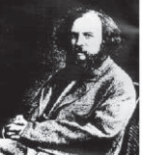

Dmitri Ivanovich Mendeléev was born in Tobolsk in Western Siberia, Russia on 8 February 1834. After his early education, Mendeléev could join a university only due to the efforts of his mother. Dedicating his investigations to his mother he wrote, “She instructed with example, corrected with love and travelled with me to places spending her last resources and strength. She knew that with the aid of science without violence, with love but firmness, all superstitions, untruth and errors can be removed.” The arrangement of elements he proposed is called Mendeléev’s Periodic Table. The Periodic Table proved to be the unifying principle in chemistry. It was the motivation for the discovery of some new elements.

Mendeléev’s Periodic Table was published in a German journal in 1872. In the formula for oxides and hydrides at the top of the columns, the letter ‘R’ is used to represent any of the elements in the group. Note the way formulae are written. For example, the hydride of carbon, CH4\text{CH}_{4}

, is written as RH4\text{RH}_{4}

and the oxide CO2\text{CO}_{2}

, as CO2\text{CO}_{2}

.

#### 5.2.1 - Achievements of Mendeléev’s Periodic Table

While developing the Periodic Table, there were a few instances where Mendeléev had to place an element with a slightly greater atomic mass before an element with a slightly lower atomic mass. The sequence was inverted so that elements with similar properties could be grouped together. For example, cobalt (atomic mass 58.9) appeared before nickel (atomic mass 58.7). Looking at Table 5.4, can you find out one more such anomaly?

Further, Mendeléev left some gaps in his Periodic Table. Instead of looking upon these gaps as defects, Mendeléev boldly predicted the existence of some elements that had not been discovered at that time. Mendeléev named them by prefixing a Sanskrit numeral, *Eka* (one) to the name of preceding element in the same group. For instance, scandium, gallium and germanium, discovered later, have properties similar to *Eka*–boron, *Eka*–aluminium and *Eka*–silicon, respectively. The properties of *Eka*–Aluminium predicted by Mendeléev and those of the element, gallium which was discovered later and replaced *Eka*-aluminium, are listed as follows (Table 5.5).

**Table 5.5** Properties of *eka*-aluminium and gallium

| **Property** | *Eka* -aluminium | **Gallium** |
| --- | --- | --- |
| Atomic Mass | 68 | 69.7 |
| Formula of Oxide | E2O3E_{2}O_{3} | Ga2O3\text{Ga}_{2}O_{3} |
| Formula of Chloride | ECl3E\text{Cl}_{3} | GaCl3\text{Ga}\text{Cl}_{3} |

This provided convincing evidence for both the correctness and usefulness of Mendeléev’s Periodic Table. Further, it was the extraordinary success of Mendeléev’s prediction that led chemists not only to accept his Periodic Table but also recognise him, as the originator of the concept on which it is based. Noble gases like helium (He), neon (Ne) and argon (Ar) have been mentioned in many a context before this. These gases were discovered very late because they are very inert and present in extremely low concentrations in our atmosphere. One of the strengths of Mendeléev’s Periodic Table was that, when these gases were discovered, they could be placed in a new group without disturbing the existing order.

#### 5.2.2 - Limitations of Mendeléev’s Classification

Electronic configuration of hydrogen resembles that of alkali metals. Like alkali metals, hydrogen combines with halogens, oxygen and sulphur to form compounds having similar formulae, as shown in the examples here.

On the other hand, just like halogens, hydrogen also exists as diatomic molecules and it combines with metals and non-metals to form covalent compounds.

| Compounds of H | Compounds of Na |
| --- | --- |
| HCL | NaCl |
| H2OH_{2}O | Na2O\text{N}\text{a}_{2}O |
| H2SH_{2}S | Na2S\text{N}\text{a}_{2}S |

Certainly, no fixed position can be given to hydrogen in the Periodic Table. This was the first limitation of Mendeléev’s Periodic Table. He could not assign a correct position to hydrogen in his Table.

Isotopes were discovered long after Mendeléev had proposed his periodic classification of elements. Let us recall that isotopes of an element have similar chemical properties, but different atomic masses.

Thus, isotopes of all elements posed a challenge to Mendeleev’s Periodic Law. Another problem was that the atomic masses do not increase in a regular manner in going from one element to the next. So it was not possible to predict how many elements could be discovered between two elements — especially when we consider the heavier elements.

##### Activity 5.1

Looking at its resemblance to alkali metals and the halogen family, try to assign hydrogen a correct position in Mendeléev’s Periodic Table.

To which group and period should hydrogen be assigned?

##### Activity 5.2

Consider the isotopes of chlorine, Cl-35 and Cl-37.

Would you place them in different slots because their atomic masses are different?

Or would you place them in the same position because their chemical properties are the same?

#### Questions

Use Mendeléev’s Periodic Table to predict the formulae for the oxides of the following elements:

K, C, AI, Si, Ba.

Besides gallium, which other elements have since been discovered that were left by Mendeléev in his Periodic Table? (any two)

What were the criteria used by Mendeléev in creating his Periodic Table?

Why do you think the noble gases are placed in a separate group?

### 5.3 - Making Order Out of Chaos – The Modern Periodic Table

In 1913, Henry Moseley showed that the atomic number (symbolised as Z) of an element is a more fundamental property than its atomic mass. Accordingly, Mendeléev’s Periodic Law was modified and atomic number was adopted as the basis of Modern Periodic Table and the Modern Periodic Law can be stated as follows:

‘Properties of elements are a periodic function of their atomic number.’

Let us recall that the atomic number gives us the number of protons in the nucleus of an atom and this number increases by one in going from one element to the next. Elements, when arranged in order of increasing atomic number, lead us to the classification known as the Modern Periodic Table (Table 5.6). Prediction of properties of elements could be made with more precision when elements were arranged on the basis of increasing atomic number.

#### Activity 5.3

How were the positions of cobalt and nickel resolved in the Modern Periodic Table?

How were the positions of isotopes of various elements decided in the Modern Periodic Table?

Is it possible to have an element with atomic number 1.5 placed between hydrogen and helium?

Where do you think should hydrogen be placed in the Modern Periodic Table?

**Table 5.6** Modern Periodic Table

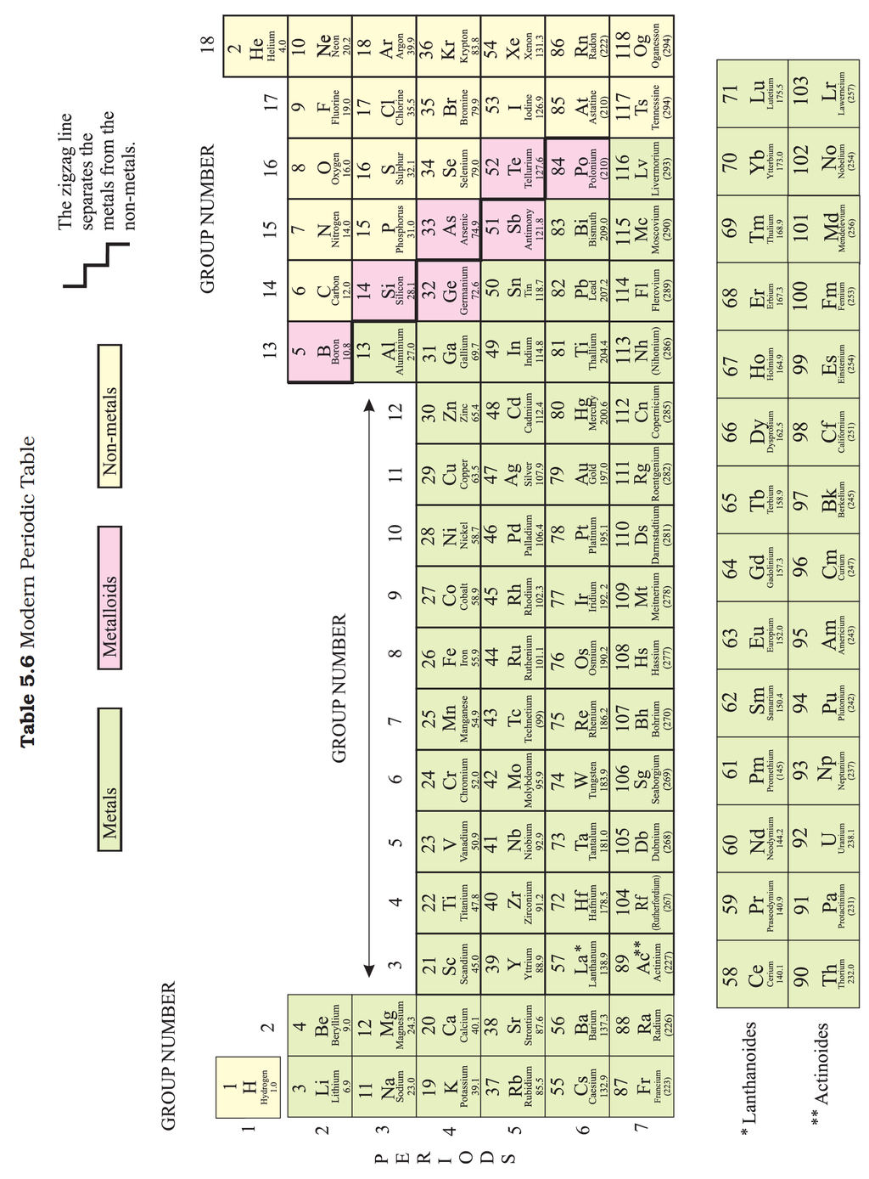

As we can see, the Modern Periodic Table takes care of three limitations of Mendléev’s Periodic Table. The anomalous position of hydrogen can be discussed after we see what are the bases on which the position of an element in the Modern Periodic Table depends.

#### 5.3.1 - Position of Elements in the Modern Periodic Table

The Modern Periodic Table has 18 vertical columns known as ‘groups’ and 7 horizontal rows known as ‘periods’. Let us see what decides the placing of an element in a certain group and period.

##### Activity 5.4

Look at the group 1 of the Modern Periodic Table, and name the elements present in it.

Write down the electronic configuration of the first three elements of group 1.

What similarity do you find in their electronic configurations?

How many valence electrons are present in these three elements?

You will find that all these elements contain the same number of valence electrons. Similarly, you will find that the elements present in any one group have the same number of valence electrons. For example, elements fluorine (F) and chlorine (Cl), belong to group 17, how many electrons do fluorine and chlorine have in their outermost shells? Hence, we can say that groups in the Periodic Table signify an identical outer-shell electronic configuration. On the other hand, the number of shells increases as we go down the group.

There is an anomaly when it comes to the position of hydrogen because it can be placed either in group 1 or group 17 in the first period. Can you say why?

##### Activity 5.5

If you look at the Modern Periodic Table (5.6), you will find that the elements Li, Be, B, C, N, O, F, and Ne are present in the second period. Write down their electronic configurations.

Do these elements also contain the same number of valence electrons?

Do they contain the same number of shells?

You will find that these elements of second period do not have the same number of valence electrons, but they contain the same number of shells. You also observe that the number of valence shell electrons increases by one unit, as the atomic number increases by one unit on moving from left to right in a period.

Or we can say that atoms of different elements with the same number of occupied shells are placed in the same period. Na, Mg, Al, Si, P, S, Cl and Ar belong to the third period of the Modern Periodic Table, since the electrons in the atoms of these elements are filled in K, L and M shells. Write the electronic configuration of these elements and confirm the above statement. Each period marks a new electronic shell getting filled.

How many elements are there in the first, second, third and fourth periods?

We can explain the number of elements in these periods based on how electrons are filled into various shells. You will study the details of this in higher classes. Recall that the maximum number of electrons that can be accommodated in a shell depends on the formula 2n22n^{2}

where ‘n’ is the number of the given shell from the nucleus.

For example,

K Shell=2×(1)2 = 2\text{K\ S}hell\ = \ 2\ \times \ (1)^{2}\text{\ =\ 2}

, hence the first period has 2 elements.

L Shell =2×(2)2 = 8\text{L\ S}h\text{ell\ } = \ 2\ \times \ (2)^{2}\text{\ =\ 8}

, hence the second period has 8 elements.

The third, fourth, fifth, sixth and seventh periods have 8, 18, 18, 32 and 32 elements respectively.

The reason for this you will study in higher classes.

The position of an element in the Periodic Table tells us about its chemical reactivity. As you have learnt, the valence electrons determine the kind and number of bonds formed by an element. Can you now say why Mendeléev’s choice of formulae of compounds as the basis for deciding the position of an element in his Table was a good one? How would this lead to elements with similar chemical properties being placed in the same group?

#### 5.3.2 - Trends in the Modern Periodic Table

**Valency:** As you know, the valency of an element is determined by the number of valence electrons present in the outermost shell of its atom.

##### Activity 5.6

How do you calculate the valency of an element from its electronic configuration?

What is the valency of magnesium with atomic number 12 and sulphur with atomic number 16?

Similarly find out the valencies of the first twenty elements.

How does the valency vary in a period on going from left to right?

How does the valency vary in going down a group?

**Atomic size:** The term atomic size refers to the radius of an atom. The atomic size may be visualised as the distance between the centre of the nucleus and the outermost shell of an isolated atom. The atomic radius of hydrogen atom is 37 pm(picometre, 1 pm = 10−12m)\left( \text{picometre,\ 1\ pm\ =\ 1}\text{0}^{- \text{12}}m \right)

.

Let us study the variation of atomic size in a group and in a period.

##### Activity 5.7

Atomic radii of the elements of the second period are given below:

Period II elements: B Be O N Li C

Atomic radius (pm):88 111 66 74 152 77

Arrange them in decreasing order of their atomic radii.

Are the elements now arranged in the pattern of a period in the Periodic Table?

Which elements have the largest and the smallest atoms?

How does the atomic radius change as you go from left to right in a period?

You will see that the atomic radius decreases in moving from left to right along a period. This is due to an increase in nuclear charge which tends to pull the electrons closer to the nucleus and reduces the size of the atom.

##### Activity 5.8

Study the variation in the atomic radii of first group elements given below and arrange them in an increasing order.

Group 1 Elements: Na Li Rb Cs K

Atomic Radius (pm): 186 152 244 262 231

Name the elements which have the smallest and the largest atoms.

How does the atomic size vary as you go down a group?

You will see that the atomic size increases down the group. This is because new shells are being added as we go down the group. This increases the distance between the outermost electrons and the nucleus so that the atomic size increases in spite of the increase in nuclear charge.

**Metallic and Non-metallic Properties**

##### Activity 5.9

Examine elements of the third period and classify them as metals and non-metals.

On which side of the Periodic Table do you find the metals?

On which side of the Periodic Table do you find the non-metals?

As we can see, the metals like Na and Mg are towards the left-hand side of the Periodic Table while the non-metals like sulphur and chlorine are found on the right-hand side. In the middle, we have silicon, which is classified as a semi-metal or metalloid because it exhibits some properties of both metals and non-metals.

In the Modern Periodic Table, a zig-zag line separates metals from non-metals. The borderline elements – boron, silicon, germanium, arsenic, antimony, tellurium and polonium – are intermediate in properties and are called metalloids or semi-metals.

As you have seen in Chapter 3, metals tend to lose electrons while forming bonds, that is, they are electropositive in nature.

##### Activity 5.10

How do you think the tendency to lose electrons changes in a group?

How will this tendency change in a period?

As the effective nuclear charge acting on the valence shell electrons increases across a period, the tendency to lose electrons will decrease. Down the group, the effective nuclear charge experienced by valence electrons is decreasing because the outermost electrons are farther away from the nucleus. Therefore, these can be lost easily. Hence metallic character decreases across a period and increases down a group.

Non-metals, on the other hand, are electronegative. They tend to form bonds by gaining electrons. Let us learn about the variation of this property.

##### Activity 5.11

How would the tendency to gain electrons change as you go from left to right across a period?

How would the tendency to gain electrons change as you go down a group?

As the trends in the electronegativity show, non-metals are found on the right-hand side of the Periodic Table towards the top.

These trends also help us to predict the nature of oxides formed by the elements because it is known to you that the oxides of metals are basic and that of non-metals are acidic in general.

#### Questions

How could the Modern Periodic Table remove various anomalies of Mendeléev’s Periodic Table?

Name two elements you would expect to show chemical reactions similar to magnesium. What is the basis for your choice?

Name

three elements that have a single electron in their outermost shells.

two elements that have two electrons in their outermost shells.

three elements with filled outermost shells.

Lithium, sodium, potassium are all metals that react with water to liberate hydrogen gas. Is there any similarity in the atoms of these elements?

Helium is an unreactive gas and neon is a gas of extremely low reactivity. What, if anything, do their atoms have in common?

In the Modern Periodic Table, which are the metals among the first ten elements?

By considering their position in the Periodic Table, which one of the following elements would you expect to have maximum metallic characteristic?

Ga Ge As Se Be

### What you have learnt

Elements are classified on the basis of similarities in their properties.

Döbereiner grouped the elements into triads and Newlands gave the Law of Octaves.

Mendeléev arranged the elements in increasing order of their atomic masses and according to their chemical properties.

Mendeléev even predicted the existence of some yet to be discovered elements on the basis of gaps in his Periodic Table.

Anomalies in arrangement of elements based on increasing atomic mass could be removed when the elements were arranged in order of increasing atomic number, a fundamental property of the element discovered by Moseley.

Elements in the Modern Periodic Table are arranged in 18 vertical columns called groups and 7 horizontal rows called periods.

Elements thus arranged show periodicity of properties including atomic size, valency or combining capacity and metallic and non-metallic character.

### Exercises

Which of the following statements is not a correct statement about the trends when going from left to right across the periods of periodic Table.

The elements become less metallic in nature.

The number of valence electrons increases.

The atoms lose their electrons more easily.

The oxides become more acidic.

Element X forms a chloride with the formulaXCl2\ X\text{Cl}_{2}

, which is a solid with a high melting point. X would most likely be in the same group of the Periodic Table as

Na

Mg

AI

Si

Which element has

two shells, both of which are completely filled with electrons?

the electronic configuration 2, 8, 2?

a total of three shells, with four electrons in its valence shell?

a total of two shells, with three electrons in its valence shell?

twice as many electrons in its second shell as in its first shell?

What property do all elements in the same column of the Periodic Table as boron have in common?

What property do all elements in the same column of the Periodic Table as fluorine have in common?

An atom has electronic configuration 2, 8, 7.

What is the atomic number of this element?

To which of the following elements would it be chemically similar? (Atomic numbers are given in parentheses.)

N(7) F(9) P(15) Ar(18)

The position of three elements A, B and C in the Periodic Table are shown below –

| *Group 16* | *Group 17* |
| --- | --- |
| - | - |
| - | A |
| - | - |
| B | C |

State whether A is a metal or non-metal.

State whether C is more reactive or less reactive than A.

Will C be larger or smaller in size than B?

Which type of ion, cation or anion, will be formed by element A?

Nitrogen (atomic number 7) and phosphorus (atomic number 15) belong to group 15 of the Periodic Table. Write the electronic configuration of these two elements. Which of these will be more electronegative? Why?

How does the electronic configuration of an atom relate to its position in the Modern Periodic Table?

In the Modern Periodic Table, calcium (atomic number 20) is surrounded by elements with atomic numbers 12, 19, 21 and 38. Which of these have physical and chemical properties resembling calcium?

Compare and contrast the arrangement of elements in Mendeléev’s Periodic Table and the Modern Periodic Table.

### Group Activity

We have discussed the major attempts made for classifying elements. Find out (from the internet or library) about other attempts to classify elements.

We have studied the long form of the Periodic Table. The Modern Periodic Law has been used to arrange elements in other ways too. Find out what are these.

## Chapter 6 – Life Processes



1064CH06

How do we tell the difference between what is alive and what is not alive? If we see a dog running, or a cow chewing cud, or a man shouting loudly on the street, we know that these are living beings. What if the dog or the cow or the man were asleep? We would still think that they were alive, but how did we know that? We see them breathing, and we know that they are alive. What about plants? How do we know that they are alive? We see them green, some of us will say. But what about plants that have leaves of colours other than green? They grow over time, so we know that they are alive, some will say. In other words, we tend to think of some sort of movement, either growth-related or not, as common evidence for being alive. But a plant that is not visibly growing is still alive, and some animals can breathe without visible movement. So using visible movement as the defining characteristic of life is not enough.

Movements over very small scales will be invisible to the naked eye – movements of molecules, for example. Is this invisible molecular movement necessary for life? If we ask this question to professional biologists, they will say yes. In fact, viruses do not show any molecular movement in them (until they infect some cell), and that is partly why there is a controversy about whether they are truly alive or not.

Why are molecular movements needed for life? We have seen in earlier classes that living organisms are well-organised structures; they can have tissues, tissues have cells, cells have smaller components in them, and so on. Because of the effects of the environment, this organised, ordered nature of living structures is very likely to keep breaking down over time. If order breaks down, the organism will no longer be alive. So living creatures must keep repairing and maintaining their structures. Since all these structures are made up of molecules, they must move molecules around all the time.

What are the maintenance processes in living organisms? Let us explore.

### 6.1 - What are Life Processes?

The maintenance functions of living organisms must go on even when they are not doing anything particular. Even when we are just sitting in class, even if we are just asleep, this maintenance job has to go on. The processes which together perform this maintenance job are life processes.

Since these maintenance processes are needed to prevent damage and break-down, energy is needed for them. This energy comes from outside the body of the individual organism. So there must be a process to transfer a source of energy from outside the body of the organism, which we call food, to the inside, a process we commonly call nutrition. If the body size of the organisms is to grow, additional raw material will also be needed from outside. Since life on earth depends on carbon-based molecules, most of these food sources are also carbon-based. Depending on the complexity of these carbon sources, different organisms can then use different kinds of nutritional processes.

The outside sources of energy could be quite varied, since the environment is not under the control of the individual organism. These sources of energy, therefore, need to be broken down or built up in the body, and must be finally converted to a uniform source of energy that can be used for the various molecular movements needed for maintaining living structures, as well as to the kind of molecules the body needs to grow. For this, a series of chemical reactions in the body are necessary. Oxidising-reducing reactions are some of the most common chemical means to break-down molecules. For this, many organisms use oxygen sourced from outside the body. The process of acquiring oxygen from outside the body, and to use it in the process of break-down of food sources for cellular needs, is what we call respiration.

In the case of a single-celled organism, no specific organs for taking in food, exchange of gases or removal of wastes may be needed because the entire surface of the organism is in contact with the environment. But what happens when the body size of the organism increases and the body design becomes more complex? In multi-cellular organisms, all the cells may not be in direct contact with the surrounding environment. Thus, simple diffusion will not meet the requirements of all the cells.

We have seen previously how, in multi-cellular organisms, various body parts have specialised in the functions they perform. We are familiar with the idea of these specialised tissues, and with their organisation in the body of the organism. It is therefore not surprising that the uptake of food and of oxygen will also be the function of specialised tissues. However, this poses a problem, since the food and oxygen are now taken up at one place in the body of the organisms, while all parts of the body need them. This situation creates a need for a transportation system for carrying food and oxygen from one place to another in the body.

When chemical reactions use the carbon source and the oxygen for energy generation, they create by-products that are not only useless for the cells of the body, but could even be harmful. These waste by-products are therefore needed to be removed from the body and discarded outside by a process called excretion. Again, if the basic rules for body design in multi-cellular organisms are followed, a specialised tissue for excretion will be developed, which means that the transportation system will need to transport waste away from cells to this excretory tissue.

Let us consider these various processes, so essential to maintain life, one by one.

#### Questions

Why is diffusion insufficient to meet the oxygen requirements of multicellular organisms like humans?

What criteria do we use to decide whether something is alive?

What are outside raw materials used for by an organism?

What processes would you consider essential for maintaining life?

### 6.2 - Nutrition

When we walk or ride a bicycle, we are using up energy. Even when we are not doing any apparent activity, energy is needed to maintain a state of order in our body. We also need materials from outside in order to grow, develop, synthesise protein and other substances needed in the body. This source of energy and materials is the food we eat.

**How do living things get their food?**

The general requirement for energy and materials is common in all organisms, but it is fulfilled in different ways. Some organisms use simple food material obtained from inorganic sources in the form of carbon dioxide and water. These organisms, the autotrophs, include green plants and some bacteria. Other organisms utilise complex substances. These complex substances have to be broken down into simpler ones before they can be used for the upkeep and growth of the body. To achieve this, organisms use bio-catalysts called enzymes. Thus, the heterotrophs survival depends directly or indirectly on autotrophs. Heterotrophic organisms include animals and fungi.

#### 6.2.1 - Autotrophic Nutrition

Carbon and energy requirements of the autotrophic organism are fulfilled by photosynthesis. It is the process by which autotrophs take in substances from the outside and convert them into stored forms of energy. This material is taken in the form of carbon dioxide and water which is converted into carbohydrates in the presence of sunlight and chlorophyll. Carbohydrates are utilised for providing energy to the plant. We will study how this takes place in the next section. The carbohydrates which are not used immediately are stored in the form of starch, which serves as the internal energy reserve to be used as and when required by the plant. A somewhat similar situation is seen in us where some of the energy derived from the food we eat is stored in our body in the form of glycogen.

6CO2+12H2O→ChlorophyllSunlightC6H12O6(Glucose)+6O2+6H2O6\text{CO}_{2} + 12H_{2}O\overset{\begin{matrix} \text{Chlorophyll} \\ \text{Sunlight} \\ \end{matrix}}{\rightarrow}\underset{\left( \text{Glucose} \right)}{C_{6}H_{12}O_{6}} + 6O_{2} + 6H_{2}O

Let us now see what actually happens during the process of photosynthesis. The following events occur during this process –

Absorption of light energy by chlorophyll.

Conversion of light energy to chemical energy and splitting of water molecules into hydrogen and oxygen.

Reduction of carbon dioxide to carbohydrates.

These steps need not take place one after the other immediately. For example, desert plants take up carbon dioxide at night and prepare an intermediate which is acted upon by the energy absorbed by the chlorophyll during the day.

Let us see how each of the components of the above reaction are necessary for photosynthesis.

If you carefully observe a cross-section of a leaf under the microscope (shown in Fig. 6.1), you will notice that some cells contain green dots. These green dots are cell organelles called chloroplasts which contain chlorophyll. Let us do an activity which demonstrates that chlorophyll is essential for photosynthesis.

##### Activity 6.1

Take a potted plant with variegated leaves – for example, money plant or crotons.

Keep the plant in a dark room for three days so that all the starch gets used up.

Now keep the plant in sunlight for about six hours.

Pluck a leaf from the plant. Mark the green areas in it and trace them on a sheet of paper.

Dip the leaf in boiling water for a few minutes.

After this, immerse it in a beaker containing alcohol.

Carefully place the above beaker in a water-bath and heat till the alcohol begins to boil.

What happens to the colour of the leaf? What is the colour of the solution?

Now dip the leaf in a dilute solution of iodine for a few minutes.

Take out the leaf and rinse off the iodine solution.

Observe the colour of the leaf and compare this with the tracing of the leaf done in the beginning (Fig. 6.2).

What can you conclude about the presence of starch in various areas of the leaf?

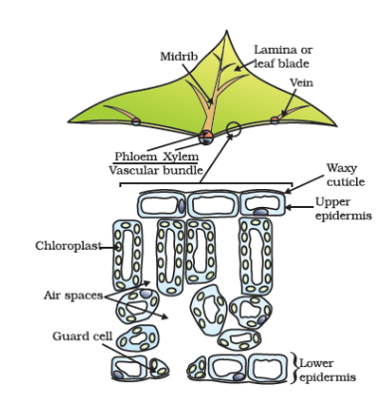

Figure 6.1 Cross-section of a leaf

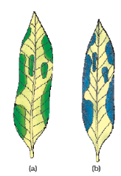

Figure 6.2 Variegated leaf (a) before and (b) after starch test

Now, let us study how the plant obtains carbon dioxide. In Class IX, we had talked about stomata (Fig. 6.3) which are tiny pores present on the surface of the leaves. Massive amounts of gaseous exchange takes place in the leaves through these pores for the purpose of photosynthesis. But it is important to note here that exchange of gases occurs across the surface of stems, roots and leaves as well. Since large amounts of water can also be lost through these stomata, the plant closes these pores when it does not need carbon dioxide for photosynthesis. The opening and closing of the pore is a function of the guard cells. The guard cells swell when water flows into them, causing the stomatal pore to open. Similarly the pore closes if the guard cells shrink.

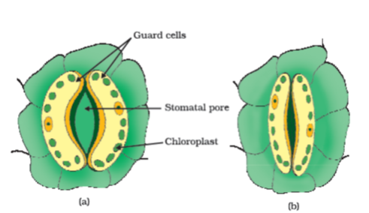

Figure 6.3 (a) Open and (b) closed stomatal pore

##### Activity 6.2

Take two healthy potted plants which are nearly the same size.

Keep them in a dark room for three days.

Now place each plant on separate glass plates. Place a watch-glass containing potassium hydroxide by the side of one of the plants. The potassium hydroxide is used to absorb carbon dioxide.

Cover both plants with separate bell-jars as shown in Fig. 6.4.

Use vaseline to seal the bottom of the jars to the glass plates so that the set-up is air-tight.

Keep the plants in sunlight for about two hours.

Pluck a leaf from each plant and check for the presence of starch as in the above activity.

Do both the leaves show the presence of the same amount of starch?

What can you conclude from this activity?

Based on the two activities performed above, can we design an experiment to demonstrate that sunlight is essential for photosynthesis?

So far, we have talked about how autotrophs meet their energy requirements. But they also need other raw materials for building their body. Water used in photosynthesis is taken up from the soil by the roots in terrestrial plants. Other materials like nitrogen, phosphorus, iron and magnesium are taken up from the soil. Nitrogen is an essential element used in the synthesis of proteins and other compounds. This is taken up in the form of inorganic nitrates or nitrites. Or it is taken up as organic compounds which have been prepared by bacteria from atmospheric nitrogen.

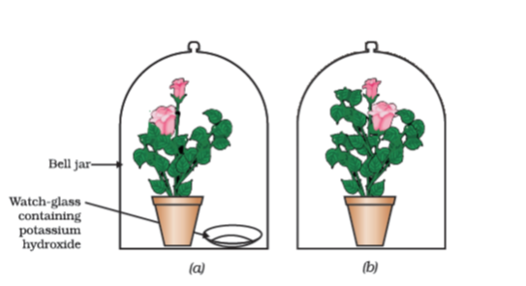

Figure 6.4 Experimental set-up (a) with potassium hydroxide (b) without potassium hydroxide

#### 6.2.2 - Heterotrophic Nutrition

Each organism is adapted to its environment. The form of nutrition differs depending on the type and availability of food material as well as how it is obtained by the organism. For example, whether the food source is stationary (such as grass) or mobile (such as a deer), would allow for differences in how the food is accessed and what is the nutritive apparatus used by a cow and a lion. There is a range of strategies by which the food is taken in and used by the organism. Some organisms break-down the food material outside the body and then absorb it. Examples are fungi like bread moulds, yeast and mushrooms. Others take in whole material and break it down inside their bodies. What can be taken in and broken down depends on the body design and functioning. Some other organisms derive nutrition from plants or animals without killing them. This parasitic nutritive strategy is used by a wide variety of organisms like cuscuta (amar-bel), ticks, lice, leeches and tape-worms.

#### 6.2.3 - How do Organisms obtain their Nutrition?

Since the food and the way it is obtained differ, the digestive system is different in various organisms. In single-celled organisms, the food may be taken in by the entire surface. But as the complexity of the organism increases, different parts become specialised to perform different functions. For example, *Amoeba* takes in food using temporary finger-like extensions of the cell surface which fuse over the food particle forming a food-vacuole (Fig. 6.5). Inside the food-vacuole, complex substances are broken down into simpler ones which then diffuse into the cytoplasm. The remaining undigested material is moved to the surface of the cell and thrown out. In *Paramoecium*, which is also a unicellular organism, the cell has a definite shape and food is taken in at a specific spot. Food is moved to this spot by the movement of cilia which cover the entire surface of the cell.

#### 6.2.4 - Nutrition in Human Beings

The alimentary canal is basically a long tube extending from the mouth to the anus. In Fig. 6.6, we can see that the tube has different parts. Various regions are specialised to perform different functions. What happens to the food once it enters our body? We shall discuss this process here.

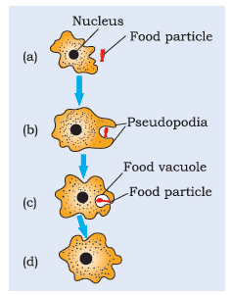

Figure 6.5 Nutrition in Amoeba

##### Activity 6.3

Take 1 mL starch solution (1%) in two test tubes (A and B).

Add 1 mL saliva to test tube A and leave both test tubes undisturbed for 20-30 minutes.

Now add a few drops of dilute iodine solution to the test tubes.

In which test tube do you observe a colour change?

What does this indicate about the presence or absence of starch in the two test tubes?

What does this tell us about the action of saliva on starch?

We eat various types of food which has to pass through the same digestive tract. Naturally the food has to be processed to generate particles which are small and of the same texture. This is achieved by crushing the food with our teeth. Since the lining of the canal is soft, the food is also wetted to make its passage smooth. When we eat something we like, our mouth ‘waters’. This is actually not only water, but a fluid called saliva secreted by the salivary glands. Another aspect of the food we ingest is its complex nature. If it is to be absorbed from the alimentary canal, it has to be broken into smaller molecules. This is done with the help of biological catalysts called enzymes. The saliva contains an enzyme called salivary amylase that breaks down starch which is a complex molecule to give simple sugar. The food is mixed thoroughly with saliva and moved around the mouth while chewing by the muscular tongue.

It is necessary to move the food in a regulated manner along the digestive tube so that it can be processed properly in each part. The lining of canal has muscles that contract rhythmically in order to push the food forward. These peristaltic movements occur all along the gut.

From the mouth, the food is taken to the stomach through the food-pipe or oesophagus. The stomach is a large organ which expands when food enters it. The muscular walls of the stomach help in mixing the food thoroughly with more digestive juices.

The digestion In stomach is taken care of by the gastric glands present in the wall of the stomach. These release hydrochloric acid, a protein digesting enzyme called pepsin, and mucus. The hydrochloric acid creates an acidic medium which facilitates the action of the enzyme pepsin. What other function do you think is served by the acid? The mucus protects the inner lining of the stomach from the action of the acid under normal conditions. We have often heard adults complaining about ‘acidity’. Can this be related to what has been discussed above?

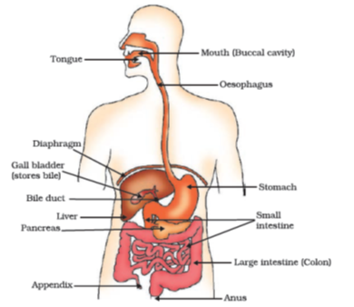

Figure 6.6 Human alimentary canal

The exit of food from the stomach is regulated by a sphincter muscle which releases it in small amounts into the small intestine. From the stomach, the food now enters the small intestine. This is the longest part of the alimentary canal which is fitted into a compact space because of extensive coiling. The length of the small intestine differs in various animals depending on the food they eat. Herbivores eating grass need a longer small intestine to allow the cellulose to be digested. Meat is easier to digest, hence carnivores like tigers have a shorter small intestine.

The small intestine is the site of the complete digestion of carbohydrates, proteins and fats. It receives the secretions of the liver and pancreas for this purpose. The food coming from the stomach is acidic and has to be made alkaline for the pancreatic enzymes to act. Bile juice from the liver accomplishes this in addition to acting on fats. Fats are present in the intestine in the form of large globules which makes it difficult for enzymes to act on them. Bile salts break them down into smaller globules increasing the efficiency of enzyme action. This is similar to the emulsifying action of soaps on dirt that we have learnt about in Chapter 4. The pancreas secretes pancreatic juice which contains enzymes like trypsin for digesting proteins and lipase for breaking down emulsified fats. The walls of the small intestine contain glands which secrete intestinal juice. The enzymes present in it finally convert the proteins to amino acids, complex carbohydrates into glucose and fats into fatty acids and glycerol.

Digested food is taken up by the walls of the intestine. The inner lining of the small intestine has numerous finger-like projections called villi which increase the surface area for absorption. The villi are richly supplied with blood vessels which take the absorbed food to each and every cell of the body, where it is utilised for obtaining energy, building up new tissues and the repair of old tissues.

The unabsorbed food is sent into the large intestine where its wall absorb more water from this material. The rest of the material is removed from the body via the anus. The exit of this waste material is regulated by the anal sphincter.

##### More to know!

**Dental caries**

Dental caries or tooth decay causes gradual softening of enamel and dentine. It begins when bacteria acting on sugars produce acids that softens or demineralises the enamel. Masses of bacterial cells together with food particles stick to the teeth to form dental plaque. Saliva cannot reach the tooth surface to neutralise the acid as plaque covers the teeth. Brushing the teeth after eating removes the plaque before the bacteria produce acids. If untreated, microorganisms may invade the pulp, causing inflammation and infection.

#### Questions

What are the differences between autotrophic nutrition and heterotrophic nutrition?

Where do plants get each of the raw materials required for photosynthesis?

What is the role of the acid in our stomach?

What is the function of digestive enzymes?

How is the small intestine designed to absorb digested food?

### 6.3 - Respiration

#### Activity 6.4

Take some freshly prepared lime water in a test tube.

Blow air through this lime water.

Note how long it takes for the lime water to turn milky.

Use a syringe or *pichkari* to pass air through some fresh lime water taken in another test tube (Fig. 6.7).

Note how long it takes for this lime water to turn milky.

What does this tell us about the amount of carbon dioxide in the air that we breathe out?

#### Activity 6.5

Take some fruit juice or sugar solution and add some yeast to this. Take this mixture in a test tube fitted with a one-holed cork.

Fit the cork with a bent glass tube. Dip the free end of the glass tube into a test tube containing freshly prepared lime water.

What change is observed in the lime water and how long does it take for this change to occur?

What does this tell us about the products of fermentation?

We have discussed nutrition in organisms in the last section. The food material taken in during the process of nutrition is used in cells to provide energy for various life processes. Diverse organisms do this in different ways – some use oxygen to break-down glucose completely into carbon dioxide and water, some use other pathways that do not involve oxygen (Fig. 6.8). In all cases, the first step is the break-down of glucose, a six-carbon molecule, into a three-carbon molecule called pyruvate. This process takes place in the cytoplasm. Further, the pyruvate may be converted into ethanol and carbon dioxide. This process takes place in yeast during fermentation. Since this process takes place in the absence of air (oxygen), it is called anaerobic respiration. Breakdown of pyruvate using oxygen takes place in the mitochondria. This process breaks up the three-carbon pyruvate molecule to give three molecules of carbon dioxide. The other product is water. Since this process takes place in the presence of air (oxygen), it is called aerobic respiration. The release of energy in this aerobic process is a lot greater than in the anaerobic process. Sometimes, when there is a lack of oxygen in our muscle cells, another pathway for the break-down of pyruvate is taken. Here the pyruvate is converted into lactic acid which is also a three-carbon molecule. This build-up of lactic acid in our muscles during sudden activity causes cramps.

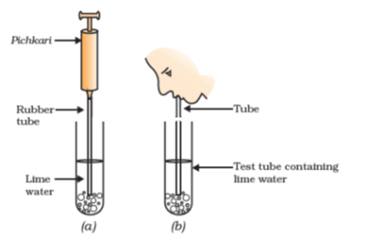

Figure 6.7 (a) Air being passed into lime water with a pichkari/syringe, (b) air being exhaled into lime water

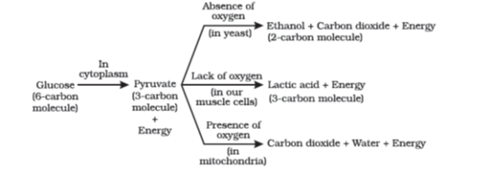

Figure 6.8 Break-down of glucose by various pathways

The energy released during cellular respiration is immediately used to synthesise a molecule called ATP which is used to fuel all other activities in the cell. In these processes, ATP is broken down giving rise to a fixed amount of energy which can drive the endothermic reactions taking place in the cell.

Since the aerobic respiration pathway depends on oxygen, aerobic organisms need to ensure that there is sufficient intake of oxygen. We have seen that plants exchange gases through stomata, and the large inter-cellular spaces ensure that all cells are in contact with air. Carbon dioxide and oxygen are exchanged by diffusion here. They can go into cells, or away from them and out into the air. The direction of diffusion depends upon the environmental conditions and the requirements of the plant. At night, when there is no photosynthesis occurring, CO2\text{C}\text{O}_{2}

elimination is the major exchange activity going on. During the day, CO2\text{C}\text{O}_{2}

generated during respiration is used up for photosynthesis, hence there is no CO2\text{C}\text{O}_{2}

release. Instead, oxygen release is the major event at this time.

Animals have evolved different organs for the uptake of oxygen from the environment and for getting rid of the carbon dioxide produced. Terrestrial animals can breathe the oxygen in the atmosphere, but animals that live in water need to use the oxygen dissolved in water.

##### More to know!

**ATP**

ATP is the energy currency for most cellular processes. The energy released during the process of respiration is used to make an ATP molecule from ADP and inorganic phosphate.

ADP+℗→EnergyADP∼℗=ATPADP + ℗\overset{\text{Energy}}{\rightarrow}ADP\sim ℗\ = \ ATP

℗: Phosphate

Endothermic processes in the cell then use this ATP to drive the reactions. When the terminal phosphate linkage in ATP is broken using water, the energy equivalent to 30.5 kJ/mol is released.

Think of how a battery can provide energy for many different kinds of uses. It can be used to obtain mechanical energy, light energy, electrical energy and so on. Similarly, ATP can be used in the cells for the contraction of muscles, protein synthesis, conduction of nervous impulses and many other activities.