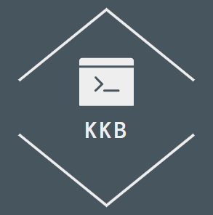



Table of Contents

1. Topic 2

2. Authors 2

3. Summary 3

Goal 3

Main stages in accomplishment of the project: 3

Planning 3

Realization 3

Presentation 3

Level of difficulty main problems during realization: 3

Explanation of some of the code: 3

Diagram: 5

4. Explanation of functions 6



# Authors

Anton Slavchev Slavov

[Asslavov18@codingburgas.bg](mailto:Asslavov18@codingburgas.bg)



Bozhidar Damyanov Dimitrov

BDDimitrov18@codingburgas.bg

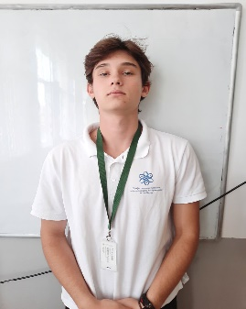

Hussein Semir Abumelih

hsabumelih18@codingburgas.bg

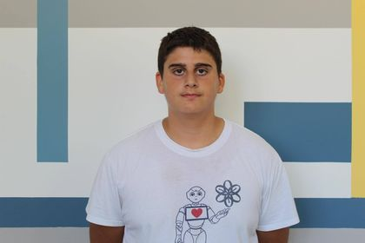

Mario Nikolaev Slavov

[MNSlavov18@codingburgas.bg](mailto:MNSlavov18@codingburgas.bg)



Volen Plamenov Mateev

VPMateev18@codingburgas.bg

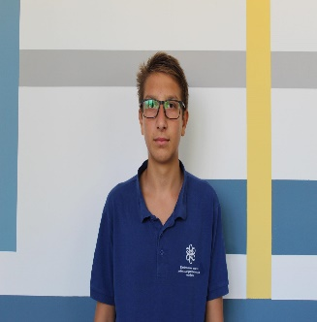

# Topic

The topic of our program is preset, it completes calculations regarding sets.

# Summary

Goal - our goal was to create a useful program that calculates sets of numbers.

## Main stages in accomplishment of the project:

Planning – In this stage, given the fact that we already had a set project, we only had to plan the execution and that is what we did. We made a schedule, distributed the work that had to be done, and started working.

Realization – In this second step we started writing the code of our project and creating the presentation and documentation which explain everything in further detail.

Presentation – The final step is presenting the finished product in front of the judges.

## Level of difficulty main problems during realization:

The most difficult part of completing our project was writing the code for the program. Along the way, we had a few misreadings about the functionality of different parts of the code. We also had a few accidents with GitHub but in the end, we managed to overcome everything and complete our duties.

Explanation of some of the code:

Start: First the program asks you to enter the sets you need to work with.

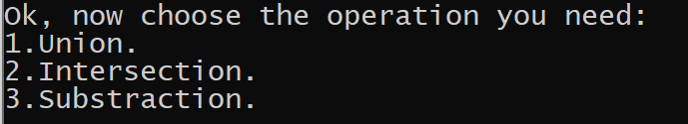

Menu: once the user enters the sets, they are given the possible methods to work with.

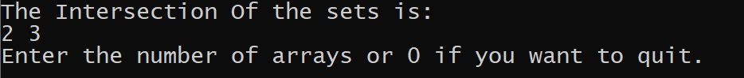

The end result: once the user picks an option, set of intigers is printed on the screen.

## Diagram:

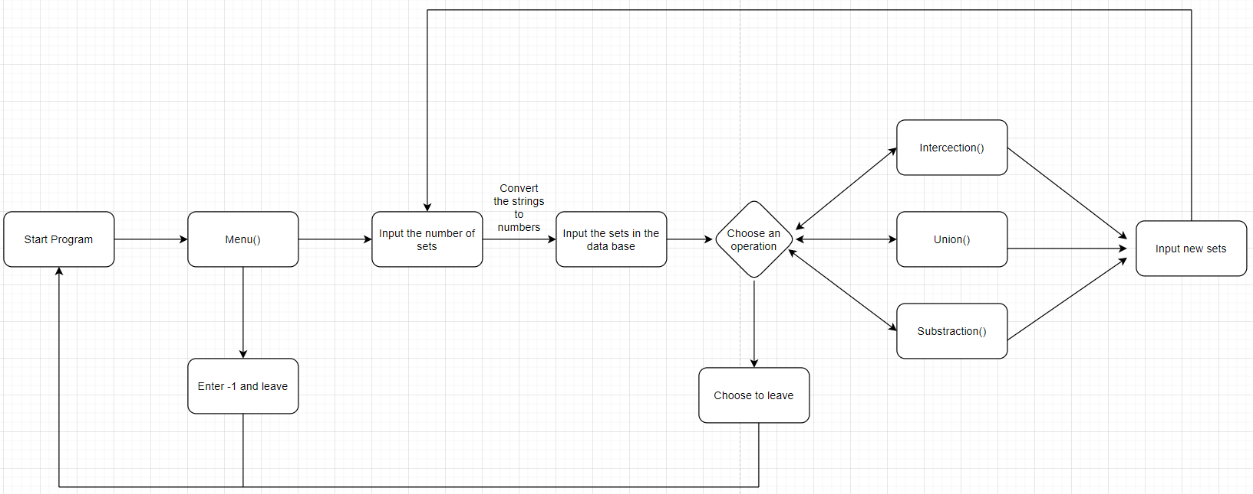

# Explanation of functions

|  |  |  |  |
| --- | --- | --- | --- |
| Function name | Arguments | Purpose | Return value |
| Menu | vector<int> sub;  size_t i, j, n, tek;  bool found, foundInNoSet; | way to let the user choose what he need the program to do. |  |
| stringToNumber | string numTxt  int base = 1;  int num = 0; | is used to convert charecters to a nubers and then retunt the transformed number | num |
| divideStrings | vector<int> numsArr;  string line | divide all sting in to substrings use the stringToNumber function,soo that whrite them in the vector. | numArr |
| Union | vector<int> uni;  size_t i, j, n;  bool found;  vector<vector<int>> sets | function that gets all sets in the vector and unite them in one big set | uni |
| Intersection | vector<int> inter;  size_t i, j, n, tek;  bool found, foundInAll;  vector<vector<int>> sets | function that takes the numbers which participate in all of the sets and show it to the user | inter |
| Substraction | vector<int> sub;  size_t i, j, n, tek;  bool found, foundInNoSet;  vector<vector<int>> sets | function that gets meny sets and see which number from the first set don't atted at the otther one and shows them to the user. | sub |
| main | fstream inputs;  string line; | function is mainly used to call Menu functiot and open the file. |  |