***CS 306 PROJECT***

***HMS***

# Main Menu

Simple Clean looking menu that will take you to according to what you want to do.

# What would you like to add ? ( first part)

-Patients

* You fill a form writing the details of the patient and press submit (once pressed it will show down the end of the table list ).

# -**Doctors**

* Graphical user interface

  Description automatically generatedSimple menu where you write doctor full name and select specialization from specialization table( this specialization part will be explained down below )

# -Specialization

* Form here you write the specialization available and how much it costs

# **-Patient to Room**

-There is a roomassignment.php file which is for assigning a patient to a room, you select room type and preferred room then it diverts to roomassignmentpatient.php

- roomassignmentpatient.php asks for patient ID, entry date and length of stay

-if the patient ID does not exist you are once again diverted to newpatient.php, apart from that you just enter entrydate and stay length the exit date is automatically calculated

- roomassignmentpatient.php diverts to makeassignment.php which just does the insertion

First you pick what type of roomtype you want (intensive or normal) then you press First submit. Now in the preffered room it will show you all the empty rooms of that specific type which you can use to add a patient to it. Down below I will show the slides

After you press the second submit you will come to this screen where you put the patient ID then you press first submit then you put the room entry data and how many days will that patient stayGraphical user interface, application
After you press the second submit you will get the selected room to change from empty to occupied in the rooms table and pID ( 4 is the one I added ) will show it is assigned to rID 6 with an entry date and an exit date and its bill id.

# What would you like to find? (second part)

-Patient’s Room

* Write name of patient and it will show what room ID he/she is in.

-Patient’s Bill

-Pretty similar, asks for patientID then diverts to bills.php which checks if the patientID exists if it doesn’t then you are diverted to getpatientID

-bills.php diverts to display bills which is just a table that shows all your bills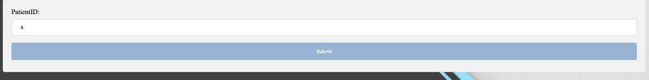

-Doctor with a specific Specialization

* Graphical user interface, text, application, email

  Description automatically generatedYou write the specialization you need and it will show you all the doctors and their ids with that specific specialization.

# What would you like to modify? (third part)

-Rooms

This will give you all the occupied rooms you can select from after you press submit the room will be set to empty and it will change in the rooms table to empty

# Medical (fourth part)

-Consultation

-There is a consult.php file which is used for making a new consultation, it diverts to consultpatient.php once you select what specialization you want and what doctor you want to see

-consultpatient.php diverts to makeconsult.php which is an empty page that just does the insertion

-within consultpatient.php if the patient ID you add does not exist it diverts you to newpatient.php page

-newpatient.php is where we create the patient and put him into our database

- Now I will show you the following screenshots of consultation

1- You pick the type of specialization you need ( which is obtained from specialization table we did in part 1 ) then you press submit, after that it will show you the doctors in that specialization and you pick the on you need.

After that we simply put patient ID then submit ( first one ) then put the consult date and submi

This is what will show after submitting and the results are obtained in consultation table

# Payment

-Billing

* First you will put the patient ID that needs to get paid lets say 1

-Note: roomID, patient ID, doctor ID are all just auto increments by the system itself, billID is generated randomly