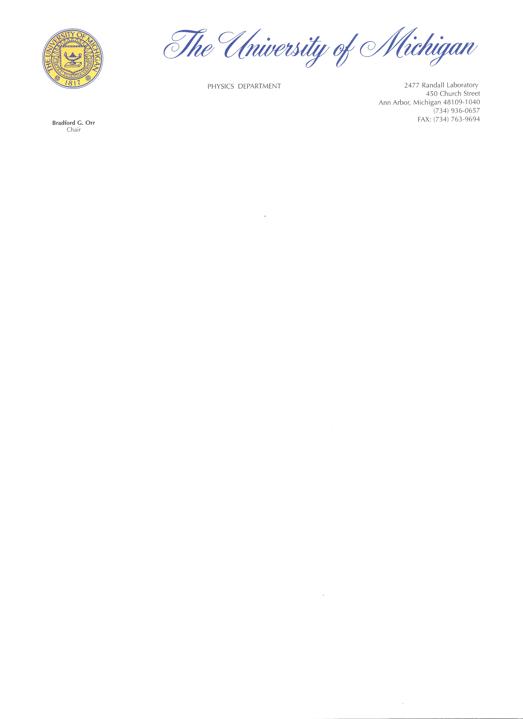

March 8, 2023

Dear Editors:

The submitted article presents a novel and intuitive perspective on the age-old principle of least action, used as an essential tool across many areas of physics. While the basic mathematics behind the stationary action principle is well established, two aspects that have been sorely lacking and that we provide here are (1) a clear geometric interpretation of the action principle and (2) a tight connection between the mathematics and the physics it represents.

At the recommendation of Revati Thorat from the Nature Springer Transfer Desk, we are transferring the article from Foundations of Physics to Scientific Reports. Given the practical importance of the principle of least action and its foundational place within physics as a discipline, we feel that Scientific Reports would be an excellent home for the work and that the insights provided will be of interest to the journal’s wide readership across physics.

Sincerely,



Christine A. Aidala  
 Professor of Physics  
 University of Michigan  
 +1-734-764-7611  
 [caidala@umich.edu](mailto:caidala@umich.edu)