**INSTITUTE OF PUBLIC ADMINISTRATION AND MANAGEMENT (IPAM)**

Course: BSc Information Systems (Hons) Year 3

Module & Code: Software Engineering II ISM 322

Lecturer: Mr Daniel Chaytor

Second Semester

**Group Project**

**Proposal: Student Web Portal**

**Group One(1)**

**Augustine Ansumana 21437 ansumanaaugustine@gmail.com**

**Mohamed Solomon 21112 mohamedsolomon111@gmail.com**

**Vanessa Denzilia Sonia Lewis 20977 denzilialewis854@gmail.com**

**Salamata Bah 21209 siasalma12@gmail.com**

Ghithub account: <https://github.com/assv-portal/com-web-portal.git>

**Table of Content**

**Contents Page NO:**

Individual Contributions Breakdown............................................................................. 2 - 3

Contributions breakdown..................................................................................................2 -3

Problem Statement.......................................................................................................... 4

Aims and Objectives...................................................................................................... 5

Glossary of terms.......................................................................................................... . 6

Requirements Specification.............................................................................................. 7- 8

Use case ………………………………………………………………………………………………………………………… 8

Traceability Matrix ………………………………………………………………………………………………………. 9

Sequence Diagram ………………………………………………………………………………………………………… 10

Activity Diagram ……………………………………………………………………………………………………………..11

User Interface Specification Diagram.................................................................................. 12 -14

**Contribution breakdown Page**

|  |  |  |  |  |  |
| --- | --- | --- | --- | --- | --- |
| **Features** | **Description** | Augustine Ansumana | Mohamed Solomon | Vanessa Denzilia Sonia Lewis | Salamata Bah |
| Interface features | This involves the development of all the pages. The whole design and the positioning of the various content of the pages.it involve the smoot navigation of the site and also the home page | **30%** | **25%** | **20%** | **25%** |
| Loin/register | This gives the user the access to gain to the system in other for them to download and upload content | **30%** | **20%** | **25%** | **25%** |
| upload | Every lecturer is of the institute given the opportunity to upload their material to portal for student access it easy. | **40%** | **20%** | **20%** | **20%** |
| Download | This gives both the lecture and student with login to downloads resources form the portal | **40%** | **20%** | **20%** | **20%** |
| logout | After finished browsing the system user can logout from the system | **20%** | **40%** | **20%** | **20%** |
| comment & social features/ Send message | Student must have easy access to communicate to the administration. The contact page feature gives access to student to make their comment which goes direct to the admin and also make it possible to access and email number and contact number to place a call if a student wishes to. | **30%** | **20%** | **20%** | **30%** |
| Portal Profile/About Page | This can be access on the about page. The about page gives a full description of the different service the whole system offers. With just a click on the about link in the navigation panel the information is display on the screen with a slider | **20%** | **20%** | **40%** | **20%** |

**Statement of the Problem**

We all want our academic process to go on seamlessly without any problems or difficulties where everyone is aware of the outcome and status.

Today we have so many release failures that result to students not having access Educational Material from the lecturers digitally. If we ignore this problem, it will reach a point wherein it will be difficult to handle this situation and student may not be able to complete the notes due for the semester on time to meet the deadline for the exams.

We will use our web portal system methodology in solving these difficulties and improve on our processes.

The purpose of this study is to develop a web based Online Portal that as a solution to the problems of the student’s access to material currently in the institution.

Today’s education scenario is rapidly changing and demanding. The system demands greater levels of communication between student and lecturer to have optimum use of resources.

The Online Portal is a system fulfilling demands and enacting as a bridge of communication amongst students and Lecturer.

The main objective of this system is to reduce the difficulties student have in accessing Lecture notes ad timetable and easy way for lecturer to share educational resources at any time.

In short it is platform that provides students and lecturers with a single access point to information. As the saying goes, a problem well stated is half solved.

A PROBLEM WELL STATED IS ALREADY HALF SOLVED is our inspirational adage thus our team have created a web portal system methodology in solving these difficulties to make the learning process level for students and lecturers.

**Aims and Objectives**

Our goal is to create a platform wherein the students will have easy access to learning materials to capacitate them, and also the lectures can pass on their knowledge to the students accurately. With more clarity around what my team is trying to fix in the educational sector, the more efficient we’ll be solving the problem just like our inspirational adage says above. Education should be interactive, easy and accessible for students and lecturers that are why we created this WED PORTAL SYSTEM. We will continue to work industriously towards solving this problem

The purpose of this study is to prefer solution to the above stated problems being faced and to develop a web portal using HTML, CSS JAVA SCRIPT AND PHP to develop each web page The objectives are as below:

* To have an effective way of providing courses information to students
* To improve the privacy, user-friendliness and to enable convenient access to the different kinds resources mounted on the portal
* To create simple way provides a pre-assessment module that allow courses verification to the students when login on the website.
* Through this system, the students will be able to use the Portal effetely communicate lecturer and administration via comment

**GLOSSARY OF TERMS**

**HOME:** This page is specifically to show what the portal is all about ie, the features that it contains, you can also see all you need to access the portal as a student or lecturer.

**ABOUT**: What the portal entails, it shows the mission, what the portal will provide for the student and lecturers when they access it. It is like a brief summary of what they will see in the portal.

**CONTACT**: This page allows you to see the different places where you can contact the Institution; also there is a space for you to leave your various comments or inputs towards the website.

**LOG IN &REGISTER**: It shows you what you need to input to get access to the portal as a student or a lecturer. If you don’t have a login then you just need to register to get access to the site and get what you want.

**Student**: is a user who is studying at the Institution

**Lecturer**: is a Lecturer at a Institution

**Institution:** is a large important organization such as a university, church or bank.

**Portal** – presents information from diverse sources in a unified way. The web portals offer other services such as contact, student resources ect.

**Password**: the password is a mixture of letters and numbers sent to you with your username prior to registration - you will need this for online registration and once you have registered you can change the password. You will need your username and password for logging in to the portal.

**Upload:** this is what is used to input resource to the system

**Download:** this is what is used to access resources after uploads

**Logout**: this is the process where you leave the system or be out of the system

**Requirements Specification**

**Actors**

Student

Lecture

* Student: are the ones who will have login to the system to have access to resources and timetable.
* Teacher: are the one who will deliver the recourses, and check the status of how student makes comments.

**Use-case model**

We are going to present a graphical overview of the functionality of our system in terms of actors and their goals which are presented as uses cases. Roles of the actors in the system are depicted in these diagrams.

**Use Cases**

**Lecturer/student**

* Login /signup
* Upload
* Download
* Send
* Logout

**Description**

Functionality provided for all type of actors student and Lecturer

When a user successfully login, then it activates session for that user depending upon the type of user. If the user is a Lecturer, then session of Lecturer client module shall be activated and similarly for student users.

This package contains all the functionalities that a student and Lecturer can do.

Use case diagram

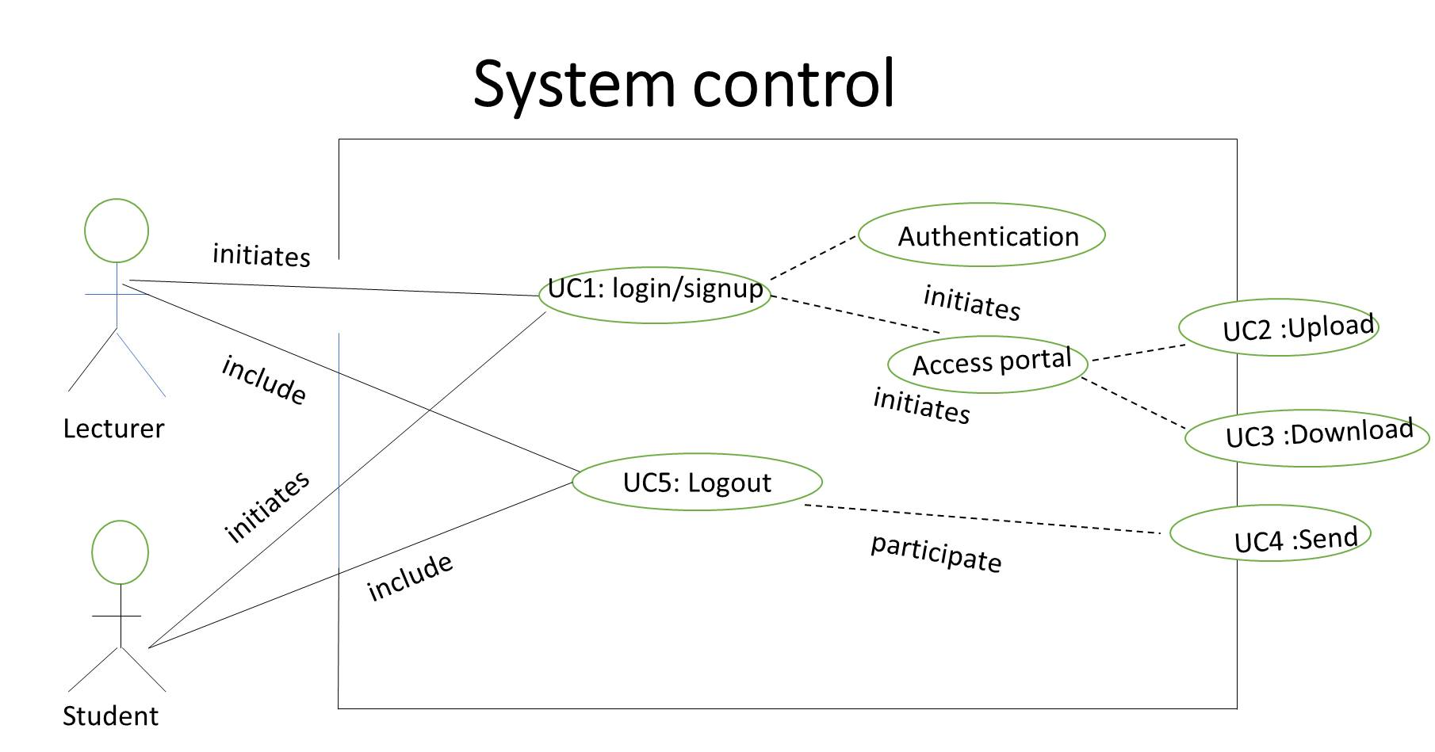

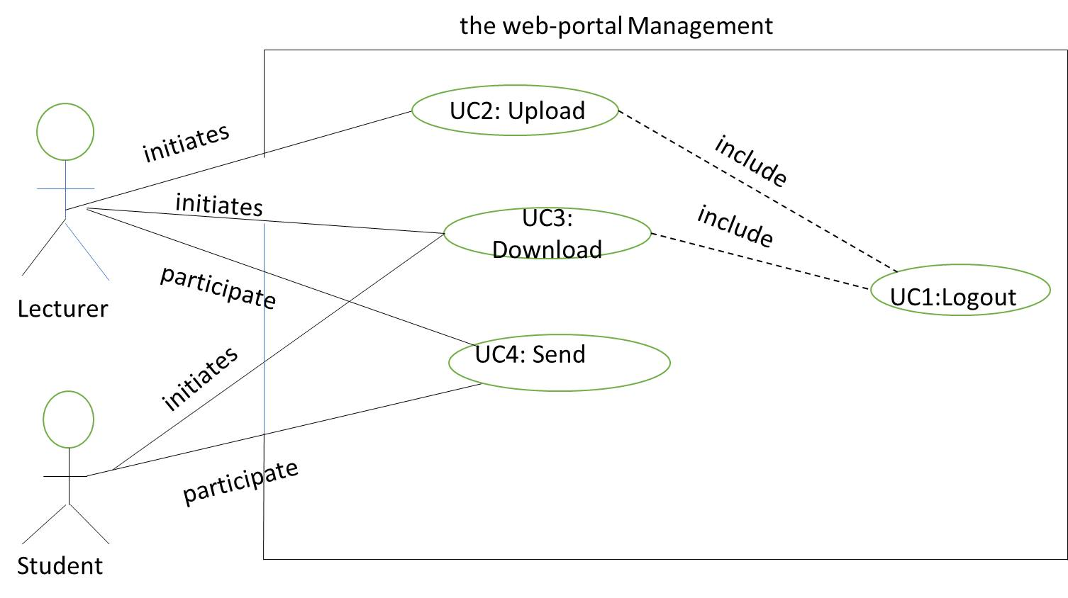

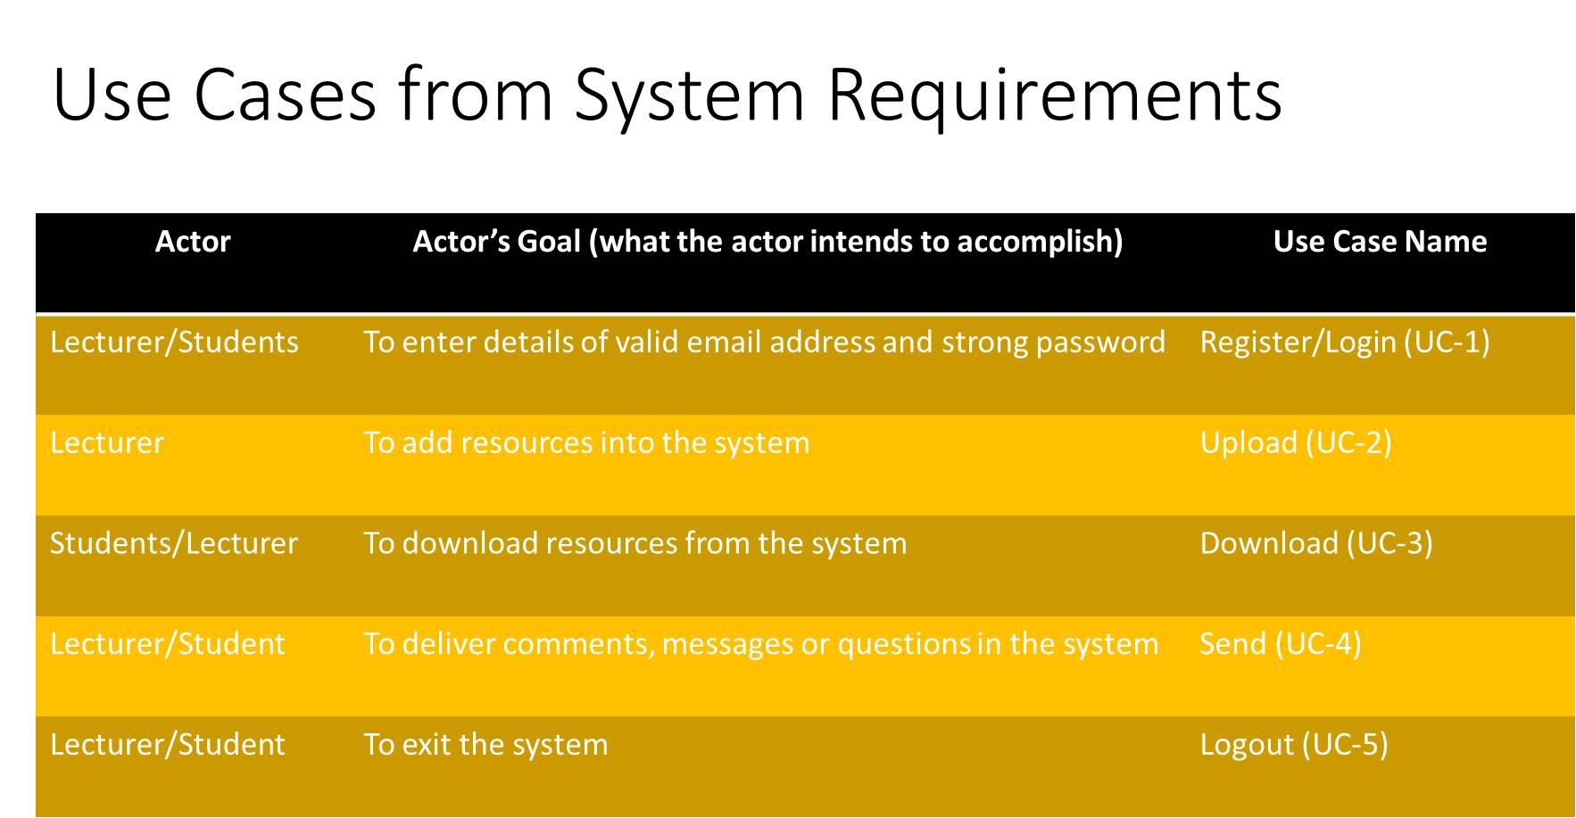

Traceability Matrix

UC-1 Login/Register

UC-2 Upload

UC-3 Download

UC-4 Send

Uc-5 Logout

|  |  |  |  |  |  |
| --- | --- | --- | --- | --- | --- |
|  | Uc1 | Uc2 | Uc3 | Uc4 | Uc5 |
| Req 1 | x |  |  |  | x |
| Req 2 |  |  |  |  | x |
| Req 3 | x |  |  |  |  |
| Req 4 | x | x |  |  |  |
| Req 5 | x |  | x |  |  |
| Req 6 |  |  |  | x |  |
|  |  |  |  |  |  |

REQ 1. Keep user logout when not in use

REQ 2. Logout when logout is press

REQ 3. Login in when actual user details is enter

REQ 4. Upload resource when upload is press

REQ 5. Download resources when user press on the item

REQ 6: send message when send is press

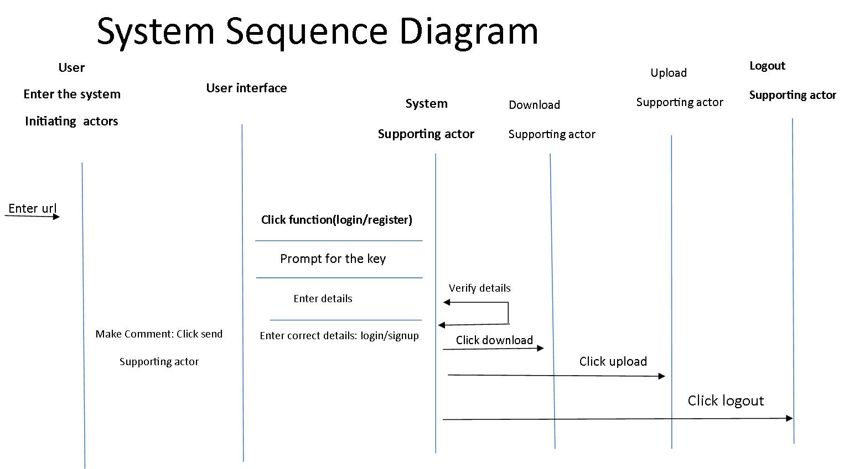

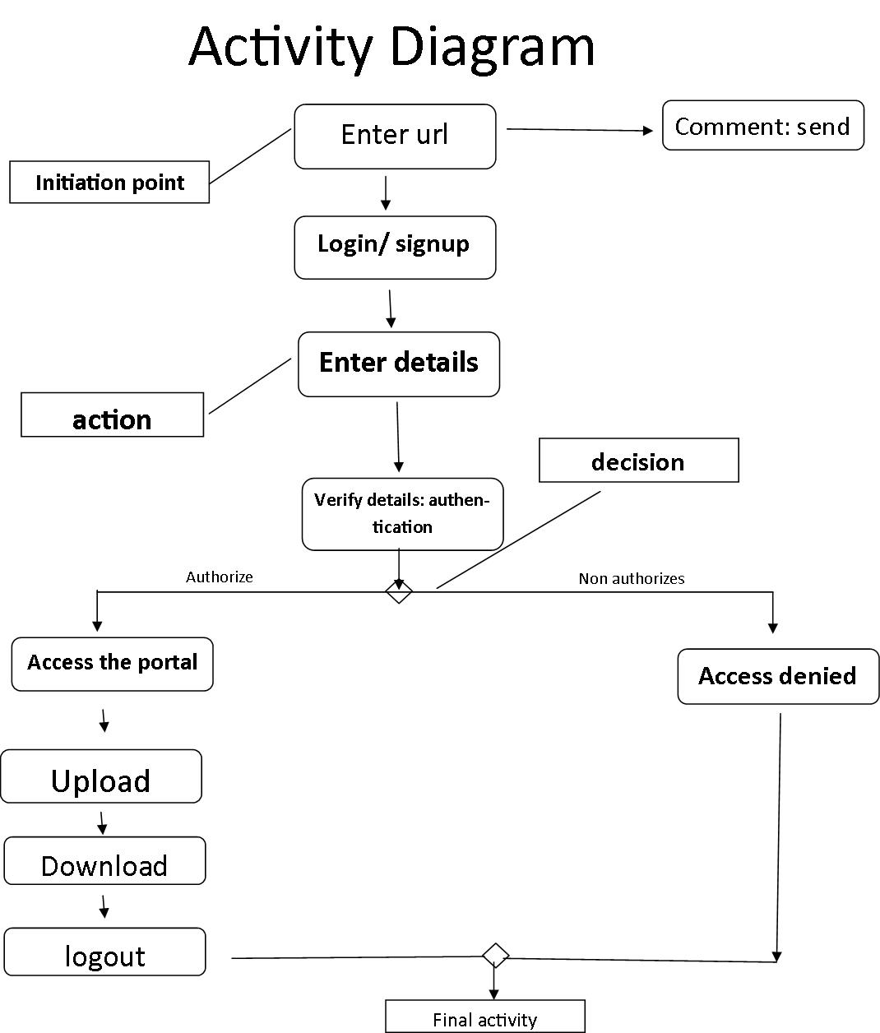

**Below are diagrams of user Interface Specification diagram**

The login

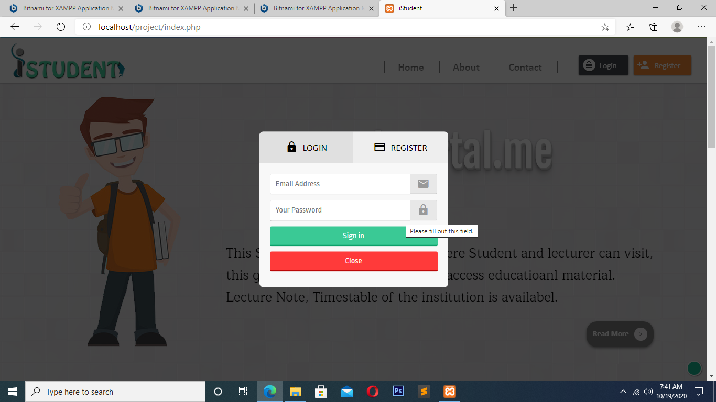

**SIGN UP/ RIGISTRATION**

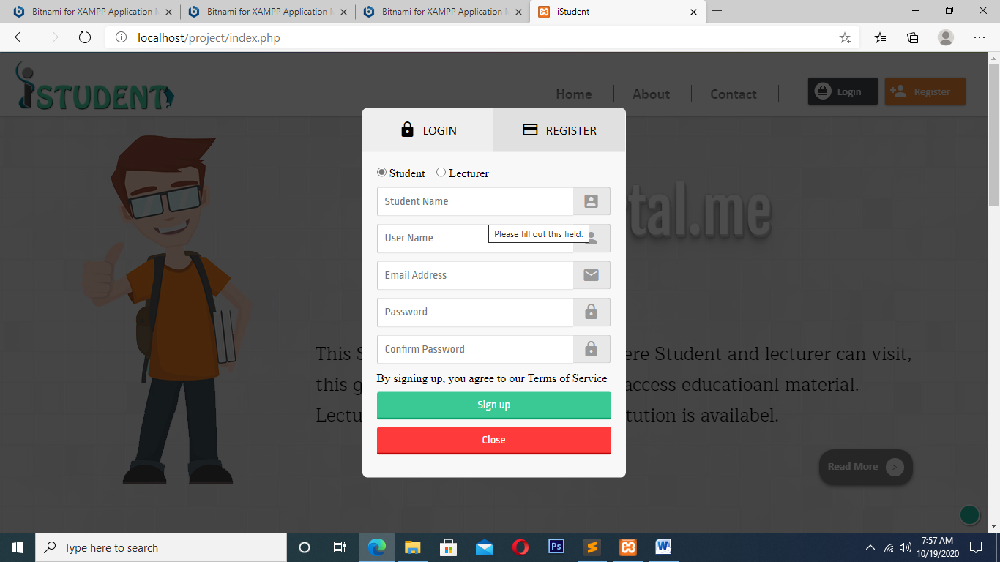

**Home Page**

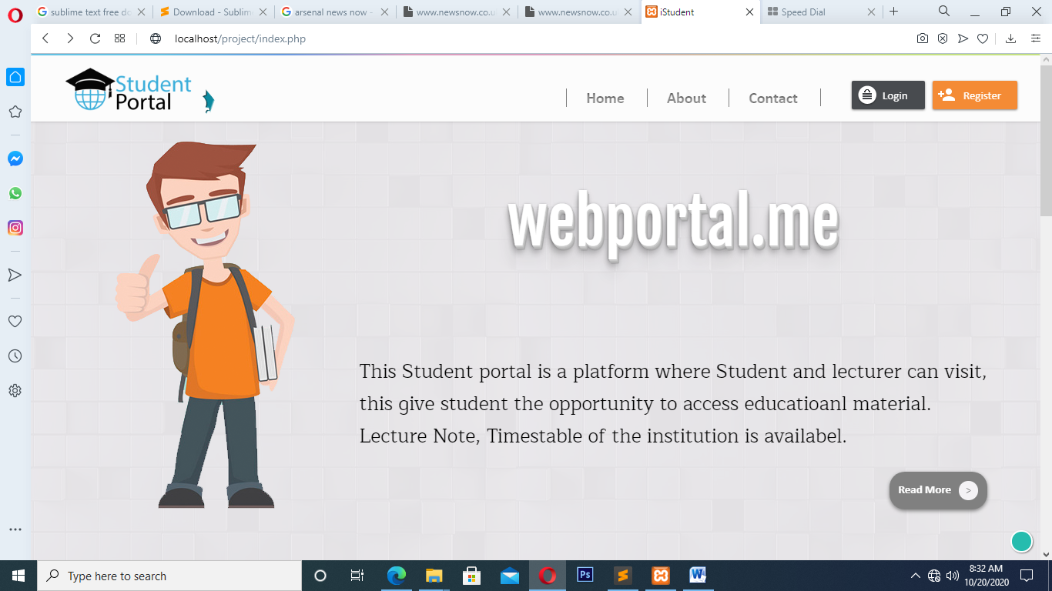

**About page**

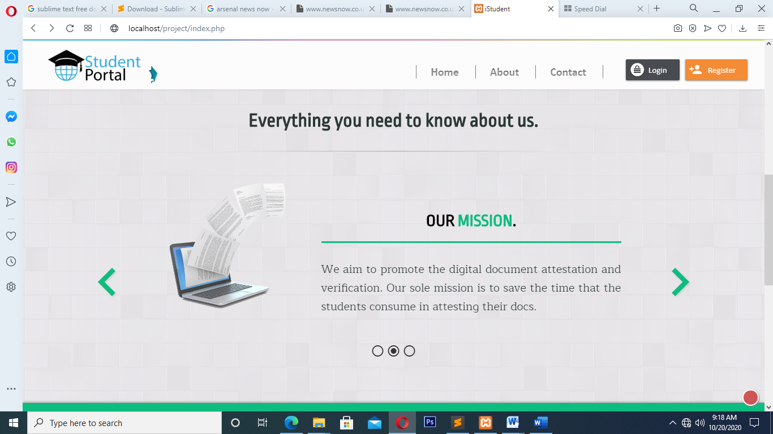

**Contact Page**

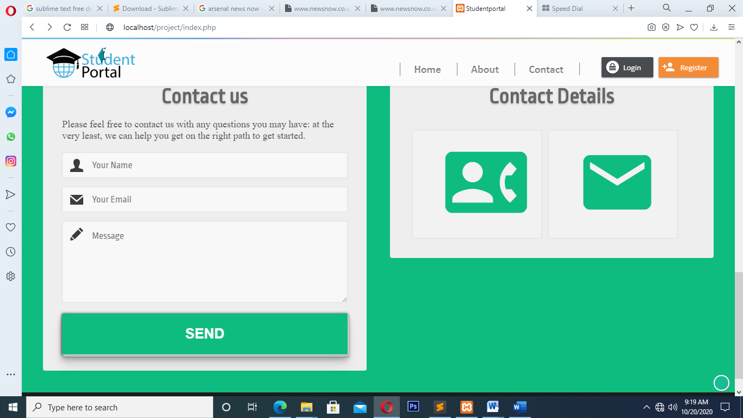

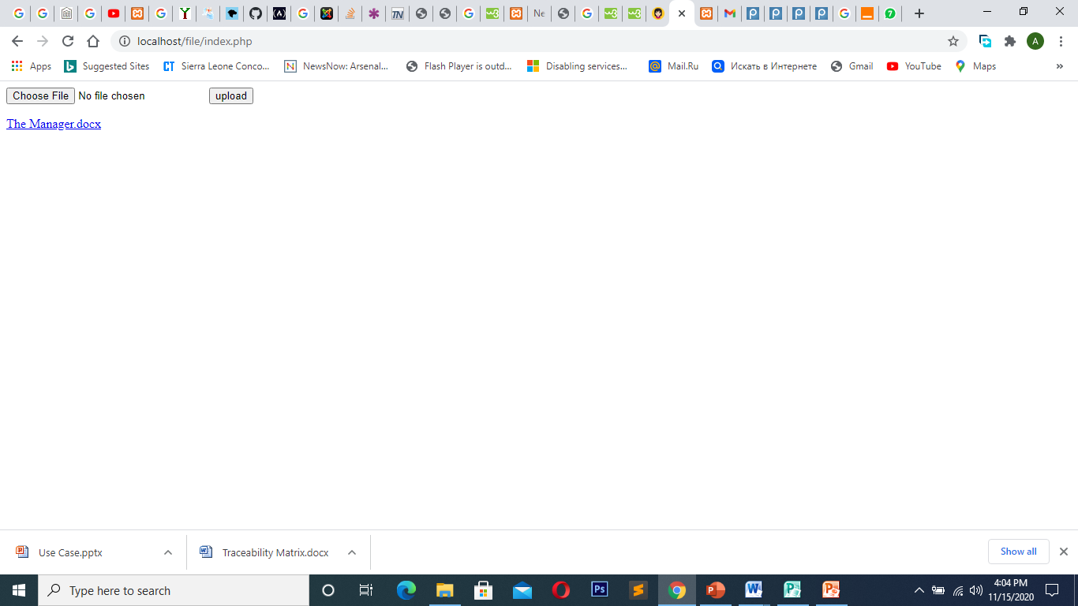Upload

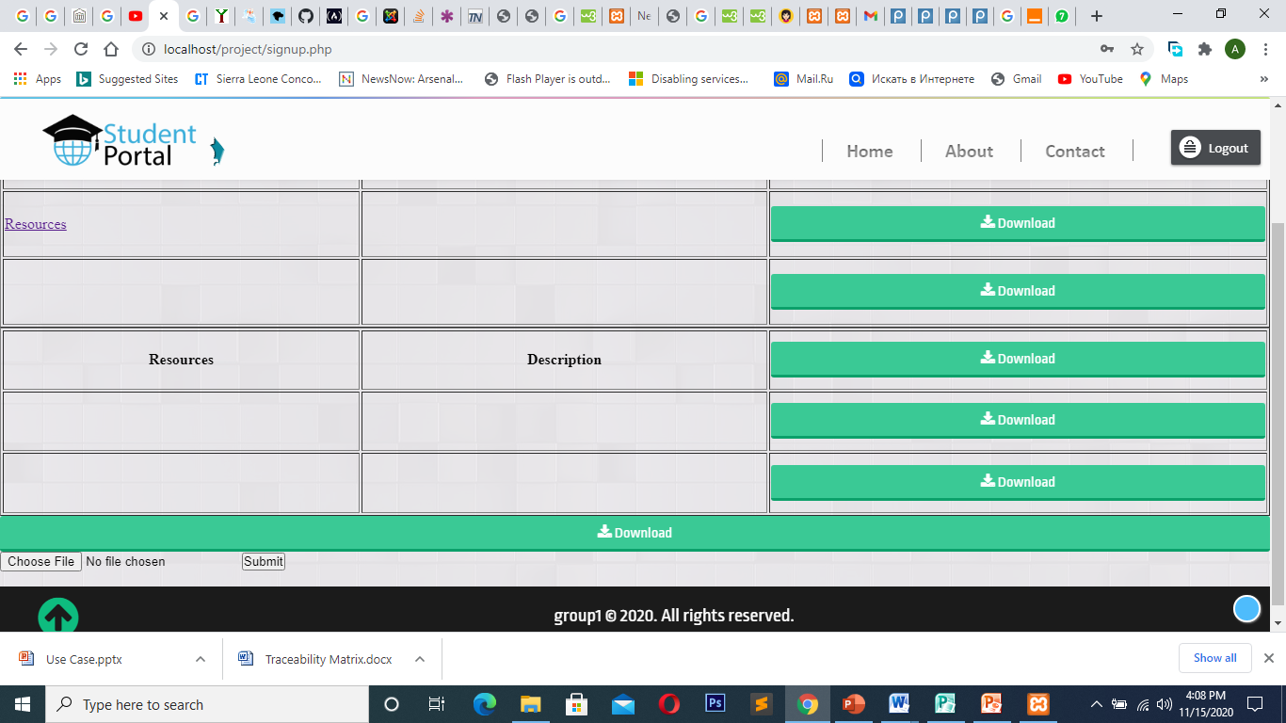Download

Logout

