First Pre-Defense Document

Development of a Machine Vision System for Searching for Victims in Emergency Situations Using an Unmanned Aerial Vehicle
Разработка системы технического зрения для поиска пострадавших в чрезвычайных ситуациях с применением беспилотного летательного аппарата
Project name: SAR-Vision (Search and Rescue Vision)
Team: Kurmantaev Ali, Shalmanov Assylzhan, Shakalova Diana
Supervisor: Kutpanova Zarina
Repository: https://github.com/assylzhan-se/uav-sar-vision
YouTrack: https://sarvision.youtrack.cloud/projects/SAR
October 2026

Contents
1. Project Proposal 2
2. Evidence of Relevance 4
3. Literature Review 5
4. Existing System Comparison 7
5. Technology Comparison 9
6. Requirements Specification 11
7. Architecture and Diagrams 12
8. UX and Prototype 16
9. Verification and Evaluation Plan 18
10. Project Management and Risks 20
11. Supervisor Feedback 23
References 23
Appendix A. Question Guide for User Discussions 24

1. Project Proposal

1.1 Project information
Table 1. Project information
Item | Details
Title | Development of a Machine Vision System for Searching for Victims in Emergency Situations Using an Unmanned Aerial Vehicle
Title (Russian) | Разработка системы технического зрения для поиска пострадавших в чрезвычайных ситуациях с применением беспилотного летательного аппарата
Project name | SAR-Vision (Search and Rescue Vision)
Team | Kurmantaev Ali, Shalmanov Assylzhan, Shakalova Diana
Supervisor | Kutpanova Zarina
Stage | First pre-defense (analysis and design)

1.2 Problem statement
Unmanned aerial vehicles (UAVs) are increasingly used in search and rescue (SAR) operations because they can cover large or hard-to-reach areas quickly [9]. However, the footage they collect is usually reviewed by a human operator. This is difficult for several reasons:
- At typical survey altitudes, a person may occupy only a few dozen pixels in an image, so they are easy to miss [1], [2].
- A single flight can produce hundreds of photographs or a long video. Reviewing it takes time and the operator’s attention decreases over a long session.
- In poor lighting or partial vegetation cover, people are harder to see in visible-light (RGB) imagery. Thermal imagery can help in these conditions but has its own limitations [4], [6].
- After a possible person is spotted, the operator still needs to estimate where that point is on the ground so that a ground team can be sent.
Published work shows that automated person detection can support this process. For example, the SARUAV system contributed to locating a missing person during a real operation in Poland [8]. At the same time, detecting very small objects, limiting false alarms and processing data quickly on field hardware remain open problems [9], [10].

1.3 Target users
Table 2. Target users
User | Need
UAV operator in a rescue unit or volunteer search team | Be alerted to possible people in the footage instead of reviewing every frame manually
Search coordinator | See reviewed detections on a map and pass locations to ground teams
Ground search team (indirect user) | Receive approximate coordinates of a location to check
These user groups are based on the literature and on the team’s understanding of SAR work. They have not yet been validated with users; the plan for this is described in Section 2.

1.4 Aim and objectives
Aim. To develop a machine vision system that helps a UAV operator find possible victims in aerial imagery by automatically detecting people, estimating their approximate ground coordinates and presenting the results for human review.
The system is a decision-support tool. It does not replace rescuers and does not make rescue decisions on its own; every detection must be reviewed by an operator.
Objectives:
- Review existing research, datasets and systems for person detection in UAV imagery.
- Validate the main assumptions about user needs through discussions with practitioners.
- Prepare training and test data from public SAR datasets.
- Train and evaluate a person detection model for RGB imagery and compare it with a baseline.
- Implement estimation of a detection’s ground coordinates from UAV telemetry.
- Build an operator interface for reviewing, confirming or rejecting detections and exporting confirmed locations.
- Evaluate the system against the metrics in Section 9.

1.5 Scope
The full set of features we would like to support (RGB and thermal imagery, live video, offline maps, geolocation, operator review and export) is too large to build at once. We therefore define a minimum viable product (MVP) and treat the remaining features as extensions.
Table 3. Scope
Category | Features
MVP (first version) | Person detection in RGB images and recorded video; small-object handling by image tiling; approximate geolocation for a downward-facing (nadir) camera over flat terrain; operator interface with a detection list and map; confirm/reject; CSV/KML export; local operation on a laptop without internet access
Planned extensions (if time allows) | Live video stream input (RTSP); separate thermal detection model; tracking to merge repeated detections of the same person; geolocation for tilted cameras
Out of scope | Building or modifying a UAV, flight control or route planning; onboard (in-flight) processing; identification of individuals; assessment of a person’s medical condition; certification for operational use
The main dependency for field testing is access to a UAV that records telemetry (for example, a DJI enterprise model). If access is not available, evaluation will rely on public datasets and recorded footage (see risk R1 in Section 10).

1.6 Expected outcomes
- A person detection model fine-tuned on public SAR datasets, with results reported against the targets and baseline in Section 9.
- A processing pipeline that takes images or video with telemetry and produces geolocated detections.
- A web-based operator interface for reviewing and exporting detections.
- An evaluation report covering detection quality, processing speed and geolocation error.
The expected technical contribution is not a new detection algorithm. It is the integration of an existing detector, small-object techniques, telemetry-based geolocation and a human review workflow into one tool that runs locally, together with an evaluation of how well this combination works.

1.7 Engineering complexity
The project involves several non-trivial engineering problems:
- Detecting small objects in high-resolution frames, which requires tiling and fine-tuning rather than an off-the-shelf model [10], [11].
- Balancing detection quality against processing speed on a laptop GPU.
- Converting pixel positions into geographic coordinates using camera parameters and telemetry, and estimating the resulting error.
- Synchronising video frames with telemetry records.
- Integrating several components (input, inference, geolocation, storage, user interface) into a system that a non-specialist can operate.

2. Evidence of Relevance
This section separates three kinds of evidence: findings from published sources, assumptions that still need to be checked, and the plan for collecting evidence from users.

2.1 Evidence from published sources
Table 4. Evidence from published sources
ID | Finding | Source
E1 | UAVs are widely used in SAR. Open challenges include data processing, small-object detection and operation under limited resources. | [9]
E2 | Automated person detection in UAV imagery has contributed to locating a missing person in a real operation. | [8]
E3 | People in aerial SAR imagery are small objects. Detectors fine-tuned on SAR data perform better than general-purpose detectors. | [1], [2]
E4 | Thermal imagery is useful for detecting people, but it has lower resolution and fewer public datasets than RGB imagery. | [4], [5], [6]
E5 | YOLO-based detectors adapted for small objects can run in real time on embedded hardware. | [10]
These sources show that the general problem is real and actively studied. They do not show what users in Kazakhstan specifically need, which equipment they use or how they currently work. That gap is covered in Sections 2.2 and 2.3.

2.2 Assumptions that require validation
Table 5. Assumptions that require validation
ID | Assumption (hypothesis) | Requirements affected
H1 | UAV footage is currently reviewed manually, and this takes a significant amount of time. | Project aim
H2 | Reliable internet access is often unavailable in the field, so processing must run locally. | NFR-3
H3 | Missing a person is considered worse than receiving false alarms, so recall should be prioritised over precision. | FR-1, FR-8
H4 | Teams use UAVs that record GPS position, altitude and camera orientation in a usable format. | FR-4
H5 | Coordinates are most useful as a map point or a file that opens in common mapping tools. | FR-7
Until they are validated, these assumptions are treated as provisional, and the requirements that depend on them may change.

2.3 User research plan and status
Status: user discussions have not yet been conducted as of the date of this document. No results are reported here.
Plan. The team plans to hold 3–5 semi-structured discussions (about 20–30 minutes each, in person or online) with:
- UAV operators or rescuers from emergency services (for example, regional emergency departments);
- members of volunteer search teams;
- UAV pilots who carry out thermal or aerial survey work.
The question guide is given in Appendix A. For each discussion, the team will record the respondent’s role (without personal data unless consent is given), the date, the main answers and which hypotheses were supported or contradicted. Notes will be stored in the repository under docs/interviews/.
How findings will be used. Each hypothesis H1–H5 will be marked as supported, contradicted or unclear. Requirements linked to a contradicted hypothesis will be revised. For example, if users report that coordinates are always passed by voice radio, the export format in FR-7 would be reconsidered.

3. Literature Review

3.1 Search method
Sources were found through Google Scholar, IEEE Xplore, MDPI and arXiv. We used search terms such as UAV search and rescue person detection, small object detection aerial images, thermal human detection UAV and real-time object detection. We included work on detecting people or small objects in UAV imagery, public datasets suitable for SAR and widely used detection architectures. Most sources are from 2021–2025. A few earlier papers are kept because they introduced methods or datasets that the project builds on directly.
The review uses 16 sources: 15 peer-reviewed publications (11 of them from 2021 or later) and the documentation of the Ultralytics framework. Sources [17]–[19] are used only in the system comparison in Section 4.

3.2 Analysis of key publications
Table 6. Analysis of key publications
Ref. | Focus and method | Data | Main finding | Limitation | Use in SAR-Vision
[1] 2019 | Deep-learning person detection for land SAR | HERIDAL (introduced) | Deep learning is applicable to SAR aerial imagery; provides a benchmark dataset | RGB only; not designed for real time | HERIDAL as a training and test set
[2] 2021 | Comparison of Faster R-CNN, YOLOv4, RetinaNet and Cascade R-CNN for SAR | VisDrone, SARD (introduced) | YOLOv4 selected for its speed, accuracy and low false-detection rate; robustness to weather and motion blur tested | Simulated rescue scenes | SARD dataset; supports choosing a one-stage detector
[3] 2022 | Benchmark for detection and tracking from drones | VisDrone | Small objects are a major difficulty in drone imagery | Mostly urban scenes | Pre-training data before SAR fine-tuning
[4] 2023 | High-altitude thermal dataset | HIT-UAV: 2,898 images, 60–130 m | Public thermal data for persons and vehicles; YOLOv4 baseline reached 89.88% AP for persons | Limited scene variety | Thermal extension (FR-10)
[5] 2022 | Paired visual and thermal dataset for wilderness SAR | WiSARD | Supports experiments combining RGB and thermal imagery | Small size | Possible thermal and fusion experiments
[6] 2022 | Faster R-CNN and SSD on aerial thermal images | OSU Thermal, AAU PD T | Faster R-CNN (ResNet50) gave the best accuracy (55.7% mAP@0.5 on AAU PD T); SSD (MobileNet-v1) was fastest (44 FPS on a GTX 1080) | Desktop GPU only | Illustrates the accuracy–speed trade-off
[7] 2019 | Onboard embedded vision on an autonomous UAV for SAR | Authors’ data | Human detection can run onboard without an operator in the loop | Constrained model size and hardware | Argument for and against onboard processing (Section 5)
[8] 2021 | Case study of the SARUAV system | Real operation | First documented rescue supported by an automated human detection system | Post-flight analysis | Evidence of relevance; system compared in Section 4
[9] 2023 | Survey of UAVs for SAR | Literature | Summarises tasks and open challenges in UAV-based SAR | No experiments | Framing of the problem
[10] 2025 | YOLO adapted for small objects in SAR (feature fusion variants, extra P2 head, attention modules) | VisDrone, then HERIDAL | YOLOv5s-PBfpn-Deconv reached mAP@50 of 0.802 on HERIDAL and ran in real time on a Jetson Nano | RGB only | Two-stage transfer learning; reference result for evaluation
[11] 2022 | SAHI: slicing images into tiles for training and inference | VisDrone, xView | Slicing at inference raised AP by 5.1–6.8% for the tested detectors, and by up to 14.5% when combined with slice-based fine-tuning | Higher inference time | Tiling for small people (FR-3)
[12] 2024 | RT-DETR: real-time transformer detector | COCO | 53.1% AP at 108 FPS on a T4 GPU (R50 version) | Larger compute needs than small YOLO models | Alternative detector (Section 5)
[13] 2024 | YOLOv10: detection without non-maximum suppression | COCO | Lower latency at comparable accuracy | Limited SAR-specific evidence | Alternative detector (Section 5)
[14] 2016 | YOLO: single-stage real-time detection | PASCAL VOC | Detection treated as one regression problem; very fast | Weak on small objects in early versions | Foundation of the selected model family
[15] 2015 | Faster R-CNN: two-stage detection with a region proposal network | PASCAL VOC, COCO | High accuracy | Slower than one-stage detectors | Accuracy-oriented alternative
[16] | Ultralytics YOLO framework (documentation) | — | Tools for training, evaluation and export to ONNX/TensorRT | Not a scientific publication | Implementation tool

3.3 Analysis
Detector families. Two-stage detectors such as Faster R-CNN [15] tend to be accurate but slower. One-stage detectors such as YOLO [14] and SSD trade some accuracy for speed. The comparison by Sambolek and Ivašić-Kos [2] selected YOLOv4 for SAR because it combined good accuracy, speed and few false detections. A similar trade-off appears in thermal imagery [6]. Transformer-based real-time detectors such as RT-DETR [12] are a newer option; their advantage on very small objects in aerial imagery is less established, and they need more compute.
Small objects. This is the most consistent difficulty reported in the literature [1], [3]. Three techniques recur. The first is fine-tuning on domain-specific data [2]. The second is staged transfer learning from a general drone dataset to a SAR dataset [10]. The third is changing the input scale, either through architectural changes such as an additional high-resolution detection head [10] or by slicing large images into tiles [11]. Tiling does not require changing the model, but it increases processing time. This matters for our speed requirement.
Thermal imagery. Thermal datasets [4], [5] and studies [6] show that people can be detected in thermal images, but public data is limited and differs from RGB data in resolution and appearance. A thermal model would need to be trained and evaluated separately. For this reason, thermal detection is treated as an extension rather than part of the MVP.
Where processing happens. Onboard processing [7], [10] avoids sending video to the ground, but it limits model size and requires suitable hardware on the UAV. Processing on a ground laptop allows larger models and does not require modifying the aircraft, but it depends on being able to get video and telemetry from the UAV.
From detection to action. Most studies report detection metrics such as mAP. Fewer describe how detections are reviewed by operators or turned into ground coordinates, although this step determines whether a detection helps a rescue team [8]. This gap motivates the geolocation and review components of SAR-Vision.
Good results on public datasets do not guarantee similar performance in real operations. Terrain, season, altitude and camera models in Kazakhstan may differ from those in HERIDAL or SARD, which were collected in Croatia. This is why the evaluation plan includes testing on our own footage where possible.

3.4 Implications for SAR-Vision
Table 7. Implications for SAR-Vision
Finding from the literature | How the project responds
People in aerial images are small objects | Tiling (SAHI), fine-tuning on SAR data, evaluation of tiled versus untiled inference
SAR-specific fine-tuning improves results | Staged training: VisDrone, then HERIDAL and SARD
Thermal data is limited | Thermal model postponed to an extension; separate evaluation if implemented
Domain shift between datasets and real scenes | Separate test on local footage when available; results reported separately
Detection alone is not enough for rescue teams | Geolocation, operator review and export are part of the MVP

4. Existing System Comparison

4.1 Systems selected
We compared four existing approaches that a SAR team could use today, plus the planned SAR-Vision design:
- S1 – Manual review. The operator watches the live view or reviews recorded footage. This is the baseline practice.
- S2 – SARUAV. Software developed at the University of Wrocław for detecting people in UAV photographs [8], [17].
- S3 – Loc8. Image-scanning software that searches photographs for user-defined colours [18].
- S4 – DJI Matrice 4 series onboard AI. Commercial enterprise UAVs with built-in detection of people, vehicles and vessels [19].
- S5 – Research prototype. The YOLO-based small-object detector of Ciccone and Ceruti [10].
Evidence for commercial products comes from news and industry articles rather than full technical documentation. Where a feature could not be confirmed, the table says so instead of assuming it.

4.2 Comparison
Table 8. Comparison
Criterion | S1 Manual review | S2 SARUAV | S3 Loc8 | S4 DJI Matrice 4 onboard AI | S5 Research prototype [10] | SAR-Vision (planned)
Detection method | Human observer | Automated detection of people in photos [8], [17] | Pixel-level search for user-defined colour palettes; not person-specific [18] | Onboard AI detection and tracking of people, vehicles and vessels [19] | Fine-tuned YOLOv5 variant | Fine-tuned YOLO with tiling
Imagery | Any camera | Visible or near-infrared photos; not based on thermal data [17] | Photos; thermal use not stated [18] | RGB confirmed; thermal AI detection not confirmed [19] | RGB | RGB (MVP); thermal as extension
Timing | Live, limited by attention | Post-flight photo analysis [17] | Post-capture; real-time frame extraction announced as beta in 2020 [18] | In flight (described; latency not specified) [19] | Real time on Jetson Nano | Recorded data (MVP); live stream as extension
Location output | Estimated manually | Coordinates of identified places [17] | Image latitude/longitude in report [18] | Not confirmed from reviewed source | Not reported in reviewed material | Estimated coordinates of each detection
Operator review workflow | Not applicable | Map reports for rescuers [17] | User reviews flagged images [18] | Not confirmed | Not a system | Confirm/reject with persistent status
Hardware dependence | None | Works with photos from various cameras [17] | Works with photos from various sources [18] | DJI aircraft only | Jetson Nano | Any laptop; NVIDIA GPU recommended
Availability | Free | Licensing terms not confirmed | Subscription (as of 2020) [18] | Included with purchase of the aircraft | Research paper | Open source (academic project)

4.3 Discussion
The comparison shows that automated assistance for SAR imagery already exists in several forms, so SAR-Vision is not a new idea. The differences lie in how existing tools work:
- SARUAV is the closest system in purpose and has been used in a real rescue [8]. It works on photographs after the flight and does not use thermal data [17].
- Loc8 searches for colours rather than recognising people [18]. This works when the missing person wears distinctive clothing, but it depends on that information and on the background.
- DJI’s onboard AI recognises people during the flight [19], but it is tied to specific DJI aircraft. The reviewed source does not describe how detections are exported or geolocated.
- Research prototypes such as [10] report strong detection results but focus on the model rather than on an operator workflow.
SAR-Vision aims to combine an open, fine-tuned person detector with telemetry-based geolocation and an operator review workflow in a tool that runs locally and does not depend on a specific UAV vendor. Whether this combination is useful in practice is what the evaluation in Section 9 and the user discussions in Section 2 are intended to show. We do not claim that it will outperform the systems above.

5. Technology Comparison
This section covers four key technical decisions. Each decision lists the alternatives considered, how they compare against the criteria that matter for this project, and the current choice. Decisions marked provisional will be confirmed or revised through experiments in the next stage.

5.1 D1 – Person detection model
Criteria: detection quality on small objects after fine-tuning (FR-1), processing speed on a laptop GPU (NFR-1), and the maturity of training and export tools.
Table 9. D1 – Person detection model
Alternative | Advantages | Disadvantages
YOLO family (Ultralytics YOLOv8 / YOLO11) | Fast one-stage detector; widely used in SAR research [2], [10]; mature tools for training, evaluation and ONNX/TensorRT export [16] | Small objects still need tiling or architecture changes; Ultralytics code is licensed under AGPL-3.0, which is acceptable for an open academic project but restricts closed commercial use
RT-DETR [12] | Transformer detector with real-time speed on a server GPU; no non-maximum suppression step | Higher compute and memory needs; less SAR-specific evidence
Faster R-CNN [15] | Strong accuracy, frequently used as a reference [6] | Usually too slow for the throughput target on a laptop
Choice (provisional): YOLO, small or medium model size. It offers the best balance of speed, accuracy and tooling for our constraints. RT-DETR will be trained on the same data as a comparison if time allows. YOLOv10 [13] is a further option with lower latency but less SAR-specific evidence, so it is not part of the initial plan.

5.2 D2 – Where processing runs
Criteria: works without internet (NFR-3), does not require modifying the UAV, computing power available for the model, and cost.
Table 10. D2 – Where processing runs
Alternative | Advantages | Disadvantages
Onboard (e.g. NVIDIA Jetson on the UAV) [7], [10] | No video link needed; detections available during flight | Requires mounting and powering extra hardware; limited model size; not possible with most off-the-shelf enterprise UAVs
Ground laptop with GPU | Works offline; no UAV modification; larger models possible | Needs video and telemetry from the UAV, either live from the controller or after landing
Cloud server | Highest compute capacity | Requires a reliable internet connection, which is often unavailable in the field (assumption H2)
Choice: ground laptop. The MVP processes recorded footage and photos after they are copied from the UAV. Live stream input is an extension because getting a stream from a consumer controller depends on the UAV model (risk R4).

5.3 D3 – Application structure and component communication
Criteria: ease of development for a three-person team, ability to split work, support for a map-based interface, and room for later extensions.
Table 11. D3 – Application structure and component communication
Alternative | Advantages | Disadvantages
Single desktop script (OpenCV windows) | Fastest to prototype | Hard to build a map and review list; hard to split work between team members
Python backend (FastAPI) and browser interface, connected by REST and WebSocket | Clear separation between processing and interface; maps available through Leaflet; runs locally in a browser | Two codebases to maintain; slightly more setup
ROS 2 nodes | Standard in robotics; suited to onboard extensions | Steep learning curve; unnecessary for offline processing on a laptop
Choice (provisional): FastAPI backend and a browser interface. REST handles commands, and WebSocket pushes new detections to the interface. The frontend framework (React or Vue) has not been decided yet. Leaflet with locally stored map tiles is planned for the map.

5.4 D4 – Data storage
Criteria: runs on a single laptop without a database server, easy to copy the data of one operation, sufficient for simple queries.
Table 12. D4 – Data storage
Alternative | Advantages | Disadvantages
SQLite and image files on disk | No server; one file per operation; supported by the Python standard library | Not intended for many concurrent users
PostgreSQL with PostGIS | Strong spatial queries; multi-user | Needs a server installation; more than the MVP requires
MongoDB | Flexible document schema | Needs a server; no clear benefit for our data
Choice: SQLite. If several workstations later need to share data, PostgreSQL would be reconsidered.

5.5 Summary of the proposed stack and implementation order
Table 13. Summary of the proposed stack and implementation order
Layer | Technology | Status
Detection | PyTorch, Ultralytics YOLO, SAHI | Provisional; to be confirmed by experiments
Image and video input | OpenCV, FFmpeg | Selected
Telemetry | Image EXIF/XMP metadata and DJI SRT subtitle files (fields vary by model) | To be confirmed once the UAV model is known
Backend | Python, FastAPI, WebSocket | Provisional
Storage | SQLite | Selected
Interface | React or Vue (undecided), Leaflet | Undecided / provisional
Optimisation | ONNX Runtime or TensorRT | Only if the speed target is not met without it
Implementation will follow this order: (1) RGB detection on images with baseline evaluation; (2) tiling and fine-tuning; (3) geolocation for photos with metadata; (4) storage and operator interface; (5) video input with telemetry synchronisation. Live streams and thermal detection will only be added after the MVP works end to end.

6. Requirements Specification
Priorities follow the MoSCoW method: M (must), S (should), C (could) and W (won’t in this version). All numerical values are proposed targets that have not yet been measured. They may be adjusted after the baseline experiments and user discussions, and any change will be recorded in the repository.

6.1 Functional requirements
Table 14. Functional requirements
ID | Requirement | Pri. | Acceptance criterion | UC / Test
FR-1 | Detect people in RGB aerial images and video frames and mark each detection with a bounding box and confidence score | M | On the HERIDAL test split: recall ≥ 0.80 and precision ≥ 0.70 at IoU 0.5, at a confidence threshold chosen on the validation split | UC-2 / T-1
FR-2 | Accept a folder of images (JPG) and a recorded video file (MP4) as input | M | Both input types are processed end to end in a demonstration | UC-1 / T-6
FR-3 | Support tiled (sliced) inference for high-resolution images | M | Tiling can be switched on and off; its effect on recall for small persons is reported | UC-2 / T-2
FR-4 | Estimate the latitude and longitude of each detection from UAV telemetry, for a nadir camera over approximately flat terrain | M | Mean horizontal error ≤ 10 m and maximum ≤ 20 m over at least 10 ground markers at 50 m altitude | UC-2 / T-4
FR-5 | Show detections to the operator as a frame with boxes, a list with thumbnails and markers on a map | M | Every stored detection appears in the list and, if it has coordinates, on the map | UC-3 / T-6
FR-6 | Let the operator confirm or reject each detection; save the status | M | Statuses are unchanged after the application is restarted | UC-4 / T-7
FR-7 | Export confirmed detections to CSV and KML | M | Files open in a spreadsheet and in Google Earth; coordinates match the database | UC-5 / T-7
FR-8 | Let the operator change the confidence threshold | S | Changing the threshold changes the number of displayed detections | UC-6 / T-6
FR-9 | Accept a live video stream (RTSP) as input | S | A stream from a test server is processed continuously for 10 minutes | UC-1 / T-6
FR-10 | Detect people in thermal images with a separate model | S | Recall ≥ 0.80 for the person class on the HIT-UAV test split at IoU 0.5 | UC-2 / T-3
FR-11 | Alert the operator when a new detection appears | S | A visual alert is shown within 1 s of the detection being stored | UC-3 / T-6
FR-12 | Merge repeated detections of the same person across consecutive frames | C | Defined after the MVP; measured on annotated video | —
FR-13 | Support geolocation for tilted camera angles | C | Defined after FR-4 is validated | —
FR-14 | Run detection onboard the UAV | W | Out of scope | —

6.2 Non-functional requirements
Table 15. Non-functional requirements
ID | Requirement | Pri. | Acceptance criterion | Test
NFR-1 | Throughput: process 1920×1080 video without tiling at ≥ 10 frames per second | M | Mean FPS over a 5-minute video, measured 5 times on the reference laptop | T-5
NFR-2 | Latency in live-stream mode: from frame arrival to detection displayed | S | 95th percentile ≤ 1 s (applies only if FR-9 is implemented) | T-5
NFR-3 | Full operation without internet access, including the model, map tiles and interface | M | All MVP functions work with the network disabled | T-8
NFR-4 | Runs on Windows 10/11 or Ubuntu 22.04; NVIDIA GPU recommended; slower CPU-only mode available | M | Installation following the README succeeds on a clean machine | T-6
NFR-5 | Usability: an operator without machine-learning knowledge can complete the main workflow | S | 3 test users complete UC-1 to UC-5 without help; SUS score reported (target ≥ 70) | T-9
NFR-6 | No credentials or operation data in the repository; operation data stored locally | M | Repository and .gitignore reviewed before each tagged submission | Review
NFR-7 | Geolocation, telemetry parsing and export are covered by unit tests | S | Unit tests pass in continuous integration; line coverage of these modules ≥ 70% | T-10
Reference laptop. NFR-1 and NFR-2 will be measured on a laptop with an NVIDIA RTX 3060 or comparable GPU. The exact model, drivers and library versions will be recorded with the results. If the team’s hardware differs, the target will be stated for the hardware actually used.

6.3 Notes on the acceptance criteria
- Detection metrics. Recall and precision are calculated at an intersection-over-union (IoU) threshold of 0.5 between predicted and ground-truth boxes. Test splits are never used for training or for tuning the threshold. Recall is the primary metric because a missed person is more costly than a false alarm (assumption H3); precision is kept as a constraint so that the operator is not overloaded.
- Throughput with tiling. NFR-1 applies to untiled inference. Tiling multiplies the number of model runs per frame, so its speed will be reported separately. Tiling is expected mainly for high-resolution still photographs.
- Geolocation accuracy. The error depends on the UAV’s GNSS accuracy, altitude above ground, camera orientation and terrain. The 10 m target applies only to the stated conditions. Ground truth positions measured with a phone also contain an error of a few metres, which will be reported.
- Dataset results and real use. Meeting FR-1 on HERIDAL does not show that the system will perform equally well in Kazakhstan. Results on local footage, if collected, will be reported separately.

7. Architecture and Diagrams
This section describes the proposed architecture. Apart from a draft geolocation module (Section 7.4), none of the components has been implemented yet. The diagrams are drawn in PlantUML. Editable sources are kept in diagrams/src/ and exported images in diagrams/png/.

7.1 System context
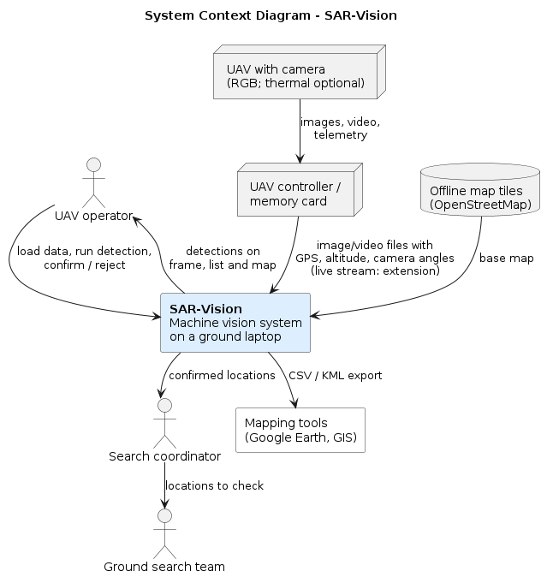
Figure 1. System Context Diagram of SAR-Vision. Source: Authors’ own work.
SAR-Vision runs on a laptop at the ground station (Figure 1). In the MVP, the operator copies images or video and their telemetry from the UAV’s memory card or controller. The system detects possible people, estimates their positions and shows the results on a frame, in a list and on an offline map. The operator reviews each detection. Confirmed locations are exported as CSV or KML for the search coordinator, who passes them to ground teams. Live stream input from the controller is planned as an extension.

7.2 Use cases
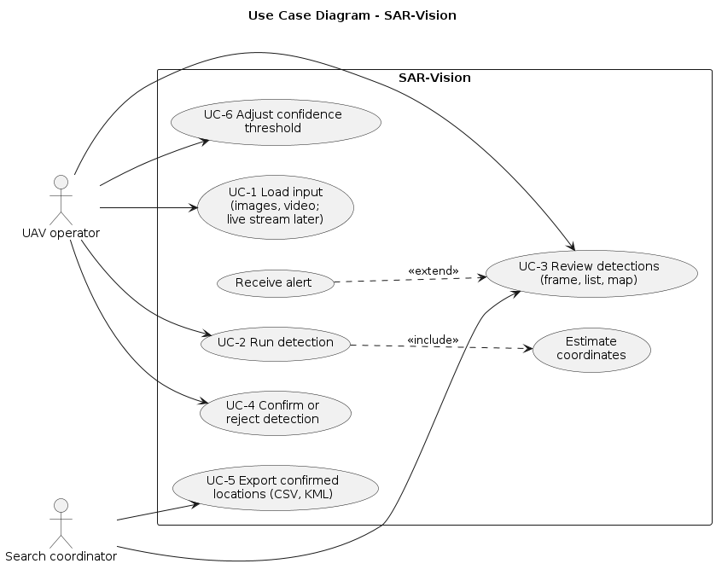
Figure 2. Use Case Diagram of SAR-Vision. Source: Authors’ own work.
Table 16. Use cases
ID | Use case | Actor | Requirements
UC-1 | Load input (image folder, video file; live stream later) | Operator | FR-2, FR-9
UC-2 | Run detection, including coordinate estimation | Operator | FR-1, FR-3, FR-4, FR-10
UC-3 | Review detections on the frame, list and map | Operator, coordinator | FR-5, FR-11
UC-4 | Confirm or reject a detection | Operator | FR-6
UC-5 | Export confirmed locations | Coordinator | FR-7
UC-6 | Adjust the confidence threshold | Operator | FR-8

7.3 Components (draft)
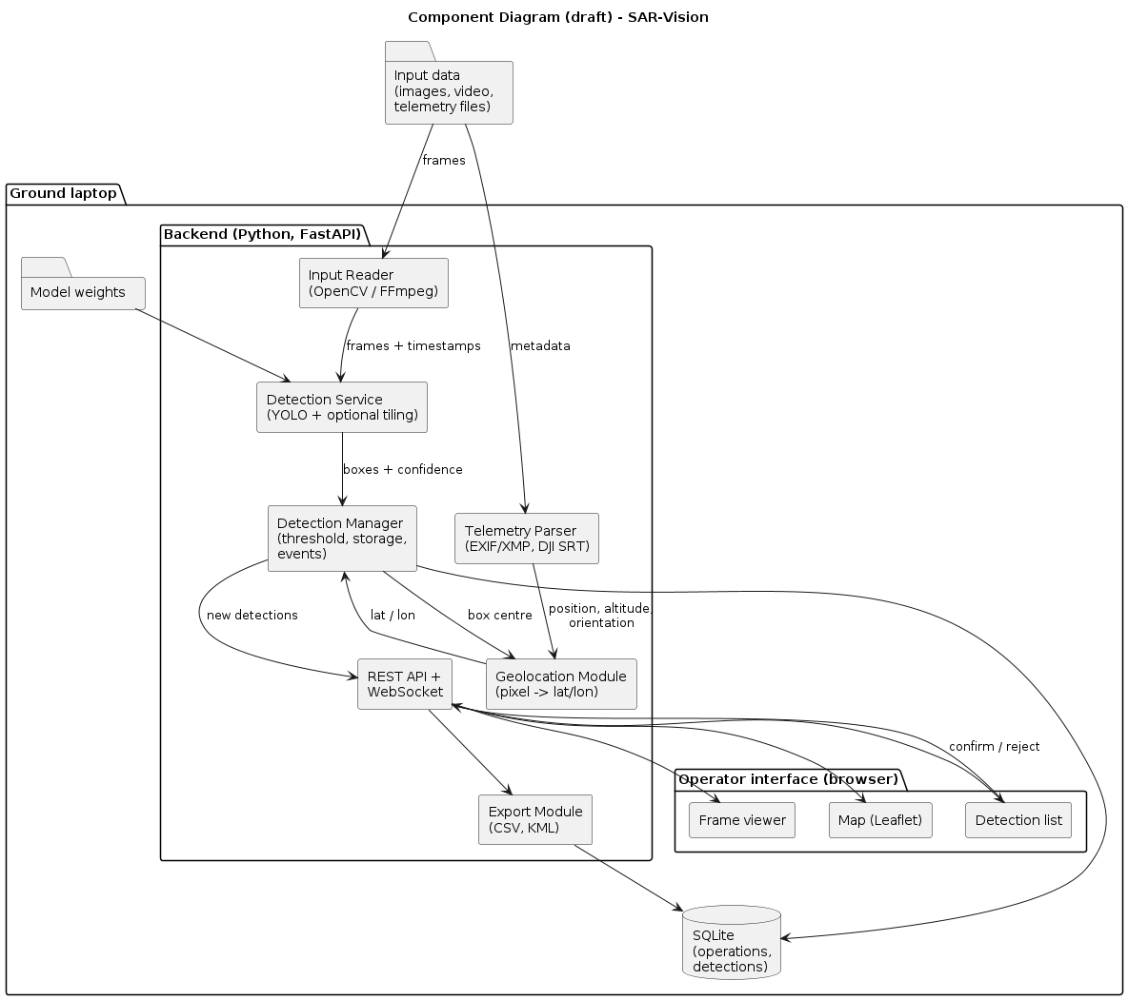
Figure 3. Component Diagram (draft) of SAR-Vision. Source: Authors’ own work.
Table 17. Components (draft)
Component | Responsibility | Technology | Status
Input Reader | Reads images and video frames with timestamps | OpenCV, FFmpeg | Planned
Telemetry Parser | Extracts position, altitude and camera angles from image metadata or DJI SRT files | Python | Planned
Detection Service | Runs the person detector, optionally with tiling | Ultralytics YOLO, SAHI | Planned
Geolocation Module | Converts a pixel position into latitude and longitude | Python | Draft with unit tests
Detection Manager | Applies the threshold, stores detections, publishes events | Python | Planned
REST API and WebSocket | Connects the backend and the interface | FastAPI | Planned
Export Module | Writes CSV and KML files | Python | Planned
Operator interface | Frame viewer, map and detection list with confirm/reject | React or Vue, Leaflet | Mockups only (Section 8)
Storage | Operations and detections | SQLite | Planned
The draft data model has two main entities:
- Operation(id, name, created_at, notes)
- Detection(id, operation_id, source_file, frame_time, bbox, confidence, lat, lon, status, note, reviewed_at)
Here status takes the values new, confirmed or rejected.

7.4 Geolocation method and assumptions
For the MVP, geolocation assumes a camera pointing straight down (nadir) over approximately flat terrain:
- The ground sample distance (GSD), in metres per pixel, is GSD = (H × s_{w}) / (f × W), where H is the height above ground, s_{w} is the sensor width, f is the focal length and W is the image width in pixels.
- The detection’s offset from the image centre is converted to metres: dx = (u − W/2) × GSD to the right and dy = (V/2 − v) × GSD forward, where (u, v) is the pixel position and V is the image height.
- The offset is rotated by the camera’s heading (gimbal yaw) into east and north components.
- These components are added to the UAV position using a local approximation: Δlat = d_{N} / 111 320 and Δlon = d_{E} / (111 320 × cos(lat)).
This approach has known error sources:
- DJI metadata usually reports altitude relative to the take-off point, not height above the ground directly below the UAV. Terrain differences therefore cause scale errors.
- GNSS position error, heading error and gimbal angles that are not exactly vertical all add to the result.
- Lens distortion is ignored.
- For video, frames must be matched to telemetry records by time.
A draft of steps 1–4 has been written in Python (src/sar_vision/geolocation.py), with six unit tests that pass locally. It has not yet been validated against real flight data; that is test T-4. Support for tilted cameras (FR-13) would require projecting the viewing ray onto the ground and is planned only as an extension.

8. UX and Prototype
The prototype consists of static mockups of the operator interface, made in HTML. They show the intended workflow and are not screenshots of a working system. All coordinates, file names and detections shown are illustrative. The mockup source is prototype/mockups.html, and exported images are in prototype/.

8.1 Operator workflow
- Select input. The operator creates an operation, selects an image folder or video file, and chooses the model, confidence threshold and tiling option (Figure 6, left).
- Process and display. Frames are processed. Possible detections appear as boxes on the frame, as entries in the list and, when telemetry is available, as markers on the map. A short alert is shown for each new detection (Figure 4).
- Review. The operator opens a detection to inspect an enlarged frame and its details, including the assumptions behind the estimated position (Figure 5).
- Confirm or reject. The operator marks the detection as confirmed or rejected and can add a note. The status is saved.
- View location. Confirmed detections are shown in green on the map. Detections without telemetry have no position and are shown only in the list.
- Export. The coordinator exports confirmed detections as CSV or KML (Figure 6, right).
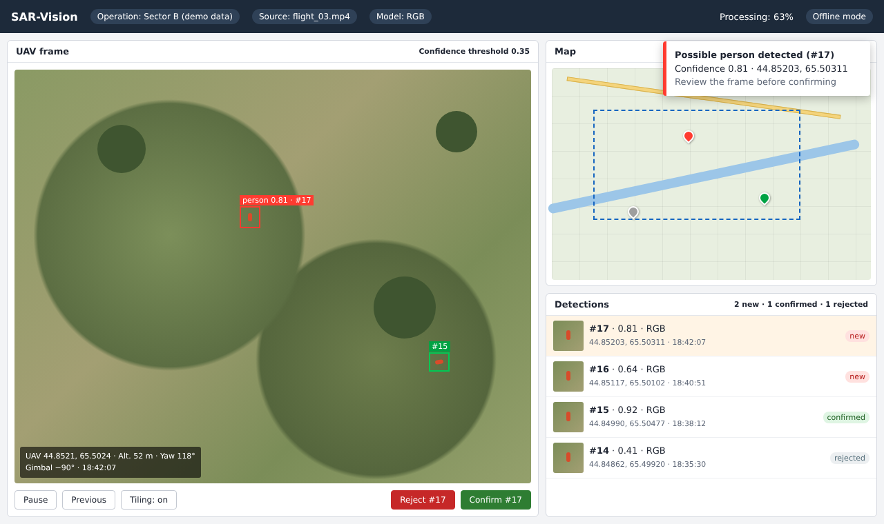
Figure 4. Mockup of the main operator screen. Source: Authors’ own work.
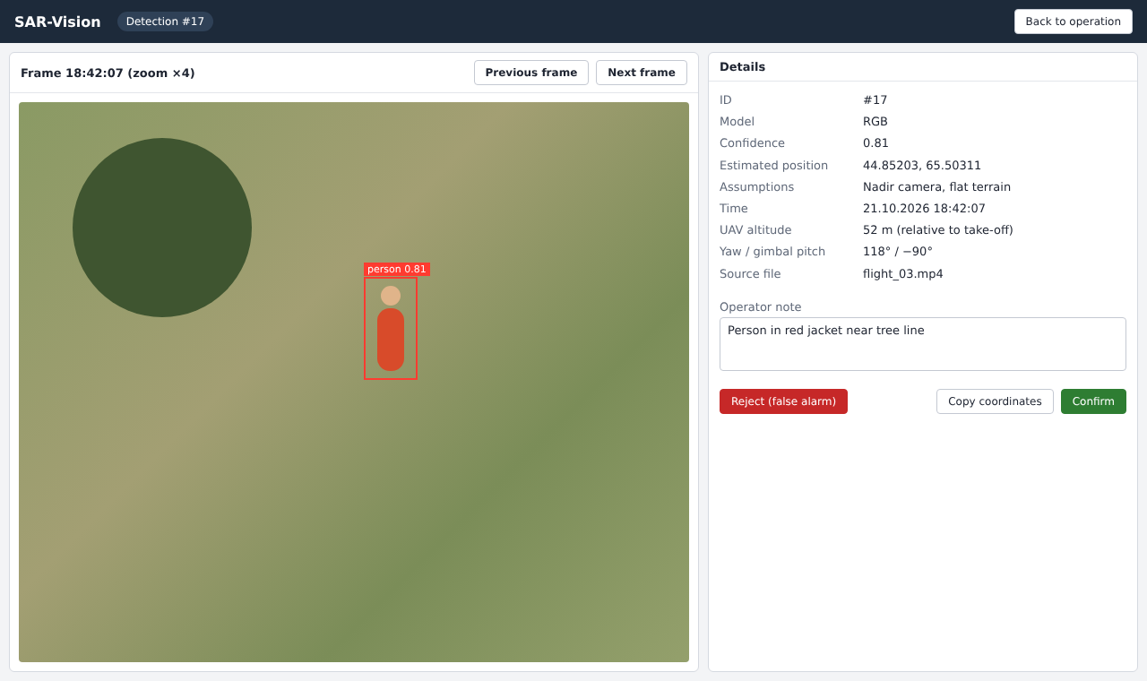
Figure 5. Mockup of the detection review screen. Source: Authors’ own work.
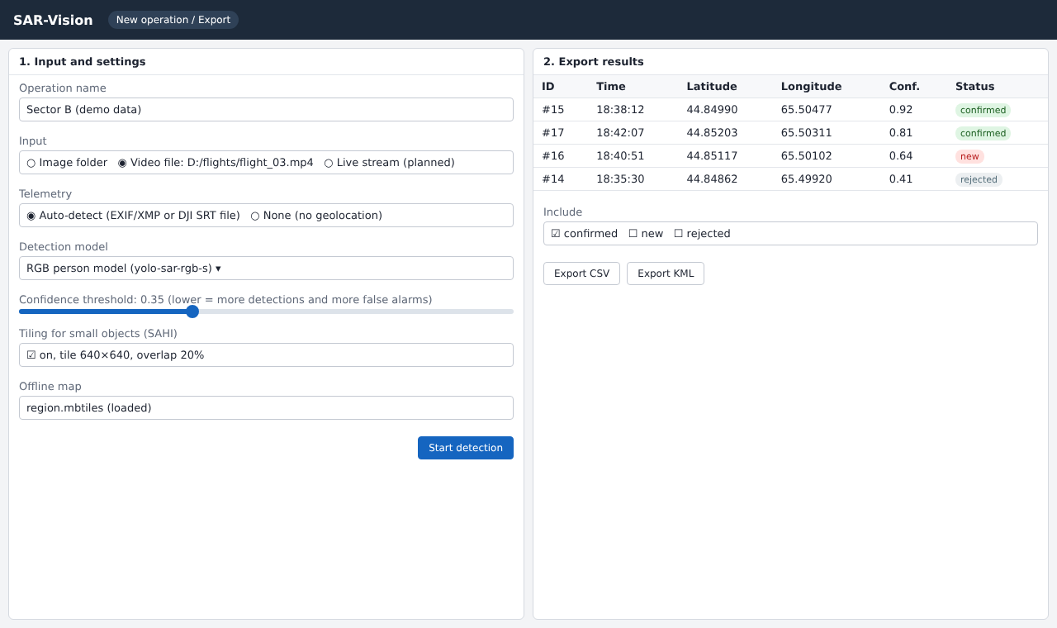
Figure 6. Mockup of the operation setup and export screen. Source: Authors’ own work.

8.2 Planned interface between backend and frontend
The backend will expose a small REST API, plus a WebSocket channel for new detections. The endpoints below are a draft and may change during implementation.
Table 18. Planned interface between backend and frontend
Method | Path | Purpose
POST | /api/operations | Create an operation and set its input
POST | /api/operations/{id}/start | Start processing
GET | /api/operations/{id}/detections | List detections, optionally filtered by status
PATCH | /api/detections/{id} | Confirm or reject a detection and add a note
GET | /api/operations/{id}/export?format=csv | Export confirmed detections (CSV or KML)
WS | /ws/operations/{id} | Push new detections to the interface

9. Verification and Evaluation Plan

9.1 What the evaluation should show
The evaluation should answer four questions:
- Does fine-tuning and tiling improve person detection compared with an off-the-shelf model?
- Is processing fast enough for practical use on a laptop?
- How accurate are the estimated coordinates under the stated assumptions?
- Can operators complete the review workflow without help?
Current status: no evaluation has been carried out yet. The only completed check is a set of unit tests for the draft geolocation module. All tests below are planned.

9.2 Data
Table 19. Data
Dataset | Use | Split
VisDrone [3] | Pre-training on drone imagery (pedestrian and people classes) | Official splits
HERIDAL [1] | Main SAR training and test set (RGB) | Official train/test; validation taken from train
SARD [2] | Additional SAR training data; secondary test | 70/15/15 if no official split
HIT-UAV [4] | Thermal extension (FR-10) | Official splits
Own footage (if a UAV is available) | Local conditions; geolocation test | Test only
Test data is never used for training or for choosing thresholds.

9.3 Metrics
Table 20. Metrics
Metric | Definition | Related requirement
Recall, precision | At IoU 0.5 and a fixed confidence threshold chosen on validation data | FR-1, FR-10
mAP@0.5 | Standard detection metric, for comparison with published results | FR-1
False positives per image | Average number of false detections per image; indicates operator workload | FR-1
Throughput (FPS) | Mean processed frames per second for 1920×1080 video, with and without tiling | NFR-1
Latency | Time from frame arrival to display, 95th percentile (live mode only) | NFR-2
Geolocation error | Horizontal distance in metres between the estimated and measured marker positions | FR-4
SUS score | System Usability Scale, after the usability session | NFR-5

9.4 Baselines
Table 21. Baselines
Baseline | Purpose
B1: YOLO pretrained on COCO, person class only, no fine-tuning | Shows the effect of SAR-specific training
B2: Fine-tuned model without tiling | Shows the effect of tiling on small people
B3: Published result of [10] on HERIDAL (mAP@50 = 0.802) | Places our result relative to recent work; differences in setup will be noted
A small comparison with manual review (time taken and people found by volunteers on the same footage) may be added if time permits. It is not part of the acceptance criteria.

9.5 Test plan
Table 22. Test plan
ID | Test | Conditions | Pass criterion | Status
T-1 | RGB detection quality | HERIDAL test split; B1 and B2 also evaluated | FR-1 targets | Planned
T-2 | Effect of tiling | Images with persons smaller than 32 px | Recall with tiling reported against B2 | Planned
T-3 | Thermal detection (extension) | HIT-UAV test split | FR-10 target | Planned, if FR-10 is implemented
T-4 | Geolocation accuracy | ≥ 10 ground markers with phone-GPS positions, 50 m altitude, nadir camera, flat area | FR-4 targets | Planned; depends on UAV access (R1)
T-5 | Throughput and latency | 5-minute 1080p video, reference laptop, 5 runs | NFR-1 (and NFR-2 if live mode exists) | Planned
T-6 | End-to-end functional test | Image folder and MP4 input; threshold change; alerts | FR-2, FR-5, FR-8, FR-11 | Planned
T-7 | Review and export | Confirm 3 and reject 2 detections, restart, export CSV and KML | FR-6, FR-7 | Planned
T-8 | Offline operation | Network disabled during T-6 | NFR-3 | Planned
T-9 | Usability | 3 participants complete UC-1 to UC-5, then answer the SUS questionnaire | NFR-5 | Planned
T-10 | Unit tests | pytest for geolocation, telemetry parsing and export; run in GitHub Actions on each pull request | NFR-7 | Partly done: 6 geolocation tests pass locally; CI not yet set up

9.6 Measurement conditions to be recorded
For every reported result, the following will be recorded: model and weights version, input size, confidence and IoU thresholds, tiling settings, hardware (CPU, GPU, RAM), operating system, driver and library versions, and the number of repeated runs. For T-4, the UAV model, altitude source, weather and ground truth method will also be recorded. Results from public datasets and from our own footage will be reported separately.

10. Project Management and Risks

10.1 Team and responsibilities
Responsibilities follow the task assignment in YouTrack and may be adjusted as the project develops. Each member is responsible for their own commits, pull requests and YouTrack tasks.
Table 23. Team and responsibilities
Member | Main responsibility | Further tasks
Kurmantaev Ali (Құрмантаев Әли Романұлы) | Literature review (SAR-4), technology comparison (SAR-6) | Interface mockups (SAR-9), geolocation module (SAR-11)
Shalmanov Assylzhan (Шалманов Асылжан Саясатұлы) | Repository and README (SAR-1), proposal (SAR-2), requirements (SAR-7) | Existing system comparison (SAR-5), detection demo (SAR-13)
Shakalova Diana (Шакалова Диана Аскаровна) | User research (SAR-3), verification plan (SAR-10) | Architecture diagrams (SAR-8), project plan and supervisor feedback (SAR-12)
Supervisor: Kutpanova Zarina.

10.2 Repository and task tracking
Repository. A GitHub repository will contain source code, documentation, diagrams (PlantUML sources and PNG exports), prototype materials, tests and configuration examples. The planned structure is:
README.md docs/ diagrams/src, diagrams/png
prototype/ src/ tests/
config/ requirements.txt .gitignore
The README will include the project description, problem, users, team and responsibilities, supervisor, scope, status, technologies, links to YouTrack and the documentation, and setup and test instructions. Secrets and operation data are excluded through .gitignore; only example configuration files with placeholder values are committed.
Repository: https://github.com/assylzhan-se/uav-sar-vision. YouTrack: https://sarvision.youtrack.cloud/projects/SAR.
Workflow. The main branch holds reviewed work. Each change is linked to a YouTrack task:
- branch: SAR-7-requirements
- commit message: SAR-7: Add requirements and acceptance criteria
- pull request: describes the change, references the task and explains how the change was checked
Another team member reviews each pull request before it is merged. The task in YouTrack links back to the pull request and is closed only when its acceptance criterion is met. Each pre-defense submission is marked with a Git tag (pre-defense-1, pre-defense-2, final-pre-defense). Tags are not moved after submission.
Contribution evidence. The committee will assess each member’s individual contribution through commit history, pull requests and reviews. At the time of writing, this history has not yet been created. The documents in this submission should be committed by their respective authors through separate pull requests, not uploaded in a single commit.

10.3 Tasks for the first pre-defense
The following tasks are recorded in YouTrack (project key SAR).
Table 24. Tasks for the first pre-defense
ID | Task | Assignee | Acceptance criterion | Priority
SAR-1 | Repository structure, README, .gitignore | Shalmanov | All README sections present | Critical
SAR-2 | Project proposal and scope | Shalmanov | Section 1 reviewed by the supervisor | Critical
SAR-3 | User discussions (3–5) | Shakalova | Notes for each discussion stored in docs/interviews/ | Critical
SAR-4 | Literature review | Kurmantaev | ≥ 12 sources, ≥ 8 scientific | Critical
SAR-5 | Existing system comparison | Shalmanov | 3–5 systems, 6–10 criteria, sources cited | Major
SAR-6 | Technology comparison | Kurmantaev | ≥ 3 decisions with 2–3 alternatives each | Major
SAR-7 | Requirements and acceptance criteria | Shalmanov | Every requirement has a priority and a test | Critical
SAR-8 | Context, use case and component diagrams | Shakalova | .puml sources and PNG exports committed | Critical
SAR-9 | Interface mockups | Kurmantaev | Three screens covering UC-1 to UC-5 | Major
SAR-10 | Verification and evaluation plan | Shakalova | Metrics, baselines and tests defined | Major
SAR-11 | Draft geolocation module and unit tests | Kurmantaev | pytest passes | Normal
SAR-12 | Project management, supervisor review, full document | Shakalova | Feedback recorded in Section 11 | Critical
SAR-13 | Baseline detection demo script | Shalmanov | Script draws person boxes on a test image | Normal

10.4 Milestones
The dates after the first pre-defense are proposed targets and depend on the official schedule.
Table 25. Milestones
Milestone | Target | Main result
M1 Analysis and design | 24 October 2026 (pre-defense 1) | This document, diagrams, mockups, repository and task board
M2 Data and baseline | November 2026 | Prepared datasets; baseline B1 evaluated; first fine-tuned model
M3 Processing pipeline | December 2026 | Images/video, detection, geolocation and storage working from the command line
M4 MVP with interface | Pre-defense 2 (date to be announced) | Operator interface, review and export; first metrics
M5 Evaluation and extensions | February–March 2027 | Tests T-1 to T-10; extensions if time allows
M6 Final version | Final pre-defense (date to be announced) | Complete system and thesis

10.5 Risks
Table 26. Risks
ID | Risk | Likelihood | Impact | Mitigation | Fallback
R1 | No access to a UAV with telemetry for field tests | High | High | Ask the university, emergency services and commercial pilots early | Evaluate on public datasets and recorded footage; report geolocation as untested
R2 | Not enough GPU capacity for training | Medium | High | Use small and medium models; free cloud notebooks for training | Reduce image size or number of experiments
R3 | Detection quality below target | Medium | Medium | Staged transfer learning, tiling, threshold tuning | Report the achieved results honestly and analyse the causes
R4 | Live video cannot be obtained from the UAV controller | Medium | Low (extension) | Check the options for the specific UAV model | Process recorded footage after landing (MVP)
R5 | Telemetry is missing or inaccurate | Medium | Medium | Confirm the metadata format with sample files early | Show detections without coordinates; report the error sources
R6 | User discussions cannot be arranged | Medium | High | Contact several organisations in parallel | Short online questionnaire and expert discussions
R7 | Team workload and missed deadlines | Medium | Medium | Weekly check-ins; tasks with deadlines in YouTrack | Drop could requirements first
R8 | Flight restrictions | Medium | Medium | Fly only at permitted sites with a licensed pilot | Use existing recordings

10.6 Dependencies and next steps
Several parts of the plan depend on earlier steps:
- The telemetry parser and geolocation tests depend on knowing which UAV model and file format users have (SAR-3, R1, R5).
- Model training depends on dataset preparation and GPU access (R2).
- The interface depends on the API contract in Section 8.2.
The next steps after the first pre-defense are:
- Hold the user discussions and update the requirements.
- Download and convert the datasets.
- Evaluate baseline B1.
- Start fine-tuning.

11. Supervisor Feedback
Status: pending. At the time of writing, the supervisor has not yet reviewed these documents, so no feedback is reported.
Feedback will be collected mainly as comments on pull requests in the repository, so that each comment and the resulting change can be traced. A summary will be kept in the table below.
Table 27. Supervisor Feedback
No. | Date | Item reviewed | Supervisor’s comment | Team’s response | Link (pull request or commit)
1 | — | Project proposal and scope | Pending | — | —
2 | — | Requirements and acceptance criteria | Pending | — | —
We plan to discuss the following questions with the supervisor:
- Is the MVP scope appropriate for a three-person diploma project, and should any planned extension be removed or added?
- Are the proposed targets for recall, throughput and geolocation error reasonable?
- Can the university help with access to a UAV with telemetry and with flight permissions?
- Are there contacts in emergency services who could take part in the user discussions?

References
[1] D. Božić-Štulić, Ž. Marušić, and S. Gotovac, “Deep learning approach in aerial imagery for supporting land search and rescue missions,” International Journal of Computer Vision, vol. 127, no. 9, pp. 1256–1278, 2019, doi: 10.1007/s11263-019-01177-1.
[2] S. Sambolek and M. Ivašić-Kos, “Automatic person detection in search and rescue operations using deep CNN detectors,” IEEE Access, vol. 9, pp. 37905–37922, 2021, doi: 10.1109/ACCESS.2021.3063681.
[3] P. Zhu, L. Wen, D. Du, et al., “Detection and tracking meet drones challenge,” IEEE Transactions on Pattern Analysis and Machine Intelligence, vol. 44, no. 11, pp. 7380–7399, 2022.
[4] J. Suo, T. Wang, X. Zhang, H. Chen, W. Zhou, and W. Shi, “HIT-UAV: A high-altitude infrared thermal dataset for unmanned aerial vehicle-based object detection,” Scientific Data, vol. 10, art. 227, 2023, doi: 10.1038/s41597-023-02066-6.
[5] D. Broyles, C. R. Hayner, and K. Leung, “WiSARD: A labeled visual and thermal image dataset for wilderness search and rescue,” in Proc. IEEE/RSJ Int. Conf. Intelligent Robots and Systems (IROS), 2022, pp. 9467–9474, doi: 10.1109/IROS47612.2022.9981298.
[6] K. R. Akshatha, A. K. Karunakar, S. B. Shenoy, A. K. Pai, N. H. Nagaraj, and S. S. Rohatgi, “Human detection in aerial thermal images using Faster R-CNN and SSD algorithms,” Electronics, vol. 11, no. 7, art. 1151, 2022, doi: 10.3390/electronics11071151.
[7] E. Lygouras, N. Santavas, A. Taitzoglou, K. Tarchanidis, A. Mitropoulos, and A. Gasteratos, “Unsupervised human detection with an embedded vision system on a fully autonomous UAV for search and rescue operations,” Sensors, vol. 19, no. 16, art. 3542, 2019, doi: 10.3390/s19163542.
[8] T. Niedzielski, M. Jurecka, B. Miziński, W. Pawul, and T. Motyl, “First successful rescue of a lost person using the human detection system: A case study from Beskid Niski (SE Poland),” Remote Sensing, vol. 13, no. 23, art. 4903, 2021, doi: 10.3390/rs13234903.
[9] M. Lyu, Y. Zhao, C. Huang, and H. Huang, “Unmanned aerial vehicles for search and rescue: A survey,” Remote Sensing, vol. 15, no. 13, art. 3266, 2023, doi: 10.3390/rs15133266.
[10] F. Ciccone and A. Ceruti, “Real-time search and rescue with drones: A deep learning approach for small-object detection based on YOLO,” Drones, vol. 9, no. 8, art. 514, 2025. [Online]. Available: https://www.mdpi.com/2504-446X/9/8/514
[11] F. C. Akyon, S. O. Altinuc, and A. Temizel, “Slicing aided hyper inference and fine-tuning for small object detection,” in Proc. IEEE Int. Conf. Image Processing (ICIP), 2022, pp. 966–970, doi: 10.1109/ICIP46576.2022.9897990.
[12] Y. Zhao, W. Lv, S. Xu, J. Wei, G. Wang, Q. Dang, Y. Liu, and J. Chen, “DETRs beat YOLOs on real-time object detection,” in Proc. IEEE/CVF Conf. Computer Vision and Pattern Recognition (CVPR), 2024, pp. 16965–16974.
[13] A. Wang, H. Chen, L. Liu, K. Chen, Z. Lin, J. Han, and G. Ding, “YOLOv10: Real-time end-to-end object detection,” in Advances in Neural Information Processing Systems (NeurIPS), 2024. arXiv:2405.14458.
[14] J. Redmon, S. Divvala, R. Girshick, and A. Farhadi, “You only look once: Unified, real-time object detection,” in Proc. IEEE Conf. Computer Vision and Pattern Recognition (CVPR), 2016, pp. 779–788.
[15] S. Ren, K. He, R. Girshick, and J. Sun, “Faster R-CNN: Towards real-time object detection with region proposal networks,” in Advances in Neural Information Processing Systems (NeurIPS), vol. 28, 2015, pp. 91–99.
[16] Ultralytics, “Ultralytics YOLO documentation.” [Online]. Available: https://docs.ultralytics.com (accessed Oct. 21, 2026).
[17] PAP – Science in Poland, “The system SARUAV developed by Wrocław scientists will significantly shorten the search for missing persons.” [Online]. Available: https://scienceinpoland.pl/en/node/78720 (accessed Oct. 21, 2026).
[18] Commercial UAV News, “Loc8 locates people and objects quickly and effectively,” Aug. 19, 2020. [Online]. Available: https://www.commercialuavnews.com/public-safety/loc8-locates-people-and-objects-quickly-and-effectively (accessed Oct. 21, 2026).
[19] DroneXL, “DJI launches AI-powered Matrice 4 series enterprise drone,” Jan. 8, 2025. [Online]. Available: https://dronexl.co/zh/2025/01/08/dji-launches-ai-powered-matrice-4-series-enterprise-drone/ (accessed Oct. 21, 2026).

Appendix A. Question Guide for User Discussions
- What is your role, and how often do you take part in search operations?
- Which UAVs and cameras (RGB, thermal, zoom) do you use, and what flight data do they record?
- How are UAV images and video reviewed during a search, and by whom?
- Roughly how long does it take to review the material from one flight?
- Have people ever been missed in the footage? What made them hard to see?
- Which conditions are most difficult (night, forest, snow, water, rubble)?
- Is internet access usually available in the field? What equipment do you use there?
- Which is worse for you: missing a person or receiving many false alerts? How many false alerts per flight would be acceptable?
- In what form do you prefer to receive the coordinates of a possible person?
- Which functions would be essential for such a tool, and which would be nice to have?

