Lab 4

As we get started today, please be sure to do the following things. By now you should be familiar with these steps.

1) Add and commit any changes you have to code:
git add .
git commit -m “This is my commit message”
git push origin master

The last steps says to push your code back into your own repository (and not in mine - if you wanted to push it back into my repository, I’d have to approve your changes).

2) Please pull from my repository, like before (you can’t pull before committing your code)
git pull upstream master

3) Help! I’m stuck and Rio’s getting started with the lab!
Please raise your hand and a TA or a helper will be with you. As a last resort, create a new directory and clone everything from scratch:
git clone https://github.com/rioleo/CS147.git

Some changes this time around:

This document should work as a standalone doc, so if you fall behind, just remember where you got lost and follow the directions. We’ll have activity time so that you can catch up if you’re feeling a bit lost.

Step 4: Let’s pick up where we left off last time! Last time we showed our users all the books we had. You could just as easily imagine showing the user all your recipes, all your stories, all your medical advice, all your friends, all of … anything!

Let’s get started with our first form!

<form action="submit.php" method="post">
<input type=”enter a type here from below” name=”somename”>
</form>

If you’re stuck for ideas: hci.st/lab41 has a demo, which you can also try on your mobile device.

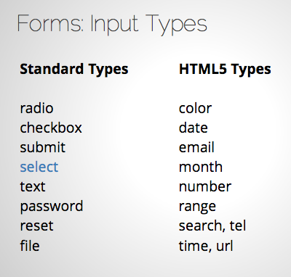

Some Styling 5
class="chzn-select"

Step 6: Getting back on track. Let’s all use the same form.
https://raw.github.com/gist/3897808

Step 7: Let’s now create the table that will store our user data. If you get lost, create a new table in your database like so:

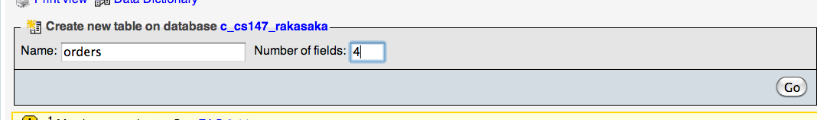

What are the four fields we’re going to store data into?

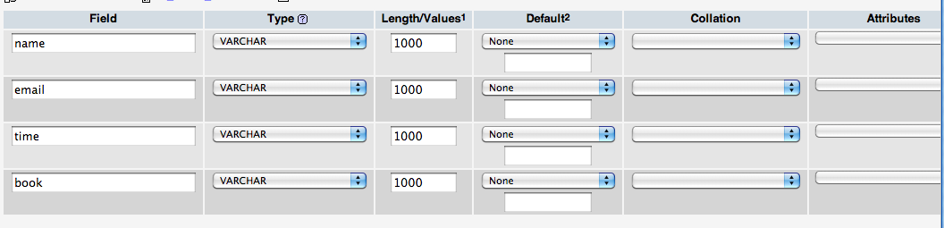

Step 8: These are the Request Headers that contain the variables that are sent over to the page, indexed into an array.
$name = $_POST["name"];
$book = $_POST["book"];
$email = $_POST["email"];

Step 8.5. Chrome’s Inspect Element and console can help decrypt some of the mysteries

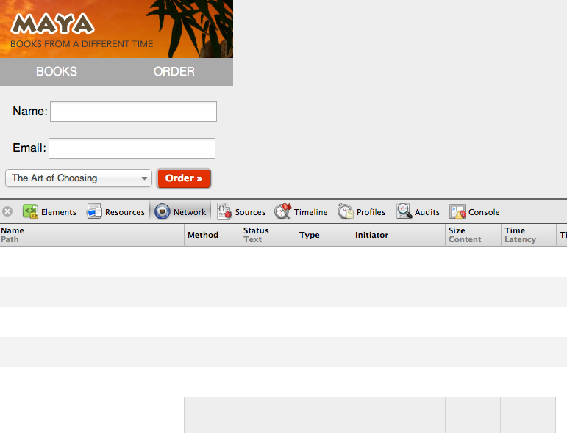
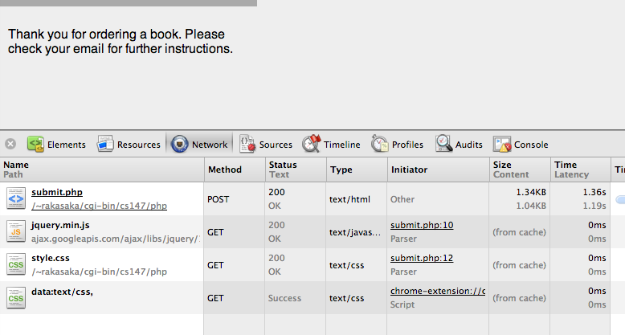

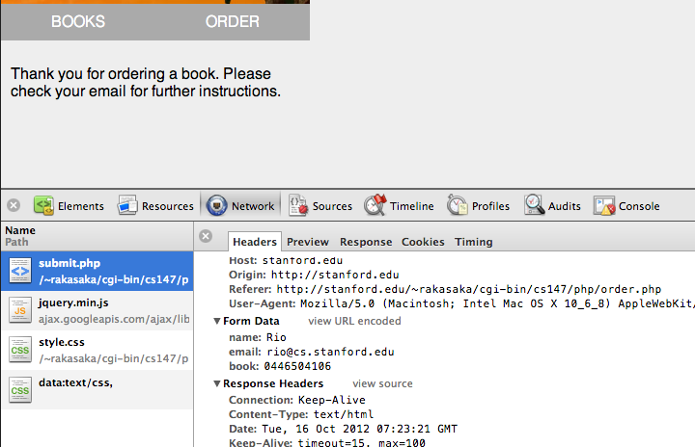

Step 9: Submit Activity
Using the following resource, come up with a suitable MySQL query that inserts a new row into the table you just created. When you’re ready, submit it as part of this week’s activity.

http://www.w3schools.com/php/php_mysql_insert.asp

If you’re really stuck, consider using phpMyAdmin to insert a new row.
As an additional challenge, consider how you would enter the date and time of the submission.

Step 10: Take care of orders. We’ll give them a thank you message and email them too.
Let’s put in the query we just made into $query.

Step 10: AJAX!
We’ll walk through the process together. If you’re stuck, check back here after class and I’ll have the complete code pasted here.

Additional thoughts:

On the topic of safety, when you’re working with passwords, you might think it suffices to compare the user’s input for the password with one that is stored in a database (say, for example, a table that has username, email and password stored). The problem inherently lies with the fact that the database can be compromised, leaking all your user’s credentials. To circumvent that, a preliminary step is to hash the password using a method called md5. md5 is a one-way function that maps a string to a 16-byte value that uniquely identifies the string, but cannot uncover what the original string was. So for example, the string “password” generates the hash “5f4dcc3b5aa765d61d8327deb882cf99”, but with “5f4dcc3b5aa765d61d8327deb882cf99” it would be exceedingly difficult to determine that “password” generated it unless you essentially brute-force it. So if you store the string “5f4dcc3b5aa765d61d8327deb882cf99” in your database and then calculate the md5 hash of the user input, then you can compare the two and see if they are the same. I say it’s a preliminary step because the best security is to encrypt the traffic upon which your data is transmitted first.

