Research on McGurk effect based on Russian language material

Introduction

This work is about McGurk effect in Russian language. It is a phenomenon of interaction between audio and video stimuli. We decided to investigate it on the actual words in the modern Russian language.

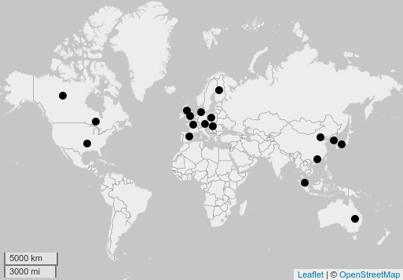

1. Map

There are languages which the McGurk effect was studied on. Some of them, for example English, have a strong effect and others, for instance Polish, almost have not. We read and analyzed these articles to understand factors which can influence on people. We have found the most frequent factors and have decided that there are gender and age, mother language (Russian language). Another factor that should be mentioned is that participants had to live at least for few months in Moscow or Moscow region.

Methodology

Constructing the experiment, we relied on the article [Gries 2013], which describes in detail the process. The parameters in this paper are the type of consonant on video recording (3), type of consonant on the audio (3), gender of the listener (2) (3 \* 3 \* 2 = 18.). For the experiment in the article, the author advises to develop a set of words that implements a unique set of parameters. After creating unique sets of parameters, it is suggested to consider variables that are not of interest to us, so that subjects can not guess the stimulus that really interests us, and that too high frequency of the stimuli of interest does not affect the interpretation of the results. In our work this means that two third of the videos will not contain stimulus. The procedure should be made pseudo-random. It is necessary to "fix" the random order according to the principle: the first element is not a stimulus of interest, the incentives do not go in a row, and the same type of stimuli appears in different orders.

The effect of McGurk was investigated on the basis of the Russian language, using an experiment in which Russian speakers were interviewed. Among participants, there are 12-77 years old men and women (at approximately equal percentage) that have been living in Moscow or the Moscow region. None of them has a linguistic education. During the experiment it was suggested to watch a video in which the announcer told stories on an abstract topic, and at the end respondents were asked some questions to find out whether the effect of McGurk on Russian media is working. After a question, the people were asked to arrange a series of words in the correct order. This task had 9 stimulus and 18 fillers. We were convinced that the order of stimulus did not have an influence on answers.

Results

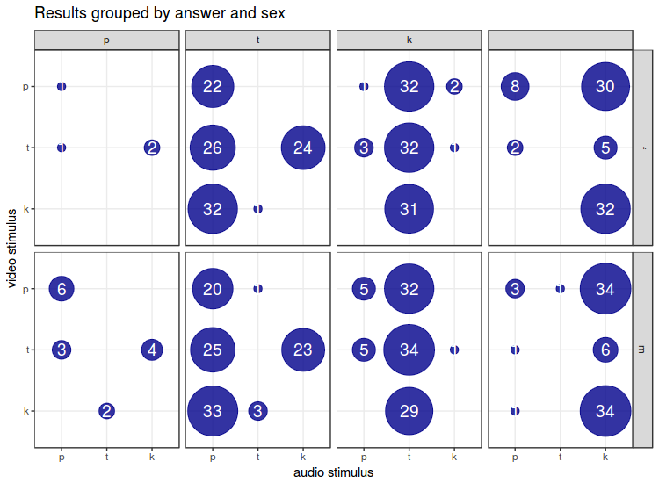

1. Results

The total results of the experiment are presented in 2 Results. The inconsistent answers are considered as to be caused by the McGurk effect. As it can be seen from the data the majority of answers were based on audio signal that means that it is difficult to say about the McGurk effect in Russian listeners. It is not the answers we waited for. Nevertheless, there is one more unexpected thing. According to the diagram, the most of experimentalists chose *–k* when video stimuli were *–p* and audio stimuli was *–t*.

References

Brancazio, L., Miller, J. L. (2005). Use of visual information in speech perception: Evidence for a visual rate effect both with and without a McGurk effect. *Attention, Perception, & Psychophysics, 67*(5),759-769.

Burnham, D., Dodd, B. (2004). Auditory–visual speech integration by prelinguistic infants: Perception of an emergent consonant in the McGurk effect*. Developmental psychobiology, 45*(4), 204-220.

Cathiard, M. A., Schwartz, J. L., Abry, C. (2001). Asking a naive question about the McGurk Effect: why does audio [b] give more [d] percepts with visual [g] than with visual [d]?. *In AVSP 2001-International Conference on Auditory-Visual Speech Processing.*

Cluff, M. S., Luce, P. A. (1990). Similarity neighborhoods of spoken two syllable words: Retroactive effects on multiple activation. *The Journal of the Acoustical Society of America*, *87*(S1), S125-S126.

Colin, C., Radeau, M., Soquet, A., Demolin, D., Colin, F., Deltenre, P. (2002). Mismatch negativity evoked by the McGurk–MacDonald effect: A phonetic representation within short-term memory. *Clinical Neurophysiology*, *113*(4), 495-506.

de Gelder, B., Bertelson, P., Vroomen, J., Chen, H. C. (1995). Inter-language differences in the mcgurk effect for dutch and Cantonese listeners. In *EUROSPEECH*.

Dupont, S., Aubin, J., Ménard, L. (2005). A study of the McGurk effect in 4-and 5-year-old French Canadian children. *ZAS Papers in Linguistics, 40*, 1-17.

Fixmer, E., Hawkins, S. (1998). The influence of quality of information on the McGurk effect. In *AVSP'98 International Conference on Auditory-Visual Speech Processing*.

Grassegger, H. (1995). McGurk effect in German and Hungarian listeners. In *proceedings of the international congress of phonetic sciences, Stockholm* (Vol. 4, No. 3, p. 2).

Green, K. P., Kuhl, P. K., Meltzoff, A. N. (1988). Factors affecting the integration of auditory and visual information in speech: The effect of vowel environment. *The Journal of the Acoustical Society of America, 84*(S1), S155-S155.

Green, K. P., Kuhl, P. K., Meltzoff, A. N., Stevens, E. B. (1991). Integrating speech information across talkers, gender, and sensory modality: Female faces and male voices in the McGurk effect. *Attention, Perception, Psychophysics*, *50*(6), 524-536.

Gries, S. T. (2013). Statistics for linguistics with R: A practical introduction. Walter de Gruyter

Hardison, D. M. (1999). Bimodal speech perception by native and nonnative speakers of English: Factors influencing the McGurk effect. *Language Learning*, *49*(s1), 213-283.

Hayashi, Y., Sekiyama, K. (1998). Native-foreign langage effect in the mcgurk effect: A test with chinese and japanese. *In AVSP'98 International Conference on Auditory-Visual Speech Processing.*

Hayashi, Y., Sekiyama, K. (1998). Native-foreign langage effect in the mcgurk effect: A test with chinese and japanese. In *AVSP'98 International Conference on Auditory-Visual Speech Processing*.

Johnson, K., Strand, E. A., D'Imperio, M. (1999). Auditory–visual integration of talker gender in vowel perception. *Journal of Phonetics, 27*(4), 359-384.

Majewski, W. (2008). McGurk effect in Polish listeners. Archives of Acoustics, 33(4), 447-454.

McGurk, H., MacDonald, J. (1976). Hearing lips and seeing voices.

Munhall, K. G., Gribble, P., Sacco, L., Ward, M. (1996). Temporal constraints on the McGurk effect. *Perception Psychophysics*, *58*(3), 351-362.

Nath, A. R., Beauchamp, M. S. (2012). A neural basis for interindividual differences in the McGurk effect, a multisensory speech illusion. *Neuroimage, 59*(1), 781-787.

Nicholls, M. E., Searle, D. A., Bradshaw, J. L. (2004). Read my lips: Asymmetries in the visual expression and perception of speech revealed through the McGurk effect. *Psychological science, 15*(2), 138-141.

Sams, M., Manninen, P., Surakka, V., Helin, P., Kättö, R. (1998). McGurk effect in Finnish syllables, isolated words, and words in sentences: Effects of word meaning and sentence context. *Speech Communication, 26*(1), 75-87.

Sekiyama, K. (1994). Differences in auditory-visual speech perception between Japanese and Americans: McGurk effect as a function of incompatibility. *Journal of the Acoustical Society of Japan (E), 15(3),* 143-158.

Sekiyama, K., Tohkura, Y. I. (1991). McGurk effect in non‐English listeners: Few visual effects for Japanese subjects hearing Japanese syllables of high auditory intelligibility. *The Journal of the Acoustical Society of America, 90(4)*, 1797-1805.

Зализняк, А. А. (1980). Грамматический словарь русского языка. Словоизменение

Ляшевская, О. Н., Шаров, С. А. (2009). Частотный словарь современного русского языка (на материалах Национального корпуса русского языка). URL: http://dict. ruslang. ru/freq. php