**Правительство Российской Федерации**

**Федеральное государственное автономное образовательное учреждение высшего образования**

**Национальный исследовательский университет «Высшая школа экономики»**

**Факультет гуманитарных наук**

**Образовательная программа**

**«Лингвистическая теория и описание языка»**

**КУРСОВАЯ РАБОТА**

На тему Особенности реализации фонетических процессов в чтении вслух

*Название темы на английском Features of the implementation of phonetic processes in reading aloud*

Студентка 1 курса

группы № МЛТОЯ191

Ирина Юрьевна Астафьева

Научный руководитель

Инна Арнольдовна Зибер

старший преподаватель

Москва, 2020 г.

Table of Contents

Introduction 3

Literature Review 4

Research question and hypotheses 6

Methods 7

Data Analysis 10

Results 18

Conclusions and implications 19

Acknowledgments 20

References 20

Appendices 23

### 

### Introduction

There are many studies which conduct an investigation into the process of vowel reduction. The science distinguishes two concepts of the reduction in the field of phonetics and phonology. The phonological sense of reduction concerns deep representation of sound; phonemes; vowel qualities and relate to prosodic and segmental vowel contexts (Flemming 2005). Phonological processes are considered as natural ‘rules’ and form phonological code (Brady et al. 2013). Many scientists consider the phonetic part of reduction as a superficial realization of complex phonological processes (Scheibman 2000).

The second understanding of reduction is phonetic reduction, that is, a decrease in the duration of vowels in an unstressed position. The phonetic process studies the acoustic realization of speech. To the best of my knowledge, most of the research into the process of reduction includes both phonetic and phonological understanding of this process (Kohler 1990; Burzio 2007; Gahl et al. 2012 and others), but in this paper I only consider the phonetic side of the problem.

The size of the vowel reduction differs in different speakers and depends on many factors such as native language, city or town of living, age, neighbourhood density, rate of speech, frequency of the words and others (Clopper et al. 2018). The current study is focused on the factor of spontaneous speech and reading and the effect of the implementation of reduced vowels in these conditions. For this purpose the experiment was conducted.

During the experiment, the participants read the text in pairs several times, and then memorized and performed it. The reading, in which speakers saw the text for the first time, was analyzed and considered an experimental condition for "reading". The presentation of the memorized text was also analyzed, it was considered a condition of "spontaneous speech". The hypothesis of the study was that the mean duration of reduced vowels is significantly different in speaking and reading condition. This effect was tested on the Standard Russian language material.

Results of the experiments imply it is true that durations of reduced vowel differ depending on the speaking or reading condition. Furthermore, for each group of reduced vowels under consideration (pre-stressed vowels, post-stressed vowels in the middle of the word, post-stressed vowel in the end of the word before pause), it is true that the duration of analysed sounds is longer in reading aloud. The longer duration of the reduced vowel is a sought feature of the implementation of the phonetic processes in reading aloud.

Data visualization and statistical computations were conducted with Python language (Van Rossum, Drake 2009). I used the following packages Statmodel (Seabold, Perktold 2010), Matplotlib (Hunter 2007), Pandas (McKinney et al. 2010).

This study could be helpful for teachers and educators for improving online-education systems and proctoring during the oral defences to control knowledge of the study material by heart.

### Literature Review

Unstressed vowel reduction is a central theme in the field of phonetics and phonology. A full inventory of vowels can be realized only in syllables with lexical stress, while in unstressed syllables, some amount of contrast neutralization occurs, as a result of which only part of the inventory is realized on the surface (Barnes 2007).

Many specialists believe that vowel reduction has two specific meanings in the phonetic and phonological field. Despite the close and inextricable connection, these concepts are very different (Kohler 1990; Burzio 2007). For instance, recent studies (Gahl et al. 2012) highlight that in spontaneous speech phonological neighborhood density (“a measure of the number of words <...> that are phonologically similar to a target word”) affects the sound reduction and words with large amounts of neighbors are recognized more slowly and less accurately. Scientists considered phonetic variations as a function of the phonological density of the neighborhood. The example reflects the close connection between the two concepts: phonetic realization influences phonological interpretation and at the same time is considered as only one factor of the model. However, there is a point of view that phonology does not include phonetics (Iosad 2012).

Linguistes (Crosswhite 2004) describe the phonological vowel reduction as changes in unstressed vowels or ‘unstressed vowels undergo neutralisation’. Latest research suggests that languages typically use two main strategies for phenomenon: contrast-enhancing reduction and prominence-based reduction. The main aim of the first type (contrast-enhancing reduction) is to avoid difficult-to-perceive vowel qualities in all positions except the most perceptual vowel positions (stressed position). For instance, Belorusian /o, e/ are neutralized to [a]: [ˈnoɣi] ‘legs’ and [naˈɣa] ‘leg’; [ˈrek’i] ‘river’ and [raˈka]. The motivation of the second reduction type (prominence-based reduction) is to avoid particularly long or other prominent and major characteristics (as, for example, high intensity) for unstressed position vowels. A wide assortment of vowel reduction patterns fall into this category (Crosswhite 2004).

Vowel reduction in phonetics takes into account the implementation of sounds and is tendency of shrinking vowels in weak positions due to coarticulation or propensity of centralization, or even both (Padgett, Tabain 2005). Speech speed, segmental context, consonant qualities along with other characteristics have a significant influence on the sound as a consequence the general word vowel space is diminished. The studies dedicated to the study of phonetic processes are aimed at studying acoustic implementation and factors which could have influence on the sound realisation (for instance, lexical frequency, neighbourhood density, contextual predictability, speaking style) (Clopper et al. 2018). Often the realization of sounds is studied in the field of speech acquisition, in such works the pronunciation of two significantly different age groups is compared (Lahey, Ernestus 2014).

The phenomenon of phonetic reduction occurs in sign languages as well. M. E. Tyrone and C. E. Mauk’s research (Tyrone, Mauk 2010) demonstrates that along with factors such as grammar and sociolinguistic characteristics of reader, vertical space dimension and signing rate, phonetic context, utterance position have a significant influence on phonetic reduction.

Speaking of vowel reduction, it is impossible not to mention closely related concept of stress. In Russian dialects and in the literary variant of the Standard Russian language, one can observe a different rhythmic structure of the word. In standard language, the main phonetic correlators of stress are the duration and spectral characteristics of a vowel, which are formants structure, pitch and vowels’ duration (Lyakso et al. 2009), intensity, sound-to-tone ratio and others (Kamen, Watson 1991). According to these parameters, in Standard Russian a two-component prosodic core is distinguished, which includes the stressed and the pre-stressed syllables. These two syllables are opposed to all other syllables, because in these syllables ultra-short reduced vowels are impossible and the whole vowel inventory can be realized (Knyazev, Pozharitskaya 2005). This principle is related to the A. A. Potebnya's «formula» (Bryzgunova 2007): the relative duration of a vowel is calculated by the formula 1-2-3-1-1, where 3 is a stressed vowel, 2 is the first pre-stressed vowel, 1 is the rest of the unstressed.

The vowel inventory also differs in dialects and in the literary version of the language. For Standard Russian it is true that in continuous speech, the position characteristic of the main sound types is the stressed syllable of the word; for [a], [o], [u], [ɨ], [ɛ] - after non-palatalised consonants ([ɐnˈa] ‘she’, [sʊˈxoj] ‘dry’, [buk] ‘beech’, [tɨ] ‘you’, [ˈɛtə] ‘it’), for [i], [e] - after palatalised ([lʲist] ‘sheet’; [ˈʂejə] ‘neck’). Vowels in stressed position are also called “fully formed” vowels, in contrast to “reduced” ones, which are pronounced in unstressed syllables and are characterized by a shorter duration and less distinct timbre due to the shift of their articulation towards the center compared to the stressed ones (Knyazev, Pozharitskaya 2000).

In the pre-stressed syllable, all vowels are characterized by a weak reduction; such a reduction measure is called its first stage. The same vowels are pronounced also at the beginning of a word and after a vowel in pre-stressed syllables. The second degree of reduction is the other reduced vowels than the pre-stressed position.

The vowel reduction is associated with a change in the quality of sounds. A reduction that is not associated with a change in the type of sound is called quantitative reduction. It means shrinking the duration of a vowel (compared to the duration of the same vowel when stressed) and, as a consequence, in a slight displacement of articulation towards the center of the vocal space. Along with the quantitative reduction of unstressed syllables, a change in vowel qualities can occur, which is sometimes called a qualitative reduction. Nevertheless, an increase in quantitative contraction does not obligatorily lead to a change in the types of sound, and a change in the types of sound can occur with very weak quantitative contraction (Knyazev, Pozharitskaya 2000). In this paper the quantitative reduction is under consideration.

Frequently studies that are related to the phenomenon of reduction are devoted to the study of spontaneous speech. Moreover, it seems that scientists use the spontaneous speech material as the default one for studying the reduced sounds. For example, linguists (Barry, Andreeva 2001) when considering the comparable phenomena of reduction on the material of several languages that belong to different rhythmic groups, use the recordings of quasi-spontaneous dialogues of the speakers of the Russian, Bulgarian, Italian, Modern Greek, Polish and Czech languages are used. In (Kohler 1996) the process of removing vowels in German as a result of reduction is also described by the author using the material of conversational speech. Obviously, some papers (Kuo, Weismer 2016) control the parameters of spontaneity and participants are asked to both speak and read. According to Son et al. (2004) the correlations between word redundancy, logarithm of word frequency and measurement of acoustic reduction are stronger in reading rather than in spontaneous speech. However, it seems that not many researchers set out to determine whether such pronunciations actually differ.

### Research question and hypotheses

One could easily observe that a lot of recent studies are focused from one hand on the phonological or both phonological and phonetic areas simultaneously and from the other hand on spontaneous speech but reading.

Linguists take advantage of phonetics for explaining phonological ideas and theories (Barry, Andreeva 2001; Kohler 1996; Gahl et al. 2012). In this paper I would like to focus only on the phonetic interpretation of the described phenomena and I take into account features of the implementation of phonetic processes in reading aloud in comparison with spontaneous speech. I base on Russian language material.

With data from the experiment I aimed at determining how the duration of reduced vowel in reading condition differs in contrast to spontaneously speaking condition. All participants of the experiment in pairs read the text and then “retold” it. In addition, I tried to control if the answers of participants and the following factors are related:

* Type of experiment condition: reading or speaking;
* Position of reduced vowel with respect to stressed one;
* Age;
* Gender.

The main hypothesis is that duration of reduced vowels in reading condition differ from duration reduced vowels in conversational speech.

The present study may help to improve existing speech recognition systems and systems for online-education during the oral defenses.

### Methods

For the current research, I conducted an experiment that was partially constructed according to the advice of Gries (2013). Five pairs of speakers read the text (it is available in the appendices (Appendix 1)) four times and then performed it. The text for reading was a reduced play by Dmitry Danilov “*Svidetelskie pokazania*” (*“Witness's testimonies”* (Danilov 2018)) which was the imitation of the conversational speech. The characters' responses are the answers to the questions of the invisible investigator who makes inquiries about this case. The text is an excellent emulation of a real life situation written in a living modern language. Moreover, the response format made it possible to reduce the text to make it small, easy to remember, but at the same time retain the text natural and complete. The play includes both high frequency (for example, ‘ispovedovat’sya’ *to confess*) and low frequency words (for example, ‘pozvonit’’ *to call/ring*) (Lyashevskaya, Sharov 2009). When choosing the text, I took into account only these semantic and syntactic factors, but I did not consider such features as, for instance, the palatalised or non-palatalised feature of the consonant environment (Kouznetsov 2002) giving preference to naturalness of speech and the simplest memorization of sentences.

Speakers read the text in a quiet empty room at a comfortable and natural speech tempo in pairs to imitate the real play format. All the participants read the text from the computer screen; the vision of each participant in the experiment was perfect or corrected for perfect. After the first reading, the participants were asked to read the text several more times in order to reproduce the conversation by heart and play out a performance. Speakers were allowed to read the text as many times as they needed to learn their lines. It took four or five readings. The first pronunciation I called the condition of reading, and the performance – the condition of spontaneous speech (or just speaking). The format of the experiment allowed the speaker to be expected to repeat most of the words naturally.

I divided all words from the text with reduced vowels into eight groups by different positions in relation to a stressed vowel (Table 1).

|  |  |  |  |  |
| --- | --- | --- | --- | --- |
| group number | position | syllable type (open/close) | the position (after palatalised/ non-palatalised consonant) | example |
| 1 | pre-stressed reduced vowels | - | after palatalised consonants | *принесли [prʲɪnʲɪs′li[1]] ‘(they) brought’* |
| 2 | post-stressed reduced vowels | closed syllables | after palatalised consonants | *ходит [′хоdʲɪt] ‘she/he goes’* |
| 3 | post-stressed reduced vowels | open syllables | after palatalised consonants | *вежливый [′vʲeʐlʲɪvɨj] ‘polite’* |
| 4 | post-stressed reduced vowels | open syllables before pause | after palatalised consonants | *из двести [ɨz′dvʲesʲtʲɪ] ‘from the two hundred’* |
| 5 | pre-stressed reduced vowels | - | after non-palatalised consonants | *хорошо [хərɐ′sho] ‘good’* |
| 6 | post-stressed reduced vowels | closed syllables | after non-palatalised consonants | *это [′ɛtə] ‘this’* |
| 7 | post-stressed reduced vowels | open syllables | after non-palatalised consonants | *пятнадцатой [pʲɪt′natsətəj] ‘fifteen’* |
| 8 | post-stressed reduced vowels | open syllables before pause | after non-palatalised consonants | *nado ze [′nadəʐə] ‘gee’* |

Table 1. Groups of reduced vowels.

When compiling the resulting table, the described word groups were taken into account. In addition, I took into account the age of the speaker, gender, experimental conditions (reading or speaking) and vowels’ durations. The recordings were made with a Tascam DR-05X voice recorder (format: Mp3, sample rate: 48 kHz, audio channels: Mono, bitness (or digit capacity) 24 bit) and annotated in Praat (Boersma, Weenink 2020).

Data manipulation and statistics were made with statmodel package (Seabold, Perktold 2010), graphing was made with matplotlib package (Hunter 2007) and pandas package (McKinney et al. 2010). Data analysis was performed in the Python language (Van Rossum, Drake 2009).

The code that reflects the progress of the statistical analysis as well as all the materials (recordings, annotation, list of words, transcription) are available online in a special GitHub repository (i, 2020).

Giving a brief summary, five pairs of speakers read the text and then acted it out as a scene. The first reading is considered a condition for reading, and oral speech with the preliminary memorization of the text is a condition for spontaneous speech. For the analysis I identified eight groups of reduced vowels in respect to their position to stressed-vowel.

### Data Analysis

#### Data Visualization

10 volunteers, 5 men, 5 women, from 17 to 25 years old participated in the experiment; each participant produced from 75 to 95 sounds for analysis for two experimental conditions; of these sounds, 40 to 51 sounds were contained in unique words. Nobody knew the text before the experiment; all participants were from Moscow originally or were living in Moscow more than six years. I expected all speakers to have significantly different reduced vowels’ durations depending on the experimental condition. Probationers’ age is presented as a bounded variable and can not be presented simultaneously as two or more categories, or as a continuous variable. However, one can expect that the gender of the subject influences the reduced vowels’ duration, because speakers are considered in the equal ratio of gender.

The graph (Figure 1) demonstrates the duration distribution of analysed sounds grouped by speakers’ gender. The left boxplot reflects duration measurement for women’s data, the right one represents the same information but for men. The charts are identical, which implies that the participants’ answers are not gender specific. It means that the factor is not considered in the current research.

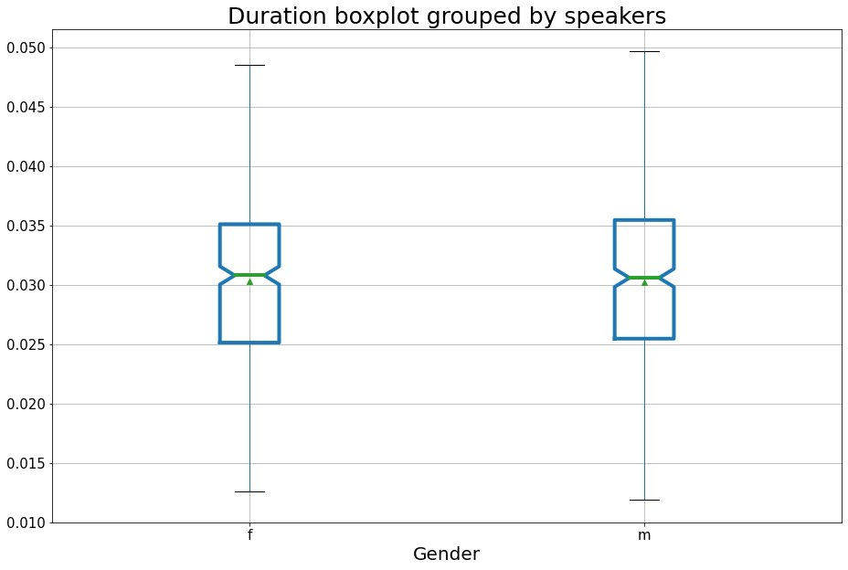

Figure 1. Duration boxplot grouped by speakers’ gender.

Initially, for analysis, I identified eight groups of lowered positions relative to the stressed vowel. The plot (Figure 2) illustrates the number of sounds for analysis for each group (Table 1).

The abscissa axis (Figure 2) contains information on each speaker separately, and the ordinate axis presents an amount of data for each group. The graph highlights that for groups 3 and 7 almost no occurrences are observed. Such differences in group 7 for each speaker are explained by the fact that some speakers either pronounced a vowel of complete formation in this position, or the boundaries of the reduced one could not be discerned due to the proximity to sibilants.

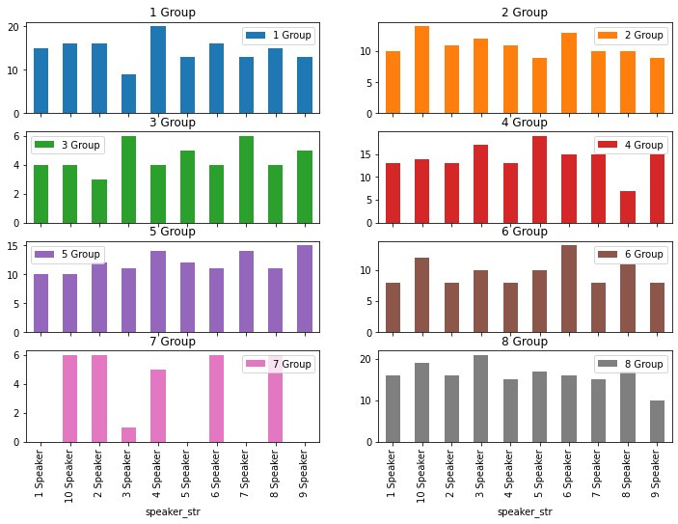

Figure 2. Duration boxplot grouped by groups of reduced vowels.

These groups belong to one type of position for vowel analysis: post-stressed reduced vowels of open syllables. For this reason, I decided to ignore grouping by non-palatalised and palatal/palatalised consonants for better statistical model performance. Thus, in the final model, I analyzed only four groups (Table 2).

|  |  |  |
| --- | --- | --- |
| group number | position | syllable type (open/close) |
| 1 | pre-stressed reduced vowels | - |
| 2 | post-stressed reduced vowels | closed syllables |
| 3 | post-stressed reduced vowels | open syllables |
| 4 | post-stressed reduced vowels | open syllables before pause |

Table 2. ‘New’ groups of reduced vowels for analysis.

The boxplots (Figure 3) illustrate distribution of reduced vowel duration between four groups for the analysis. The abscissa axis presents different groups of reduced vowels (from left to right: post-stressed reduced vowels of closed syllables; post-stressed reduced vowels of open syllables; post-stressed reduced vowels of open syllables before pause; pre-stressed reduced vowels), and the ordinate axis displays the data boxplot for each group. The top graph reflects the reduced vowel continuation data of each group for reading condition; the bottom graph contains the same information for the condition of spontaneous speech. Both diagrams emphasize that the duration of the analyzed sounds is different in each group. This means that the factor will be taken into account when compiling the final model. The differences of boxplot for each group signify different model impacts.

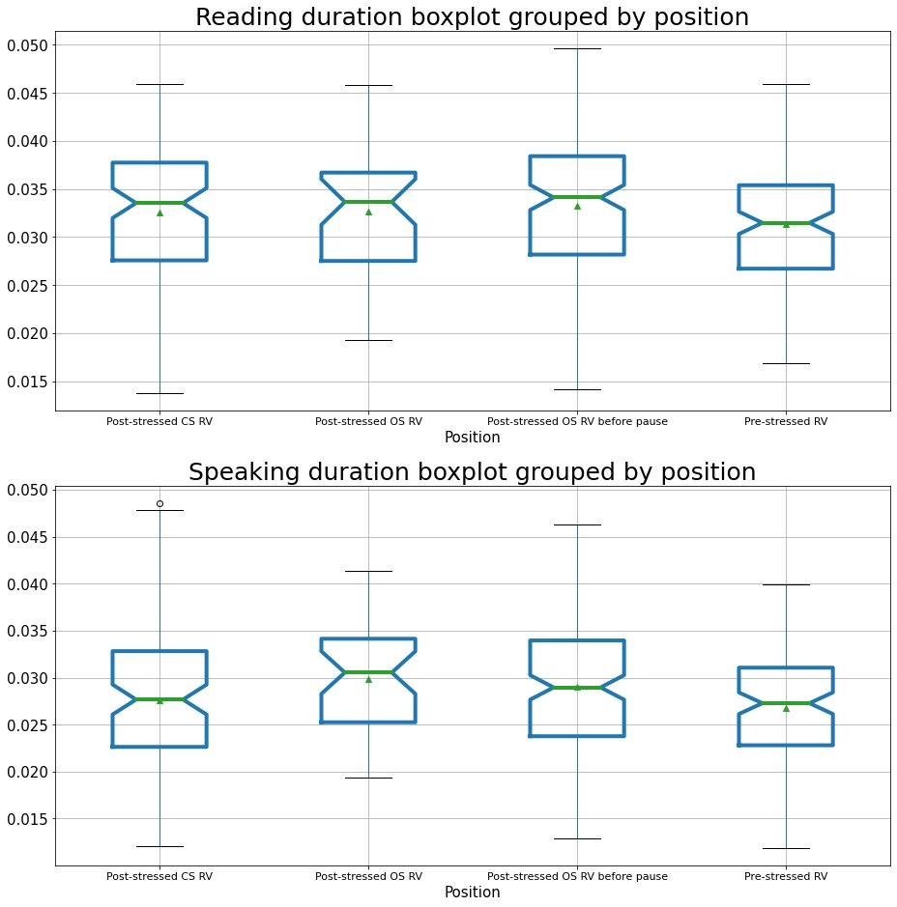

Figure 3. Speaking duration of reduced vowel grouped by position.

The barplot (Figure 4) manifests the mean vowel duration difference by condition (reading either speaking) for each participant of the experiment. The abscissa axis demonstrates information on each speaker for each condition (the left bar in each group displays duration for reading condition; the right one emphasizes duration for speaking condition), and the ordinate axis presents the mean duration of all reduced vowels in seconds. The graph expresses in general some speakers pronounce reduced vowels faster (for example, speaker 6) or slower (for example, speaker 4), nevertheless, the results for all participants are approximately equal; indeed, reduced vowels shortens better when reading than when speaking spontaneously. The proportional difference in duration is also the same. Of all the speakers, the most striking and noticeable difference is for speaker 1, which is associated with the individual characteristics of the participants’ speaking.

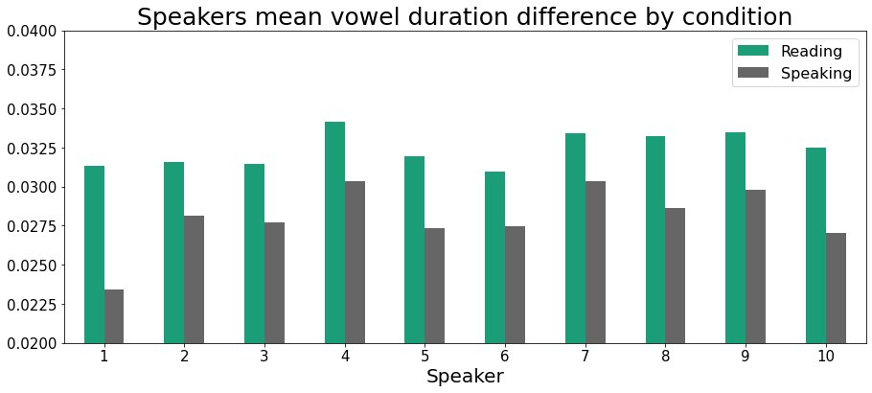

Figure 4. Duration boxplot grouped by groups of reduced vowels.

#### Data Modeling

The figures (Figure 3; Figure 4) make it obvious that the vowels in the two experimental conditions are strikingly different. The statistical model was built to determine how much the duration in speaking is shortened compared to reading condition and whether this decrease is statistically significant.

For the statistical analysis I chose mixed-effect models with random intercept and random slope. In the selected method effects (or factors) affecting the dependent variable can be conditionally divided into two types: fixed and random. Random effects are those effects that randomly vary in the study and do not reflect all possible values of the factor in the general population. Fixed effects typically are those independent variables which levels one can set and control (Chetverikov 2015) but present model has both intercept and slope as random parameters.

Mixed-effect models offer many advantages over the classical linear model (Baayen 2012). Firstly, the classical linear model provides predictions for the subjects and items selected in the data, but mixed-effect models make predictions for “unknown speakers” by multiple interactions of speakers and items under analysis. Secondly, the mixed effects model allows one to make predictions for replication studies with the same subjects or items more precise. Finally, mixed-effect models are better able to detect significant effects without increasing the number of Type I error rates which erroneously rejects the correct hypothesis.

Due to a set of various factors that are not controlled in the experiment (for instance, the influence of neighboring sounds on pronunciation, the peculiar properties of articulation of each speaker, the comfortable tempo in which the speaker are usually talking and others), it allows to assume that each person is strongly influenced by the parameter of speaking condition after reading the text. The total duration is different in relation to the speaker.

The following formula represents dependence of duration on factors:

$$Duration ̴ 1 + Condition + Position + (1+Condition | Speaker)$$

The formula means that reduced vowel duration depends on constant value; experimental condition (reading or speaking) and position of the sound in relation to the stressed vowel (three groups for analysis), also, there are random effects for each statistical unit that implies constant and condition factors could be different for each speaker. In other words, the experimental condition and position of the sounds (pre-stressed sounds; post-stressed sounds in the middle of the words; post-stressed sounds in the end of the words) influence the duration of each sound differently and it is mandatory to take this into account in the model.

The subsequent formula presents much stricter mathematical expression:

$$Y_{i} = C_{} + c_{i}+ (α + a_{i})⋅ X + β ⋅Z + ε$$

$$ε∼N(0, σ^{2})$$

$$a_{i}∼N(0, {σ_{1}}^{2})$$

$$c_{i}∼N(0, {σ_{2}}^{2_{}})$$

in which:

* i is an index number of the probationers;
* Yi is the duration of the pronunciation of the vowel by the speaker number i,
* C is a fixed intercept;
* ci is a random intercept;
* $α$ is a fixed slope of factor X which means belonging to a Condition parameter;
* ai random slope of factor X;
* β is a fixed slope of factor Z which means belonging to a Position parameter,
* ε is a model error.

With package Statsmodels (Seabold, Perktold 2010) in Python 3 (Van Rossum, Drake 2009) the model was conducted. The figure (Figure 5) demonstrates the output of the model. The coefficient (p-value = 0.068 > 0.05) in the group of post-stressed reduced vowels of closed syllables is not statistically significant at the confidence level of 5%.

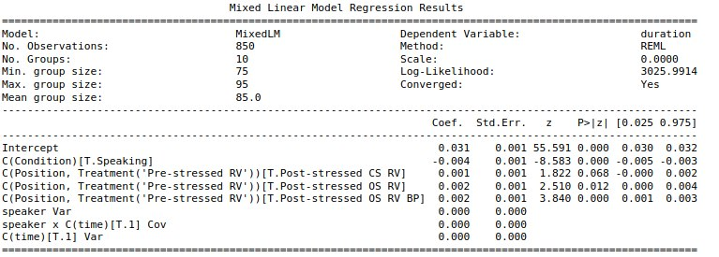

Figure 5. The model for 4 groups of reduced vowels.

The data from the group seems to be similar to groups of pre-stressed vowels and to post-stressed reduced vowels of open syllables. For compiling the final model the group of post-stressed reduced vowels of closed syllable is included into post-stressed reduced vowels of open syllable due to position of analysed sounds in the word.

The table (Figure 6) illustrated the output of the final model. The column P>|z| emphasizes that all coefficients are statistically significant (p-value < 0.05). Thus, according to the data, the research hypothesis is true and there is statistically significant difference between duration of reduced vowels in reading and spontaneous speech.

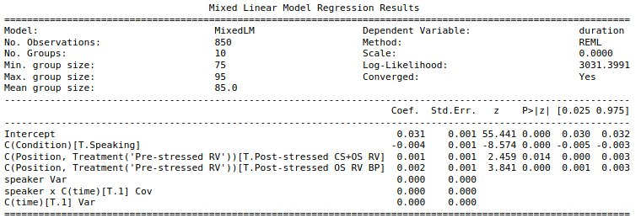

Figure 6. The model for 3 groups of reduced vowels.

The graph (Figure 7) produces information about the speaker’s influence on the output of the model. The colored bars emphasize the degree of influence of each speaker on the model; the abscissa axis provides information on each speaker separately, and the ordinate axis shows time in seconds. The histograms emphasize that for both experimental conditions, speaker 1 has the greatest influence on the model; the smallest is speaker 2.

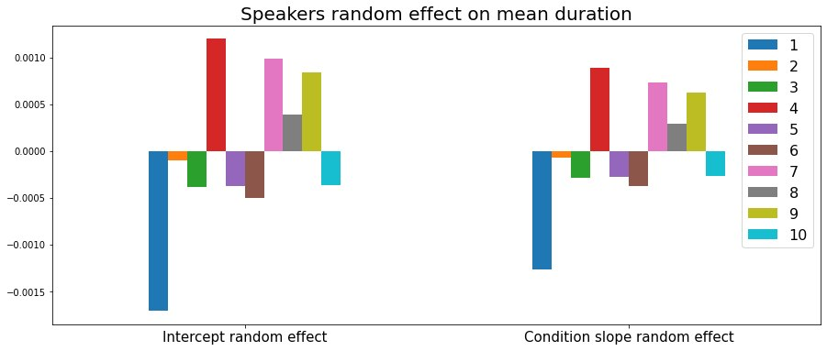

Figure 7. The speaker’s influence on the output of the model.

The graph (Figure 8) signifies model coefficients: the average duration of pre-stressed reduced vowels in reading condition is approximately 0.0311 seconds (I will use the termin base duration of the model). When reading a reduced vowel in the middle of a word, the duration increases roughly by 0.0014 seconds; reading a reduced vowel in the end of a word, the duration increases by 0.0021 seconds. The mean duration of reduced vowels for speaking condition decreases by 0.0043 seconds.



Figure 8. Model coefficients.

The table (Figure 9) produces information about model 95% confidence interval for coefficients. The second row indicates that the true effect of mean vowel duration reduction at 95% confidence level lies between 0.0034 seconds and 0.0054 seconds when re-adding text. By way of explanation, the constructed model based on the impact of experimental condition and reduced vowel position (pre-stressed; post-stress in the middle/end of the word) predicts the interval from 0.0034 seconds to 0.0054 seconds for re-adding text. The model has coefficients for each condition and position of reduced sound in the word as well. This is the finding result of my paper.

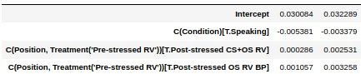

Figure 9. Model 95% confidence interval for coefficients.

### Results

As is stated in the earlier sections, the purpose of this research was to determine if there is a statistical difference between durations of reduced vowels in speaking and reading condition. The subject was reduced vowels in real life speech and while reading. The present study is the pilot study in the field and suggests preliminary results. To obtain more accurate results, a larger amount of data is required for analysis, as well as for comparing not only groups of words, but also specific words with the analyzed sounds in pairs.

The main research question of the present study concerns the implementation features of phonetic processes in reading aloud. The hypothesis was that reduced vowels when read aloud differ from reduced vowels in spontaneous speech. This hypothesis was confirmed; the reduced vowels’ duration is significantly different under experimental conditions. According to the data, a feature of the implementation of such sounds when reading aloud is an increase in the duration in relation of spontaneous speech.

The findings were obtained by the mixed-effect model with random intercept and random slope. I reduced eight groups that were originally allocated for analysis to four, and when analyzing the data, I considered groups of reduced vowels depending on their position in relation to the stressed vowel sound (Table 2).

In the constructed model experimental condition and position of the sound were the factors that contributed to the model. In addition, the condition effect could be different for each probationer.

One (post-stressed reduced vowels of open syllables) out four groups presented statistically insignificant differences from the other two groups (pre-stressed reduced vowels and post-stressed reduced vowels of closed syllables). To solve this problem, it was decided to analyze three groups of vowels: pre-stressed vowels; post-stressed vowels of closed and open syllables (in the middle of the word) and post-stressed ones before a pause. The model displayed the statistically significant difference for all of the coefficients. One can interpret this finding as the fact that for each group of reduced vowels under consideration, it is true that the duration of the reduced vowels is different when reading and speaking. A feature of the reduced vowels in reading aloud condition can be considered the lengthening of the duration in comparison with the reduced vowels of spontaneous speech.

Based on these results, one can assume that the mean duration of reduced vowels in reading aloud would always be longer than the mean duration of the same set of vowels in reading.

### Conclusions and implications

To the best of my knowledge, the current paper is the first one to explore vowel reduction in the way of comparing the same set of words from one speaker. The assumption was that reduced vowels in the reading condition are significantly different from the reduced vowels in speaking condition. The hypothesis was confirmed; according to the collected data, reduced vowels differ in terms of experimental condition. Moreover, for all of the highlighted groups indicate that in reading condition analysed sound duration is longer in comparison with spontaneous speech condition.

The present research implies gender does not affect the overall difference in vowel reduction. Using statistical model constructing, it was determined that the average length of contracted vowels varied significantly depending on the experimental conditions. In addition, it is true for all selected groups of reduced vowels (pre-stressed; post-stressed in the middle of the word; post-stressed before pause) that the duration of abbreviated speech is longer in reading than in spontaneous speech.

The experiment was conducted on the material of Russian language, and it is possible to inspect the effect of vowel reduction depending on the position in relation to the stressed vowel on the other languages' material. One can study the influence of various factors as, for instance, age, pace of speech, words frequency, semantic predictability, neighbourhood density and others (Clopper et al. 2018), on the effect of the sound reduction in spontaneous speech. Furthermore, the results can be taken into account in the following studies by collecting additional data and analyzing differences not only by group, but also by specific words in different experimental conditions. This will help clarify and confirm the results of the experiment.

The results have both practical and scientific applications. It can help improve existing speech recognition systems for online education systems, such as monitoring during an oral presentation to avoid reading instead of speaking.

### Acknowledgments

I cannot express enough thanks to all of the participants of the experiment for reading stimulus text and permission to use the results for research. I am also extremely grateful to Inna Sieber for the fact that at the last moment she agreed to supervise this work and did not leave me completely alone with the scientific world and for the advice on this article as well.

My completion of this work could not be so accomplished without my relatives and close friends whose support and encouragement meant a lot to me. In addition, I want to thank every person who discussed the present study with me, expressed critical ideas and contributed in every way to improve the paper. My heartfelt thanks.

### References

Baayen, R. H. (2012). Mixed-effects models. *The Oxford handbook of laboratory phonology*, 668-677.

Barnes, J. (2007). Phonetics and phonology in Russian unstressed vowel reduction: A study in hyperarticulation. *Ms., Boston University*.

Barry, W. J., & Andreeva, B. (2001). Cross-language similarities and differences in spontaneous speech patterns. *Journal of the International Phonetic Association*, 51-66.

Benigni, V., & Masini, F. (2010, May). Phrasal lexemes and reduction strategies in Russian. In *Poster presented at the 14th International Morphology Meeting. Budapest* (pp. 13-16).

Boersma, Paul & Weenink, David (2020). Praat: doing phonetics by computer [Computer program]. Version 6.1.26, retrieved 5 October 2020 from <http://www.praat.org/>

Brady, S. A., & Shankweiler, D. P. (Eds.). (2013). *Phonological processes in literacy: A tribute to Isabelle Y. Liberman*. Routledge.

Bryzgunova, E.A. (2007). Ideolect and supra-dialectal form of the Russian language.

Burzio, L. (2007). Phonology and phonetics of English stress and vowel reduction. *Language Sciences*, *29*(2-3), 154-176.

Chetverikov, A.A. (2015). Linear models with mixed effects in cognitive research. *Russian Journal of Cognitive Science, 2* (1), 41-51.

Clopper, C. G., Turnbull, R., Cangemi, F., Clayards, M., Niebuhr, O., Schuppler, B., & Zellers, M. (2018). Exploring variation in phonetic reduction: Linguistic, social, and cognitive factors. *Rethinking reduction*, 25-72.

Crosswhite, K. (2004). Vowel reduction. *Phonetically based phonology*, 191-231.

Crosswhite, K. M. (2000). Vowel reduction in Russian: a unified account of standard, dialectal, and “dissimilative” patterns. *University of Rochester working papers in the language sciences*, *1*, 107-172.

Cubberley, P. (2002). *Russian: A linguistic introduction*. Cambridge University Press.

Danilov D. (2018) "Witness's testimonies" // Journal "http://www.nm1925.ru" (http://www.nm1925.ru/Archive/Journal6_2018_7/Content/Publication6_6956/Default.aspx). Viewed: 04/04/2020.

Flemming, E. (2005). A phonetically-based model of phonological vowel reduction. *Manuscript. Cambridge: MIT*.

Gahl, S., Yao, Y., & Johnson, K. (2012). Why reduce? Phonological neighborhood density and phonetic reduction in spontaneous speech. *Journal of memory and language*, *66*(4), 789-806.

Gries, S. T. (2013). *Statistics for Linguistics with R: A Practical Introduction*. Walter de Gruyter.

Hunter, J. D. (2007). Matplotlib: A 2D graphics environment. *Computing in Science &amp; Engineering*, *9*(3), 90–95.

i. (2019). *Contribute to astafyevai/Vowel-reduction development by creating an account on GitHub*. Retrieved from https://github.com/astafyevai/vowel-reduction (Original work published 2020)

Iosad, P. (2012). Vowel reduction in Russian: No phonetics in phonology. *Journal of Linguistics*, *48*(3), 521-571.

Kamen, R. S., & Watson, B. C. (1991). Effects of long-term tracheostomy on spectral characteristics of vowel production. *Journal of Speech, Language, and Hearing Research*, *34*(5), 1057-1065.

Knyazev, S.V., & Pozharitskaya, S.K. (2005). *Modern Russian literary language: phonetics, graphics, spelling, orthoepy*. Academic project.

Kohler, K. J. (1990). Segmental reduction in connected speech in German: Phonological facts and phonetic explanations. In *Speech production and speech modelling* (pp. 69-92). Springer, Dordrecht.

Kohler, K. J. (1996). Articulatory reduction in German spontaneous speech. In *1st ETRW on Speech Production Modeling: From Control Strategies to Acoustics; 4th Speech Production Seminar: Models and Data*.

Kouznetsov, V. B. (2002). Spectral Dynamics and Classification of Russian Vowels. *Acoustical physics*, *48*(6).

Kuo, C., & Weismer, G. (2016). Vowel reduction across tasks for male speakers of American English. *The Journal of the Acoustical Society of America*, *140*(1), 369-383.

Lahey, M., & Ernestus, M. (2014). Pronunciation variation in infant-directed speech: Phonetic reduction of two highly frequent words. *Language Learning and Development*, *10*(4), 308-327.

Lyakso, E. E., Frolova, O. V., & Grigoriev, A. S. (2009). The acoustic characteristics of russian vowels in children of 6 and 7 years of age. In *Tenth Annual Conference of the International Speech Communication Association*.

Lyashevskaya, O., & Sharov, S. (2009). Frequency dictionary of modern Russian language (on materials of the Russian national corpus).

McKinney, W., & others. (2010). Data structures for statistical computing in python. In *Proceedings of the 9th Python in Science Conference* (Vol. 445, pp. 51–56).

Padgett, J., & Tabain, M. (2005). Adaptive dispersion theory and phonological vowel reduction in Russian. *Phonetica*,*62*(1), 14-54.

Savinov, D.M. (2013). *Evolution of vocalism systems in southern Russian dialects. Institut russkogo i︠a︡zyka im*. VV Vinogradova RAN.

Scheibman, J. (2000). I dunno: A usage-based account of the phonological reduction of don't in American English conversation. *Journal of pragmatics*, *32*(1), 105-124.

Seabold, S., & Perktold, J. (2010). statsmodels: Econometric and statistical modeling with python. In *9th Python in Science Conference*.

Son, R. V., Bolotova, O., Pols, L. C., & Lennes, M. (2004). Frequency effects on vowel reduction in three typologically different languages (Dutch, Finish, Russian). In *Eighth International Conference on Spoken Language Processing*.

Tyrone, M. E., & Mauk, C. E. (2010). Sign lowering and phonetic reduction in American Sign Language. *Journal of Phonetics*, *38*(2), 317-328.

Van Rossum, G., & Drake, F. L. (2009). *Python 3 Reference Manual*. Scotts Valley, CA: CreateSpace.

### Appendices

1. The text.

Ч1: Это из двести пятнадцатой? Знаю, конечно. Разбился?! Да вы что?! Такой вежливый всегда, улыбается... Да, конечно. Обязательно позвоню, если что.

Ч2: А, этот... соседушка мой. Да он мутный какой-то был. Да нет, не общались, не дружили. Да, хорошо. Если что, позвоню.

Ч1: Да вы что?! Ужас какой. Нет, не знала. Кошмар вообще. Ну надо же.

Ч2: Да, это наш прихожанин. Ходит к нам в церковь. У меня исповедуется регулярно. Что? Царствие Небесное. Суицид? Да... новость вы мне принесли. Ну давайте, задавайте, что делать.

Ч1: Не припоминаю что-то. Как, вы сказали? А, да. Ну, помню, смутно. Да мы встречались один раз, вроде бы, если я не путаю. Нет, не помню.

Ч2: Да, одноклассник мой. Правда, что ли? Ну, вообще! Во как. Жалко. Надо же.

Ч1: Совсем не помню его. Ничего не могу о нем сказать.

Ч2: Я его очень смутно помню. Да, был парень такой. Ничего не могу о нем сказать.

Ч1: Я ничего не могу о нем сказать.

Ч2: Я ничего не могу о нем сказать.

Ч1: Я ничего не могу о нем сказать.

1. IPA transcription (Cubberley 2002).