Amanda Travitzky

GEOG678

Lab2 task 2

<https://tamu.maps.arcgis.com/apps/mapviewer/index.html?webmap=a309d089ff87466f9ba1958dca9bd9de>

<https://tamu.maps.arcgis.com/home/item.html?id=a309d089ff87466f9ba1958dca9bd9de>

<https://services1.arcgis.com/qr14biwnHA6Vis6l/arcgis/rest/services/Parks_Amnada_Travitzky/FeatureServer>

link from the app on my phone showing that it can be shared:

[https://fieldmaps.arcgis.app?referenceContext=center&itemID=a309d089ff87466f9ba1958dca9bd9de&center=-22.161648845498377,-49.97867555315613&scale=593.4298698294549](https://urldefense.com/v3/__https:/fieldmaps.arcgis.app?referenceContext=center&itemID=a309d089ff87466f9ba1958dca9bd9de&center=-22.161648845498377,-49.97867555315613&scale=593.4298698294549__;!!KwNVnqRv!EaDpW6K95XXm-yxHTW7tKJ_bjovtYg9T9TrJSmmutSwPbJCbbWG4U8GFYwbGOSlI0b0GRfjBSouczzW_qDaioklBUg$)

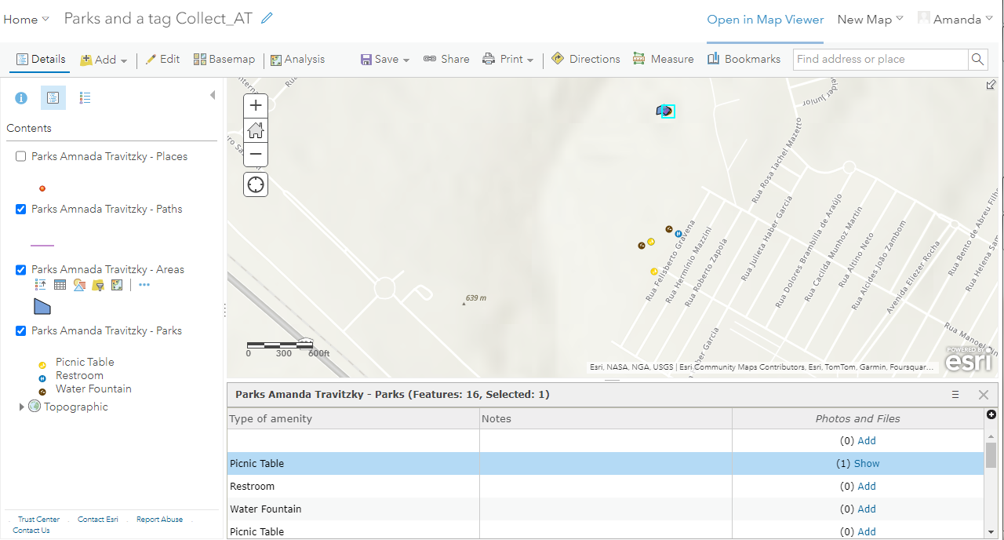

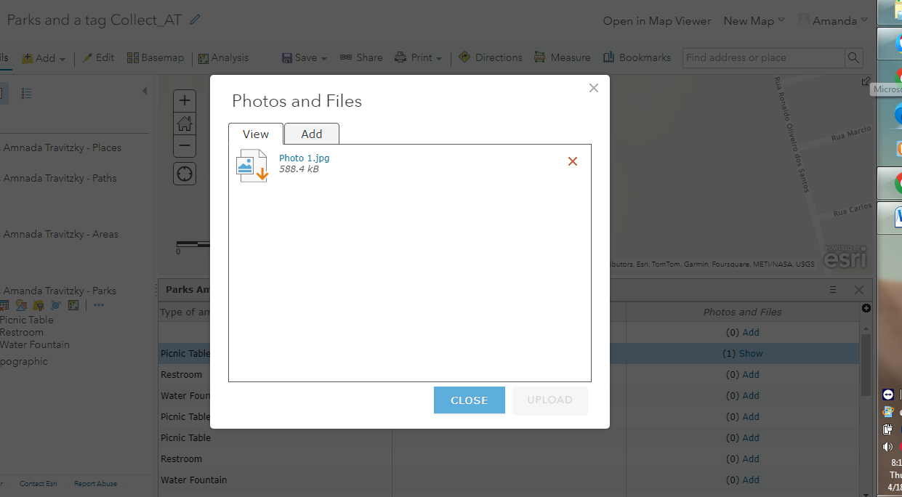

The above picture shows that I was able to take a photo and attach it using the app on my phone

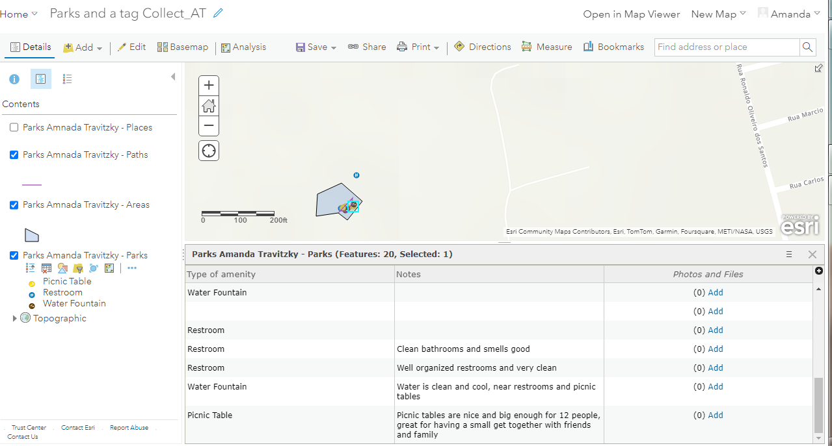

This photo shows that I was able to create a note in the app on my phone

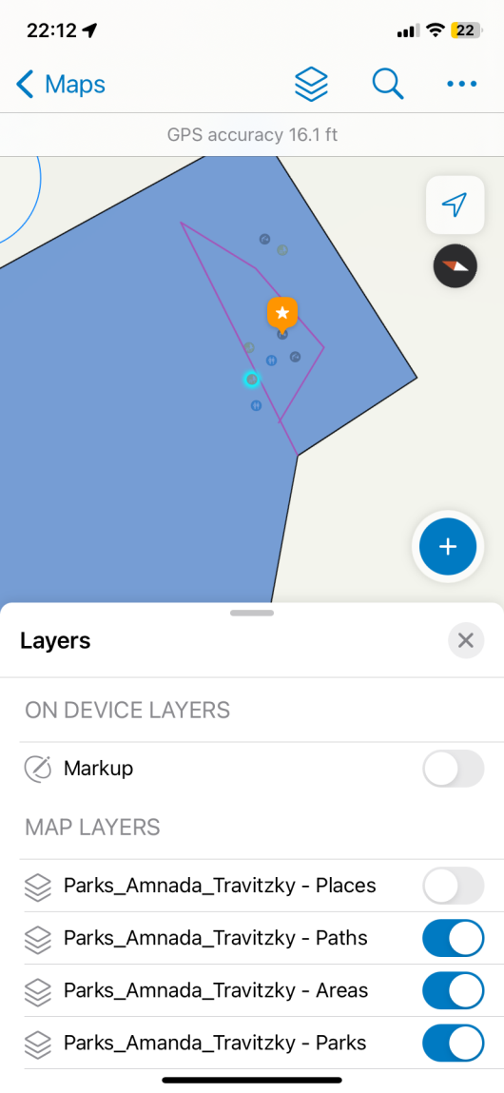

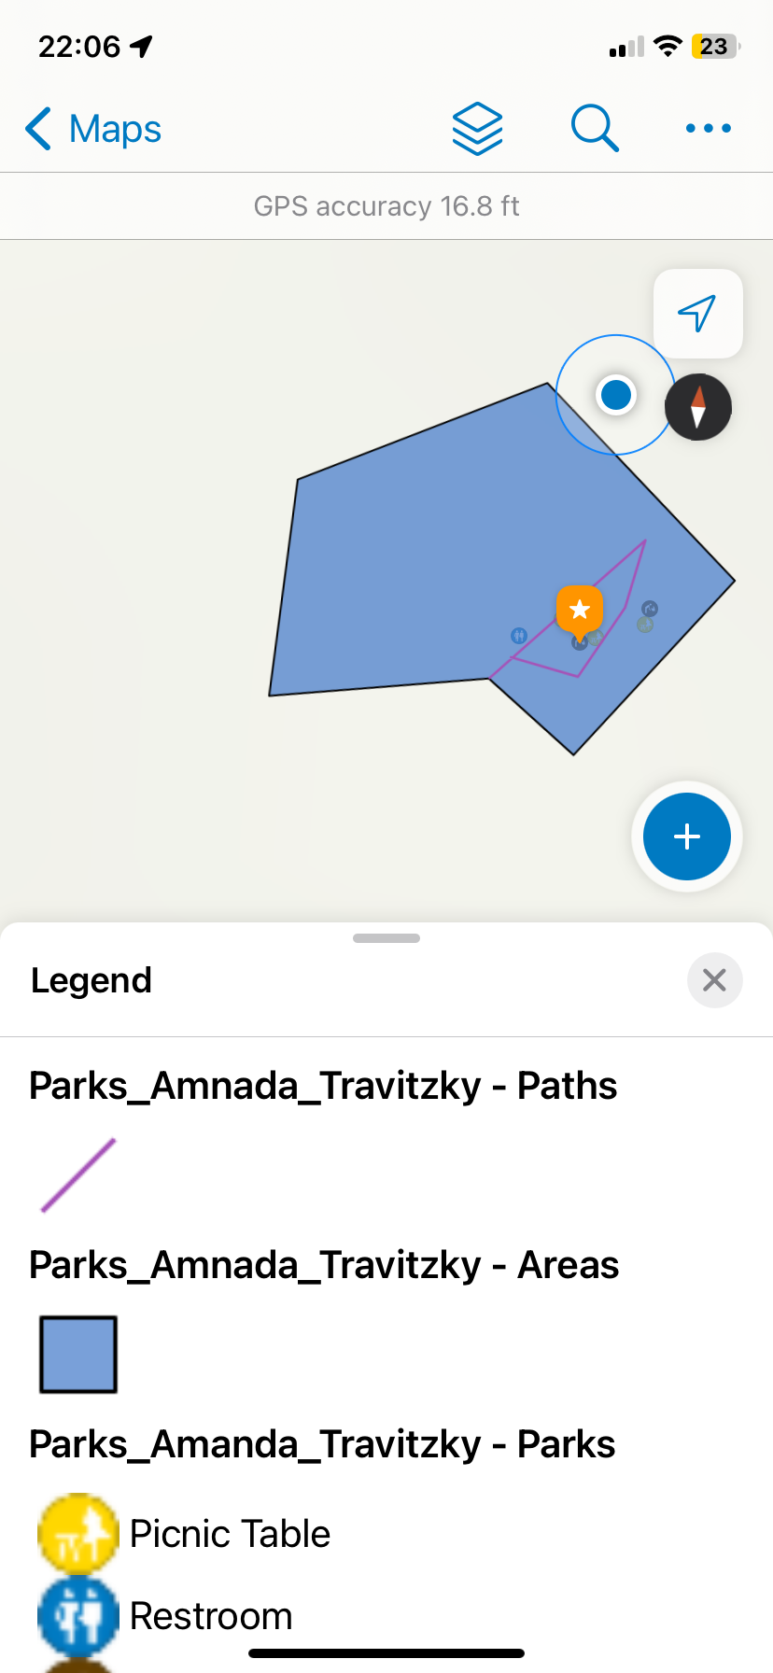

here are 2 screenshots of the map on my phone