

|  |  |  |  |  |
| --- | --- | --- | --- | --- |
| Pusat Niaga Duta Mas  Blok C1 no.02-03 Jl. RS Fatmawati no.39 Jakarta Selatan 12150 |  | p. 021 72796016  f. 021 72790155 |  | info@upcrenewables.co.id  www.upcrenewables.com |

**UPC WebGIS**

Installation Manual

Step by step installation manual for maintenance and day to day support

Contents

1. Foreword 2

Objectives 2

1. Installations Steps 2

Install the database 2

Install the ODBC in client PC 3

Configure ODBC 4

Connecting Excel to PostgreSQL 6

Accessing Website 6

# Foreword

In order to running WebGIS sytems, we need to install it first into the server. As we know that the requirements to run this systems are Server installations and also client installations. This documents also explain how to configuring excel data entry features to support the WebGIS.

## Objectives

This documents is created for user to installing and configuring UPC Web GIS Data Management Excel.

# Installations Steps

## Install the database

We need to install the PostgreSQL database on the server. For the client we just need the ODBC to connect to the database. Here are the steps to installing database:

1. Locate the installation files.
2. Double click on the postgresql-9.4.5-2-windows-x64.exe and the next to install the database.

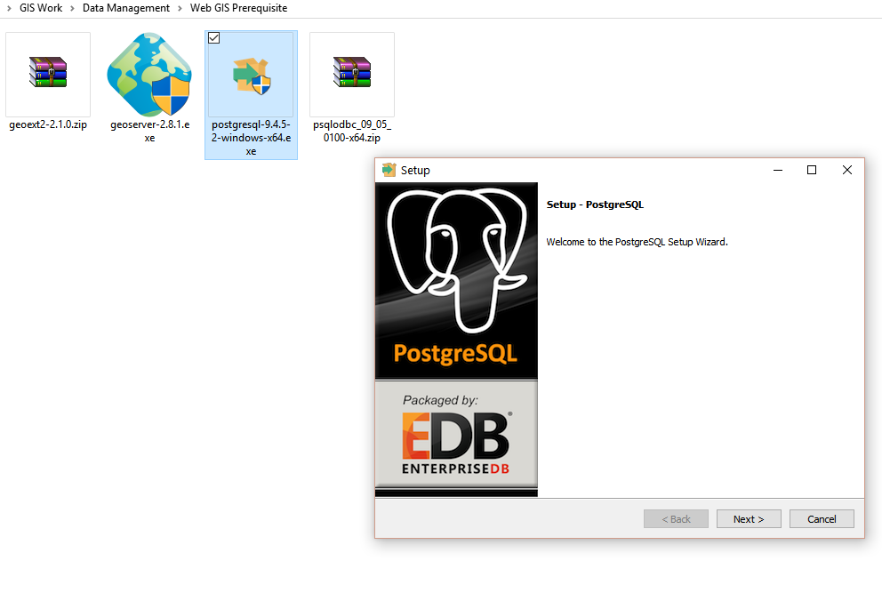

## Install the ODBC in client PC

In order to make a connection to a database server, we need an ODBC driver for specific database in the server. For this instance we will use the postgreSQL database connector to install in the client PC. Here are the steps to install ODBC:

1. On the Start Menu, navigate to All Apps > PostgreSQL 9.4 > Application Stack Builder

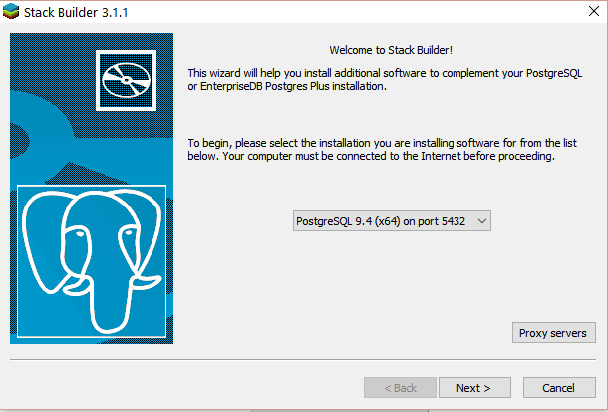

1. And then click next to continue picking the specific ODBC driver for PostgreSQL

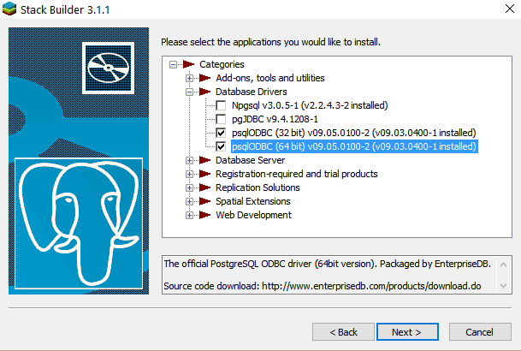

1. Choose the psqlODBC with 32 and 64 bit driver and then click next to install those drivers

## Configure ODBC

After installing the ODBC drivers, it is time to configure those driver to connect to the PostgreSQL database server. Here is the steps:

Find the ODBC in the windows start menu

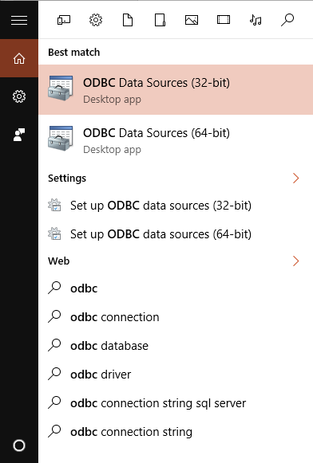

Click on the ODBC Data Sources (32-bit)

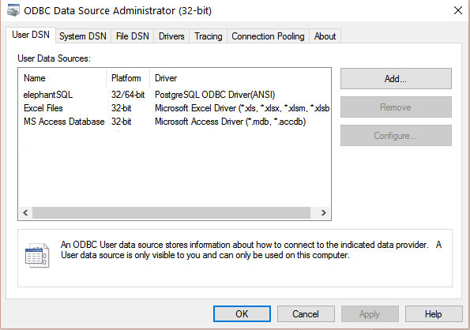

Click the “Add” button to add new ODBC connection

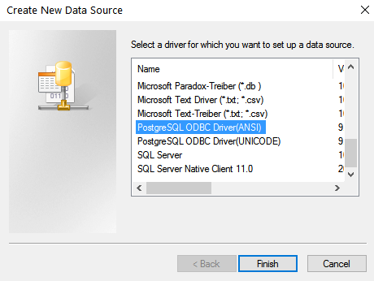

Select the “PostgreSQL ODBC Driver (ANSI)” and click on “Finish” button

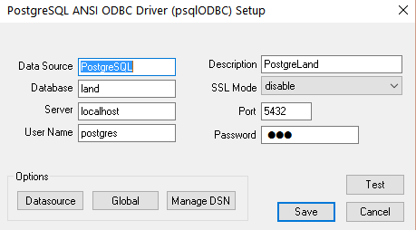

Fill the details above and click on the “Test” button to test the connections

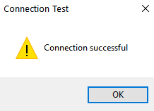

Click on “OK” and then “Save” to saving the ODBC connections.

## Connecting Excel to PostgreSQL

To connect into the PostgreSQL from Excel, there are settings in the Configurations sheets as below:

Activate the “Configurations” sheet by running the showConfigurations macro on module 1.

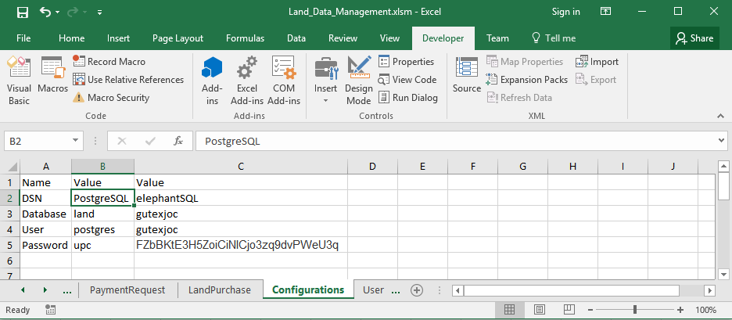

Fill the Data Source Name (DSN), Database, User and Password on the column B as in the PostgreSQL database server

## Accessing Website

To gain access in the website, first we need to register the user on the excel or in the database.

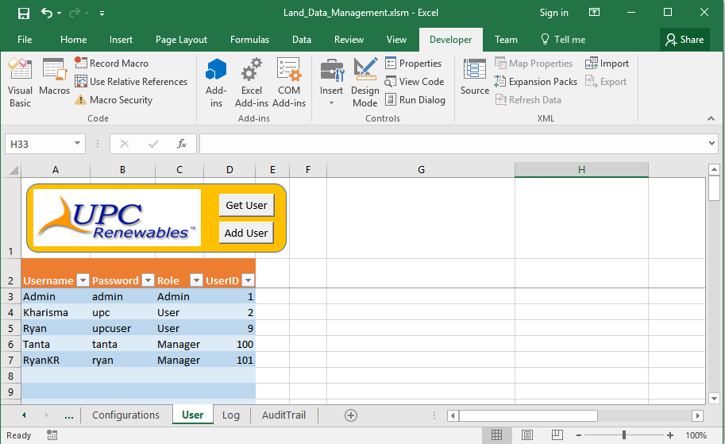

Please go to the url in a browser to access the website and login with the specified username and password.

url: <http://upc-geographic.rhcloud.com/>

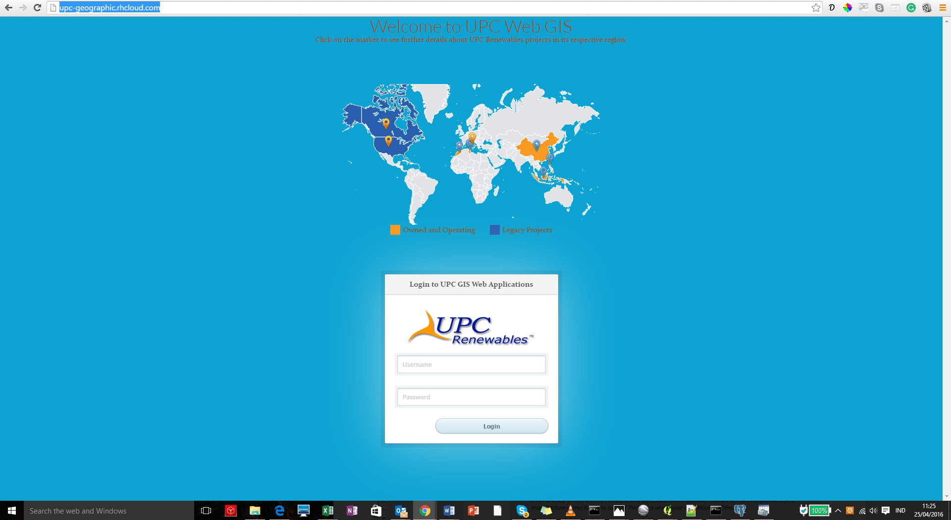

If the user is granted and login is success then the website will be redirect to the Web GIS page as below:

