

|  |  |  |  |  |
| --- | --- | --- | --- | --- |
| Pusat Niaga Duta Mas  Blok C1 no.02-03 Jl. RS Fatmawati no.39 Jakarta Selatan 12150 |  | p. 021 72796016  f. 021 72790155 |  | info@upcrenewables.co.id  www.upcrenewables.com |

**UPC Data Management**

User Manual

Step by step manual for using the systems

Contents

1. Foreword 2

Objectives 2

1. Data Entry 2

Login to the Excel 2

Manage PAP Data 4

Manage Parcel Data 8

Manage Payment Request Data 9

Manage Land Purchase Data 11

# Foreword

This documents is use as a guidelines to support the Excel Data Management.

## Objectives

This documents is created for user for using UPC Data Management Excel.

# Data Entry

## Login to the Excel

We need to login first in order to using the excel for data entry to database:

1. Locate the excel files.
2. Double click on Land_Data_Management.xlsm and login screen will appear.

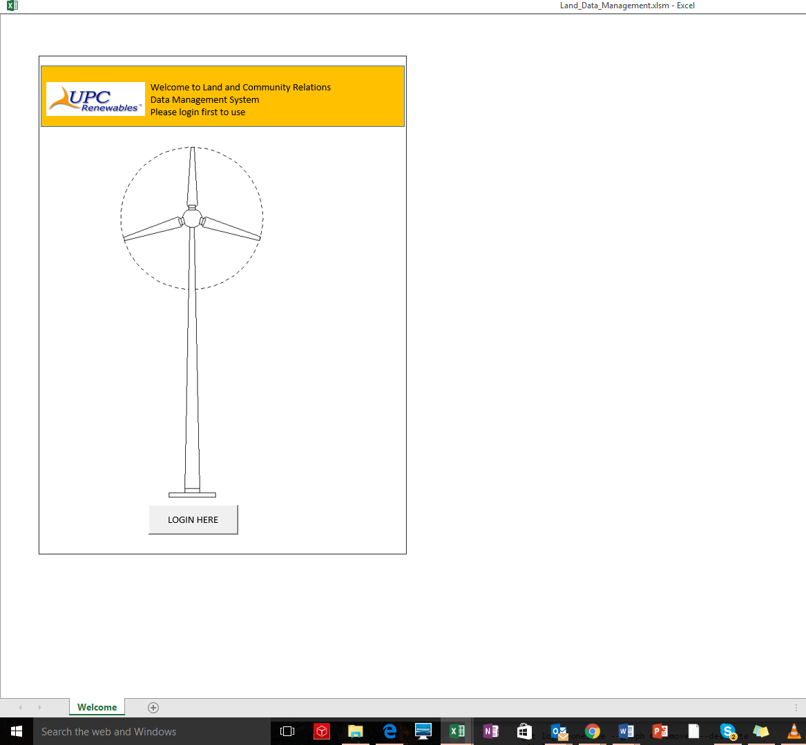

1. Click on the “LOGIN HERE” button to login to the excel sheet

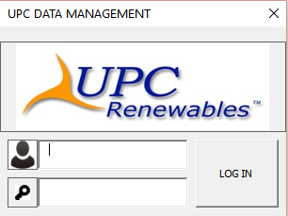

1. Type in the username and password and then click on the “LOG IN” button to login.

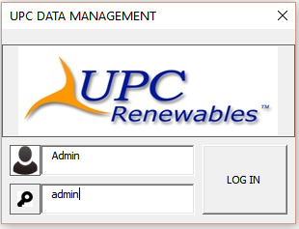

1. User successfully login.

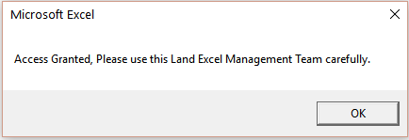

## Manage PAP Data

In order to manage a Parcel Affected Person (PAP) data, please follow the steps below:

1. Click on the “PAP” sheet and the sheet will appear as below

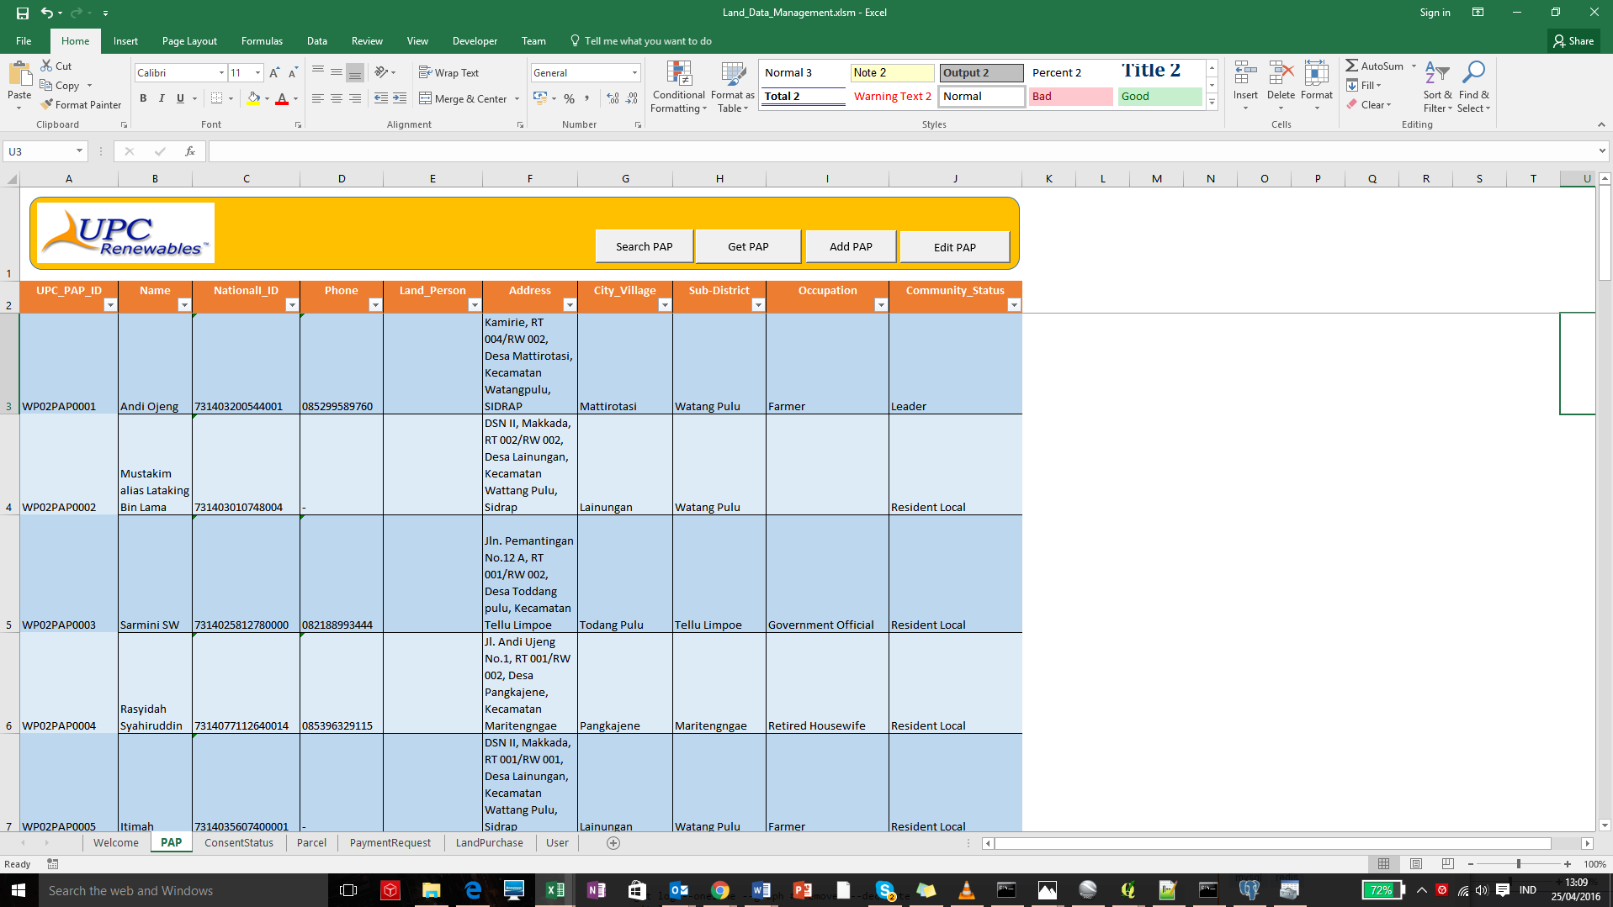

1. Search PAP Features
2. Click on the “Search PAP” button

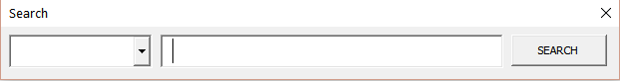

1. Click on the triangle button to see the field for search and also type the keyword for search

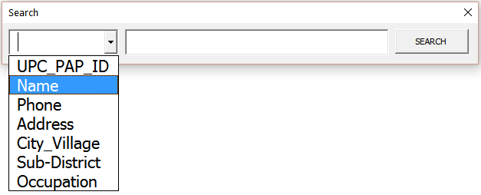

1. Pick the Name and type “Andi” for search name contains “Andi”

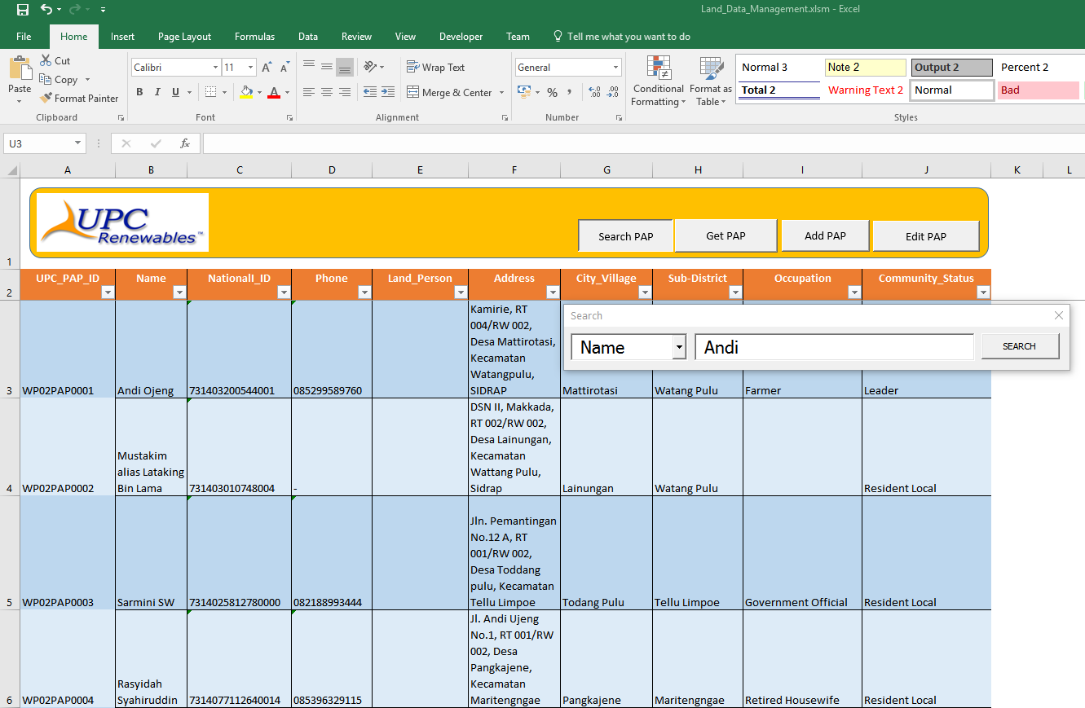

1. Click on the search button and the results will appear on the sheet

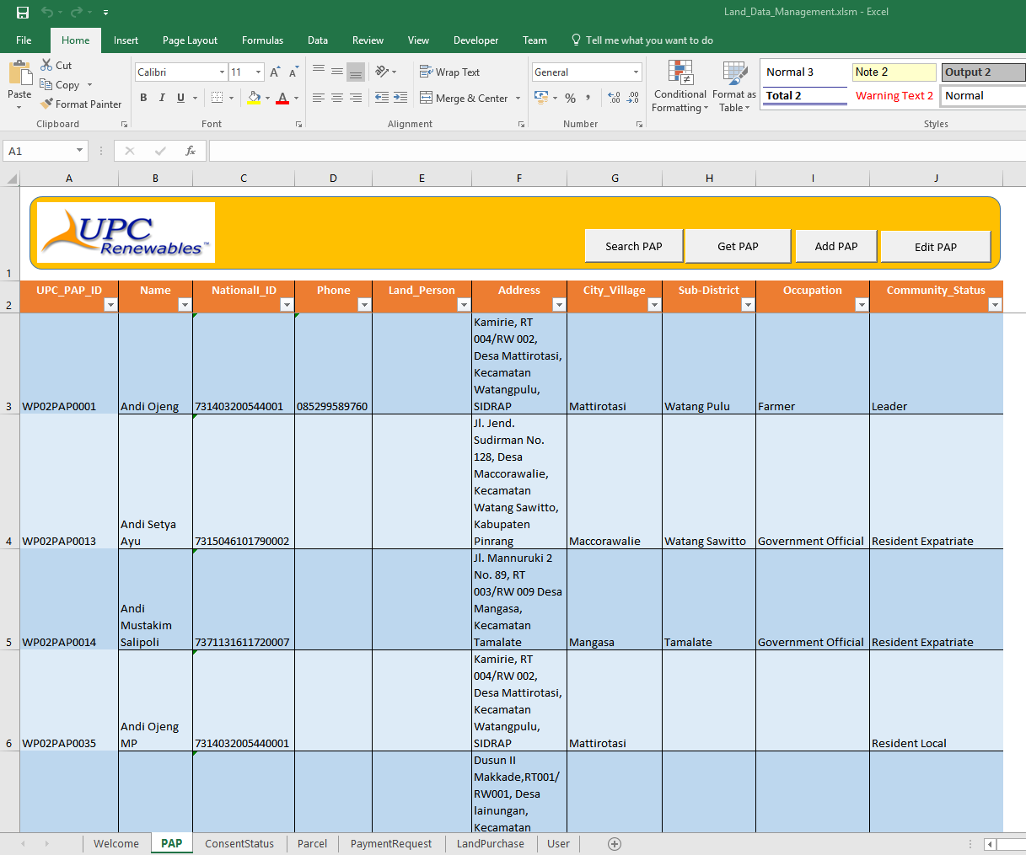

1. Get PAP Features
2. Get PAP Features is use to get all PAP data from database

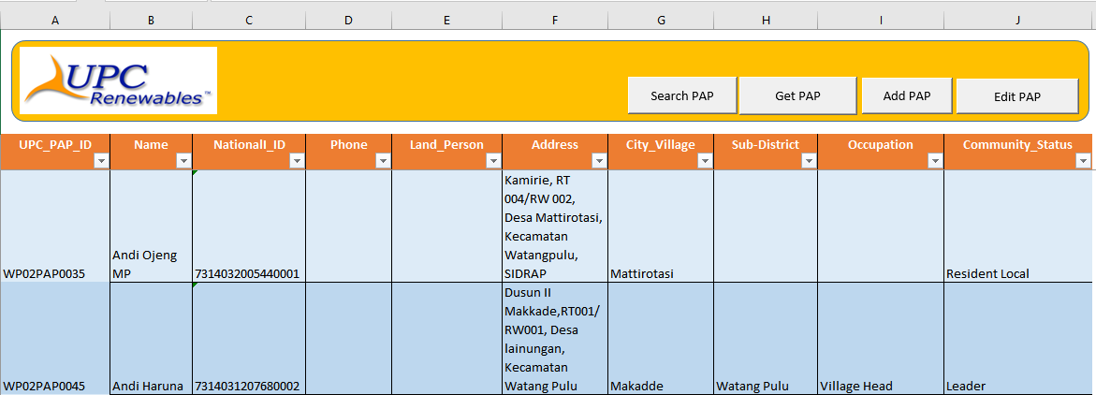

1. Click on the “Get PAP” button to get data and view the results on the active sheet

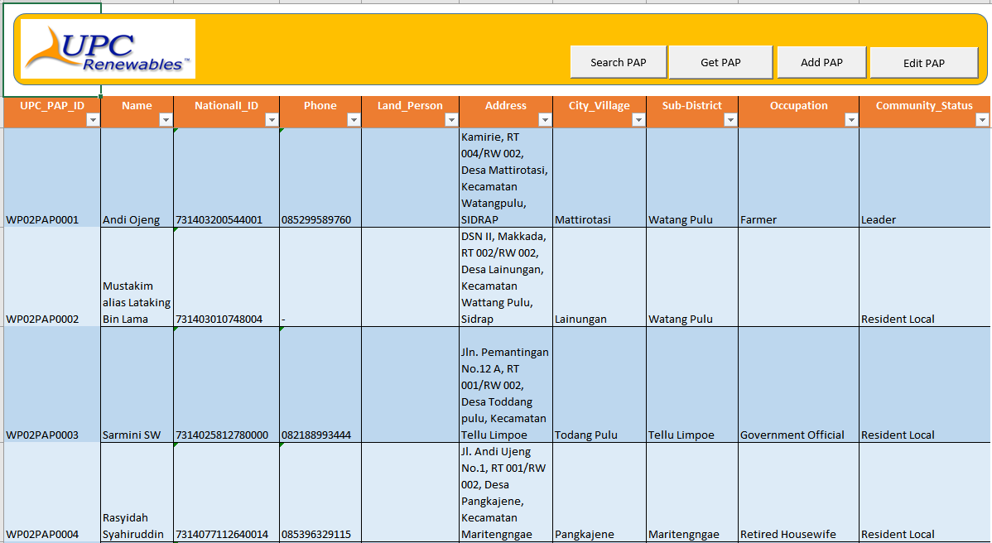

1. Add PAP Features

This Add features are used for adding one row of a PAP data with the “Add PAP” button clicked. Just add the details below and then click on “SAVE” button to save on database or “CANCEL” to cancel add PAP.

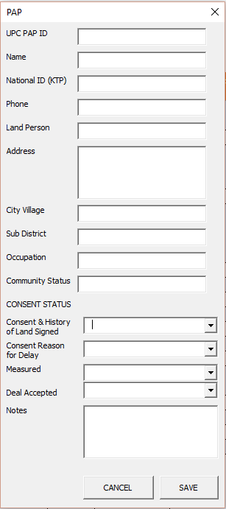

1. Edit PAP Features

This Edit features are used for editing one row of a PAP data with the “Edit PAP” button clicked and point to the first cell e.g A4 to update PAP data in the single row.

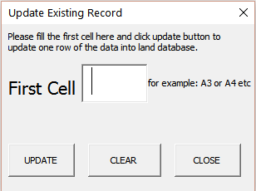

## Manage Parcel Data

In order to manage a Parcel data, please follow the steps below:

1. Click on the “Parcel” sheet and the sheet will appear as below

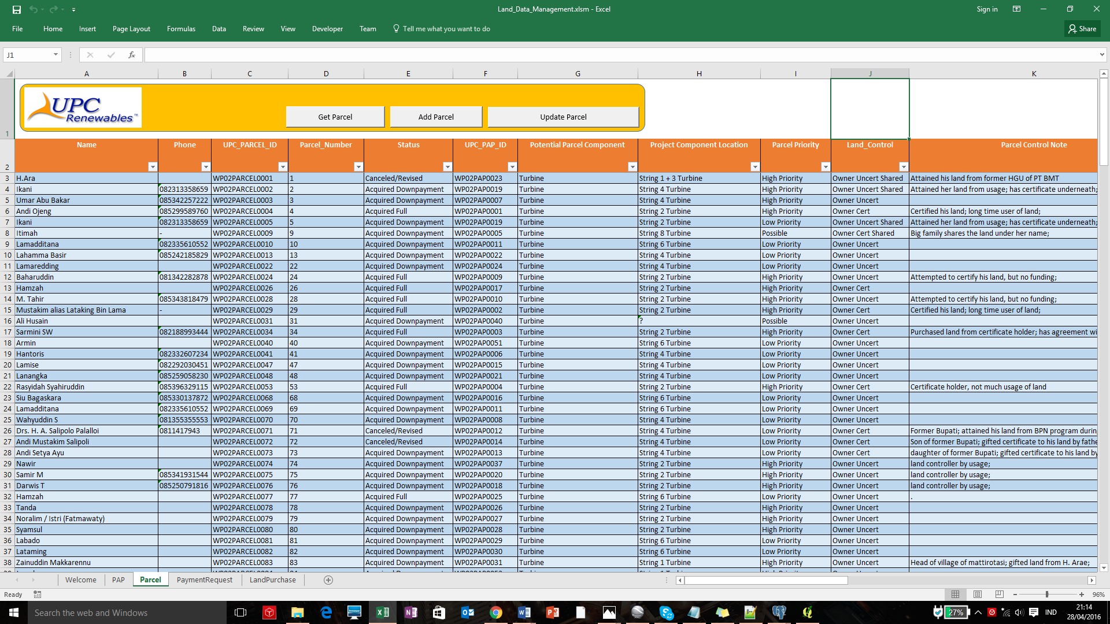

1. Get Parcel Features
2. Get Parcel Features is use to get all Parcel data from database
3. Click on the “Get Parcel” button to get data and view the results on the active sheet



1. Update Parcel Features

This Update features are used for editing one row of a Parcel data with the “Update Parcel” button clicked and point to the first cell e.g A4 to update Parcel data in the single row.



1. Add Parcel Features

This Add features are used for adding one row of a Parcel data with the “Add Parcel” button clicked. Just add the details below and then click on “SAVE” button to save on database or “CANCEL” to cancel add Parcel.

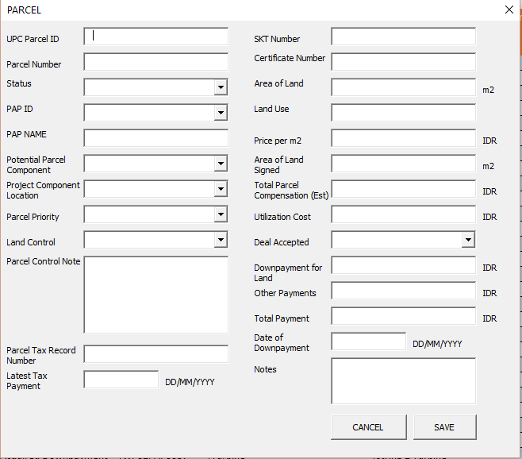

## Manage Payment Request Data

In order to manage a Payment Request data, please follow the steps below:

1. Click on the “PaymentRequest” sheet and the sheet will appear as below

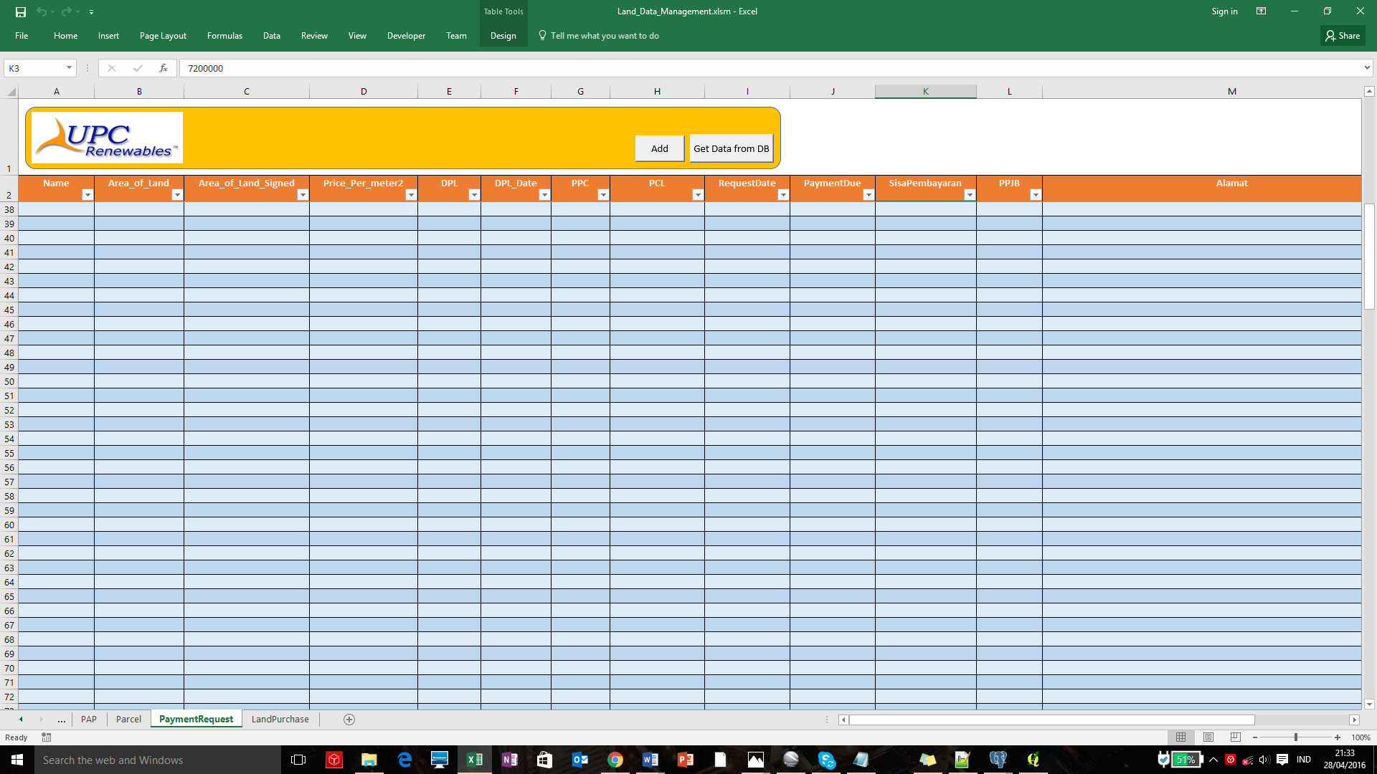

1. Get Payment Request Features
   1. Get Parcel Features is use to get all Payment Request data from database
   2. Click on the “Get Data from DB” button to get data and view the results on the active sheet

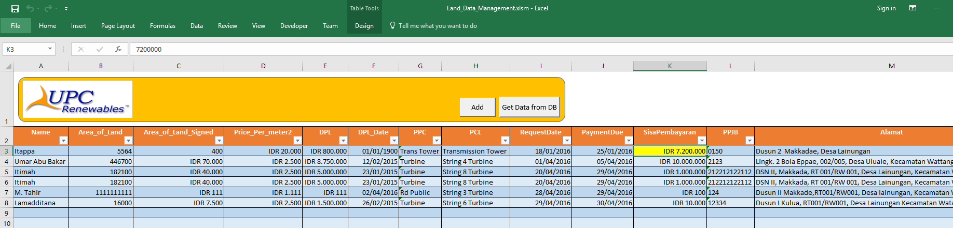

1. Add Payment Request Features

This Add features are used for adding one row of a Payment Request data with the “Add” button clicked. Just add the details below and then click on “SAVE” button to save on database or “CANCEL” to cancel add data.

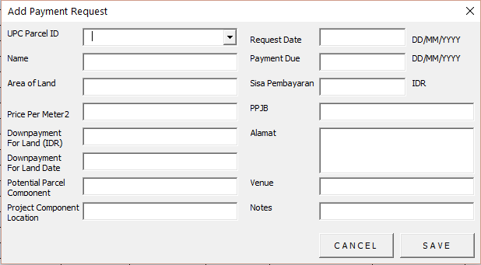

## Manage Land Purchase Data

In order to manage a Land Purchase data, please follow the steps below:

1. Click on the “LandPurchase” sheet and the sheet will appear as below

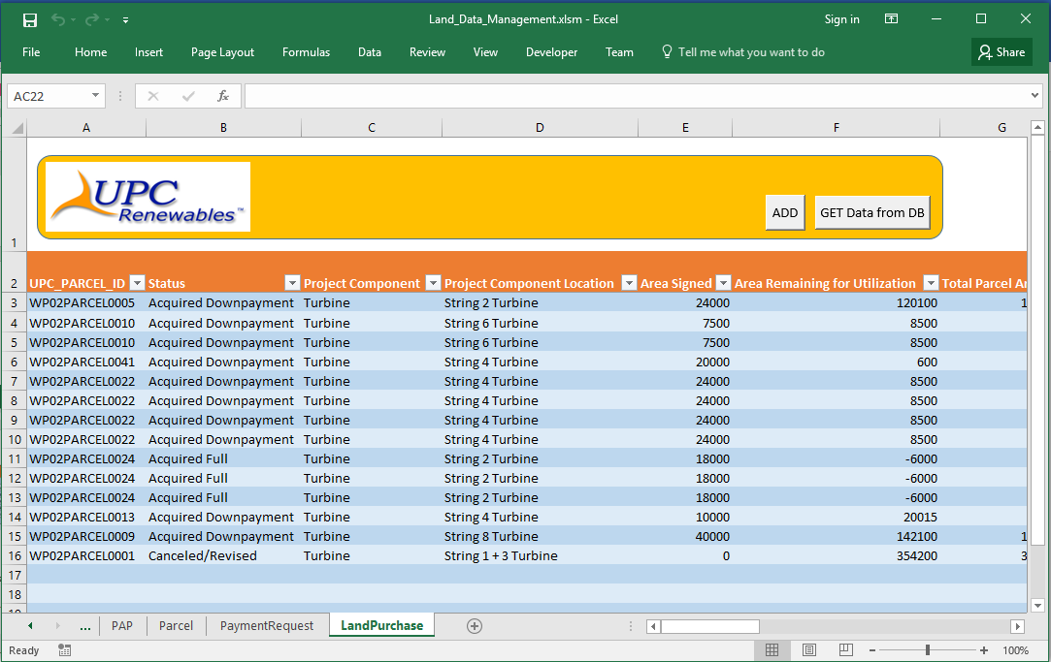

1. Get Land Purchase Features
   1. Get Parcel Features is use to get all Land Purchase data from database
   2. Click on the “Get Data from DB” button to get data and view the results on the active sheet

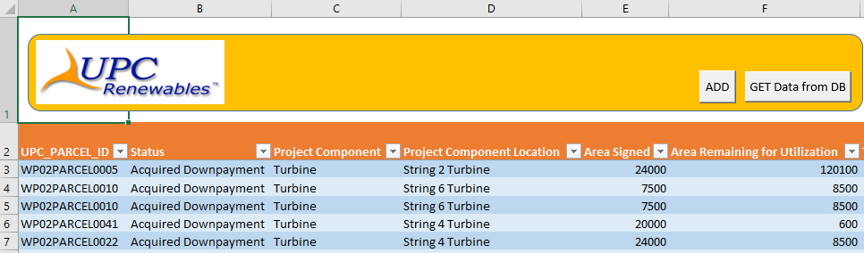

1. Add Land Purchase Features

This Add features are used for adding new Land Purchase data. Please follow the steps below:

* 1. Click on “Add” button

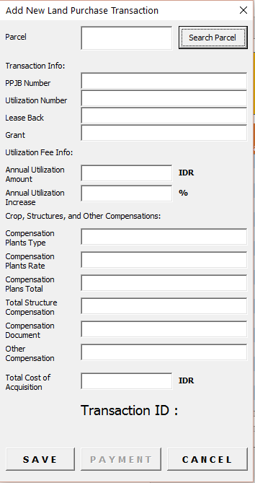

* 1. Click on “Search Parcel” button and Pick one of them

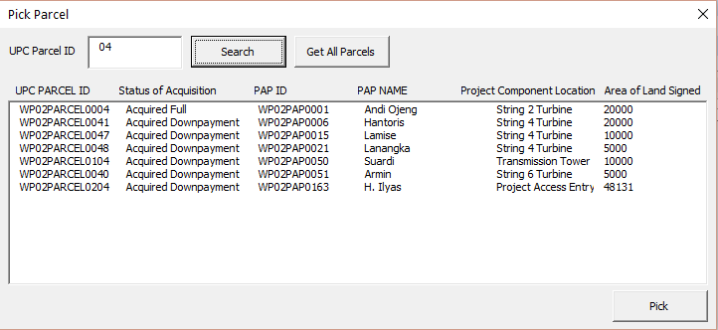

* 1. Click on “SAVE” button to save the changes after completely fill the empty textbox
  2. Click on “PAYMENT” button to add Payment term data.

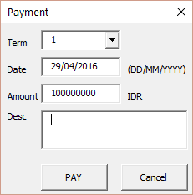

* 1. Click on “PAY” button
  2. Click on “X” close button on the top right corner to close the form