HICS 207 – ORGANIZATION CHART
1. INCIDENT NAME | 2. DATE PREPARED | 3. TIME PREPARED | 4. OPERATIONAL PERIOD DATE/TIME
5. ORGANIZATIONAL CHART
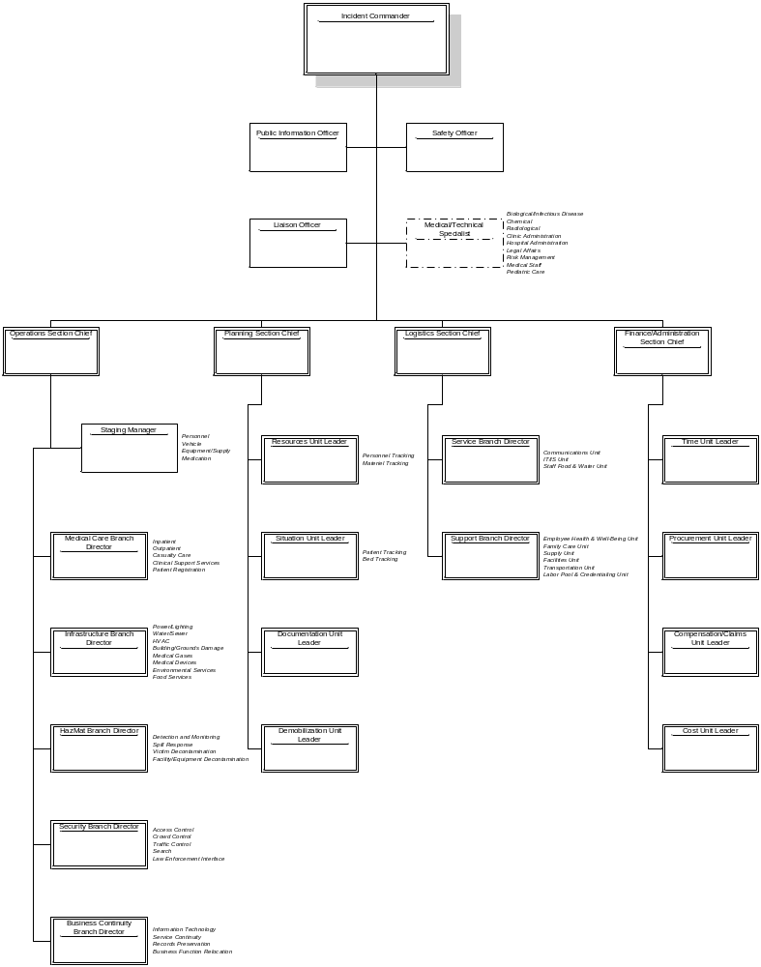
6. FACILITY NAME

