**Building Personal Blogs with IBM Cloud Static Web Apps**

**Introduction to IBM Cloud Static Web Apps**

IBM Cloud Static Web Apps is a powerful platform for building and deploying static web applications. With its intuitive interface and robust feature set, it's the perfect choice for developers looking to create fast, secure, and scalable web apps. In this section, we'll introduce you to the basics of IBM Cloud Static Web Apps and show you how to get started building your own personal blog.

## Setting up Your Personal Blog with IBM Cloud

IBM Cloud Static Web Apps provides an easy way to create and host your personal blog. Follow these steps to set up your blog:

1. Create an IBM Cloud account if you don't already have one.
2. Create a new static web app in the IBM Cloud console.
3. Choose a template or create your own custom design for your blog.
4. Add your blog content and customize the look and feel of your blog.
5. Integrate dynamic content such as comments or social media feeds.
6. Optimize your blog for performance and security.
7. Publish your blog to the world and share your thoughts with others!

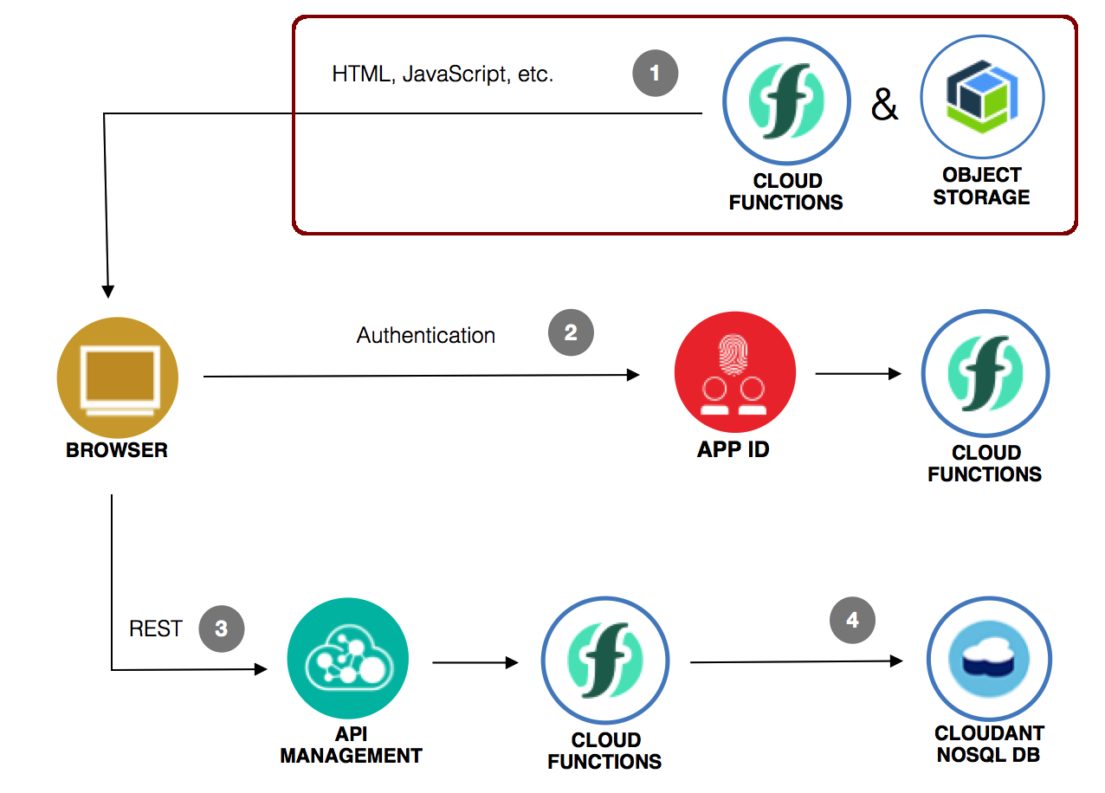

## Customizing Your Blog's Look and Feel

Make your blog stand out with a unique theme that reflects your personality and style.

## Adding Dynamic Content to Your Blog

### Integrating a Database

To add dynamic content to your blog, you'll need to integrate a database. IBM Cloud Static Web Apps supports several popular databases, including MongoDB and PostgreSQL.

### Displaying Blog Posts

Once your database is set up, you can use serverless functions to retrieve and display your blog posts on your website. You can also use client-side JavaScript frameworks like React or Vue to create a more interactive experience for your readers.

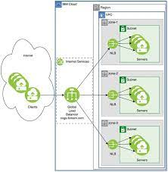

**Optimizing Your Blog for Performance and Security**

### Performance Optimization

To ensure your blog loads quickly and efficiently, it's important to optimize its performance. This can be achieved by minimizing the size of your images and other media files, using a content delivery network (CDN), and implementing caching techniques. Additionally, you can use IBM Cloud's built-in monitoring tools to identify and address any performance bottlenecks.

### Security Measures

Keeping your blog secure is crucial for protecting both your data and your visitors' information. To achieve this, you can implement SSL encryption, use strong passwords and two-factor authentication, and regularly update your software and plugins. IBM Cloud also offers advanced security features such as DDoS protection and vulnerability scanning to further enhance your blog's security.

**Conclusion**

* Share Your Thoughts with the World

With IBM Cloud Static Web Apps, publishing your personal blog has never been easier. Share your ideas and insights with a global audience in just a few clicks.