# AS32-TTL-100 User Manual v4.0

1. Module introductions 1
   1. Features introductions 1
   2. Basic usages 2
   3. Electrical parameters 3
   4. Series Products 4
2. Module functions 5
   1. Pin definition 5
   2. Module and MCU connection 6
   3. Module and PC connection 6
3. Command format 8
   1. Parameters set instructions 8
   2. Module default set 11
   3. Working parameters read 11
   4. Version number read 11
   5. Reset command 11
   6. Voltage read command 11
4. Working modes 12
   1. Modes switch 12
   2. General mode (mode 0) 13
   3. Wake-up mode (mode 1) 13
   4. Power saving mode (mode 2) 14
   5. Sleep mode (mode 3) 14
5. Fast communication test 15
6. AUX detailed explanation 16
7. About us 18

1 Module introductions AS32-TTL-100



**1.1 Features introductions**

AS32-TTL-100 is a 100mW, industrial-grade wireless data transmission module with high stability. The module uses SX1278 main chip, LORA spread spectrum transmission, TTL level output, compatible with 3.3V and 5V IO port voltage. And the module on the basis of the old version

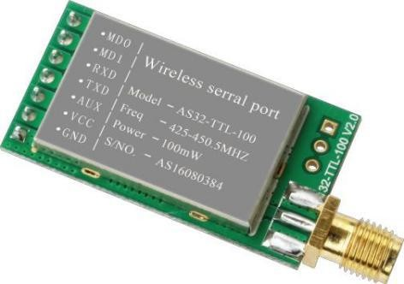has been upgraded as following: the use of efficient loop interleaving error correction coding algorithm, the coding efficiency, error correction capability. In the case of sudden interference, it can actively correct the disturbed data packets. The maximum continuous error correction 64bit greatly improves the module's anti-jamming and transmission distance, and in the absence of error correction algorithm, this error packet can only be discarded; The LORA spread spectrum gives the module greater communication distance.

The module has four operating modes that can be switched freely at run time. In power saving mode, the current consumption is only a few dozen uA, ideal for ultra low power applications.

AS32’s operating frequency is 410MHz ~ 441MHz, a total of 32 information channels, each channel’s interval is 1M. The serial port baud rate ,transceiving frequency, transmitting power, RF rate and other parameters can be modified on Online.

Features of the products： Typical application**：**

Working frequency band: 433MHz no application

* frequency band

Hotel electronic door locks, biometric access control management system

* a variety of power levels (maximum 100mW) ✓ Medical and electronic instrumentation automation control

✓

* a variety of baud rates, a variety of RF rates ✓ Intelligent teaching equipment, baby care, medical ward call

system

* four kinds of work modes ✓ Home appliances and intelligent lighting control
* ultra low power consumption ✓ Anti - theft alarm smart card, railway locomotive remote Water, electricity, gas, heating automatic meter reading

detection

* sleep current is only 1.5uA ✓
* support the air wake-up function ✓

system or reactive power compensation and power grid monitoring

LED screen wireless transmission of text, pictures and

wireless control

* double 256 loop FIFO ✓ Wireless crane scale, vehicle monitoring, aging equipment

testing

efficient cycle of intertwined error correction coding,

* the maximum error correction 64bit

Industrial equipment data wireless transmission and industrial environmental monitoring

* built-in watchdog, never crash ✓ Video monitoring PTZ control, access control attendance Weather / oil / water equipment information collection and

✓

card reader

* frequency 410- 441M, providing 32 channels ✓

natural environment detection street lamp detection control

Receive sensitivity up to -130dBm, transmission

* distance of 3000 meters
* Mine attendance positioning system, gas detection alarm

Automatic subcontracting transmission to ensure the integrity of the packet

✓

support module voltage read function

✓



1.2 Basic usages

* the most simple use: transparent transmission of data, for example: 3 bytes of data AA BB CC sent from the A to B , B will receive data AA BB CC.
* flexible use: fixed-point transmission, networking construction, relay and other applications, such as module A (address 0x1234, channel 0x51) needs to send data AA BB CC to module B (address 0x1200, channel 0x50) , The communication format is: 12 00 50 AA BB CC, where 1200 is the module B’s address and 50 is the channel, then module B can receive AA BB CC. Similarly, if module B needs to transmit data AA BB CC to module A with a communication format of 12 34 51 AA BB CC, module A can receive AA BB CC.
* Power saving usage: When the module is in power saving mode (mode 2), the response delay time of the configured module can adjust the whole power consumption of the module. The module can be configured the maximum reception response delay of 2000ms. The average current of the module is about several tens of uA.
* sleep usage: When the module is in sleep mode mode 3, the wireless receiver shutting down the MCU is dormant, then the whole current of the module is about 1.5uA, in this situation the module can still receive configuration data sent over by MCU.
* Broadcast and data monitoring: the module address is set to 0xFFFF, you can monitor all modules of the data transmission on the same channel ; data sent can be received by modules of any address on the same channel , which plays the role of broadcasting and listening





1.3 Electrical parameters

|  |  |  |
| --- | --- | --- |
| NO. | Parameter name | Parameter value detail |
| 1 | Module size | 20 * 36mm (without antenna and SMA connector) |
| 2 | Source of the devices | all imported components, origin: Japan, the United States, Germany |
| 3 | Production process | lead-free, electrostatic bag packaging |
| 4 | Interface mode | 1 * 7 * 2.54mm, plug-in packaging, you can use the universal board and DuPont line |
| 5 | Working frequency | 410 - 441MHz, 1000KHz step forward, factory default 433.0MHz |
| 6 | supply voltage | 2.0V-5.5VDC, meet a variety of system requirements; Note: if the power supplying voltage is less than 3.6V the output power will decline, but the impact on the receiving is very small |
| 7 | Communication level | maximum 5.2V. The difference between the recommended and supply voltage is less than 0.3V to reduce power consumption. |
| 8 | Measured distance | about 3000m (test conditions: sunny, open, maximum power, antenna gaining 5dBi, height greater than 2m, 2.4K air rate) |
| 9 | Transmitting power | Maximum 20 dBm (about 100mW), 4 levels available to adjust(0-3), each level increases and decreases of about 3dBm |
| 10 | Air rate | 6 levels available to adjust (0.3,1.2,2.4,4.8,9.6,19.2Kbps) |
| 11 | Sleep current | 1.5uA（MD1 =1，MD0 = 1） |
| 12 | Transmitting current | 110mA@100mW (voltage 5V) |
| 13 | Receiving current | 18mA (mode 0, mode 1) | the minimum is about 30uA (mode 2 + 2s wake up) |
| 14 | Communication Interface | UART serial port, 8N1, 8E1, 8O1, from 1200 to 115200  In total of 8 baud rates |
| 15 | Drive mode | UART serial port can be set to push-pull / pull-up, open-drain |
| 16 | Transmitting length | Internal ring fifo cache 256 bytes, the internal automatic subcontracting sending. Some combination of airspeed and baud rates can send infinite length of packets. |



|  |  |  |
| --- | --- | --- |
| 17 | Receiving length | Internal ring fifo cache 256 bytes, the internal automatic subcontracting sending. Some combination of airspeed and baud rates can send infinite length packets. |
| 18 | Module address | Can be configured 65536 addresses (easy to construct networking, support for broadcast and fixed-point transmission) |
| 19 | RSSI support | Built-in intelligent processing, users do not worry |
| 20 | Receiving sensitivity | [-130dbm@2.4Kbps](mailto:-130dbm@2.4Kbps) (receive sensitivity and serial port baud rate, delay time are independent) |
| 21 | Antenna type | SMA antenna / spring antenna |
| 22 | Operation temperature | -40 ~ +85℃ |
| 23 | Operation humidity | 10%-90% relative humidity No condensation |
| 24 | Storage temperature | -40 ~ +125℃ |
|  |  |  |



1.4 Products of the series

|  |  |  |  |  |  |  |  |
| --- | --- | --- | --- | --- | --- | --- | --- |
| Module type number | Carrier frequency  HZ | Chip solution | packaging | size（mm） | Maximum transmitting power  dBm | Communication distance | Antenna type |
| AS32-TTL-100 | 410M~441M | SX1278 | Plug- in | 20 * 36 | 20 | 3.0 | SMA-K |
| ★ all wireless modules of AS32 series can intercommunicate ★ | | | | | | | |



**2 Module functions AS32-TTL-100**

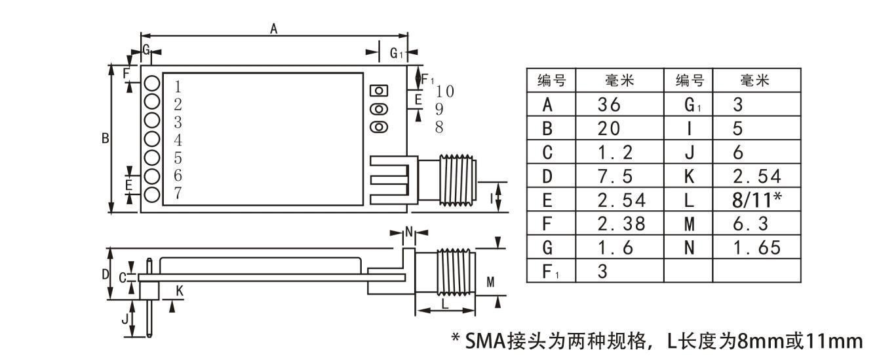

2.1Pin definition

|  |  |  |  |
| --- | --- | --- | --- |
| 1 | MD0 | Input (very weak pull-up) | Cooperate with MD1 to decide 4 working modules Can not be left in the air |
| 2 | MD1 | Input (very weak pull-up) | Cooperate with MD0 to decide 4 working modules Can not be left in the air |
| 3 | RXD | input | TTL serial input, connected to external TXD output pin. Can be configured as open-drain or pull-up input, see parameter settings |
| 4 | TXD | output | TTL serial output, connected to external RXD input pin. Can be configured as open-drain or pull-up output, see parameter settings |
| 5 | AUX | output | Used to indicate the working status of the module, the user wake up the external MCU, power-on during the initialization period of self-test, it output low power level, can be configured to Open-drain output, or push-pull output, see parameter settings |
| 6 | VCC |  | Power input, voltage 2.0-5.5V (Note: less than 3.6V the output power will decline, but the impact on the reception performance is very small.) |
| 7 | GND |  | Ground line, connected to the power supply reference ground |

2.2 Module and MCU connection

## .

* When wireless serial module is in TTL level,please connect MCU of TTL level.
* Some 5V MCUs may require a 10K pull-up resistor in the module's TXD and AUX pins

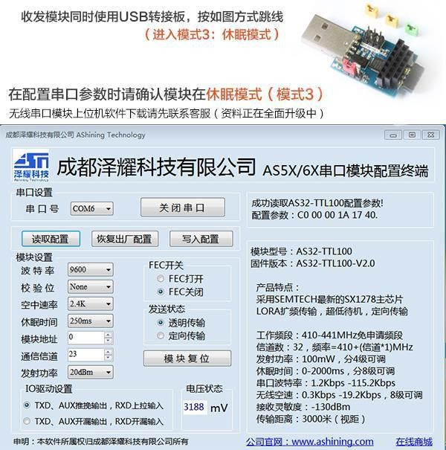

2.3 Module and PC connection

Step 1: unplug the (yellow) jumper cap in USB switch board MD0, MD1 , as shown above, power (red) jumper cap can be selected as 3.3V, no need to care SET

Step 2: Insert the module into the 7PIN seat of the adapter board, the antenna end is outward, insert the adapter board into the computer USB port

Step 3: open our configuration software, select the corresponding serial number and then click on the "open serial port", if the opening fails, please select other serial numbers until the opening is successful

Step 4: Click "Read Configuration", the interface as shown above, display the current configuration of the module

Step 5: Change the configuration as needed, and then click "Write Configuration" to write the new parameters to the module

Step 6: If you need to reconfigure, following "Step 5". If the configuration is completed, please click "Close Serial" and then remove the module

**3 Command format AS32-TTL-100**

In the sleep mode (mode 3: MD1 = 1, MD0 = 1), the list of supporting commands is as follows (only support 9600, 8N1 formats in configuration)

|  |  |  |
| --- | --- | --- |
| Serial number | Command format | Command function |
| 1 | 0xC0 + 5byte configured parameters | Set the module parameters,the parameters set by the command can be saved after power failure |
| 2 | 0xC1 + 0xC1 + 0xC1 | Reading the module configuration parameters command |
| 3 | 0xC2 + 5byte configured parameter | Set the module parameters,the parameters set by the command can not be saved after power failure |
| 4 | 0xC3 + 0xC3 + 0xC3 | Read the version number of the module hardware |
| 5 | 0xC5+ 0xC5 + 0xC5 | Reset the module command |
| 6 | 0xC5+ 0xC5 + 0xC5 | Read the actual voltage of the module |



**3.1 Parameters set instructions**

Working parameters setting can use the C0 or C2 command, the difference is: C0 command will write parameters into FLASH module which can be saved when the power is down. C2 command is to temporarily modify the instruction, the parameters will not be power-down saved, C2 command suits for the occasion where the operating parameters are frequently modified , do not save FLASH to extend its service life. For example: C2 12 34 1A 17 44.

Working parameters configuration table (default: C0 12 34 1A 17 44)

|  |  |  |  |
| --- | --- | --- | --- |
| Serial  number | name | description | Remarks |
| 0 | HEAD | Fixed 0xC0 or 0xC2,shows that this frame data is controlling command | * Must be 0xC0 or C2   C0: The parameters set are saved when the power is down.  C2: The parameters set are not saved when the power is down. |
| 1 | ADDH | Module address high byte (default 12H) | 00H-FFH |
| 2 | ADDL | Module address low byte (default 34H) | 00H-FFH |
| 3 | SPEED | Rate parameters, including serial port rate and | * both communication serial ports’ modes can be different |



|  |  |  |  |
| --- | --- | --- | --- |
|  |  | air rate  7,6: serial check bit 00: 8N1 (default)  01: 8O1  10: 8E1  11: 8N1 (equivalent to 00)  -------------------------------------------------  5,4,3 TTL serial port rate (bps)  000: The serial port baud rate is 1200 001: The serial port baud rate is 2400 010: The serial port baud rate is 4800 011: Serial baud rate is 9600 (default) 100: The serial port baud rate is 19200 101: The serial port baud rate is 38400 110: Serial baud rate is 57600  111: The serial port baud rate is 115200  -------------------------------------------------  2,1,0 wireless air speed (bps) 000: The air velocity is 0.3K 001: air speed is 1.2K  010: air speed is 2.4K (default) 011: The air speed is 4.8K 100: air speed is 9.6K  101: The air rate is 19.2K | ---------------------------------------   * both communication baud rates can be different * Serial baud rate and wireless transmission parameters are independent which does not affect the wireless transceiving Characteristics.   --------------------------------------   * The lower air rate, the farther transmitting distance, the stronger anti-jamming performance, the longer sending time. * Both air wireless transmission rates must be the same. |
| 4 | CHAN | Communication frequency (410M + CHAN *  1M) (default 17H: 433M) | * 00H-1FH, corresponding to 410 -441MHz |
| 5 | OPTIO N | 7, fixed-point sending enable bit (class MODBUS)  0: transparent transfer mode (default) 1: Fixed-point transmission mode  --------------------------------------  6 IO drive mode (default 1)  1: TXD, AUX push-pull output, RXD pull-up input  0: TXD, AUX open output, RXD open input  --------------------------------------  5,4,3 wireless wake-up time (for the receiver, is the listening interval  Time; for the launch side, is the time to continue to launch wake-up code)  000: 250ms (default)  001: 500ms  010: 750ms  011: 1000ms  100: 1250ms  101: 1500ms  110: 1750ms  111: 2000ms | * When it is 1, the first 3 bytes of each user’s data frame are high , low address and channel. When transmitting, the module changes its own address and channel   After completion return to the original settings.  ---------------------------------------   * This bit is used to internal pull-up resistor of the enable module. With Open-drain mode the electrical level has stronger ability to adapt, but requires an external pull-up resistor   ---------------------------------------   * transceiver module is working in mode 0, the delay time is invalid and can be any value. * The transmitter side works in mode 1, which will continue to launch wake- up Codes of the corresponding time. * Receiver work in mode 2, this time refers to the receivers’ listening interval time (wireless wake-up), can only receive the transmitter’s data sent in mode 1 * The wake-up time set by the transmitter can not be less than the listening interval time of the receiver, otherwise it may lose data when it is two-way communication, both sides can set a matched wake-up time . |

|  |  |  |  |
| --- | --- | --- | --- |
|  |  | -----------------------------------------------  2, reserved  -----------------------------------------------  1, 0 transmit power (approx. Value)  00: 20dBm (default)  01: 17dBm  10: 14dBm  11: 11dBm | * The longer wake-up time, the lower average receiving current.   ---------------------------------------  ---------------------------------------   * External power supply must provide more than 200mA current output capability. And ensure that the power supply ripple is less than 100mV. * Do not recommend the use of smaller power to send as its power efficiency is not high. |

Example (meaning of serial number 3 "SPEED"):

|  |  |  |  |  |  |  |  |  |  |
| --- | --- | --- | --- | --- | --- | --- | --- | --- | --- |
| Binary bit | 7 | 6 | 5 | 4 | | 3 | 2 | 1 | 0 |
| Specific value ( configuration for user） | 0 | 0 | 0 | 1 | | 1 | 0 | 0 | 0 |
| meaning | Serial port parity bit 8N1 | | The serial port baud rate is 9600 | | | | The air rate is 0.3K | | |
|  | 1 | | | | 8 | | | | |
| Module type number |
| AS32-TTL-100 |
| Corresponding hexadecimal |



3.2Module default set

）

|  |  |  |  |  |  |  |  |
| --- | --- | --- | --- | --- | --- | --- | --- |
| Model number | frequenc y(MHZ) | ID  address(HE X) | Default channel | Air rate (Kbps) | Baud rate (bps) | format | Transmitting power（mW |
| AS32-TTL-100 | 433.00 | 0x1234 | 23channel | 2.4 | 9600 | 8N1 | 100 |



3.3 Read Working parameters

In the sleep mode (MD1 = 1, MD0 = 1), the user issues a command to the module serial port (HEX format): C1 C1 C1, the module will return to the current configuration parameters. For example: C0 12 34 1A 17 44.



3.4 read Version number

In the sleep mode (MD1 = 1, MD0 = 1), the user sends to the module serial port (HEX format): C3 C3 C3, the module will return to the current version number: For example: AS32-TTL-100-V1.0.



3.5 Reset command

In sleep mode (MD1 = 1, MD0 = 1), the user initiates (HEX format): C4 C4 C4 to a module serial port, the module will generate a reset. During the reset process, the module performs self-test and AUX output is low. After reset, AUX output is high and the module starts to work normally. At this point, you can switch mode or initiate the next instruction.



3.6 Voltage read command

In the sleep mode (MD1 = 1, MD0 = 1), C5 C5 C5 is initiated to the module serial port, and the module returns to the current voltage value. The return format is: C5 VH VL, where VH and VL are voltage data. For example: the module returns to C5 0C 1C, 0C1C is converted to decimal to get 3100, which shows that the current voltage is 3.1V.

**4 Working modes AS32-TTL-100**

The module has four operating modes set by pins MD1, MD0; Details are shown in the following table

|  |  |  |  |  |
| --- | --- | --- | --- | --- |
| modes（0-3） | MD1 | MD0 | Mode introduction | Remarks |
| 0 General mode | 0 | 0 | Serial port open, wireless open, transparent transmission | The receiver must be in modes 0,1 |
| 1 Wake-up mode | 0 | 1 | Serial port open, wireless on, and the only difference between mode 0 is that before the data package is launched, the wake-up code will increase automatically, so as to wake up  the receiver working in mode 2 | The receiver can be in mode 0,1,2 |
| 2 Power saving mode | 1 | 0 | The serial port receiving is closed and the wireless is in the air wake-up mode and once receiving  the wireless data, open the serial port to send data | 1the transmitter must be in model 1  2 no transmitting in this mode |
| 3 Sleep mode | 1 | 1 | Module comes into the sleep, it can receive the parameter setting command | See the detailed description of the working parameters |



4.1 Modes switch

Users can combine MD1, MD0 high and low level to determine the module’s working mode. You can use the 2 GPIOs of the MCU to control mode switching. When the MD1 and MD0 are changed: If the module has serial data not yet completed through the wireless transmission, the transmitter will not be able to enter the new working mode. If the module receives the wireless data and sends out the data through the serial port completely, it will enter the new work mode , so the mode switch can only be effective in the AUX output 1, otherwise it will delay the switch.

For example, in mode 0 or mode 1, the user inputs a large amount of data continuously and switches the mode at the same time. The

switching mode operation is invalid at this time. After the module has processed all the user data, then detect new mode. The general recommendation is: detecting the AUX pin output state, waiting for 2ms after AUX output high level and then switch.

When the module is switched from the other mode to the sleep mode, and the data has not been processed yet, the module will not enter the sleep mode until they are done. This feature can be used for fast dormancy to save power. For example, if the transmitter module works in mode 0, the user initiates the serial data "12345", and then you do not have to wait for the AUX pin to be idle (high), it can switch directly to sleep mode, and the users’ main MCU is immediately dormant, the module will automatically send all data through the wireless , within 1ms it automatically enters into the sleep mode which saves MCU’s working time, reduces power consumption.

Similarly, any mode switching can take advantage of this feature, after the module processed the current mode event, within 1ms, it will automatically enter the new mode, eliminating the need for users to query AUX work, and can achieve the purpose of rapid switching. Such as from the transmitting mode to the receiving mode, The users’ MCU can also enter the sleep mode before the mode switch, using the external interrupt function to obtain AUX changes, so the mode switch.

This operation is very flexible and efficient, designed in accordance with the convenience of the users’ MCU, and can reduce the overall system workload as much as possible, improve system efficiency and reduce power consumption.



4.2 General mode (mode 0)

0MD1 = 0, MD0 = 0, the module is operating in mode 0.

Transmitting: The module receives the user data from the serial port and transmits the wireless packet length to 58 bytes . When the user enters the data volume to 58 bytes, the module will start the wireless transmission. At this time, the user can continue to input the data to be transmitted. When the user needs to transmit bytes less than 58, the module waits 3 bytes time, if no user data continuously to enter, then the data is deemed to be terminated, then the module will send out all the data packets through the wireless. When the module receives the first user data, the AUX output low electrical level. when the module puts all the data into the RF chip and starts the launch, AUX output high electrical level which indicates that the last packet of wireless data has been launched , the user can continue to enter up to 256 bytes of data. Data Packets sent via mode 0 can only be received by the receiving module in mode 0, mode 1.

Receiving: The module always turns on the wireless reception function and can receive data packets from mode 0 and mode 1. After receiving the packet, the module AUX output low electrical level, and delay 2ms, began to send wireless data through the serial port TXD pin, when all wireless data is sent out through the serial port, AUX output high electrical level.



4.3 Wake-up mode (mode 1)

0MD1 = 0, MD0 = 1, the module works in mode 1.

Transmitting: the data packet transmission conditions of the module and the AUX function are equivalent to mode 0, the only difference is: the module will automatically add the wake-up code before each data packet, the length of the wake code depends on the wake-up time of the users’ parameter setting .The wake-up code is used to wake up the receiving module that works in mode 2. So, data sent by mode 1 can be received by modes 0,1,2.

Receiving: Equivalent to mode 0.



4.4 Power saving mode (mode 2)

MD1 = 1, MD0 = 0, the module operates in mode 2.

transmitting: The module is in dormant state, the serial port is closed, can not receive serial data from external MCU, so this mode does not have the wireless transmission function.

Receiving: In mode 2, the transmitter must operate in mode 1. The wireless module periodically monitors the wake-up code and upon receipt of a valid wake-up code, the module will continue to be on receiving state, and wait for the entire valid packet to be received. Then the module will have AUX output low electrical level, after 2ms delay , open the serial port , it will receive the wireless data sent by TXD, after the completion , AUX output high electrical level. The wireless module continues to enter the "sleep-monitor" working state (polling). By setting a different wake-up time, the module has different receiving response delays (up to 2s) and average power consumption (minimum 30uA). The user needs to achieve a balance between the communication delay time and the average power consumption.



4.5 Sleep mode (mode 3)

MD1 = 1, MD0 = 1, the module operates in mode 3. transmitting: Unable to transmit wireless data.

Receiving: Unable to receive wireless data.

Set parameters : sleep mode is available for module parameter set, you can use serial port 9600, 8N1, through a specific instruction format to set the module operating parameters, see detailed description of the working parameters.

Note: When entering from dormant mode to other modes, the module will reconfigure the parameters. During configuration, AUX remains low electrical level. After the completion it will output high electrical level, it is recommended that users detect AUX rising edge.

**5 Fast communication test AS32-TTL-100**

Plug the USB test board (choosing accessories of our company) into the computer and make sure the drive is installed correctly. Insert the mode selection jumper on the USB test board (ie MD1 = 0, MD0 = 0), as shown in the red box below, let the module work in normal mode (mode 0).

Choosing 3.3V or 5V power supply is ok. Run the "serial port debugging assistant" software, and select the correct serial port number, observe the sending window and the corresponding receiving window.

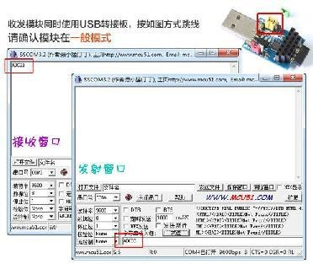

15

16

**6 AUX detailed explanation AS32-TTL-100**

AUX is used for wireless transceiver buffering instructions and self-test instructions. It indicates whether the module has transmitted the data through the wireless , or has received the wireless data been issued by the serial port or the module is initializing the self-test process or not.

Aux function introduction:

Function 1: Serial data output indication (use for wake up external MCU in dormant)

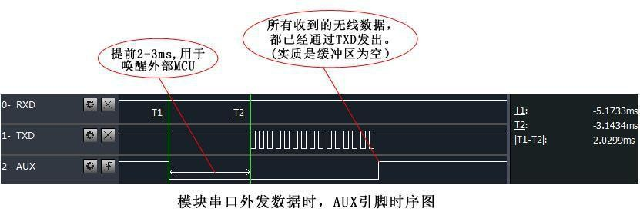

Function 2: Wireless transmitting indication

Empty buffer: internal 256 bytes of buffer data, are written to the wireless chip (automatic subcontract). When AUX = 1, the user initiates data less than 256 bytes consecutively and it does not overflow.

When AUX = 0, the buffer is not empty: when the internal 256 bytes of buffer data are not all written to the wireless chip or launched yet, at this point the module waiting for user data finished may be overtime or is ongoing wireless packet transmission.

Note: AUX = 1 does not mean that all serial data through the wireless transmitting is completed, it may be that the last packet of data

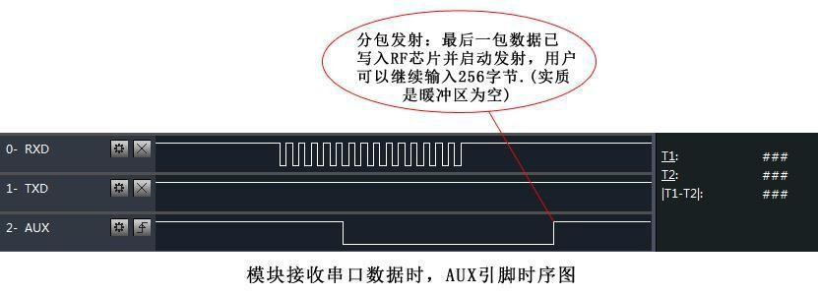

is being launched.

Function 3:the module is in configuration(Only when resetting and exiting sleep mode)

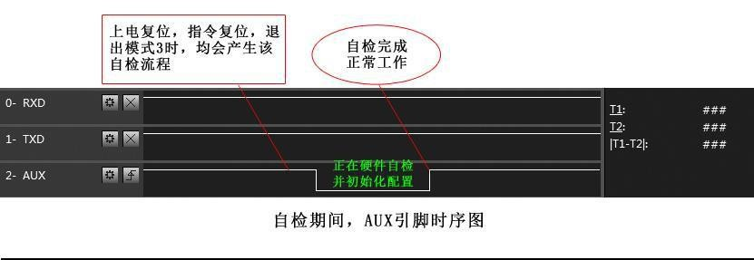

Precautions:

For above functions 1 and 2, the low electrical level output is priority, that is: to meet any of the low level output conditions, AUX output low level; when all low level conditions are not met, AUX output high level.

When the AUX output low, it shows that the module is busy, this time will not proceed mode detection. When the module AUX output high level within 1ms, it will complete the mode switch.

After the user switches to the new operating mode, the module will enter the mode in at least 2ms after the AUX rising edge. If AUX is always high, then mode switch will take effect immediately.

When users enter into other mode from mode 3(sleep mode) or in the process of reset,the module will reset users’ parameters,during this time,AUX will output low electrical level.