Name _____________________ Date: _________________

**Thinking about Distributions**

1. Go to menti.com and enter your favorite number between 1-10.
2. Imagine what this distribution might look like if we displayed the results in a histogram. What are some of the possible shapes we might see for the distribution and explain why you would expect each one to look like that. Try to estimate what the center, and spread might be for each one as well. First, imagine what it would look like if people were just randomly selecting one of the ten numbers. Then, try to come up with at least two of your own possible outcomes and explanations for why people might select that pattern of numbers instead.
   1. Possible Outcome #1 - What would it look like if people were randomly selecting a number? (include shape, center, spread, and your explanation)
   2. Possible Outcome #2 (your own idea):
   3. Possible Outcome #3 (your own idea):
3. How did the histogram for our class turn out? Was it like you expected?
4. Next, imagine what the boxplot would look like for this distribution. Will it appear evenly distributed?

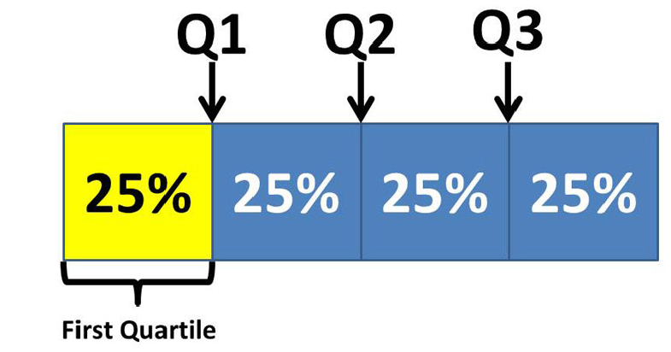

1. Let’s put the numbers in R and get the five number summary. Draw the boxplot to scale. What is equal across the intervals between ______________ and ______________? How about ______________ and _______________ ?
2. Now, let’s check the boxplot in R to compare with ours. How did it turn out? What do you think is the process that produced this outcome?