**Classwork 5**

**The Population and The DGP**

**A Known DGP: Randomness**

**Summary of R Code for a 1:10 Population**

*(see the Assignment for Classwork 5 in Canvas for full code)*

# This saves the numbers 1-10 in a vector called one_ten.pop

one_ten.pop <- c(1:10)

# This saves that vector to a data frame called FavNum

FavNum <- data.frame(one_ten.pop)

# This creates a density histogram of one_ten.pop with 10 bins

gf_dhistogram(~one_ten.pop, data = FavNum, bins = 10, color ="orchid")

# This is our model of the population if the process is random

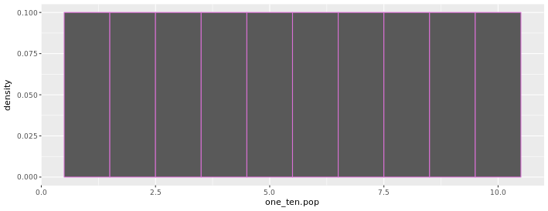

# There are different ways to sample from our population: sample() and resample()

# This will sample 10 times (n=10) WITHOUT replacement (runs out of values after the tenth time)

sample(one_ten.pop, 10)

# Or we could use do()* to repeat the process 25 times

do(25)*sample(one_ten.pop, 1)

# This will sample 25 times (n=25) WITH replacement each time

resample(one_ten.pop, 25)

#### The following code repeats 5 times to create 5 samples of N=25 ####

#### Sample 1 Code (N=25) ####

# This will sample 25 times (n=25) WITH replacement each time and save the samples to a vector called sample1_n25

sample1_n25 <- resample(one_ten.pop, 25)

# This will save sample1_n25 in our data frame (FavNum)

FavNum <- data.frame(sample1_n25)

# This will create a density histogram of sample1_n25

gf_dhistogram(~sample1_n25, data = FavNum, bins = 10, color ="yellow")

# Repeat Sample 1 Code (N=25) for: sample2_n25, sample3_n25, sample4_n25, sample5_n25

|  |  |
| --- | --- |
| plot  sample1_n25 | plot  sample2_n25 |
| plot  sample3_n25 | plot  sample4_n25 |
| plot  sample5_n25 | |

#### The following code repeats 5 times to create 5 more samples but with N=1000) ####

#### Sample 1 Code (N=1000) ####

# This will sample 1000 times (n=1000) WITH replacement each time and save the samples to a vector called sample1_n1000

sample1_n1000 <- resample(one_ten.pop, 1000)

# This will save sample1_n1000 in our data frame (FavNum)

FavNum <- data.frame(sample1_n1000)

# This will create a density histogram of sample1_n1000

gf_dhistogram(~sample1_n1000, data = FavNum, bins = 10, color ="yellow")

# Repeat Sample 1 Code (N=1000) for: sample2_n1000, sample3_n1000, sample4_n1000, sample5_n1000

|  |  |
| --- | --- |
| plot  sample1_n1000 | plot  sample2_n1000 |
| plot  sample3_n1000 | plot  sample4_n1000 |
| plot  sample5_n1000 | |