**Name: Classwork 12.1**

**Interpreting Confidence Intervals**

1. Here is the best fitting model AND confidence interval for FEEDBACK model. Which part of the DGP are we interested in: or ?

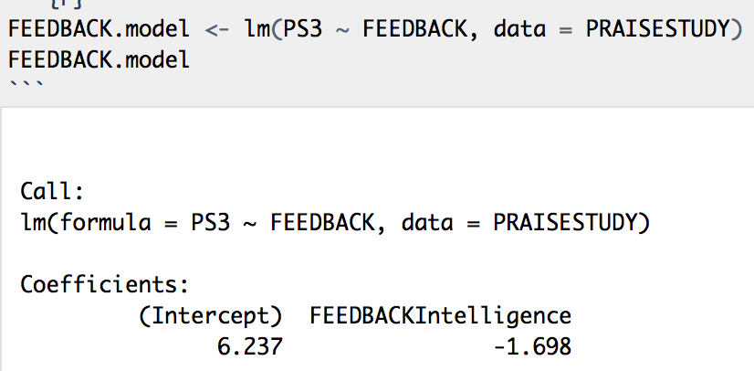

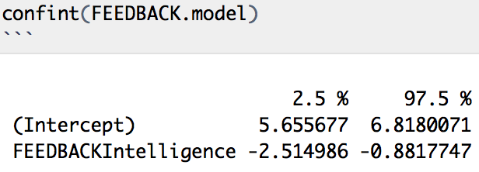

1. Why do we say we are interested in rather than ?
2. What would it mean if the real could have been 0?
3. What do the numbers -2.51 and -.88 mean?

**Hypothesis Testing (Reasoning Forward) vs. Confidence Intervals (Reasoning Backwards)**

1. How is the distribution triad involved in Hypothesis Testing versus Confidence Intervals?
2. What do you need to know about sampling distributions for the upcoming quiz?

**Review of Chapters 7 and 8**

In week 5, we talked about the Mueller and Dweck study where they praised kids in different ways.

PRAISESTUDY <- read.csv("http://bit.ly/muellerdweck_study1", header=TRUE)

PRAISESTUDY <- filter(PRAISESTUDY, FEEDCODE != 2)

PRAISESTUDY$FEEDBACK <- factor(PRAISESTUDY$FEEDCODE, levels = c(1,0), labels = c("Effort", "Intelligence"))

1. Where is the best fitting FEEDBACK model on this scatterplot? Where is the empty model? (Label them.)
2. Choose one point and draw the residual from the complex model and the residual from the empty model. (Label these residuals.)

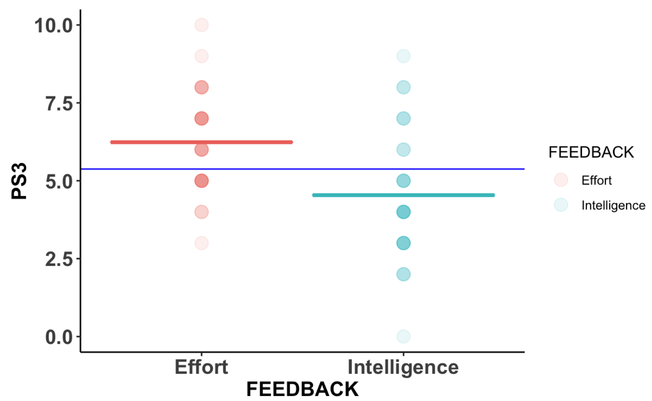

1. Here are the best fitting estimates for the FEEDBACK model. From the model fits can you tell how much of the variation has been explained? Would it help to put them in GLM form? Why or why not?

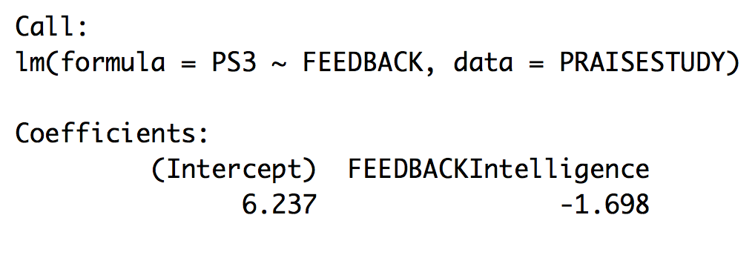

1. Where is the best fitting PS1 model on this scatterplot? Where is the empty model? (Label them.)
2. Choose one point and draw the residual from the complex model and the residual from the empty model. (Label these residuals.)

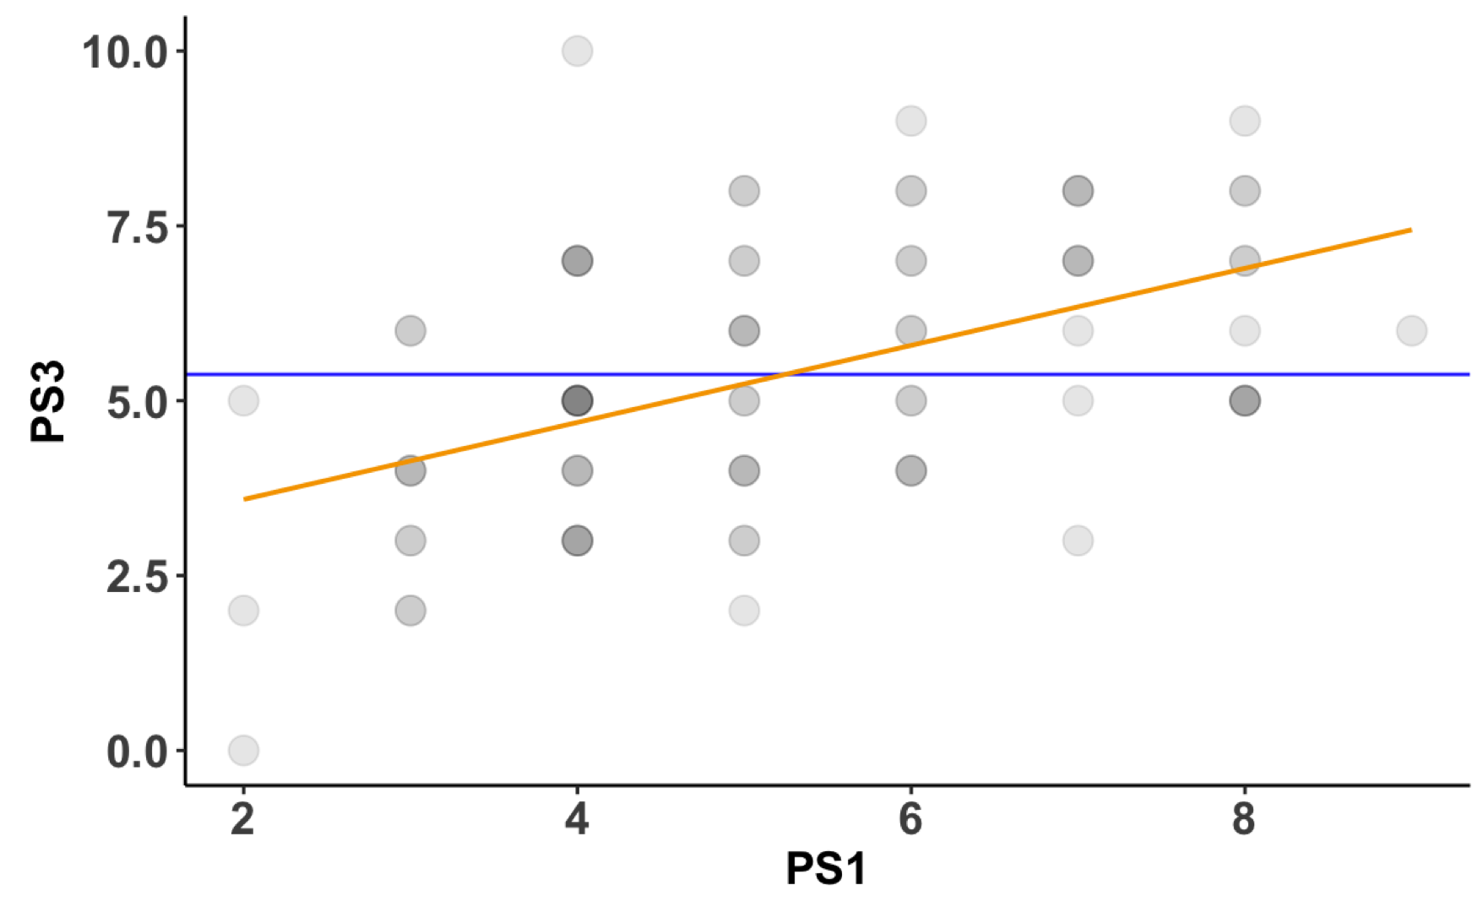

1. Here are the best fitting estimates for the PS1 model. From the model fits can you tell how much of the variation has been explained? Would it help to put them in GLM form? Why or why not?

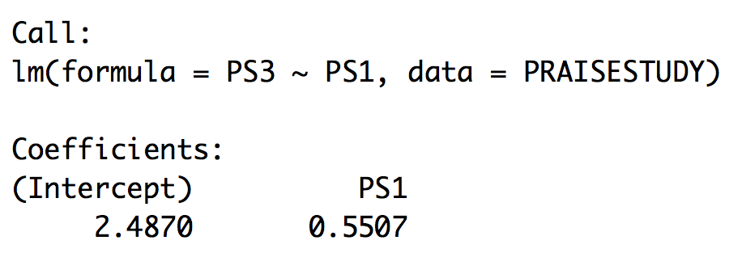

**What is a Sampling Distribution for?**

1. Remember we used **shuffle()** and made a bunch of shuffled histograms and tried to see whether our real sample could be detected from the shuffled samples? Now let’s try it with our model using PS1 scores to predict PS3 scores. The first one is the “real” data… how does it look different from the shuffled scatterplots?

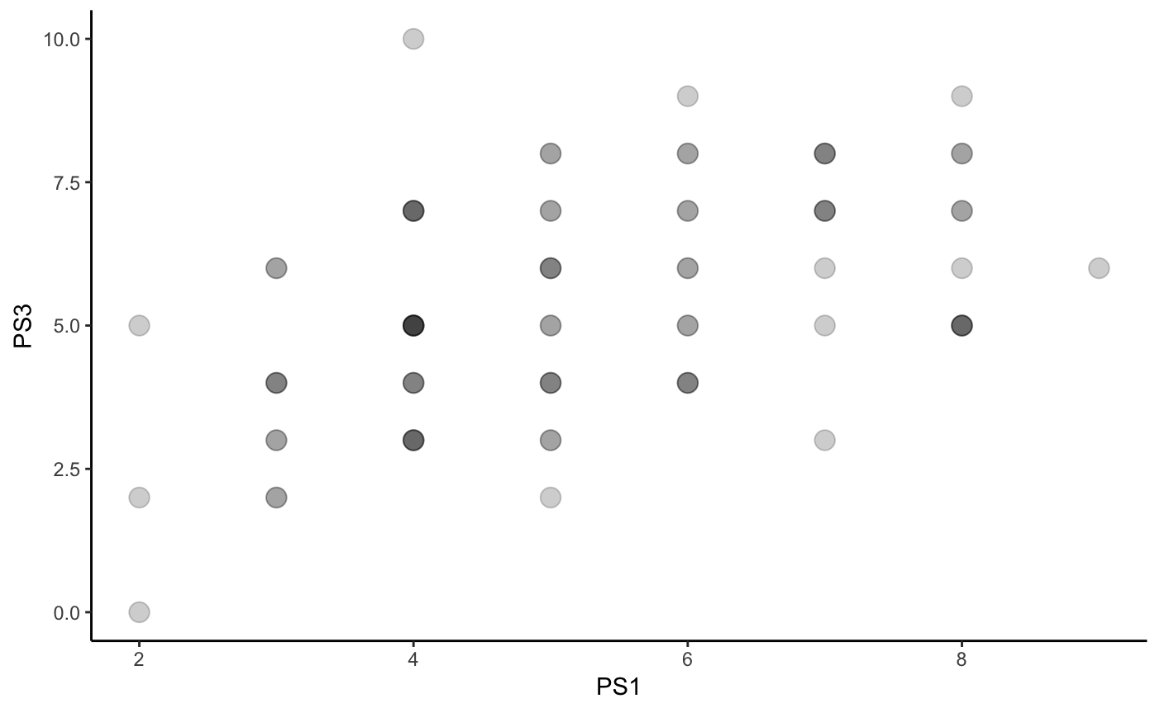 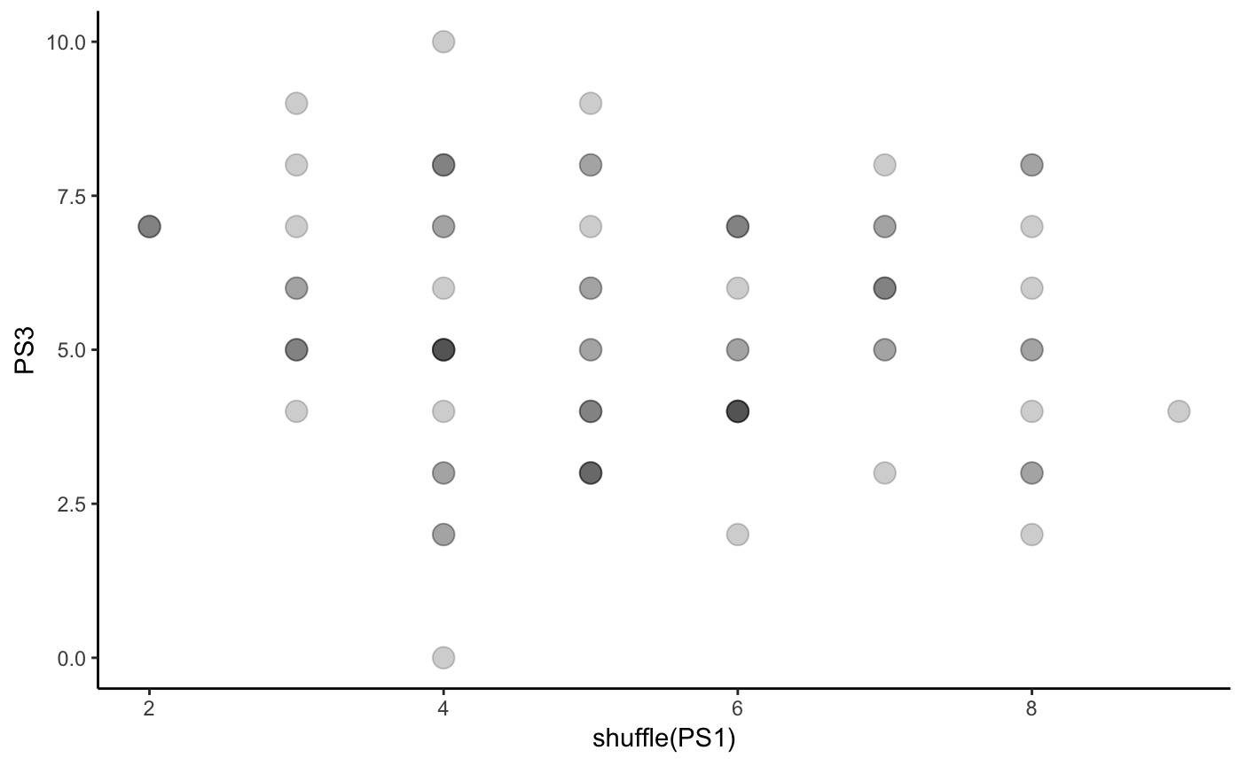 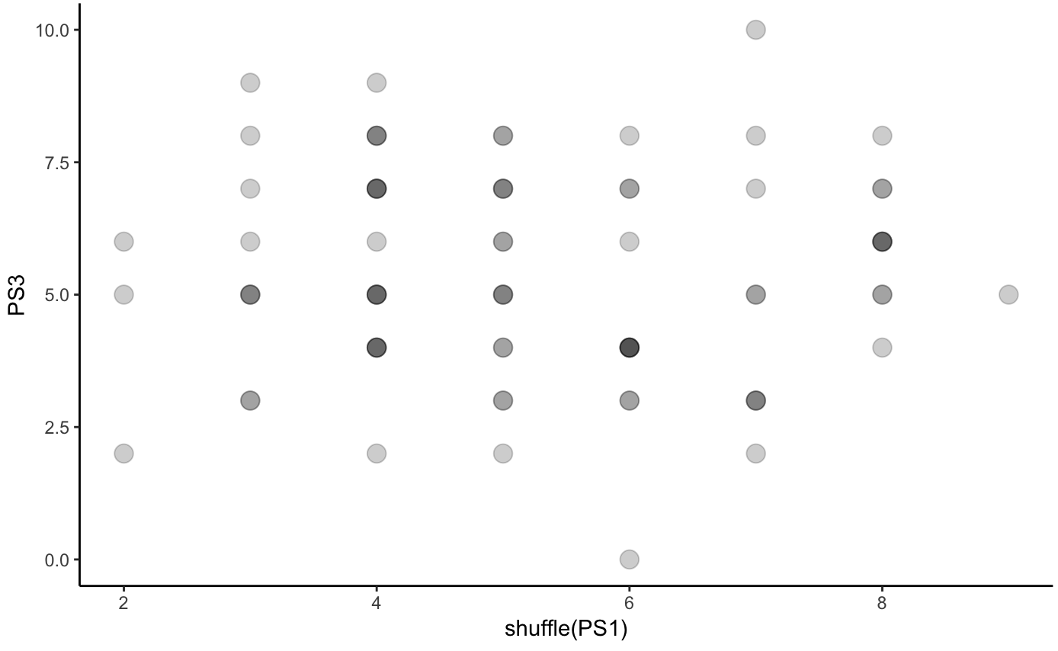 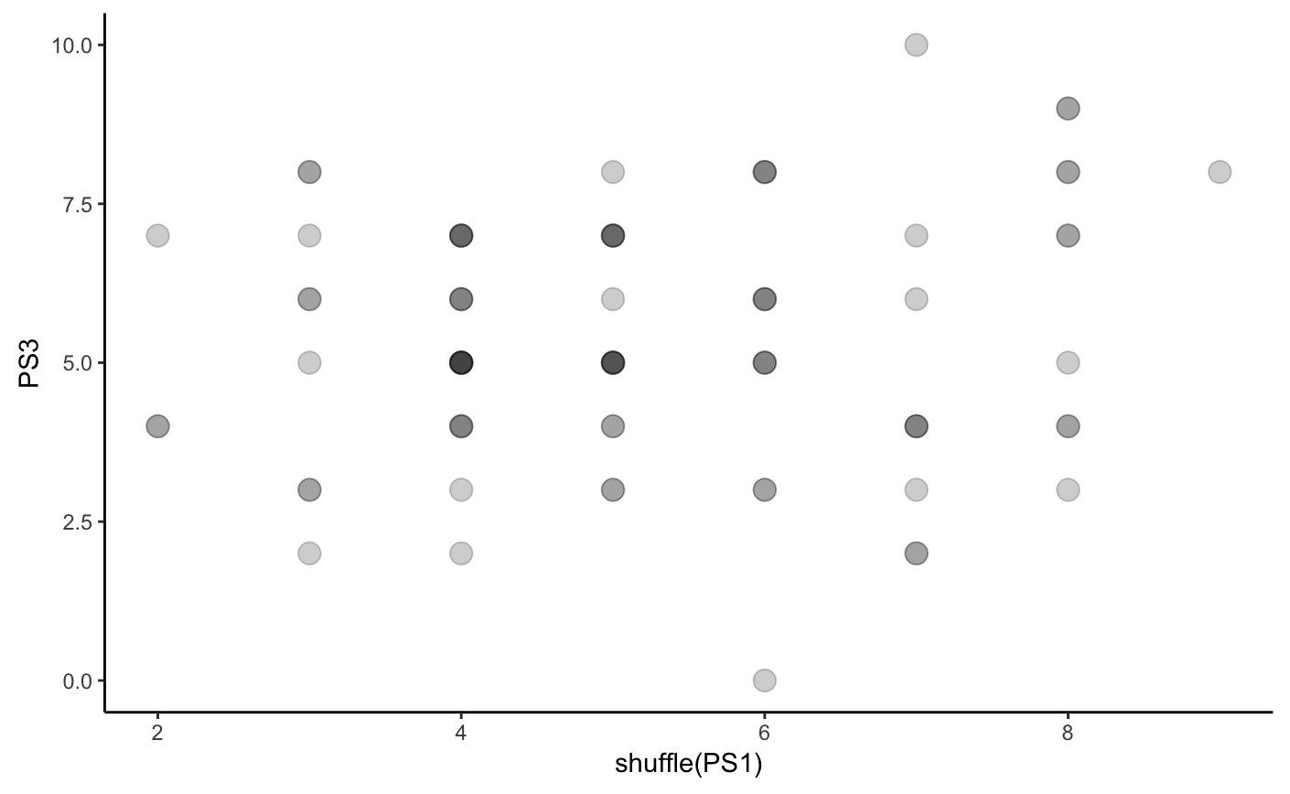

1. What sample statistic is really different in the sample versus the shuffled scatterplots: ?

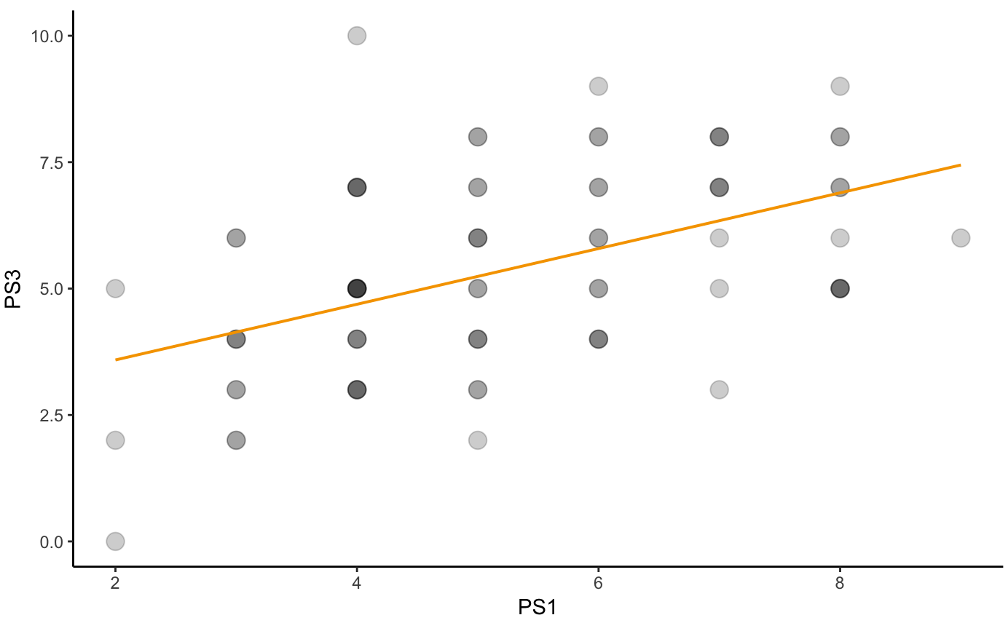 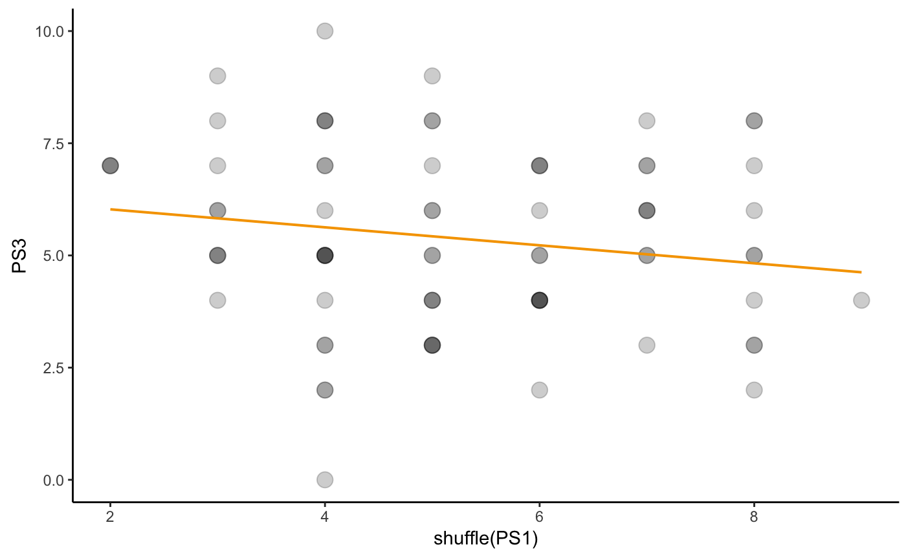 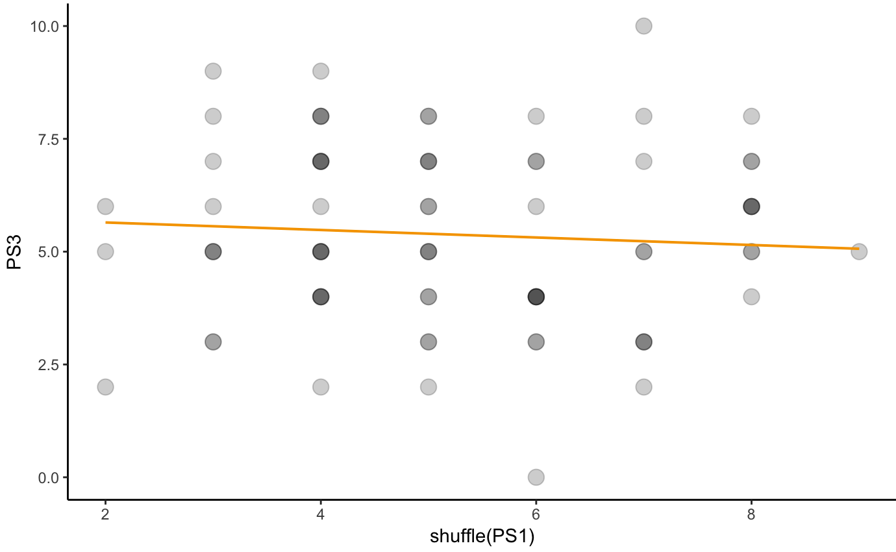 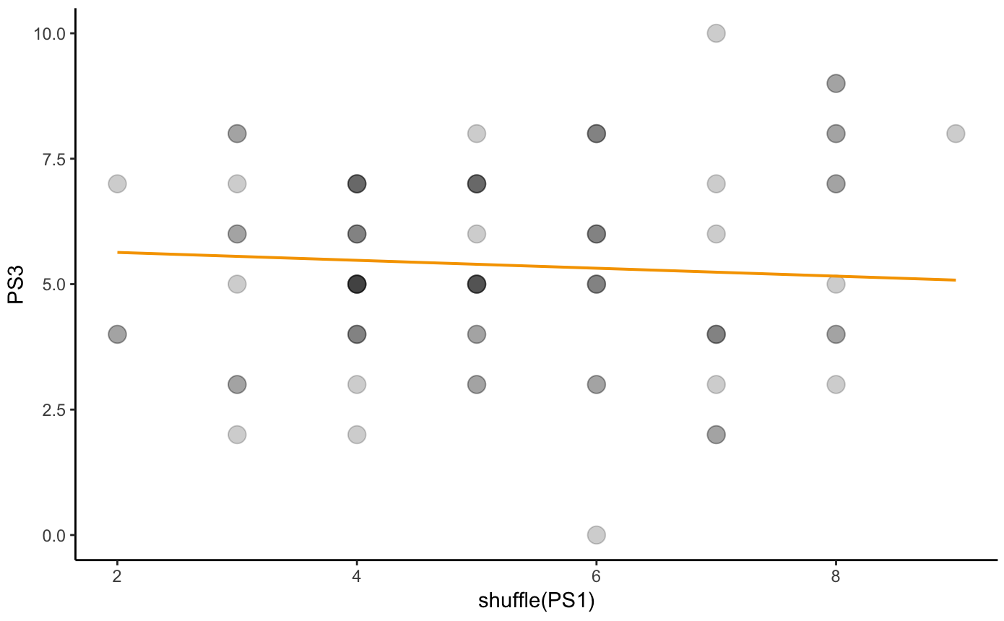

1. We have an intuition that really is different from the shuffled s. Let’s try and show exactly how different it is. Here we will create a plan with the distribution triad.
2. Let’s think about this as model comparison.

PS1 model:

Empty model:

What if our sample estimate of could have come from a DGP with = 0? Write that PS1 model here:

Is it any different from the empty model?

1. Let’s carry out the plan we conceived of using R.