**Name: Classwork 14.1**

**Analyzing Yeager, Hirschi, & Josephs’ Hypothesis**

**Respect Hypothesis:** Respectful instructions will create better medical adherence (especially in adolescents)

1. What variable might explain the variation in another variable? What is YH&J’s story of the DGP?
2. Let’s practice making the data available in DataCamp Sandbox (again). Download the file and make it available on DataCamp Sandbox or RStudio using your directions that you wrote before.
3. Now let’s go back to YHJ’s hypothesis.
   1. **Explore variation.** Explore the variation using a plot or graph.
      1. What would a 0 mean on this outcome variable?
      2. Did respect make a difference? Argue each side with a partner.
         1. Made a difference:
         2. Did not make a difference:
      3. Where would the predictions from the Respect model be in this plot? Residuals from Respect model? Where is the variation that has been “explained”?

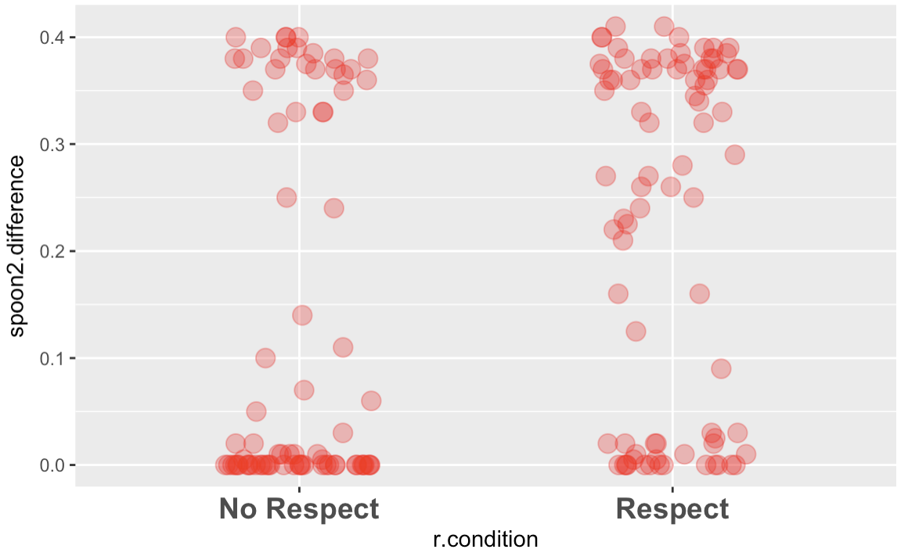

* 1. **Model variation**. Create the best fitting model and write it down here. Interpret your model’s estimates here.
  2. **Evaluate model**.
     1. PRE
        1. Interpret the PRE for the Respect model.
        2. Is it possible that we could have gotten this PRE from a random process (where these groups are essentially the same but they are just a little different because of sampling variation)?
        3. If you created such a DGP and a corresponding sampling distribution, how many of the PREs would be more extreme than the one you got?
 $b_{1}$

       4. Is it possible that we could have gotten this $b_{1}$ from a random process (where these groups are essentially the same but they are just a little different because of sampling variation)?
        5. If you created such a DGP and a corresponding sampling distribution, how many of the $b_{1}$ s would be more extreme than the one you got?
        6. Why is the shape of the sampling distribution of $b_{1}$ s different from the shape of the sample data?
     2. What are the range of possible $β_{1}$ s that could have produced our sample?

In your notebook, use the distribution triad to draw a picture of i, ii, and iii.