**Name:**

**Classwork 3**

**Questions from 1.4 - Save Your Work In R Objects**

1. Help us write better directions… how do we instruct students to answer NUM rather than print(10)

|  |  |
| --- | --- |
| DataCamp: ch1-10  *# Assign 5 to num and 10 to NUM*  num <-  NUM <-  *# Now write the code to print out the number 10* |  |

1. What is missing/wrong about these answers?

|  |  |
| --- | --- |
| DataCamp: ch1-20  *# Write some code that will store the answer to the question:* ***is the first element in the vector many.hellos "hi"?*** *in an R object called firstIsHi*  #answer 1  many.hellos[1]=="hi"  #answer 2  firstIsHi <- "hi"  #answer 3  firstisHI <- many.hellos[1]  #answer 4  many.hellos == "hi" <- firstIsHi |  |

**Questions from Chapter 2**

1. What is missing/wrong about this answer?

|  |  |
| --- | --- |
| DataCamp: ch2-8  *# arrange MindsetMatters by Wt in descending order*  *# also save it back into MindsetMatters*  #answer 1  MindsetMatters <-  arrange(MindsetMatters, desc(Age)) |  |

**Measurements**

Psychology is hard because we are constantly trying to measure invisible stuff like intelligence, social belonging, memory, perception, anxiety, etc. Then we want to figure out whether this stuff changes, improves, differs across people, predicts some future outcome, etc. Later, we will learn to create models that will help us do stuff like make predictions. But it all starts with figuring out measurement -- how would we know how much of *something* exists? How would we know how that thing varies across people?

Let’s start by measuring something easy. Heads.

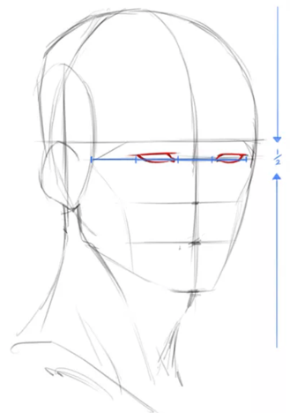**======= Head Sketch Survey =======**

**When people are taught to sketch faces, they are told to place the eyes at the midline of the head (see picture). This sometimes strikes people as wrong because they think the eyes are slightly above the midline of the head.**

1. **Before actually measuring your head, what you do you think? Circle the option that best fits your opinion.**
   1. **I think my eyes are basically at the midline of my head.**
   2. **I think my eyes are above the midline of my head.**
   3. **I think my eyes are below the midline of my head.**
2. **Self-Measurements: Now measure the length of your head and calculate where midline would be. Also measure where your eyes are in relation to the midline. Write your measurements in boxes below.**

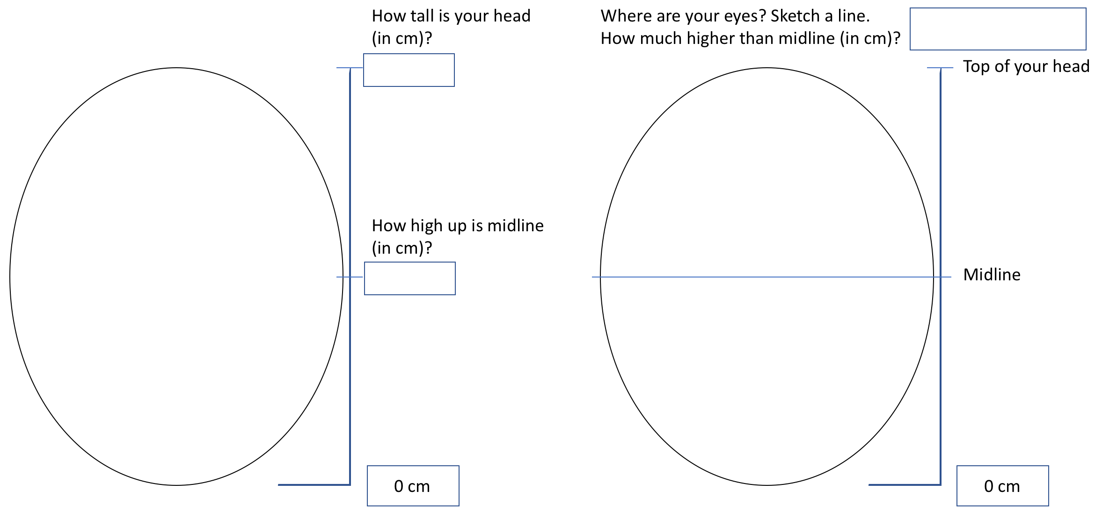

1. **Based on your measurements (in question 2), are your eyes on the midline?** 
   1. **My eyes are basically at the midline of my head.**
   2. **My eyes are above the midline of my head.**
   3. **My eyes are below the midline of my head.**
2. **Get together with a partner. Don’t show them your measurements. Silently let them measure you. Fill these out with THEIR measurements of YOUR face. Try to keep a poker face. Take turns.**

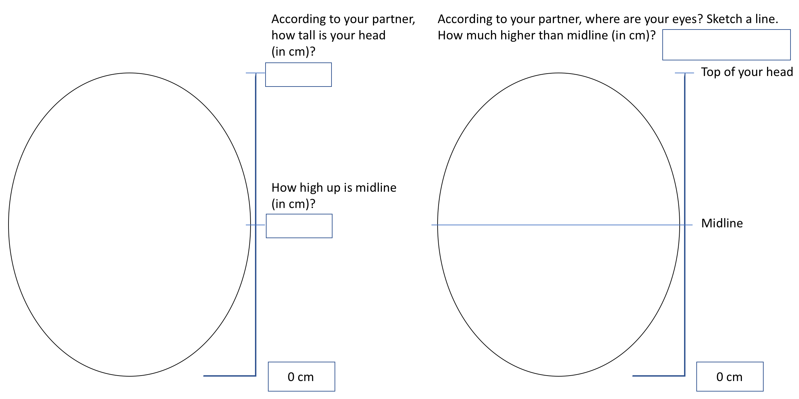

1. **How tall are you (in cm)? Feel free to either use the provided ruler or convert from inches to cm with a calculator (1 inch = 2.54 cm).**

**======= end of Head Sketch Survey =======**

1. Did your partner come up with identical measurements for your head/eyes/etc? Why do you think that is?
2. What are some things you could do if you wanted to make these measurements more similar? That is, how can you reduce the variability in your measurements?
3. Do you think we completely reduce the variability in measurement? Why or why not?
4. Now we're going to have the 3 tallest and 3 shortest students in the class share with us their head measurements. Create a rough plot of their head lengths in the space below.

___________ ___________ ___________ ___________ ___________ ___________

1. Now we will try to “explain” some of this variation. We know some of these students are tall and some are short. Which of these measurements came from the tall students? Which came from the short students? (Color code the plot you made above.)
2. Ah, so here’s what we just did:
3. What do you think it means to “explain” variation?
4. Does explaining variation mean that the variation just goes away?

**Lab: Measurements 🡪 Tidy Data Format**

1. On pg. 2.6 in the textbook, we talk about a data format called Tidy Data. Let’s remind ourselves of the three principles of Tidy Data:

1)

2)

3)

1. Each person in this class filled out a survey today. In groups of 4, discuss how we might put the data on the Head Sketch Survey into Tidy Data format.
2. Go to this google spreadsheet: <http://bit.ly/tidyheads>

Put in your 4 surveys into one of the sheets (Dr. Ji will assign your group a number)

1. What is “an observation” in our little head sketch study?
2. How is an observation different from a variable?
3. How is a value different from a variable?
4. Dr. Ji’s classes have done this exercise before. One of her classes had an average head height of 20.05 cm. According to tidy data principles, how would we put this data into our data frame (the one we created in our spreadsheet)?
5. Note that there are a number of ways to make this data tidy! Here’s one common way that many psychology studies do it: