**Name:**

**Classwork 5**

**Psychology Study: Mueller & Dweck (Lecture)**

Here is the code to get the data:

**PRAISESTUDY <- read.csv("http://bit.ly/muellerdweck_study1", header=TRUE)**

Mueller and Dweck did a study with kids, giving them IQ test questions, and randomly assigning them to one of three **FEEDBACK** conditions:

* Control (no further comment)
* Intelligence Praise (“hey, you did great; you must be so smart!”)
* Effort Praise (“hey, you did great; you must have tried hard!”)

For today, let’s ignore the Control condition and just look at the Intelligence and Effort conditions.

1. How would we filter for data from just these two conditions?
2. What are the observations in this data frame?

More details about the study to come but students did three sets (10 puzzles in each set). We will call them puzzle sets (PS) and label them **PS1**, **PS2**, **PS3**.

1. Make visualizations to look at whether **FEEDBACK** explains any of the variation in **PS1**, **PS2**, and **PS3**? (You should make 3 separate visualizations. Make notes about the R code you might want to use below.)

Which variable looks like **FEEDBACK** explains some of its variation?

R practice: If you made histograms, can you get rid of the gaps between bars in your histograms?

1. Let’s review our working definition of “explaining variation”:
2. When we look at a visualization and think – yeah, this one looks like some of the variation is explained – what features of the visualization should we look at?
3. How would we write a word equation for when **FEEDBACK** explains some of the variation in **PS1**? How about for **PS3**?
4. How would we write a word equation for when **FEEDBACK** does not explain the variation in **PS1**? How about for **PS3**?
5. Let’s learn a little more about the study. Study’s procedure: **PS1** (easy problems), verbal feedback, **PS2** (difficult), **PS3** (easy problems). Is it possible for **FEEDBACK** to cause **PS1** scores to be better or worse? Why or why not?
6. So why does it look like the groups are slightly different on their **PS1** scores?
7. Is it possible for **FEEDBACK** to cause **PS3** scores to be better or worse? Why or why not?
8. Check out the data but be careful not to jump to conclusions.
   1. 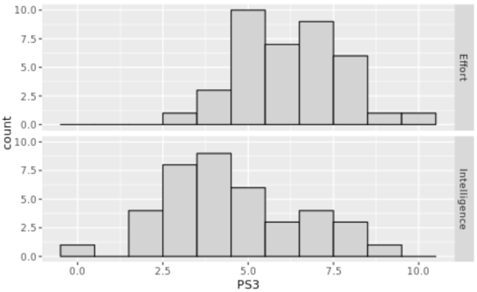What are some reasons (from the data) for suspecting that **FEEDBACK** really does explain some of the variation in **PS3** scores?
   2. What are some reasons (from the data) for suspecting that **FEEDBACK** does **not** explain some of the variation in **PS3** scores?
   3. Is it possible to have gotten this pattern of data if we just shuffled these scores into two different groups?
9. Let’s assume this was a well conducted experiment. In that case, there are two reasons why these two groups look different on their **PS3** scores. What are those reasons?

**Simulating a Random Process: Mueller & Dweck (Lab)**

1. Remember Westvaco? How did we “simulate” a random process then? Which R function acts like that?
2. Now we have a slightly different situation – we have values in two groups. How does the R function **shuffle()** mimic a random process?
3. How would we create a visualization of the shuffled data? Write the code here.
4. How is that different from the code for creating a visualization of the actual data?
5. Let’s go back to our “whole thing” diagram. If we create a bunch of histograms from shuffled data, where would we put that in this diagram?
6. If we shuffled the PS3 scores into two random groups, would our actual sample look similar or different from those random shuffled?
7. One of the faceted histograms below is the empirical sample. Can you tell which one it is? What are you looking for that is different in the empirical sample?

|  |  |  |
| --- | --- | --- |
|  |  |  |
|  |  |  |
|  |  |  |

1. Do you think the likelihood of getting a pattern of data like the empirical sample from a random process is high? Low? Medium? Explain your reasoning.
2. If the likelihood of getting a sample like the empirical sample from a random process is low, what theory of the DGP would that rule out? What theory would it support?
3. Compare and contrast today’s example to the Westvaco “whole thing” exercise. What was similar? What was different?