**UNIVERSITI TUN HUSSEIN ONN MALAYSIA**

Faculty of Computer Science and Information

Technology **Department of Software Engineering**  **BIE30803 Software Testing**

# RAIHAN AFIQAH BINTI LATIP (AI200096)

**Practical 5: Automate test cases using Selenium IDE**

|  |  |
| --- | --- |
| **Objective:** | 1. To know the process to automate test cases using Selenium 2. To automate test case generation |
| **Instructor:** | Dr Noraini Ibrahim |
| **Duration:** | 1 hour and 50 minutes |
| **Laboratory:** | Online Platform Google Meet meet.google.com/gfg-vnpc-aut |
| **Tools/Software:** | 1. Java 2. Eclipse 3. Selenium 4. Selenium IDE |
| **References:** | <https://www.guru99.com/installing-selenium-webdriver.html><https://www.youtube.com/watch?v=FRn5J31eAMw><https://usem.site/> |
| **Instruction** | Follow instructions in this practical worksheet. |
| **Report** | 1. Demo your TC001_ValidLogin during lab session. |

Run Login test case

1. Check your IDE Selenium by click on Extension Icon .

2. Click on “Selenium IDE”.

3. Click on “Create a new project”.

4. Give a Project Name

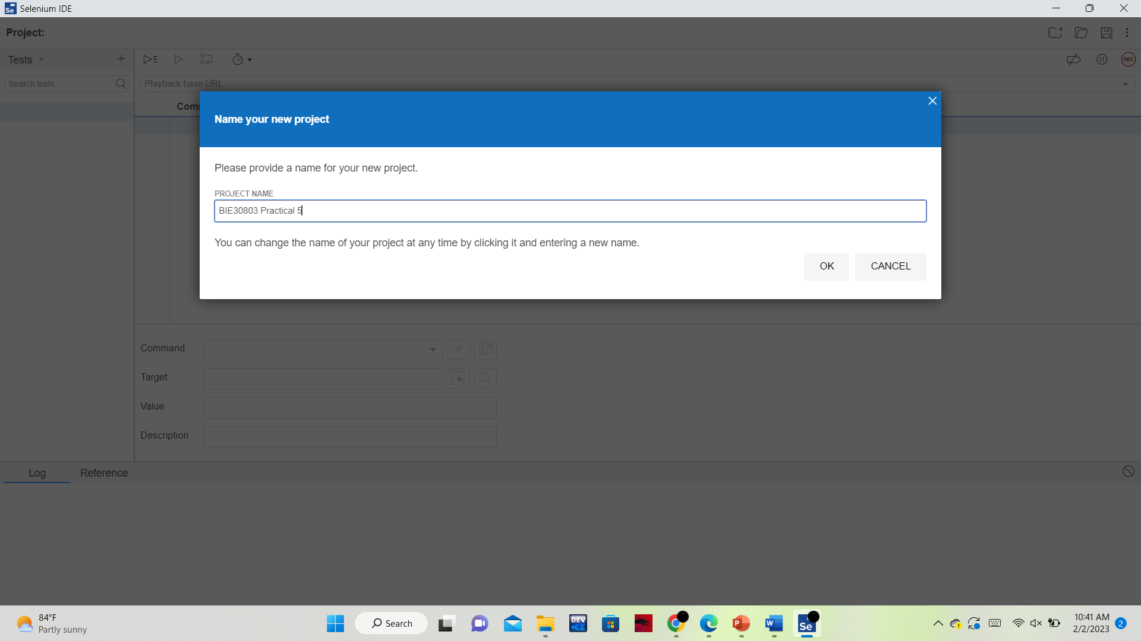

5. Click on “REC” icon and enter https://usem.site/ . Click START RECORDING.

6. Enter the username (dina) and password (AniRun11)

7. System will display the user profile page.

8. Right click and choose Selenium IDE>Verify>Present.

9. Click on stop recording. Click on Run current test.

10. TC001_ValidLogin completed successfully.

