Dr. Mohd Hamdi Irwan Bin Hamzah & Puan Ruhaya Binti Ab. Aziz

|  |  |  |
| --- | --- | --- |
| Applied Information Technology And Computer Science Vol. 0 No. 0 (2000) 000-000 | | |
| logo-penerbit.gif | © Universiti Tun Hussein Onn Malaysia Publisher’s Office  **AITCS**  Homepage: <http://publisher.uthm.edu.my/periodicals/index.php/aitcs> |  |
| e-ISSN :2773-5141 | | |

SK SEMERAH PADI HOMEWORK MANAGEMENT SYSTEM (SK SP HMS)

**Raihan Afiqah Latip**1 **Noraini Ibrahim**1 *

1Fakulti Sains Komputer dan Teknologi Maklumat,

Universiti Tun Hussein Onn Malaysia, Parit Raja, Batu Pahat, 86400, MALAYSIA

DOI: https://doi.org/10.30880/aitcs.0000.00.00.000

Received 29 Month 2022; Accepted 01 January 2022; Available online 02 January 2022

***Abstract****:* Sekolah Kebangsaan Semerah Padi Homework Management System (SK SP HMS) is a web-based system that mainly acts as a platform for teachers to add and grade homework and for students to submit their homework. The system aims to improve the flaws discovered in the current process that requires the student to submit their physical book to the teacher and the teacher needs to review and return the book to the student after they review it. Meanwhile, a scrum model is used to develop this project by using an object-oriented approach. The programming languages used are Hypertext Preprocessor (PHP) and HyperText Mark-up language (HTML). This system is built to assist the students and teacher to complete their task more efficiently and assist the parents to monitor their child's progress.

***Keywords****:* Sekolah Kebangsaan Semerah Padi Homework Management System, web-based system

## Introduction

Homework is an important thing for students. Briefly it [1] is a task assigned for students to complete out of school hours. It is one of the methods used to test the student’s level of understanding. Homework also helps students to build up their thinking and problem-solving skills. An efficient homework management system (HMS) is important to keep things organized.

Sekolah Kebangsaan Semerah Padi (SK SP) is a primary school located at Kuching, Sarawak. The existing process for SK SP HMS is still done traditionally. The issue arises with the implementation of the current HMS at SK SP where it is difficult for students to manage the homework, it is challenging for

teachers to manage student homework and it is difficult for parents to monitor their child’s homework progress.

As a result, this project aims to design, develop, and test the solution to solve the issues by creating HMS for SK SP that would help students and teachers to manage their task efficiently. In addition, it would also help the parents to monitor their child's progress easily. The system stakeholders which will be using the proposed system are the admin, teacher, student, and parents. The project's significance is to improve the student’s educational well-being, to develop student’s time management skills and to have a conducive learning environment. There will be 7 modules in SK SP HMS which are login, register user, manage user information, manage homework, submit homework, record grade, and generate report.

The following section of the report are organized as follows. Section 2 covers the related work which consist of web-based application, homework management system, study of existing related system, and comparison with existing system. Meanwhile in section 3 discuss the project’s methodology and in section 4 result and discussion is analyzed. Lastly section 5 is the conclusion of the project.

## Related Work

This section explains about the concepts of web-based applications and similar applications that can be compared with the proposed system in the project are studied.

* 1. Web-based application

A web-based application is a program that is accessible over an internet connection instead of existing within a device’s memory. Most of the time web-based applications run inside a web browser. In the last ten years, there has been a significant change in the state of web application development which may be caused by the improvement of greater bandwidth [2]. Few examples of web applications are Gmail, Facebook, Instagram, and Twitter [3].

The performance, reliability and quality of web-based applications are important things that should be considered. The common issues of web applications are web site crashes and security breaches. It should be handled and managed to avoid bad user experience. Some advantages of using web-based applications are it is always up to date since the update is automated and it is accessible anywhere with internet access.

* + 1. Homework management system (HMS)

In many fields of study such as chemistry, physics and mathematics, web-based homework systems have replaced traditional paper-and-pencil homework [4]. People are adapting with technology and the students nowadays prefer to do things digitally including submitting the homework.

There are a lot of homework management systems available. Some HMS use web-based applications, and some may use mobile applications or both. For example, Google Classroom [5] is available for Chrome operating system (Chrome OS) and Android. The proposed system will be developed using web-based applications for easier access for the user.

* 1. Study of Existing Related Systems

Three existing systems are investigated through each system characteristics to support the study of the proposed system. The three existing systems selected are Frog VLE, Google Classroom and AUTHOR- UTHM.

* + 1. Comparison with existing systems

The features between the three existing systems and the proposed system are compared and listed in Table 1.

Table 1: Comparison of existing system with proposed system

|  |  |  |  |  |
| --- | --- | --- | --- | --- |
| Features/System | Frog VLE [6] | Google Classroom [7] | AUTHOR-UTHM [8] | SK SP HMS |
| Login | Users need to input Yes ID/NRIC and password to login into the system | Users need to login with Google Account to login into the system | Users need to input username and password to login into the system | Users need to input username and password to login into the system |
| Register user | The admin needs to register the user to allow them login into the system | Users need to have Google Account to login into the system | The admin needs to activate student’s Author account to login into system | The admin needs to register the user to allow them login into the system |
| Manage user information | The admin may add, edit, and delete the user information | The instructor may add, edit, and delete the user information | The admin may add, edit, and delete the user information | The admin may add, edit, and delete the user information |
| Add Homework | Instructor may click on the  +(plus) button in FrogBar to add homework | The instructor may click on the “+ Create” in classwork section button to add homework | The lecturer may click “Add project” to add homework | The teacher may click “Add” button to add homework |
| Submit Homework | The student may drop or drag the file they want to upload and click “hand- in” button to submit homework | The student may upload google drive, link, or file and click “turn in” to submit homework | The student may click browse to submit. They can upload up to 100MByte per-file | The student may upload the file (.doc/.jpeg) |

|  |  |  |  |  |
| --- | --- | --- | --- | --- |
| Grade Homework | The instructor may mark the homework virtually and the student should be able to view it after the instructor upload the grade | The instructor will upload the mark on the classwork section and the student should be able to view it after the instructor upload the grade | The lecturer will upload the mark on the mark section and the student should be able to view it after the instructor upload the grade | Teacher should be able to mark the student and upload the grade so that the student and parent may view the grade |
| Generate report | Markbook is the latest feature in Frog VLE that easily allows instructors to review classroom progress for online and offline assignments across the year. | Teachers can create [student Progress](https://docs.google.com/document/d/1toZ5kzJBK6X5lZrYLALJsBJJRU_zUn9F-2VoTVLd0gk/edit?usp=drive_web&ouid=103849804399107067156) [Reports](https://docs.google.com/document/d/1toZ5kzJBK6X5lZrYLALJsBJJRU_zUn9F-2VoTVLd0gk/edit?usp=drive_web&ouid=103849804399107067156) based on Google Classroom activity across all classes connected in Schoolytics and over any date range. The teacher may share the report with the student. | This feature is not available | Teacher, student, and parent may view the grade report |
| Announcement | This feature is not available | The instructor may post announcement on the steam section | The lecturer may put an announcement on stream section | This feature is not available |
| Communicate with teacher | The system can be used to communicate with teachers, students, and parents | On the stream section there is a comment feature which allow student in the class to communicate with lecturer | On the stream section there is a reply feature which allow student to communicate with lecturer | This feature is not available |

Based on table 1 the proposed system has all the features listed except for announcements and communicates with teacher features. The similarities and difference can be used to improve HMS for SK SP.

## Methodology/Framework

The development of SK SP HMS is based on the scrum model. Scrum models include a few important phases. Table 2 shows the phases in scrum methodology and the outcome from the findings.

* 1. Software process

A scrum model was chosen for the methodology of this project. The advantage of using this model is it produce a higher quality since the process is iterative until the product meet the requirements.

Table 2: Activity based on scrum framework

|  |  |  |
| --- | --- | --- |
| Phase | Activity | Outcome |
| Pre-sprint phase | Determine features Determine task item for each feature  Review the stakeholder | Proposal of the project Product backlog  Gantt chart  Use case diagram  Class diagram |
| Sprint 0 | Sprint 0 Planning for login features  Sprint 0 Implementation for login use case  Sprint 0 Testing for login use  case | Sequence diagram for login use case  Activity diagram for login use case  Code for login use case |
| Sprint 1 | Sprint 1 Planning for register user features  Sprint 1 Implementation for register user use case  Sprint 1 Testing for register user use case | Sequence diagram for register user use case Activity diagram for register user use case  Code for register user use case |
| Sprint 2 | Sprint 2 Planning for manage user information features  Sprint 2 Implementation for manage user information use case  Sprint 2 Testing for manage user information use case | Sequence diagram for manage user information use case  Activity diagram for manage user information use case  Code for manage user information use case |
| Sprint 3 | Sprint 3 Planning for manage homework features  Sprint 3 Implementation for manage homework use case Sprint 3 Testing for manage homework use case | Sequence diagram for manage homework use case Activity diagram for manage homework use case  Code for manage homework use case |

|  |  |  |
| --- | --- | --- |
| Sprint 4 | Sprint 4 Planning for submit homework features  Sprint 4 Implementation for submit homework use case Sprint 4 Testing for submit homework use case | Sequence diagram for submit homework use case  Activity diagram for submit homework use case  Code for submit homework use case |
| Sprint 5 | Sprint 5 Planning for grade homework and generate report features  Sprint 5 Implementation for grade homework and generate report use case Sprint 5 Testing for grade homework and generate report use case | Sequence diagram for grade homework and generate report use case  Activity diagram for grade homework and generate report use case  Code for grade homework and generate report use case |

* 1. Pre-sprint phase

Sprint planning is a phase where the team will determine the product backlog items, they will work on during sprint and discuss their plan to complete the product backlog items

* + 1. Use case diagram

Behavior diagram in UML is portrayed using a use case diagram [9]. It can be used to describe the functional requirements of the proposed system. Based on Figure 2 there are 7 functions which are login, register student, teacher, parent, manage student, parent, and teacher information, add homework, grade homework, submit homework and generate reports.

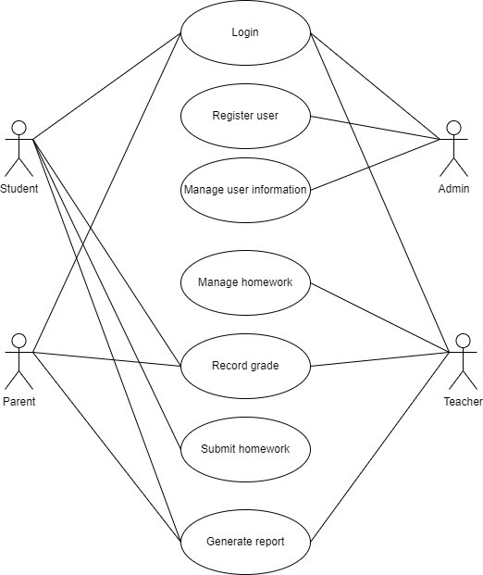

Figure 1: Use case diagram for SK SP HMS

* + 1. Class diagram

The static behavior of the application system is represented using a class diagram. It represents the details such as class name and attributes [10]. The class diagram for SK SP HMS is attach in appendix a

## Result and discussion

This section will discuss the outcome for sprint 0 and sprint 1. Meanwhile for other remaining progress their sequence, activity, use case specification, and wireframe is attached in appendix b.

* 1. Sprint *0*

This section shows the use case specification with interface, sequence, and activity diagram for sprint 0 outcome which is login features. The use case specification is attached in appendix b



* 1. Sprint *1*

This section shows the use case specification with interface, sequence and activity diagram for sprint 1 outcome which is register features. The use case specification is attached in appendix b

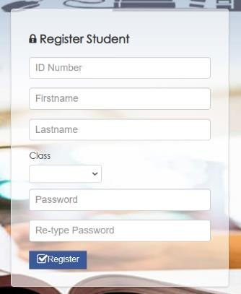

## Conclusion

SK SP HMS is designed to facilitate the user to complete their task efficiently. The object-oriented software development model was chosen as the project methodology and used the scrum model as guidance throughout the project. This project is expected to benefit HMS users. Advantages of using this system is the HMS user can replace the older system which was less efficient. The disadvantage of using this system is the system requires an internet connection. For future recommendations, the system should implement a homework management system that can have notification updates.

Acknowledgement

Author wishes to give their endless gratitude to the lecturers, Faculty of Computer Science and Technology and University Tun Hussein Onn Malaysia for all the support given.

## References

1. Xu, J., Du, J., Cunha, J., & Rosário, P. (2021). Student perceptions of homework quality, autonomy support, effort, and math achievement: Testing models of reciprocal effects. *Teaching and Teacher Education*, *108*, 103508.
2. Satrom, B. (2018). Choosing the Right JavaScript Framework for Your Next Web Application.

*Prog./Kendo UI*, *34*.

1. Chinnathambi, K. (2018). *Learning react: A hands-on guide to building web applications using react and Redux*. Addison-Wesley.
2. Serhan, D. (2019). Web-Based Homework Systems: Students' Perceptions of Course Interaction and Learning in Mathematics. *International Journal on Social and Education Sciences*, *1*(2), 57- 62.
3. *Get the Classroom app - Classroom Help*. (2022). Google.com. <https://support.google.com/edu/classroom/answer/6118412?hl=en>
4. *Homework :: Frog | Schools & Education*. (2023). Frogeducation.com. <https://www.frogeducation.com/community/training/homework>
5. *Get started with Classroom for students - Android - Classroom Help*. (2019). Google.com. [https://support.google.com/edu/classroom/answer/9582544?hl=en&co=GENIE.Platform%3DAnd](https://support.google.com/edu/classroom/answer/9582544?hl=en&co=GENIE.Platform%3DAndroid&zippy=%2Ccommunicate-with-your-teacher-or-classmates%2Cwork-offline%2Cjoin-a-video-meeting%2Cstart-or-turn-in-your-classwork%2Csee-your-feedback-or-grade%2Cmanage-your-account-classes-or-notifications%2Cexplore-the-classes-page%2Cexplore-the-stream-page%2Cexplore-the-classwork-page%2Cexplore-the-people-page) [roid#zippy=%2Ccommunicate-with-your-teacher-or-classmates%2Cwork-offline%2Cjoin-a-](https://support.google.com/edu/classroom/answer/9582544?hl=en&co=GENIE.Platform%3DAndroid&zippy=%2Ccommunicate-with-your-teacher-or-classmates%2Cwork-offline%2Cjoin-a-video-meeting%2Cstart-or-turn-in-your-classwork%2Csee-your-feedback-or-grade%2Cmanage-your-account-classes-or-notifications%2Cexplore-the-classes-page%2Cexplore-the-stream-page%2Cexplore-the-classwork-page%2Cexplore-the-people-page) [video-meeting%2Cstart-or-turn-in-your-classwork%2Csee-your-feedback-or-grade%2Cmanage-](https://support.google.com/edu/classroom/answer/9582544?hl=en&co=GENIE.Platform%3DAndroid&zippy=%2Ccommunicate-with-your-teacher-or-classmates%2Cwork-offline%2Cjoin-a-video-meeting%2Cstart-or-turn-in-your-classwork%2Csee-your-feedback-or-grade%2Cmanage-your-account-classes-or-notifications%2Cexplore-the-classes-page%2Cexplore-the-stream-page%2Cexplore-the-classwork-page%2Cexplore-the-people-page) [your-account-classes-or-notifications%2Cexplore-the-classes-page%2Cexplore-the-stream-](https://support.google.com/edu/classroom/answer/9582544?hl=en&co=GENIE.Platform%3DAndroid&zippy=%2Ccommunicate-with-your-teacher-or-classmates%2Cwork-offline%2Cjoin-a-video-meeting%2Cstart-or-turn-in-your-classwork%2Csee-your-feedback-or-grade%2Cmanage-your-account-classes-or-notifications%2Cexplore-the-classes-page%2Cexplore-the-stream-page%2Cexplore-the-classwork-page%2Cexplore-the-people-page) [page%2Cexplore-the-classwork-page%2Cexplore-the-people-page](https://support.google.com/edu/classroom/answer/9582544?hl=en&co=GENIE.Platform%3DAndroid&zippy=%2Ccommunicate-with-your-teacher-or-classmates%2Cwork-offline%2Cjoin-a-video-meeting%2Cstart-or-turn-in-your-classwork%2Csee-your-feedback-or-grade%2Cmanage-your-account-classes-or-notifications%2Cexplore-the-classes-page%2Cexplore-the-stream-page%2Cexplore-the-classwork-page%2Cexplore-the-people-page)
6. *Instructor’ s ver.1.0*. (n.d.). Retrieved January 10, 2023, from <https://cad.uthm.edu.my/images/manual_pengguna/author-document-instructor_part2.pdf>
7. Fauzan, R., Siahaan, D., Rochimah, S., & Triandini, E. (2021). A different approach on automated use case diagram semantic assessment. *International Journal of Intelligent Engineering and Systems*, *14*(1), 496-505.
8. Kulkarni, R. N., & Prasad, P. P. R. (2021). Abstraction of UML Class Diagram from the Input Java Program. *International Journal Of Advanced Networking And Applications*, *12*(4), 4644-4649.

**APPENDIX a (Use Case Specification*.***

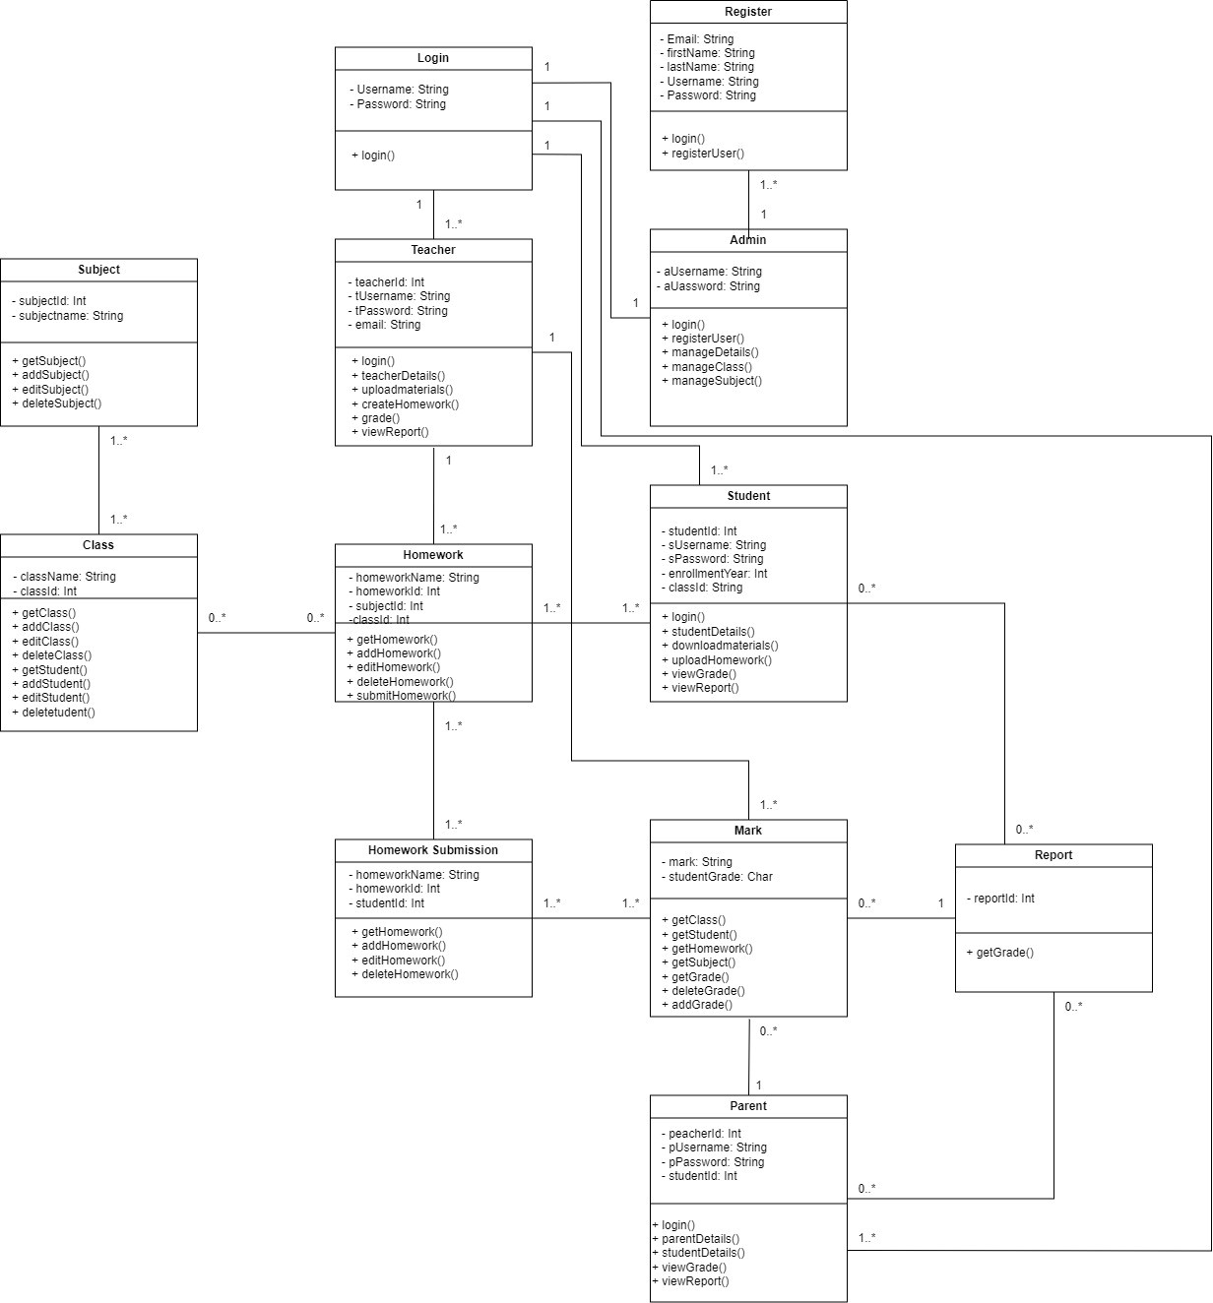

Figure 1: Class diagram for SK SP HMS

**APPENDIX b (Use Case Specification*.***

# Use Case Specification for Login

|  |  |  |  |  |  |  |
| --- | --- | --- | --- | --- | --- | --- |
| **History Log** | 1.0.0 | 1. Create initial use case | | | | |
|  | 1.0.1 | 1. Fixed alternative flow in normal flow | | | | |
| **Version** | 1.0.1 | | | | | |
| **Use Case ID** | UC-1 | | | | | |
| **Use Case Name** | Login | | | | | |
| **Created By** | Raihan Afiqah | | | **Updated By** | Raihan Afiqah | |
| **Date Created** | 8 January 2022 | | | **Last Revision**  **Date** | 8 January 2022 | |
| **Actors** | Admin, Teacher, Parent, Student | | | | | |
| **Description** | Login of user into the system | | | | | |
| **Preconditions** | Users need to insert username and password | | | | | |
| **Post conditions** | User will be redirected to home page | | | | | |
| **Normal Flow** | * 1. Verify the users      1. Users need to insert valid username and password      2. System redirects users to the homepage      3. If the user is new user, they need to ask user to register them first | | | | | |
| **Alternative flow** | NONE | | | | | |
| **Exceptions** | * 1. **Fail to login**      1. System pop up to inform users that invalid user and password      2. System will pop up to input correct username and password | | | | | |
| **Related requirement** | **ID** | | **Requirement** | | | **Priority** |
| FR01-01 | | The system should allow user to  login into the system using registered username and password. | | | Basic |
|  | FR01-02 | | The system should allow only registered user to login into the  system | | | Excitement |

|  |  |  |  |
| --- | --- | --- | --- |
|  | FR01-03 | The system should redirect user to respective home page upon  successful login | Performance |
|  | CR01-01 | The system shall not allow unregistered user to login into  system | Basic |
| **Activity Diagram** | | | |
| Diagram  Description automatically generated  Figure 1.1: Activity diagram for use case login | | | |

|  |
| --- |
| **Sequence Diagram** |
| Diagram  Description automatically generated  Figure 1.2: Sequence diagram for use case login |

|  |  |  |  |  |  |  |
| --- | --- | --- | --- | --- | --- | --- |
| **History Log** | 1.0.0 | 1. Create initial use case | | | | |
|  | 1.0.1 | 1. Fixed alternative flow in normal flow | | | | |
| **Version** | 1.0.1 | | | | | |
| **Use Case ID** | UC-2 | | | | | |
| **Use Case Name** | Register user | | | | | |
| **Created By** | Raihan Afiqah | | | **Updated By** | Raihan Afiqah | |
| **Date Created** | 8 January 2022 | | | **Last Revision**  **Date** | 8 January 2022 | |
| **Actors** | Admin | | | | | |
| **Description** | Register user into the system | | | | | |
| **Preconditions** | Admin need to login into the system | | | | | |
| **Post conditions** | Admin will be redirected to user view detail page | | | | | |
| **Normal Flow** | * 1. User Registration      1. Admin will input all details for new user      2. System will store into the database      3. If the registration is successful, the system will redirect to users view detail page | | | | | |
| **Alternative flow** | NONE | | | | | |
| **Exceptions** | * 1. **Fail to register**      1. System pop up to inform user registration fail      2. System will pop up to input correct detail | | | | | |
| **Related requirement** | **ID** | | **Requirement** | | | **Priority** |
| FR02-01 | | The system should allow admin to  register new user into the system | | | Basic |
|  | FR02-02 | | The system should be able to store the registered user information in the database | | | Basic |

|  |
| --- |
| **Activity Diagram** |
| Diagram  Description automatically generated with medium confidence  Figure 2.1: Activity diagram for use case register user |
| **Sequence Diagram** |
| Graphical user interface  Description automatically generated with medium confidence  Figure 2.2: Sequence diagram for use case register user |

|  |  |  |  |  |
| --- | --- | --- | --- | --- |
| **History Log** | 1.0.0 | 1. Create initial use case | | |
|  | 1.0.1 | 1. Fixed alternative flow in normal flow | | |
| **Version** | 1.0.1 | | | |
| **Use Case ID** | UC-3 | | | |
| **Use Case Name** | Manage user information | | | |
| **Created By** | Raihan Afiqah | | **Updated By** | Raihan Afiqah |
| **Date Created** | 8 January 2022 | | **Last Revision**  **Date** | 8 January 2022 |
| **Actors** | Admin | | | |
| **Description** | Add, edit, and delete user information | | | |
| **Preconditions** | Admin need to login into the system | | | |
| **Post conditions** | System will redirect user to user view detail page | | | |
| **Normal Flow** | * 1. Add user detail      1. Admin click “add” button      2. Admin enter all the user details      3. Admin click “submit” button      4. System add the information   2. Edit user detail      1. Admin click “edit” button      2. Admin update the user details      3. Admin click “submit” button      4. System edit the user information   3. Delete user detail      1. Admin click “delete” button      2. System prompt confirmation message      3. Admin click “delete” button      4. System delete user information | | | |
| **Alternative flow** | NONE | | | |
| **Exceptions** | * 1. **Fail to add user detail**      1. System pop up to inform user detail addition fail      2. System will pop up to input correct detail | | | |

|  |  |  |  |
| --- | --- | --- | --- |
|  | * 1. **Fail to edit user detail**      1. System pop up to inform update user detail fail      2. System will pop up to try again   2. **Fail to delete user detail**      1. System pop up to inform user detail deletion fail      2. System will pop up to try again | | |
| **Related requirement** | **ID** | **Requirement** | **Priority** |
| FR03-01 | The system should allow admin to  register new user into the system | Basic |
|  | FR03-0 | The system should be able to store  the registered user information in the database | Basic |
| **Activity Diagram** | | | |
| Diagram  Description automatically generated  Figure 3.1: Activity diagram for use case manage user information | | | |

|  |
| --- |
| **Sequence Diagram** |
| Graphical user interface, table  Description automatically generated  Figure 3.2: Sequence diagram for use case Manage user information |

1. Use Case Specification for Manage homework

|  |  |  |  |  |
| --- | --- | --- | --- | --- |
| **History Log** | 1.0.0 | 1. Create initial use case | | |
|  | 1.0.1 | 1. Fixed alternative flow in normal flow | | |
| **Version** | 1.0.1 | | | |
| **Use Case ID** | UC-4 | | | |
| **Use Case Name** | Manage homework | | | |
| **Created By** | Raihan Afiqah | | **Updated By** | Raihan Afiqah |
| **Date Created** | 8 January 2022 | | **Last Revision**  **Date** | 8 January 2022 |
| **Actors** | Teacher | | | |
| **Description** | Add, edit, and delete homework | | | |
| **Preconditions** | Teacher needs to login into the system | | | |
| **Post conditions** | System will redirect user to homework view detail page | | | |
| **Normal Flow** | * 1. Add homework detail      1. Teacher click “add” button      2. Teacher enter all the homework details      3. Teacher click “submit” button      4. System add homework   2. Edit homework detail      1. Teacher click “edit” button      2. Teacher update the homework details      3. Teacher click “submit” button      4. System edit the homework   3. Delete homework detail      1. Teacher click “delete” button      2. System prompt confirmation message      3. Teacher click “delete” button      4. System delete homework | | | |
| **Alternative flow** | NONE | | | |
| **Exceptions** | * 1. **Fail to add homework**      1. System pop up to inform homework addition fail      2. System will pop up to input correct detail | | | |

|  |  |  |  |
| --- | --- | --- | --- |
|  | * 1. **Fail to edit homework**      1. System pop up to inform the update homework fail      2. System will pop up Try again   2. **Fail to delete homework**      1. System pop up to inform user homework deletion fail      2. System will pop up Try again | | |
| **Related requirement** | **ID** | **Requirement** | **Priority** |
| FR04-01 | The system should allow teacher to  add homework | Basic |
|  | FR04-02 | The system should allow teacher to  edit homework | Basic |
|  | FR04-03 | The system should allow teacher to  delete homework | Basic |
| **Activity Diagram** | | | |
| A screenshot of a computer  Description automatically generated with medium confidence  Figure 4.1: Activity diagram for use case Manage homework | | | |

|  |
| --- |
| **Sequence Diagram** |
| A screenshot of a computer  Description automatically generated with medium confidence  Figure 4.2: Sequence diagram for use case Manage homework |

# Use Case Specification for Submit homework

|  |  |  |  |  |  |  |
| --- | --- | --- | --- | --- | --- | --- |
| **History Log** | 1.0.0 | 1. Create initial use case | | | | |
|  | 1.0.1 | 1. Fixed alternative flow in normal flow | | | | |
| **Version** | 1.0.1 | | | | | |
| **Use Case ID** | UC-5 | | | | | |
| **Use Case Name** | Submit homework | | | | | |
| **Created By** | Raihan Afiqah | | | **Updated By** | Raihan Afiqah | |
| **Date Created** | 8 January 2022 | | | **Last Revision**  **Date** | 8 January 2022 | |
| **Actors** | Student | | | | | |
| **Description** | Submit and delete submitted homework | | | | | |
| **Preconditions** | Student needs to login into the system | | | | | |
| **Post conditions** | System will redirect user to submit homework view page | | | | | |
| **Normal Flow** | * 1. Add homework detail      1. Student click “add” button      2. Student upload the homework      3. System add homework   2. Delete homework detail      1. Student click “delete” button      2. System prompt confirmation message      3. Student click “delete” button      4. System delete submitted homework | | | | | |
| **Alternative flow** | NONE | | | | | |
| **Exceptions** | * 1. **Fail to add homework**      1. System pop up to inform homework addition fail      2. System will pop up to input correct detail   2. **Fail to delete submitted homework**      1. System pop up to inform user homework deletion fail      2. System will pop up Try again | | | | | |
| **Related requirement** | **ID** | | **Requirement** | | | **Priority** |
| FR05-01 | | The system should allow student to  submit homework | | | Basic |

|  |  |  |  |
| --- | --- | --- | --- |
|  | FR05-02 | The system should be able to allow student to delete submitted  homework | Basic |
| **Activity Diagram** | | | |
| Diagram, engineering drawing  Description automatically generated  Figure 5.1: Activity diagram for use case Submit homework | | | |

|  |
| --- |
| **Sequence Diagram** |
| Diagram, engineering drawing  Description automatically generated  Figure 5.2: Sequence diagram for use case Submit homework |

1. Use Case Specification for Record grade

|  |  |  |  |  |
| --- | --- | --- | --- | --- |
| **History Log** | 1.0.0 | 1. Create initial use case | | |
|  | 1.0.1 | 1. Fixed alternative flow in normal flow | | |
| **Version** | 1.0.1 | | | |
| **Use Case ID** | UC-6 | | | |
| **Use Case Name** | Record grade | | | |
| **Created By** | Raihan Afiqah | | **Updated By** | Raihan Afiqah |
| **Date Created** | 8 January 2022 | | **Last Revision**  **Date** | 8 January 2022 |
| **Actors** | Teacher, Student, Parent | | | |
| **Description** | Add, edit, delete, and view grade | | | |
| **Preconditions** | Users need to login into the system | | | |
| **Post conditions** | System will redirect user to grade view page | | | |
| **Normal Flow** | * 1. Add grade      1. Teacher click “add” button      2. Teacher enter grade      3. Teacher click “submit” button      4. System add the grade   2. Edit grade      1. Teacher click “edit” button      2. Teacher update the grade      3. Teacher click “submit” button      4. System edit the grade   3. Delete grade      1. Teacher click “delete” button      2. System prompt confirmation message      3. Teacher click “delete” button      4. System delete grade         1. View grade            1. User click view grade            2. System redirect user to grade view page            3. Choose year | | | |

|  |  |  |  |
| --- | --- | --- | --- |
|  | 3. System display grade | | |
| **Alternative flow** | NONE | | |
| **Exceptions** | * 1. **Fail to add grade**      1. System pop up to inform grade addition fail      2. System will pop up Try again   2. **Fail to edit grade**      1. System pop up to inform update grade fail      2. System will pop up Try again   3. **Fail to delete grade**      1. System pop up to inform grade deletion fail      2. System will pop up Try again | | |
| **Related requirement** | **ID** | **Requirement** | **Priority** |
| FR06-01 | The system should allow teacher to  add grade | Basic |
|  | FR06-02 | The system should allow teacher to  edit grade | Basic |
|  | FR06-03 | The system should allow teacher to  delete grade | Basic |
|  | FR06-04 | The system should allow student and parent to view grade | Basic |

|  |
| --- |
| **Activity Diagram** |
| Diagram  Description automatically generated  Figure 6.1: Activity diagram for use case Record grade |

|  |
| --- |
| **Sequence Diagram** |
| Diagram  Description automatically generated  Figure 6.2: Sequence diagram for use case record grade |

# Use Case Specification for Generate report

|  |  |  |  |  |  |  |
| --- | --- | --- | --- | --- | --- | --- |
| **History Log** | 1.0.0 | 1. Create initial use case | | | | |
|  | 1.0.1 | 1. Fixed alternative flow in normal flow | | | | |
| **Version** | 1.0.1 | | | | | |
| **Use Case ID** | UC-6 | | | | | |
| **Use Case Name** | Generate report | | | | | |
| **Created By** | Raihan Afiqah | | | **Updated By** | Raihan Afiqah | |
| **Date Created** | 8 January 2022 | | | **Last Revision**  **Date** | 8 January 2022 | |
| **Actors** | Teacher, Student, Parent | | | | | |
| **Description** | To generate grade report | | | | | |
| **Preconditions** | Users need to login into the system | | | | | |
| **Post conditions** | System will redirect user to report view page | | | | | |
| **Normal Flow** | * 1. Generate report      1. Select Report option      2. Choose year      3. System will generate the grade report | | | | | |
| **Alternative flow** | NONE | | | | | |
| **Exceptions** | * 1. **No grade added for the year**      1. The report will not display   2. **Fail to generate report**      1. System pop up to inform report cannot be generated      2. System will pop up Try again | | | | | |
| **Related requirement** | **ID** | | **Requirement** | | | **Priority** |
| FR07-01 | | The system should allow teacher, parent, and student to generate report | | | Basic |

|  |
| --- |
| **Activity Diagram** |
| A screenshot of a computer  Description automatically generated with medium confidence  Figure 7.1: Activity diagram for use case Generate report |

|  |
| --- |
| **Sequence Diagram** |
| A screenshot of a computer  Description automatically generated  Figure 7.2: Sequence diagram for use case Generate report |

Outcome (wireframe) for sprint 3- sprint 6

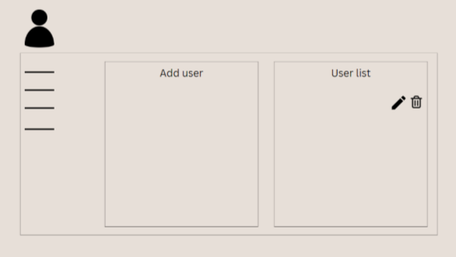

Figure 8.1: Wireframes manage user information

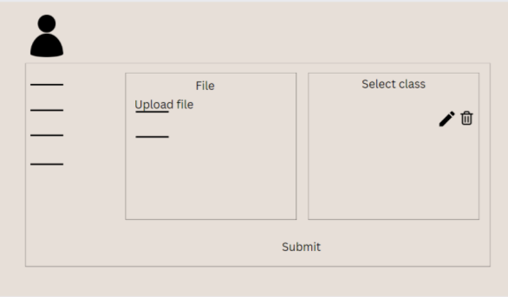

Figure 8.2: Wireframes manage homework

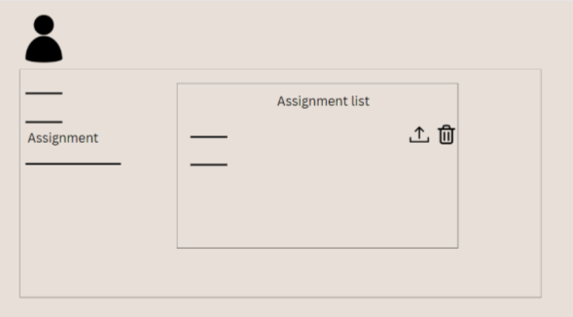

Figure 8.3: Wireframes submit assignment

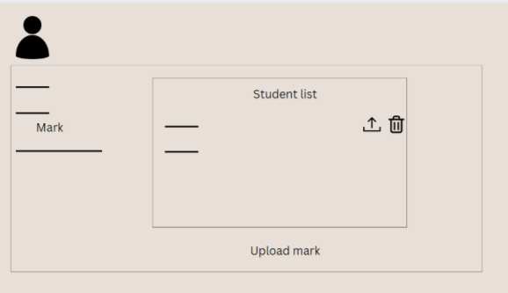

Figure 8.4: Wireframes grade homework

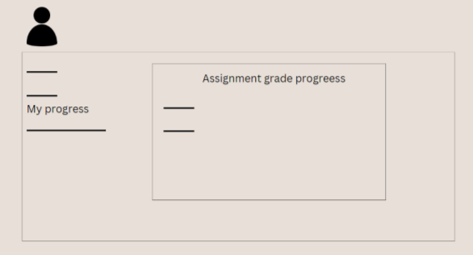

Figure 8.5: Wireframes generate report