**C Sc 335 Analysis and Design Artifacts for Final Project**

**1. Team Name:**  DrakeandStarks

**2. Project: Risk**

**3. Team Members**: Matthew Drake Alex Starks

**4. Candidate Objects or Class Hierarchies**

List the most important objects, or an inheritance hierarchy name, and the single responsibility of each.

|  |  |
| --- | --- |
| **Candidate Object** | **Single Responsibility in 1 or 2 sentences** |
| Dice | Be able to roll between 1-6. |
| Cards | Show territory, type of card (infantry, calvary, artillery). |
| Player | Hold cards, send decisions elsewhere |
| Territory | Be able to show how many armies are in that territory, who currently controls that area. |
| Battle | Continue rolling die until the attacker retreats, or one side is out of armies. |
| World | Show all the different territories in the world |
| AI | Be able to make a decision automatically on where to deploy reinforcements, where to fortify, what to attack, how many dice to use in the battle. |
| Game | Handles all the objects and manages all aspects of the game. |
| Continent | If controlled by one player, give an extra bonus of reinforcements. |
| Reinforcements | Allow players to use reinforcements |

**5. Sequence Diagram 1:** Your team UML Sequence Diagram should show the most important scenario you can think of. Your sequence diagram should show most of your objects from above and how they communicate with each other.

*This Sequence Diagram must be created with the sequence diagram editor* [https://www.websequencediagrams.com/#](https://www.websequencediagrams.com/)

*Export and Image and copy and paste it here*

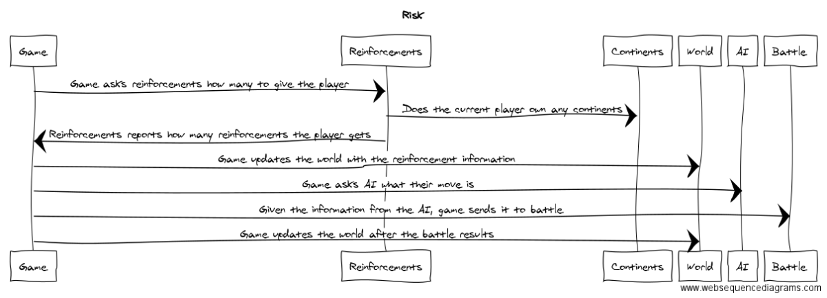

**6. Sequence Diagram 2:** Your team UML Sequence Diagram should show the second most important scenario you can think of. Your sequence diagram should show most of your objects from above and how they communicate with each other.

*This Sequence Diagram must be created with the sequence diagram editor* [https://www.websequencediagrams.com/#](https://www.websequencediagrams.com/)

*Export and Image and copy and paste it here*

