1 Introduction
We are all aware of the existence of distinctive, complex genres within the music environment. Genres are a complex amalgamation between musicality, lyricality, and the emotion exuded by the artist. WRITE SOME MORE ABOUT GENRES AND THE PAST
To properly define the role that lyrics play in defining musical genres, we seek to leverage our knowledge of natural language processing language encoding to develop a model to exclusively use musical lyrics to help define the role that lyricality plays in defining musical genre. Here we will explore the effectiveness of baseline, simplistic models, such as Bag-of-Words models, and how we can leverage classical natural language processing techniques to fine tune model accuracy and precision, as well as more complex small language models, API enabled large language models to see if a more robust model enables additional lyrical understanding or the excess noise confuses the model and potentially results in reduced capabilities of genre encoding when compared to the Spotify listed results.

2 Methodology

2.1 Data Selection

2.2 Data Cleaning
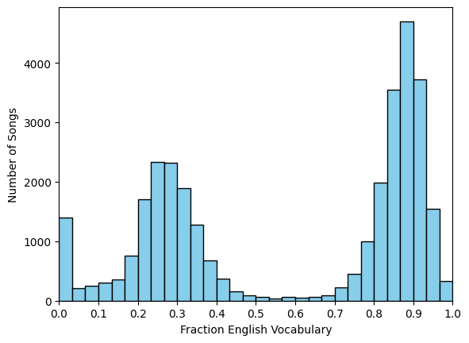

2.3 Model Creation

