Alisa Steensen

Module 5.2

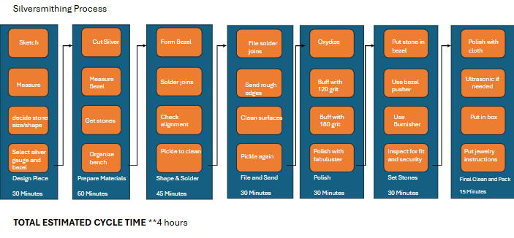

|  |  |
| --- | --- |
| Design Process | 30 Minutes |
| Prepare Materials | 60 Minutes |
| Shape & Solder | 45 Minutes |
| File & Sand | 30 Minutes |
| Polish | 30 Minutes |
| Set Stones | 30 Minutes |
| Final Clean and Pack | 15 Minutes |

Here’s how the time breaks down:

* **Design + Prep:** 90 mins
* **Forming + Finishing (Shape, Solder, File, Sand, Polish):** 105 mins
* **Set + Clean + Pack:** 45 mins

This shows most time is spent on physical handling and finishing.

Now it is time to use the information from my value stream map and lean metrics to optimize my silversmithing process. This is where critical thinking and creativity come into play to help improve efficiency while keeping quality high. Below are several data-driven decisions that could improve my jewelry-making workflow:

### **Eliminating Waste**

I can eliminate the extra 10-15 minutes I often spend measuring and cutting silver by preparing material in advance for my most common designs (like standard ring bands or pendant shapes). This also allows me to use metal sheets more efficiently, with less scrap. Additionally, purchasing calibrated bezel cups that perfectly fit my most-used stone sizes could remove the need to build custom bezels from scratch in many cases, saving around 20-30 minutes per piece. Also, by keeping tools and materials better organized on my bench, I can avoid wasting time searching for files, polishing wheels, or small parts, a small change that could easily save several minutes across every project.

### **Workflow Orchestration**

Right now, I tend to polish, set stones, and do the final cleaning as separate steps. Instead, I could polish and inspect as I go and pack the piece immediately after setting the stone. This would reduce task switching and double handling of the piece. I could also batch similar tasks. For example, shape and solder multiple pieces before switching to the filing and sanding stage. This reduces time spent changing tools and settings on my soldering station and polishing equipment.

### **Governance Models**

A review of my process shows that safety could be improved in a few areas. For example, I often leave the soldering torch set up while I move to filing or polishing. I should introduce a rule that the torch must always be turned off and secured between steps to prevent accidents. Similarly, creating a standard quality checklist, for things like solder joint strength and stone tightness, could help ensure consistent output and reduce the chance of rework later.

## **Conclusion**

This project was valuable because it helped me see exactly where my time goes and how I can work smarter in my silversmithing. The same ideas of mapping, measuring, and improving could apply to other creative or production tasks I do, from jewelry making to packaging or even running my business’s online store. By thinking critically about each step, I can save time, reduce waste, and still create high-quality jewelry I’m proud of, maybe with a little extra time to design something new.

Reference:

Knight, L. (2020, October 29). *3 easy steps for using VSM in everyday life*. ConnectALL. Retrieved June 24, 2025, from <https://www.connectall.com/3-easy-steps-for-using-vsm-in-everyday-life/>