Alisa Steensen

Module 3.2

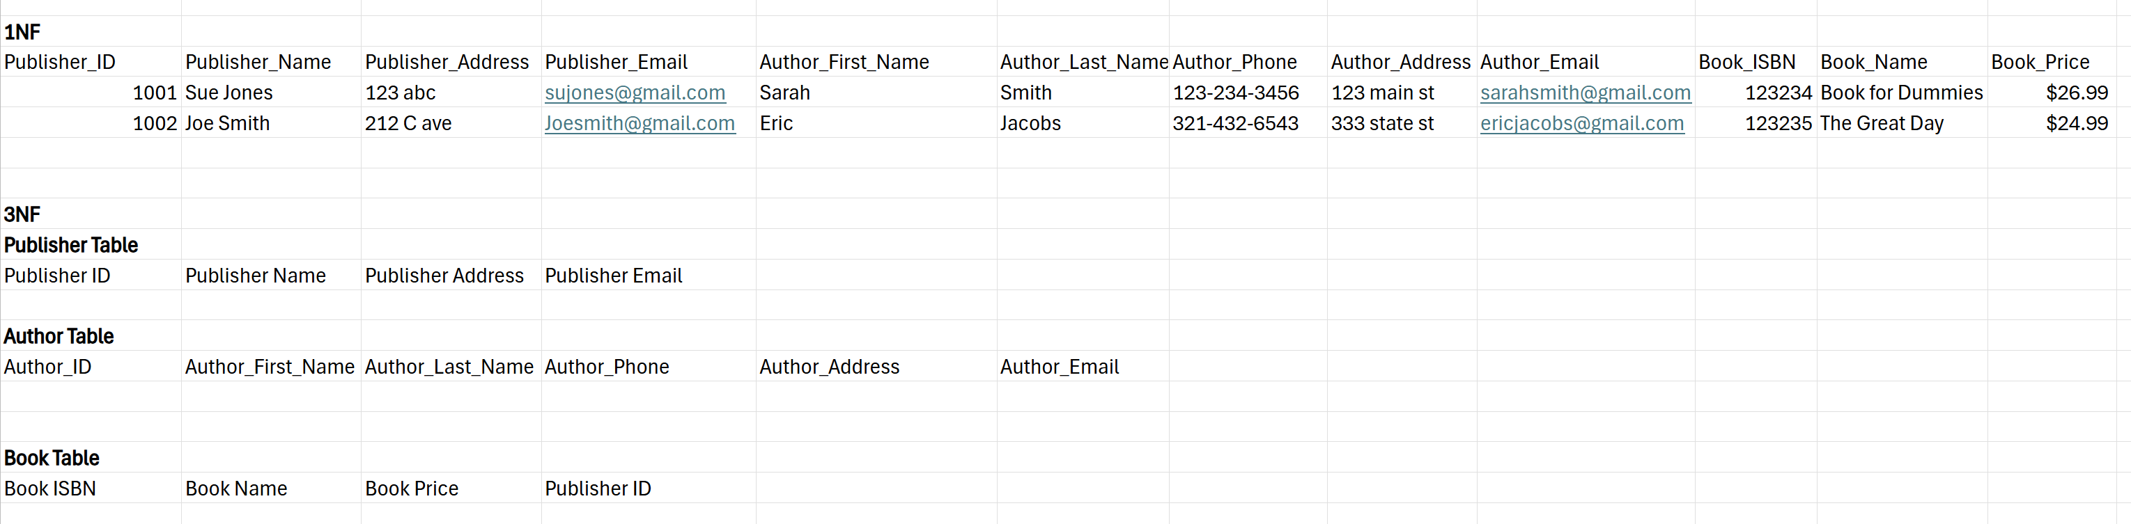

Assumptions:

I assumed the first table would include all information for the publisher, author and book. But then once it broke down into the 3NF table format, I grouped the publisher, author and book into their own tables. I also added an author_id, which I felt like would be beneficial in finding authors. I did consider adding an author to book table, but wasn’t sure if that was required of the assignment. I think that having a author to book table would be helpful in locating books with specific author ID’s. Also, I did assume that all of the ID’s were the keys to the supporting records.