Alisa Steensen

Module 5.2

Function: Count

You would use this function when needing to count the number of items in the table. Here the example shows it will count the number of contacts in my table. In the contacts table it can help you find the total number of contacts.

Statement: select count(\*) as TotalContacts from contacts;

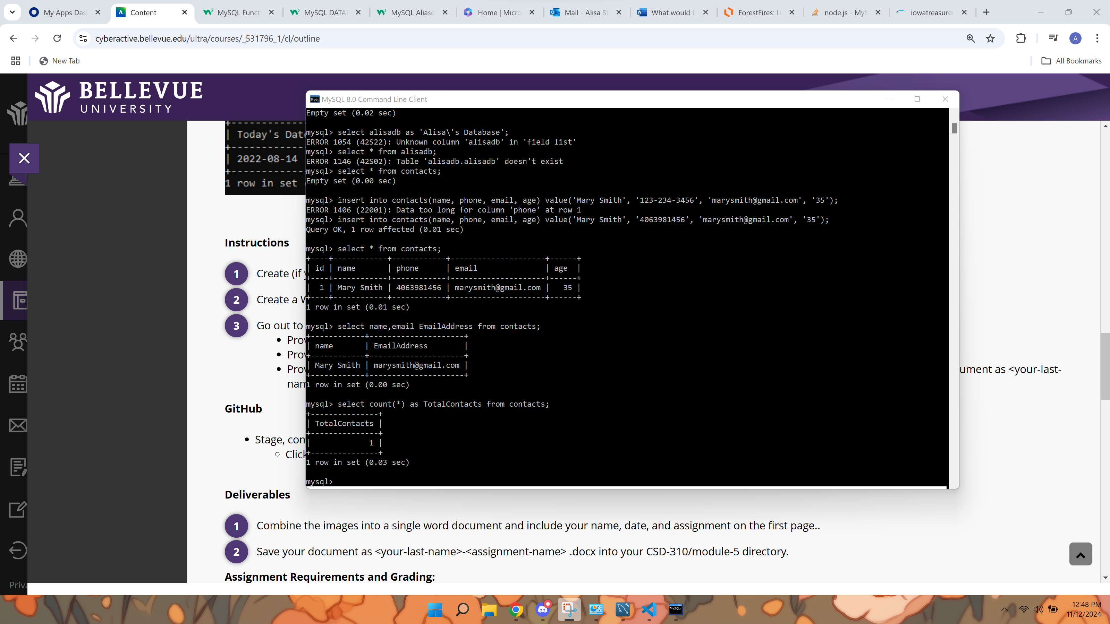

Function: Average

You would use this function when needing to calculate the average in a table or return the average value of an expression. For example, in my table I am using the function to calculate the average age of the contacts in my table. In a contacts table, you can calculate the average age, providing insights into the general age range of your contacts.

Statement:

select ave(age) as AverageAge from contacts;

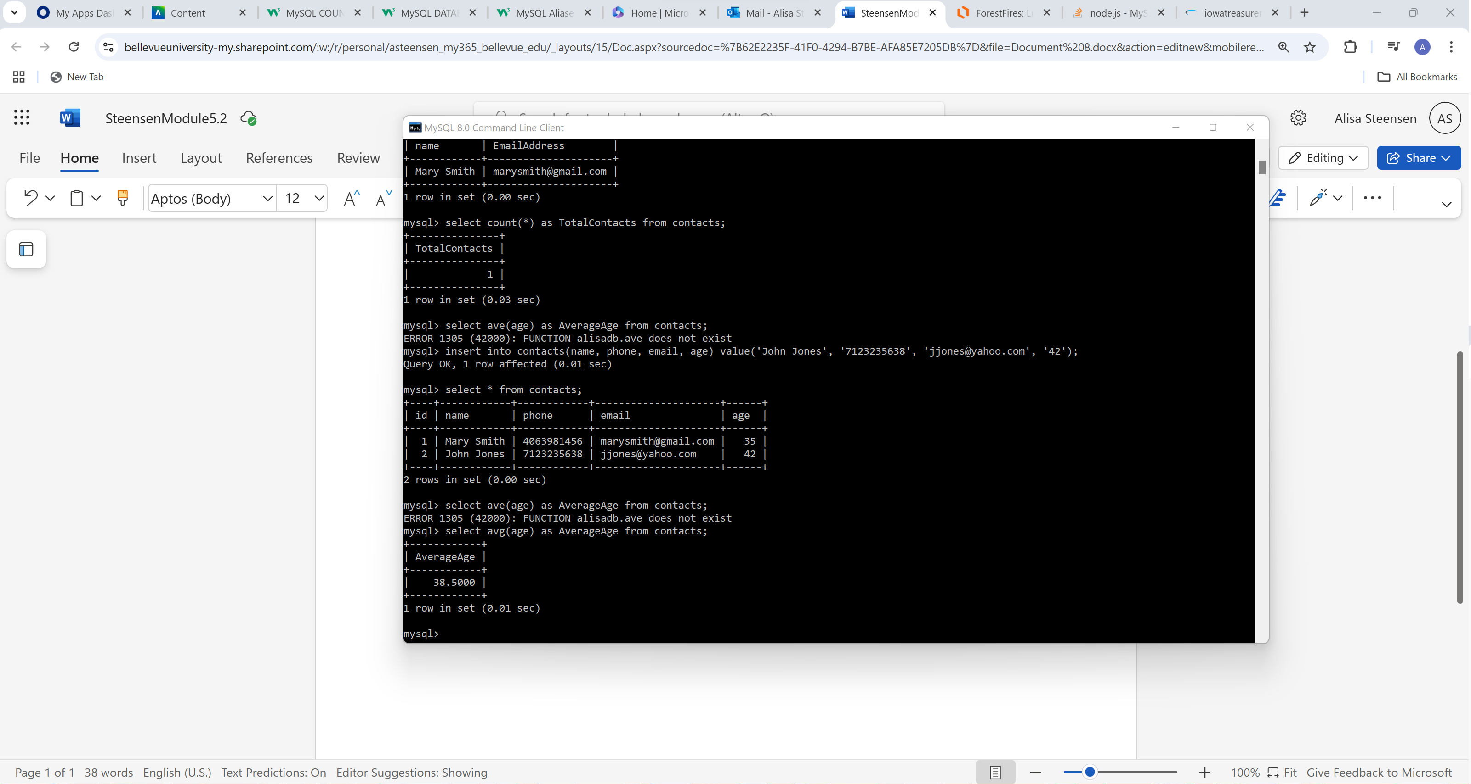

Function: Upper

This function will convert a string to uppercase. For example, I have used it to convert the names in my contacts to uppercase. If your contacts’ names are entered in mixed cases, you can use UPPER() to ensure all names are displayed in uppercase.

Statement: select upper(name) as UpperCaseName from contacts;

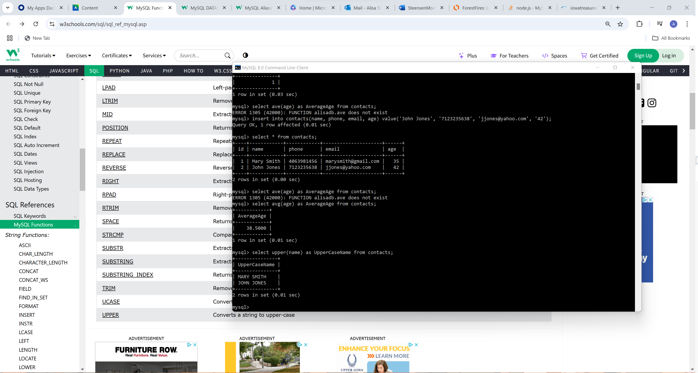

Function: Length

This function returns the length of the string. For example, I want to see the length of the phone numbers in my contacts, and the length function will give me 10 because there is 10 integers in the phone numbers. To check if all phone numbers meet specific length requirements, you can use LENGTH() to identify entries that are too short or too long.

Statement: select length(phone) as PhoneLength from contacts;

