Assignment 1 – Report

**Aleksandar Stefanovic – s3605170 Kunga Kartung – s3588773**

**Analysis**

The site is relatively user friendly and has an abundance of information, however the layout of information could be reformed therefore reducing the navigation needed to reach the relevant pages. The tables used for presenting past and in progress tickets are in contrast with the simplicity of the rest of the site. Being heavy with detail, this is one of the few weak points in the sites design.

The landing page for the site is clear in design, apart from a shopping cart being used as an icon to request a service. Even so, the overall function of the page isn’t clear, with little information being conveyed that isn’t already found in the navigation bar. With that in mind, the page could be improved by adding information to explain how to use the site instead of the image with the same options as the navigation bar.

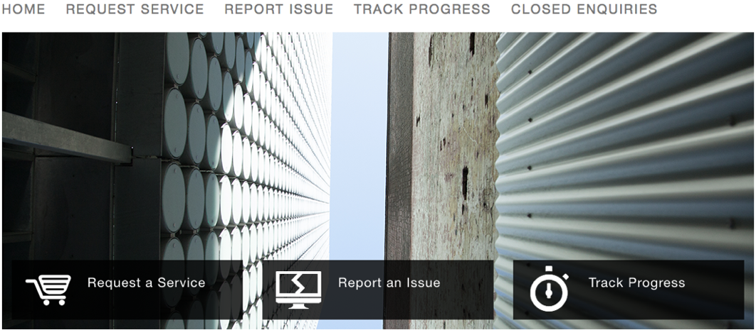

**Fig 1.1** Home Screen showing the navigation bar and the three main options along the bottom of the image to be the same therefore quite unnecessary. Also the shopping cart icon for requesting a service can be seen.

The ‘request service’ page lists services available for various areas in tiles. Even though the design isn’t bad, it could be simplified into just a list, with subheadings replacing the various tiles, allowing for a more mobile friendly layout and not confusing the user with the panel-like divisions that may seem like buttons. The headings of each tile could stand out more compared to the rest of the text so users’ can find easily find relevant headings.

The ‘ticketing’/’report an issue page’ is set up concisely, each form input being clear and easy to interact with, except for the attachments icon out of sight in the top right of the form. The dropdown inputs have a default “-- None --” option that shows up when selecting another option, rather than having the default as just a placeholder. When submitting a form, an alert will show up when inputs are missing, unnecessary given that missing or invalid inputs are given a clear red outline. The ability to collapse parts of the form is another feature that could be removed, as its utility is limited in such a short form. Also, the basic bootstrap styling could be redone to convey a style closer the rest of RMIT’s webpages.

The ‘user card’, as can be seen by hovering over the ‘i’ icon next to the name in the ticketing pages, is another detailed feature that could be improved by replacing it. Currently, to edit the card you need to hold shift and then the window persists. This is not only cumbersome, but also requires the use of a keyboard, and it is not evident how a mobile device or other pointing devices will be able to interface with the card. To replace this, either a separate page can be used to capture this data, allowing for all devices to change it in a simple series of form inputs or a popup may also suffice. On the other hand, this feature could be removed altogether as not many users would fill out that field let alone click/hover over it.

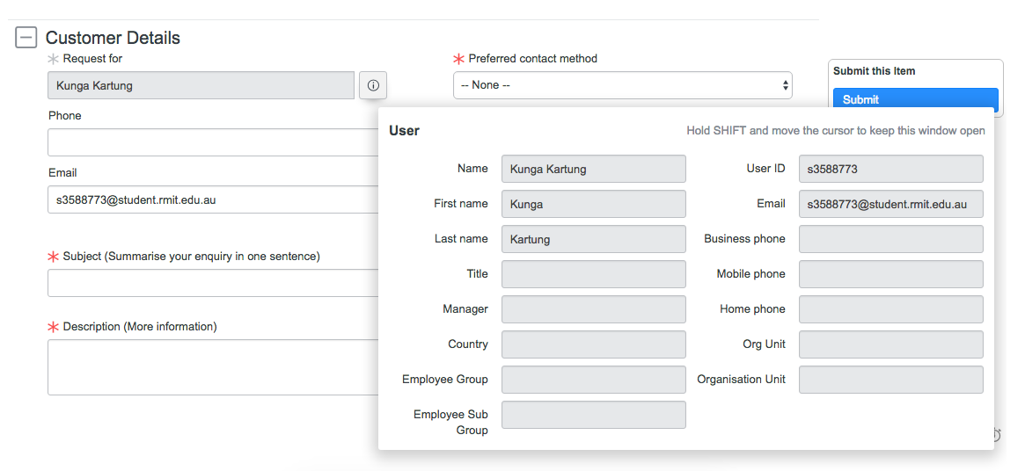

**Fig 1.2** The cumbersome and ineffective method to edit a user’s details. Hard to replicate cross platform i.e. mobiles.

The ‘track progress’ and ‘closed enquiries’ pages share the same weaknesses, with good design barred by a heavy and overcomplicated table system. The customization and search capabilities of the system are outside of the needs of a user that will not have enough tickets to utilise them. Support search and filters are taxing on the loading times and an inflexible layout that will not translate well into mobile or similar platforms. The utility of separating the tracked and closed enquires is also debatable, especially if the large tables were compacted to a smaller design by just displaying the tickets as separate ‘cards’.

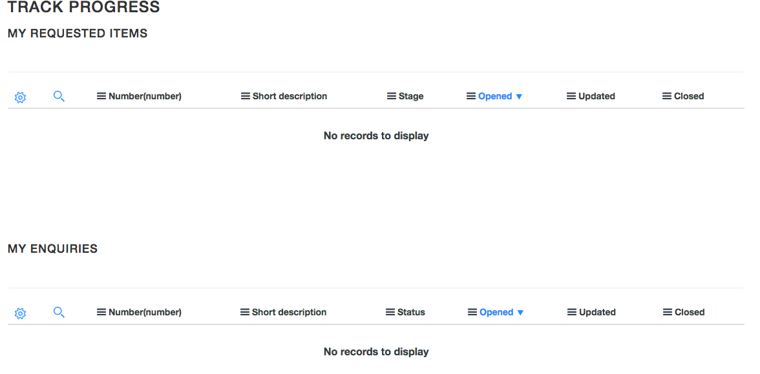

**Fig 1.3** The table being unnecessarily complicated table system. The customization and search capabilities not needed by a user.

When requesting an enquiry from any of the selections, the layout in all have the same problems. The same collapsing function, attachments icon and obtrusive ‘i’ icon can be found, with their corresponding drawbacks. In addition, the submit button on the side may also pose a problem, as the scrolling animation being used may render the form unusable depending on the size of the screen. Keeping the button fixed at the bottom of the form does not subtract from the users’ experience, while being more reliable and consistent.

**Recommendation**

To help simplify the site, all the superfluous elements identified before should be removed, while retaining the necessary inputs for submitting tickets and viewing them. Firstly, the home page can be removed from the site, there is little information conveyed in its current form, and the site is simple enough that the user can navigate and understand through just the navigation and scroll bar.

Creating a ticket can now be streamlined, with the ‘Request a Service’ and ‘Report Issue’ pages being merged into one and the listing of services not being required. The form fields used to report an issue can be preserved, just changing the ‘customer details’ section to not contain the drop-down button and having the ‘i’ either as a popup or removing it completely. The submit button should also be placed at the bottom right of form as opposed to moving with the page. These will help allow mobile-friendly scaling to size the forms appropriately for mobile devices.

Viewing completed and in progress tickets can similarly be simplified, with the removal of the table system for both types of tickets and removing the further separation found in the three tables on both the ‘Track Progress’ and ‘Closed Enquiries’ pages on the current support site. Instead, the two pages will be merged into one, with subheadings separating the completed and in progress tickets. In addition, each ticket will be put into a ‘card’ for layout, allowing for an intuitive and scalable design that has the ticket, post information and comments all in one place. However, this design removes the granular control of the table, sorting could be implemented but limited. These compromises align the site with the needs of the user, eliminating advanced features that do more harm than good.

In conclusion, the largest problems with the site arise from overly granular, complex controls and unnecessary content that can be removed, merged or simplified. In doing this, we create a simpler interface that still satisfy the needs of the range of users from primary to advanced. This also allows easier scaling for mobile platforms.