aSTEP

Introduction & Motivation
In modern research and education, spatio-temporal data has become a cornerstone for understanding complex real-world phenomena—ranging from mobility patterns and urban planning to environmental monitoring and social behaviour analysis. However, managing and analysing such data at scale remains a significant challenge for student projects and collaborative research activities.
AAU’s Spatio-Temporal Data Analytics Platform (aSTEP) is established to address this challenge. It serves as a unified, scalable, and intelligent data management and analytics infrastructure tailored for AAU’s student-driven multi-project ecosystem. The platform provides seamless support for the processing, storage, and analysis of large-scale spatio-temporal datasets, acting as a backbone for:
- Data-driven research and innovation
- Cross-disciplinary collaboration
- AI-empowered decision-making and insights
By integrating advanced data analytics tools with real-world datasets, aSTEP not only accelerates research productivity but also strengthens hands-on learning, problem-based thinking, and methodological rigor—fully aligned with the AAU PBL philosophy.

Applications
The aSTEP platform supports a wide spectrum of spatio-temporal and geo-data analytics, enabling both research and real-world applications across multiple domains. Representative use cases include:

🔷 Trajectory Management & Analytics
- Vehicle and vessel trajectory processing
- Mobility pattern mining and route optimisation
- Anomaly detection (e.g., abnormal driving/sailing behaviour)
- Transforming raw GPS coordinates into semantic geographic information

🔷 Time Series & IoT Data Analysis
- Energy consumption forecasting
- Health and behavioural trend analysis
- Environmental and climate monitoring
- Sensor/IoT-based signal modelling and prediction

🔷 Spatial Intelligence, Remote Sensing & Urban Analytics
- Land-use and POI inference from geo-data
- Human behaviour and mobility modelling
- Smart city planning and sustainability analysis
- Integration of satellite, UAV, and remote sensing data
- Geographic pattern extraction from orbital satellite observations

🔷 AI + Multi-Modal Data Fusion
- Fusion of GPS, text, image, sensor, and satellite data
- Foundation models for spatio-temporal and geo-intelligence
- Digital twins and simulated scenario generation
- AI-driven decision support for complex real-world planning

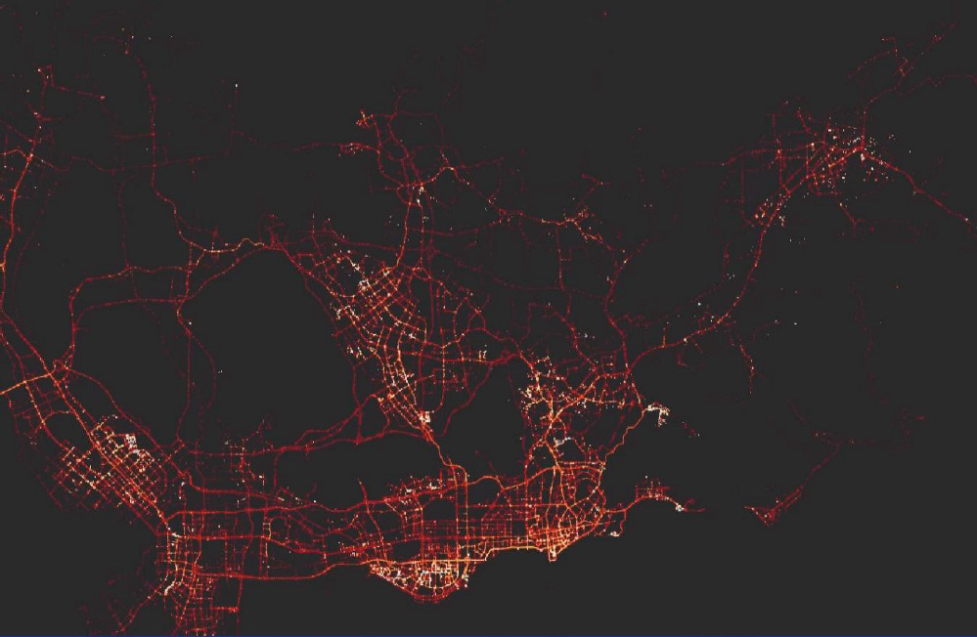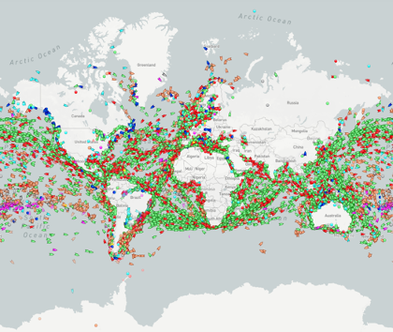
Vehicle Trajectory Analysis Vessel trajectory Analysis


Time series Analysis
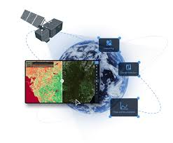
Satellite data analysis

Contributors
The development and maintenance of aSTEP rely on collaborative efforts across multiple groups at AAU. The platform serves as a shared resource for student projects, research prototypes, and cross-disciplinary innovation.

🔷 Core Contributors
- aSTEP Multi-Project Teams
  - Fall 2025 (sw-5-3, 2, 6, 9, 11)
- Data Engineering, Science & Systems (DESS) Group
- Data Section

