

AsTeRICS Enobio Models

User guide to correctly run Enobio models within the Asterics platform
Starlab

Document Information
Issue Date | 19/10/2012
Deliverable Number
WP Number | WP6 Non-Classical User interfaces
Status | Draft
Dissemination Level

Version History
Version | Date | Changed | Author(s)
0 | 18/10/12 | Draft version | David Ibáñez Soria
1 | 20/10/12 | Document Revision | Aureli Soria-Frisch
2 | 21/10/12 | Revision Changes applied | David Ibáñez Soria
3 | 07/10/12 | Picture improvement | David Ibáñez Soria

Table of Content
Document Information 2
Version History 3
Table of Content 4
1 Introduction 6
2 Enobio Set-Up 7
2.1 Introduction 7
2.2 Asterics Enobio Montage 8
2.2.1 Headcap montage 8
2.3 Asterics head band montage 12
2.4 Taking Care of Enobio 13
3 Connecting the Flickering Panels 15
3.1 Introduction 15
3.2 Stimulation Panels Montage 15
4 Asterics Models based on Enobio 17
4.1 Visualizing Enobio Brain Signals 17
4.1.1 Model Name 17
4.1.2 Goal 17
4.1.3 Requirements 17
4.1.4 Usage 17
4.2 Blink training 18
4.2.1 Model Name 18
4.2.2 Goal 18
4.2.3 Requirements 18
4.2.4 Usage 18
4.3 Alpha Controlled Music Player 19
4.3.1 Model Name 19
4.3.2 Goal 19
4.3.3 Requirements 19
4.3.4 Usage 19
4.4 Enobio Camera Mouse 21
4.4.1 Model Name 21
4.4.2 Goal 21
4.4.3 Requirements 21
4.4.4 Usage 21
4.5 SSVEP Training 22
4.5.1 Model Name 22
4.5.2 Goal 22
4.5.3 Requirements 22
4.5.4 Usage 22
4.6 SSVEP Controlled Music Player 24
4.6.1 Model Name 24
4.6.2 Goal 24
4.6.3 Requirements 24
4.6.4 Usage 24

- Introduction
This document aims to be a user guide for researchers in charge of testing the models of the AsTeRICS platform that use Enobio. The document has been divided in three main parts.
- Introduction to Enobio and montage.
- Introduction to the flickering stimulation panels and montage
- Models explanation and configuration.
- Enobio Set-Up
  - Introduction
Enobio is a wearable, modular and wireless electrophysiology sensor system for the recording of:
- EEG (Electroencephalogram - brain activity).
- ECG (Electrocardiogram - heart activity).
- EOG (Electrooculogram - eye muscle activity).
It consist of four independent channels that acquire biosignal measurements at 250 Hz measuring the voltage between the electrode attached to a channel and reference ,usually placed in the left ear lobe.
The following figure shows Enobio box ports and connections. For further information please check the user manual provided along with Enobio software.

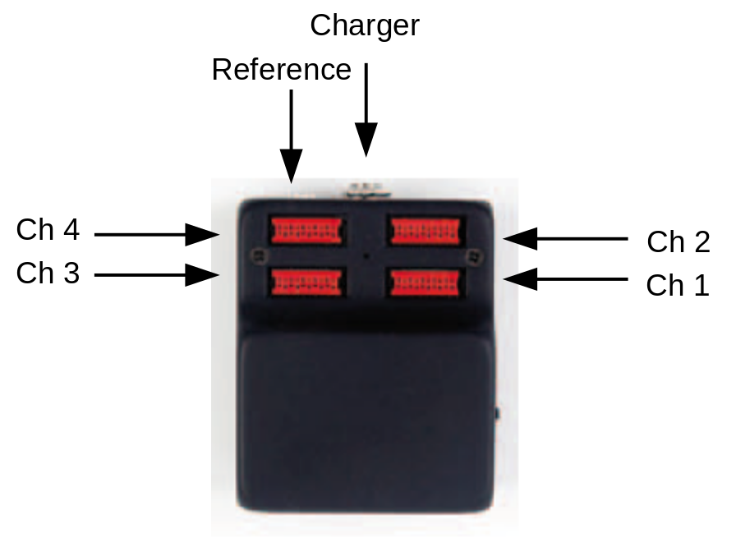
Figure 1 Enobio Box

  - Asterics Enobio Montage
Enobio is provided with a head cap and a band. All models provided by Starlab can be used with the head cap but only some of them with the band. This chapter describes how to correctly mount Enobio to run the available AsTeRICS models.
Models that can run using the Enobio band:
- EnobioVisualization
- EnobioCameraMouse
- BlinkDetectorTrainer
Models that can run using the Enobio cap
- EnobioVisualization
- EnobioCamerMouse
- BlinkDetectorTrainer
- AlphaMusicPlayer
- SSVEPMusicPlayer
- SSVEPTrainProtocol

    - Headcap montage
- Put on the Enobio cap.

- 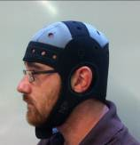

- Stick Enobio to the back part of the cap using the velcro.
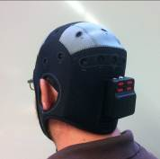

- Connect the reference and put a bit of gel in it using the provided syringe.

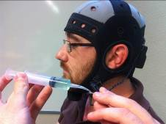

- Clip the reference to the user’s left ear lobe.
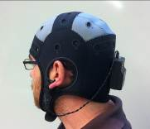

- Place the electrode pellet in the following positions labelled in the neoprene Enobio cap.
Enobio Channel | Pelet Head Cap Position
Channel 1 | O1
Channel 2 | Oz
Channel 3 | O2
Channel 4 | Fp1 or Fpz or Fp2

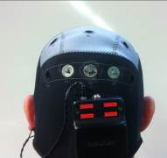

- Once pellet has been placed in the Enobio cap conductive gel is needed to achieve the necessary conductivity. Put gel inside the electrode through its hole (see figure below left) using the provided syringe (see figure below right). Be careful to put the necessary to reach the user’s scalp but not too much.

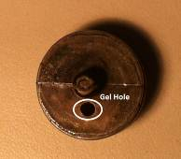 | 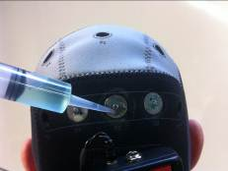

- Connect the electrode holder to its cable (see figure below left) and attach them to its position according to the table above (see figure below right).
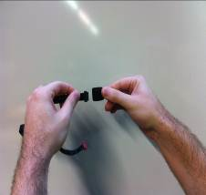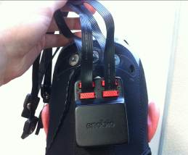

- Clip the electrode holder in its corresponding pellet.
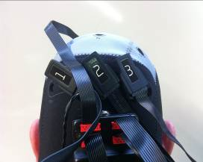
- Make sure all the electrodes have good skin contact.
- Connect the Antenna.
- Switch on the Enobio box.
- Run ARE.
- Run ACS
- Run the Enobio_Visualization.acs model
- Look at the signal of each electrode and make sure that every channel is in range (green color) and the signal is stable. If not put more gel in the electrodes that show any problem or press them to make good contact with the scalp surface.
- You are ready to start your session using Enobio!

  - Asterics head band montage
- Place a dry electrode in the Enobio band.
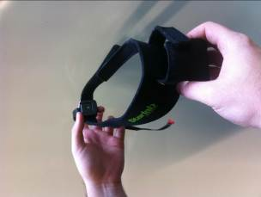
- Connect the electrode to channel 4. The channels connection when using the band is shown in the following table.
Enobio Channel | Head Cap Position
Channel 1 | Not Connected
Channel 2 | Not Connected
Channel 3 | Not Connected
Channel 4 | Forehead

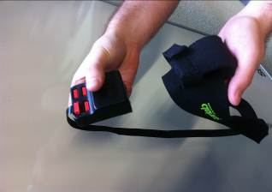
- Connect the reference and put the Enobio box in the band pocket
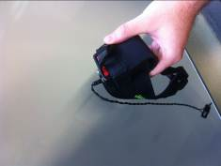
- Wear the Enobio band. The electrode shall be placed in the forehead free of hair. Put some inside the reference and clip it in the left ear lobe.
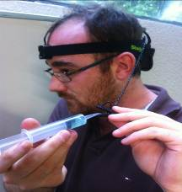
- Connect the Antenna.
- Switch on the Enobio box.
- Run ARE.
- Run ACS
- Run the Enobio_Visualization.acs model
- Look at the signal of channel 4 and make sure it is in range (green color) and stable. If not put more gel in the reference or adjust the band until the signal goes to green.
- You are ready to start your session using Enobio!
  - Taking Care of Enobio
After every session take care of your equipment following the next steps:
- Remove the reference and clean it with water and a damp cloth.
- If you have used the cap remove the pellet from the electrode and clean it with water.
- Wash the Enobio head cap or band with water.
- Clean the electrode with a damp cloth.
- Charge your Enobio for it to be ready for the next session.
- Keep everything together in the Enobio box provided.

- Connecting the Flickering Panels
  - Introduction
The flickering stimulation panels are external customizable light sources that flash at a configurable frequency and duty cycle. They are responsible of eliciting steady state evoked potentials to the user staring at the flickering light source.

The system is compound of a central unit in charge of managing the communication with the PC and four external stimulation light sources (Panels). The communication between the computer and the embedded platform is done with a serial connection via USB.

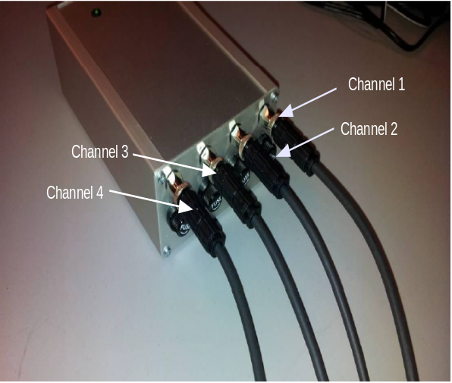  Figure 2 Control Unit | 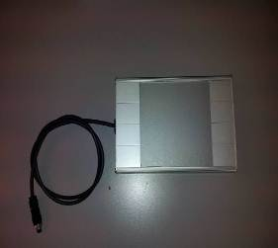  Figure 3 Stimulation Light Panel

  - Stimulation Panels Montage
- Connect the control unit to an USB port of the computer/platform where ARE is running.
- Check the COM port used by the control unit in the Windows OS( Start->Control Panel -> Hardware and Sound -> Device Manager -> Ports).
- Connect the control unit to its charger.
- Attach two panels to channel 1 and 2.
- The panel attached to channel 1 shall be placed at the right of the user.
- The panel attached to channel 2 shall be placed at the left of the user.
- Panels shall be placed at eye-level.
- The user shall be placed at one meter of the stimulation panels.
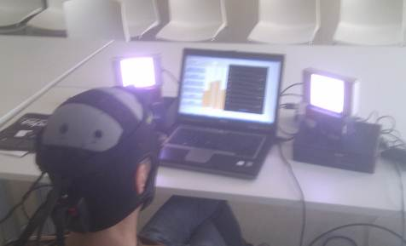
Figure 4 Stimulation panels set up

- Asterics Models based on Enobio
This chapter describes the currently available models uploaded to the AsTeRICS repository developed by Starlab. The functionality of every model is presented as well as the needed requirements.
  - Visualizing Enobio Brain Signals
    - Model Name
Enobio_Visualization.acs
    - Goal
Monitor the EEG data streaming from Enobio in real time. Before using any Enobio model it is advised to visualize the Enobio data stream in order to check that everything has been correctly connected and the signals are in range. This means we recommend to run this model before starting any model test/evaluation.
    - Requirements
- Enobio (cap and band montage)
    - Usage
Run the model and have a look at the measured signal at each electrode. If the signal is in range its color is set to green, otherwise it is set to yellow. This model is especially useful to check the quality of the measured signal.
- If the signal corresponding to a channel does not become green check that the corresponding electrode is correctly connected and that it makes good contact with the scalp. If needed put a bit more gel.
- If every signal does not become green check the reference and put more gel in it.
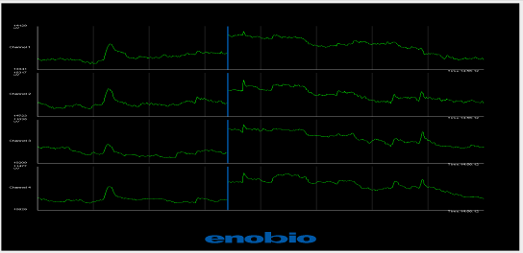
  - Blink training
    - Model Name
BlinkDetectorTrainer.acs
    - Goal
It has been proved that people suffering from severe motor disabilities do not control their intentional blinks in the same way as healthy people do. This model aims to personalize the blinking detection parameters used in the BlinkDetector plugin.
    - Requirements
- Enobio (cap and band montage)
    - Usage
- Run the model and check channel four has been set to green, the signal is stable and blinks can be easily distinguished.
- Ask the user to stay still and follow the protocol that will appear in the upper text box. The protocol consists of 5 simple blinks and 5 double blinks the user has to do every time he is required to. Explain the user he/she shall not blink more times than he/she is required to.
- Press the start button to begin the protocol. At any time protocol can be aborted pressing the stop button.
- Once the protocol has finished the calculated parameters will appear.
- If some calculated parameter have zero value repeat the training. Usually this is due to more detected blinks than the requested.
- Update the BlinkDetector plugin, when needed, with the values calculated in the blink training as follows:
maxThreshold: Maximum Threshold
minThreshold: Minimum Threshold
BlinkLength: Blink Length
DoubleBlinkSeparation: Double Blink Separation
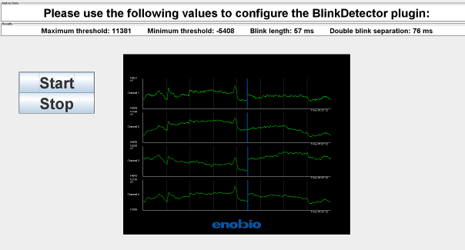
  - Alpha Controlled Music Player
    - Model Name
AlphaMusicPlayer.acs
    - Goal
This model allows the user to start/stop an audio player by measuring his/her relaxation level. If the user close his eyes and relaxes the audio reproduction will toggle between start/stop state.
    - Requirements
- Enobio (cap montage)
- .wav audio file placed in AsTeRICS\bin\ARE\data\music
    - Usage
- Select the audio file to be played in the Waveplayer.1 plugin in its filename property.
- Set your local path for the images to be displayed in the the plugins:
  - StartText and StopText: text property
  - StartImage and StopImage: default property
- Run the model and check channel two has been set to green and the signal is stable and clean.
- Ask the user to stay still during the whole experiment.
- Ask the user to close the eyes and relax every time he/she wants to start/stop the audio reproduction.
- BarDisplay2 plugin represents the relaxation level of the subject and the threshold that triggers the audio player.
- If the relaxation parameters of the subject do not correspond to the ones set as default it can be customized in the plugins:
  - Threshold.1: ThresholdHigh and ThresholdLow set to the threshold value chosen for the current subject.
  - BarDisplay.2: Threshold set to the new threshold value to monitorize the relaxation performance of the user.

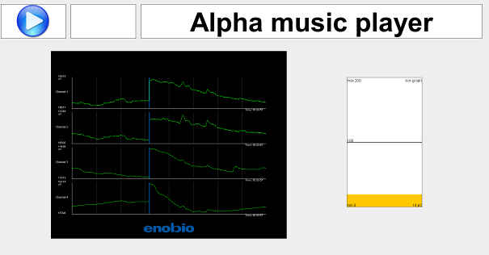

  - Enobio Camera Mouse
    - Model Name
EnobioCameraMouse.acs
    - Goal
This model allows the user to have full control of a computer mouse hands free. A webcam tracks the noise of the user mapping it into the mouse position within the screen. Left and right click events correspond respectively to single blink and double blink events measured in Enobio.
    - Requirements
- Enobio (cap and band montage).
- Webcam.
    - Usage
- Ask the user to look at the center of the screen he has in front of him.
- Explain the user the mouse will follow his nose and that for left and right click he has to blink or double blink respectively.
- Run the model and let the user control the computer.
- The model works with some default parameters for blink detection. In case these parameters do not work for the user undergoing the evaluation, please run the blink detection trainer (see Sec 4.2) and update the blinkDetector.1 plugin according to its values.
- It is possible to adjust the speed of the mouse acting on the sliders placed on the right side of the user interface.

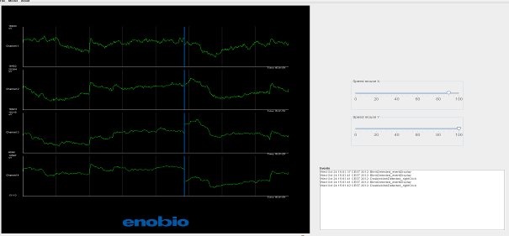
  - SSVEP Training
    - Model Name
SSVEPTraining.acs
    - Goal
- Steady state evoked potentials (SSVEP) are a response measured in the occipital region of the brain when a person is focusing his attention to a flickering light source. It is a subject dependent phenomenon, i.e. the parameters used in its detection have to be individually tuned for every specific subject. This Model carries out the training for SSVEP detection, i.e. founds out the optimal SSVEP parameters for each user.
- The selection of optimal parameters is based on acquisition of data realized within the model described here.
- The data acquisition consists of 5 stimulation tests (each one at 12, 14, 16, 18 and 22 Hz) consisting of:
  - 5 non stimulation periods (with the panels switched off)
  - Followed by 5 stimulation periods (with the panels flickering at the trial frequency).
- A beep warns the user one second before each stimulation period starts. During the stimulation periods the user shall not blink.
- Once the trial has finished the operator is warned through a different beep sound.
    - Requirements
- Enobio (cap montage).
- Flickering stimulation panels.
    - Usage
- Type the com port in the comport property of the FlickeringLightStimulator.1 plugin. (i.e. ‘COM3’)
- Run the model and check that the EEG measurement corresponding to channel 1, 2, and 3 are set to green and that the signal are stable
- Type the subject name in the Id. Box and press enter.

- Tell the subject to stay still. Inform him that just before a stimulation period a beep sound will be played and that he/she shall not blink during the stimulation.

- Press the button start protocol.

- Once the trial is finished press the button Next Stim Freq to continue the protocol with the following stimulation frequency.

- If a stimulation period is not valid it can be aborted pressing the button Abort and repeated pressing the button Repeat Stim Freq.
- Check that the folder AsTeRICS\bin\are\data\SSVEPTrainFiles contains 6 .txt files named with the user ID followed by _12, _14, _16,_18, _20 and _22. These are the training files generated.

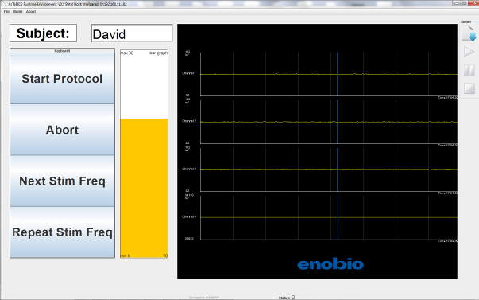
  - SSVEP Controlled Music Player
    - Model Name
MusicPlayerSSVEP.acs
    - Goal
- Once you have obtained the optimal training files for each SSVEP user, you can use them in the application implemented through this model.
- SSVEP controlled music player is an application that allows controlling a music player being able to start playing the current music file, stop it or switch to the next song of your track-list. The audio files that play the model be in wav format and stored in AsTeRICS\bin\ARE\data\music.
- In contrast to the alpha control model (see sec 4.3) the model MusicPlayerSSVEP.acs allows to start/pause, and to change the track
- The user decides when turn on the panels by double blinking This action will allow him/her to interact to the music player by looking at the panel of the action he/she wants to realize.
- Just after the double blink has been recognize the two panels the user has in front of start flickering for a short time period of about 3 seconds. The user shall focus his attention to one of the panels. If it is the right one the next track song will be played. If it the left one the audio reproduction will toggle between the start/stop state.

- It is important that the user follows the following protocol while using this model
  - Look at the panel that carries the action he/she wants to.
  - Double blink to trigger the panels.
  - Stay still while the panels are flickering.
  - Move freely once the action has been carried out
    - Requirements
- Enobio (cap montage).
- Flickering stimulation panels.
- Previously recorded train signals.
- Audio .wav files placed in AsTeRICS\bin\ARE\data\music
    - Usage
- Type the com port in the comport property of the FlickeringLightStimulator.1 plugin. (i.e. ‘COM3’).
- Set your local path for the images to be displayed in the the plugins:
- StartText, StopText, UpPanelText, DownPanelText, LeftPanelText, RightPanelText: text property
- StartImage, StopImage, UpPanelImage, DownPanelImage, LeftPanelImage, RightPanelImage: default property.
- Run the model and check that the EEG measurement corresponding to channel 1, 2, 3 and 4 are set to green and that the signal are stable
- Type the subject name in the User Name box and press enter (This name shall be the same as the one typed in the procedure).
- The model works with some default parameters for blink detection. In case these parameters do not work for the user undergoing the evaluation, please run the blink detection trainer (see Sec 4.2) and update the blinkDetector.1 plugin according to its values.
- Type 2 in the Number of Panels box and press enter.
- Explain the subject the protocol to interact with the model described in the previous chapter.
- Click the Calc Config File button and wait until a window displaying Config File Succesfully calculated appears. This process may take around one minute.
- Click the Update Config File button. At this point the system will start working.
- Let the user to freely interact with the system carrying out the actions he wants to.
- When the panel placed on the right has been detected an arrow pointing to the right is displayed, an arrow pointing to the left otherwise.
- Monitorize the Enobio signals are in green colour and stable during the session.
- The model works with some default parameters for blink detection. In case these parameters do not work for the user undergoing the evaluation, please run the blink detection trainer (see Sec 4.2) and update the blinkDetector.1 plugin according to its values.

