

AsTeRICS

Developer Manual
Version 2.2

Version History
Version | Date | Changed | Author(s)
0.1 | August 19, 2010 | First draft | UCY
0.2 | December 20, 2010 | Added ACS and Thrift guides | KI-I
0.3 | December 26, 2010 | Added setup and build environment descriptions, changed document structure, updated component development guide, added Native ASAPI and JNI development descriptions | FHTW
0.4 | March 16, 2011 | Added one click build script and information about ignoring COM ports in CIMPortManager | FHTW
0.5 | July 29, 2011 | Added coding guidelines section | FHTW
0.6 | September 19, 2011 | Added local storage information | FHTW
0.8 | September 28, 2011 | Added header template and javadoc example | FHTW
0.9 | October 27, 2011 | Integrated Plugin Tool descriptions and CIM Protocol Description, reorganized structure | FHTW
1.2 | January 13, 2012 | Reworked structure, added Introduction, added PluginCreation Tools | FHTW
1.5 | June 20th, 2012 | Some minor revisions based upon user feedback, additions of features for the final AsTeRICS prototype | FHTW
1.5a | October 23, 2012 | Update of thrift, adding schema compiler instructions for C# | KI-I
2.0 | Nov 13, 2012 | Added updates for final system prototype; updated CIM protocol information | FHTW
2.2 | Jul 10, 2013 | Updates for Release Version 2.2, added debugging instructions, fast raw port controller, updated file/directory structure | FHTW

Table of Contents

Version History 2
1 Introduction 7
1.1 About the AsTeRICS project 7
1.2 About this document 7
1.3 The AsTeRICS Runtime Environment 8
1.3.1 ARE Components 9
1.4 About OSGi 9
2 Getting Started with AsTeRICS Development 10
2.1 The AsTeRICS Source Code Repository 10
2.1.1 Repository structure 10
2.2 Setting up the Eclipse IDE for ARE development 11
2.3 Building ARE Middleware, Services and Components 13
2.3.1 One Click Builds 13
2.3.2 Understanding the component build-scripts 14
2.4 Starting the ARE middleware and component deployments 15
2.4.1 Structure of the runtime folder “./bin/ARE”: 15
2.4.2 Structure of the loader.ini file 16
2.4.3 Running a deployment 16
2.5 Debugging the ARE 17
3 A Quick Guide to AsTeRICS Plugin Development 19
3.1 The Plugin Creation Wizard 20
3.1.1 Created files and folders 21
3.2 Plugin Activation in ACS and ARE 24
3.2.1 The Plugin Activation Tool 24
3.2.2 Component-Collection Management in the ACS 25
4 Writing AsTeRICS Plugin Code 26
4.1 ARE Coding Guidelines 26
4.1.1 Port Naming Conventions 26
4.1.2 Property Naming Conventions 26
4.1.3 Bundle Descriptor Naming Conventions 27
4.1.4 AsTeRICS Source File header 27
4.1.5 JavaDoc compatible comments 27
4.2 Implementing AsTeRICS components 28
4.2.1 The Bundle Descriptors 28
4.2.2 The Deployment Descriptor 29
4.2.3 The Manifest file 30
4.2.4 Structure of OSGi bundles containing ARE components 30
4.2.5 Component lifecyle 31
4.2.6 Step-by-Step implementation: Averager processor 32
5 Services and Utils: Infrastructure for plugins 34
5.1 Communicating with peripherals: CIM Communication service 34
5.1.1 CIMPortController 35
5.1.2 CIMPortManager 35
5.1.3 CIMEventHandler 36
5.1.4 CIMProtocolPacket 37
5.1.5 Serial ports not adhering to CIM Protocol (Raw Ports) 37
5.2 Communication through a socket interface: Remote Connection Manager 38
5.2.1 IRemoteConnectionListener 38
5.2.2 RemoteConnectionManager 39
5.3 Local Storage Service 40
5.4 Data Conversion Utilities 40
5.5 Logging 41
5.5.1 Status checking 42
5.6 The ARE Thread Pool 43
5.7 The ARE GUI support 44
5.8 ARE core events notification services 45
5.9 Dynamic Properties 46
5.10 Data Synchronization 46
5.11 Interfacing Native C/C++ Code via JNI 48
5.11.1 Specifying native libraries in the Manifest 48
5.11.2 Java-Implementation: JNI-Bridge 48
5.11.3 C-Implementation: Callbacks and JNI code 50
5.12 External Helper Applications and Tools for Plugins 52
6 Communication Interface Modules and Protocol 53
6.1 Communication Mechanism and Packet Format 54
6.2 Request / Reply - Code 55
6.2.1 Request/Reply Code in LSB 55
6.2.2 Mode / Status code in MSB 56
6.3 Feature Lists and CIM-IDs of all AsTeRICS CIMs 56
6.3.1 HID-CIM 56
6.3.2 PT-1 GPIO – CIM (Legacy GPIO) 57
6.3.3 Phone-CIM (Windows Phone OS) 58
6.3.4 PT-1 ADC – CIM (Legacy ADC/DAC) 59
6.3.5 BMA180 Accelerometer Sensor 60
6.3.6 PT-1 Core – CIM 61
6.3.7 EOG-CIM 62
6.3.8 Sensorboard – CIM 63
6.3.9 Arduino – CIM 64
6.3.10 PT2 Core - CIM 65
6.3.11 PT2 GPI – CIM (DigitalIn) 67
6.3.12 PT2 GPO – CIM (DigitalOut) 67
6.3.13 PT2 ADC – CIM (AnalogIN) 68
6.3.14 PT2 ZigBee – CIM 68
6.4 Demo Implementations of the CIM protocol 69
7 Into the Deep: Concepts of the ARE middleware 70
7.1.1 Runtime Model Concepts 70
7.1.1.1 Components 71
7.1.1.2 Ports 72
7.1.1.3 Channels 74
7.1.1.4 Component Architecture of ARE 74
8 ASAPI Clients and Serialisation 77
8.1.1 ASAPI and ARE Interconnection 78
8.1.1.1 ASAPI and ARE in the configuration process 79
8.2 Available ASAPI commands 82
8.3 Serialisation 85
8.3.1 The Thrift definition file 85
8.3.2 The Thrift Compiler 86
8.3.3 The Thrift Library 86
8.3.4 Simple Java Client 86
9 Native ASAPI Libraries 87
9.1 Phone Library 87
9.1.1 Phone Library interface: 87
9.1.2 Example of use 89
9.2 GSM Modem Library 90
9.2.1 GSM Modem Library interface: 90
9.2.2 Example of use 92
9.3 3D-Mouse Library 93
9.3.1 3D-Mouse Library interface 93
9.3.2 Example of use 93
9.4 Keyboard Library 94
9.4.1 Keyboard Library interface 94
9.4.2 Example of use 96
10 Appendix A: OSGI-related Information 97
10.1 The OSGi framework and it’s layers 97
10.2 Modularization in OSGi 98
10.3 Using OSGi in AsTeRICS 98
11 Appendix B: Building the ACS 100
11.1 Setup of the Development environment 100
11.2 Update Process of the Schemata 101
12 Appendix C: Guidelines for Building Vision-Plugins 102
12.1 OpenCV 102
12.2 Boost Library 103
12.3 VideoInput 105
12.4 Building facetrackerLK 108
12.5 FaceTracker Library 109
13 References and Resources 110

- Introduction
  - About the AsTeRICS project
AsTeRICS – the Assistive Technology Rapid Integration and Construction Set – is an open framework for the development of Assistive Technologies, with the main focus on novel, affordable and flexible AT-solutions. A plethora of sensor- processing- and actuator plugins provides a powerful, AT-centred infrastructure which can be used to control home automation equipment, entertainment and ICT-devices or use ambient assistive services by means of desired sensor combinations – without programming a single line of code. Interested 3rd parties like research institutions or companies in the field of AT can use the framework to integrate their products into the existing AT-landscape.


The project has been initiated in 2010 as a Special Targeted Research Project in the Seventh Framework Programme of the European Commission in the ICT work programme. For further information, please visit the project homepage http://www.asterics.org

  - About this document
This document provides resources for developers to work with the AsTeRICS framework. It includes step-by-step introductions how to set up the development environment, and a “10-Minutes Guide to AsTeRICS Plugin Development” which outlines plugin creation for the AsTeRICS Runtime Environment (ARE) with the AsTeRICS Plugin Wizard.
Furthermore, this document outlines important ARE services which can be used for error reporting or communication with external modules, describes the naming conventions for programming and plugin creation, illustrates the formation of an example ARE deployment, and describes the usage of OSGi bundles - i.e., self-contained modules. (For a brief overview on OSGI see chapter 1.4).
Last but not least, the developer manual also gives some deeper insights into the middleware, the CIM port manager and the communication framework between ACS and ARE which is based upon the ASAPI client/server architecture using Thrift. (For an introduction to ASAPI – the AsTeRICS Application Programming Interface - see chapter 8).
To get used to the AsTeRICS system’s capabilities and concepts, it is recommend to download and install the AsTeRICS setup (installer) package from the project homepage, and to read the AsTeRICS User Manual, which describes the main system components: the AsTeRICS Configuration Suite (ACS) and the AsTeRICS Runtime Envirunment (ARE).

  - The AsTeRICS Runtime Environment
The AsTeRICS Runtime environment (ARE) is an OSGi-based middleware [3] which allows software plugins to run in parallel. The plugins usually represent a sensor or an actuator and are implemented as independent OSGi bundles. The runtime environment identifies AsTeRICS plugins from other OSGi bundles based on metadata defined inside the plugins.
The ARE expects from plugin-developers to define the structure of their plugins (properties, inputs, outputs and event ports) in XML files. Based on these XMLs, the middleware constructs a runtime representation of each installed AsTeRICS plugin.
Furthermore, the ARE expects a runtime model (system model) which usually comes from the AsTeRICS Configuration Suite (ACS). The ACS is running on a Windows Personal Computer (.net 4.0 required) and mainly used to graphically design the layout of the system as a network of interconnected components. The system model is another XML file that defines the components participating in a specific application, connections between them, events and other properties. Based on this file, ARE knows which plugins to activate and how to define the data flow between them. Since the system model represents the main communication means between the ACS and the ARE, it is expected to be a serialisable object, easy to transfer and translate. ARE and ACS communicate through an appropriate TCP/IP-based communication protocol named ASAPI.
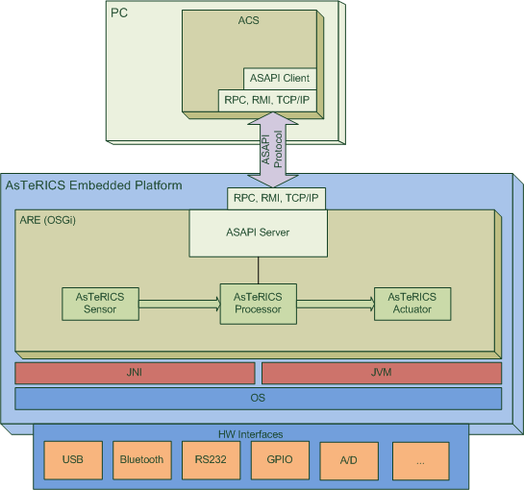

The ARE also provides “services” to plugin developers (for example communication support for COM ports) and it allows reporting errors on the runtime environment, registering event listeners and interacting with its graphical user interface (ARE GUI).
The ARE GUI is a simple graphical environment developed to allow end-users to interact directly with the runtime environment. It may be used to modify runtime parameters of a model via buttons or sliders, and to monitor live signals and events of the running model.

    - ARE Components
The ARE consist of the following main parts:
- The ARE middleware
- ARE plugins (also referred to as “components”) – sensor, processor and actuator modules which provide functional building blocks for assistive functionalities
- A service layer which provides infrastructure to the ARE components,
for example COM port and communication management for connection of the Communication Interface Modules (CIMs)
The ARE is commonly deployed on an embedded device, running an appropriate operating system (OS), typically an embedded variant of Windows. On top of the OS, an appropriate Java Virtual Machine (JVM) is used to host the OSGi component framework which provides support for modularity and dynamic loading/unloading of components.
All the core components of the framework (described in detail later) are defined as OSGi modules. Certain components that need to access legacy code (e.g., written in C or C++) are also deployed on top of OSGi, and are interfaced to the native code using Java Native Interface (JNI) as needed. In this regard, and with the exception of the pluggable components that use native code interfaces with platform-specific JNI bindings, the ARE middleware is expected to be platform independent.
The implementation requires basically JAVA 1.7 (JDK/JRE 7) and an OSGi framework (which is part of the source code downloads).
  - About OSGi
The Open Service Gateway initiative (OSGi) is an open specification that enables the modular assembly of software built with the Java technology [3]. The OSGi Service Platform facilitates the componentization of software modules and applications and assures interoperability of applications and services over a variety of networked devices.
OSGi technology is the dynamic module system for Java™. Java provides the portability that is required to support products on many different platforms. The OSGi technology provides the standardized primitives that allow applications to be constructed from small, reusable and collaborative components. These components can be composed into an application and deployed; The OSGi Service Platform provides a service-oriented architecture that enables these components to dynamically discover each other for collaboration, and thereby forms the optimal basis for the AsTeRICS middleware.

- Getting Started with AsTeRICS Development
  - The AsTeRICS Source Code Repository
The AsTeRICS source code repository is available as a .zip package at the AsTeRICS Homepage. The source code contains open source software modules in JAVA, C++ and C, and proprietary modules by AsTeRICS partners which are available in binary from (.dll or .exe).
The licenses of the utilized software packages and 3rd party products can be viewed in the file /documentation/licenses.doc
Currently, the editor for OSKA (the on-screen keyboard application) is the only commercial software package within the AsTeRICS framework – and not included in the free downloads. The OSKA editor is only needed if you want to design custom on-screen keyboard layouts for OSKA (see AsTeRICS User Manual).

    - Repository structure
The source code repository is organised in the following subfolders:
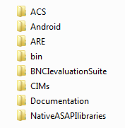
The ACS folder contains the AsTeRICS Configuration Suite source code.
The Android folder contains a server application for Android phones which allows interfacing with the AsTeRICS Android plugin to use phone functions in AsTeRICS models.
The ARE folder contains the middleware and service layers and ARE components.
The bin folder contains subfolders where ARE and ACS executable files are placed during the build flow. These folders contain additional configuration files or dependencies, for example the config.ini and loader.ini files which specify the modules which are loaded by the ARE at startup.
Additionally, the bin folder contains several resources which are useful, e.g. a pre-built ACS with demo models (in the ACS\models folder) and the OSKA application.

The BNCIevaluationSuite is a collection of matlab files for analysis and comparison of algorithms for Brain Computer Interfaces (contributed by Starlab).
The CIM folder contains firmware for the microcontroller modules used to interface the system to the environment (maintained by IMA and FHTW).
The Documentation folder contains the User- and the Developer Manual, and OSKA manual and the licence information for the developed and all utilized source code and libraries.
The NativeASAPI folder contains C++ libraries for mobile-phone and GSM modem access, 3d-mouse and tremor reduction from own C++ projects.

  - Setting up the Eclipse IDE for ARE development
The ARE framework is not bound to a specific tool flow or IDE. For the convenience of the development process and ease-of-use for new developers, an Eclipse-based build is available and will be described in this section. If you prefer a different IDE you can skip this section. The described setup applies for Microsoft Windows operating systems. If Java and the Eclipse IDE are already installed, steps 1 - 3 can be omitted.
- Download and Install the Java Development Kit 7 (JDK 7)
from http://www.oracle.com/technetwork/java/javase/downloads/index.html
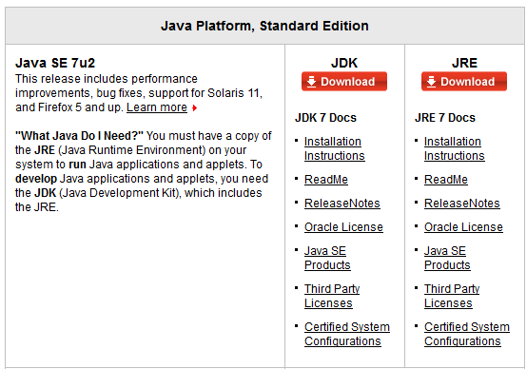
Choose the 32bit version for your operating system, because some necessary components for interfacing hardware are not supported by the 64bit version by now
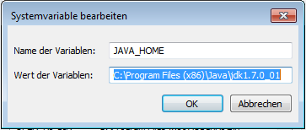
- Create a System Environment Variable “JAVA_HOME” which points to the folder where you installed the Java JDK. The dialog for system environment variables can be found via System Properties -> Advanced -> Environment Variables

- Download and install Eclipse from http://www.eclipse.org/downloads/
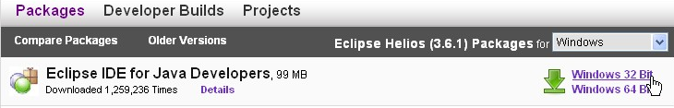
Note that the 32-bit version is also recommended for 64-bit machines e.g. running Windows-7 (as there have been reported problems with the 64-bit version)
- Download and extract the AsTeRICS source code package and extract the .zip file into a desired location on your hard disk
- Start eclipse.exe (If starting the first time, create a workspace folder as suggested)
- Choose File -> New -> JavaProject in the Eclipse main menu, disable the option “Use default location” and browse to the ARE subfolder of the downloaded AsTeRICS source code zip file:
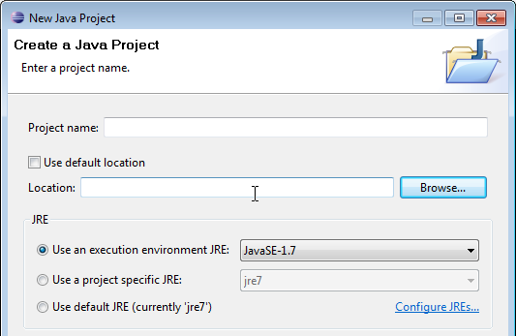
- Then you should see something like this:
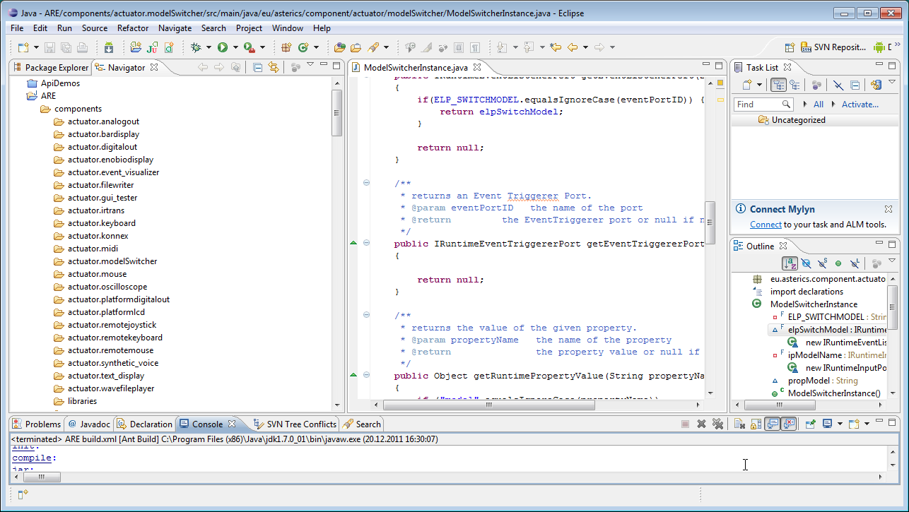
Congratulations ! – You have now a working AsTeRICS build environment !
Eclipse provides different views (Window -> Show View), where the Navigator and the Package Explorer are most useful for Java source code development.
Note that the “Refresh” command (F5) synchronizes the Navigator view with changes in the local file system.
  - Building ARE Middleware, Services and Components
For building the ARE middleware and components (plugins), the supplied ANT build scripts are recommended. Apache ANT is a command-line based build tool for Java applications [8]. Eclipse provides an ANT plugin which operates these build scripts (named “build.xml” in the AsTeRICS repository).
The middleware, the services and the components have separate build.xml files. The middleware and services are required for building the components. To build everything, a top-level build script is available in the ARE folder. To use this top-level build script, switch to the Java Project Perspective, right-click the “build.xml” file located in ARE-section of the Navigator window (as shown below) and select the second menu entry in the context menu: “2 RunAs -> Ant Build”:
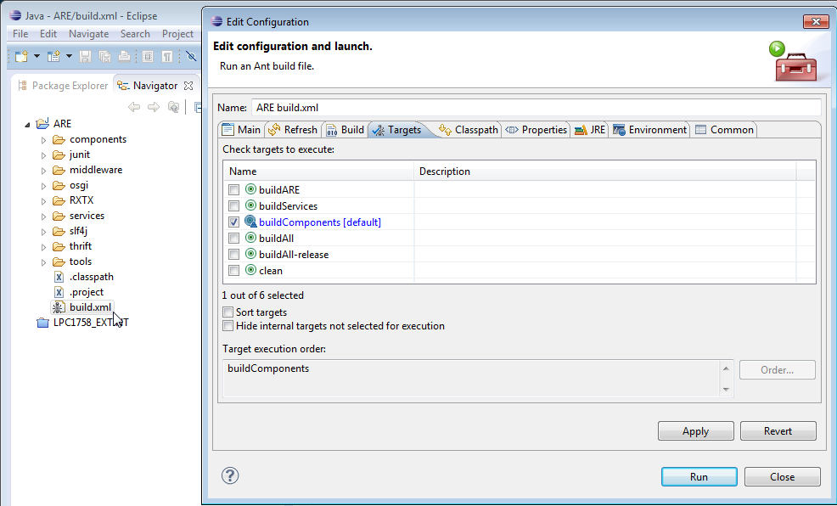
This opens the “Edit configuration and launch” window, where the build targets of the top-level build script can be selected. These build targets provide different “on-Click” builds for the AsTeRICS framework.
    - One Click Builds
The top-level build script allows building all components that exist in the source tree. It also defines several properties which are inherited to all component build scripts. An important example is the “debug” property which defines via compiler options if the code shall be instrumented with source code level debugging information (“true”) or not (“false”).
The top-level build script provides the following targets:
- BuildARE: builds just the middleware
- BuildServices: builds the middleware and all services (eg. CIMCommunication etc.)
- BuildAll: cleans build targets, builds middleware, services and components
- BuildAll-release: cleans build targets, builds middleware, services and components
without source-level debug information for the eclipse remote debugger
- Clean: cleans build targets (removes all jar files and the out directory)

The source level debug information is enabled by all build targets of the top-level build script except “BuildAll-release”.
Alternatively, individual services or components can be built by selecting their associated “build.xml” script from the corresponding subfolders In these scripts, source level debugging information is per default disabled in the compilation step.
    - Understanding the component build-scripts
A typical ANT build script for an ARE component looks like the following:
<project name="asterics.${component.id}" default="jar" basedir=".">
<property name="component.id" value="processor.MyComponent"/>
<!-- set global properties for this build -->
<property name="build" location="../out/production/${component.id}"/>
<property name="src.java" location="src/main/java"/>
<property name="dist" location=".."/>
<property name="runtime" location="../../../examples/ARE"/>
<property name="osgi" location="../../osgi"/>
<property name="middleware" location="../../middleware"/>
<property name="services" location="../../services"/>
<property name="classpath" location=".."/>
<path id="asterics.classpath">
<pathelement location="bin"/>
<pathelement location=
"${osgi}/org.eclipse.osgi_3.6.0.v20100517.jar"/>
<pathelement location="${middleware}/asterics.ARE.jar"/>
</path>
<property name="resources" location="src/main/resources"/>
<target name="init">
<!-- Create the time stamp -->
<tstamp/>
<!-- Create the build directory structure used by compile -->
<mkdir dir="${build}"/>
</target>
<target name="compile" depends="init" description="compile the source ">
<javac srcdir="${src.java}" destdir="${build}" verbose="true" debug="${debug}"
classpath="${classpath}"> <classpath refid="asterics.classpath"/>
</javac>
</target>
<target name="jar" depends="compile"
description="generate the OSGi bundle" >
<jar jarfile="${dist}/asterics.${component.id}.jar" basedir="${build}"
manifest="${resources}/META-INF/MANIFEST.MF">
<fileset dir="${resources}"/>
</jar>
<copy file="${dist}/asterics.${component.id}.jar"
tofile="${runtime}/asterics.${component.id}.jar"/>
</target>
</project>
In the first section of the build script, folder locations for the build intermediates, the final build products (.jar file) and the classpath are defined. The classpath usually points to the “bin” folder, the middleware “asterics.ARE.jar” and the osgi distribution. If a component needs additional resources, their location has to be defined here.
Subsequently the build script defines two build targets: the compilation of the Java source code and the creation of the .jar file. If the .jar file shall contain additional .dlls with native code, they have to be specified in the Manifest file as shows in section 5.11.1.
After the .jar file has been created in the distribution folder, it is copied to the runtime folder (/bin/ARE).
  - Starting the ARE middleware and component deployments
To test the ARE and component bundles, open the folder “/bin/ARE”, and locate the batch file “start.bat”:
    - Structure of the runtime folder “./bin/ARE”:
This folder contains dependencies for running the ARE middleware and the .jars resulting from ANT builds, it has the following structure:
/
+- bin/
+- ARE/
+- data/ folder for plugin working data
+- models/ stored models (configurations)
+- profile/
+- config.ini system bundles to be started
+- loader.ini plugin-bundles to be started
+- org.eclipse.osgi/ osgi configuration folder
+- 1238790741.log system log messages, stack trace
+- tools/ plugin helper apps and dlls
+- .logger stores console logging settings
+- ARE.exe starts the ARE without console output
+- areProperties stores recent window/GUI properties
+- <my_component.jar> component bundle(s)
+- asterics.ARE.jar ARE middleware
+- asterics.mw.services.cimcommunication.jar CIM port manager
+- asterics0.log application log file
+- jtester.exe helper app for checking Java version
+- logging.properties configuration of loglevel etc.
+- org.eclipse.osgi_3.6.0v20100517.jar osgi distribtion
+- sleeper.exe helper app for launcher timing
+- start.bat starts ARE with console output
+- start_debug.bat starts ARE with Eclipse debug support
+- start_noconsole.bat starts ARE without console output
+- VCChecker.jar helper jar for checking VC redist dependency

Important Note: The osgi configuration folder “org.eclipse.osgi” in the “profile” subdirectory has to be deleted if .dlls in .jar bundles are updated or changed. (This folder is automatically created when starting the ARE and holds working data for the OSGI-bundles.) The One-Click build.xml script described in chapter 2.3.1 deletes the folder automatically.
    - Structure of the loader.ini file
The loader.ini file located in the folder “./bin/ARE/profile/” specifies bundles which will be started by the ARE middleware automatically (using the OSGI lifecycle management commands). This file is created by the AsTeRICS Plugin Activation Tool (see section 3.2) but could also be updated manually. Basically it contains a list of .jar files for the built components as shown in the following list:

asterics.actuator.AnalogOut.jar
asterics.actuator.AndroidPhoneControl.jar
asterics.actuator.ApplicationLauncher.jar
asterics.actuator.BarDisplay.jar
asterics.actuator.DigitalOut.jar
asterics.actuator.EnobioDisplay.jar
asterics.actuator.EventVisualizer.jar
asterics.actuator.FileWriter.jar
asterics.actuator.FS20Sender.jar
asterics.actuator.GSMModem.jar
asterics.actuator.ImageBox.jar
asterics.actuator.IrTrans.jar
asterics.actuator.Keyboard.jar

Please note that only the components defined in the loader.ini file will be available in the ARE. Models involving ather components cannot be deployed from the ACS, nor started.
A number of additional bundles which are needed to start the ARE middleware and services are specified in the config.ini file, most notably the ARE middleware “asterics.ARE.jar” and the service layer for CIM communication. This file usually does not need to be changed.
    - Running a deployment
The “ARE.exe” starter application launches the ARE without console output and without debugging instrumentation.
Alternatively, the commandline batch script “start_debug.bat” which is provided in the folder “.bin/ARE” runs Java with additional configuration parameters including:
- the location of the OSGi distribution
- the profile subfolder which contains the config.ini file: “./bin/ARE/profile”
- debugging instrumentation for the remote debugging server connection
After starting the ARE middleware, bundles are loaded and started as specified in “loader.ini”. If everything is properly configured, the ARE window comes up with a GUI and provides ASAPI server functionalities for connection of the ACS or other client applications.
  - Debugging the ARE
If the ARE is started using the “start_debug.bat” script and source-level debug information was added during the compilation (see section 2.3), debugging with Eclipse is supported via a remote debugging connection. This is a convenient way for debugging an OSGI-based java framework with a lot of plugins. To enable the debugging support in Eclipse, a Debug Configuration is created via the dedicated menu entry:

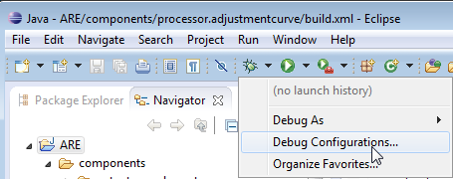

Create a “Remote Java Application” Debug Configuration and assign a name for it, e.g. “ARE”. Then, specify the connection properties of the Debug Configuration to use the Host “localhost” and the Socket/Port “1044” (this port is given in the ARE build scripts for the remote debug server to listen for incoming client connections):

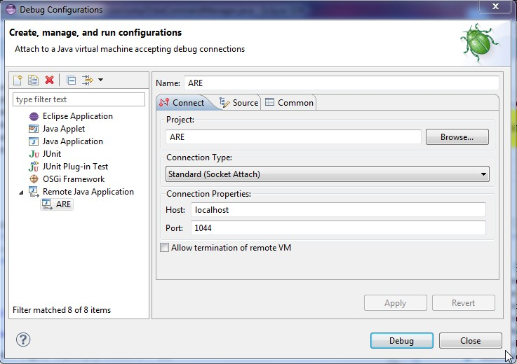

Now launch the ARE using “start_debug.bat”. The messages in the console window should indicate the establishment of the listening socket 1044 for the debugging connection:
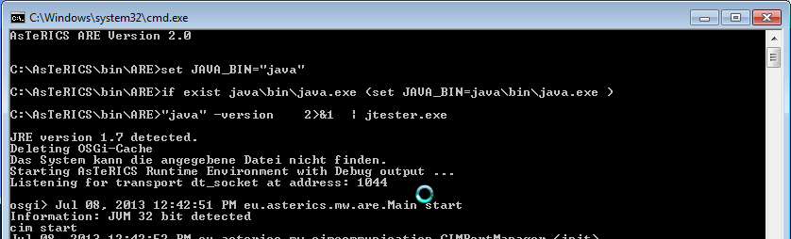
Now, the usual debugging support of Eclipse can be used, including breakpoints in middleware or components, variable and context watch windows, single stepping etc. All these operations are performed in the Eclipse “Debug” perspective.
The following screenshot shows a program execution of the ARE which ran into a breakpoint (here: the OSKA plugin was halted as a command was selected in the OSKA-application and transferred to the ARE plugin’s command handler:
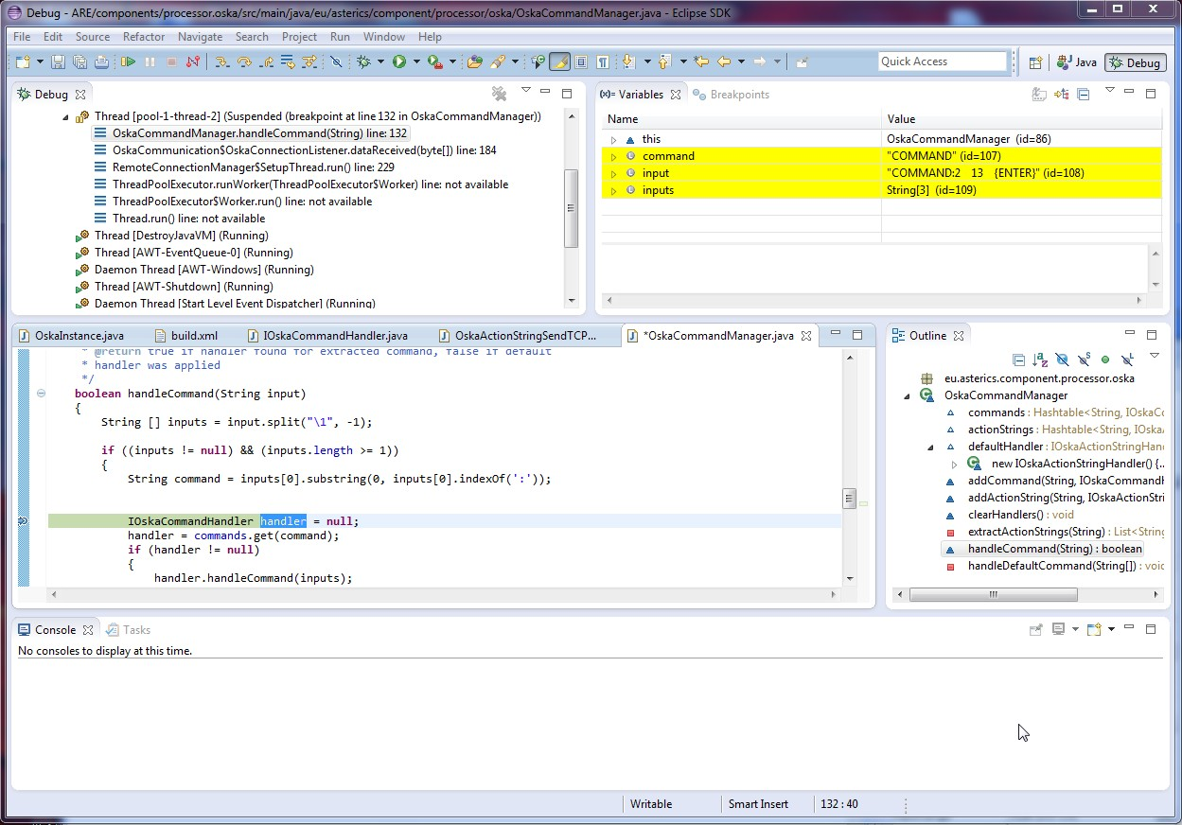

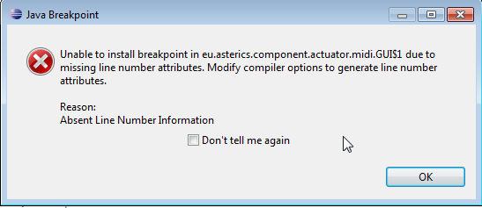
If the source-level debug information is missing (due to compilation without debugging support) an error message indicates a problem, e.g. the missing line number for breakpoint installation:

- A Quick Guide to AsTeRICS Plugin Development
This section describes the AsTeRICS Plugin-Creation tool and the plugin-activation process. These tools make it easy to create new plugins and make them available in ACS and ARE. They can be started manually from their location in the AsTeRICS_runtime.zip package (folder: “ACS/tools”) – or they can be launched from the “Misc.” – Tab in the main menu of the ACS:
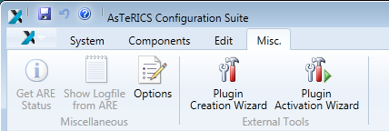

The creation of a new AsTeRICS plugin for the runtime environment involves several steps:
- creating the folder structure to store the plugin files
- creating the ANT build script file
- creating the manifest file
- creating the bundle-descriptor, which specifies the ports and properties of the plugin
- creating the source code file of the JavaInstance
  - defining the ports and properties and implementing the get- and set-methods for input-, output-, eventListener- and evenTrigger ports
  - implementing the get- and set- methods for property values and the input ports receive handlers
This process is similar for each plugin, and involves much work and sources of errors, especially for people who work with the AsTeRICS framework for the first time.
Usually, you look for a plugin with similar specifications, copy its folder structure and then rename and change the files as desired. But also this process needs some effort and errors/typos can be introduced very easily.
The purpose of the AsTeRICS Plugin Creation Tools is to make it easy to create new plugins, by providing the necessary folder structure, the bundle descriptor and a template for the JAVA source code.

  - The Plugin Creation Wizard
The plugin Creation wizard allows definition of characteristics of a new plugin and creates the needed folders and files for the Eclipse build flow, including the JAVA source code skeleton and the plugin’s bundle descriptor.
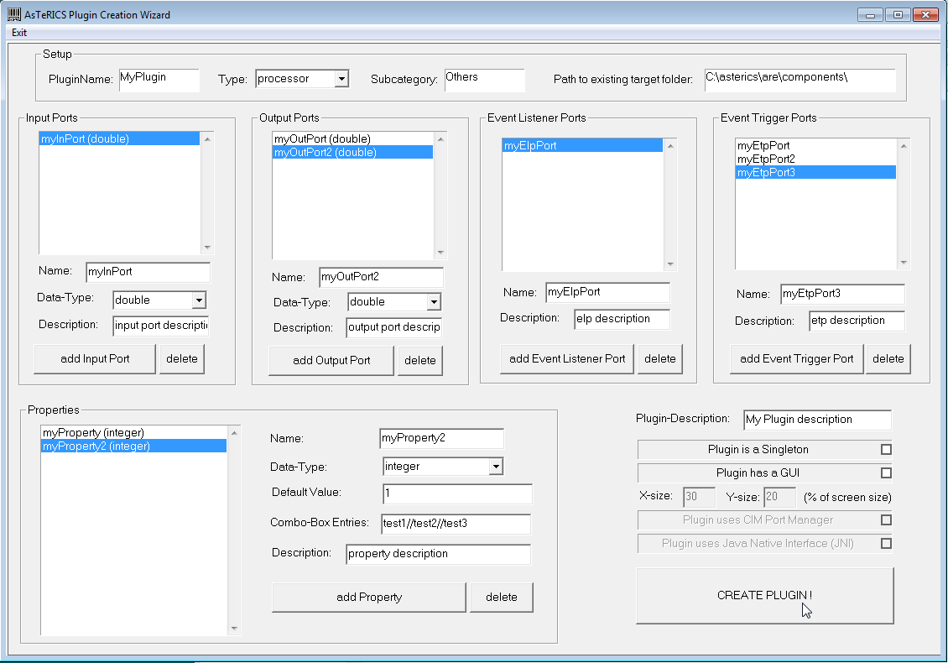

As can be seen in the above figure, desired input- and output ports, data types, properties and plugin-features are simply selected and added to list boxes on the screen.
Important Notes:
- the path to the target folder has to exist in the local file system, and must point to the ARE/components directory where all plugin source files are located, e.g.: “C:\asterics\bin\components\”.
- The plugin name must be specified in CamelCase letters (capital first letter), e.g. “MyPlugin”. Type and Subcategory have to be specified - they define the location where the plugin will appear in the ACS Components menu.
- It is possible to create a list of possible text-selections in a combo-box in the ACS property editor. The data type for this property must be integer, the property gets the number of the selected item. Text-captions for the combo-box entries must be separated with double slash, e.g: “Mode 1//Mode 2//Mode 3”.
    - Created files and folders
After “Create Plugin!” has been pressed and the plugin creation was completed successfully, following sub-folders and files are begin created:
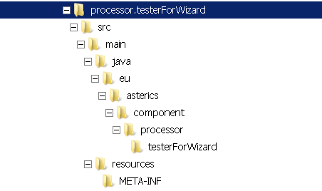

The root folder contains the build script, which can be executed inside Eclipse to compile and build the plugin (.jar) file:
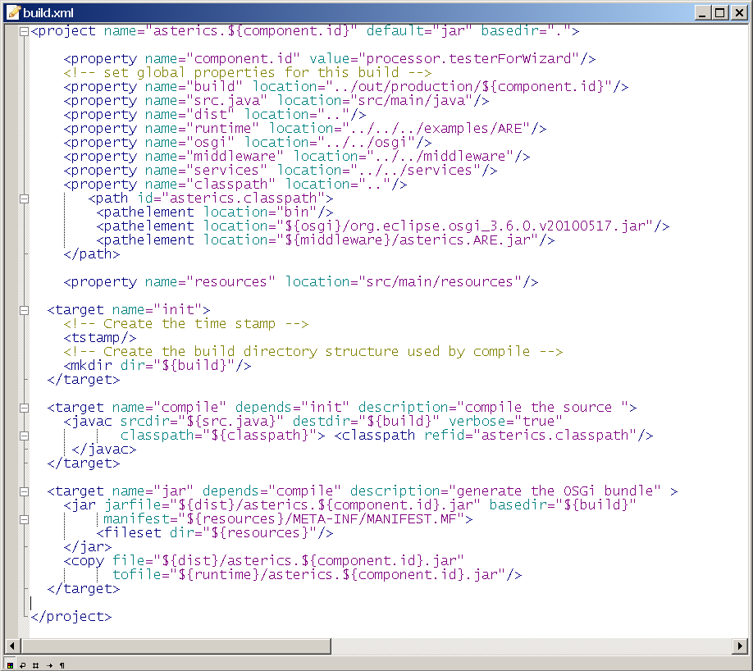

The META-INF folder contains the manifest file
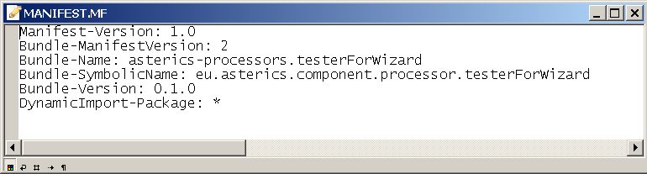
The “resources” folder contains the bundle descriptor (bundle_descriptor.xml):
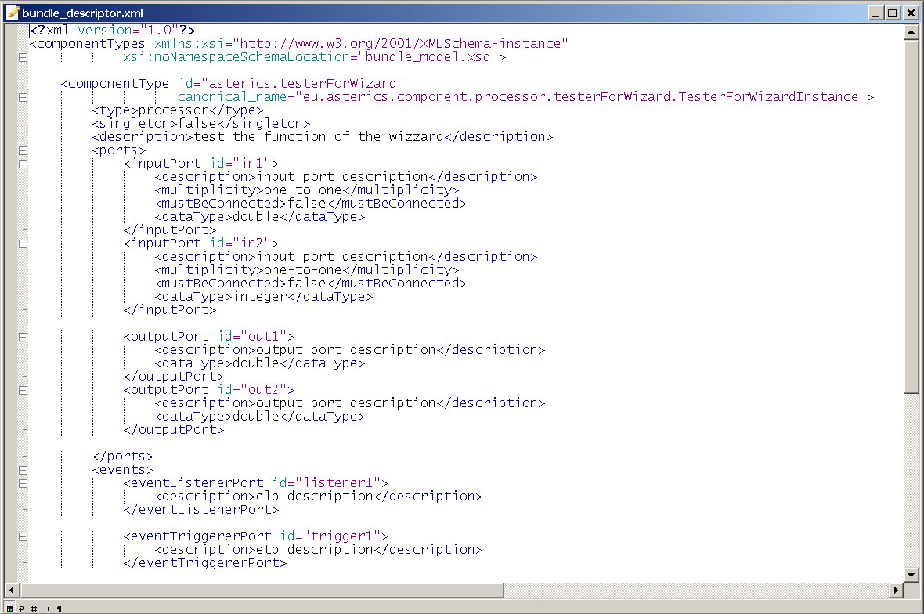

The source code folder “src\main\java\eu\asterics\component\<pluginType>\<pluginName>” contains a template for the plugin source code in JAVA, including the definitions of the selected ports and properties and the needed get- and set- methods for ports and property values. The code skeleton complies to the AsTeRICS coding guidelines and contains the AsTeRICS source file header (only a small portion is shown in the following screenshot).
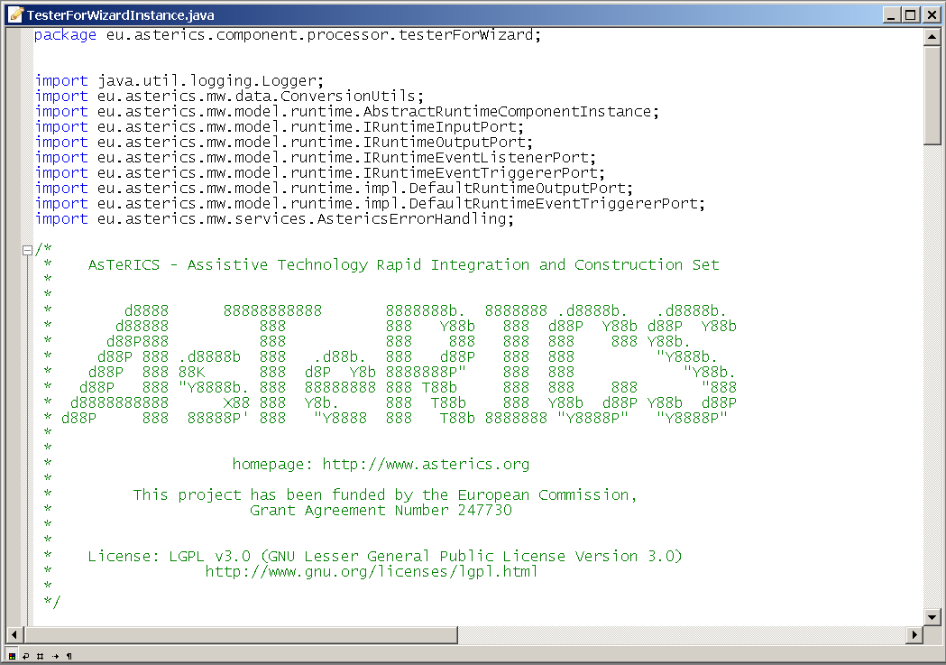

After the Eclipse IDE has been opened (or refreshed), the plugin code can be built using the provided build script (right-click build.xml -> RunAs -> Ant Build in the plugin’s folder)
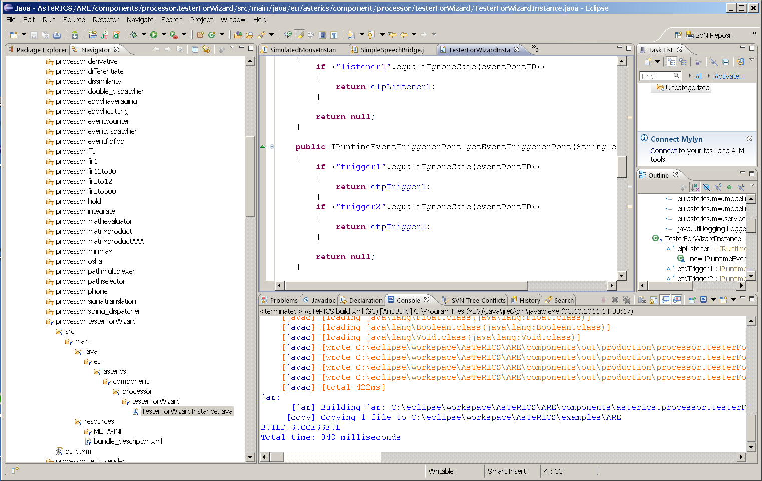
To see the plugin in the ACS editor window and/or start it inside the runtime environment, the Plugin Activation Tool can be used (see section 3).

  - Plugin Activation in ACS and ARE
To use a new AsTeRICS plugin which has been built using the Eclipse build flow and exists as executable .jar file/OSGI bundle, two steps are necessary:
- The Plugin has to be announced to the ACS – so that it gets visible in the graphical editor and can be used for the creation of deployment models. This is done by adding the bundle descriptor of the new plugin to a component-collection file (extension “.abd”) in the ACS-folder. These component collections contain all bundle-descriptors of components which can be used in the ACS and selected via the ACS’ Component-Collection Manager (see User Manual, ACS section).
- The name of the .jar file of the bundle has to be added to the “loader.ini” file of the AsTeRICS Runtime Environment (ARE). This file specifies bundles/components that are loaded by the ARE at startup. All plugins which are used in ARE models – or to be precise: the bundles which contain those plugins – have to be loaded in the ARE framework to be available for deployment.
There are two alternative ways to support this plugin activation process: the Plugin Activation Tool or the Component-Collection download and management via the ACS.
    - The Plugin Activation Tool
The Plugin Activation Tool is a separate executable file which is located in the ACS subfolder “/tools”. It is part of the ACS distribution available in the AsTeRICS_Runtime.zip package). The tool branches recursively into the source directories of ARE components, gets out the component descriptions, stores them into the component collection file of the ACS and adds the entries to the “loader.ini” file of the ARE. To enable exclusion of non-working or obsolete components from the ARE/ACS, the tool provides a “blacklist” for undesired components.

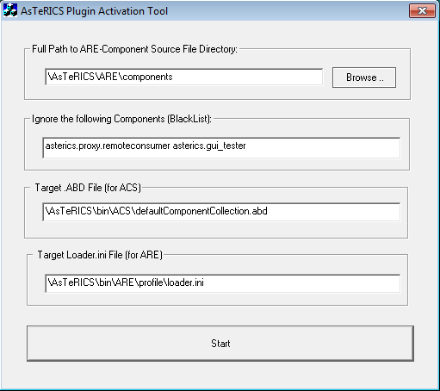
After starting the PluginActivation tool, the file path to the ARE components source folder, the blacklisted plugins and the filenames for the ACS component collection and the ARE “loader.ini” file have to be specified as absolute paths.
Default entries for these values can be edited in the “setup.ini”-file in the following format:
ComponentLocation="\AsTeRICS\bin\ARE\components"
BlackList="asterics.event_generator asterics.events_example" ComponentCollection="\AsTeRICS\bin\ACS\defaultComponentCollection.abd”
LoaderFile="\AsTeRICS\bin\ARE\profile\loader.ini”
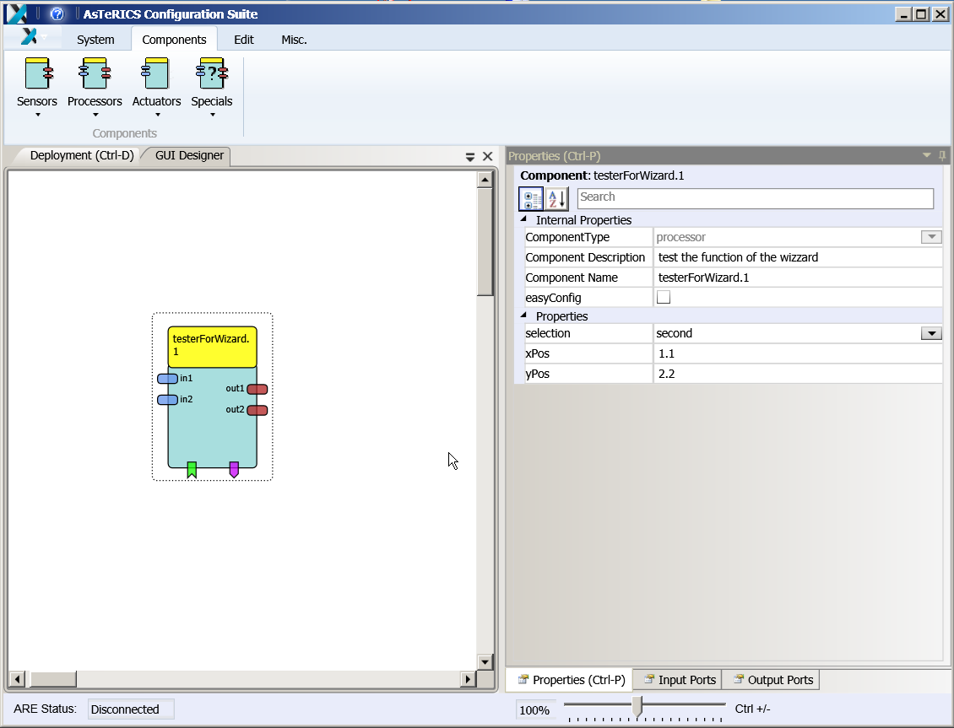
After running the Plugin Activation tool, press “start” to generate the “loader.ini”- and the ACS component collection file at the specified locations. If the ARE runs on a separate platform, the “loader.ini”-file has to be copied to the file system of the ARE and stored in the subfolder “./profile”.
Subsequently, the plugin can be selected in the “components” menu of the ACS, and the ARE will activate the plugin at startup.

    - Component-Collection Management in the ACS
The ACS provides a function for downloading the bundle descriptions of all active plugins directly from a running ARE and creating a component collection file from this information. (“System”- tab, Button “Download Component Collection”):
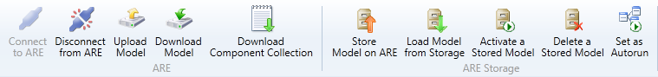
The component collection will be stored as “.abd” – file in the ACS folder, subfolder “componentcollections”. The new component collection can be used right after download, but will not be available after an ACS restart.
Within the ACS Component-Collection Manager (in the “Miscellaneous” tab), component collections can be selected or set as default collection for the ACS startup. For details see the User Manual, ACS section.
Please note that the “loader.ini” – file has to be updated manually in the ARE’s “profile” subfolder, by addition of the new .jar filename. After restart of the ARE and connection to the ACS, the component collection can be downloaded.

- Writing AsTeRICS Plugin Code
  - ARE Coding Guidelines
Coding guidelines are necessary to allow new developers to quickly find their through the code of the ARE. They are created in such a way to provide means for developers to understand code of each other but they also make sure that non-technical users can find their way through a model in ACS.
The basic coding guidelines are:
- Plugins, ports and properties should be named intuitively in the bundle descriptor. Only if necessary, the corresponding variables in the plugin code should be named differently. However they should adhere to the naming conventions stated in section 4.1.2 and different names should be commented in the code sections which translate the name into the variable (getInputPort(), getRuntimeProperty() …)
- Variable names should always use the Java naming conventions
- Every method should be preceded by a JavaDoc compatible header in order to allow new developer to grasp what is going on in it
- Where reasonable code comments should be added to improve understanding of code internals
- Code should be indented by two spaces per indentations stage. Indentations should be done using space and not tabs. Tabs should be converted to spaces.
- Parentheses should be placed in a separate line to facilitate readability

    - Port Naming Conventions
Variables of port instances should be named with a prefix indicating what kind of port it is. The rest of the port name should indicate the port’s use and adhere to the standard Java variable naming conventions. The available prefixes are:
- ip: indicates that the port is an instance of IRuntimeInputPort
- op: indicates that the port is an instance of IRuntimeOutputPort
- elp: indicates that the port is an instance of IRuntimeEventListenerPort
- etp: indicates that the port is an instance of IRuntimeEventTriggererPort
A variable holding an event listener port could therefore be named elpKeyPressed.

    - Property Naming Conventions
Plugin properties should be directly mapped to a variable in the plugin code. The variable’s should be prepended with the prefix prop and adhere to standard Java naming conventions. Thus a property could be named InputGainValue and the corresponding variable should be named propInputGainValue.
    - Bundle Descriptor Naming Conventions
The bundle descriptor should serve as an abstraction layer between the user who creates models in the ACS and the developer. Thus the names for plugins, ports and properties in the bundle descriptor should be as intuitive as possible. Names in the bundle descriptor should not include prefixes because the added information is also conveyed in the presentation of plugins in the ACS.
The bundle descriptor can translate intuitive names (e.g. input.switch) to the canonical names of plugins (e.g. GpioInputInstance) allowing coexistence of a user and a developer language. This method of name translation can be applied for plugin names, port names and property names.
    - AsTeRICS Source File header
Every source file of the AsTeRICS project which will be released as open source under the LGPL license should have the following header:
/*
* AsTeRICS - Assistive Technology Rapid Integration and Construction Set
*
*
* d8888 88888888888 8888888b. 8888888 .d8888b. .d8888b.
* d88888 888 888 Y88b 888 d88P Y88b d88P Y88b
* d88P888 888 888 888 888 888 888 Y88b.
* d88P 888 .d8888b 888 .d88b. 888 d88P 888 888 "Y888b.
* d88P 888 88K 888 d8P Y8b 8888888P" 888 888 "Y88b.
* d88P 888 "Y8888b. 888 88888888 888 T88b 888 888 888 "888
* d8888888888 X88 888 Y8b. 888 T88b 888 Y88b d88P Y88b d88P
* d88P 888 88888P' 888 "Y8888 888 T88b 8888888 "Y8888P" "Y8888P"
*
*
* homepage: http://www.asterics.org
*
* This project has been partly funded by the European Commission,
* Grant Agreement Number 247730
*
*
* License: GPL v3.0 (GNU General Public License Version 3.0)
* http://www.gnu.org/licenses/gpl.html
*
*/
    - JavaDoc compatible comments
JavaDoc compatible comments should be used to indicate the author of a source file, and to describe the purpose of a function/method/class and the respective parameters and return values.

Example for a source file header info:
/**
* Bardisplayinstance.java
* Purpose of this module:
* Implements the Bardisplay actuator plugin
*
* @author Chris Veigl [veigl@technikum-wien.at]
* Date: Mar 7, 2011
* Time: 10:55:05 AM
*/

Example for a method of a class:
/**
* Returns the value of the given property
* @param propertyName the name of the property
* @return the property value
*/
public Object getRuntimePropertyValue(String propertyName)
  - Implementing AsTeRICS components
This section describes the basic steps required for implementing an AsTeRICS component including a brief introduction to OSGi. To illustrate the implementation steps, we take a walk-through with the implementation of a simple processor component.
The AsTeRICS schemata of the XML descriptors include two concepts: the bundle descriptors and the deployment descriptors.
    - The Bundle Descriptors
Bundle descriptors are used to describe the content of an individual bundle (typically encapsulating one or more components). As such, they contain information about the included components, their ports, their customizable properties and optionally their GUI.
The following shows a bundle descriptor of a simple processor-plugin (subtype for the ACS components menu is “Basic Math”). The plugin provides an averaging function for n values (property “buffer-size”) and has one input port and one output port for integer values:
<?xml version="1.0"?>
<componentTypes xmlns:xsi="http://www.w3.org/2001/XMLSchema-instance"
xsi:noNamespaceSchemaLocation="bundle_model.xsd">
<componentType
id="asterics.averager"
canonical_name="eu.asterics.component.processor.averager.AveragerComponent">
<type subtype="Basic Math">processor</type>
<description>Linked list-based averager</description>
<ports>
<inputPort id="in_1">
<description>Input port of averager</description>
<multiplicity>one-to-one</multiplicity>
<mustBeConnected>true</mustBeConnected>
<dataType>integer</dataType>
</inputPort>
<outputPort id="out_1">
<description>Output port of averager</description>
<dataType>integer</dataType>
</outputPort>
</ports>
<properties>
<property name="buffer-size"
type="integer"
value="50"
description="The size of the averager's buffer"/>
</properties>
</componentType>
</componentTypes>
    - The Deployment Descriptor
Deployment descriptors instruct the ARE of the desired application deployment structure. The deployment descriptor is typically composed in the AsTeRICS Configuration Suite (ACS) but can also be written with a text editor (as the bundle descriptor). Basically the deployment descriptor contains several component descriptions (copied from the corresponding bundle descriptors), actual property values and the channel connection between input- and output ports of the components.
Please note that the type_id argument of the component element in deployment descriptor must match the id argument of the componentType element on the bundle descriptor. This is how the ARE detects the referred plugin type in the deployment model.
The following demo deployment descriptor describes a simple model containing two plugins and one channel:
<?xml version="1.0" encoding="UTF-8"?>
<model xmlns:xsi="http://www.w3.org/2001/XMLSchema-instance"
xsi:noNamespaceSchemaLocation="deployment_model.xsd">

<components>

<component type_id="sensor.SignalSource" id="sensor.SignalSource.1">
<description>A Source of two signal cahnnels </description>
<ports>
<outputPort portTypeID="outport1"/>
<outputPort portTypeID="outport2"/>
</ports>
<properties>
</properties>
</component>

<component type_id="actuator.SignalTarget" id="actuator.SignalTarget.1">
<description>A Signal Target</description>
<ports>
<inputPort portTypeID="in_x"/>
<inputPort portTypeID="in_y"/>
</ports>
</component>
</components>

<channels>
<channel id="channel.1">
<description>Connects SignalSource.1 (outport 1)
to SignalTarget.1 (in_x)</description>
<source>
<component id="sensor.SignalSource.1"/>
<port id="outport1"/>
</source>
<target>
<component id="actuator.SignalTarget.1"/>
<port id="in_x"/>
</target>
</channel>
</channels>
</model>
    - The Manifest file
The Manifest file tells the bundle name and other informations like import packages and .dlls to the OSGi. A typical Manifest looks as follows:
Manifest-Version: 1.0
Bundle-ManifestVersion: 2
Bundle-Name: asterics-processors.averager
Bundle-SymbolicName: eu.asterics.component.processor.averager
Bundle-Version: 0.1.0
DynamicImport-Package: *

Please note the empty line at the end of the Manifest file. It seems that OSGi needs that empty line in order to work properly. An example of a Manifest file of a component containing native code .dlls can be found in section 5.11.
    - Structure of OSGi bundles containing ARE components
As a common OSGi bundle, an AsTeRICS component must be packaged in a JAR file, containing the class files (object code) and the Manifest file. In addition to these, the AsTeRICS middleware expects the bundle descriptor. At this point, it should be noted that it is possible to include multiple AsTeRICS components in a single OSGi bundle, as long as the bundle descriptor describes all of them.
Overall, the file structure in a typical AsTeRICS bundle looks as follows:
/
+- eu/
+- asterics/
+- component/
+- ...
+- lib/
+- native/
+- my_library.dll
+- META-INF/
+- MANIFEST.MF
+- bundle_descriptor.xml

The Java object code is included in the corresponding folders representing the package structure (e.g., “/eu/asterics/component/...” etc). Optionally, if libraries are needed - native or not-, then they are included in the “/lib” folder. The Manifest is included in the “META-INF” folder as per the standard Java/OSGi practice. Finally, the AsTeRICS bundle descriptor is included directly in the root of the JAR file (i.e. “/”).

    - Component lifecyle
An ARE component implementation needs to realise the actual component with its lifecycle (i.e., ways to access its ports and properties, and methods realizing its lifecycle). This is illustrated in the following code:
package eu.asterics.mw.model.runtime;

public interface IRuntimeComponentInstance
{
// ------------------ Lifecycle support methods ------------------------- //

public void start();
public void pause();
public void resume();
public void stop();

// ------------------ Component support methods ------------------------- //

public IRuntimeInputPort getInputPort(final String portID);
public IRuntimeOutputPort getOutputPort(final String portID);
public IRuntimeEventListenerPort getEventListenerPort(final String eventPortID);
public IRuntimeEventTriggererPort getEventTriggererPort(final String eventPortID);

public Object getRuntimePropertyValue(String propertyName);
public List<String> getRuntimePropertyList(String key);

public Object setRuntimePropertyValue(String propertyName, Object newValue);

public void syncedValuesReceived (HashMap <String, byte[]> dataRow);

}

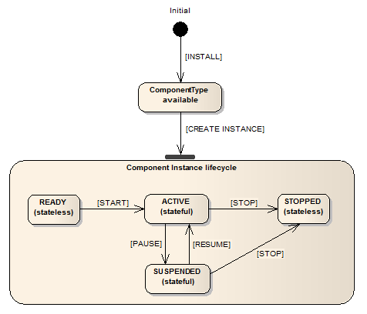
The lifecycle support methods are used to intercept AsTeRICS events concerning the component’s lifecycle. In principle, a component can be any of the following:
- READY,
- ACTIVE,
- SUSPENDED and
- STOPPED
These states and their possible transitions are illustrated in the figure on the right:
The rest of the methods are used for supporting the component operations, namely accessing the input/output ports of the component, as well as getting/setting its supported properties.

    - Step-by-Step implementation: Averager processor
In the following, the implementation on a simpe “averager” component is described. This component realizes some simple processing functionality: It collects its most recent input from one input port and produces its average at one output port. The number of samples to be stored and used for the computation of the average is controlled by a property.
The component shall have a single input port (named “in_1”), a single output port (named “out_1), and a single property (named “buffer-size”) which has the type “integer” and the default value “50”.
Using the PluginCreationWizard, the bundle descriptor, the Manifest file, the build script and the skeleton for the JAVA-code can be generated (see section3.1).
Then the actual Java-Code which implements the plugin’s functionality can be added.
The functionality of this component is quite simple: It takes as input integer values, which are queued in a buffer in a first in, first out order (FIFO). Whenever a new value is added, the average of the buffer value is computed and provided in the output. The size of the buffer is controlled by the “buffer-size” property. A possible implementation is shown below.
public static final int DEFAULT_BUFFER_SIZE = 10;
private final LinkedList<Integer> buffer = new LinkedList<Integer>();
private int bufferSize = DEFAULT_BUFFER_SIZE;

public Object setRuntimePropertyValue(String propertyName, Object newValue)
{
if("buffer-size".equalsIgnoreCase(propertyName))
{
final Object oldValue = bufferSize;

if(newValue != null)
{
if(newValue instanceof Integer)
{
bufferSize = (Integer) newValue;
// truncate unnecessary tail elements
while(bufferSize < buffer.size())
{
buffer.removeLast();
}
}
else
{
AstericsErrorHandling.instance.reportError(this,
"Invalid property value for "+propertyName+":"+newValue);
}
}
return oldValue;
}
return null;
}

private int addInt(final int in)
{
buffer.addFirst(in);
if(buffer.size() > bufferSize) buffer.removeLast();

float sum = 0f;
for(int item : buffer) sum += item;

return Math.round(sum / buffer.size());
}

private class InputPort1 implements IRuntimeInputPort
{
public void receiveData(byte[] data)
{
int in = ConversionUtils.byteArrayToInt(data);
outputPort1.sendData(ConversionUtils.intToByteArray(addInt(in)));
}
}

private class OutputPort1 extends DefaultRuntimeOutputPort
{
@Override
public void sendData(byte[] data)
{
super.sendData(data);
}
}
}

Note that the implementation details above build upon the code which is generated by the AsTeRICS PluginCreationWizard tool. Specifically, the above methods belong to the class of the desired “Averager” plugin, which extends and implements the abstract class “AbstractRuntimeComponentInstance”. This class provides some standard implementation of the lifecycle support methods.
The implementations of the input and output ports implement or override that of the “IRuntimeInputPort” and “DefaultRuntimeOutputPort” respectively. In the first case, the “receiveData” method is overridden so that the input bytes are converted to an integer, then processed using the local, private method “addInt”, and finally delegated to the output port. The latter has actually no implementation. A dummy implementation is used to illustrated overriding the “sendData” method, although this could be avoided altogether.
The private method “addInt” realized the core functionality of the averager component. Finally, the get/set property value methods are implemented to allow for getting/setting the value of the “buffer-size” property, in a straightforward manner.
Note that components with multiple input ports have to take care about synchronization (the data of the input ports could come from components running in different threads). Use “synchronized” as e.g. shown in the “asterics.processor.mathevaluator” component:
synchronized double calculateOutput() throws ParseException
- Services and Utils: Infrastructure for plugins
The ARE Services are a set of classes that enable the direct interaction between AsTeRICS plugins and other software to directly interact with the runtime environment. The most significant ARE Services are:
- CIM Communication Service: the ARE CIM Communication service layer is a unified approach to allow plugins of the ARE to communicate with their associated hardware modules attached to the AsTeRICS platform via a COM port. A range of hardware modules are provided which implement the dedicated Communication Interface Module (CIM) protocol. Further details on this communication protocol and implementation details for the ARE CIM Communication Service can be found in chapter 5.12.
- Remote Connection Service: the remote connection services allows external software that cannot be integrated into the standard plugin inter communication system used by the ARE, for example because of programming language incompatibilities, to work with the AsTeRICS system. For example, the interconnection of OSKA (the On-Screen Keyboard Application developed by AsTeRICS partner SENSORY) and the ARE uses the Remote Connection Service to send key selection information to the ARE. On the other hand, the ARE can reply with cell selection commands or other information. The actual communication is done via a protocol that can be understood by the Java ServerSocket implementation. The port number that the external software component connects to identifies the connecting component.
- Local Storage Service: The Local Storage Service will allow plugins to store individual working data “per model” and “per plugin-instance”. This is necessary when plugins need to store own calibration data, pattern recognition samples or similar data. In course of the architectural refinements for the final prototype, a service class will be provided which generates an according folder and respective file read- and write methods.
  - Communicating with peripherals: CIM Communication service
Communication between actuator and sensor components in the ARE and peripheral devices is currently defined to use a serial communication i.e. a COM port or a virtual COM port. Messaging via this interface can either adhere to the CIM protocol (see section 5.12) or use any other protocol using the raw port implementation of the CIM communication services.
All the communication with peripheral devices is done through a service in the ARE service layer called CIM Communication. The service is provided as a separate OSGi bundle which places its classes in the package eu.asterics.mw.services.cimcommunication. Access to the classes is done by exporting the entire package in the bundle.

Four classes of the CIM Communication service are important to the component programmer:
- CIMPortManager
- CIMController
- CIMProtocolPacket
- CIMEventHandler
    - CIMPortController
CIMPortController is an abstract class which hides the actual implementation of the port controller. The port controller provides the same methods for sending packets using the CIM protocol, for raw port implementations and for future uses such as a port controller handling Zigbee connections.
    - CIMPortManager
All CIM ports and other COM ports are access through the main class of the package CIMPortManager. This is implemented as a singleton with a public access method getInstance(). Thus all calls to the CIM communication service have to be done through:
CIMPortManager.getInstance()
Upon creation the CIMPortManager detects all the connected CIMs and registers them in a HashMap. CIMs are identified and stored by the combination of their CIM Id and their unique number. Therefore multiple CIMs of the same CIM Id can be used on the AsTeRICS platform.
On some computers there exist certain serial ports which do not work correctly and behave strangely. An example of such a port is a loopback port which echoes everything written to it or ports created by Bluetooth dongles. Since the CIMPortManager iterates through all serial ports, these ports can cause problems in the auto detection of attached CIMs and even lock up the runtime. Therefore a file ignore_ports.txt in the directory data/cimcommunication is parsed upon start of the auto detection. This file should be filled with the name of the COM ports behaving erratically one name per line.
To be able to communicate with a CIM, the CIM port manager provides several methods:
public CIMPortController getConnection(short cimId)
public CIMPortController getConnection(short cimId, long uniqueNumber)

These methods return a CIMPortController (read on for details) instance of the requested CIM. The method using two parameters will return the instance to the port controller which works with the CIM of the exact CIM ID and unique number. If the CIM cannot be found, null will be returned.
Requesting a connection without naming a unique number will return the first port controller connected to a CIM of the correct ID found in the HashMap holding all the port controllers.
Sending data to the connected peripheral can be done in several ways using the following methods of CIMPortManager:
public int sendPacket(short cimId, byte [] data,
short featureAddress, short requestCode, boolean crc)

public int sendPacket(CIMUniqueIdentifier cuid, byte [] data,
short featureAddress, short requestCode, boolean crc)

public int sendPacket(CIMPortController ctrl, byte [] data,
short featureAddress, short requestCode, boolean crc)

Basically these three methods do the same thing, however they do it at different speeds as the first two methods will look up the port controller that the packet should be sent to. Again the method taking only the CIM ID as a parameter will look up the first correct port controller. The third method which is passed the CIMPortController instance returned on getConnection() is the fastest method and should be used whenever possible.
Sending a CIM packet is done by providing the feature address and request code for a certain packet. The feature addresses and request codes can be found in the CIM protocol specification and the basic addresses and requests are also provided as static fields in the CIMProtocolPacket class. If data has to be attached to a CIM protocol packet a byte array holding said data has to be passed to the method, otherwise the data parameter of the method has to be set to null. The caller can also decide whether a CRC checksum should be added to the packet although this is currently unimplemented.
    - CIMEventHandler
Receiving a packet is done through use of the CIMEventHandler interface. This interface should be implemented by plugins that wish to communicate with CIMs (or raw ports). The interface contains two methods:
public void handlePacketReceived(CIMEvent e);
public void handlePacketError(CIMEvent e);
These methods are called upon correct reception of a packet or upon discovery of an error (timeout of a reply, packet transmission errors, incorrect order of incoming packets …) respectively by the port controller.
Upon correct reception of a CIM protocol based packet the method handlePacketReceived() is called with an instance of CIMEventPacketReceived as parameter. After conversion of the CIMEvent to this class, the packet can be extracted from the event and processed further.
All detected errors lead to a call of handlePacketError() with an appropriate CIMEvent implementation. The possible implemenations are:
- CIMEventErrorPacketFault: holds information to error in packet and the broken packet itself
- CIMEventErrorPacketLost: holds information on serial number of lost packet

To register the event handler with a specific CIM port controller, the CIMPortController class exposes the following methods:
- addEventHandler(CIMEventHandler hdlr)
- removeEventHandler(CIMEventHandler hdlr)
A port controller can handle multiple attached event handlers and remove each one separately.
    - CIMProtocolPacket
This class holds all the information given in a packet transferred to or from a CIM. There are two ways the developer has to use this class. Upon sending packets the sending component has to set the feature address and the request code. The CIMProtocolPacket class provides the constants as static field to facilitate setting commands.
public final static byte COMMAND_REQUEST_FEATURE_LIST = 0x00;
public final static byte COMMAND_REPLY_FEATURE_LIST = 0x01;
public final static byte COMMAND_REQUEST_WRITE_FEATURE = 0x10;
public final static byte COMMAND_REPLY_WRITE_FEATURE = 0x10;
public final static byte COMMAND_REQUEST_READ_FEATURE = 0x11;
public final static byte COMMAND_REPLY_READ_FEATURE = 0x11;

public final static byte COMMAND_EVENT_REPLY = 0x20;

public final static byte COMMAND_REQUEST_RESET_CIM = (byte) 0x80;
public final static byte COMMAND_REPLY_RESET_CIM = (byte) 0x80;
public final static byte COMMAND_REQUEST_START_CIM = (byte) 0x81;
public final static byte COMMAND_REPLY_START_CIM = (byte) 0x81;
public final static byte COMMAND_REQUEST_STOP_CIM = (byte) 0x82;
public final static byte COMMAND_REPLY_STOP_CIM = (byte) 0x82;

Furthermore the class contains constants for the global features that every CIM has to provide.
public static final short FEATURE_UNIQUE_SERIAL_NUMBER = 0;
Upon reception of an incoming packet the component associated with the CIM sending the packet is notified and a reference to the packet is passed as an instance of CIMProtocolPacket wrapped in a CIMEvent instance. The developer can access all the fields of the packet via the getter methods the class provides:
public short getAreCimID()
public byte getSerialNumber()
public short getFeatureAddress()
public short getRequestReplyCode()
public byte[] getData()
public int getCrc()

    - Serial ports not adhering to CIM Protocol (Raw Ports)
Some peripherals use a proprietary protocol to transfer their data. If this is the case the user can open a raw port through the CIMPortManager method:
public CIMPortController getRawConnection(String portName, int baudRate)
This will open the port with the name specified in the parameter portName and set the communication to the specified Baud rate.
Data can be sent to peripheral using the sendPacket() method for the returned CIMPortController. The packet will simply transfer the byte array passed in the data parameter and ignore the values giving the in the other parameter fields.
Received data will be forwarded to the event handler through calls to handlePacketReceived() with a CIMEventRawPacket as parameter. This class holds a public member variable b which holds the value of the received byte. The event handler has to handle the reconstruction of the proprietary packet itself.
HighSpeed Raw Ports:
public CIMPortController getRawConnection(String portName, int baudRate, boolean highSpeed)

A second variant opf the getRawConnection method allows specification of a “highSpeed” parameter. If highSpeed is true, the CIMPortController does not apply any connection handling or callbacks for received data to avoid performance problems in higher bandwidth streaming use cases. In this case, the CIMPortController can return the JAVA InputStream for the openend COM port connection and the plug developer can use it as desired:
portController = CIMPortManager.getInstance().getRawConnection(”COM12”,115200,true);
in = portController.getInputStream();
if (in.available() > 100) myHandlePacket ((byte) in.read());

  - Communication through a socket interface: Remote Connection Manager
When using third party software that runs on the same platform (as for example the prominently used On Screen Keyboard Application OSKA), it becomes necessary to establish a communication between ARE and the third party application. This is managed by the RemoteConnectionManager found in the package eu.asterics.mw.services. The main interface to this manager are the classes RemoteConnectionManager and IRemoteConnectionListener.
    - IRemoteConnectionListener
This interface is implemented by plugins that need to communicate via a socket communication. The interface contains the following methods:
void connectionEstablished();
void dataReceived(byte [] data);
void connectionLost();
void connectionClosed();
connectionEstablished() is called whenever a plugin requests a connection and the connection has been established. This can either happen if a connection has already been established before or if the new connection has finished its setup and connection process.
dataReceived() is called whenever new data arrives from the other end of the connection. Data is transferred in a byte array and has to be processed by the event listener.
connectionLost() is called when the connection management cannot read from or write to the socket.
connectionClosed() is called after the connection has been closed.
    - RemoteConnectionManager
The RemoteConnectionManager is implemented as a singleton and can be accessed via a public static member of the class. Thus access is always achieved through:
RemoteConnectionManager.instance

A connection is opened by a call the RemoteConnectionManager’s method:
boolean requestConnection (String port, IRemoteConnectionListener l)
This call will try to access a connection on the specified port. Although the port is actually an integer it is passed as a String here. The method will return true if a connection on this port has already been established and attach the remote connection listener passed in the second argument to the connection. If there is no active connection on the specified port, the requestConnection method will initiate the setup of the connection and return false. With this return value the user can decide whether he needs to perform setup actions or will be able to do this in the connectionEstablished() callback.
The socket connection handling is implemented using two threads, one for sending, one for receiving data. The receiver thread will continuously read data from the socket and forward it to the registered listener calling the dataReceived() method. Since incoming data is handled in another thread than the plugin which will use the socket connection, access to the methods handling this data or the way of passing data should be done in a synchronised code block.
Sending data is done calling the method sendData of RemoteConnectionManager:
public boolean writeData(String port, byte[] data)
This method is called using a String holding the port number of the connection socket and an array of bytes to be sent. The call to this method will place the data in an outgoing queue and return true if this was successful. Thus it is not guaranteed that the data has already been sent when the method returns. The sender thread will grab data from the outgoing queue and transfer it via the socket or call the connectionLost() method of the registered listener if there are problems while sending.
Once the connection to a socket is not needed anymore, the user has to close the connection, calling the following method of RemoteConnectionManager:
public void closeConnection(String port)

This will close the socket connection, end all threads and return.
  - Local Storage Service
If a model needs to save its own calibration data, training data or other private data that can be different in every model and every instance, the local storage service provides a method to save different data to the same file name on a per plugin instance per model basis.
The service uses a directory tree structure that is placed in the directory the OSGi is run from. Data is saved in a directory called “storage”. In this directory, directories for every model name of a model that uses at least one plugin that accesses local storage can be found. In the third directory layer, directories with the plugin instance name of every plugin that accesses local storage can be found. Thus if a model named “timertest” uses a plugin instance named “timer1” that saves local data this data can be found at the path location “storage/timertest/timer1”.
The service practically consists of only one method:
public File getLocalStorageFile(IRuntimeComponentInstance component, String fileName)

Calling this method located in the AREServices class will return a File object pointing to the requested file name or null if the file could not be opened or the model name could not be retrieved. After opening the file the standard JAVA ways to manipulate files apply.
  - Data Conversion Utilities
The middleware provides the class “ConversionUtils” with the following methods which are useful for type conversion to and from byte-arrays:
public static byte[] intToByteArray(int value)
public static int byteArrayToInt(byte [] b)
static public boolean booleanFromByte(final byte bits)
static public byte [] booleanToBytes(final boolean b)

static public boolean booleanFromBytes(final byte [] bytes)
static public byte [] booleanToBytes(final boolean b)

static public short shortFromBytes(final byte [] bytes)
static public byte [] shortToBytes(final short s)

static public int intFromBytes(final byte [] bytes)
static public byte [] intToBytes(final int i)

static public long longFromBytes(final byte [] bytes)
static public byte [] longToBytes(final long l)

static public float floatFromBytes(byte [] bytes)
static public byte [] floatToBytes(final float f)

static public byte [] doubleToBytes(final double d)
static public double doubleFromBytes(byte [] bytes)
static public byte [] stringToBytes(final String s)
static public String stringFromBytes(byte [] bytes)

  - Logging
The Logging support provides a uniform way of error reporting in the runtime environment so we have utilized the Java logging libraries and the various severity levels supported. The AsTeRICS error handling mechanism is used extensively from the runtime core classes but also utilized by the AsTeRICS components via the AstericsErrorHandling interface.
Each component is allowed to report an error message, a debug information or a simple information to be displayed on the screen. The ARE maintains four separate log files and updates them whenever a new error occurs. In particular there are different loggers for reporting severe errors, warnings, fine errors and one logger that contains them all.
ARE also maintains a status object for the current status of the runtime environment. Whenever a fatal error occurs (either internally or caused by one of the deployed components) the status changes to fatal error. Other possible statuses are unknown, OK, deployed, running and paused.
The ACS can request the current status of the runtime environment and update its own state accordingly. For example the ACS user can be informed about the current ARE status while the ACS will terminate a connection (or refuse to establish a new one) with a non-working ARE.
Using a Logger is the recommended way to report notifications or error descriptions to the user. In the ARE framework, using the Java logging service is recommended. The Java logger can be configured using the file “logging.properties” (see section 2.3.3.1) and used as follows:
import java.util.logging.Logger;
(…)
Logger.getAnonymousLogger().info("Component started ");

ARE provides a unified logging and error reporting mechanism. The AstericsErrorHandling class provides 4 types of loggers to be used by the ARE, deployed components and the ACS. It also provides methods for status checking which are responsible for monitoring the current status of the ARE and deployed Components.
The 4 different loggers correspond to different severity levels as follows:
Level severe: only severe errors are logged. Such errors cause an ARE failure and must be addressed immediately. Severe loggers should be used only by ARE. Errors of this type will be written in the “asterics_logger_severe.log” file.
Level warning: only warnings and upper level messages are logged. Warnings are important and must be addressed soon but not as fatal as the severe errors. Warnings can be logged by components using the following method call:
public void reportError(IRuntimeComponentInstance component, String errorMsg)
The messages will be written in the “asterics_logger_warning.log” file.
Level info: only informative and upper level messages are logged. Use this logger when you normally wanted to print something on the screen.
public void reportInfo(IRuntimeComponentInstance component, String info)

The messages will be written in the “asterics_logger.log” file.
Level fine: only debug and upper level messages are logged. Usage of this logger is mainly for debugging or development time. Use the following command:
public void reportInfo(IRuntimeComponentInstance component, String info)

The messages will be written in the “asterics_logger_fine.log” file.
Please note that each logger by default also logs all messages with severity level higher than its own as well. E.g. the warning logger logs warning and severe messages, the info logger logs informative, warning and severe messages etc.
    - Status checking
The status checking mechanism is responsible for recording the current status of the ARE or the error state of a component. The status is recorded by creating and storing objects called statusObjects. A statusObject stores the status of its creator as a string, its creator (the ARE or the specific component) and the error message.
public static void setStatusObject(String status, String componentID,
String errorMsg)

The status of the ARE can be one of the following strings:
UNKNOWN: initial state for the ARE
OK: ARE is running and ready to deploy a model
DEPLOYED: A model has been deployed and the ARE is now ready to run the model
RUNNING: A model is running on the ARE
PAUSED: A model has been deployed and the ARE is in paused mode
ERROR: An error occurred
FATAL_ERROR: A fatal error occurred, model or deployment aborted
The status of a component can only be the ERROR state because this is the only state of a component that we are interested in recording for later use. An ERROR statusObject is automatically created when a component calls the reportError method as described above.
For retrieving the statusObjects, the following method is used:
public StatusObject[] queryStatus(boolean fullList)

This method is particularly useful for the ACS to determine the current status of the runtime environment and of the deployed components. If the ARE or one of the components are in a problematic state it can be reflected in the ACS.
The boolean fullList argument specifies whether the error list to be returned will include all statusObjects generated since the ARE startup or just those that have not been requested by the ACS before.

  - The ARE Thread Pool
In order to avoid resource greedy threads and to achieve best thread handling, ARE uses one of the Thread Pool implementations provided by Java since JRE 1.5. In particular, we have utilized the java.util.concurrent.Executors library for creating a CachedThreadPool.
A cached thread pool will create threads as needed but will reuse previously instantiated threads when they are available and inactive. A cached thread pool is particularly useful for many short-lived asynchronous tasks and improves the performance of the runtime environment.
Developers are expected to use the ARE thread pool for executing their tasks that require a new Thread. You will need to import the middleware services package in order to get access to the AstericsThreadPool class. Below is a typical example of using the AsTeRICS thread pool for a thread that will handle the sending data from an output port.
import eu.asterics.mw.services.AstericsThreadPool;
(…)
AstericsThreadPool.instance.execute(
new Runnable()
{
public void run()
{
runtimeInputPort.receiveData(data);
}
});
  - The ARE GUI support
The ARE provides a panel area (“ARE Desktop”) where plugins can display their graphical elements using the ARE GUI support classes. The ACS provides a dedicated canvas editor that allows end users positioning and resizing graphical elements of the plugins. Based on this information, the ARE displays plugins on the local device, maintaining the correct screen position and aspect ratio of graphical elements with respect to the screen resolution of the deployment device. (For more information about the usage of the ACS GUI editor and the ARE GUI control panel refer to the User Manual.)
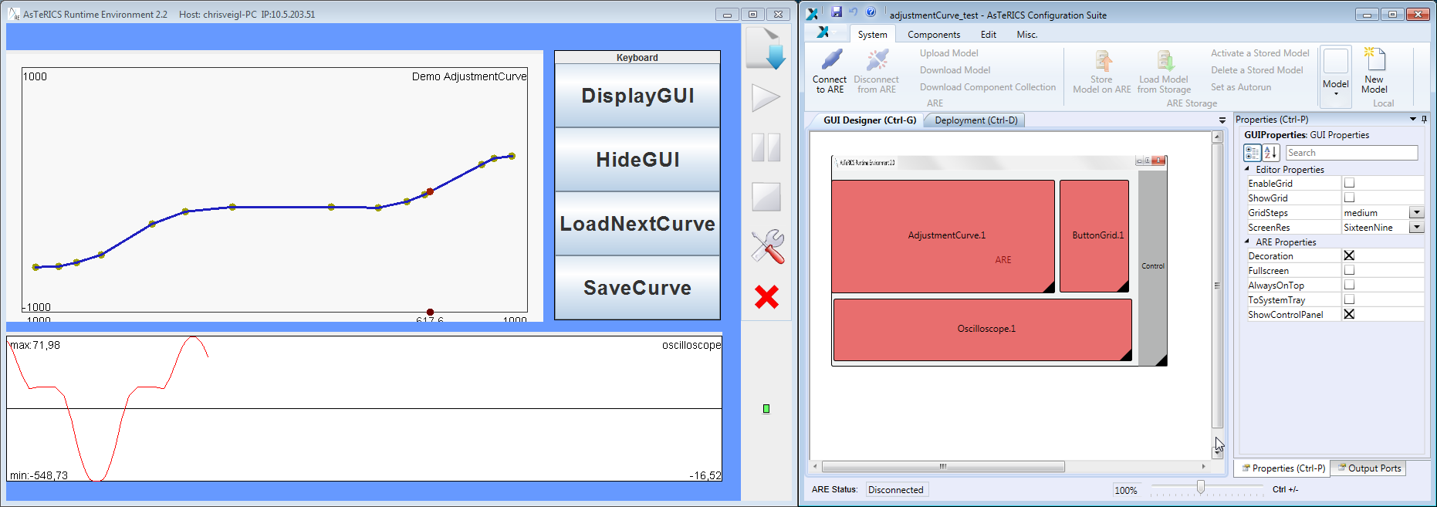
GUI composition using the ACS GUI designer (right), resulting ARE GUI (left)

In order to be recognized as GUI-plugin by ACS and ARE, the bundle descriptor of the plugin has to be extended with a dedicated <gui> entry, which specifies the default size in a virtual coordinate system of 10000/10000 pixels. In the deployment model, the ACS will create position and size information according to the area defined in the ACS GUI designer.

<gui>
<width>5000</width>
<height>3000</height>
</gui>
The gui element addition to the bundle descriptor

The AsTeRICS middleware provides some services to the plugin developers in order to allow them displaying their GUI element onto the ARE Desktop. The middleware services encapsulate the complexity of dealing with positioning and allow displaying all GUI elements onto the same container: the ARE Desktop.
All GUI services are defined in eu.asterics.mw.services.AREServices so developers need to import this class in order to get access to the following methods:
- void displayPanel (JPanel panel, IRuntimeComponentInstance componentInstance, boolean display)
This method is used for displaying (or hiding) a plugin’s panel at/from the ARE desktop. Developers need to pass
- the panel they want to be displayed (or removed)
- the plugin object, in order to help the middleware finding the desired position and dimensions from the deployment model
- a boolean argument specifying if they wish to hide or show the given panel.
- Dimension getAvailableSpace(IRuntimeComponentInstance componentInstance)
The space that each plugin will occupy on the ARE desktop is defined by the designer on the ACS and passed to the ARE via ASAPI. Plugin developers can get the available space for their graphical elements by calling the getAvailableSpace method which will return the space occupied for the plugin object passed as argument.
- Point getComponentPosition (IRuntimeComponentInstance componentInstance)
The positioning of plugin’s GUI elements is defined by the designer on the ACS and passed to the ARE via ASAPI. Plugin developers can get the position of their graphical elements by calling the getComponentPosition which will return the position on screen for the plugin object passed as argument.
- void adjustFonts(JPanel panel, int maxFontSize, int minFontSize, int offset)
This service can be used by plugin developers interested in auto-adjusting the fonts of their GUI components depending on the space occupied for their plugins on the ARE desktop. They need to pass
- a panel to which all the internal fonts will be auto-adjusted
- the maximum font size (in case there is more space available than needed)
- the minimum font size, in case there is too little space which causes the text to become non-readable. Finally, the offset argument is used in case we want to occupy a percentage of the available space.
A good approach to GUI plugin development is to analyse existing plugins which provide GUI elements, e.g. the BarDisplay or Oscilloscope actuators, or the Slider or Cellboard sensor components.
  - ARE core events notification services
The ARE core events notification service allows plugins to register/unregister to the ARE middleware in order to receive notifications of ARE core events.
- void registerAREEventListener(IAREEventListener clazz)
It is sometimes necessary that plugins can be notified of various ARE events so they can react as needed. This method can be called by component instances that wish to be notified of such ARE events. Currently, the core events supported are:
  - preDeployModel: registered ARE event listeners will be notified just before the deployment of a model.
  - postDeployModel: registered ARE event listeners will be notified immediately after the deployment of a model.
  - preStartModel: registered ARE event listeners will be notified just before the currently deployed model is started.
  - postStopModel: registered ARE event listeners will be notified immediately after the deployed model has been stopped.
- void unregisterAREEventListener(IAREEventListener clazz)
Plugins already registered for receiving ARE core events can un-register using this method.
  - Dynamic Properties
In some applications, the ACS should be able to provide several options for property values which are not known in advance but depend on the current state of the ARE (see AsTeRUCS User Manual, section “Dynamic Properties”).. A typical example is the selection of a file which is available in the ARE file system (e.g. a .wav-file for the wave player plugin). This feature is particularly useful for plugins that are hardware dependent (selecting e.g. a soundcard or a midi player), or depend on the file system.
If a plugin is implementing a dynamic property, the values will be requested from the ARE, as soon as the ACS is synchronized with the ARE, via the ASAPI function:
List<String> getRuntimePropertyList(String componentID, String key).
The ARE middleware will forward the request for valid property values to the component instance with the given ID. The List<String> getRuntimePropertyList(String key) method has to be implemented in the AbstractRuntimeComponentInstance class which every AsTeRICS component extends.
The method implementation creates the list of valid properties and returns it to the middleware and the latter forwards the string list to the ACS via ASAPI. The ACS will dynamically update the property list in the properties window.
For an example of the dynamic property implementation, see the WaveFilePlayer plugin.
  - Data Synchronization
Some plugins need data of multiple input ports to be able to start processing. Due to the threaded nature of the input-ports, it could happen that one input port of a plugin receives multiple values before another port gets one value, although both signal channels deliver values at the same sampling rate.
The synchronization service provides a buffering mechanism at the middleware level that can be utilized by plugin developers in order to make sure that incoming data of selected input ports arrives synchronized.
To use the synchronization service in the plugin coee, plugin developers are expected to extend the DefaultRuntimeInputPort instead of implementing the IRuntimeInputPort. Basically, DefaultRuntimeInputPort provides a default implementation for the necessary buffering methods, as shown in the table below.
public abstract class DefaultRuntimeInputPort implements IRuntimeInputPort {

private boolean buffering;
public void receiveData(final byte [] data) {
;
}
public void startBuffering (AbstractRuntimeComponentInstance c,
String portID) {
this.buffering = true;
}
public void stopBuffering (AbstractRuntimeComponentInstance c,
String portID) {
this.buffering = false;
}
public boolean isBuffered () {return this.buffering;}
}

The designer can define that a plugin's input port should be synchronized with some other input ports via the ACS. This will cause an argument change of the inputPort element on the deployment model file (e.g., <inputPort portTypeID="inB" sync="true">).
As soon as a model is deployed on the ARE, the middleware collects per component every port noted as synchronized port. When the model is successfully deployed and started, the ARE will buffer data which enters synchronized input ports until data on all synchronized ports has arrived. At that point, the ARE will call a new AbstractRuntimeComponentInstance callback method.
Developers that wish to support data synchronization need to implement the following method at their component instances.
public void syncedValuesReceived(HashMap<String, byte[]> dataRow)
Where dataRow is a HashMap between Input Port ID and byte[]. For synchronized input ports, instead of implementing the regular void receiveData(byte[] data) method which delivers incoming data of a single port, developers need to implement the syncedValuesReceived method which will be called from the ARE with synchronized data from all the input ports that have been selected.

  - Interfacing Native C/C++ Code via JNI
    - Specifying native libraries in the Manifest
The Manifest file of a bundle which includes native libraries has to specify these .dlls as shown in the following example:
Manifest-Version: 1.0
Bundle-ManifestVersion: 2
Bundle-Name: asterics-sensors.mycomponent
Bundle-SymbolicName: org.asterics.mycomponent
Bundle-Version: 0.1.0
Bundle-NativeCode: lib/native/mylib1.dll;
lib/native/mylib2.dll;
lib/native/mylib3.dll;
osname=win32;processor=x86;
osname=win;processor=x86-64;
osname=win8;processor=x86;
osname=win8;processor=x86-64;
osname=windows 8;processor=x86;
osname=windows 8;processor=x86-64;
osname=windows8;processor=x86;
osname=windows8;processor=x86-64DynamicImport-Package: *

Components which interface native code via JNI and their respective manifest files can be found in the SVN, e.g. the “webcamera” component or the signal processing plugins by Starlab.
Note that the .jar containing the .dlls can be built manually using the command:
jar -cvfm ..\mybundle.jar META-INF\MANIFEST.MF .

    - Java-Implementation: JNI-Bridge
The recommended way to interface Java code of an ARE component with native code in a .dll is a bridge class which encapsulates the JNI functions and callbacks and maps the functions of the ARE component’s lifecycle-, port- and property-management to the corresponding functions in the native code. Here is a simple example which comprises one component property and receives data callbacks from a thread implemented in C. The received values are transferred to the component’s output port:
package org.asterics.jni;
import org.asterics.mycomponent.MyComponentInstance;
import java.util.logging.Logger;

public class Bridge
{
/* Statically load the native library */
static
{
System.loadLibrary("mylib1"); // loads mylib1.dll
System.loadLibrary("mylib2"); // loads mylib2.dll
System.loadLibrary("mylib3"); // loads mylib3.dll
}

private static final Logger logger = Logger.getAnonymousLogger();
private final MyComponentInstance.OutputPort my_outport;

public Bridge(final MyComponentInstance.OutputPort my_outport)
{
this.my_outport = my_outport;
}
/**
* Activates the underlying native code/hardware.
*
* @return 0 if everything was OK, a negative number otherwise
*/
native public int activate();
/**
* Deactivates the underlying native code/hardware.
*
* @return 0 if everything was OK, a negative number otherwise
*/
native public int deactivate();
/**
* Gets the value of the named property.
*
* @param key the name of the property to be accessed
* @return the value of the named property
*/
native public String getProperty(String key);

/**
* Sets the named property to the defined value.
*
* @param key the name of the property to be accessed
* @param value the value to be assigned to the named property
* @return the value previously assigned to the named property
*/
native public String setProperty(String key, final String value);
/**
* This method is called back from the native code on demand to signify
* an internal error. The first argument corresponds to an error code
* and the second argument corresponds to a textual description
* of the error.
* @param errorCode an error code
* @param message a textual description of the error
*/
private void errorReport_callback(
final int errorCode,
final String message)
{
logger.severe(errorCode + ": " + message);
}
/**
* This method is called back from the native code to send data
* to the component’s output port.
*
* @param data1 (range is [0, Short.MAX_VALUE])
*/
private void newData_callback(final int data1)
{
my_outport.sendData(data1);
}
}

    - C-Implementation: Callbacks and JNI code
The native C-code needs to be compiled into a .dll and include the JNI header files and libraries. An example for the Microsoft Visual Studio compiler looks as follows:
The following C-example shows how to implement a JNI-callback from a C-thread and an ARE-compliant exchange of a component property:
#include <jni.h>

static JavaVM * g_jvm;
static jobject g_obj = NULL;

const char * propertyKey = "myProperty";
const char * propertyValue = "20";

JNIEXPORT jint JNICALL Java_org_asterics_jni_Bridge_activate
(JNIEnv * env, jobject obj)
{
jint error_code = 0;
error_code = env->GetJavaVM(&g_jvm);
if(error_code != 0)
{
return error_code;
}
jclass cls = env->GetObjectClass(obj);
jmethodID mid = env->GetMethodID(cls, "newData_callback", "(IIII)V");
if (mid == NULL) return -1; /* method not found */
// explicitly ask for a global reference
g_obj = env->NewGlobalRef(obj);

my_c_thread_init();
return error_code;
}

JNIEXPORT jint JNICALL Java_org_asterics_jni_Bridge_deactivate
(JNIEnv * env, jobject obj)
{
jint error_code = 0;
my_c_thread_exit();
env->DeleteGlobalRef(g_obj);
return error_code;
}

JNIEXPORT jstring JNICALL Java_org_asterics_jni_Bridge_getProperty
(JNIEnv *env, jobject obj, jstring key)
{
const char *strKey;
jstring result;

if (key == NULL) return NULL; /* OutOfMemoryError already thrown*/
strKey = env->GetStringUTFChars(key, NULL);

if(strcmp(propertyKey, strKey) == 0)
{
result = env->NewStringUTF(propertyValue);
}
else
{
result = NULL; /* property was not found */
}
env->ReleaseStringUTFChars(key, strKey);
return result;
}

JNIEXPORT jstring JNICALL Java_org_asterics_jni_Bridge_setProperty
(JNIEnv *env, jobject obj, jstring key, jstring value)
{
const char *strKey;
const char *strValue;
jstring result;

if (key == NULL) return NULL; /* OutOfMemoryError already thrown*/
strKey = env->GetStringUTFChars(key, NULL);

if (value == NULL) return NULL; /* OutOfMemoryError already thrown */
strValue = env->GetStringUTFChars(value, NULL);

if(strcmp(propertyKey, strKey) == 0)
{
result = env->NewStringUTF(propertyValue);
pollingIntervalValue = strValue;
}
else
{
result = NULL; /* property was not found */
}

env->ReleaseStringUTFChars(key, strKey);
env->ReleaseStringUTFChars(value, strValue);
return result;
}

// prepare JNI callback
JNIEnv *env;
g_jvm->AttachCurrentThread((void **)&env, NULL);
jclass cls = env->GetObjectClass(g_obj);
jmethodID mid = env->GetMethodID(cls, "newCoordinates_callback", "(IIII)V");

// perform JNI callback
env->CallVoidMethod((jint)my_new_data);

This native C-code needs to be compiled into a .dll, the JNI header files and libraries have to be specified to the compiler and linker respectively. An example for the Microsoft Visual Studio build tools looks as follows:
cl -c -I "C:\Program Files (x86)\java\jdk1.6.0_21\include" -I "C:\Program Files (x86)\java\jdk1.6.0_21\include\win32" -I ".\3rdparylib" my_c_file.cpp /ZI /nologo /W3 /WX- /Od /Oy- /D "WIN32" /D "_DEBUG" /D "_WINDOWS" /D "_CRT_SECURE_NO_WARNINGS" /D "_VC80_UPGRADE=0x0710" /D "_MBCS" /Gm- /EHsc /RTC1 /MTd /GS /fp:precise /Zc:wchar_t /Zc:forScope /Gd /analyze- /errorReport:queue
link my_c_file.obj /DLL /OUT:".\my_c_file.dll" /INCREMENTAL:NO /NOLOGO /LIBPATH:"libmsvc" /LIBPATH:"3rdparylib" "odbc32.lib" "odbccp32.lib" "comctl32.lib" "winmm.lib" "opengl32.lib" "ole32.lib" "strmiids.lib" "uuid.lib" "kernel32.lib" "user32.lib" "gdi32.lib" "winspool.lib" "comdlg32.lib" "advapi32.lib" "shell32.lib" "oleaut32.lib" /NODEFAULTLIB:"libcd.lib" /NODEFAULTLIB:"atlthunk" /NODEFAULTLIB:"LIBCMT" /MANIFESTUAC:"level='asInvoker' uiAccess='false'" /DEBUG /SUBSYSTEM:WINDOWS /TLBID:1 /DYNAMICBASE:NO /MACHINE:X86 /ERRORREPORT:QUEUE
Note that the compiler and linker switches may differ depending on the nature of your dependency libraries and setup.

  - External Helper Applications and Tools for Plugins
Some pluings make use of external helper applications which are self-contained binary executable files and communicate with the particular ARE plugin (usually via a socket interface). These helper applications are stored in the folder ARE/tools.
Currently, the following plugins use external tools:
Plugin Name | Helper Application and Purpose | Interface
SpeechProcessor | Tools/SpeechProcessor.exe  This application creates an instance of the Microsoft speech server for speech synthesis and recognition. It accepts a list of commands from the plugin and sends back recognized voice commands. | TCP/IP socket
OscGestureFollower | Tools/GestureFollower/gfOSC_v1.4.exe  The GestureFollower algorithm by IRCAM. Allows training and recognition of several signal patterns (for example from multichannel sensor data). | TCP/IP socket, Open Sound control (OSC) protocol
FaceTrackerCLM | Tools/EyesStateTrainer/EyesStateDetect.exe  Tools/EyesStateTrainer/EyesStateRecord.exe  Tools/EyesStateTrainer/EyesStateTrain.exe  Training application for detection of open or closed eyes of a user for application with the FaceTrackerCLM plugin. The training process is exaplained in the Model Guide for the FaceTrackerCLM plugin. | Offline, interface via file
SSVEPStimulator | Tools/blit.exe  Creates a flickering images from a given bitmap file and it’s x/y coordinates on the desktop screen for Software-generated visual stimulation in SSVEP BCI tasks. | Commandline parameters to the application call
SSVEPFileWriter  ProtocolSSVEPTrain SSVEPDetect | Tools/SSVEPTrainFunction.exe  Finds significant frequencies in an SSVEP training recording which has been generated by the SSVEPFileWriter plugin | Offline, interface via file:

- Communication Interface Modules and Protocol
This section describes the communication protocol between the AsTeRICS Runtime Environment and the Communication Interface Modules (CIMs) via the USB standard interface.
The CIM – protocol is a bi-directional communication standard between ARE and the external modules. As described in chapter 5.1, the ARE provides services for connection and communication with external hardware modules, if these modules support the CIM communication protocol in their firmware. The CIM protocol defines a unique ID for the CIM type, and commands for reading and writing so-called “features” from/to the CIM.
All USB CIMs will be identified and will communicate via USB CDC virtual serial ports. (If desired, a CIM could be connected also via a real serial port and use the same protocol.)
Usually, no system driver development is needed to obtain a virtual COM port when a CIM is plugged into the computer’s USB port: An appropriate .inf-file is sufficient to create the COM port in the Windows operating system. This .inf file has to be specified only at the first connection.
Currently, two different .inf files are supplied with the AsTeRICS Runtime distribution:
- the Arduino.inf (for the Arduino UNO microcontroller which is used for general purpose digital I/O and analog input via the Arduino processor plugin
- the .inf file for all IMA CIMs (Analog In, Digital In/Out, Acceleration CIM, ..)

In the communication process, the ARE acts as master and the CIM acts as slave: The CIM will usually answer only on a request from the ARE.
Additionally, CIMs could send data without being requested from the ARE – for example periodic updates of a value. These periodic updates use a reserved
The CIMs provide a full list of supported features upon an identification request. This offers flexibility if a new module type is manufactured, where already known features with known commands are integrated but the number and combination of features is different from the previous module types.
To provide the possibility to identify CIMs of the same type in the ARE (e.g. when two GPIO CIMS are connected), a unique serial number is hardcoded in firmware and can be queried via a feature request.

  - Communication Mechanism and Packet Format
The following table shows the CIM protocol structure:

Data field | Size (bytes) | Range of values | Description
Packet ID | 2 | “@T” (0x4054 ) | In case of the lost packet synchronization the 2-bytes packet ID helps to identify the beginning of a packet, so that a lost communication with the CIM will be resynchronized
ARE ID  ( CIM ID ) | 2 |  | If the packet is sent from ARE to CIM, the ARE-ID identifies the ARE software version (e.g. “0x010E” means 1.14).  If the packet is sent from CIM to ARE, the CIM-ID identifies the CIM type in the MSB and the CIM version in the LSB (e.g. “0x0105” means CIM type 0x01 = HID actuator, version 5).  The CIM version informs the ARE about specific feature deviations due to hardware and/or firmware revisions.  The CIM may refuse to execute or respond to certain or all commands from ARE, if the ARE version value is below the minimum compatible version required
Data Size | 2 | 0x0000-0x0800 | Some of the commands or the answers from CIM may require optional data like the ADC/DAC values. The size says how many data is attached to the command or answer. The maximum data size is limited to 2048 bytes. If ARE sends a higher size value, the CIM will handle it as incorrect packet and it will not respond to it, but try to resynchronize the packet reception. In case there is no data attached to the packet this value will be 0x0000.
Serial packet  number | 1 | 0x00-0x7f  (0x80-0xff for event-replies from CIM ) | The serial number in a packet which is sent from ARE to CIM is incremented by the ARE every packet, with values ranging from 0x00 to 0x7f. The CIM sends the same value in the response packet. This helps to identify what reply belongs to which request.  A packet which is sent from CIM to ARE without request (e.g. in reaction to an event or periodically) will have different serial numbers with the highest bit (0x80) set, incremented by the CIM
CIM-Feature address | 2 |  | This value from 0x0000 to 0xffff defines the addressed CIM-feature. The feature address 0x0000 holds a serial number which is unique for all manufactured CIMs of a specific type. All other features (and the associated addresses) will be defined for a particular AsTeRICS CIM-Type. A feature definition includes the amount of data which is expected in the optional data field. If a command is not associated with a specific feature (e.g. the request “get feature list”) the feature address can have any value and will have no effect. For a specification of currently defined features please refer to section 6.3.
Request Code  ( Reply code ) | 2 |  | The LSB of this value represents a command code which is globally valid for all CIM-Types.  If sent from ARE to CIM, the MSB specifies the transmission mode.  If sent from CIM to ARE, the MSB holds an error/status code related to the transmission. For a detailed description of Request/Reply codes please refer to section 6.2.
Optional data | 0-2048 |  | The packet can contain up to 2048 bytes of additional data. The actual length is given in the “Data Size” field.
Optional CRC checksum | 0 or 4 | CRC32 checksum | (if CRC-Bit in “Command”-field is set)  CRC32 with 0x04c11db7 polynomial used also in e.g. ZIP or Ethernet protocol.

CIM Protocol Important notes:
- Italic descriptions refer to communication from CIM to ARE
- All integer values (version, data size, serial number, feature address, command, checksum) in the packet are stored in little-endian format in the packet.
- The minimum packet size (without optional data, without CRC) is 11 byes,
the maximum packet size (2048 bytes data, CRC) is 2063 bytes.
  - Request / Reply - Code
The request-/reply codes have to be supported by all CIMs and specify a generic way to read/write features etc. Requests are sent from ARE to CIM, replies are sent from CIM to ARE – and are usually a direct acknowledgement to a request. The only exception is when a CIM replies data periodically or on occurrence of an event.
All CIMs have to implement command with codes < 0x80, others can be implemented optionally (e.g. the command 0x80-“reset CIM” could be useful to re-initialise CIM-functions, 0x82-“stop CIM” could establish a failsafe state if necessary.)
A request/reply consists of a high-byte (MSB) and a low byte (LSB). The LSB specifies the actual command-ID. In case the packet is sent from ARE to CIM the MSB specifies the transmission mode (e.g. with/without CRC). In case the packet is sent from CIM to ARE, the MSB holds an error / status information
MSB (8-bit) | LSB (8-bit)
Mode / Status code | Request/Reply code
Every request from ARE to CIM will be acknowledged by a corresponding reply packet. A reply packet may contain feature-associated data .
    - Request/Reply Code in LSB
Request / Reply code | Direction | Description | Expected Data
0x00 | ARE→CIM | request feature list | -
0x00 | CIM→ARE | reply feature list | list of supported features  (eg. 8 bytes for 4 feature addresses)
0x10 | ARE→CIM | request write feature | bytes according to feature
0x10 | CIM→ARE | reply write feature | bytes according to feature
0x11 | ARE→CIM | request read feature | bytes according to feature
0x11 | CIM→ARE | reply read feature | bytes according to feature
0x20 | CIM→ARE | event reply | bytes according to feature
0x80 | ARE→CIM | request reset CIM | -
0x80 | CIM→ARE | reply reset CIM | -
0x81 | ARE→CIM | request start CIM | -
0x81 | CIM→ARE | reply start CIM | -
0x82 | ARE→CIM | request stop CIM | -
0x82 | CIM→ARE | reply stop CIM | -

    - Mode / Status code in MSB
Mode /  Status code | Direction | Description
Bit 0 | ARE→CIM | CRC-mode:  Bit value ==0 :CRC is not appended to packet and not checked on receiving side  Bit value ==1: CRC is checked on receiving side,  packet is dropped if CRC wrong;
Bits 1-7 | ARE→CIM | Currently not used
Bit 0 | CIM→ARE | CRC-mode, as in received packet from ARE
Bit 1 | CIM→ARE | Error 1: Lost packets  (serial number mismatch)
Bit 2 | CIM→ARE | Error 2: CRC mismatch
Bit 3 | CIM→ARE | Error 3: Invalid or unsupported feature
Bit 4 | CIM→ARE | Error 4: Invalid ARE version
Bit 5 | CIM→ARE | Error 5: CIM not ready
Bit 6 | CIM→ARE | Currently not used
Bit 7 | CIM→ARE | Other Error, description available in data field

  - Feature Lists and CIM-IDs of all AsTeRICS CIMs
The following section defines the CIM-ID’s, the feature addresses and the expected data for a particular feature request/reply for all AsTeRICS CIMs.
    - HID-CIM
CIM-ID | Feature-address | Access | Descritption | Data
0x0101:  HID  actuator  version 1 | 0x0000 | r | Unique serial number | 4 bytes
0x0101:  HID  actuator  version 1 | 0x0001 | w | MOUSE x/y pos  (relative change) | 4 bytes: xxyy
0x0101:  HID  actuator  version 1 | 0x0002 | w | MOUSE buttonstate | 1 byte:  Bit 0=left click, Bit 1=right click, Bit3=middle click
0x0101:  HID  actuator  version 1 | 0x0003 | W | MOUSE wheel | 1 byte: wheel displacement
0x0101:  HID  actuator  version 1 | 0x0010 | w | KEYBOARD keypress | 2 bytes: keycode, modifier
0x0101:  HID  actuator  version 1 | 0x0011 | w | KEYBOARD keyhold | 2 bytes: keycode, modifier
0x0101:  HID  actuator  version 1 | 0x0012 | w | KEYBOARD keyrelease | ----------
0x0101:  HID  actuator  version 1 | 0x0020 | w | JOYSTICK joy1pos-analog | 4 bytes: xxyy
0x0101:  HID  actuator  version 1 | 0x0021 | w | JOYSTICK joy2pos-analog | 4 bytes: xxyy
0x0101:  HID  actuator  version 1 | 0x0022 | w | JOYSTICK joy3pos-digital | 1 byte:  Bits 0-3: left/right/up/dwn
0x0101:  HID  actuator  version 1 | 0x0023 | w | JOYSTICK joybuttonstate | 2 bytes:  Bits 0-9: button pressed 0/1

    - PT-1 GPIO – CIM (Legacy GPIO)
CIM-ID | Feature-address | Access | Descritption | Data
0x0201:  GPIO version 1 sensor/ actuator, | 0x0000 | r | Unique serial number | 4 bytes
0x0201:  GPIO version 1 sensor/ actuator, | 0x0001 | r | GPIO Input State | 1 byte:  Bit 0 = Input 1; Bit 7 = Input 8
0x0201:  GPIO version 1 sensor/ actuator, | 0x0002 | r/w | GPIO Input Threshold Voltage | 4 bytes:  bytes 0,1: threshold voltage value for inputs 1-4 (0 to 25000 mV)  bytes 2,3: threshold voltage value for inputs 5-8 (0 to 25000 mV)
0x0201:  GPIO version 1 sensor/ actuator, | 0x0003 | r/w | GPIO Input Pullup State | 1 byte:  Bit 0 = Input 1; Bit 7 = Input 8  Value: 0 = off; 1 = on, 33K resisor connected to 3.3 V
0x0201:  GPIO version 1 sensor/ actuator, | 0x0004 | r/w | GPIO Input Value Change Event | 1 byte:  Bit 0 = Input 1; Bit 7 = Input 8  Value: 0 = off; 1 = on
0x0201:  GPIO version 1 sensor/ actuator, | 0x0005 | r/w | GPIO Periodic Input Value Event | 2 bytes:  bytes 0,1: period time 0 (off) to 65535 milliseconds
0x0201:  GPIO version 1 sensor/ actuator, | 0x0010 | r/w | GPIO Output State | 1 byte:  Bit 0 = Output 1; Bit 7 = Output 8
0x0201:  GPIO version 1 sensor/ actuator, | 0x0011 | r/w | GPIO Output Pullup State | 1 byte:  Bit 0 = Output 1; Bit 3 = Output 4  Value: 0 = off; 1 = on
0x0201:  GPIO version 1 sensor/ actuator, | 0x0020 | w | Store current CIM state to EEPROM as default power-on state | none
0x0201:  GPIO version 1 sensor/ actuator, | 0x0030 | r/w | 5-24 V power output | 2 bytes:  bytes 0,1: 0 (bypass to USB 5V), 5000-25000 mV

    - Phone-CIM (Windows Phone OS)
CIM-ID | Feature-address | Access | Descritption | Data
0x0301: Phone actuator, version 1 | 0x0000 | r | Unique serial number | 4 bytes
0x0301: Phone actuator, version 1 | 0x0001 | w | Phone Application Configuration:  init | request:  4 bytes (init)
reply:
4 bytes (error_code)
0x0301: Phone actuator, version 1 | 0x0002 | w | Phone Application Configuration:  close | request:  4 bytes (close)
reply:
4 bytes (error_code)
0x0301: Phone actuator, version 1 | 0x0010 | w | Phone Manager:  make call | request:  4 bytes: command (make call)  1 byte: phone_id_len  X bytes: phone_id
reply:
4 bytes (error_code)
0x0301: Phone actuator, version 1 | 0x0011 | w | Phone Manager:  accept call | request:  4 bytes (accept)
reply:
4 bytes (error_code)
0x0301: Phone actuator, version 1 | 0x0012 | w | Phone Manager:  drop call | request:  4 bytes (drop)
reply:
4 bytes (error_code)
0x0301: Phone actuator, version 1 | 0x0013 | r | Phone Manager:  receive call event | 1 byte: phone_id_len  X bytes: phone_id
0x0301: Phone actuator, version 1 | 0x0014 | w | Phone Manager: get phone state | request:  4 bytes (get phone state)  reply:  4 bytes (error_code)  1 byte (state_code)
0x0301: Phone actuator, version 1 | 0x0020 | w | Message Manager:  send SMS | request:  1 byte: phone_id_len  X bytes: phone_id  2 bytes: message_len  Y bytes: message
reply:
4 bytes (error_code)
0x0301: Phone actuator, version 1 | 0x0021 | r | Message Manager:  receive SMS event | 1 byte: phone_id_len  X bytes: phone_id  2 bytes: message_len  Y bytes: message

    - PT-1 ADC – CIM (Legacy ADC/DAC)
CIM-ID | Feature-address | Access | Descritption | Data
0x0401:  ADC version 1 sensor/ actuator, | 0x0000 | r | Unique serial number | 4 bytes
0x0401:  ADC version 1 sensor/ actuator, | 0x0001 | r | GPIO Input State | 1 byte:  Bit 0 = Input 1; Bit 1 = Input 2
0x0401:  ADC version 1 sensor/ actuator, | 0x0003 | r/w | GPIO Input Pullup State | 1 byte:  Bit 0 = Input 1; Bit 1 = Input 2  Value: 0 = off; 1 = on, 33K resisor connected to 3.3 V
0x0401:  ADC version 1 sensor/ actuator, | 0x0004 | r/w | GPIO Input Value Change Event | 1 byte:  Bit 0 = Input 1; Bit 2 = Input 2  Value: 0 = off; 1 = on
0x0401:  ADC version 1 sensor/ actuator, | 0x0005 | r/w | GPIO Periodic Input Value Event | 2 bytes:  bytes 0,1: period time 0 (off) to 65535 milliseconds
0x0401:  ADC version 1 sensor/ actuator, | 0x0010 | r/w | GPIO Output State | 1 byte:  Bit 0 = Output 1; Bit 1 = Output 2
0x0401:  ADC version 1 sensor/ actuator, | 0x0020 | w | Store current CIM state to EEPROM as default power-on state | none
0x0401:  ADC version 1 sensor/ actuator, | 0x0040 | r | ADC Input Value | 18 bytes:  bytes 0-1: ADC01 input value...  byte 6-7: ADC04 input value  0-24000 mV  bytes 8-10: ADC05 input value  bytes 11-13: ADC06 input value  in Ohms, 1.5E+06 is maximum  0xFFFFFF means anything above 1.5 MOhm  byte 14-15: ADC07 input value  byte 16-17: ADC08 input value  0-24000 mV
0x0401:  ADC version 1 sensor/ actuator, | 0x0050 | r/w | DAC Output Value | 4 bytes:  byte 0: DAC01 0..24.0 V  ...  byte 3: DAC04 0..24.0 V  e.g. 240 is 24.0V

    - BMA180 Accelerometer Sensor
CIM-ID | Feature-address | Access | Description | Data
0x0501  BMA180 accelerometer sensor version 1 | 0x0000 | r | Unique serial number | 4 bytes
0x0501  BMA180 accelerometer sensor version 1 | 0x0020 | w | Store current state to EEPROM as default power-on state | none
0x0501  BMA180 accelerometer sensor version 1 | 0x0060 | r/w | BMA180 direct register access | READ  request byte 0: address 00-5B  reply byte 0: value  WRITE  request byte 0: address 00-5B  request byte 1: value  reply has no data  Not all registers or their bits can be written, please see the BMA180 reference manual  NOTE: This is for PT1 HW testing purposes only and shall be never used for normal operation as there can occur collision with new data reading in a high priority interrupt function. If you still want to use it, disable all BMA180 interrupts in ctrl_reg3 first. As a consequence, the feature 0x0063 will have no new data until the new_data_int in ctrl_reg3 is re-enabled.
0x0501  BMA180 accelerometer sensor version 1 | 0x0061 | r/w | BMA180 bandwidth (data sample frequency) | 1 byte: bandwidth  0x00 ... 10 Hz  0x01 ... 20 Hz  0x02 ... 40 Hz  0x03 ... 75 Hz  0x04 ... 150 Hz  0x05 ... 300 Hz  0x06 ... 600 Hz  0x07 ... 1200 Hz  other values are not allowed and will result in an error reply
0x0501  BMA180 accelerometer sensor version 1 | 0x0062 | r/w | BMA180 range | 1 byte: range  0x00 ... 1 g  0x01 ... 1.5 g  0x02 ... 2 g  0x03 ... 3 g  0x04 ... 4 g  0x05 ... 8 g  0x06 ... 16 g  other values are not allowed and will result in an error reply
0x0501  BMA180 accelerometer sensor version 1 | 0x0063 | r | BMA180 X/Y/Z data | 7 bytes  byte 0: TRUE if new data are acquired since last read, otherwise false  bytes 1-2: acc_x 14-bit value  bytes 3-4: acc_y 14-bit value  bytes 5-6: acc_z 14-bit value
0x0501  BMA180 accelerometer sensor version 1 | 0x0064 | r/w | Accelerometer Data Event | 1 byte  0x00 ... disabled  0x01-0xFF ... enabled, feature 0x0063 X/Y/Z data is sent automatically every time when new data are acquired.  The period is set by feature 0x0061

    - PT-1 Core – CIM
CIM-ID | Feature-address | Access | Descritption | Data
0x0601:  Core CIM version 1 | 0x0000 | r | Unique serial number | 4 bytes
0x0601:  Core CIM version 1 | 0x0001 | r | GPIO Input State | 1 byte:  Bit 0 = Input 1; Bit 3 = Input 4
0x0601:  Core CIM version 1 | 0x0002 | r/w | GPIO Input Threshold Voltage | 2 bytes:  bytes 0,1: threshold voltage value for inputs 1-4 (0 to 25000 mV)
0x0601:  Core CIM version 1 | 0x0003 | r/w | GPIO Input Pullup State | 1 byte:  Bit 0 = Input 1; Bit 3 = Input 4  Value: 0 = off; 1 = on, 33K resisor connected to 3.3 V
0x0601:  Core CIM version 1 | 0x0004 | r/w | GPIO Input Value Change Event | 1 byte:  Bit 0 = Input 1; Bit 3 = Input 4  Value: 0 = off; 1 = on
0x0601:  Core CIM version 1 | 0x0005 | r/w | GPIO Periodic Input Value Event | 2 bytes:  bytes 0,1: period time 0 (off) to 65535 milliseconds
0x0601:  Core CIM version 1 | 0x0010 | r/w | GPIO Output State | 1 byte:  Bit 0 = Output 1; Bit 3 = Output 4
0x0601:  Core CIM version 1 | 0x0011 | r/w | GPIO Output Pullup State | 1 byte:  Bit 0 = Output 1; Bit 3 = Output 4  Value: 0 = off; 1 = on
0x0601:  Core CIM version 1 | 0x0020 | w | Store current CIM state to EEPROM as default power-on state | none
0x0601:  Core CIM version 1 | 0x0070 | w | clear status LCDisplay | none
0x0601:  Core CIM version 1 | 0x0071 | w | clear window on status LCDisplay | 8 bytes  bytes 0,1: top left X  bytes 2,3: top left Y  bytes 4,5: width  bytes 6,7: height  * byte per value would be now sufficient but in case of larger display in future word size is used
0x0601:  Core CIM version 1 | 0x0072 | r/w | set text window on status LCDisplay | 8 bytes  bytes 0,1: top left X  bytes 2,3: top left Y  bytes 4,5: width  bytes 6,7: height  * window must fit on the display otherwise error is returned
0x0601:  Core CIM version 1 | 0x0073 | r/w | set text font | 1 byte:  0 ... Terminal 6 – 6x8 pixels  1 ... Terminal 9 – 6x12 pixels  2 ... Terminal 18 – 12x24 pixels
0x0601:  Core CIM version 1 | 0x0074 | w | print | 1 to 2048 bytes  null-terminated string, prints only part which fits in the text window set by feature 0x0072  Special characters:  \n - goes to next line but keeps the column.  \r - clears the line inside the window from the current position to the end of the line and then it goes to the beginning of the line. (So \r\r clears the full line.)  \b - goes one character back and clears it.  \t - TAB function, the step is 4 columns, clears the text from the current position to the new one (so 1-4 characters depending on the position)  \f - clears the whole text window and sets the position to the top left corner of the window.
0x0601:  Core CIM version 1 | 0x0075 | w | draw bitmap | 9 to 2048 bytes  bytes 0-1: top left X  bytes 2-3: top left Y  bytes 4-5: width  bytes 6-7: height  bytes 8-2047: bitmap stream, standard Windows 2-color BMP order  * only part which fits the display is drawn  * first byte bit 0 is (0,0), bit 7 is (7,0)  * if the bitmap width is e.g. 10 pixels, stream has 2 bytes per row and bits 2 to 7 of the second byte are ignored
0x0601:  Core CIM version 1 | 0x0076 | r/w | status LCDisplay backlight | 1 byte - backlight 0-100%
0x0601:  Core CIM version 1 | 0x0080 | r | read front panel buttons state | 1 byte  bit 0 ... left  bit 1 ... right  bit 2 ... down  bit 3 ... up  bit 4 ... OK  1 – pressed, 0 – not pressed
0x0601:  Core CIM version 1 | 0x0081 | r/w | front panel buttons change event mask | 1 byte  bit 0 ... left  bit 1 ... right  bit 2 ... down  bit 3 ... up  bit 4 ... OK  1 – enabled, 0 – disabled

    - EOG-CIM
CIM-ID | Feature-address | Access | Descritption | Data
0xa101:  EOG version 1 sensor/ actuator | 0x0000 | r | Unique serial number | 4 bytes
0xa101:  EOG version 1 sensor/ actuator | 0x0001 | w | Activate Periodic Value Reports | 2 bytes:  bytes 0,1: period time 0 (off) to 65535 milliseconds
0xa101:  EOG version 1 sensor/ actuator | 0x0002 | r | Channel Value Report | 4 bytes: 2 channels of ADC values  Byte 1: chn1 low byte  Byte 2: chn1 high byte  Byte 3: chn2 low byte  Byte 4: chn2 high byte

    - Sensorboard – CIM
CIM-ID | Feature-address | Access | Descritption | Data
0xa201:  Sensor-board for low-cost eye tracker | 0x0000 | r | Unique serial number | 4 bytes
0xa201:  Sensor-board for low-cost eye tracker | 0x0001 | w | Activate Periodic Value Reports | 2 bytes:  bytes 0,1: period time 0 (off) to 65535 milliseconds
0xa201:  Sensor-board for low-cost eye tracker | 0x0002 | r | Sensor Value Report | 35 bytes of sensor values:
  1:accelerometer X MSB
  2:accelerometer X LSB
  3:accelerometer Y MSB
  4:accelerometer Y LSB
  5:accelerometer Z MSB
  6:accelerometer Z LSB
  7:gyro X MSB
  8:gyro X LSB
  9:gyro Y MSB
  10:gyro Y LSB
  11:gyro Z MSB
  12:gyro Z LSB
  13:compass X MSB
  14:compass X LSB
  15:compass Y MSB
  16:compass Y LSB
  17:compass Z MSB
  18:compass Z LSB
  19:IR-Cam, point 1 X MSB
  20:IR-Cam, point 1 X LSB
  21:IR-Cam, point 1 Y MSB
  22:IR-Cam, point 1 Y LSB
  23:IR-Cam, point 2 X MSB
  24:IR-Cam, point 2 X LSB
  25:IR-Cam, point 2 Y MSB
  26:IR-Cam, point 2 Y LSB
  27:IR-Cam, point 3 X MSB
  28:IR-Cam, point 3 X LSB
  29:IR-Cam, point 3 Y MSB
  30:IR-Cam, point 3 Y LSB
  31:IR-Cam, point 4 X MSB
  32:IR-Cam, point 4 X LSB
  33:IR-Cam, point 4 Y MSB
  34:IR-Cam, point 4 Y LSB
  35:pressure sensor

    - Arduino – CIM
CIM-ID | Feature-address | Access | Descritption | Data
0xa001:  Arduino version 1 sensor/ actuator | 0x0000 | r | Unique serial number | 4 bytes
0xa001:  Arduino version 1 sensor/ actuator | 0x0001 | r/w | Set Pin Directions (input or output) | 2 bytes: Data Direction State of Port B (DDRB) and Port D (DDRD)  Bit 0 : Pin = Input  Bit 1 : Pin = Output
0xa001:  Arduino version 1 sensor/ actuator | 0x0002 | w | Set Output Pin States  or Input Pin Pullup State | 2 bytes:  Byte 1: Output Pin values of PORT B  Byte 2: Output Pin values of PORTD  For Input Pins: activate pullup:  Value: 0 = off; 1 = on
0xa001:  Arduino version 1 sensor/ actuator | 0x0003 | r | Get Input PIN Change | 2 bytes:  Byte 1: input PIN values of Port B  Byte 2: input PIN values of Port D
0xa001:  Arduino version 1 sensor/ actuator | 0x0004 | w | Activate ADC Periodic Value Reports | 2 bytes:  bytes 0,1: period time 0 (off) to 65535 milliseconds
0xa001:  Arduino version 1 sensor/ actuator | 0x0005 | r | ADC Value Report | 12 bytes: 6 channels of ADC values  Byte 1: chn1 low byte  Byte 2: chn1 high byte  Byte 3: chn2 low byte  Byte 4: chn2 high byte  Byte 5: chn3 low byte  Byte 6: chn3 high byte  Byte 7: chn4 low byte  Byte 8: chn4 high byte  Byte 9: chn5 low byte  Byte 10: chn5 high byte  Byte 11: chn6 low byte  Byte 12: chn7 high byte
 | 0x0006 | w | Set PIN Mask for auto send back Input PIN Change events | 2 bytes:  Byte 1: input pins of Port B  Byte 2: input pins of Port D
 | 0x0007 | w | Set PWM channel value | 2 bytes  Byte 1: channel number (0-5)  Byte 2: channel value (0-255)

    - PT2 Core - CIM
CIM-ID | Feature-address | Access | Descritption | Data
0x0602:  Core CIM version 2 | 0x0000 | r | Unique serial number | 4 bytes
0x0602:  Core CIM version 2 | 0x0001 | r | DigitalInput State | 1 byte:  Bit 0 = Input 1; Bit 2 = Input 3
0x0602:  Core CIM version 2 | 0x0003 | r/w | DigitalInput Pullup State | 1 byte:  Bit 0 = Input 1; Bit 2 = Input 3  Value: 0 = off; 1 = on, 33K resisor connected to 3.3 V
0x0602:  Core CIM version 2 | 0x0004 | r/w | DigitalInput State Change Event | 1 byte:  Bit 0 = Input 1; Bit 2 = Input 3  Value: 0 = off; 1 = on
0x0602:  Core CIM version 2 | 0x0005 | r/w | Periodic DigitalInput State Event | 2 bytes:  bytes 0,1: period time 0 (off) to 65535 milliseconds
0x0602:  Core CIM version 2 | 0x0010 | r/w | DigitalOutput State | 1 byte:  Bit 0 = Output 1; Bit 1 = Output 2
0x0602:  Core CIM version 2 | 0x0011 | r/w | DigitalOutput Pullup State | 1 byte:  Bit 0 = Output 1; Bit 1 = Output 2  Value: 0 = off; 1 = on
0x0602:  Core CIM version 2 | 0x0020 | w | Store current CIM state to EEPROM as default power-on state | none
0x0602:  Core CIM version 2 | 0x0031 | r/w | 12 V GPO power output | 1 byte:  0 disable, 1-255 enable
0x0602:  Core CIM version 2 | 0x0040 | r | AnalogInput Value | 6 bytes  bytes 0-2: Input 1 value  bytes 3-5: Input 2 value  * the values are in mV or miliohms according to the sensor type connected
0x0602:  Core CIM version 2 | 0x0070 | w | clear status LCDisplay | none
0x0602:  Core CIM version 2 | 0x0071 | w | clear window on status LCDisplay | 8 bytes  bytes 0,1: top left X  bytes 2,3: top left Y  bytes 4,5: width  bytes 6,7: height  * byte per value would be now sufficient but in case of larger display in future word size is used  * the current accessible display area is 114 x 64 pixels
0x0602:  Core CIM version 2 | 0x0072 | r/w | set text window on status LCDisplay | 8 bytes  bytes 0,1: top left X  bytes 2,3: top left Y  bytes 4,5: width  bytes 6,7: height  * window must fit on the display otherwise error is returned  * the current accessible display area is 114 x 64 pixels
0x0602:  Core CIM version 2 | 0x0073 | r/w | set text font | 1 byte:  0 ... Terminal 6 – 6x8 pixels  1 ... Terminal 9 – 6x12 pixels  2 ... Terminal 18 – 12x24 pixels
0x0602:  Core CIM version 2 | 0x0074 | w | print | 1 to 2048 bytes  null-terminated string, prints only part which fits in the text window set by feature 0x0072  Special characters:  \n - goes to next line but keeps the column.  \r - clears the line inside the window from the current position to the end of the line and then it goes to the beginning of the line. (So \r\r clears the full line.)  \b - goes one character back and clears it.  \t - TAB function, the step is 4 columns, clears the text from the current position to the new one (so 1-4 characters depending on the position)  \f - clears the whole text window and sets the position to the top left corner of the window.  0x1f – the letters after this special character are inverted.  0x1e – the letters after this special character are not inverted.
0x0602:  Core CIM version 2 | 0x0075 | w | draw bitmap | 9 to 2048 bytes  bytes 0-1: top left X  bytes 2-3: top left Y  bytes 4-5: width  bytes 6-7: height  bytes 8-2047: bitmap stream, standard 16-level grayscale  * only part which fits the display is drawn  * first byte bit 0-3 is (0,0), bit 4-7 is (1,0)  * if the bitmap width is e.g. 11 pixels, 6 bytes per row and bits 4 to 7 of the last byte are ignored
0x0602:  Core CIM version 2 | 0x0076 | r/w | status LCDisplay brightness | 1 byte - brightness 0-100%  * for backward compatibility, the brightness can be set in the CIM’s internal menu
0x0602:  Core CIM version 2 | 0x0078 | w | draw 16x16 predefined icon | 6 bytes  bytes 0-1: top left X  bytes 2-3: top left Y  bytes 4-5: icon index  0 .. minus, 1 .. plus, 2 .. up,  3 .. down, 4 .. left, 5 .. right,  6 .. play, 7 .. pause
0x0602:  Core CIM version 2 | 0x0082 | r | read touch panel state | 4 bytes  bytes 0-1 ... display coordinate X  bytes 2-3 .. display coordinate Y  value -1 means not touched
0x0602:  Core CIM version 2 | 0x0083 | r/w | touch panel event enable | 1 byte  1 – enabled, 0 – disabled  when enabled, CIM send the X/Y coordinates every time the display is touched
0x0602:  Core CIM version 2 | 0x0090 | r | battery level | 1 byte  not accessible on request, every time the battery charge level changes, the CIM sends the level automatically  * 1-100 % when discharging,  * 101-200 % when charging.  * 254 – battery missing or dead  * 255 battery status is uknown (e.g. during startup)  Level <15 means hibernate system immediately.

    - PT2 GPI – CIM (DigitalIn)
CIM-ID | Feature-address | Access | Descritption | Data
0x0701:  GPI version 1 | 0x0000 | r | Unique serial number | 4 bytes
0x0701:  GPI version 1 | 0x0001 | r | GPIO Input State | 1 byte:  Bit 0 = Input 1; Bit 5 = Input 6
0x0701:  GPI version 1 | 0x0003 | r/w | GPIO Input Pullup State | 1 byte:  Bit 0 = Input 1; Bit 7 = Input 8  Value: 0 = off; 1 = on, 33K resisor connected to 3.3 V
0x0701:  GPI version 1 | 0x0004 | r/w | GPIO Input Value Change Event | 1 byte:  Bit 0 = Input 1; Bit 7 = Input 8  Value: 0 = off; 1 = on
0x0701:  GPI version 1 | 0x0005 | r/w | GPIO Periodic Input Value Event | 2 bytes:  bytes 0,1: period time 0 (off) to 65535 milliseconds
0x0701:  GPI version 1 | 0x0020 | w | Store current CIM state to EEPROM as default power-on state | none
0x0701:  GPI version 1 | 0x0077 | r/w | RGB status LED override | 1 byte:  bit 0-1: red  bit 2-3: green  bit 4-5: blue  00 – override off  01 – always off  10 – always on  11 – blinking

    - PT2 GPO – CIM (DigitalOut)
CIM-ID | Feature-address | Access | Descritption | Data
0x0801:  GPO version 1 | 0x0000 | r | Unique serial number | 4 bytes
0x0801:  GPO version 1 | 0x0010 | r/w | GPIO Output State | 1 byte:  Bit 0 = Output 1; Bit 4 = Output 5  outputs 1-2 are relays, 3-5 are OC
0x0801:  GPO version 1 | 0x0011 | r/w | GPIO Output Pullup State | 1 byte:  Bit 2 = Output 3; Bit 4 = Output 5  Value: 0 = off; 1 = on
0x0801:  GPO version 1 | 0x0020 | w | Store current CIM state to EEPROM as default power-on state | none
0x0801:  GPO version 1 | 0x0031 | r/w | 12 V power output | 1 byte:  0 disable, 1-255 enable
0x0801:  GPO version 1 | 0x0077 | r/w | RGB status LED override | 1 byte:  bit 0-1: red  bit 2-3: green  bit 4-5: blue  00 – override off  01 – always off  10 – always on  11 – blinking

    - PT2 ADC – CIM (AnalogIN)
CIM-ID | Feature-address | Access | Descritption | Data
0x0901:  ADC version 1 | 0x0000 | r | Unique serial number | 4 bytes
0x0901:  ADC version 1 | 0x0020 | w | Store current CIM state to EEPROM as default power-on state | none
0x0901:  ADC version 1 | 0x0040 | r | AnalogInput Value | 6 bytes  bytes 0-2: Input 1 value  bytes 3-5: Input 2 value  * the values are in mV or miliohms according to the sensor type connected
0x0901:  ADC version 1 | 0x0041 | r/w | ADC Periodic Input Value Event | 2 bytes:  bytes 0,1: period time 0 (off) to 65535 milliseconds  value lower than ~50 ms results in period of 20 to 50 ms
0x0901:  ADC version 1 | 0x0077 | r/w | RGB status LED override | 1 byte:  bit 0-1: red  bit 2-3: green  bit 4-5: blue  00 – override off  01 – always off  10 – always on  11 – blinking

    - PT2 ZigBee – CIM
CIM-ID | Feature-address | Access | Descritption | Data
0x0a01:  ZigBee version 1 | 0x0000 | r | Unique serial number | 4 bytes
0x0a01:  ZigBee version 1 | 0x0020 | w | Store current CIM state to EEPROM as default power-on state | none
0x0a01:  ZigBee version 1 | 0x0077 | r/w | RGB status LED override | 1 byte:  bit 0-1: red  bit 2-3: green  bit 4-5: blue  00 – override off  01 – always off  10 – always on  11 – blinking
 | 0x0090 | w | Init ZigBee pairing mode for 60 seconds | none
 | 0x0091 | w | End ZigBee pairing mode imediately | none
 | 0x0092 | r | Get full paired wireless CIMs list | 2+6xN bytes  byte 0-1: N...number of CIMs  followed by N-times  byte 0-3: unique serial number  byte 4-5: CIM ID  where CIM ID value means:  0x0b01 ... GPI v. 1  0x0c01 ... GPO v. 1  0x0d01 ... Accelerometer v. 1
 | 0x0093 | r | Get active paired wireless CIMs list | same as above but the list is limited to CIMs which sent at least 1 event since the last ZigBee-CIM start
 | 0x0094 | w | Erase CIM from paired list | 6 bytes  byte 0-3: unique serial number  byte 4-5: CIM ID  Note: returned error when the specified CIM not paired
 | 0x0095 | r/w | Send and receive remote wireless CIM features | 8+N bytes  byte 0-3: unique serial number  byte 4-5: CIM ID  byte 6-7: data length N  byte 8-(7+N): feature data  * when CIM ID 0x0b01, sent as event by the CIM only, N=1, byte 8: GPI input state bit 0-5 ... input 1-6 state  * when CIM ID 0x0c01, write-only, N=1, byte 8: bit 0-1 ... relay output 1-2 state  * when CIM ID 0x0d01, sent as event by the CIM only, N=6, byte 8-13: accelerometer data ax,ay,az  Note: When the connection to the destination is lost, the response can take up to ~5 seconds.

  - Demo Implementations of the CIM protocol
In the AsTeRICS Source Code package, the following microcontroller firmware implementations of the CIM protocol can be found:
- Folder /CIMs/Arduino: an implementation for the 8-bit Atmel ATmega328 AVR microcontroller architecture, with features for reading / writing GPIO and ADC
- Folder /CIMs/HID_actuator: an implementation for the 8-bit Atmel AT90USB1286, with features for mouse/keyboard/joystick emulation
- Upon special request, CIM firmware for the Arm Cortex M3 or other architectures can be delivered by AsTeRICS partners IMA of FHTW
The corresponding JAVA implementations on the ARE-side can be found in the respective plugins (Arduino and RemoteMouse, RemoteKeyboard, RemoteJoystick)
- Into the Deep: Concepts of the ARE middleware
The following section describes the ARE architecture for executing system models in more detail. A High-Level view of all system components looks as follows:

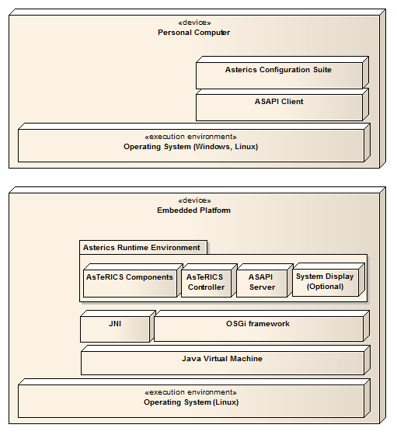
Figure 1: High-level view of the system architecture (deployment model)

    - Runtime Model Concepts
The ARE hosts and controls the components that realize the Assistive Technology (AT) applications. As such, it features a component-based approach, where various specialized plug-ins (i.e., sensors, processors and actuators) are interfaced together to realize the desired behavior. The main runtime model concepts in the ARE are the components (plugins), the ports, and the channels (also known as bindings). These concepts are available for introspection and reflection in runtime (i.e., their properties can be both queried and edited).
It should be noted that these concepts describe merely types of runtime artifacts. For instance, component specifies a special component type that can be instantiated multiple times. In each instantiation, all attributes are static, except the properties that can be edited in runtime. For example, a specialized signal processing processor can be instantiated multiple times, with different property values, and can be connected to different components. While both component instances share the same type, they are individually used and maintained in the ARE.
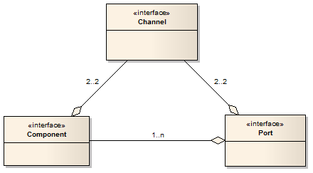
Figure 2: Simple view of the runtime model
These artifacts and their relationships are illustrated in Figure 2. This figure illustrates the relationships between components, ports and bindings. A component consists of one or more ports. A binding, on the other hand connects exactly two components, via two corresponding ports. A more detailed description of the main runtime concepts and their relationships is provided in the following paragraphs.
      - Components
The components are the main artifacts in the ARE runtime model. As mentioned before, components can serve one of three main roles:
- Sensors: these are components which only feature output ports (i.e., they do not depend on input from any other components). Typical sensors are commonly coupled to underlying hardware sensors to generate their output data (e.g., a face tracking sensor which is coupled to a web-camera), but they can also be completely realized internally (e.g., a signal generator).
- Processors: these are components which feature both input and output ports. This is the most common type of components, and provides the foundation for forming applications. The processor components can be either realized completely internally (e.g., an average which keeps track of the last n values of a scalar value and always outputs their average value) or they can be coupled to some external software library or even coupled to a hardware component (e.g., utilize legacy libraries for complex signal processing, or even utilize specialized hardware accelerators for highly demanding computations).
- Actuators: these are components which only feature input ports (i.e., they do not produce any output that can be utilized by other components). The main role of actuators is to enable the desired functionality of the applications, and for testing (e.g., a mobile phone actuator allows to place or answer phone calls and to send SMS messages, while an oscilloscope actuator allows for viewing, and thus testing or debugging, of signal generators).

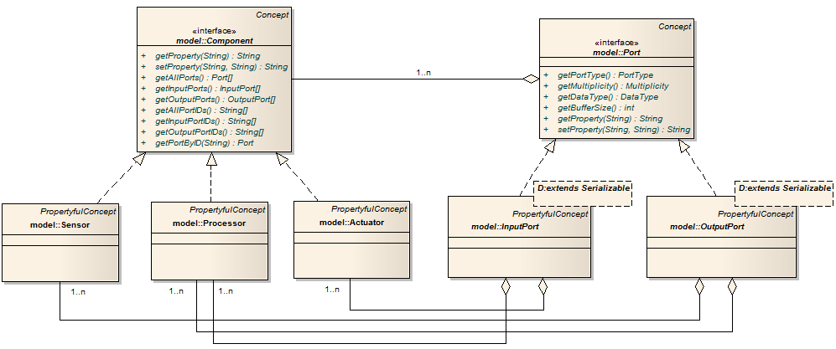
Figure 3: Complex view of runtime model for the component concept
These concepts are illustrated in Figure 3. A component can be any of three main realizations: sensor, processor, and actuator. On the other hand, a port can be instantiated either as an input or an output port. Sensors have one-or-more output ports only, actuators have one-or-more input ports only, and processors have both one-or-more input ports and one-or-more output ports.
      - Ports
The ports are the main concepts allowing interfacing between components. Ports are classified as input or output ports, depending on their role. Each port features a buffer where data is accumulated before it is communicated outwards (output ports) or before it is internally consumed (input ports).
Furthermore, each port is associated with a specific data type, indicating the type of the data communicating through the port. Examples of such data types, carrying the representation and semantics as inherited from the Java language, are:
- Byte: a single byte
- Boolean: “true” or “false”
- String: an array of bytes, representing ASCII characters
- Integer: a 32-bit integer
- Double: a 64-bit double precision scalar
The main properties and relationships of the port concept are illustrated in Figure 4.
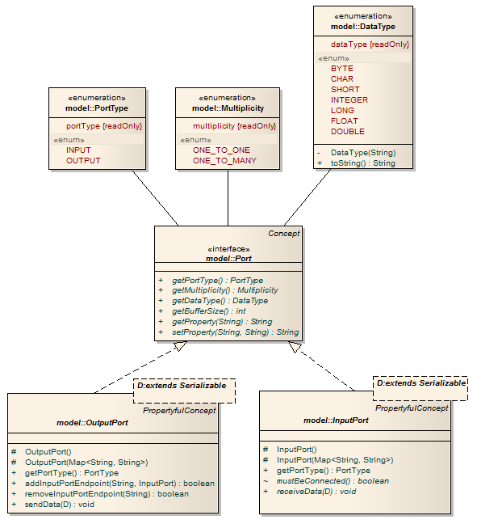
Figure 4: Runtime model for the port concept
The port concept features methods for accessing the port type, its multiplicity, its data type, and also for getting and setting property values. The main subtypes of port are the OutputPort and the InputPort.
It should be pointed out that the input port is different from the output port by featuring an additional method for checking whether a binding to the port is mandatory or not. This is needed to check whether a component is resolved or not (i.e., by checking whether all its input ports marked as “mustBeConnected” are indeed connected). This is important because it ensures that all the defined components are functional, i.e., appropriately connected, before they are activated.
Finally, it should be noted that special port types will also be defined for event communication. Unlike common ports which communicate a fixed data type, event ports will be able to communicate different events, encoded in a uniform way. Input event port types will be defined with the “mustBeConnected” property set to false by definition. Also, output event ports will allow the formation of multiple channels using the same output port as a common endpoint.

      - Channels
The channel is the main concept used for interfacing components through ports. As such, the channels are defined via a source port in a source component and a target port in a target component. When formed, certain checks are performed to ensure that the data types of the source and the target ports are compatible.
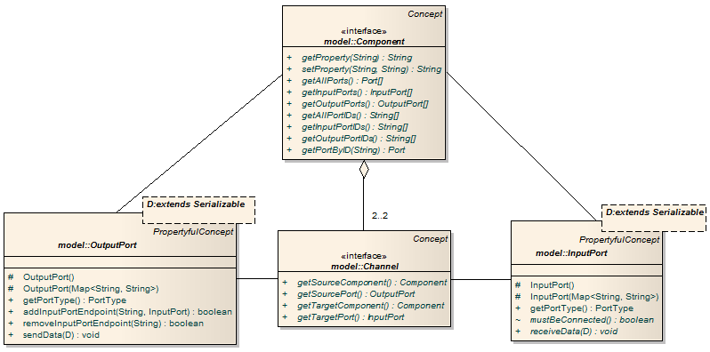
Figure 5: Runtime model for the binding concept
A typical binding is illustrated in Figure 5. The binding is associated to two components, and an input and output port, one from each of them.
Typically, a source, i.e., output port might be associated to multiple targets, i.e., input ports. Nevertheless, in this runtime model it is assumed that each binding consists of exactly one source and one target port. One-to-many bindings are also implicitly supported via multiple instances of one-to-one bindings.
Special channels can also be formed between event ports. In this case, both input and output ports can be used to connect multiple channels. Event channels can be formed between EventTriggerer and EventListeners ports. EventTriggerers generate events and EventListeners register to an ARE service for listening to generated events. ARE is responsible for disseminating the generated events to the plugins that have been registered for listening to these events.
      - Component Architecture of ARE
This subsection describes the internal architecture of the ARE component. Naturally, the main scope of this component is to maintain and realize the deployed model. As such, it features the following sub-components:
- Controller: This component is responsible for coordinating the actions inside the ARE. To achieve this, it uses the other sub-components described below.
- ModelManager: The model manager is used to maintain and manage the model (cf. section 7.1.1). As such, it provides methods for transforming the model from and to standard representations (such as XML), for validating its consistency, and for editing the properties of the modeled concepts (i.e., of the components, channels and ports). A special feature of the model manager is that it includes an input event port that allows it to be controlled by the Assistive Technology application for switching between various individual models.
- Configurator: The configurator is the component which translates the model into actual components and channels. It is thus responsible for realizing the encoded models and also for coordinating the activation (i.e., start) and deactivation (i.e., pause and stop) of the corresponding components. Before realizing certain models, the configurator utilizes the validation services of the model manager. Also, in order to access existing ones, or create new instances of components, the configurator uses the services available by the component repository. Finally, it also provides support for forming new channels (or dissolving existing ones) between certain ports.
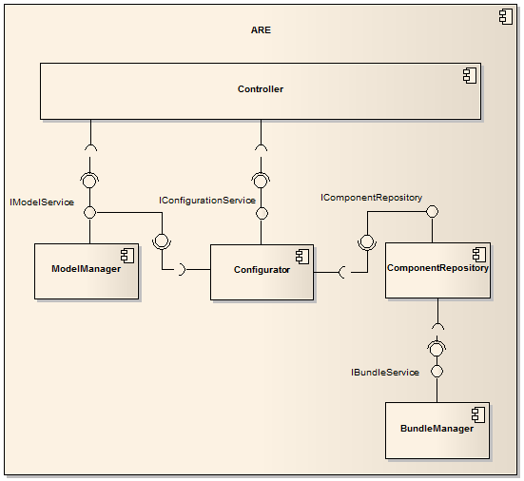
Figure 6: Internal architecture of the ARE
- ComponentRepository: The component repository serves two roles. First, it maintains a list with the available component types, which can be changed when new components are installed or existing ones uninstalled. Second, it maintains a repository with the current component instances. New instances can be dynamically created, and existing ones be dissolved.
- BundleManager: This component allows for dynamically installing (or uninstalling) software bundles containing one or more components. This is needed to allow for easy updating of ARE instances with new (or updated) component implementations. For this purpose, the OSGi bundle mechanisms will be used. In essence, when a new bundle is installed (or uninstalled), it will be checked whether it contains AsTeRICS components. If it does, the components will be registered (or unregistered) with the component repository by reading appropriate metadata from the bundles.
The relationships between the sub-components are illustrated in Figure 6. Also, to illustrate the interaction between these components in use, consider the sequence diagram illustrated in Figure 7.
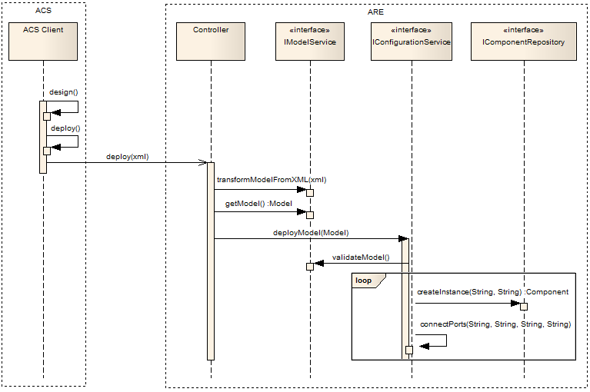
Figure 7: Sequence diagram illustrating a typical interaction between ACS and ARE
In this diagram, an ACS client is used to design an application model (i.e., graphically in an appropriate GUI), which is then deployed in he ARE. For this, the ASAPI protocol is used, which however is not illustrated here to avoid cluttering (for more information on the ASAPI see section 8).
On receiving the deploy message, the Controller (which is the main component of the ARE) uses the model service to transform the model, which is encoded in XML, into its object representation. The resulting model is then deployed using the configuration service. The latter first validates the model, using the model service, and then performs a set of commands which aim at realizing the modeled application. These commands include the instantiation of component instances, via the component repository, and the physical connection of the corresponding ports.
- ASAPI Clients and Serialisation
The AsTeRICS Application Programming Interface (ASAPI) is an interface to enable advanced communications between the AsTeRICS Runtime Environment (ARE) and external clients. In principle, ASAPI is a service that is provided by the ARE and can be consumed by different clients deployed on the same (as the ARE) or remote devices.
While the ARE is implemented on top of JAVA/OSGi, ASAPI clients are assumed to be implemented on top of a variety of platforms. For this purpose, the actual interfacing between clients and the ARE is done at a low TCP/UDP/IP level. For this purpose, either a custom TCP/UDP/IP protocol will be developed, or an existing solution such as Google Protocol Buffers, XML RPC, or Apache Thrift could be used.
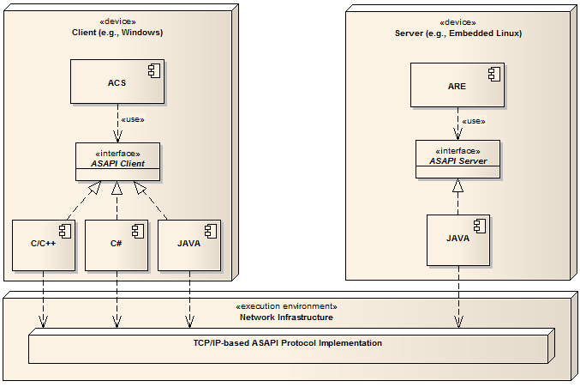
Figure 8: Basic architecture of ASAPI
The basic architecture of ASAPI is illustrated in Figure 8. The “ASAPI Server” is provided by a JAVA based implementation, which utilizes the ARE to provide the specified functionality. On the client side, two interfaces provide the needed functionality: The “ASAPI Client” which extends the “ASAPI Server” with commands for discovering and connecting/disconnecting to the server side, and the “ASAPI Native” which provides specialized functionality for deploying certain components directly in the client, bypassing the ARE. These relationships are illustrated in the above figure.

The functionality of a full ASAPI Client is defined in deliverable 2.1 – System Specification and Architecture [1], section 4.4.

    - ASAPI and ARE Interconnection
The following figure shows the ASAPI protocol connection to the ARE and the ASAPI native interface which provides certain functions for PC AT developers aside the ARE ( e.g. mobile phone access or special PC peripherals which will be investigated during WP6). The native interface can provide well defined functions (as sending an SMS) which do not imply signal processing plugins of the ARE, and can thus be accomplished directly on the PC.
As soon as the AsTeRICS Runtime Environment and the embedded platform are involved, the ASAPI command and data protocol can be used to interact with the ARE.
The ASAPI protocol is a platform independent specification per se. To implement an ASAPI client, templates in JAVA (server side) and C# (client side) will be provided as an early outcome of WP4.
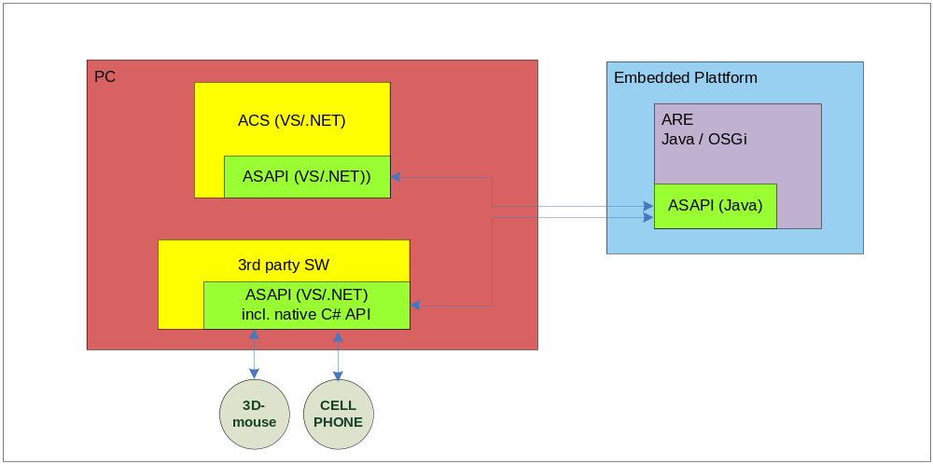
Figure 9: ASAPI client implementations with/without native functions
The following diagrams show two possible scenarios for ASAPI / ARE interconnection (1), one for the configuration of the ARE and one for the operation thereof (2).
Usually, these scenarios will involve primary and secondary users of the AsTeRICS system:
- AT developers use the Configuration Suite to set up the model for the desired AT-configuration, tailored to a specific use case or end user (1),
- End users start the system (power up the embedded platform or start the ARE on PC or netbook) to get their desired AT-configuration (which operated stand alone or in connection with 3rd-party applications on a PC or netbook (2).
      - ASAPI and ARE in the configuration process
Setting up a model
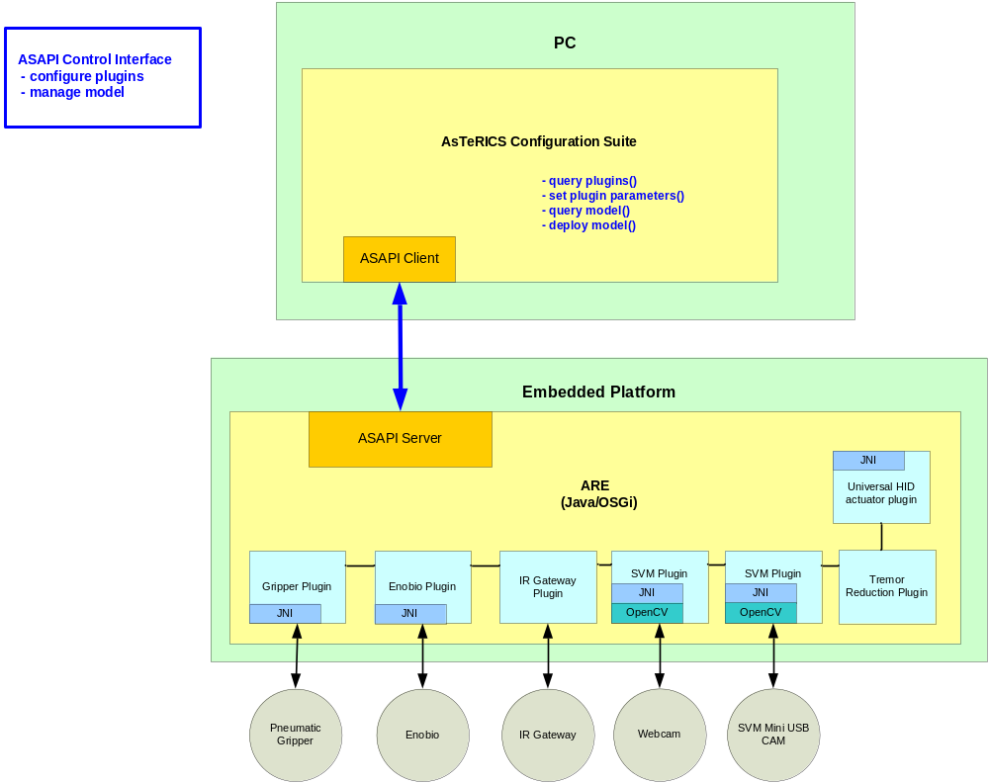Figure 10: AsTeRICS configuration scenario, model setup

Figure 10 shows the configuration process of the AsTeRICS Runtime Environment by the AsTeRICS Configuration Suite via ASAPI. The ASAPI client of the ACS connects to the ARE’s ASAPI server. It queries the available plugins and their parameters. (In the above figure, some exemplary plugins are shown for demonstration purpose).
The ACS offers dynamic graphic configuration dialogs to the user, which allows adjustment of all the plugin parameters. Plugins can be graphically connected. This process does not need any functional representation of the plugins, only a description of the plugins’ ports, data types and parameters. All these setup actions are performed via ASAPI control commands. The finalized model can be deployed to the ARE.
Monitoring, verifying and adjusting a model:

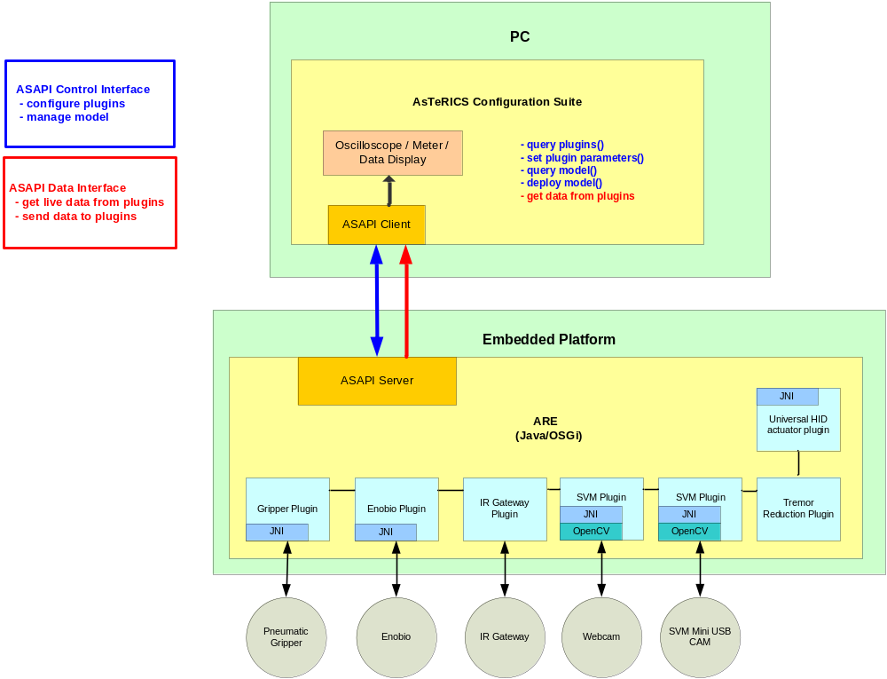
Figure 11: AsTeRICS configuration scenario, verification and error checking

To verify the setup process, a data connection to desired plugins can be opened in the Configuration Suite. Thus, live sensor values and their transformation due to the applied signal processing plugins can be monitored using feedback elements of the ACS like oscilloscope or bar graphs. Parameters of the plugins can be modified using ASAPI control commands until the desired behaviour of the ARE is present.
Additionally to the live data transmission for feedback purpose, status and error information can be queried from the ARE to determine the state of particular plugins.
ASAPI and ARE in the runtime system:

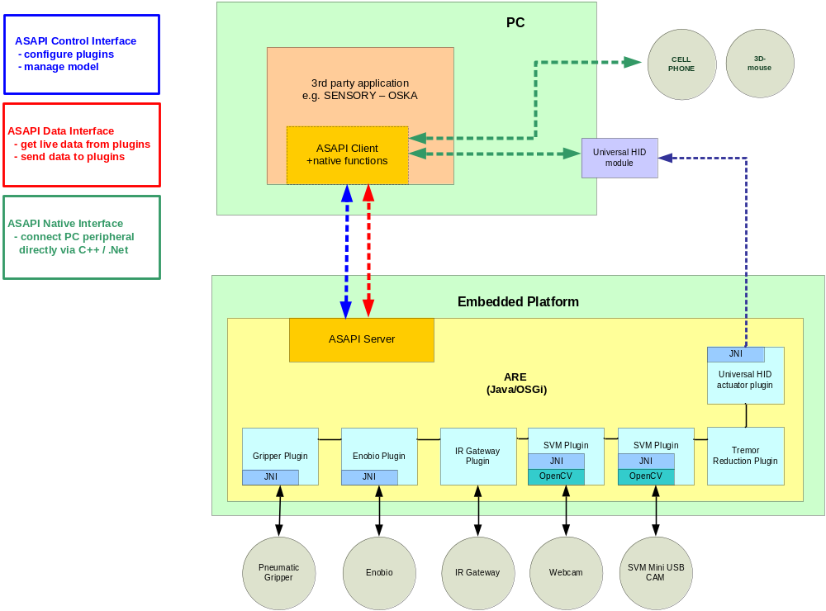

Figure 12: AsTeRICS runtime scenario
A fully configured ARE can run as a stand-alone process providing its functionality or communicate with PC AT-software. A connection between ARE and ACS is no longer required at that time.
The above runtime scenario consists of a configured ARE, with connected plugins that interface the external sensors (Enobio, SVM) and actuators (pneumatic gripper, IR gateway).
Third party applications running on the PC can optionally:
- query or send data by using ASAPI data commands
- use the ASAPI native interface to access supported PC peripherals like mobile phone, 3D mouse
- use ASAPI to connect to the running ARE and send control commands to modify model or plugin settings
If the Universal HID actuator USB dongle is used, the PC application can obtain data from the embedded platform via a mouse, joystick or keyboard hook which is provided via the ASAPI native interface (thereby omitting a dedicated TCP/IP connection to the ARE via the ASAPI client).
  - Available ASAPI commands
Method | Description
Methods to setup and deploy a model
String [] getAvailableComponentTypes(); |  | Returns an array containing all the available (i.e., installed) component types. These are encoded as strings, representing the absolute class name (in Java) of the corresponding implementation.
String getModel(); |  | Returns a string encoding the currently deployed model in XML. If there is no model deployed, then an empty one is returned.
String getModelFromFile (); |  | Returns a string encoding of the model defined in the filename passed as argument. If there is no model, an empty string is returned.
void deployModel(String modelInXML) throws AsapiException; |  | Deploys the model encoded in the specified string into the ARE. An exception is thrown if the specified string is either not well-defined XML, or not well defined ASAPI model encoding, or if a validation error occurred after reading the model.
void deployFile(String filename) throws AsapiException; |  | Deploys the model associated to the specified filename. An exception is thrown if the specified filename is not found.
public void newModel() throws AREAsapiException |  | Deploys a new empty model into the ARE. In essence, this is equivalent to creating an empty model and deploying it. This results to freeing all resources in the ARE (i.e., if a previous model reserved any).
void newModel(); |  | Deploys a new empty model into the ARE. In essence, this is equivalent to creating an empty model and deploying it using deployModel(String) above. This results in freeing all resources in the ARE (i.e., if a previous model reserved any).
void runModel() throws AsapiException; |  | It starts or resumes the execution of the model. It throws AsapiException if an error occurs while validating and starting the deployed model.
public void pauseModel() throws AsapiException; |  | Briefly stops the execution of the model. Its main difference from the stopModel() method is that it does not reset the components (e.g., the buffers are not cleared). It throws an AsapiException if the deployed model is not started already, or if the execution cannot be paused.
public void stopModel() throws AsapiException; |  | Stops the execution of the model. Unlike the pauseModel method, this one resets the components, which means that when the model is started again it starts from scratch (i.e., with a new state). It throws AsapiException if the deployed model is not started already, or if the execution cannot be stopped.
public void storeModel(String modelInXML, String filename)  throws AREAsapiException |  | Stores the XML model specified by the string parameter in the file specified by the filename parameter . Throws an AREAsapiException if the file cannot be created or if the model cannot be stored.
public String[] listAllStoredModels() throws AREAsapiException |  | Returns a list with all stored models. Throws AREAsapiException if the models directory could not be found.
public boolean deleteModelFile (String filename) throws AREAsapiException |  | Deletes the file of the model specified by the filename parameter. Throws AREAsapiException if the file could not be found or could not be deleted.
public void autostart() |  | It is called on startup by the middleware in order to autostart  a default model without the need of pressing deploy and start model first.
Methods to read and edit the model
String [] getComponents(); |  | Returns an array that includes all existing component instances in the model (even multiple instances of the same component type).
String [] getChannels(String componentID); |  | Returns an array containing the IDs of all the channels that include the specified component instance either as a source or target.
void insertComponent(String componentID, String componentType)  throws AsapiException; |  | Used to create a new instance of the specified component type, with the assigned ID. Throws an exception if the specified component type is not available, or if the specified ID is already defined.
void removeComponent(String componentID) throws AsapiException; |  | Used to delete the instance of the component that is specified by the given ID. Throws an exception if the specified component ID is not defined.
public String [] getAllPorts(String componentID) throws AsapiException; |  | Returns an array containing the IDs of all the ports (i.e., includes both input and output ones) of the specified component instance. An exception is thrown if the specified component instance is not defined.
public String [] getInputPorts(String componentID) throws AsapiException; |  | Returns an array containing the IDs of all the input ports of the specified component instance. An exception is thrown if the specified component instance is not defined.
String [] getOutputPorts(String componentID) throws AsapiException; |  | Returns an array containing the IDs of all the output ports of the specified component instance. An exception is thrown if the specified component instance is not defined.
void insertChannel(String channelID, String sourceComponentID,String sourcePortID, String targetComponentID,  String targetPortID)throws AsapiException; |  | Creates a channel between the specified source and target components and ports. Throws an exception if the specified ID is already defined, or the specified component or port IDs is not found, or if the data types of the ports do not match. Also, an exception is thrown if there is already a channel connected to the specified input port (only one channel is allowed per input port except for event ports that can have multiple event sources).
void removeChannel (String channelID) throws AsapiException; |  | Removes an existing channel between the specified source and target components and ports. Throws an exception if the specified channel is not found.
Methods to read and edit properties (even while running)

String [] getComponentPropertyKeys(String componentID); |  | Reads the IDs of all properties set for the specified component.
String getComponentProperty (String componentID, String key); |  | Returns the value of the property with the specified key in the component with the specified ID as a string.
String setComponentProperty (String componentID, String key, String value); |  | Sets the property with the specified key in the component with the specified ID with the given string representation of the value.
String [] getPortPropertyKeys(String portID); |  | Reads the IDs of all properties set for the specified port.
String getPortProperty(String componentID, String portID, String key); |  | Returns the value of the property with the specified key in the component with the specified ID as a string.
String setPortProperty(String componentID, String portID, String key, String value); |  | Sets the property with the specified key in the port with the specified ID with the given string representation of the value.
String [] getChannelPropertyKeys(String channelID); |  | Reads the IDs of all properties set for the specified component. Reads the IDs of all properties set for the specified channel.
String getChannelProperty(String channelID, String key); |  | Returns the value of the property with the specified key in the channel with the specified ID as a string.
String setChannelProperty(  String channelID, String key, String value); |  | Sets the property with the specified key in the channel with the specified ID with the given string representation of the value.
Methods for status checking
String queryStatus(); |  | Queries the status of the ARE system (i.e., OK, FAIL, etc).
public String getLogFile() |  | Serializes and returns as a string the Log file.
Table 1: ASAPI server interface

Method | Description
Methods to discover and connect/disconnect to AREs
InetAddress [] searchForAREs(); | Searches in the local area network (LAN) for available instances of the ARE. The exact protocol for discovery can vary (e.g., it could be based on UPnP, SLP, or a custom protocol).
ASAPI_Server connect(InetAddress ipAddress); | Connects to the ARE at the specified IP address. The method returns an instance of the ASAPI Server interface (described above), masking the functionality provided by the target ARE through ASAPI.
void disconnect(ASAPI_Server asapi_server); | Disconnects from the specified instance of the ASAPI Server, invalidating the reference.
Table 2: ASAPI client interface

  - Serialisation
The serialisation of the data including the calling mechanism is done by Apache Thrift [14]. For the reference implementations (ASAPI server for ARE in Java and ASAPI client for ACS in C-Sharp), the version 0.8.0 has been used. The following tutorial shows the way from the interface definition to a working Java client.
    - The Thrift definition file
In the thrift definition file, all functions which should be serializable have to be defined. The “ASAPI.thrift” file is used by the Thrift compiler to generate the server and client functions

    - The Thrift Compiler
The source code of the Thrift compiler is part of the Thrift bundle, being available at [14]. For persons, who like the usage of precompiled programs, a Windows version of the Thrift 0.8.0 compiler is available at https://dist.apache.org/repos/dist/release/thrift/0.8.0/thrift-0.8.0.exe
The compiler supports several target languages, the most commons are C++, C#, Java and php. The usage is command line based and quite simple. To get the needed Java files, the following command has to be used:
thrift --gen java asapi.thrift
This command generates the folder gen-java containing the files AsapiServer.java and AsapiException.java. For a more detailed description of the Thrift compiler, please see the compiler manual.
    - The Thrift Library
For the usage of the generated files, a library file must also be generated. The source code of the libraries is also available in the thrift-bundle from [http://incubator.apache.org/thrift/]. For all languages, being supported by the compiler, are libraries available. In the source code folders of the libraries is also a language specific instruction – please follow the instruction to generate the library file. In the case of Java, after successfully following the instructions, the file libthrift.jar will be generated.
In the case of Java, the Thrift library needs additional logging libraries. The usage of the Simple Logging Facade for Java (SLF4J) framework [15] is recommended. The Thrift 0.8.0 library was successfully tested with version 1.6.0 of SLF4J
    - Simple Java Client
All preconditions are now fulfilled, the Java client can be created now. Beside the two generated files AsapiServer.java and AsapiException.java, a main file is needed. The key lines concerning the Thrift usage are:
try {
TTransport transport = new TSocket(10.0.0.1, 9090);
TProtocol protocol = new TBinaryProtocol(transport);
AsapiServer.Client client = new Calculator.Client(protocol);
transport.open();

client.NewModel(); // Example function call
} catch (TException x) {
x.printStackTrace();
}
Important: the files libthrift.jar, slf4j-api-1.6.0.jar and slf4j-simple-1.6.0.jar must be included in the build path.

- Native ASAPI Libraries
Native ASAPI is a software development kit for 3rd party developers to help them adapt their application for people with motor disabilities. Native ASAPI will be delivered as a set of DLL libraries for the Microsoft Windows Operating system. Native ASAPI works independently of ARE.
  - Phone Library
The Phone Library is designed to control mobile phones. The library uses Bluetooth connection to connect to the Phone Library Server Application running on the mobile phone. Currently the Phone Library uses the Microsoft Bluetooth stack; other stacks will be considered. The Library is delivered as a PhoneLibrary.dll file.
Currently the Phone Library Server Application for Windows Mobile operating system has been developed. The Server application works on the phones running Windows Mobile 5.0 and above.
To install Server application (ServerInstall.cab file):
- On Windows XP install the ActiveSync application.
- Connect the phone to PC using USB cable. On Windows 7, if you connect the Windows Mobile phone for the first time, the Microsoft Windows Mobile Device Center application will be installed automatically.
- Using ActiveSync or Windows Mobile Device Center copy the Server installer to the phone.
- Run the Server installer. The server application will be installed.
    - Phone Library interface:
The library interface is declared in the PhoneLibrary.h file.
Phone library interface functions are declared with the “C” linkage. The Phone Library functions return a positive value if it succeeds. If a function fails, it returns a value lower than 0 and the returned value is the code of the error.
Library functions:
Function | Description
int init(DeviceFound deviceFound, NewSMS newSMS, PhoneStateChanged phoneStateChanged, LPVOID param) | Initializes the Phome Library. The deviceFound, newSMS and phoneStateChanged parameters are pointers to the call-back functions implemented in the Phone Library user application. The param parameter is a parameter defined by the user and passed to the call-back functions.
int close() | Closes the library.
int searchDevices() | Starts searching for devices. For each discovered device the DeviceFound call-back function is called
int connectToDevice(unsigned _int64 deviceAddress, int port) | Connects to the device defined by the deviceAddress parameter.
int disconnect() | Disconnects the device.
int makePhoneCall (LPWSTR recipientID) | Makes a phone call. The recipientID parameter is the recipient phone ID.
int acceptCall() | Accepts incoming phone calls.
int dropCall() | This function drops an incoming phone call or disconnects phone calls.
int getPhoneState(PhoneState &phoneState) | Gets actual phone state of the mobile phone.
int sendSMS(LPWSTR recipientID, LPWSTR subject) | Sends SMSs. The recipientID parameter is the recipient phone ID, the subject parameter is the message content.
Table 3: Phone library functions
Library call-back functions definitions:
Function | Description
typedef void (__stdcall *DeviceFound) (unsigned _int64 deviceAddress, LPWSTR deviceName, LPVOID param) | This function is called when a new device is found. The deviceAddress parameter is the address of the discovered device. The deviceName parameter is the name of the device. If the returned deviceAddress parameter is equal to 0, the device search process finishes.
typedef void (__stdcall *NewSMS) (LPWSTR PhoneID, LPWSTR subject, LPVOID param) | This function is called when there is a new SMS available. The PhoneID parameter is the sender phone ID. The subject parameter is the SMS content.
typedef void (__stdcall *PhoneStateChanged) (PhoneState phoneState, LPWSTR phoneID , LPVOID param) | This function is called when the phone state is changed. The phoneState parameter defines current state of the phone. The phoneID is the remote phone ID.
Table 4: Phone library call-back functions
Error codes returned by functions: (declared in the PhoneLibraryErrors.h file):
Code | Description
-1 | Default error.
-2 | Library is not initialized.
-3 | Library is initialized.
-4 | Library initialization error.
-5 | No respond from remote device.
-20 | Library is searching for the devices now.
-21 | Device is not found.
-31 | Device is connected.
-32 | Error during connecting to the device.
-33 | Device is not connected.
-34 | Default port error.
-50 | Phone ID or SMS content is empty
-1001 | Remote device default error.
-1011 | Bluetooth initialization error on the remote device.
-1015 | Packet error.
-1031 | Messenger module initialization error on the remote device.
-1032 | Messenger module is not initialized on the remote device.
-1033 | Message send error on the remote device.
-1051 | Phone module initialization error on the remote device.
-1052 | Phone module is not initialized on the remote device.
-1053 | Phone accept the call error on the remote device.
-1054 | Phone drop the call error on the remote device.
-1055 | Phone make the call error on the remote device.
-1072 | Messenger module and Phone module is not initialized on the remote device.
Table 5: Phone library error codes

Other Phone Library interface data:
Data | Description
enum PhoneState  {  PS_IDLE=1,  PS_RING,  PS_CONNECTED  }; | Indicates current phone state.
#define Default_port -1 | Indicates the default port number, which can be used in the connectToDevice method.
Table 6: Other Phone library interface data
    - Example of use
Call-back functions definitions:
void __stdcall newSMS (LPWSTR PhoneID, LPWSTR subject, LPVOID param)
{
//get incoming SMS:
getSMS(PhoneID, subject);
}

void __stdcall phoneStateChanged (PhoneState phoneState, LPWSTR phoneID , LPVOID param)
{
//auto answer on incoming phone call:
if(phoneState==PS_RING)
{
acceptCall();
}
}

Initialization of the library and connect to the phone:
int InitLib (unsigned _int64 deviceAddress)
{
int result;
result = init(deviceFound, newSMS, phoneStateChanged, NULL);
if(result < 0)
{
return 0;
}
result=connectToDevice(deviceAddress,-1);
if(result<0)
{
return 0;
}
}

Send SMS:
int SendSMS(LPWSTR recipientID, LPWSTR subject)
{
return sendSMS(recipientID, subject);
}

Make phone call:
int MakePhoneCall(LPWSTR recipientID)
{
return makePhoneCall(recipientID);
}

Disconnect the phone and close the library:
int CloseLib()
{
disconnect();
return close();
}

  - GSM Modem Library
The GSM Model Library interfaces the GSM modem devices connected to the platform. It can be used to send and receive SMS.
    - GSM Modem Library interface:
The library interface is declared in the GSMModemLibrary.h file:
Library functions:
Function | Description
int init(LPWSTR com, NewSMSAvailable newSMSAvailable,ErrorCallback errorCallback, LPWSTR pin, LPWSTR smsCenterNumber ,LPVOID param) | Initializes the library. The com parameter defines the modem serial port. The newSMSAvailable and errorCallback parameters are pointers to the call-back functions implemented in the user application. The pin parameter is the PIN code. If the PIN code is not required, this parameter should be empty. The smsCenterNumber parameter contains the user SMS center number. If the number of SMS center is not required this parameter should be empty.The param parameter is a parameter defined by the user and passed to the call-back functions.
int close() | Closes the library.
int sendSMS(LPWSTR recipientID, LPWSTR subject) | Sends SMSs. The recipientID parameter is the recipient phone ID, the subject parameter is the message content.
Int getModemPortNumber(ModemSearchResult modemSearchResult,LPVOID param) | Starts to search modems. For each modem found, the modemSearchResult call-back function is called. The param parameter is passed to the modemSearchResult call-back function.
Table 7: GSM Modem library functions

GSM Mode Library functions are declared with the “C” linkage. A function returns a positive value if it succeeds. If the function fails, it returns a value lower than 0 and the returned value is the code of the error.
Library call-back functions definitions:
Function | Description
typedef void (__stdcall *NewSMSAvailable) (LPCWSTR phoneID, LPCWSTR subject, LPVOID param) | This function is called when there is a new SMS available. The PhoneID parameter is the sender phone ID. The subject parameter is the SMS content. The param parameter it is parameter defined by user.
typedef void (__stdcall *ErrorCallback) (int result, LPVOID param) | This function is called when en error is found. The result parameter is the error code. The param parameter it is parameter defined by user.
typedef void (__stdcall *ModemSearchResult) (LPCWSTR port,LPCWSTR modemName, LPVOID param) | This function is called when the modem is found. The port parameter contains the modem port. The modemName parameter contains the modem name. The param parameter it is parameter defined by user.
Table 8: GSM Modem library call-back functions

Error codes returned by functions: (The error codes are declared in the Errors.h file)
Code | Description
-1 | Default error.
-2 | Library is not initialized.
-3 | Library is initialized.
-4 | Library initialization error.
-5 | Library is during initialization
-10 | COMM initialize false
-11 | No respond on the AT command
-12 | Cannot register to the GSM network
-13 | Modem initialize false
-14 | Write to the modem port error
-15 | Read from the mode port error
-16 | Not enough space in a buffer
-17 | No modem answer
-19 | The AT command failed
-20 | SMS read error
-21 | SMS send error
-22 | Phone ID is empty
-23 | Message content is empty
-24 | Error respond from the modem
-25 | Undefined modem answer
-26 | The string is not a number
-100 | SMS was not sent
2 | Library is initialized correctly
Table 9: GSM Modem library errors

    - Example of use
Call-back functions definitions:

void __stdcall modemSearchResult (LPCWSTR port,LPCWSTR modemName, LPVOID param){
if((wcslen(port)>0)&&( wcslen(modemName)>0))
{
//get the port for the connection with modem
getPort(port);
}
}
void __stdcall newSMS (LPWSTR PhoneID, LPWSTR subject, LPVOID param)
{
//get incoming SMS:
getSMS(PhoneID, subject);
}
void __stdcall errorCallback (int result, LPVOID param)
{
If(result==2)
{
LibraryIsInitialized=true;
}
}

Find the modem, Initialize the library and send SMS:
int InitLib ()
{
int result=0;
result=getModemPortNumber(modemSearchResult,NULL);
//wait for call-back function:
...
result= init(serialPort, newSMS, errorCallback,””,””,NULL);
//wait for initialize of the library
...
Result= sendSMS(phoneNumber,”Test SMS”);
}

  - 3D-Mouse Library
The 3D Mouse Library is designed to help in adapting 3Dconnexion 3D Mouse devices for people with motor disabilities. It works with the 3D Mice connected to PC via USB such as: SpacePilot Pro, SpaceExplorer and SpaceNavigator.
    - 3D-Mouse Library interface
The library interface is declared in the Mouse3DLibrary.h file.
Library functions:
Function | Description
int init () | Initializes the 3D Mouse Library
int close () | Closes the Library
int get3DMouseState(long *x, long *y, long *z, long *Rx, long *Ry, long *Rz, long* buttons) | Gets the actual state of the 3D mouse. Parameters are axis, axis rotation and button state.
Table 10: 3D Mouse Library functions

3D Mouse library interface functions are declared with the “C” linkage. The 3D Mouse Library function returns a positive value if it succeeds. If the function fails, it returns a value lower than 0 and the returned value is the code of the error.
Error codes returned by functions:
The error codes are declared in the Mouse3DLibraryErrors.h file.
Number | Description
-1 | Default error.
-2 | Library is not initialized.
-3 | Library is initialized.
-4 | Library initialization error
-5 | The 3D Mouse device not found.
-6 | Data acquire error.
Table 11: 3D Mouse Library errors

    - Example of use
Getting 3D Mouse state:
int getState(long *x, long *y, long *z, long *Rx, long *Ry, long *Rz, long* buttons)
{
int nResult = init()
if(nResult<0)
{
return nResult;
}
result = get3DMouseState(x, y, z, Rx, Ry, Rz, buttons);
if(nResult<0)
{
return nResult;
}
result =close();
if(nResult<0)
{
return nResult;
}
return 1;
}

  - Keyboard Library
The Keyboard Library is designed for developers who need to adapt the computer keyboard for the specialized needs of motor disabled people. For example if the application has to use standard keyboard input for the scanning and send the keys in different way. Developers using this library will be able to get information about all system key events and send key events to other applications. The library uses Low Level Keyboard Hook.
    - Keyboard Library interface
Library functions:
The library interface is declared in the KeyboardLibrary.h file.
Function | Description
KEYBOARDLIBRARY_API int __stdcall init(HookCallBack hookCallBack, LPVOID param) | Initializes the library. The hookCallBack parameter is a pointer to the call-back function. The param parameter is a parameter defined by user.
KEYBOARDLIBRARY_API int __stdcall close() | Closes the library.
KEYBOARDLIBRARY_API int __stdcall startHook() | Starts key events hooking
KEYBOARDLIBRARY_API int __stdcall stopHook() | Stops key events hooking.
KEYBOARDLIBRARY_API int __stdcall sendKeyByScanCode(int scanCode, SendKeyFlags flags) | Simulates a key event using a key scan code.
KEYBOARDLIBRARY_API int __stdcall sendKeyByVirtualCode(int virtualCode, SendKeyFlags flags) | Simulates a key event using a virtual key code.
KEYBOARDLIBRARY_API int __stdcall sendText(LPWSTR text) | Simulates text being typed in, defined by the text parameter.
KEYBOARDLIBRARY_API int __stdcall blockKeys(BlockOptions blockOptions) | Blocks or Passes key events. The blockOptions parameter defines the function's behaviour.
Table 12: Keyboard Library functions

Keyboard library interface functions are declared with the “C” linkage. The Keyboard Library function returns a positive value if it succeeds. If the function fails, it returns a value lower than 0 and the returned value is the code of the error.

Call-back function:
Function | Description
typedef int (__stdcall *HookCallBack) (int scanCode, int virtualCode,HookMessage message, HookFlags flags, LPVOID param); | This function is called if there is a new key event. The scanCode parameter defines the scan code of the key, the virtualCode parameter defines the virtual key code, the message defines message type, the flags parameter defines additional information about the key event, the param parameter is a parameter passed by the user. If the returned vaule is lest than 0, the library will block the event, if the returned value is greather than 0 the library will pass the event. If the returned value is 0 the library will block or pass the event according to the BlockKeys function.
Table 13: Keyboard Library call-back functions

Error codes returned by functions:
The error codes are declared in the KeyboardLibraryErrors.h file.
Number | Description
-1 | Default error.
-2 | Library is not initialized.
-3 | Library is initialized.
-4 | Library initialization error.
-5 | Hook in not initialized.
-6 | Hook is initialized.
-7 | Hook initialization error.
-8 | Hook stopping error.
-9 | Error during key send.
Table 14: Keyboard Library errors
Others:
Data | Description
enum HookFlags  {  HF_None=0,  HF_ExtendedKey=1,  HF_InjectedKey=2,  HF_AltKeyPressed=4,  HF_KeyPress=8,  HF_SentFromLibrary =0x10  }; | Flags which defines additional information about the event: HF_ExtendedKey - the extended key is sent, HF_InjectedKey - the key event is sent by application not by the keyboard, HF_AltKeyPressed - the Alt key is pressed, HF_KeyPress – the key is pressed down, HF_SentFromLibrary – the key is sent from the library.
enum HookMessage  {  HM_None=0,  HM_KEYDOWN=1,  HM_KEYUP,  HM_SYSKEYDOWN,  HM_SYSKEYUP  }; | Defines message type: key event down, key event up, system key event up or system key event up
enum SendKeyFlags  {  SKF_KeyDown=1,  SKF_KeyUP=2,  SKF_KeyPress=3,  SKF_KeyExtended=4,  }; | Used in the SendKeyByScanCode and SendKeyByVirtualCode functions. These flags defines the event type: key event up, key event down, extended key sent. The SKF_KeyPress flag is defindes as SKF_KeyPress=SKF_KeyDown|SKF_KeyUP.
enum BlockOptions  {  BO_BlockAll=1,  BO_PassSentFromLibrary=2,  BO_PassAll=3  }; | Used in the BlockKeys function. It defines the function's behaviour. It can take the following values: BO_PassAll, BO_PassSentFromLibrary, BO_BlockAll. If it takes the BO_PassSentFromLibrary value, the function passes keyboard events generated by SendKeyByScanCode, SendKeyByVirtualCode and SendText functions and blocks all other keyboard events.
Table 15: Other Keyboard Library interface data

    - Example of use
The call-back function will block or pass the event according to the blockKeys function:
int __stdcall hookCallBack (int scanCode, int virtualCode,HookMessage message, HookFlags flags, LPVOID param)
{
return 0;
}

Initialization of the library: starting hook, setting library to pass event generated by the library and block all other key events:
void initKeyboardLibrary()
{
int result =init(hookCallBack,0);
if(result>0)
{
startHook();
blockKeys(BO_PassSentFromLibrary);
}
}

Sending Ctrl-V key combination from the library:
#define Vkey 0x56
#define LeftCtrlkey 0xA2
void sendCtrlV()
{
sendKeyByVirtualCode(LeftCtrlkey,SKF_KeyDown);
sendKeyByVirtualCode(Vkey,SKF_KeyDown);
sendKeyByVirtualCode(Vkey,SKF_KeyUP);
sendKeyByVirtualCode(LeftCtrlkey,SKF_KeyUP);
}

Stopping hook and closing the library:
void closeLibrary()
{
stopHook();
close();
}

- Appendix A: OSGI-related Information
  - The OSGi framework and it’s layers
The core component of its specification is the OSGi framework. The Framework provides a standardized environment to applications (called bundles) and is divided in a number of layers.
L0: Execution environment
L1: Modules
L2: Life Cycle management
L3: Service registry
A ubiquitous security system is deeply intertwined with all the layers.
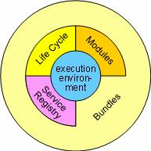
Figure 13: OSGi layers (from http://www.osgi.org/About/Technology)
The L0 Execution environment is the specification of the Java environment. Java 2 Configurations and Profiles, like J2SE, CDC, CLDC, MIDP, etc are all valid execution environments. The OSGi platform has also standardized an execution environment based on Foundation Profile and a smaller variation that specifies the minimum requirements on an execution environment to be useful for OSGi bundles.
The L1 Modules layer defines the class loading policies. The OSGi Framework is a powerful and rigidly specified class-loading model. It is based on top of Java but adds modularization. In Java, there is normally a single classpath that contains all the classes and resources. The OSGi Modules layer adds private classes for a module as well as controlled linking between modules. The module layer is fully integrated with the security architecture, enabling the option to deploy closed systems, walled gardens, or completely user managed systems at the discretion of the manufacturer.
The L2 Life Cycle layer adds bundles that can be dynamically installed, started, stopped, updated and uninstalled. Bundles rely on the module layer for class loading but add an API to manage the modules in run time. The lifecycle layer introduces dynamics that are normally not part of an application. Extensive dependency mechanisms are used to assure the correct operation of the environment.
The L3 layer adds a Service Registry. The service registry provides a cooperation model for bundles that takes the dynamics into account. Bundles can cooperate via traditional class sharing. However, class sharing is not very compatible with dynamically installing and uninstalling code. The service registry provides a comprehensive model to share objects between bundles. A number of events are defined to handle the coming and going of services. Services are just Java objects that can represent anything. Many services are server-like objects, like an HTTP server, while other services represent an object in the real world, for example a Bluetooth phone that is nearby. The service model is fully security instrumented. The service security model provides an elegant way to secure the communication between bundles passes.
  - Modularization in OSGi
One of the most useful features of OSGi is that it allows for modularization of bundles. In principle, the developer is allowed to specify exactly which classes should be imported and which ones exported (at a package level).
As outlined in 4.2.3, each bundle specifies a manifest file (placed in a JAR file at “/META-INF/MANIFEST.MF”) where it can specify this kind of details. For example, the main AsTeRICS middleware bundle could specify the following manifest file:
Manifest-Version: 1.0
Bundle-ManifestVersion: 2
Bundle-Name: asterics.middleware
Bundle-SymbolicName: org.asterics.mw
Bundle-Version: 0.1.0
Bundle-Activator: org.asterics.mw.Main
DynamicImport-Package: *
Export-Package: org.asterics.mw.component

The two last lines indicate that the required packages should be dynamically imported as needed, while the “org.asterics.mw.component” package should be made available for use by other bundles deployed within the same OSGi environment.
For further information about OSGI please refer to [9].
  - Using OSGi in AsTeRICS
The OSGi is an ideal framework for realizing some of the AsTeRICS components. In particular, OSGi is intended to provide the underlying framework for the AsTeRICS Runtime Environment (ARE) as well as the several pluggable components (i.e., sensors, processors and actuators).
The ARE middleware is realized as a collection of modules which provide bundle discovery, lifecycle management, communications, the server-side of the ASAPI communication system, etc. Furthermore, OSGi is used to manage the different components as individual bundles.
After the ARE has been started, the OSGi commands can be used to monitor bundles and manage their lifecycle:
Double-click on “start.bat”...

C:\test-deployment>java -Djava.util.logging.con
fig.file=logging.properties -jar org.eclipse.osgi_3.6.0.v20100517.jar -configura
tion profile -console

osgi> ss

Framework is launched.

id State Bundle
0 ACTIVE org.eclipse.osgi_3.6.0.v20100517
1 ACTIVE org.asterics.middleware_0.1.0

osgi> install file:asterics.sensor.webcamera.jar
Bundle id is 2

osgi> start 2

osgi> install file:asterics.processor.averager.jar
Bundle id is 3

osgi> start 3

osgi> install file:asterics.actuator.mouse.jar
Bundle id is 4

osgi> start 4

osgi> ss

id State Bundle
0 ACTIVE org.eclipse.osgi_3.6.0.v20100517
1 ACTIVE org.asterics.middleware_0.1.0
2 ACTIVE org.asterics.webcamera_0.1.0
3 ACTIVE eu.asterics.component.processor.averager_0.1.0
4 ACTIVE eu.asterics.component.actuator.mouse_0.1.0

osgi>

- Appendix B: Building the ACS
  - Setup of the Development environment
The following steps are necessary to build the ACS from it’s SVN sources:

1. Install Visual Studio
The ACS buildflow is testet with VS 2010, the usage of VS 2010 [10] is recommended. Using the free VS2010 express version is possible (with some restriction – for example no editor for GUI creation).
2. Install SVN plugin for Visual Studio
If the subversion repository should be accessed within VisualStudio, please install a SVN-extension for VS. The plugin “AnkhSvn” is recommended [11], it can be downloaded at:
http://ankhsvn.open.collab.net/
3. Install Microsoft Ribbon Library
The Microsoft Ribbon Library [12] has to be installed.
The Ribbon Library used for the compilation of the ACS is version v4.0.0.11019.1 It can be downloaded at:
http://www.microsoft.com/download/en/details.aspx?id=11877
4. Install the ResXFileCodeGenerator
For making the Resource file (for language support) also available in the .xaml format, a new code generator has to be installed. This is not required for the building process of the ACS, but it helps when developing/editing the XAML-Files. Downlaod the CodeGenerator for the Homepage (http://www.codeproject.com/KB/dotnet/ResXFileCodeGeneratorEx.aspx
) and install it.
If you are using VS2010, also add the “ResXFileCodeGeneratorEx.reg” to your Windows-registry by double clicking it. This file can be found in the “HowTo” subfolder of the SVN.
More on this code generator can be found at [13]
  - Update Process of the Schemata
The XML Schemata describes the structure of plugin (input and output ports, events, properties, GUI, …) as well as the model itself. See section 4.2.1 The Bundle Descriptors and section 4.2.2 The Deployment Descriptor for further details. Reading and writing these xml files will be done using generated classes. The xsd.exe compiler from the Microsoft Visual Studio (e.g. located at “C:\Program Files (x86)\Microsoft SDKs\Windows\ v7.0A\Bin\xsd.exe”) will be used, fulfilling these tasks. The commands
xsd.exe bundle_model.xsd /c /l:cs
xsd.exe deployment_model.xsd /c /l:cs
creates the files bundle_model.cs and deployment_model.cs, being used in the ACS. See the ACS sourcecode for more information about the files.

- Appendix C: Guidelines for Building Vision-Plugins
These notes want to provide a quick help to compile and link the computer vision supported plugins. As of the day of the release of this document there are two principal plugins: facetrackerLK and facetrackerCLM. They both depends on several C/C++ third parties libraries that the developers need to configure correctly in order to complete with success the building process. Here’s a list of the required libraries for each plugin:

- facetrackerLK:
  - OpenCv (recommended version > 2.3.x).
  - videoInput (latest available).

- facetrackerCLM:
  - OpenCv (recommended version 2.3.x).
  - videoInput (latest available).
  - Boost Library (recommended version > 1.47).
  - Facetracker , based on the source code by Jason Siragih.

OpenCv and Boost library sources are easily available respective on the official maintainer’s sites. This is not completely true instead for what concerns videoInput and FaceTracker for which specific instruction will be given separately.
As a brief disclaimer it is important to take into consideration that this guide is for developers that have a proper knowledge of the basics of application building on a Windows system. The base tools on which we base this section are Visual Express 2010 and Eclipse.
Let’s get started then.
  - OpenCV
The best way to achieve our goal is to download the original packages available from the WillowGarage webpage and read thoroughly the install guide therefore in this section we will give only a brief overview of the building process.
For the impatient, at the time of the writing of this section OpenCV distributes an installer that extracts in a folder both the sources and the prebuilt binaries. Once the installer completes copying the files what we need to do is to move headers and libraries into a location where the preconfigured Visual Express projects expect to find them.
In our case this folder is AsTeRICS\ARE\components\libraries\3rdparty\opencv, as we can see in Figure 15. The folders that should be moved into it are the includes and the libraries. The user can choose whether to link against the static or a dynamic version of the binaries. Figure 15 shows the content of the build folder as installed by the original opencv installer.
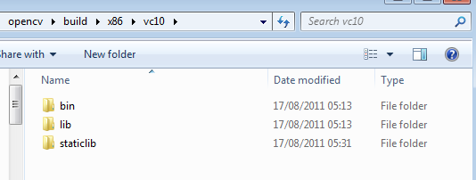
Figure 14: Folder structure created by the OpenCV installer
If the choice is to use the dynamic libraries then also the “bin“ folder should be added to the PATH system variable. This is not needed if the static version is used (just rename the name of the folder to “lib“ when copying.
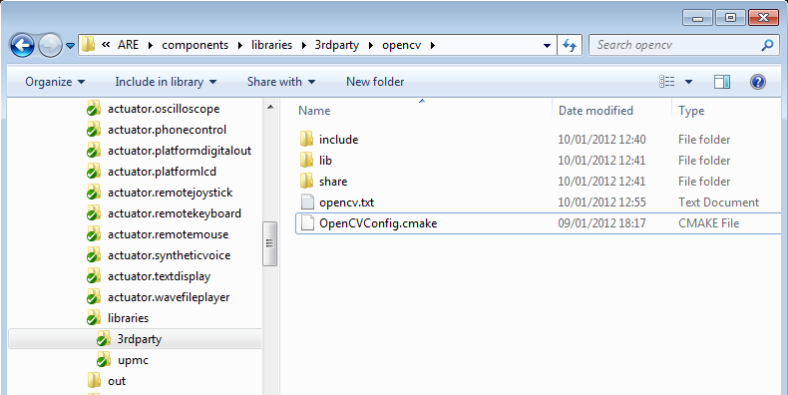
Figure 15: AsTeRics third party folder structure

As a final remark, please note that the opencv now uses the Threading Building Blocks (TBB) from Intel (instead of OpenMP) to provide where possible parallelisation of the heavy computations often required by algorithms. The TBB runtime library is shipped in the same package as the opencv-2.3.1 under the “common” folder.
  - Boost Library
The Boost libraries are required only for the facetrackerCLM plugin. As the opencv, boost has a rich “Getting Started” section which we invite developers to read. Boost uses BJam as building tool. Once downloaded the source should be unpacked in a local directory. The first step consists in building of the bjam executable. It is sufficient to execute the “bootstrap.bat” batch file in the boost root directory. Now open a console Terminal and change directory and issue the following command:
bjam toolset=msvc variant=release link=static threading=multi runtime-link=static install

This command tells the build manager to build a release, static and multithreaded version of the boost libraries which links statically to the microsoft runtime.

The build process will start, taking some time. It’s time to take a break. The command will create and install the boost libraries into the C:\Boost directory (this behaviour can be changed by specifying a different directory with the option –prefix=<PREFIX> in the command line).

The VC projects which uses the boost libraries look for the required includes and libraries specified by two environment variables: BOOST_INCLUDES and BOOST_LIBS. It is therefore necessary to set both accodingly to where the boost libraries were installed. In our case the environment variables will be set to the values as in Figure 16 and Figure 17.

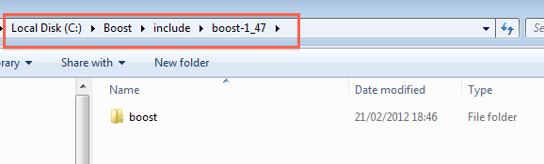
Figure 16: Boost include path

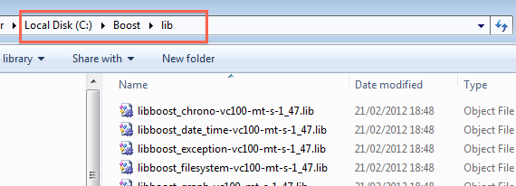
Figure 17 - Boost library path.
As a final note please keep in mind that the boost libraries use the autolinking feature that allows the linker to figure out which will be the required libraries during linking time.

  - VideoInput
Although videoInput is available on the internet as a precompiled static library we need to setup a custom project because the distributed package will not run in a multithreaded environment such as AsTeRICS.The suggested version to download is the one available on the gameoverhack github repository. Download the zipped package and unpack it on the hard drive. For our purposes VideoInput also requires the Microsoft Windows SDK 7.1 (or the latest available). The SDK, available from the Microsoft website. The SDK will provide all required DirectShow headers and libraries as explained in the following steps. Be sure to include also the “Samples” in the installation process.
Although VideoInput source also include DirectShow headers and libraries as well as DirectX libraries we will not use any of them because the building process could be quite problematic. Following these instructions instead will lead to a cleaner building process. To avoid every problem the suggestion is to remove all .lib files inside the folder.
Our starting point is the Visual Express solution videoInput.sln located in the folder “VC-2008-videoInputcompileAsLib”, see Figure 18.

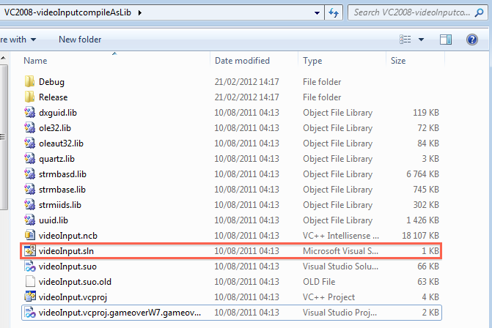
Figure 18 - videoInput solution.
When VC10 has finished conversion of the project, it will open as a Debug target but for efficiency we will switch from Debug to Release.
In order all actions that have to be taken:
1) Change reference SDK: switch Platform Toolset from v100 to Windows7.1SDK, see Figure 19
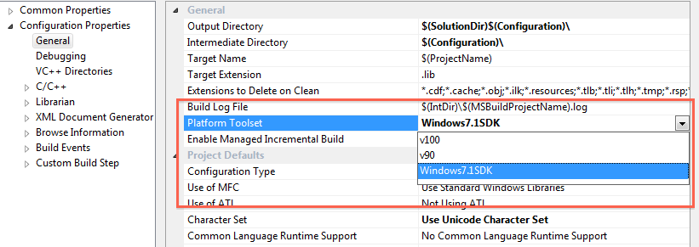
Figure 19 - Switching Platform Toolset

2) Additional Include directory for the DirectShow and modify the path to “extra” folder as in Figure 20
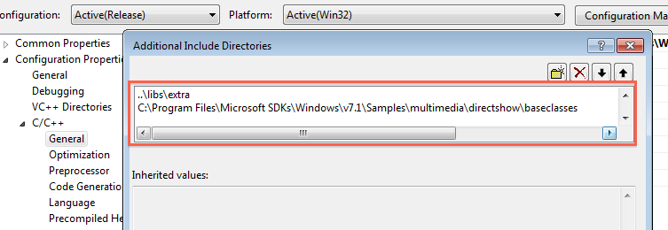
Figure 20 - Setting the DirectShow include path.

3) Remove redundant library settings. Leave only “strmiids.lib“, Figure 21
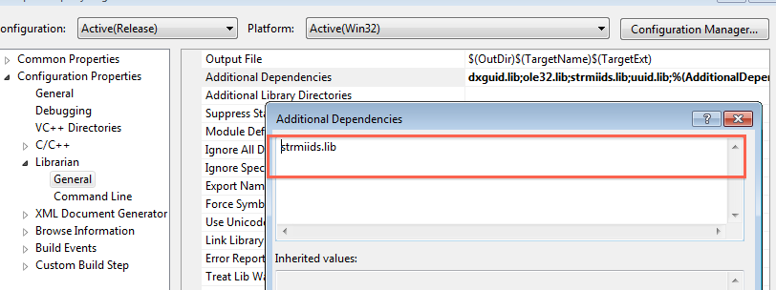
Figure 21 –Library settings.

4) Comment out DEBUG and _DEBUG pre-processing definitions in videoInput.cpp:
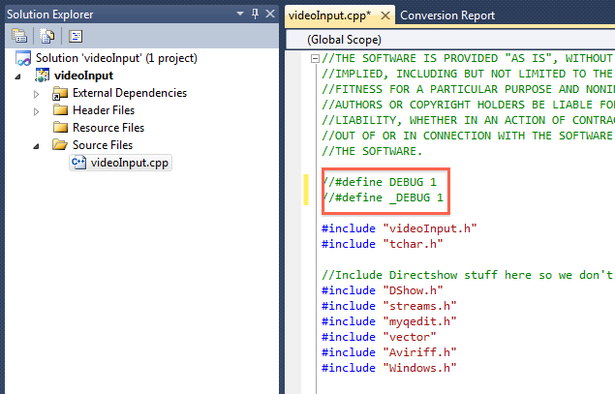
Figure 22 - Remove troubling defines when targeting Release targets.

5) Uncomment VI_COM_MULTI_THREADED define statement in videoInput.h:
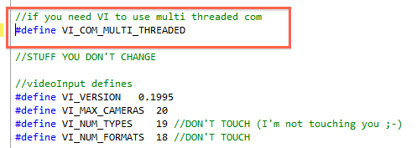
Figure 23 - Enable COM multithreading.
6) Build! Just wait.
7) Post-Build: when the building process ends we’ll find (hopefully) the compiled static library in the Release folder in the same folder as the solution. Finally we are ready to compile and link the videoInput library and use it inside the plugins’ projects. In order to do that it is necessary to move videoInput headers and libraries to the third party folder in the ARE\components directory. Figure 24 shows the contents of the videoInput folder inside the ARE\components\libraries\3rdparty folder, videoInput.h and myqedit.h should go into “include” and videoInput.lib goes into “lib”.
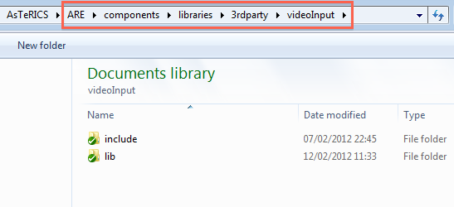
Figure 24 - videoInput final installation.

  - Building facetrackerLK
Once the Opencv 2.3.1 and VideoInput are in place, the building process of the facetrackerLK plugin is straightforward. The “webcam.sln” solution is configured with three targets: Relase (VI), Release (cv231) and Release (cv097).
The Relase (VI) target will use VideoInput to acquire from the webcam and OpenCV-2.3.1 for processing, while Release (cv231) will use OpenCV-2.3.1 for both tasks. Lastly the target Release (cv097) will use VideoInput for image acquisition and an old version of the OpenCV for processing. If we want to opt for the VideoInput based video capturing then we will proceed as in Figure 25.
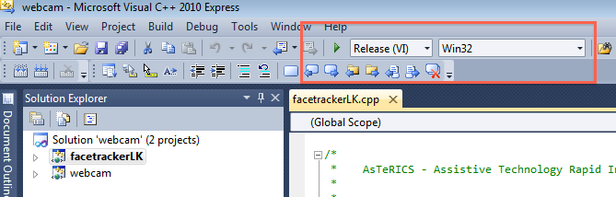
Figure 25 - Specifying the build target.

If all goes well during the building process then we will get the facetrackerLK.dll ready to be bundled in the usual jar archive that will be executed in the ARE framework.
A warning is due, the current project is configured to link against a custom build of the opencv library which requires a set of additional libraries (libjpeg, libpng, libtiff, zlib etc) as well as the tbb.lib. When not required it is possible that the linker will throw an error. In this case it is necessary to edit the header “opencv_includes.h” which contains a set of pragma directives targeting those libs.
Before doing so we should pay attention if the Java code that invokes the DLLs and the MANIFEST file are properly set. In case we want to choose the recommended solution based on the most recent opencv-2.3.1 then make sure that the lines in the class Bride.java look like in Figure 26. Otherwise uncomment the lines (above) that loads the opencv-0.97 DLLs and comment the line (below) that loads the TBB dynamic library.
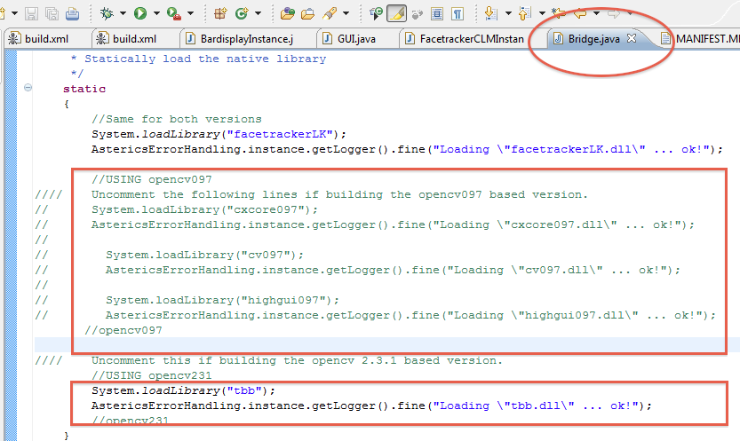
Figure 26 - Loading the right dependencies in Bridge.java for the facetrackerLK plugin.

Lastly it is sufficient to make sure that the actual MANIFEST.MF file matches the MANIFEST_videoinput.MF that is distributed with the release.

  - FaceTracker Library
At the time of writing we decided not to include the static library built upon the original sources made available by the author to the consortium. As soon as a decision will be made a mechanism for building the plugins, which depend on the FaceTracker library, will be put in place. This is not a problem anyway for the runtime distribution as the FaceTracker is compiled statically to the distributed plugins.

- References and Resources
- AsTeRICS Deliverable D2.1 – “System Specification and Architecture” - https://bscw.integriert-studieren.jku.at/bscw/bscw.cgi/40517
- AsTeRICS Deliverable D2.3 – “Report on API-specification for sensors to be integrated into the AsTeRICS Personal Platform” - https://bscw.integriert-studieren.jku.at/bscw/bscw.cgi/43571
- Open Service Gateway initiative (OSGi) - open specification - http://www.osgi.org
- Tortoise SVN client for Windows: http://tortoisesvn.tigris.org/
- Java Development Kit 6 (JDK 6): http://www.oracle.com/technetwork/java/javase/downloads/index.html
- Eclipse Integrated Development Environment: http://www.eclipse.org/downloads/
- Subclipse SVN plugin for Eclipse: http://subclipse.tigris.org/servlets/ProjectProcess?pageID=p4wYuA
- Apache ANT - commandline based build tool for Java applications: http://www.ant.apache.org
- OSGi – Tutorial by Nearchos Paspallis:
http://nearchos.blogspot.com/2008/12/starting-with-osgi-tutorial-1.html
- Microsoft Visual Studio 2010 - http://www.microsoft.com/visualstudio/en-us/products/2010-editions
- AnkSVN – SVN support plugin for Visual Studio - http://ankhsvn.open.collab.net/
- The Microsoft Ribbon Library - http://www.microsoft.com/downloads/en/details.aspx?FamilyID=2bfc3187-74aa-4154-a670-76ef8bc2a0b4
- The ResXFileCodeGenerator - http://www.codeproject.com/KB/dotnet/ResXFileCodeGeneratorEx.aspx
- Apache Thrift - http://thrift.apache.org/
- Simple Logging Facade for Java (SLF4J) framework - http://www.slf4j.org/index.html

Short Text Message
http://web.mac.com/jsaragih/FaceTracker/FaceTracker.html
http://opencv.willowgarage.com/wiki/
http://opencv.willowgarage.com/wiki/InstallGuide
http://threadingbuildingblocks.org/
http://www.boost.org/
https://github.com/gameoverhack/videoInput
https://github.com/gameoverhack/videoInput/zipball/master
http://www.microsoft.com/download/en/details.aspx?id=8442

