

AsTeRICS

Building a universal HID Actuator
for Mouse-, Keyboard- and Joystick emulation

DIY Assembly Guide
Version 1.0 beta

1 Introduction 3
2 Needed parts: 4
3 Soldering connections and flashing the HID firmware 5
4 Testing the HID actuator with the PS3 5
5 Additional Gaming Resources 7

- Introduction
The Human Interface Device (HID) protocol specifies standard USB-connected input devices. Especially mouse-, keyboard- and joystick devices are of interest for novel assistive solutions, because these devices serve as prominent input methods for computers, game consoles and other devices.
In this DIY-guide, an emulation device for USB-connected mouse- keyboard- and joystick devices will be presented which connects to the AsTeRICS system: The universal HID Actuator.
  - Operation and utilized modules
The HID actuator is plugged into a target computer, where it enumerates as mouse, keyboard and joystick (3 devices at the same time). The AsTeRICS model contains one ore more of the dedicated actuator plugins “RemoteMouse”, “RemoteKeyboard” or “RemoteJoystick”. These plugins send desired control commands to the HID actuator module. Depending on the AsTeRICS model which is used, one, two or three devices can be emulated concurrently by the HID actuator. Thus, mouse-, keyboard and joystick activity can be created from any desired sensor input or sensor combination.
One special feature of the HID Actuator is the compatibility to the Playstation-3 siaxis controller (also the PS-button works). This makes the HID Actuator interesting for accessible gaming scenarious using the PS3.
  - HID Actuator Versions
A customized hardware module for the HID actuator has beed developed by the AsTeRICS partners, which features a printed circuit board (PCB) of approximately the size of a USB stick. This version also contains a wireless module which receives the control commands for mouse-, keyboard- and joystick activities from the AsTeRICS computer via a Bluetooth link. For more information about this version of the HID Actuator as well as application scenarios, please refer to the AsTeRICS user manual, chapter 6.
However, the HID actuator described in this DIY-guide consists of a low-cost development board for Atmel AVR microcontrollers (the Teensy2.0++ board) and a FTDI cable to connect the Teensy microcontroller to the computer running the AsTeRICS Runtime Environment, which makes it very easy for electronic hobbyists to build this wired version.
- Needed parts
- 1 Mini USB cable
- Teensy++ 2.0 Board (see http://www.pjrc.com/teensy/)

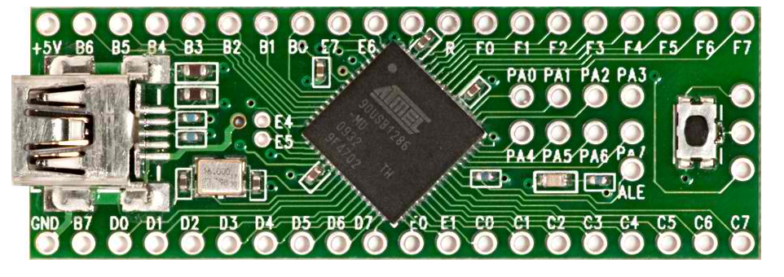

- A USB to serial cable e.g. FTDI TTL-232RG-VSW5V-WE http://www.ftdichip.com/Products/Cables/USBTTLSerial.htm

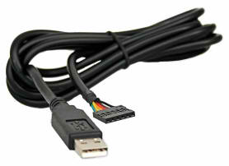

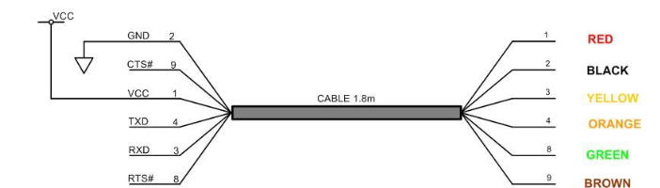

- Soldering connections and flashing the HID firmware
The first step is to solder the Tx, Rx, and GND wires from the cable to the Teensy board, according to the datasheet of the cable. In most cases you have to connect Tx from the cable to Rx of the Teensy, Rx from the cable to Tx of the Teensy and GND of the cable with GND of the Teensy.
After you finished soldering, the HID actuator firmware can be flashed to the Teensy board. For this raks, the Teensy Loader Application can be used, which is available at http://www.pjrc.com/teensy/loader.html. There you also find a step by step tutorial on how to flash the firmware hex file to the board.
The required hex file can be found in the folder /CIMs/HID_Actuator of the AsTeRICS-Runtime download package.
Finally you have to plug the FTDI “USB to serial”-cable into the computer running the AsTeRICS Runtime Environment and connect the Teensy++ board to the target computer (for example a PlayStation-3 or a desktop PC) with the mini USB cable.
The first time you plug the FTDI “USB to serial”-cable into your computer, you have to install a the driver file which can be downloaded from the FTDI homepage: http://www.ftdichip.com/Drivers/VCP.htm
The LED on the Teensy++ should flash for a few seconds and then light constantly. Now the HID actuator can be recognized by the ARE and is ready to be used as HID emulator device !
- Testing the HID actuator with the PS3
To verify that the HID actuator can communicate with the PS3, use the following steps to create a simple model, which presses the “X” key on the PS3 when the user hits a button.
- Create a new model in the ACS and add the “RemoteJoystick” component (Actuators → Input Device Emulation → RemoteJoystick). This component represents the PS3 game controller.
- Add the “DigitalIn” component (Sensors → Generic Control Input → DigitalIn) and select it. In the property editor tick the “activateEventIn1” box.
- Draw an eventchannel between the “DigitalIn” and “RemoteJoystick” component.
- The “X” button is “Button2” on the RemoteJoystick. To see which button corresponds to which PS3 button, simply select the “RemoteJoystick” component and click on the “Event Listener” tab in the “Property Editor”. There you can see the key mapping.
- Select the event channel.
- The “X” Key should be triggered by a button plugged into the first port of the GPIO module. Therefore set the properties according to the following figure:

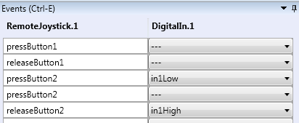
Figure 1: Properties of the eventchannel between DigitalIn and the RemoteJoystick
- If you haven’t plugged in the HID actuator and the GPIO module with a push button connected to slot 1 yet, do this now and power on the PS3.
- Restart the ARE
- Upload the model (System → Upload model)
- Start the model (System → Start model)
- When you press the Button and you are in the PS3 main menu the selected menu item should get selected.
This is just a very simple model, see Figure 2, to test if the connection works. You can find more sophisticated models which allow you to play different games using head movements, the OSKA keyboard and other input devices in the “models” folder of the ACS.
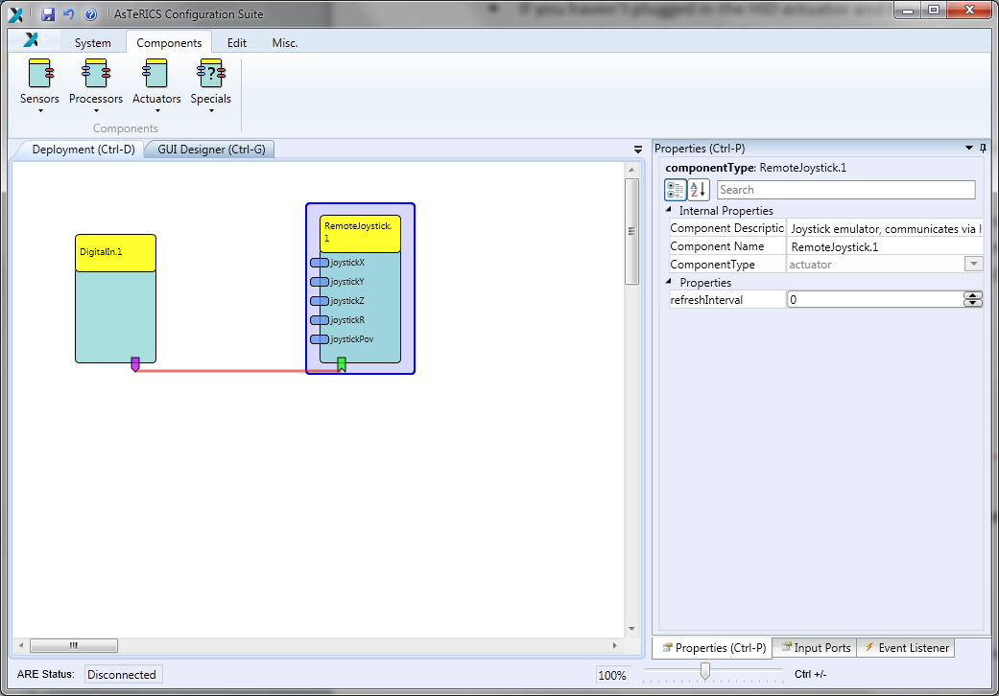
Figure 2: Simple test model to verify the communication between the PS3 and the HID actuator

- Additional Gaming Resources
Th HID Actuator is well-suited for emulating gaming device input. Various suitable games for the PC exist, partly for free - see the following suggestions:
http://www.ics.forth.gr/hci/ua-games/index_main.php?l=e&c=560
http://www.jacksonpollock.org/
http://papunet.net/games
Other great gaming resources are free emulators of old home computers, e.g. the Commodore 64. Thousands of games are available for free – some of them could be suitable for the AsTeRICS evaluation. A great resource of C64-games and emulators is the internet site:
http://www.c64games.de/index_p.php?eng=true

