

AsTeRICS

Smart Vision Module

DIY Assembly Guide
Version 1.0 beta

1 Introduction 3
2 Scene Camera / Optical Sensor 4
2.1 Wii Remote IR camera PCB 4
2.2 Case assembly 5
3 Eye camera 6
4 Sensor board 8
4.1 Sensor board case 9
5 IR-LED frame 10
6 Flashing the firmware 11
7 Using the SVM 11

- Introduction
The following Chapter describes the necessary assembly procedure for the Smart Vision Module (SVM). The Smart Vision Module can be used as a Gaze Tracking System or as a remote Blob Tracker for round markers or infrared reflectors. It consists of the following subsystems:
- A Scene camera (optical sensor of the WiiMote)
- An Eye camera (a webcam with IR-led for eye illumination and daylight filter)
- The Sensorboard (Teensy microcontroller plus optional Inertial Measurement Unit)
- An IR-LED frame (only needed for head pose compensation)
- Head mounting

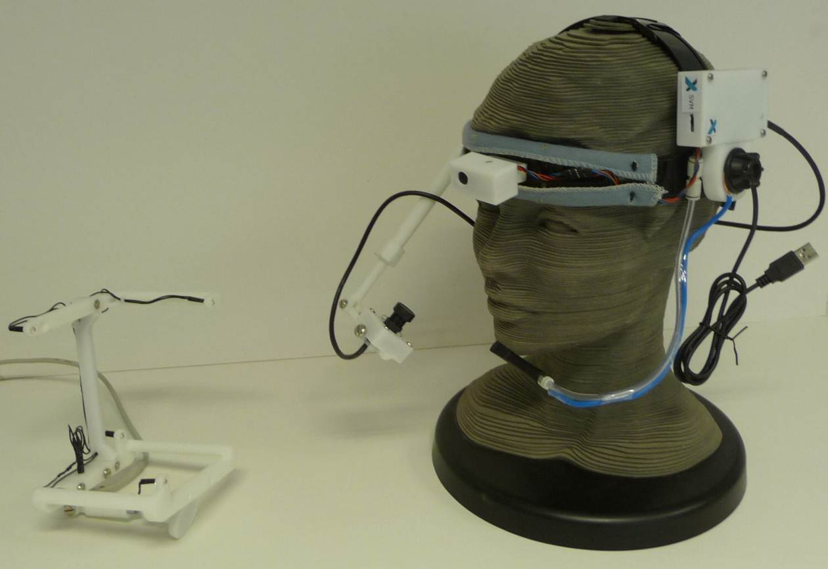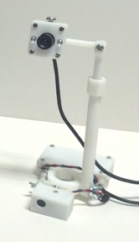
Figure 1: a) Complete SVM for gaze tracking (left), remote blob tracker (right)
The mechanical construction is made out of ABS plastic by a rapid prototyping 3D printer. The 3D .stl files are part of the AsTeRICS source code distribution and can be found in the ZIP package /CIMS/Sensorboard/3D-files.zip
To assemble the SVM, print out the mechanical parts and prepare the parts which are listed in every bill of material (BOM) table of the following Chapters. Furthermore, following tools/material is needed:
- Solder rod + Solder
- Hot glue, Instant glue
- Screwdrivers
- Hot air gun (optional)

The whole process is straight forward and no previous knowledge is required but it helps if you have some experience in do-it-yourself (DIY) projects.
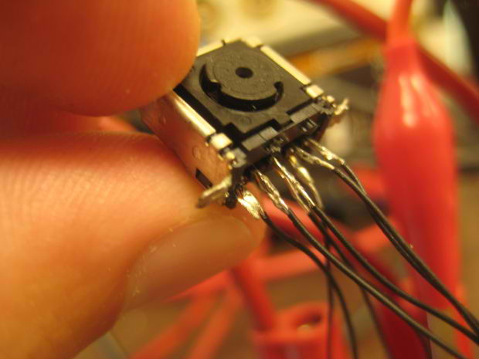
- Scene Camera / Optical Sensor
The main component of the scene camera system is the IR camera module from the Nintendo Wii Remote controller. To get the IR camera, a Wii Remote controller has to be purchased and disassembled. This procedure is described in detail in a lot of How To’s and step by step guides which are available on the net, for example here:
http://www.instructables.com/id/Wii-Remote-IR-Camera-Hack/

  - Wii Remote IR camera PCB
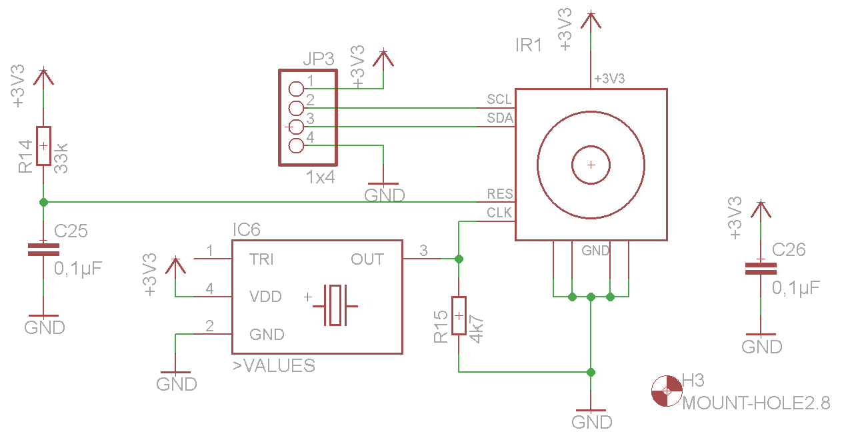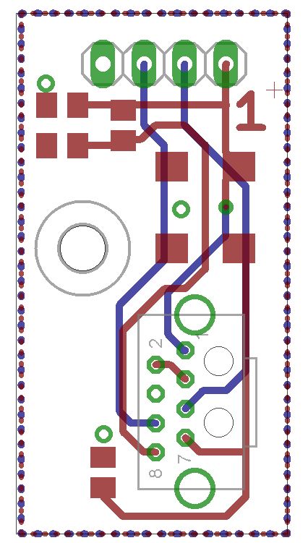
Figure 2: Wii IR camera board schematic (left) and board layout (right)

Figure 2 shows the schematic and PCB layout which is required to interface the Wiimote camera with the microcontroller, The board contains a 25Mhz oscillator and some resistors and capacitors. The design files are part of the AsTeRICS source code distribution and can be found in the folder /CIMS/Sensorboard
  - Case assembly
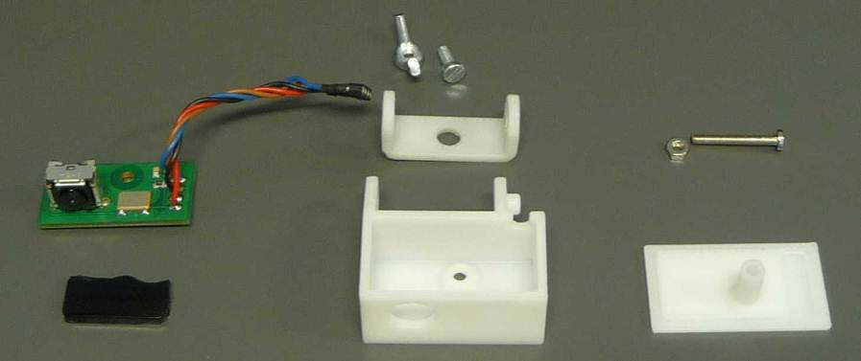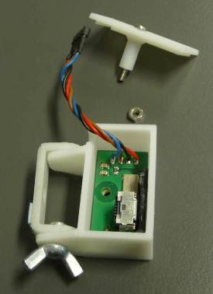
Figure 3: Scene camera / optical sensor assembly
- Solder a short cable onto the camera board and ad a connector
- Trim the IR-filter (of the Wiimote) so that it fits into the housing
- Put the PCB into the housing and use double-sided adhesive tape to fix the IR-Filter in front of the camera
- In a final step assemble the whole device like shown in the figure above, put the top cover onto the box and screw all together

Pos. | Description | Size | Amount | Further Details
1 | Screw | M3x8 | 1
2 | Wing nut | M3 | 1
3 | Screw | M2.5x18 | 1
4 | Nut | M2.5x18 | 1
5 | Cable |  | 1
6 | Connector | 2,54mm | 1 | pinheader
7 | Housing part 1 |  | 1 | See 3d-files
8 | Housing part 2 |  | 1 | See 3d-files
9 | Housing part 3 |  | 1 | See 3d-files
10 | IR filter |  | 1 | From wiimote
Camera board
11 | PCB |  | 1 | See above
12 | Oscillator | 7x5 mm | 1 | 25MHz
13 | Resistor | 0805 | 1 | 4k7
14 | Resistor | 0805 | 1 | 33k
15 | Capacitor | 0805 | 2 | 0.1µF
Table 1: BOM scene camera / optical sensor

- Eye camera
The Eye-camera consists of a modified low-cost USB webcam. It is either used for capturing a close-up picture of one eye pupil (using the dark-pupil effect when the eye is illuminated with infrared light). For this purpose, the IR-filter of the webcam is replaced with a filter which blocks visible light, and the lens is replaced by a macro lens.
Several cameras will be suitable for this modification, but some are not. A good camera is the very cheap
http://www.dealextreme.com/p/usb-2-0-1-3mp-driverless-webcam-w-microphone-and-6-led-illuminated-red-81560
The light-filter was easy to replace, the M12 lens mount allows to use different standard lenses. Here is a possible lens-set:
http://www.dealextreme.com/p/2-8mm-16mm-fixed-iris-lens-set-for-webcams-and-security-cctv-cameras-6-lens-pack-15774
Replace the 6 visible lights leds with 2 IR leds of type:
http://www.conrad.at/ce/de/product/153858/IR-EMITTER-SFH487P-T1
the intensity can be adjusted with the original potentiometer of the camera.

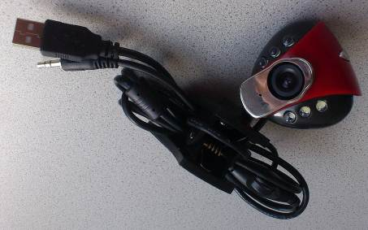
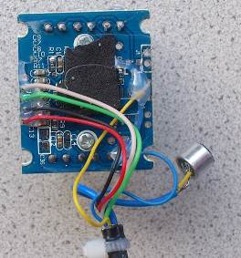
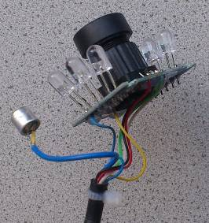

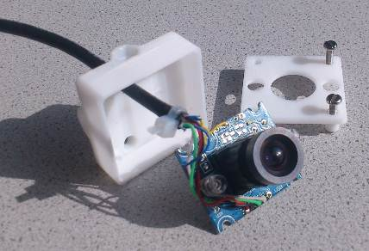
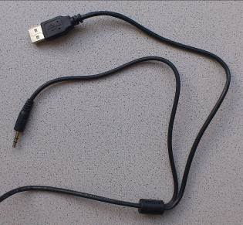
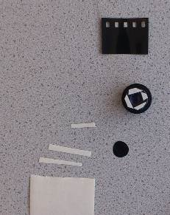
Figure 4: Eye camera assembly
Step-by-Step instructions for the eye camera build:
- Disassemble the Camera
- Remove all LED's
- Crop the microphone and the audio connectors, not the USB plug
- Solder the IR-LEDs onto the PCB in the middle position of the removed LEDs
- Use unexposed but developed photo film for the IR-filter
- Crop short and thin strips of double-sided adhesive tape to mount the photo film in front of the lens like shown in the picture above.
- Put the cable through the housing an solder it back again onto the PCB
- Replace the original with the 6mm lens
- Built all together

Needed Parts (summary):
Pos. | Description | Size | Amount | Further Details
1 | USB camera |  | 1 | See above
2 | 6mm Lens |  | 1 | See above
3 | IR-Filter |  | 1 | From wiimote
4 | IR-LED |  | 2 | See above
5 | Molex connector crimp terminal |  | 4 | Molex Nr. 08-70-1040
6 | Molex Crimp housing 4con |  | 1 | Molex Nr. 50-37-5043
7 | Camera housing base |  | 1 | See 3d-files
8 | Camera housing top |  | 1 | See 3d-files
9 | Camera arm short |  | 1 | See 3d-files
10 | Camera arm telescope |  | 1 | See 3d-files
11 | Camera arm telescope nut |  | 1 | See 3d-files
12 | Camera arm telescope base |  | 1 | See 3d-files
13 | Screw | M2.5x13 | 4 | camera housing
14 | Nut | M2.5 | 4 | camera housing
15 | Screw | M5x20 | 1 | telescope mounting
16 | Nut | M5 | 1 | telescope joint
17 | Screw | M3.5x 18 | 1 | telescope joint
18 | Washer | M3.5 | 2 | telescope joint
19 | Screw | M5x15 | 1 | camera adjustment
Figure 5: BOM eye camera
- Sensor board
The microcontroller interfaces the scene camera and (optionally) an Inertial Measurement Unit (IMU) to a PC via USB. For this, a Teensy++2.0 prototyping board from http://www.pjrc.com can be used (see Figure 6 ). The Teensy It must be modified to the 3.3V version as described here: http://www.pjrc.com/teensy/3volt.html.
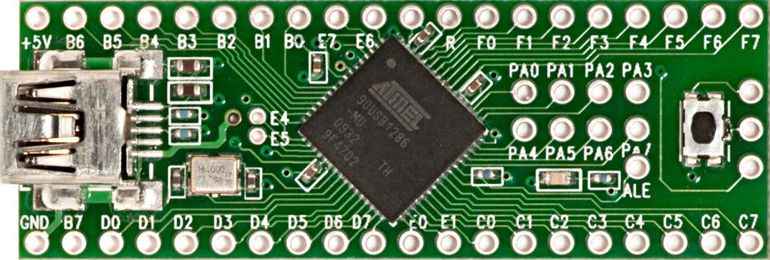
Figure 6: Teensy++2.0 development board
Connect the I2C-bus of the Teensy controller to the scene camera board and optionally to the Sparkfun 9 DOF Sensor Stick Inertial Measurement Unit (IMU) as described in Figure 7 and Table 2. If the IMU board is connected, the Teensy firmware delivers the movement / acceleration / orientation data of this sensor to the AsTeRICS Sensorboard plugin.

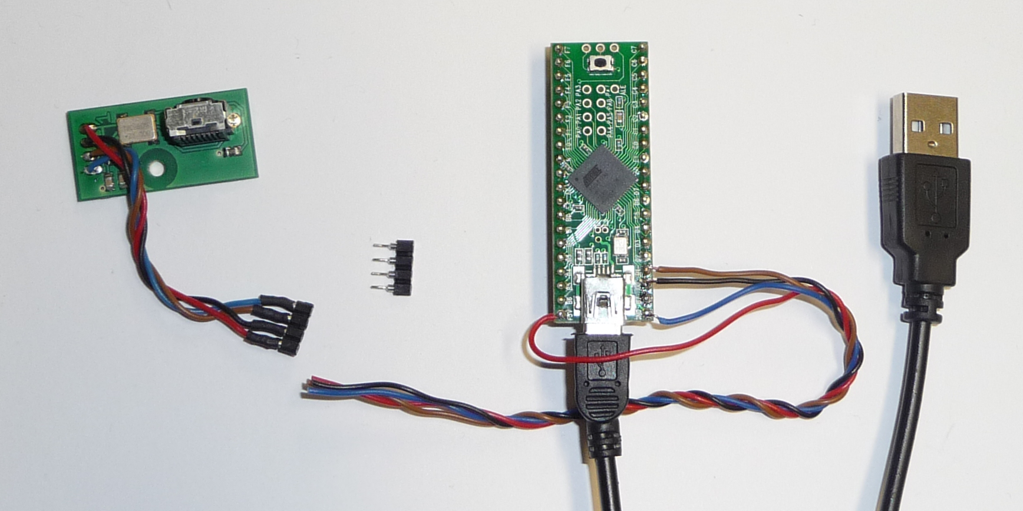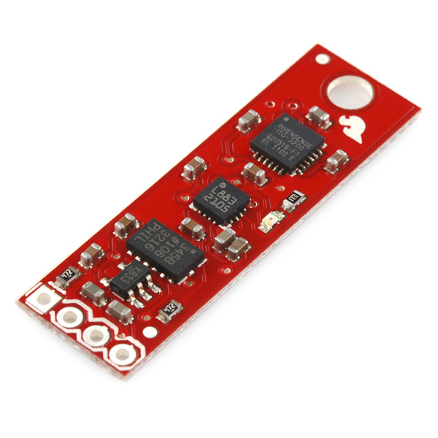
Figure 7:Connection of the Scene Camera and IMU module to the Teensy via the I2C bus
Make sure that the camera board is connected to the Teensy++ according to Table 2.
Description | Pin Nr. Scene camera | Label at IMU board | Label at Teensy board
3.3 V | 1 | VCC | +5V*
SCL | 2 | SCL | D0
SDA | 3 | SDA | D1
GND | 4 | GND | GND
Table 2: Connection details between scene camera, IMU board and Teensy board
*make sure that the board is converted to the 3.3V version

  - Sensor board case
If desired, the Teensy controller can be put into a 3d-printed “Sensorboard” case, together with the 9 DOF IMU board and an optional USB hub (to connect the Teensy and the webcamera via one USB cable to the computer). For this purpose, a cheap USB2.0 hub like e.g. http://www.chinabuye.com/black-usb2-0-4-ports-mini-hub-compatible-with-usb1-1
could be used. Two oft he 4 downstream port connected were directly soldered to the Teensy and the webcameras USB connectors respectively. The Teensy, IMU board + hub fit into the Sensorboard box:
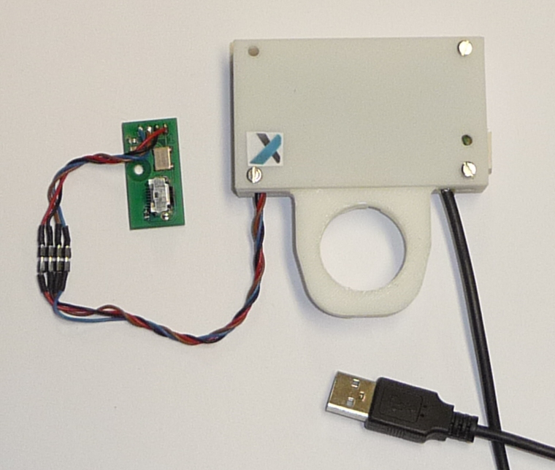

For the assembly of the Sensorboard box, the following parts are needed:

Pos. | Description | Size | Amount | Further Details
1 | Screw | M2.5x19 | 4
2 | Nut | M2.5x18 | 5
3 | Screw | M2.5x6 | 1
4 | USB-hub |  | 1 | See above
5 | Housing top |  | 1 | See 3d files
6 | Housing base |  | 1 | See 3d files
7 | Wire-to-Board Header |  | 1 | Molex Nr. 22-03-5045
Table 3: BOM sensor board case
- IR-LED frame
The IR-LED frame is needed in the gaze-tracking application for the head-pose compenstation. It is places n the computer monitor and filmed by the scene camera. The 4 IR-leds can be tracked and the POSIT algorithm is used by the AsTeRICS plugin to calculate the user’s head orientation with respect to the computer screen.
The IR LED frame consists of a 3d-printed skeleton and 4 IR-Leds + resistors which are supplied by 5 volts via a USB connector:

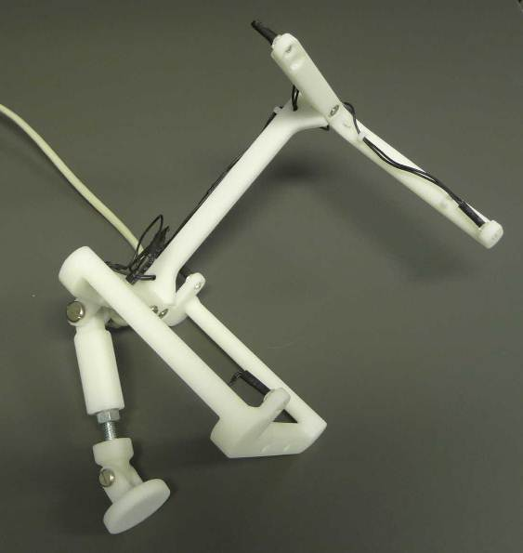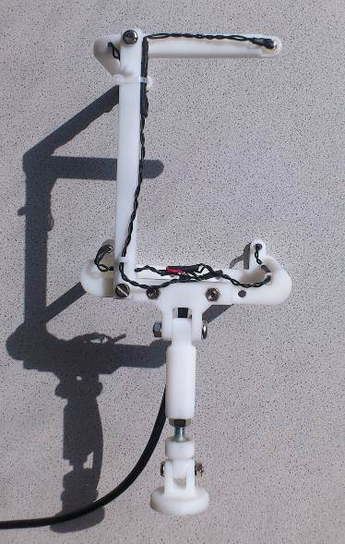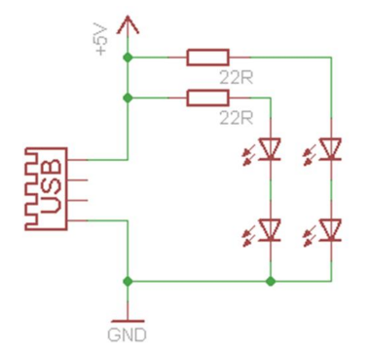
Figure 8: IR-LED frame assembly and schematic
For assembly, print the IR-LED frame 3d parts and wire the LED's and the frame according to the above schematic.
Needed parts for the LED frame:
Pos. | Description | Size | Amount | Further Details
1 | Frame top and base |  | 1 | See 3d files
2 | Frame connection |  | 1 | See 3d files
3 | Frame joint parts 1,2,3 |  |  | See 3d files
4 | Frame screw telescope |  | 1 | See 3d files
5 | IR-LED |  | 4 | See above (3)
6 | Heat shrink tube |  | 1
7 | Cable with isolation |  | 1
8 | USB cable |  | 1
9 | Resistor | 22 ohm | 2
10 | Screw | M4x20 | 5
11 | Nut | M4 | 5
12 | Screw | M5x25 | 1
13 | Nut | M5 | 1
14 | Screw | M6x40 | 1
15 | Nut | M6x40 | 2
Table 4: BOM IR-LED frame
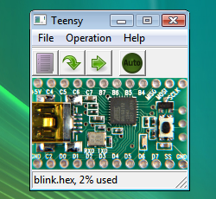
- Flashing the firmware
The source code and binary (sensorboard.hex) file for the Teensy++ controller are part of the AsTeRICS distribution and can be found in the folder /CIMS/Sensorboard.
To flash the sensorboard.hex file into the Teensy++ controller, please follow these instructions:
http://www.pjrc.com/teensy/loader.html
The Windows driver to create a Virtual COM port for communication with the Teensy++ board needs to be installed. This driver can be downloaded here:
http://www.pjrc.com/teensy/serial_install.exe
After this procedure, you should see a COM port in the Windows device manager after the teensy controller was attached via USB. The port can be used to retrieve all sensor data from the Teensy, which is done by the AsTeRICS “Sensorboard”-plugin.
- Using the SVM
Connecting the Teensy controller and verifying that a COM port is created, connect Eye camera to another USB port (or to the internal hub in the sensorboard box). Start the ARE and the ACS. Now the Sensorboard plugin and the Eyetracker plugin can be used. The Sensorboard plugin delivers IMU data and up to 4 IR-led x/y positions acquired by the Wiimote (scene) camera. The Eyetracker plugin delivers the center of a detected round blob in the webcamera image. Several models are available which integrated this data into a complete head-pose compensated Gaze-Tracking application with mouse-cursor control. Please refer to the folder ACS/models/UseCaseDemos/eyetracking.
