
AsTeRICS ModelGuide
6switch_mouse_local

Model Characteristics:

Model Name | 6switch_mouse_local.asc
Model file location | ACS\models\userEvaluation\harpo
Purpose | Six switch replacing the mouse actions.
Requirements | DigitalIn module is connected via USB. Six switches are connected to DigitalIn module.
Model Description | Six switches are used to control the computer mouse:  Switch 1 controls the left mouse button.  Switch 2 controls the right mouse button.  Switch 3 moves the mouse pointer right.  Switch 4 moves the mouse pointer left.  Switch 5 moves the mouse pointer down.  Switch 6 moves the mouse pointer up.

- Model Setup
- Connect the DigitalIn module to a USB port of the computer and attach 6 switches to the DigitalIn connectors: 1 - 6.
- Start the ARE and the ACS (the ACS can be started on the same machine or alternatively on a different computer)
- Load and start the model (refer to the AsTeRICS user manual if these steps are not clear). The graphical user interface (GUI) of the ARE will appear.
- Set the switches according to the user needs.

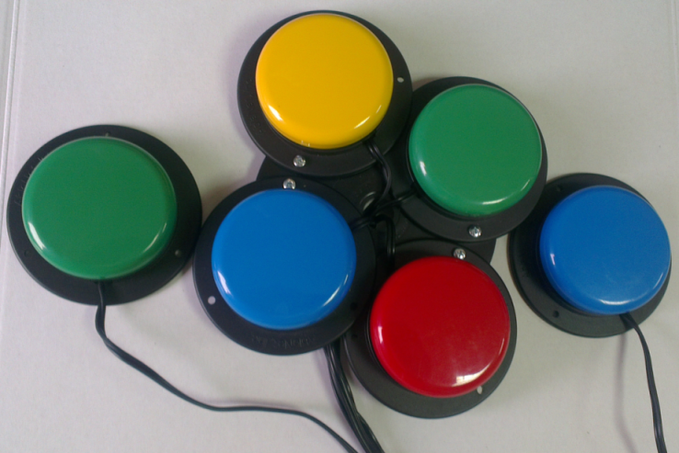
Figure 1: Example of the switches configuration

- Model usage and GUI elements
When the model has been started, the graphical user interface appears as seen below. It offers two control elements to adjust the mouse speed for X and Y directions:

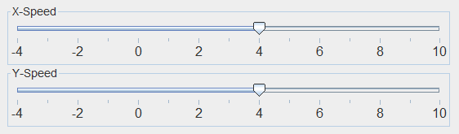
Figure 2: ARE GUI window with control options for the mouse speed

