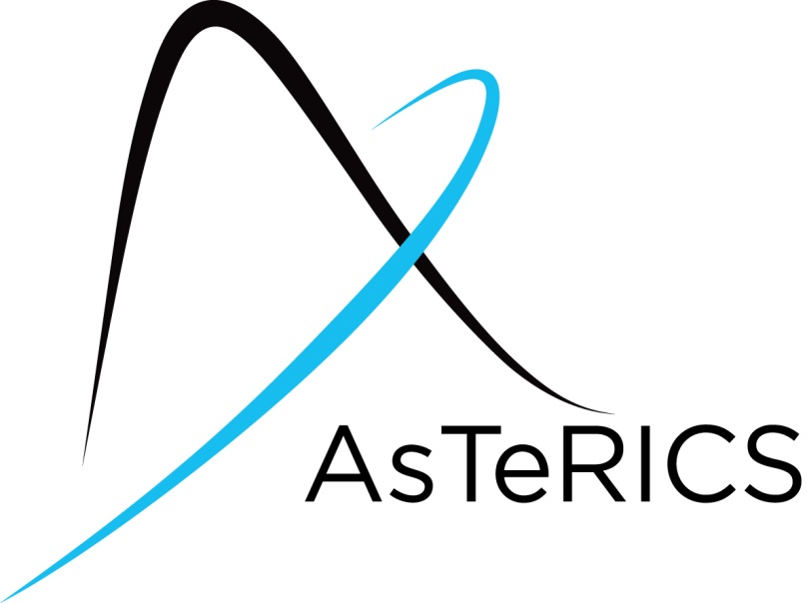
AsTeRICS ModelGuide
Speech Mouse

Model Characteristics:

Model Name | Voice_mouse_local_EN.acs
Model file location | ACS\models\userEvaluation\harpo
Purpose | The mouse pointer controlled by the speech commands.
Requirements | - A microphone must be available on the system  - Microsoft Speech Platform Server version 11, the target language and the TTS language pack must be installed  see http://www.microsoft.com/en-us/download/details.aspx?id=27225 and the ACS help of the Speech processor for further information must be present.
Model Description | The system recognizes speech commands from the user. If a command gets recognized the corresponding mouse action will be performed.

- Model Setup
- If your system has no integrated microphone, you have to plug in an external microphone and check if it is working.
- Start the ARE and the ACS (the ACS can be started on the same machine or alternatively on a different computer)
- Load and start the model (refer to the AsTeRICS user manual if these steps are not clear).
- Model usage and GUI elements
The GUI does not contain any GUI elements.
The following speech commands can be used now to control the mouse:
- Up – to move the mouse pointer up
- Down – to move the mouse pointer down
- Left – to move the mouse pointer left
- Right – to move the mouse pointer right
- Stop – to stop the mouse pointer
- Click – to perform the emulation of the left mouse click.
- Properties – to perform the emulation of the right mouse click.
- Property – to perform the emulation of the right mouse click.
- Run – to perform the emulation of the double left mouse click.
When the speech command to move the mouse pointer is recognized, the mouse pointer starts to move slowly, then its speed increases. To slow down the pointer the user has to say the speed command again.

