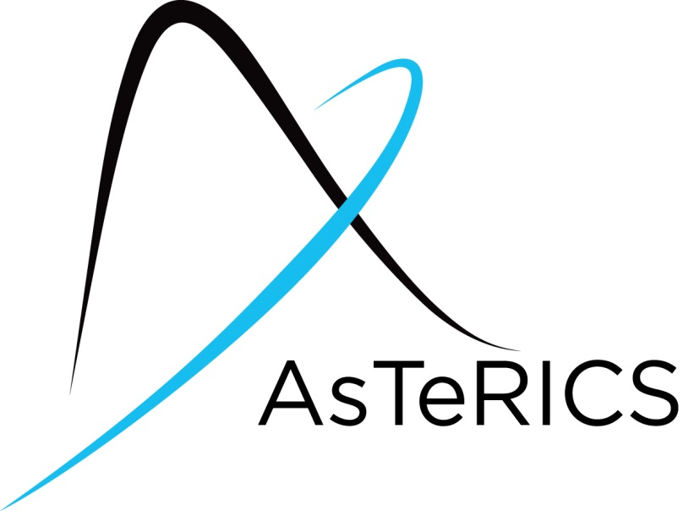
AsTeRICS ModelGuide
Speech Remote for television

Model Characteristics:

Model Name | Speech_tv_irtrans.acs
Model file location | ACS\models\useCaseDemos\environmentControl\
Purpose | TV remote controlled by speech.  Functionalities:  - Raise and lower volume  - Switch to next and previous channel  - Turn the television on and off
Requirements | - IR-Trans device connected to the AsTeRICS platform. The IR-Trans is a learnable IR-Sender which can be remotely controlled over a network connection or USB, depending which version you buy. The AsTeRICS plugin is compatible to all versions of IR-Trans.  - A microphone must be available on the system  - Microsoft Speech Platform Server version 11, the target language and the TTS language pack must be installed  see http://www.microsoft.com/en-us/download/details.aspx?id=27225 and the ACS help of the Speech processor for further information  - The IR-Trans device must learn the commands for the used television. Detailed information about the learning process can be found in the IR-Trans manuals.
Model Description | The system recognizes speech commands from the user. If a command gets recognized the corresponding IR-Code will be sent by the IR-Trans device to interact with a television.

- Model Setup
- Attach the IR-Trans device, see Figure 1, to the system where AsTeRICS is running via USB, Wifi or Ethernet. You can easily check if it’s working by using the IR-Trans Server software.
- If your system has no integrated microphone, you have to plug in an external mic and check if it is working.
- Start the ARE and the ACS (the ACS can be started on the same machine or alternatively on a different computer)
- Load and start the model (refer to the AsTeRICS user manual if these steps are not clear). The graphical user interface (GUI) of the ARE will appear.

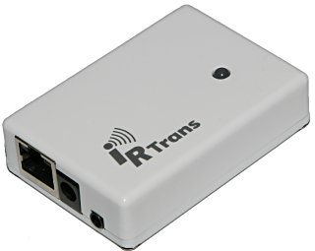
Figure 1: IR-Trans module

- Model usage and GUI elements
Before using the model, the IR-Trans module must learn the correct IR-commands for your television. Information about the learning process can be found in the IR-Trans Manual.
The name for the remote you create in the IR-Trans learning software must be “tv”.
The commands need the following names:
- on – to turn the television on
- next – to switch to the next channel
- previous – to switch to the previous channel
- louder – to raise the volume
- lower – to lower the volume

When you start the model, you can see the ARE-GUI as shown in figure 2. The GUI only contains a text display which shows the last recognized command in the top left corner.
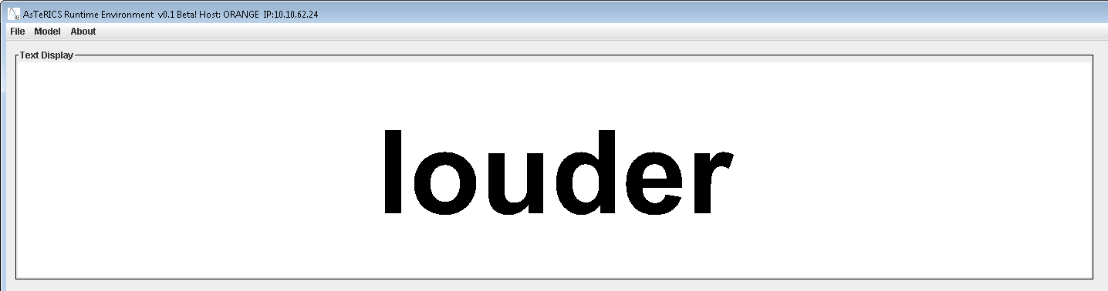
Figure 2: ARE GUI window with the textual output of the last recognized command
The following speech commands can now be used to control the TV:
- on – to turn the television on
- next – to switch to the next channel
- previous – to switch to the previous channel
- louder – to raise the volume
- lower – to lower the volume

