
AsTeRICS ModelGuide
Acceleration_headMouse_switch_local

Model Characteristics:

Model Name | Acceleration_headMouse_switch_local.asc
Model file location | ACS\models\userEvaluation\harpo
Purpose | Use the Acceleromenter as a mouse replacement.  Three switches are used to emulate the mouse buttons.
Requirements | DigitalIn module is connected via USB. Two or three switches are connected to the DigitalIn module. The Accelerometer module is connected via USB.
Model Description | Accelerometer, mounted on the user head, is used to control the movements of the mouse pointer.  Three switches are used to control the mouse buttons:  Switch 1 controls the left mouse button.  Switch 2 controls the right mouse button.  Switch 3 controls the double left mouse button click.

- Model Setup
- Connect the Accelerometer Module to a USB port of the computer and put it on the user head (using a band), behind the left ear, cable down (see figure 1).
- Connect the DigitalIn module to a USB port of the computer and attach 2 or 3 switches to the Digital In connectors: 1 - 3.
- Start the ARE and the ACS (the ACS can be started on the same machine or alternatively on a different computer)
- Load and start the model (refer to the AsTeRICS user manual if these steps are not clear). The graphical user interface (GUI) of the ARE will appear.
- The user should move the head to the neutral position. When both plots are nearly horizontal (see figure 2), click the Calibrate/Start button on the GUI.

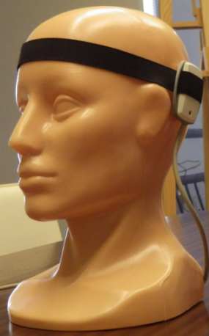
Figure 1: Mounting of the Accelerometer module on the user head.
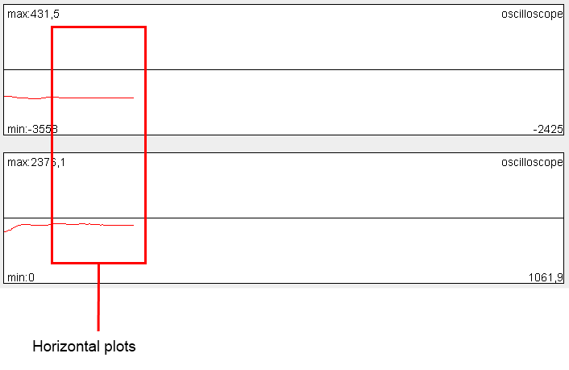
Figure 2: Example of the horizontal plots.

- Model usage and GUI elements
When the model has been started, the graphical user interface appears. The user can configure the model using five buttons:
- Calibrate/Start – Starts and calibrates the mouse. This button should be chosen when the plots are nearly horizontal.
- Stop – Stops the mouse.
- Change direction: horizontal<->vertical – Changes the reaction of the mouse pointer. The horizontal and vertical directions will be changed.
- Change direction: left<-> right – Changes the reaction of the mouse pointer. The left and right directions will be changed.
- Change direction: top<->down – Changes the reaction of the mouse pointer. The up and down directions will be changed.

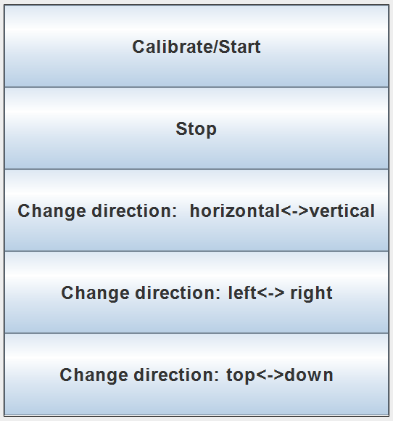
Figure 3: GUI interfaces

