

AsTeRICS

Quick-Start Guide
KI-I
Brigitte Nußbaumer

Document Information
Issue Date | 17. Juni 2013
Status | final
Dissemination Level | PU  PU Public  PP Restricted to other programme participants (including the Commission Services)  RE Restricted to a group specified by the consortium (including the Commission Services)  CO Confidential, only for members of the consortium (including the Commission Services)
Table of Contents

1 General Information 4
1.1 Definition AsTeRICS 4
1.2 Definition ACS 4
1.3 Definition ARE 4
1.4 Required devices and conditions 4

2 Installation 5
2.1 Start the installation 5
2.2 Define the installation path 5
2.3 Select components 6
2.4 Define Start Menu folder entry 6
2.5 Progress of installation 7
2.6 Installation finish 7
2.7 Complete (check) the installation 8
2.7.1 Desktop Short Cuts 8
2.7.2 Programs in the Start Menu 8

3 Creating Models – a first Example 8
3.1 Reducing Tremor 12
3.2 Adjusting the Webcam 13

General Information
These instructions will help you to install the open-source-software AsTeRICS. The installation process will be described step-by-step.

Definition AsTeRICS
„Assistive Technology Rapid Integration and Construction Set“.
With AsTeRICS, you can easily and economically build, use and adapt your efficient and individual "Assistive Technologies". The input capabilities of AsTeRICS are very flexible. AsTeRICS can be used and combined with different input-devices such as a webcam, switches or an on-screen scanning keyboard.
The various output-capabilities of the system include PC device emulation, game control, environmental control applications and utilization of embedded devices.

Definition ACS
AsTeRICS Configuration Suite is a graphical editor for easy building and adapting “Assistive Technologies”.
For this purpose you use sensors, actuators and processors, which are included in the software. You can connect these elements and build your own individual setup (also called a “model”), which is specially adapted for your needs, easily and fast.

Definition ARE
The AsTeRICS Runtime Environment is the basic software framework for all AsTeRICS applications and use-cases. The models built in the ACS will run in the ARE. The ACS can be seen as a configuration program for the ARE.

Required devices and conditions
- AsTeRICS hardware platform (http://asterics.harpo.com.pl/hardware.html)
Or a PC / notebook with Windows XP / VISTA / 7
- Internet access

Installation
An Internet connection is required during the installation.

Start the installation
Click on the following link to download and start the setup file:
http://www.asterics.eu/download/AsTeRICS_setup.exe

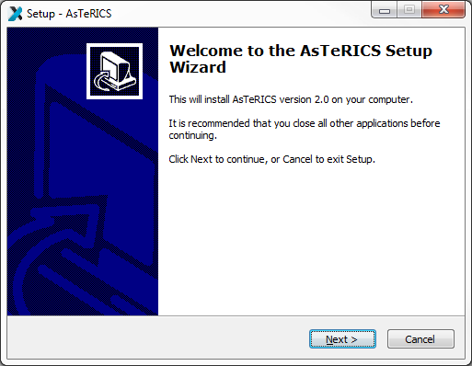
You should see the welcome window. It informs you which version of the software you are installing. Click the button „Next“.

Define the installation path

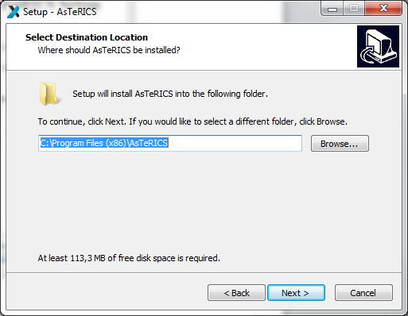
In this dialogue window you can define the installation path that means you can choose a folder, where Asterics should be installed. We suggest using the standard installation path. Then Click the button „Next“.

Select components
You can see the component selection window:
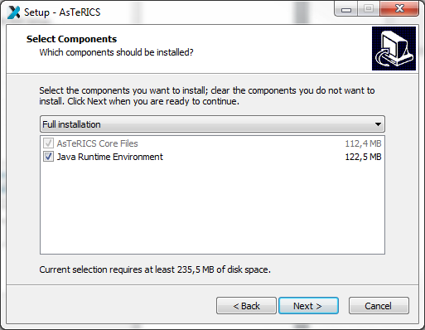
AsTeRICS needs the Java Runtime Environment (32-Bit Version). If you have already installed the Java Runtime Environment on your computer, please deselect this option and install only AsTeRICS. (Note: you need the 32-bit version also if you use a 64-bit version of Windows). Then, click the button „Next“.

Define Start Menu folder entry
In the next dialogue window you can define the name of the start menu entry.You can see the following window:
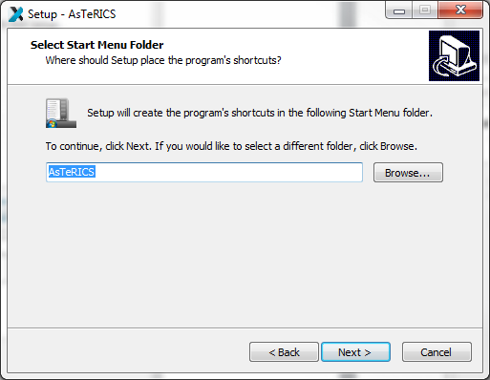
Then, click the button „Next“.

Progress of installation
In the next dialogue window you can see the progress of the installation. It can take a few minutes until the process is finished:
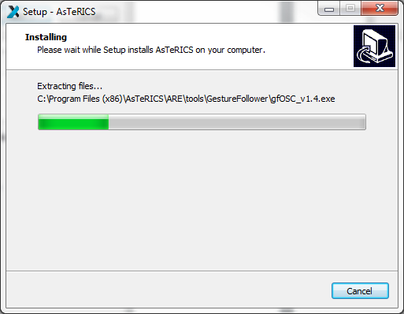

Installation finish
You can see the following window:
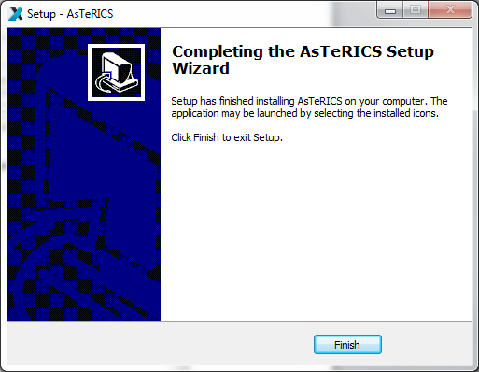
Click the button „Finish“.
You have successfully installed AsTeRICS.

Complete (check) the installation

Desktop Short Cuts
On your desktop you will find the following links (short cuts):
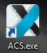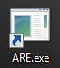
These short cuts can be used to start ACS and ARE. Alternaively, you can start these programs also from the Windows start menu, where additional liks to the Debug version of the ARE (which displays debugging information in a console window) and the AsTeRICS unistaller have been added:

Programs in the Start Menu
Under Windows-start „All Programs” you will find the start folder „AsTeRICS“ and the start-files.
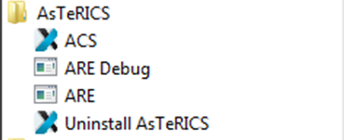

Creating Models – a first Example

A model is a collection of 1 to n components, where a component represents a plugin of the ARE. These components are connected via cannels (for data connections) and event channels (representing events). The following example will illustrate the creation of a simple webcam mouse, using the position of the nose to control the cursor and opening the mouth to trigger a mouse click. This model requires a connected and installed webcam.

In a first step, start the ACS and the ARE using the ACS.exe and ARE.exe short cuts. In the ACS window select the tab ‘Components’, then ‘Sensors’ and within the sensors the menu item ‘Computer Vision’. There select the component FacetrackerLK. The component is now on the drawing area and, if the component is selected, properties can be set (or changed) in the rightmost part of the ACS window.
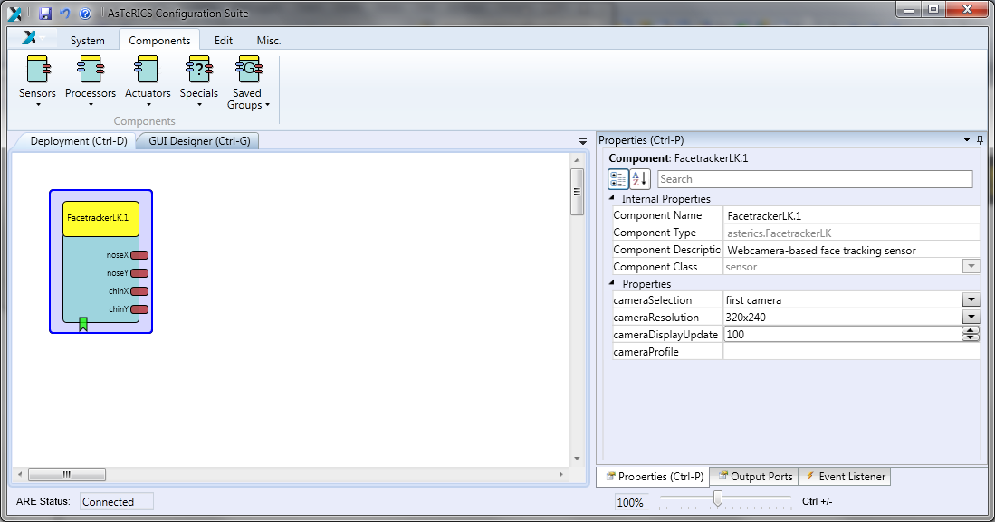
The next needed component is the ‘Mouse’, it can be found by selecting ‘Actuators’ -> ‘Input Device Emulation’. After the insert, select the Mouse component and adapt the properties. Deactivate absolutePosition and set the xMax and yMax to your screen resolution.
In the next step, connect the noseX and the noseY outputs of the ‘FacetrackerLK’ with the mouseX and mouseY inputs of the Mouse. Finally, it should look like the screenshot below.
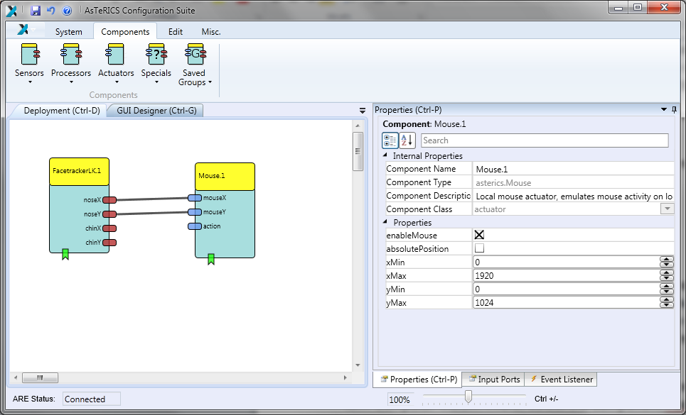
The model now would be able to use the coordinates of the nose to control the mouse cursor, but the mouse click is still missing.
For the mouse clicking functionality, we first need the ‘MathEvaluator’ (‘Processors’ -> ‘Basic Math’) plugin. We connect the noseY output of the ‘FacetrackerLK’ the with the inA input of the ‘MathEvaluator’ and likewise the chinY with inB. In the properties of the ‘MathEvaluator’, we set the property expression to ‘b-a’.
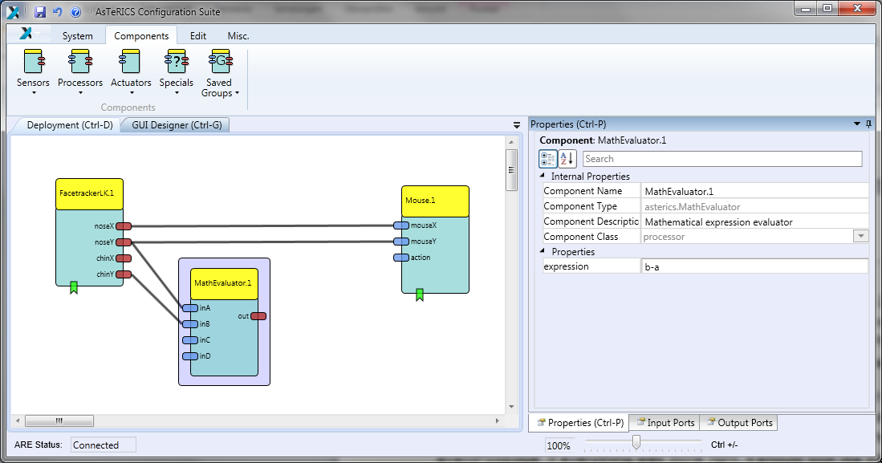
We will ‘Differentiate’ (‘Processors’ -> ‘Basic Math’) the out value to react on a fast change of the nose to chin distance.
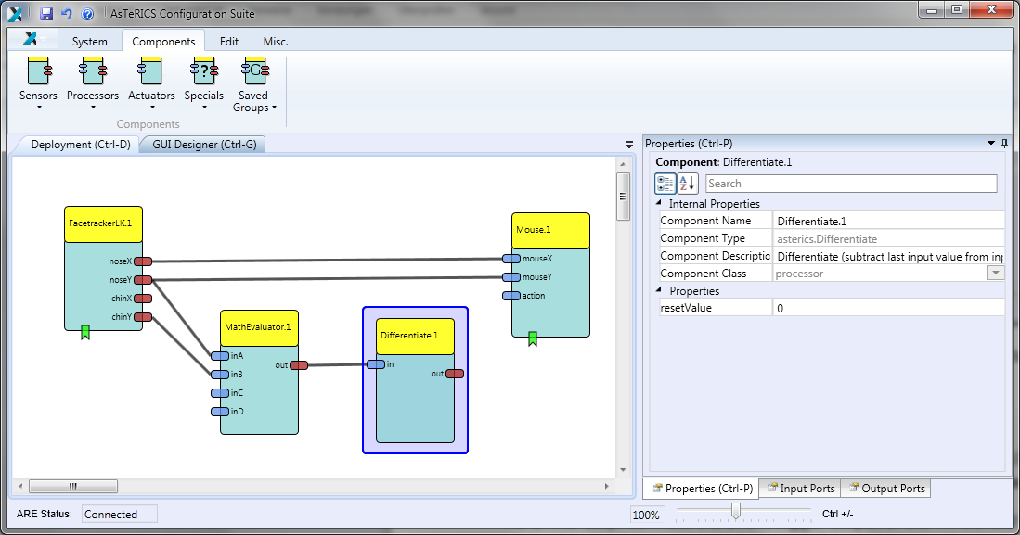
This processed value will then be forwarded to a ‘Threshold’ (‘Processors’ -> ‘Basic Math’) component. Set the thresholdLow and thresholdHigh values to 30.
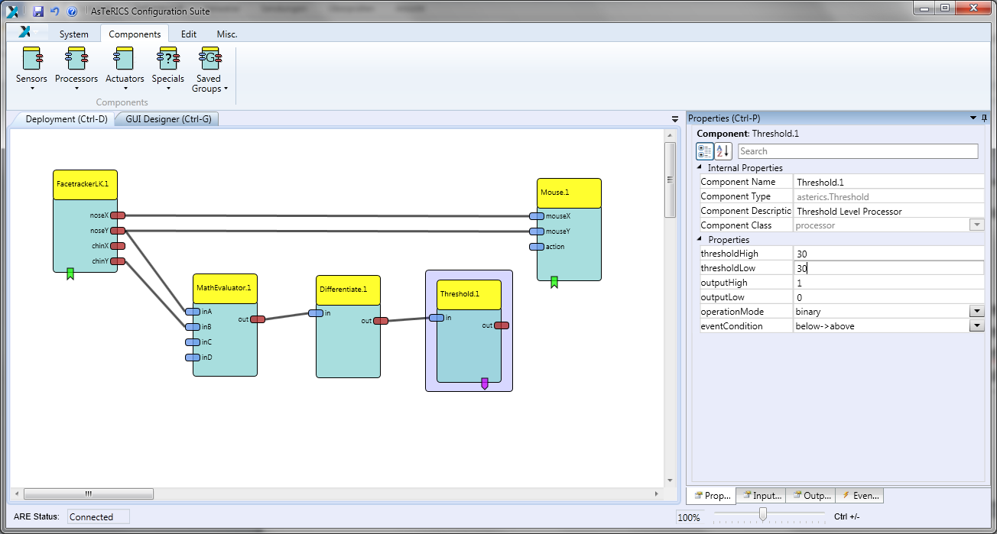
As a final step, connect the event trigger output of the ‘Threshold’ with the event listener input of the ‘Mouse’ – the event triggers and listeners are at the bottom of the components. After the connection has been made, set the leftClick to eventPosEdge in the property editor at the right. If everything was done right, it should look like the following screenshot:
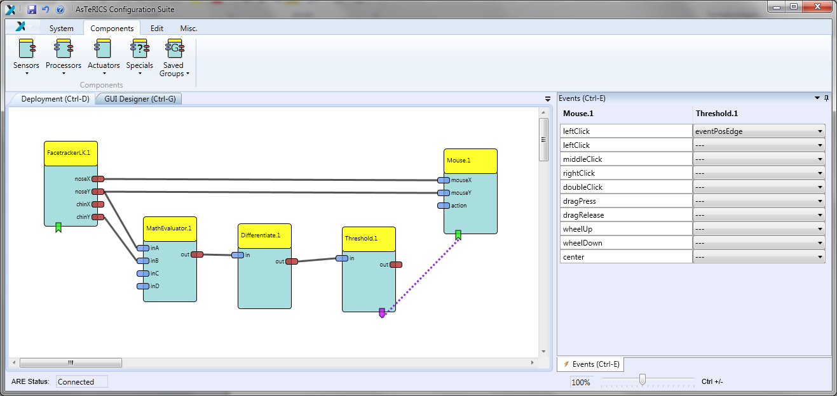
Now, upload the model to the ARE and press the ‘Start Model’ button. A window with the camera screen will appear, marking with a green and yellow circle - the position of nose and chin. Press the ‘Stop Model’ button or press F7 to stop the model and get the control of the mouse back. Below is a screenshot of the system, when running.
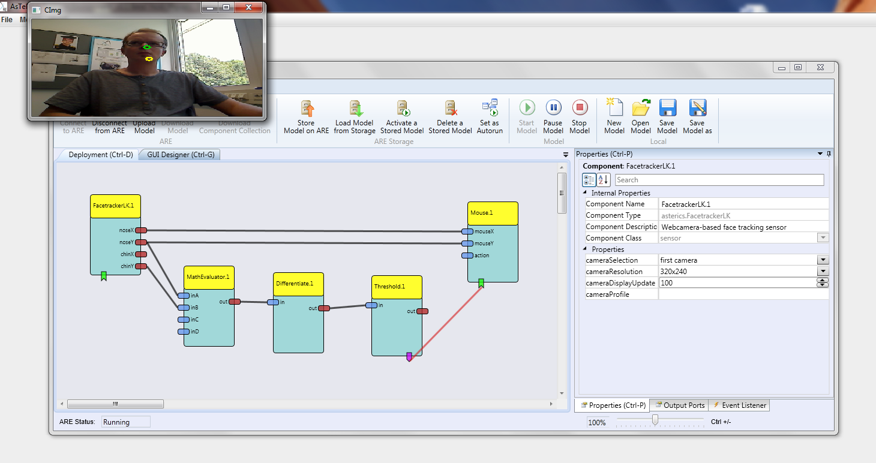
Congratulations, your first AsTeRICS model is running!

Reducing Tremor

You might have noticed that the mouse pointer has a tremor, because the head is always in movement to a certain extent. To reduce this tremor, an ‘Averager’ (‘Processors’ -> ‘Basic Math’) will be used to smoothen the X coordinates and another ‘Averager’ for the Y coordinates between the ‘FacetrackerLK’ and the ‘Mouse’. The bufferSize in the properties will be set to 5.
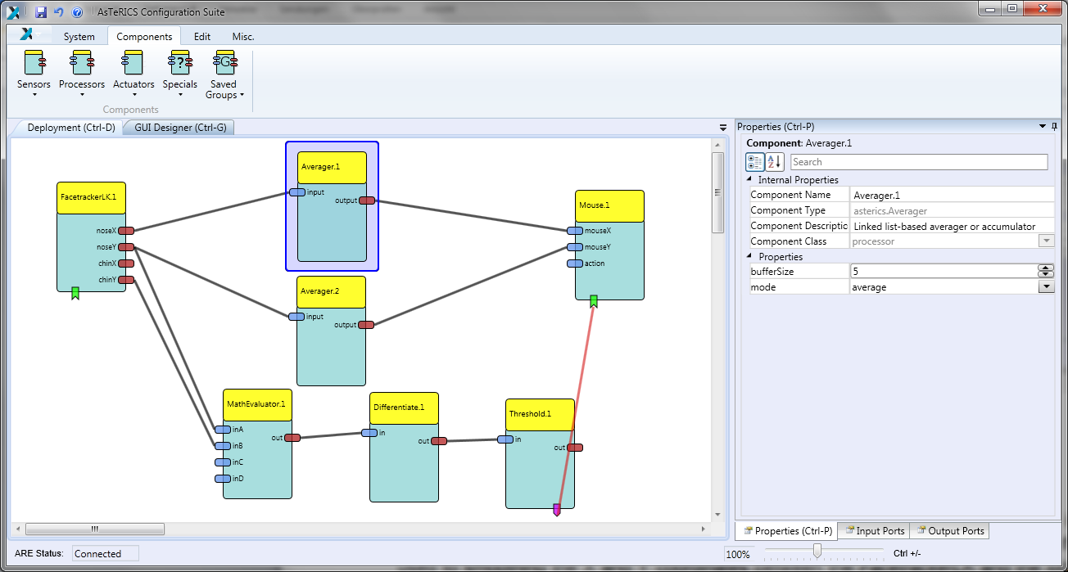
That’s all, just upload the model and start it now.

Adjusting the Webcam

If you don’t like the position of the webcam after starting the model, you can set a different start position. Select the ‘GUI Designer’ tab above the drawing area and move the webcam window to an area, which is comfortable to you. Also the size of the window can be adjusted.

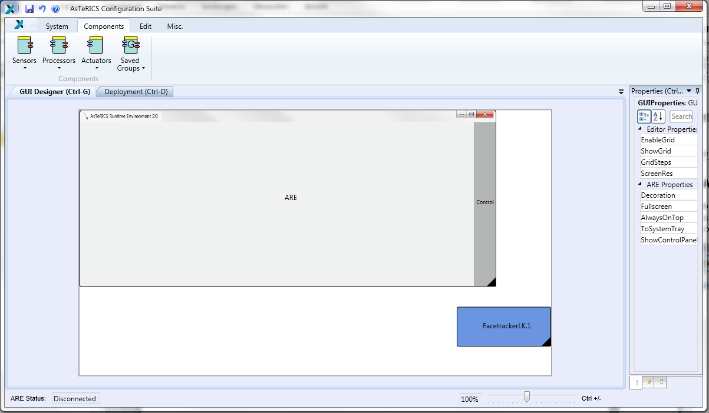

Upload and start the model to work with the changes.

For more examples and detailed descriptions of the features of ACS and ARE, please refer to the AsTeRICS user manual !

