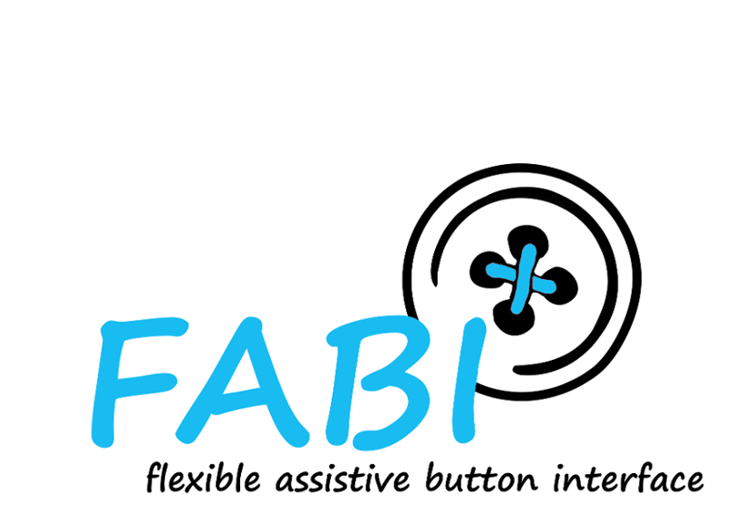
Safety Instructions

Read this safety instructions carefully before using the FABI. Improper use might cause harm and injuries for which the AsTeRICS Foundation cannot be held responsible!
- Attach only appropriate buttons to this device. In case of doubt consult an expert.
- Do not use the device in combination with safety critical devices or other medical devices.
- Use the device only with non-critical consumer electronics.
- Do not use the device in an explosive environment.

