# Instructions for cleaning and maintenance

If the mouthpiece is used to actuate the cursor movements via lip/mouth movements, a careful cleaning procedure is essential to avoid bacteria and health problems! Read this section carefully and apply the needed cleaning procedures whenever necessary.

#### Exchanging the saliva filter:

The saliva filter is placed inside the hygienic stick. Usually, no (or nearly no) saliva should enter the stick – but it strongly depends on the person using the mouthpiece and his/her condition. If saliva enters the hygienic stick, the saliva filters prevents the moisture entering the inner parts of the FlipMouse (respectively the pressure sensor). The filter can be replaces as follows:

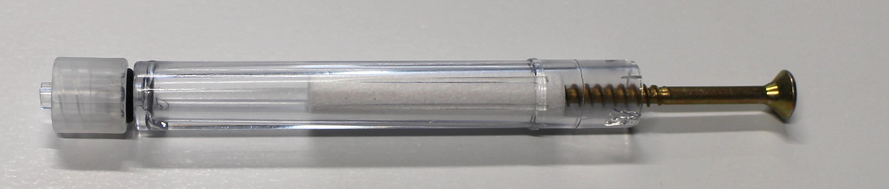

Removal of the saliva filter, using a normal screw to grab the filter

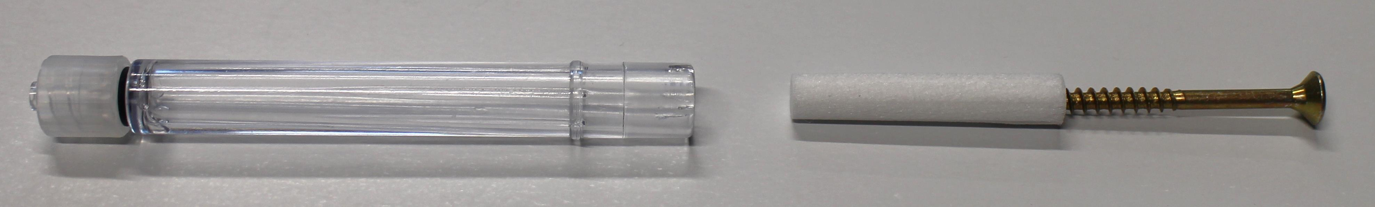

The removed filter

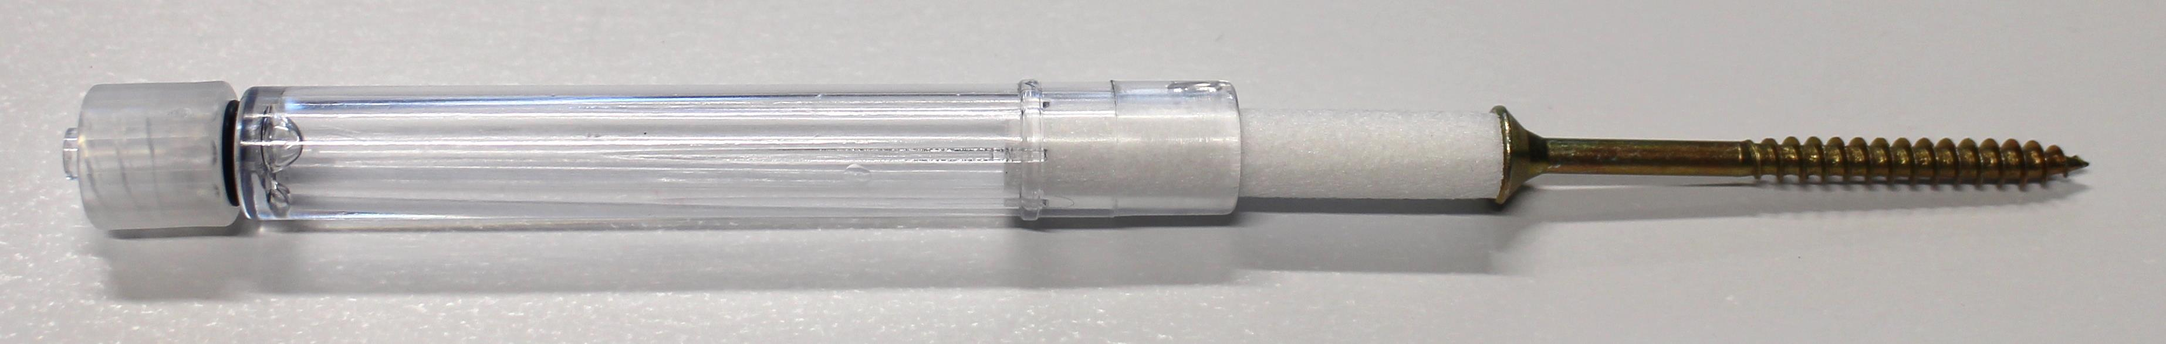

Inserting a new filter (pushing it back into the hygienic stick)

#### Disinfection of the mouthpiece/hygienic stick:

To disinfect a mouthpiece, use boiling water. Place the hygienic stick (without saliva filter) in boiling water for at least five minutes. Then let the hygienic stick dry before the next application.

#### Ordering replacement sticks and filters:

Saliva filters and hygienic sticks can be directly ordered from the Quadjoy online shop: [https://quadjoy.com/shop](https://quadjoy.com/shop/). We would like to thank Bill and Debra Street for letting us use their Quadjoy hygienic stick together with our FlipMouse device – you guys are great !!

Another possibility to order a replacement stick is <https://hackerspaceshop.com/collections/flipmouse>, where we sell the FLipMouse and its parts/addons.